Project Title
Your names and affiliation: Harriet Author, John Author, and Mary Author
Department of Electrical and Computer Engineering, Carnegie Mellon University
Abstract—A system capable of … The blue text represents instructions, while black text indicates the headings or example text. In the abstract, you should use 100 words or less to describe the big idea(s) behind your project and quantitatively explain the improvement you will make to the state of the art. Always use full sentences in the abstract and throughout the document.

Index Terms—Design, robot, sensor (Provide a list of key words or phrases in alphabetical order; use your own words and delete the ones listed as an example)

Introduction
T
his document is the design report template, which borrows from the IEEE publication format [1]. Do not alter the prescribed margins, which provide 3.5” columns. The text font is 10 pt Times New Roman. The suggested length for the text part of the design report is 8 pages, though you may extend beyond that target. You may add up to an additional three separate pages at the end of the document to handle full page figures or tables. For example, one suggestion is to use one extra page for a comprehensive system block diagram, a second extra page for a milestone and schedule chart and a third extra page for a table of parts with the budget.
The paragraph style “Text” justifies paragraphs to both the left and the right and indents the first line of the paragraph. Please use this paragraph style. This is an example of a “Text” paragraph.
The paragraph style “Normal” only justifies the text to the left, and does not indent the first line of the paragraph. Do not use this paragraph style. This is an example of a “Normal” paragraph.
The introduction should motivate why your project is needed. Be logical about how you construct the introduction – one step at a time: What is the application, which is also called the “use case”? Why is it important? Who needs it? That is, how will the user use your product to solve their problem and/or otherwise meet their needs. (There may be one or more use cases, but realistically your project will address a single use case.)
What are the competing technologies and what are the advantages of your approach? Also touch on “What are the goals?” Limit these latter parts of the introduction to one or two paragraphs.

Use-Case Requirements
You have defined the application and the corresponding user qualitatively in the introduction (section I) above. Each use case will have one or more requirements. Some requirements may at first seem qualitative. For example, a user needs (or wants) a remote-control robotic gripper that picks up cups and plates without dropping them. However most requirements can and should be cast in a quantitative form. For example, the gripper must have a failure rate of less than 1 % (1 in 100 grasps), where failure is defined as dropping the object. This section should outline the most critical quantitative metrics that your product needs to meet to solve the problem it is designed to solve.
Two further examples use-case requirements are: Example 1) The astronomical tracker must measure the altitude and azimuth of the moon relative to the user every 2 seconds at an accuracy of 1/100 the diameter of the moon. The product must perform 24/7 for 1 month intervals. (Is this even possible?!). Example 2) The ball caddy must identify tennis balls within a regulation-size court and autonomously pick up on average 20 balls in 2 minutes. The use-case requirements are not the same as the design requirements, which are described later in section IV.
This section, along with the introduction, should take at least one full column.

Architecture and/or Principle of Operation
Describe your system architecture and/or principle of operation. Begin with a drawing and/or solid model rendering to describe the overall physical system (Fig. 1), but do not be redundant with the System Implementation in section VI.
The block diagram should capture all the functions in your system. Fig. 2 and Fig. 3 give different formatted versions of one example of a system block diagram. Include a block diagram of your system in this text portion of the report if it fits and is readable. If fitting it into two-column format makes it unreadable, please enlarge and fill one of the full pages allocated to the block diagram at the end of your document.
Remember that the block diagram arrows convey how information, energy or material flows in your system. The blocks convey the operation performed on the flow variables. These are the interfaces described in the Design Review Presentation and Report guidelines.
Smaller subsystem block diagrams may help you highlight and describe features. Include input and output arrows to help connect the subsystems across multiple figures. Read the guidelines for the Design Report for additional guidelines.
You should allocate all of page 2 for this section.

(a)

(b)

- System drawing or rendering. (a) overall system. (b) zoom-in of an important feature.

The rest of this page is intentionally left blank.

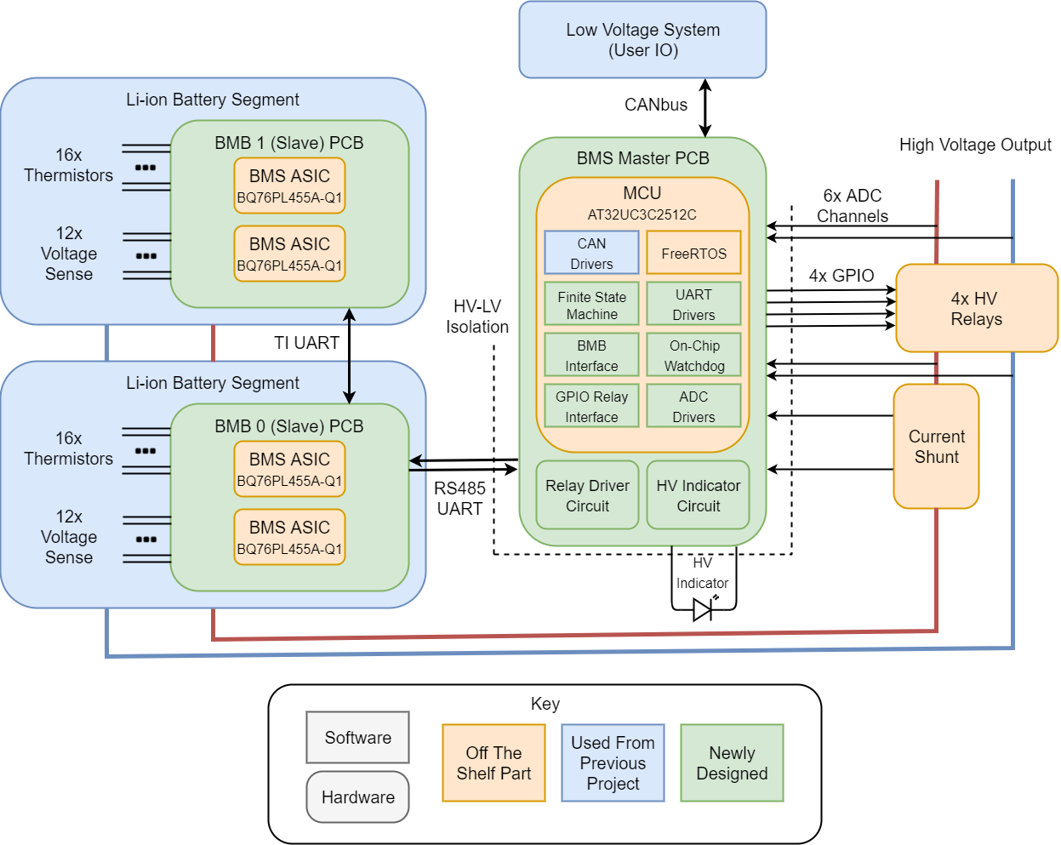

- This example of a block diagram figure is not readable. Consider making it a wide figure that spans both columns (using the Wrap text settings) as indicated in the next figure example. A good rule of thumb is that the text in the block diagram should appear at least as 8 point font (like this caption).


- The same full block diagram as in Fig. 2 is placed spanning both columns.
There is text below the figure in both columns so that your report does not have excess white space.

The rest of this column is intentionally left black.

Notice how the text below the figure in the second column wraps below the figure. (Select the figure, and use the Wrap Text option to set the setting to “Top and Bottom” to achieve this).
If you need even more space than this for your full system block diagram, rotate the figure by 90 degrees and use the optional extra page available to you at the end of the document.

The rest of this page is intentionally left blank.

Design Requirements
Now that we know something about the overall solution (from the design architecture in section III), it is time for you to translate the use-case requirements (from section II), to design requirements. In this section you will derive the qualitative and quantitative design requirements (a.k.a. design specifications), i.e. the specifications for your product’s engineering design solution to meet the use-case requirements. Be quantitative and descriptive. Several design specifications will probably be in terms of subsystem performance, where multiple subsystems perform together to meet overall use-case requirements. Example: “The optical subsystem must detect a 1 % change in the 1.1 μm wavelength photon flux in a DC background of 10 W of white bandwidth photons. A measurement must be completed every 100 ns.” This section should take up at least one full column of this document. A summary table of the specifications (don’t forget the units) or bulleted list alone is not acceptable.
You must explain how the most critical constraints relate to the problem you chose to solve as described in the Introduction and the Use-Case Requirements sections. These connections between the design requirements and the use-case requirements may require numerical derivations. If so, please use equations (formatting equations is described later in section Equation Formatting V.C. Number the equations if you need to refer to them later. Otherwise include the equations in-line – but use the equation editor to write any equations you use in your document.

Design Trade Studies
Describe trade-offs by deriving design equations and/or plotting them in graphs to identify a design (that satisfies the use-case requirements by meeting related design specifications. (Tests to be used to evaluate your design implementation and compare to the theoretical design trade-offs is the subject of the later section VII on Test, Verification and Validation.)
Trade studies of subsystems can also be included in this section. You should use sections with the Heading 2 format to split up this section as dictated by content in terms of
- Individual design specifications that help meet use-case requirements
- Individual subsections in your design

Design Specification or Subsystem
As shown in (1)…… What links the design specification A to one or more user product requirements? What limits the design specification A?

Another Design Specification or Subsystem
Equation (2) shows… Continue with the next design specification B. Or continue with the trade study for subsystem B.

Equation Formatting
The equations are an exception to the prescribed specifications of this template. Use the equation editor built in with MS Word (or alternatively using the LaTeX syntax) to format equations, ensuring the font size is 10 pt to match the surrounding text.
Number equations consecutively. Equation numbers, within parentheses, are to position flush right, as in (1), using a right tab stop. To make your equations more compact, you may use the solidus ( / ), the exp function, or appropriate exponents. Italicize Roman symbols for quantities and variables, but not Greek symbols. Use a long dash rather than a hyphen for a minus sign. Punctuate equations with commas or periods when they are part of a sentence, as in:
a  b    
Note that the equation is centered using a center tab stop. Be sure that the symbols in your equation have been defined before or immediately following the equation. Use “(1)”, not “Eq. (1)” or “equation (1)”, except at the beginning of a sentence: “Equation (1) is . . .”

Figure and Table Formatting
Place figures and tables at the top and bottom of columns. Avoid placing them in the middle of columns. Large figures and tables may span across both columns (as in Fig 3). Figure captions should be below the figures; table heads should appear above the tables. Always locate figures and tables after they are cited in the text. Use the abbreviation “Fig. 1”, even at the beginning of a sentence.
Table I. Table Type Styles
Table Head | Table Column Head
 | Table column subhead | Subhead | Subhead
copy | More table copyª
- Sample of a Table footnote. (Table footnote)
We suggest that you use a text box to insert a graphic (which is ideally a 300 dpi TIFF or EPS file, with all fonts embedded) because, in an MS Word document, this method is somewhat more stable than directly inserting a picture.
To have non-visible rules on your frame, use the MSWord “Format” pull-down menu, select Text Box > Colors and Lines to choose No Fill and No Line. (This text box keeps the outline just for indication purposes.)
- Example of a figure placed inside a text box. The “figure” in this case is a set of textual instructions.
Figure captions: Use 8 point Times New Roman for figure captions, as indicated in the examples, where the MS Word “figure caption” style is used. Use words rather than symbols or abbreviations when writing figure axis labels to avoid confusing the reader. As an example, write the quantity “Magnetization”, or “Magnetization, M”, not just “M”. If including units in the label, present them within parentheses. Do not label axes only with units. In the example, write “Magnetization (A/m)” not just “A/m”. Do not label axes incorrectly as a ratio of quantities and units. For example, write “Temperature (K)”, not “Temperature/K”.

The Design Trade Studies can use 1-3 pages. Many groups will find 1.5-2 pages enough. If you have a lot of equations and figures, you may need all 3 pages.

System Implementation
This section conveys the detailed implementation of the hardware and software aspects of your product and the constitutive subsystems. Provide one or more overall system and subsystem figures indicating the actual implementation of your product. Additional annotated drawing(s) and/or solid model rendering(s) are generally needed to describe the physical system, being complementary in content with the Architecture section III rather than redundant.
The description should then drop into more specific detail compared to the functional block diagram described in the section III. Concisely describe and, if appropriate, depict each major subsystem. Specific chips, sensors, interconnects (in case of hardware) or interfaces (in case of software), etc. should be described in this section.

Subsystem A
Use Heading 2 headings to separate out the subsystem descriptions. Additional figures comprising subsystem drawings, solid model renderings, schematics, and flowcharts are most probably needed to accurately and fully describe each subsystem’s software, hardware and interfaces.

Subsystem B
Continue with the next subsystem(s) as applicable. Follow the equation, figure and table as well as the “Text” paragraph instructions elsewhere in this template.

This section can use 1.5-3.5 pages. Most groups will use between 2 and 3 pages.

Test, Verification and Validation
This section is where you describe the testing methods you use to evaluate your design implementation and make comparisons to the theoretical design trade-offs. Describe how you will test to verify that your design has met the design requirements (i.e., design specifications) and ultimately has met the use-case requirements (i.e., validated operation for the use case). Describe how the proposed test outputs relate to the design specifications, and ultimately to the use-case specifications.
You should use sections with the Heading 2 style to group your discussion in terms of validating qualitative and quantitative use-case requirements and/or verifying design requirements.

Tests for Design Specification A
Describe the test(s) you will perform with your product to measure and verify design specification A. The test may be with the full system or with an individual subsystem as appropriate. Refer to your analysis in section IV as appropriate to discuss the significance of the test(s).

Tests for Use-Case Specification B
Continue with testing descriptions for validating the use-case specification(s).

The Test, Verification and Validation section can use up to 1 page.

Project Management
This section describes your project schedule, team member responsibilities, bill of materials with budget and risk mitigation plans, with these items partitioned using the Heading 2 headings.

Schedule
This subsection provides the schedule with milestones. You can use a full page at the end of your document to insert a detailed schedule, and refer to it in a short paragraph. This space limitation is only for the text portion of your write-up.
If your schedule was simple, you can insert it inline either as a wide figure like Fig. 3 or rotate it and fit it within a column as a typical two column figure as shown in Fig. 5. Please make sure your chart is readable (font size is at least 8 point, and the color choices are such that we can read the text. If you include your milestones in-line here, you can use more than the half column you have available for the schedule.

Team Member Responsibilities
Describe primary and secondary responsibilities of each team member. Responsibilities may be overlapping between team members as appropriate.
This subsection should be no more than half a column.
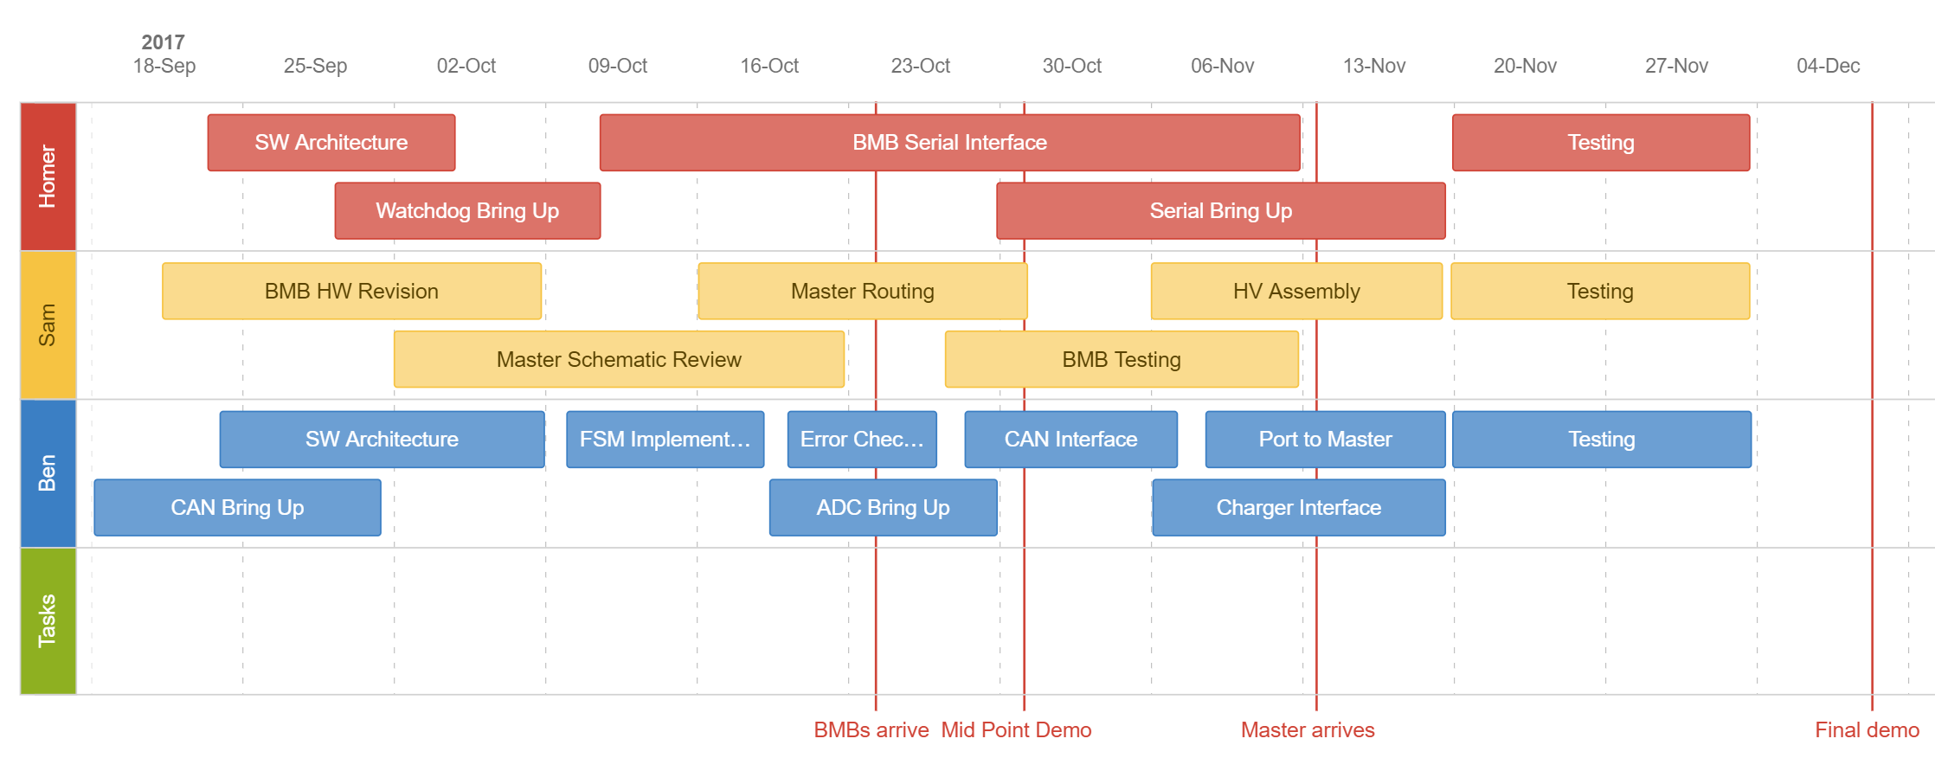
- Schedule example with milestones and team responsibilities

Bill of Materials and Budget
You can use an entire page for the table of parts and budget at the end of the report (see Table II). This is the easiest way to cut and paste any Excel based table you have been maintaining into this report. Include the description, model number, manufacturer, quantity and cost of each component purchased. (“Amazon” and “Digikey” are probably not the manufacturers of the parts you purchased.)
This section may end up being one or two sentences referring to the page where the budget spreadsheet is located in your report.

TechSpark Use Plan
Many teams you will simply say: “We do not plan on using TechSpark for our project.” For a few teams, it will be “We plan to meet in TechSpark to assemble our MVP”. For yet others it will be considerably more detailed enumerating the electronics bench use, or the laser cutter use or …. Please be as complete as possible. We understand this is just a plan.

Risk Mitigation Plans
This sub-section should identify the critical risk factors in your design and plans for how you will manage that risk. This is where you will list the known unknowns. For example, no one in the team has ever previously designed an UART for this FPGA, so our primary risk is getting sensor data to the FPGA to take advantage of its rapid computing capability.

The entire Project Management section should be no more than one page, excluding the figures for the schedule and bill of materials.

Related Work
What other projects or products are similar to what you are proposing to implement. You can use up to a full column in the two column format for this.
Use no more than one page for both Related Work and Summary.

Summary
Briefly summarize your design, with emphasis on the impact of your design to stakeholders who care about the use case. Describe what you think will be upcoming challenges in implementation and in meeting the use-case and design requirements.

Glossary of Acronyms
Include an alphabetized list of acronyms if you have lots of these included in your document. Otherwise define the acronyms inline.

MQTT – Message Queuing Telemetry Transport
OBD – On-Board Diagnostics
RPi – Raspberry Pi

References
- IEEE, IEEE Author Center: Author tools, Accessed on Jan 17, 2022, [Online]. Available: https://newauthors.ieeeauthorcenter.ieee.org/author-tools/
- J. K. Author, “Name of paper,” Abbrev. Title of Periodical, vol. x, no. x, pp. xxx-xxx, Abbrev. Month, year, doi: 10.1109.XXX.1234567.
- J. K. Author, “Title of paper,” in Abbreviated Name of Conf., City of Conf., Abbrev. State (if given), Country, year, pp. xxxxxx.
- J. K. Author, “Title of chapter in the book,” in Title of Published Book, xth ed. City of Publisher, (only U.S. State), Country: Abbrev. of Publisher, year, ch. x, sec. x, pp. xxx–xxx.
- J. K. Author, “Title of dissertation,” Ph.D. dissertation, Abbrev. Dept., Abbrev. Univ., City of Univ., Abbrev. State, year.
- Name of Manual/Handbook, x ed., Abbrev. Name of Co., City of Co., Abbrev. State, Country, year, pp. xxx-xxx.
- Title of Standard, Standard number, date.
- J. K. Author, private communication, Abbrev. Month, year.
- J. K. Author, “Title of paper,” unpublished.

Your references should be a very carefully crafted list, cited in the appropriate ways, as indicated in the example templates above. Don't merely list a Wikipedia page or a bunch of GitHub URLs. Note that any code you used in your project does need to be cited.

You can insert extra pages after the references to add full page figures or tables for
- Architecture and system description figures – if so, make sure you refer to them in section III or VI as appropriate.
- Milestone and Schedule chart – if so, make sure you refer to it from section VIII.A.
- Budget and Parts list – if so make sure you refer to it from section VIII.C.
You are allowed no more than 3 optional pages to ensure any large system diagrams, and your milestones and budget are readable at the end of your document.



Table II. Bill of Materials
Description | Model # | Manufacturer | Quantity | Cost @ | Total
Part 1 description | 0001 | MyManf | 2 | $1.99 | $3.98
Part 2 description | 0022 | YourManf | 1 | $10.02 | $10.02
Grand Total |  |  |  |  | $14.00

