Phase 1: Preprocessing Report
Group 9: Alexandros Michailidis, Antonie Wagner, Christos Botos, Yan Qiao

What we did
We merged spatially adjacent genomic regions that carry redundant copy-number information into consensus segments. The goal is to reduce the number of features before classification without losing biological signal.

Parameters
Merge method | Greedy one-pass walk along each chromosome
Merge criterion | Pearson r > 0.8 between adjacent regions (across all 100 samples)
Representation | Median CN of constituent regions per sample
Label usage | None - merging is completely label-free
Threshold justification | From the Phase 0 correlation-vs-distance analysis: adjacent regions within 0.5 Mb have median r = 0.83, and within 1 Mb median r = 0.78. A threshold of 0.8 targets regions correlated at this intermediate range - merging neighbours that are part of the same CN event while stopping at genuine breakpoints where correlation drops. Inspired by the CGHregions approach (van de Wiel & van Wieringen).

Results
2834 raw regions were reduced to 273 consensus segments (90.4% reduction). 93 segments (34%) are singletons - genuine breakpoints that couldn't be merged, the others are merged. The median segment contains 3 raw regions and the largest contains 98.

Regions per chromosome before and after merging
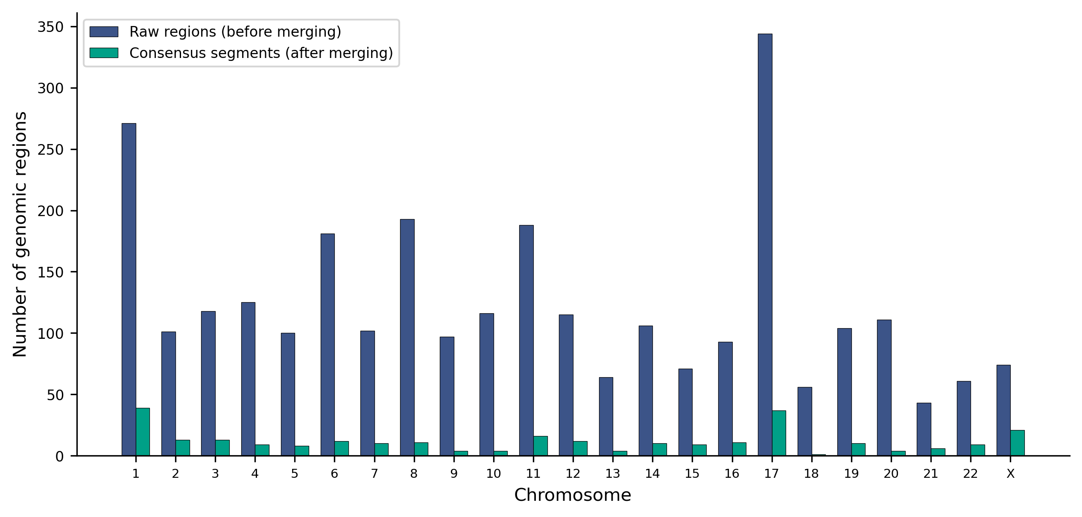
Every chromosome shows substantial reduction. Chromosome 18 has the highest reduction (98.2%, from 56 to 1 segment) while chrX has the lowest (71.6%, from 74 to 21), suggesting more heterogeneous CN profiles on the X chromosome.

Raw vs merged comparison
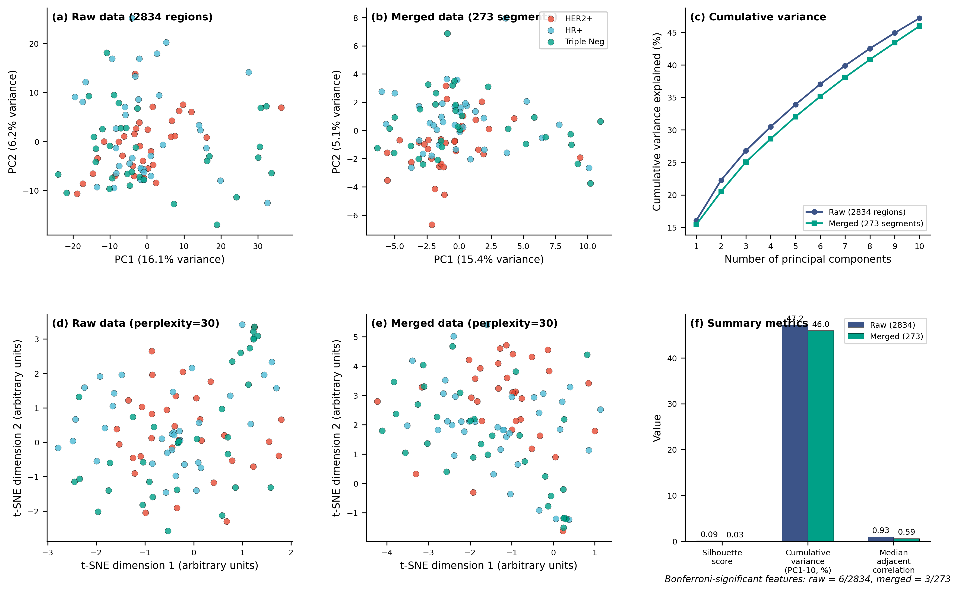
Six-panel comparison of exploration analyses on raw data (2834 regions) vs merged data (273 segments). Key observations:
- PCA structure is preserved: PC1 explains 16.1% (raw) vs 15.4% (merged). HER2+ still separates on PC1, HR+ and Triple Neg still overlap.
- t-SNE cluster structure looks the same before and after merging.
- Cumulative variance (PC1-10) doubled from 22.3% to 46.0% : signal is concentrated into fewer components after removing redundancy.
- Median adjacent correlation dropped from 0.93 to 0.59: redundancy successfully reduced.
- Silhouette score dropped from 0.09 to 0.03, but both are very low. Unsupervised clustering was never good here; this metric is not relevant for our supervised task.

Why adjacent merging and not all-pairwise? High correlation between neighbours means the same CN event spans multiple probes - that's genuine redundancy. High correlation between distant or cross-chromosome regions means co-occurring but biologically distinct events (e.g. 1q gain + 16q loss in HR+). Merging those would destroy information.

Raw features | 2834
Merged features | 273
Reduction | 90.4%
Pre-merge median adjacent r | 0.925
Post-merge median adjacent r | 0.590
Bonferroni-significant (raw) | 6 / 2834
Bonferroni-significant (merged) | 3 / 273 (all chr17, top hit = ERBB2 locus)

Bottom line
Merging removed 90.4% of features while preserving all major biological signals. The ERBB2 amplicon on chr17 is still the top hit, PCA and t-SNE structure are unchanged, and variance is now concentrated into fewer components. The merged data is a better starting point for supervised classification.

