# Deployment Instructions

## Packages

There are 5 packages in HealthCheck that are published to NuGet

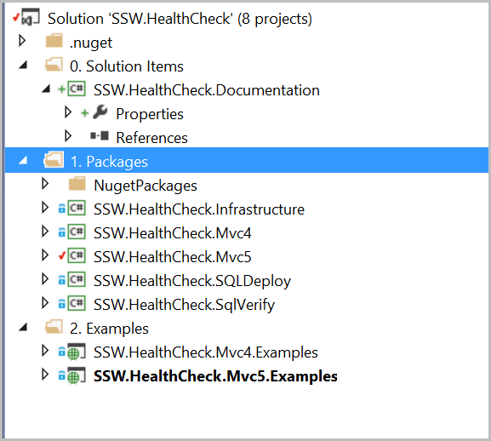

**Figure: Solution structure**

**Packages** solution folder contains all projects that are published to NuGet.

1. SSW.HealthCheck.Infrastructure – core package that other packages depend on
2. SSW.HealthCheck.Mvc4 – ASP.NET package for Mvc4
3. SSW.HealthCheck.Mvc5 – ASP.NET package for Mvc5
4. SSW.HealthCheck.SQLDeploy – HealthCheck plugin to integrate SQLDeploy check
5. SSW.HealthCheck.SqlVerify – HealthCheck plugin to integrate SqlVerify check

## Preparation

Once code is checked in, package needs to be prepared for deployment. Open project that needs to be published and go to **Properties |** **AssembleInfo.cs** and update assembly version.

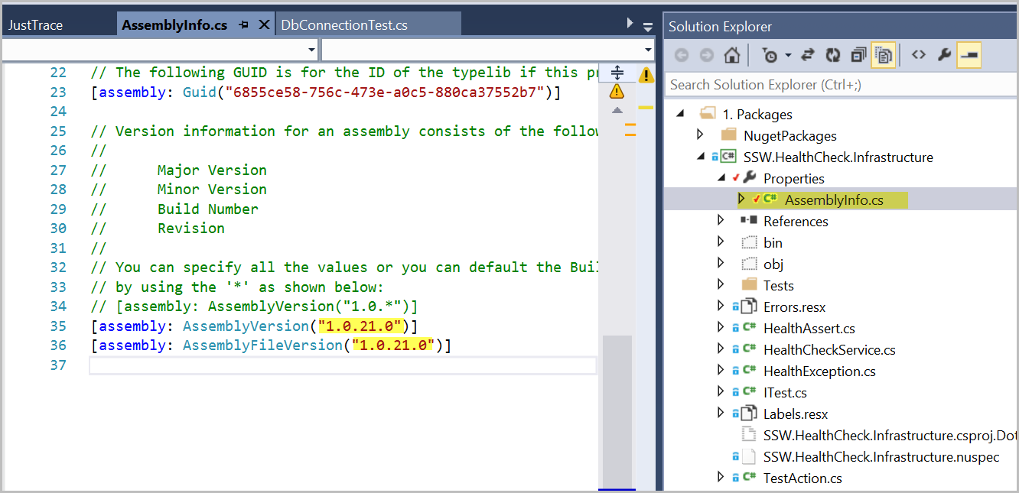

**Figure: Updating assembly version**

Once version is update, build the project.

In order to publish to NuGet, API key needs to be set. Go to **Tools | Library Package Manager | Package Manager Console**.

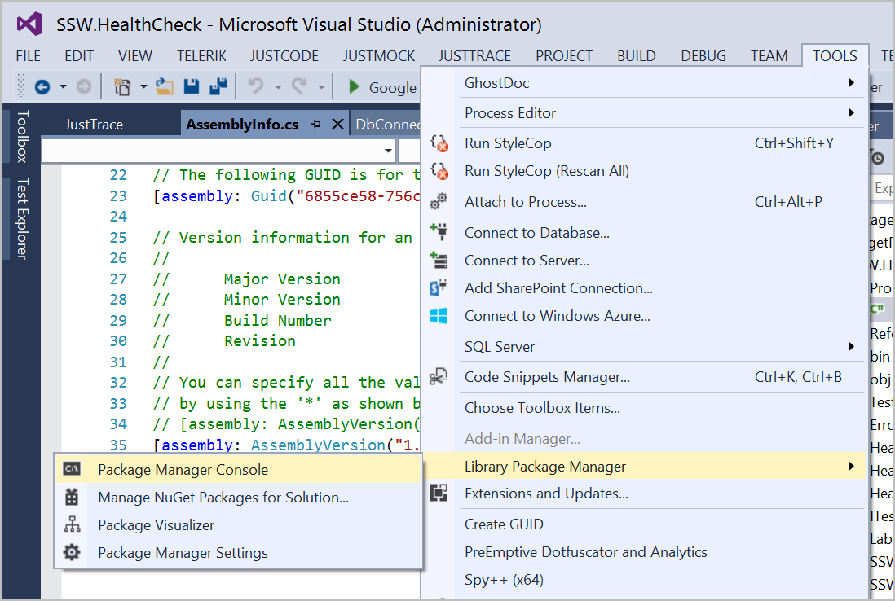

**Figure: Accessing Package Manager Console**

In console, run the following command:

NuGet SetApiKey accc4dda-5eea-4f24-b518-21019ac89673

## Packaging

Now project is ready for packaging. To create nuget package, run the following command in **Package Manager Console**

NuGet Pack “<Project Forder Name>\<Project Name>.csproj”

Here is a list of commands for each project for convenience:

1. SSW.HealthCheck.Infrastructure

NuGet Pack “SSW.HealthCheck.Infrastructure\SSW.HealthCheck.Infrastructure.csproj”

1. SSW.HealthCheck.Mvc4

NuGet Pack “SSW.HealthCheck.Mvc4\SSW.HealthCheck.Mvc4.csproj”

1. SSW.HealthCheck.Mvc5

NuGet Pack “SSW.HealthCheck \SSW.HealthCheck.Mvc5.csproj”

1. SSW.HealthCheck.SQLDeploy

NuGet Pack “SSW.HealthCheck.SQLDeploy\SSW.HealthCheck.SQLDeploy.csproj”

1. SSW.HealthCheck.SqlVerify

NuGet Pack “SSW.HealthCheck.SqlVerify\SSW.HealthCheck.SqlVerify.csproj”

## Publishing

Once package is created, it can be published to nuget. Run the following command to publish to nuget:

NuGet Push “<Package Name>.nupkg”

For example, to push **v.1.0.21** of **SSW.HealthCheck.Mvc4**, run the following **in Package Manager Console**:

NuGet Push SSW.HealthCheck.Mvc4.1.0.21.nupkg