
Ai4Sci

Scientific Machine Learning

AI for mathematics, and mathematics for AI

Chris Budd OBE, mascjb@bath.ac.uk

and

Aengus Roberts asr66@bath.ac.uk

Dept of Mathematical Sciences
University of Bath
Bath, BA2 7AY

Contents

- Foreword

- An introduction to scientific machine learning

- Machine learning architectures, and generative AI

- Machine learning for differential equations I: PINNS and the DRM

- Machine learning for differential equations II: Neural operators and their applications

- Neural ODEs and discovering dynamics with machine learning

- A case study in the use of PINNS

- Useful references

- Foreword

This guide has been developed for the Knowledge Exchange Hub in Mathematical Sciences (KE Hub) to provide mathematical scientists in Academia and/or in Business, Industry and Government (BIG) with a simple to understand introduction to Scientific Machine Learning (SciML).

The intended audience are those who need to use AI for what may be described as ‘scientific applications’. Rather than exploring all of AI we focus on the rapidly growing field of SciML. This is a set of specific AI tools designed to look at, and solve, problems, which have at their heart a scientific formulation. These may include problems formulated using differential equations, inverse problems, problems in identification, control, and engineering design. The sort of questions that we will address are ‘can a machine learning method make an accurate medical diagnosis’, ‘can machine learning forecast the weather’, and ‘can machine learning reliably design an aeroplane’ (for the record, at the current state of development the answers are: yes, maybe, and not yet).

In this guide we will introduce practitioners to the algorithms of SciML, discuss how to use them, their strengths, weaknesses, and limitations, and explain what to expect in future developments. The guide provides a mix of theory, applications, and a concrete set of case studies. The emphasis will always be on the explainability, effectiveness, and trustworthiness of these methods.

It is fair to say that SciML has yet to achieve the same level of reliability as more established tools, such as the Finite Element Method, but the ease of using SciML methods, the impressive results that they can achieve, and the speed at which these methods are developing, make it worth the investment of time to see what might be appropriate for the scientific problems that you may be encountering in your work. At the same time, like any new tool, they should be used with a degree of caution. We hope that this guide will achieve the objectives of showing you what is possible, while also allowing you to make careful judgements of whether a SciML tool is right for the problem that you wish to solve, and how to solve it in a responsible manner.

By its very nature, SciML works best when those using it are able to combine the best ideas of both science and AI. As such, this guide is meant for those who have a basic scientific and mathematical training, as they will be the most likely practitioners for the sort of problems that SciML is best placed to address. However (unlike many papers and books on machine learning) we have tried to keep the jargon, and the mathematical technicalities, to the minimum level needed to both understand the theory behind the methods, and to use them in a responsible manner. The guide will be illustrated throughout using scientific problems, usually posed in terms of differential equations.

The guide starts with a general introduction to SciML. We then discuss the various AI architectures used to solve scientific problems. We follow this with two sections looking at SciML methods for solving differential equations, leading to a description of methods for inferring the nature of a system given data measurements. The final section contains a set of case studies linked to a GitHub repository. We urge you to try these to enrich your understanding of this rapidly growing, and exciting, branch of artificial intelligence.

Chris Budd OBE, and Aengus Roberts. University of Bath

August 2026
- Introduction

1.1 Overview

AI, and in particular SciML, is rapidly making a huge impact on nearly all areas of mathematics, science, and engineering. These applications include classifying images, solving differential equations, solving inverse problems, predicting the weather, protein folding, and constructing a (dynamical) model to fit some data. All of these areas have the potential to greatly benefit science, and engineering, and many aspects of Business, Industry, Charities, and Government Departments.

Some reasons for this are (i) that AI methods (based usually on neural network (NN) architectures) are very expressive so that complex systems can be represented by a NN with (relatively) few, trainable, parameters, (ii) they make very effective use of data, (iii) good software exists to set them up and train them, and (iv) they are effective in higher dimensional problems, where more conventional methods struggle. However, this popularity comes at a price. At the moment, such methods are often seen as opaque black boxes, where it is hard, or impossible, to see what is going on inside them. It is also difficult (unlike say more transparent Finite Element Methods) to get reliable error estimates for their use, they can hallucinate (produce very wrong answers), and the output of such methods can be unstable to small perturbations. We can compare the use of such opaque black box methods with more ‘conventional, and transparent’ scientific ‘white box’ modelling which aims to use human ingenuity to derive the laws of physics, and to then solve a system (usually through some form of numerical discretisation). Whilst this methodology has been used with success for many years (since Newton if not earlier) it can be very hard to implement, and often does not make effective use of data. SciML (illustrated below) is a ‘grey box’ approach that fuses these two approaches, and aims to produce reliable AI-based methods, with guaranteed accuracy. In these notes we will introduce you to some popular SciML methods, and will discuss the strengths and weaknesses of each.
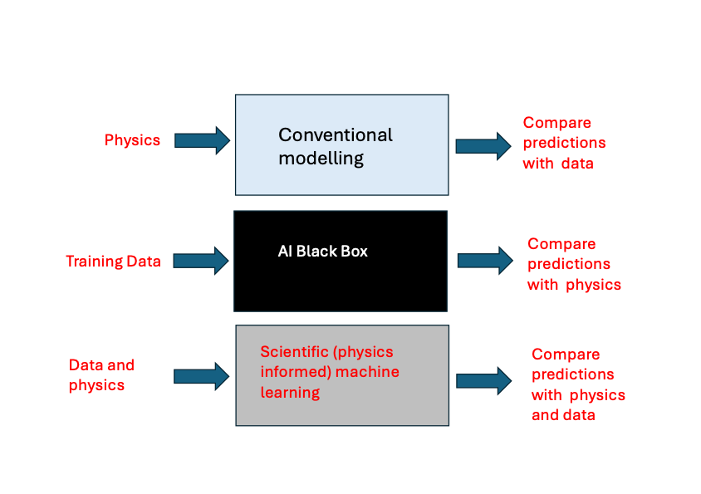
Compare predictions with data
Compare predictions with physics
Compare predictions with physics and data

Good accounts of the general use of machine learning (ML) techniques, and, in particular the use of Python to implement the ML algorithms may be found in Lynch [1], Chollet [2], and an excellent account, written for (applied) mathematicians is presented in Higham & Higham [3] .

1.2 A very simple example of SciML in action

Let’s suppose that we want to train a computer to distinguish a cat from a dog. Naively we might think that, as dogs are bigger than cats, all we need to do is to measure the size of the image, and make a decision on this single measurement. However, as the picture below shows, some cats are bigger than some dogs.

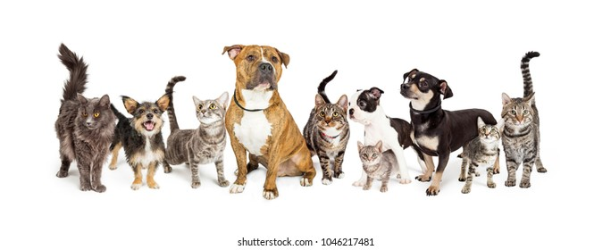

Thus we need to introduce another measurement, which we will call the floppiness of the image. We may then take a large ‘training’ set of classified images of cats and dogs and plot them according to their size and floppiness. The result might look something like this:

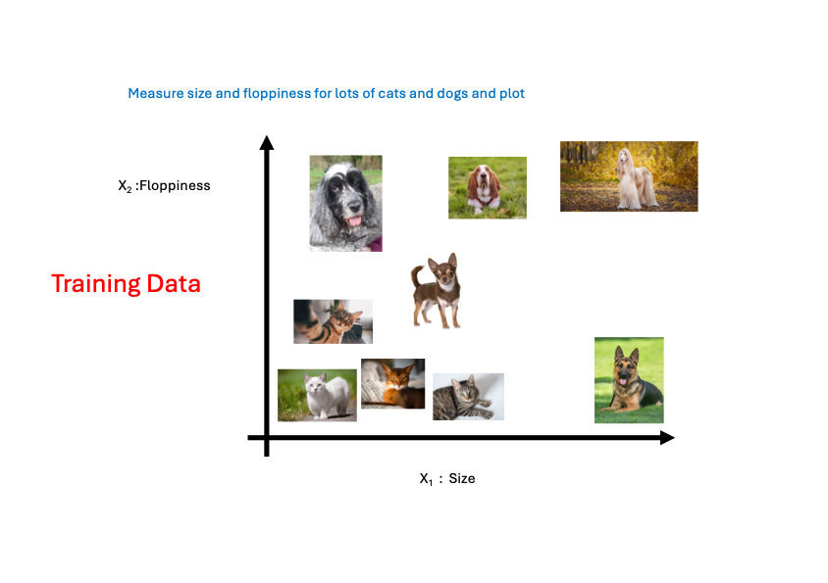

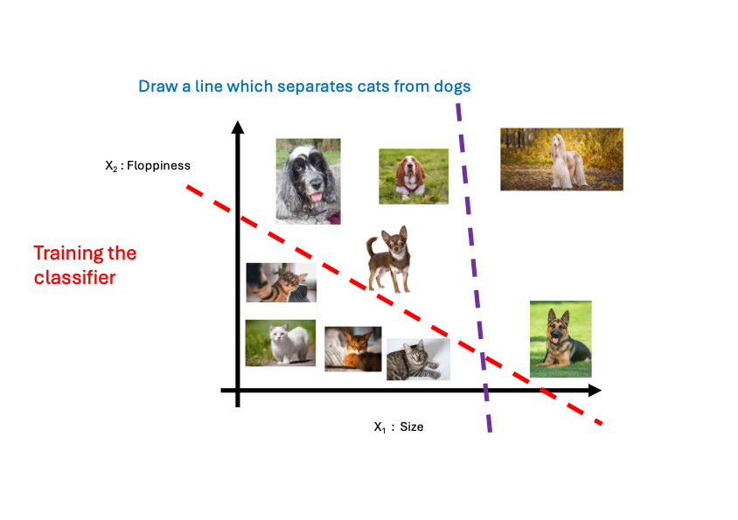
We may now try to separate cats from dogs by drawing a straight line through the training data. This line will have the property that any image above it is a dog, and every image below it is a cat. We have done this on the image below. The blue dashed line does a poor job at separating the data between the cats and the dogs, whereas the red dashed line has done a good job.

Now to tell a cat from a dog in the future, all we need to do is to plot its image as above, and see which side of the red line it lies on.

We now describe what is going on in more mathematical terms. If x₁ is the size of the image, and x₂ is the floppiness of the image, then a line in the data space is given by

$$w_{1} x_{1}+ w_{2} x_{2}+ w_{0}=0.$$

Images above the line ‘dogs’ have $w_{1} x_{1}+ w_{2} x_{2}+ w_{0}>0$ and images below ‘cats’ have $w_{1} x_{1}+ w_{2} x_{2}+ w_{0}<0.$ The coefficients w₁,w₂, and w₀ have to be ‘trained’ so that these inequalities hold for each of the labelled training images. Once we have done this, then for any other image we can tell whether it is a cat or a dog by evaluating this expression. More generally, we introduce an activation function $σ(z)$, which takes us from the expression
$${z= w}_{1} x_{1}+ w_{2} x_{2}+ w_{0},$$

to a classification of the image. In this case the activation function is the Heaviside (or step) function which satisfies the condition $σ\left(z\right)=1$ if z > 0 and $σ\left(z\right)=0$if z < 0. The operation $σ(w_{1} x_{1}+ w_{2} x_{2}+ w_{0})$ gives the value of 1 if we have a dog, and 0 if we have a cat. Hence we have a simple classifier for our image. This classifier is called a ‘perceptron’ , and this idea was first introduced in 1963. It is the simplest example of a neural net.

More generally if we have inputs x_{1, …,} x_{D} then the output has the form $σ(w_{1} x_{1}+ {…+ w}_{D} x_{D}+ w_{0})$ and this is called a shallow neural network of width D. This is illustrated below.

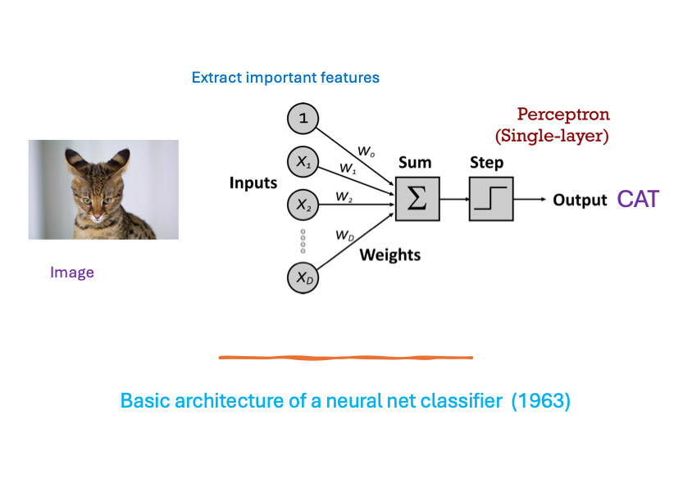

The values of w_{i} for i=1,2,.. D are called the weights, and w₀ is called the bias.

Now, suppose that we want to classify a more diverse set of images (say cats, dogs, horses, cows, ..) , and also suppose that we can’t do this by simply drawing a straight line through them. We need to use a more complex neural net to do this.

One way to do this is increasing the width D of the (shallow) neural network. However a much more efficient method is to use a deep neural network with many layers, where the output of one layer is fed into another layer, and then another etc. This is illustrated below.
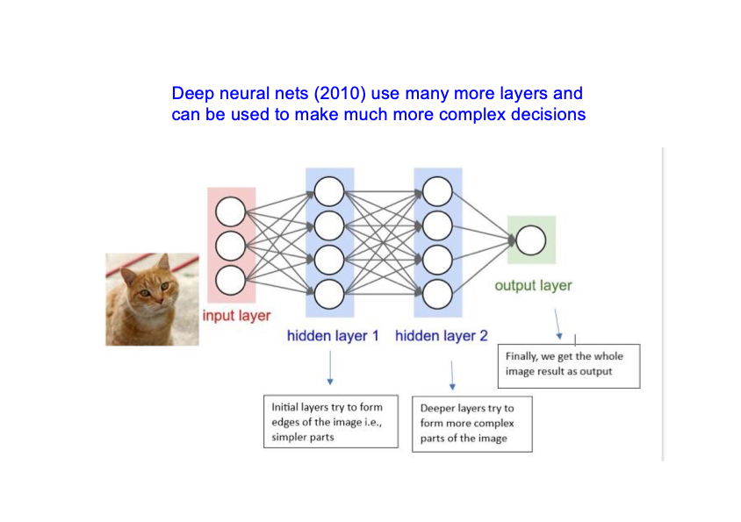

In this example the first layer can be used to extract features from the image (say the outline of the ears of the cat), and the subsequent layers can then process these features to make the classification of the image.

In a general deep neural network, each layer has its own set of weights and biases, and they process the image in different ways. The number L of layers is called the depth of the network. The ‘activation function’ $σ$ applied to the output of each layer, need not be the step function above. Popular choices are the piece-wise linear ReLU function $σ\left(x\right)=x^{+}=(x+\left|x\right|)/2$ which is the generic choice for many applications, and the function $σ\left(x\right)=tanh⁡(λx)$ which is used where differentiability is important, for example in the solution of differential equations. The choices of D,L and $σ(x)$ are called meta-parameters, which are fixed in advance, and are often chosen by experiments to simply see what works best. The set $θ$ of all of the weights and biases are the free parameters of the network, which are determined by training.

We now introduce a few important definitions.

Architecture: The overall structure, and the way that the layers are connected together, is called the architecture of the neural network, and the choice of this depends on the task the network is to perform, and how expressive and transparent it is. The example above is a fully connected architecture. We will see in Section 2, how different architectures are used in other applications.

Expressivity: This is a measure of how well a perfectly trained network is able to do the task it is designed for, for example accurately classifying multiple images. The more expressive a network is, the more images we can classify (or the more differential equations we can solve).

Trainability: Training a neural network is the process of finding the parameters $θ$so that it does a pre assigned task. Trainability is a measure of how well we are able to do this.

Transparency: This is a measure of how well we understand what the network is doing, and the impact of the different parameters in the network on the output of the network. A major criticism of AI systems is that we don’t know how they are making their decisions (for example in deciding whether to hire someone based on their CV). SciML methods, based on physics, are more transparent because we have a clearer understanding of what is going on inside them.

The deeper the network, the more expressive it is, but also the harder it is to train, and the less transparent it becomes. Using a deep neural network it is possible to classify many more types of images, or indeed any other form of data. An important example of this is the use of such architectures by doctors to diagnose clinical conditions given a medical image such as an X-Ray. As an example, Murphy et. al. [4] use a deep neural network to detect hip fracture very reliable from a raw X-Ray image.

1.3 Training a neural network

Training a neural network to find the optimal set of parameters is expensive, and often takes up a lot of time and energy! In the cats and dogs example we saw that we trained the parameters of the model to find a line which separated the data. This is an example of supervised learning where we have a pre-labled training data set. Other types of learning include reinforcement learning where there is some internal measure of success, such as finding the solution to a differential equation.

Training a neural network requires the following ingredients.

- A training data set x and an independent validation data set y. This can be made by partitioning the original data set. Typically an 80:20 split is good;
- A loss function $L\left(x,θ\right)$ which you want to be close to zero on both the training and the validation set if the network is performing correctly (for example is it correctly identifying a dog as a dog);
- A measure of how $L$ changes as you change $θ$. This is called back-propagation and is achieved in (say) PyTorch by automatic differentiation;
- An optimisation procedure, together with a learning rate (which is generally found by experiment), which will determine the optimal parameters $θ^{*}$ which minimise the loss function $L$over all elements of the training set x;
- A validation step in which the loss function is evaluated over y. This is used to check whether the optimisation process is working, and not overfitting the neural network to the training data (see later for a fuller explanation of this).

Step (iv) is usually done using some form of (stochastic) gradient descent method based on the calculations in (ii). Some excellent optimisers have been developed in recent years for ML applications, of which ADAM [3] is effective (usually), popular and easy to use.

Training is not easy. Firstly, the loss function $L$is, in general, a highly non-convex function of the parameters, and it is easy not to find the minimum of the loss function, or to get stuck in a local minimum. This is a primary cause of the ‘hallucinations’ of AI procedures, where the network does not perform as required, and misclassifications occur. The more information we can incorporate about the problem into the network design, for example by building in the physics, the better we can construct the loss function, and the more transparent the network will be. Secondly the optimisation problem can be ill-conditioned. This can make the convergence very slow and also highly sensitive to changes in the parameters. Thirdly, we can overfit to the training data x so that we fit to the noise in the data rather than to the signal. This is illustrated in the figure below where are trying to fit a smooth curve (which is the output of a neural network) through some noisy data. On the left a too simple approximation is used and the fitted curve does not approximate the data well. On the right, the approximation is too complex, and tries to go though all of the noise on the data. Such a curve would be useless when making future preductions In the middle we see the optimised fit which is a good predictor.
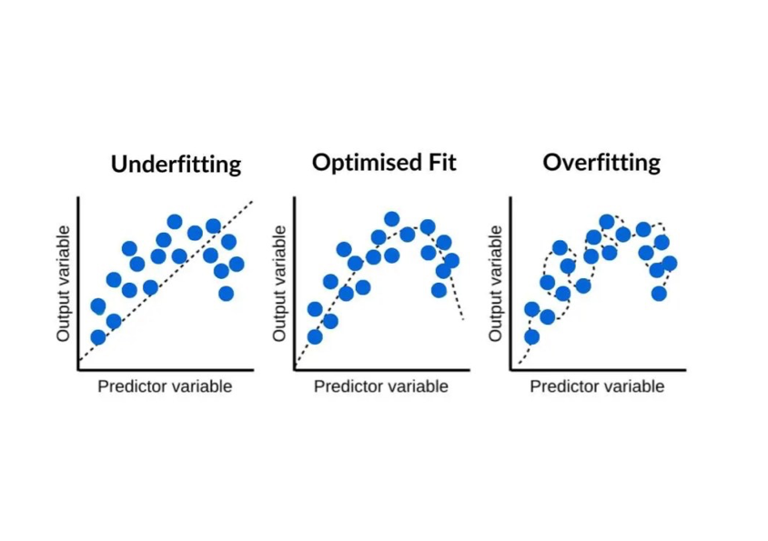

The

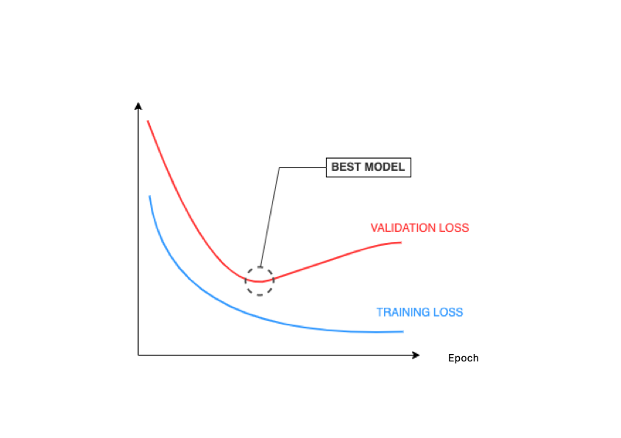
The impact of over fitting is reduced by using the validation set y (which should ideally be chosen to be significantly different from the training set x.) As the optimiser works through the process of finding parameters $θ$which minimise the loss function $L$ on the training data x (typically by looking at random samples of this set) the loss on the validation set y is also monitored. Usually the loss function initially decreases with the iterations, on both x and y, as the network starts to fit to the data. However, it then typically starts to rise on the validation set as illustrated above on the figure below. This is because the optimiser is over fitting to the (noise on) the training set x. At the point when the loss function starts to rise on y the optimisation process is terminated at the best model, as illustrated below. The model is then optimally trained and can be used (and tested) on new data.

1.4 Some advantages and disadvantages of this approach.

Once trained a deep neural network can be very effective as an image classifier, or for carrying out many other tasks, including image classification, forecasting the weather, and solving certain differential equations. However there are certainly problems associated with this approach which we now describe.

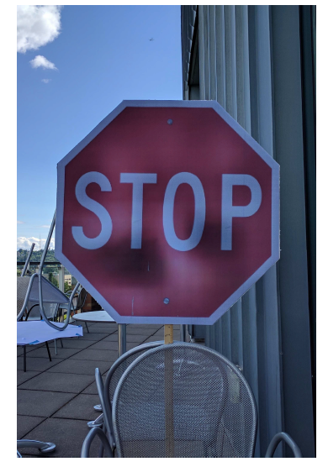

Bias: The training can be influenced by bias in the training data set. As an example, the above image of a stop sign, was misidentified as a 45mph sign after training. The reason is that the training images for 45mph signs all had blue backgrounds, and the system then identified anything with a blue background as a stop sign. Clearly this is a serious issue in the use of AI in self-driving cars. Similar serious issues of bias have been seen in the (mis)use of AI systems for grading job applications, medical diagnosis, and in deciding on prison sentences. It is very important that all forms of bias are eliminated from a training set, and this is where heavy duty statistical testing is very important.

Adversarial Attack: When a neural network is trained from a data set, to recognise an image, it is acting as a black box, and it is often not clear how, given another image it makes its classifications. In particular, it can ‘hallucinate’ and make a completely ‘wrong’ classification. One impact of this uncertainty is that it can be subject to adversarial attack. In an adversarial attack a small, but carefully selected, perturbation is be made to the image to force an incorrect classification. This is an ill-conditioning problem in numerical analysis, as described in Bungert et. al [5]. As an example, we take a picture classified as a panda, add a small amount of noise (specifically designed to ‘trick’ the neural network) and get a picture which is then identified as a gibbon.

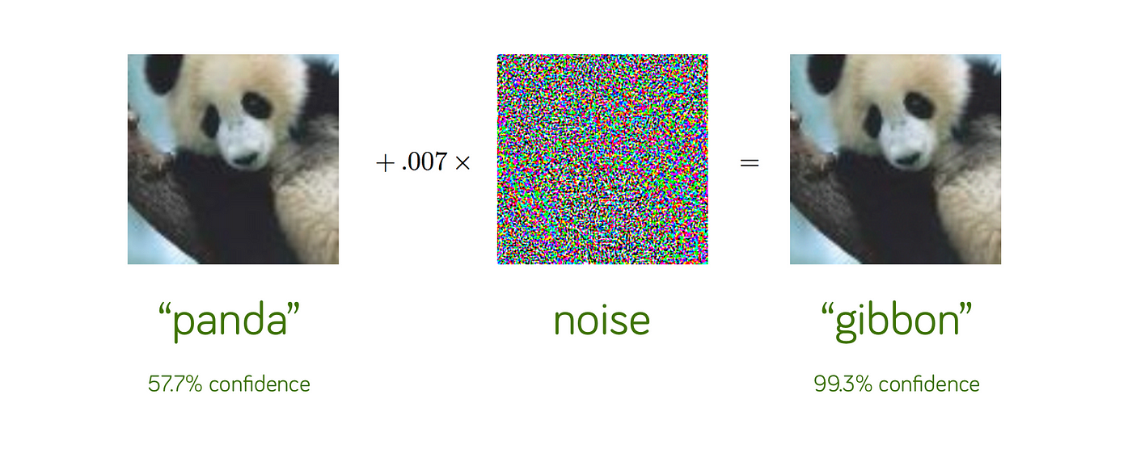

It is important to design image classifiers which are not vulnerable to such form of attack, as this greatly degrades their ability to make reliable classifications.

Moving away from the training data (stable system bias): We will see in Section 4 that SciML methods (specifically Neural Operators) can be very effective in forecasting the weather. But this begs the question of whether a weather forecast trained on Californian data could predict a storm in the UK? The answer is n, and this gets to the heart of many AI methods. They are (excellent) interpolators of data, but poor extrapolators from data. Learning only from data makes it hard to make decisions away from that data. This is why it is essential to augment the data-driven approach with extra physical information. We will see many examples of this in Sections 3, 4 and 5.

Data security, or not: When you train a neural network on a data set x, an echo of that training set is left on the parameters of the network. It is then often possible to trace back from these parameters to learn details of the training set. In principle it may be able to reverse engineer a neural network architecture to see what it has been trained on. This can cause a problem if the training data contains personal, and private, information, for example images from patient records, or data from a census. The methods of differential privacy produce synthetic data, which is based on the statistical properties of true data, but anonymises it, to train the neural network on. These methods developed, for example, by Carlin et. al. [6], are designed to keep the details of the training data secure.



In contrast, we might want to be able to detect whether neural network has been trained on illegal data, such as pornographic images, or images with copyright. At the moment this is possible, but difficult, using machine learning forensics.

1.5 In conclusion

In the next sections we will look more carefully at various methods for applying machine learning to a wide variety of scientific problems, and will look at the strengths and weakness of each. But the bottom line is: Maths is our best way of explaining how AI is working and answering questions about its limitations and its possibilities. AI doesn’t replace maths, AI is maths!

- Machine learning architectures, and generative AI

There are many different neural network architectures designed for both general and specific tasks (both scientific and well beyond). In this section we will attempt to summarise some of these architectures. A much more comprehensive account of these architectures, is described in Grohs and Kutyniok [7], and Drori [8].

2.1 The Multi-Layer Perceptron (MLP)

The basic architecture described in the Introduction is usually called a (fully connected) multi-layer perceptron or MLP. Such architectures can be adapted to a wide variety of tasks. Software packages such as PyTorch are set up to allow you to easily construct and then train, a MLP for a task. However, they may not be optimal choices for certain specific applications and we will discuss such applications next. What the MLP does well are task such as: the classification of data without any special structure, the approximation of high dimensional functions the solution of differential equations using Physics Informed Neural Networks (PINNS) and deep variational methods (see Section 3). Key to the success of the MLP is its ‘expressivity’, which (as mentioned in Section 1) its ability to represent a function in terms of its trainable parameters. A lot of work has gone into studying this problem, see [7], and we now have a good mathematical theory for it. To summarise this (without going into detail), if an MLP has width D, and depth L, and we use a continuous activation function such as the ReLU and tanh functions described in Section 1, then it is (in theory) possible to find a set of parameters $θ$ so that the error in approximating a function f(x) is proportional to $D^{-n}$ and to $e^{-αL}$ for appropriate values of n and $α$. In other words, the error is a polynomialy decreasing function of the width D but an exponentially decreasing function of the depth L. This is in contrast with (say) a standard spline approximation method which only a exhibits polynomial decrease in the error. Here we see the power of using a deep method for the approximation. It offers very small errors in approximating a function with only a small number of parameters, and certainly far fewer parameters than more conventional. The catch behind this, is that training the MLP architecture to achieve this optimal result may be very difficult, if not impossible. See [7] for more details of the problems associated with training an MLP. This is why different, more trainable, and more relaiable, architectures have been designed to deal with specific tasks.

2.2 The Convolutional Neural Network (CNN)

The CNN is a neural network designed for image processing. Conventional image processing relies on applying linear filters to an image to extract features such as edges, and the reduce the effects of noise. If the image is thought of as a high dimensional vector x (with the terms of each such vector corresponding to the intensity of each of the pixels in the image), then the action of the linear filter corresponds to the operation Ax where the matrix A is a convolution operator [7]. Such an operator acts locally on the image, applying the same operation to nearby clusters of pixels, and well defined, and sparse, structure. This structure follows from the observation that nearby pixels in an image are often closely related to each other, but are often very different from more distant pixels. An example of a convolution operator is a low pass filter, such as a moving point average, which replaces a group of pixels with the average of their intensity.

As a convolution operator has a particular structure, it has far fewer free parameters than a general matrix of the same size. It is therefore much earier to find these parameters (and to train the operator). In a CNN this structure is exploited, and the first few layers apply a series of such operators, combined with (say) a ReLU activation function and an averaging (pooling) operator, to extract the essential features of the image (for example denoising it and then extracting the edges). The deeper layers can then have an MLP architecture to learn information from these features, so that the image can be identified from the extracted features. We saw this methodology in action in the cat and dog example in Section 1. There are two advantages of a CNN over a more general MLP. Firstly, it uses trusted image processing technology, which is well understood and predictable, to do reliable feature extraction. Secondly, as described, the convolutional operators have far fewer terms than a fully connected MLP and thus can be trained much more easily. PyTorch allows you to construct, and train, a CNN with ease.

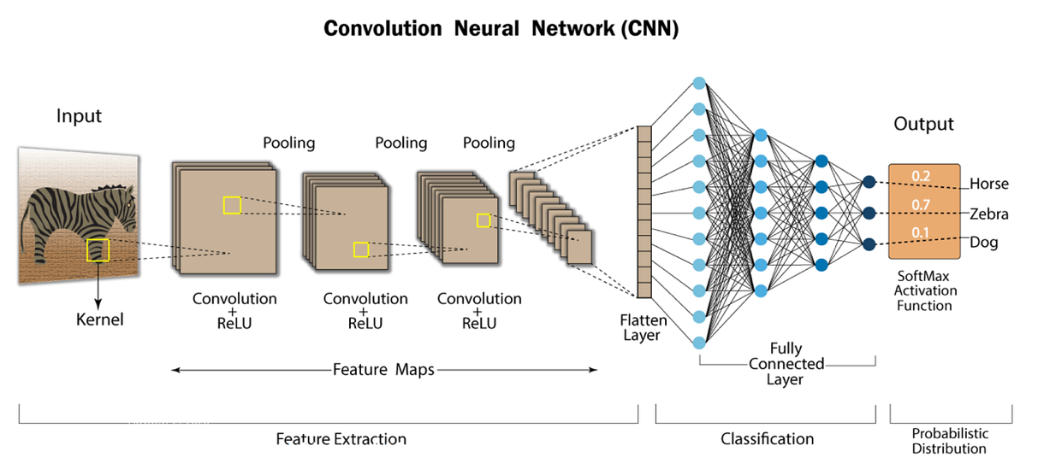

2.3 The Graph Neural Network (GNN)

The CNN is effective because it treats nearby pixels as being related. In a GNN architecture this observation is taken further to look at more general data with terms related through the edges of a graph, of which the data points are nodes. In image processing, for example, we might want to relate all data points corresponding to a particular type of feature, such as human faces in a crowd. As well as in image processing, GNNs are used across various many other fields. These include the following. Molecular drug design where the efficacy of molecules is based on their atomic structure, Social network analysis where GNNs are use to identify communities and influential users. Modelling unstructured grid data and optimizing mesh relocation in finite element methods (FEMs). Healthcare, where GNNs are used to identify progression pathways for diseases like Alzheimer's directly from patient records.

2.4 Recurrent neural networks (RNNs) and Long and Short Term Memory (LSTM) methods

Often the data we are interested in working with is not a single image, but is a stream of information x_{i} at times t_{i}. One example of this is in speech recognition, another is the location of taxis and their customers. Given any such time series for i=1 .. N an important question is, can we predict future values of x_{i} for i = N+1 .. N+m. Such a questions is of significant importance in for example, the financial industries, the power generation and transport industries, and in allocating resources in the emergency services. Traditionally this question of prediction in a time series has been addressed by statistical methods such as linear predictors or ARIMA (auto-regressive) methods. The use of neural networks allows us to bring more powerful methods to bear on this problem, which exploit both the high expressivity of the neural network, and the sequential nature of the input data. The primary tool for doing this is the ‘recurrent neural network’ (RNN)which are described in detail in [7]. RNNs are a type of neural network which take information from previous inputs, which then influences the current input and output, so they feed back into themselves. RNNs are used for prediction, translation, composition, speech recognition, and natural language processing. An RNN processes input data sequences x_{i}, via hidden states h_{i} ,to form sequences of outputs y_{i}. At every time step, an RNN updates its hidden state by combining the new input with the previous hidden state, passing it through activation functions, sharing the parameter matrices across all of the time steps. The parameter matrices for (say) a prediction are then trained using a suitable training sequence as before.

One of the problems with such an approach is a rapid loss of information (fading) through the network from one layer to the next, where data from early in the sequence gets diluted and overwritten by newer inputs. RNNs remember the immediate past well, but struggle to remember more distant events. During training via backpropagation, error signals which are sent backward through many time steps shrink exponentially. This means that the RNN cannot update its parameters based on early events, which makes training an RNN difficult. The Long and short term memory (LSTM) architecture is a particular example of an RNN, introduced by Hochreiter and Schmidhuber in 1997, designed to address the problem of information fading, by carefully storing the information at each stage and allowing control on what information is allowed to fade. LSTMs work well, and since their introduction, have established a good track record of use in applications [1,7]. In particular, LSTMs are proving very effective in prediction, and are used, for example, by the power industry and by Uber to predict future behaviour (such as customer demand) and to then allocate appropriate resources to cope with this demand. For more details of how LSTMs are used in practice, see [1] and Korstanje [10]. Below is an example from [1] of using an LSTM to predict the price of a stock:

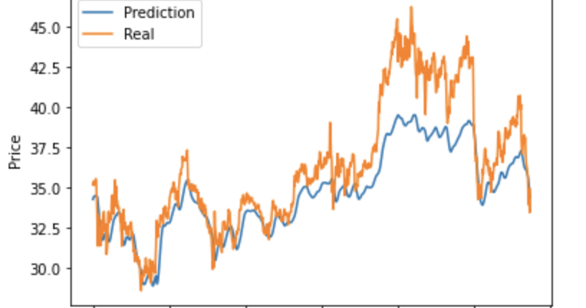

2.5 Other architectures

Transformers

There are many other machine learning architectures, designed for both general and specific tasks, and we do not have space for a good description of them all here. We refer the reader to [8] for a comprehensive account. A recent, and explosive development, has been that of Transformer Networks. The ‘T’ in Chat-GPT refers to transformer, and transformer models may have trillions of parameters. Transformer networks are based on ‘attention mechanisms’ (see Vaswami [10]), and stacks of encoders passing information on to each other, usually performing computations in parallel. Transformer networks have state of the art performance for many tasks, starting with natural language processing, e.g. Large Language Models (LLMs), but extending their applicability to computer vision and audio processing as well as many other tasks.

Echo State/Reservoir Networks

Training a full neural network is a complex and expensive task. A much simpler process is to preset the coefficients in all the layers apart from the last, and to only train the output layer. This is a straightforward exercise in linear algebra. The other layers, often called the reservoir of the network, are usually given random parameters. Whilst much simpler to train than a usual network, such reservoir or ‘echo state’ networks have proved to be remarkably effective in reproducing, and even predicting, the dynamics of chaotic dynamical systems.

2.6 Neural network based methods for inverse problems

Inverse problems are a key area in which scientific machine learning is making an important contribution. An example of an inverse problem is a medical imaging procedure, such as an MRI or a CAT scan, where noisy and incomplete, measurements are made, and from these measurements we have to infer the state of the system. Such problems are typically ill-posed (they usually have non unique solutions, and have extreme sensitivity to the input data), and require some form of regularisation to work.

As an important example of an inverse problem, is the linear problem of finding the state of a system x given measurement data y, where
A x = y + noise.

This problem lies at the heart of medical imaging using computer tomography (CT) and magnetic resonance imaging (MRI), and also remote sensing methods in the geo-sciences. In these applications A is usually an ill-conditioned matrix, and both x and y are high dimensional vectors (typically the dimension of y, whilst large, is much smaller than that of x).

The linear equation can be ‘solved’ by finding the vector x given by

${ x= argmin}_{x} {|A x -y|}^{2}$ + R(x).

Here the first term expresses the closeness of Ax to the data, and R(x) is the Regulariser which guides the solution procedure to finding a realistic state for the system. The choice of this is critical. Examples which do not use machine learning are (standard but of mixed effectiveness) Tikhonov regularisation where R(x) = ||x||², and (the very effective but complex to apply) sparsity preserving Total Variation (TV) regularisation $R\left(x\right)= ∥\left|∇x\right| ∥$. However none of these regularisers take into account the qualitative nature of the solution. As an example a doctor looking at an MRI image of a knee would use their experience of typical shapes of a knee to select a good solution. This information of what makes an appropriate image can be included into a learned regulariser . In this procedure R(x) is trained in advance using a neural network approach, by solving the inverse problem on a labled set of images of known shapes. Learned regularisers are proving very effective not only in medical imaging but other areas such as the geo-sciences and even in art restoration. (See Hertrich et al. [11] for a review of the methodology of deep learning reconstruction (DLR).) Key benefits of using a learned regulariser are: faster computations, lower radiation doses, less image noise, and a better image quality (such as a better texture)

The figure below (from [11] with permission) shows three images CT images. The one on the left is constructed using standard CT methods showing low resolution. In the middle the resolution is improved with the standard CT method, but at the expense of a higher radiation does. On the right the DLR method is used, giving comparable resolution, but with a much lower radiation dose.

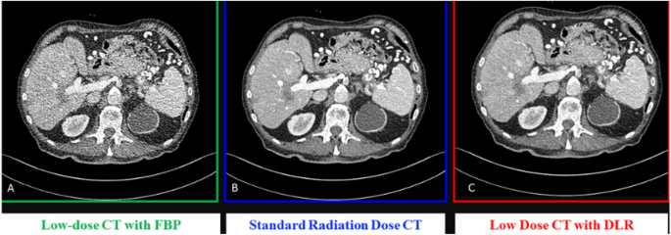

2.7 Generative AI

We conclude this section with a brief description of generative AI. This is perhaps the most rapidly growing (and controversial) area of machine learning, with direct impact on all of us.

In the problem in the introduction, we showed that we could train an ML system to classify an image given a set of training labels and images. Generative AI performs the opposite task. Given a (large) set of images which are assumed to be samples of a large distribution of similar images, Generative AI attempts to find the image from the overall distribution which most closely matches the given label. Generative AI is a very versatile tool. We can, for example, ask a generative platform to compose a poem about ML in the style of Brahms, write an essay for us on the same topic, or even give a lecture about it using the authors own voice.

The original methods used by Generative AI , used auto-regression to predict the next most likely part of a sequence, given a lot of training examples. This process is used in the auto-fill algorithms used in mobile phones. As an illustration, when faced with the sentence

The quick brown fox jumped over the lazy …

We immediately say Dog as the next word. If we are now given the sentence

The quick brown fox jumped over the ..
then we fill in with Lazy Dog etc.

Similarly, given an image with a pixel missing, we can train an algorithm to fill in the most likely remaining value for the absent pixel. If an image has more pixels missing, this process can be repeated, with an auto-regressive algorithm successively filling in more and more values for the deleted pixels. In all cases the algorithm will be guided by the labels that we require the image to satisfy. Finally we can do the whole auto-regressive process starting from a random set of pixels. By doing this we will create a whole new image.

Such auto-regressive methods give good answers, and are they used in large language model such as Chat-GPT. However they are rather slow. They have been over taken or extended by transformers, and other technologies.

An alternative, fast, and very effective, approach to generative AI is to use stochastic differential equations, and (score based) stable diffusion methods. A ‘classical’ problem in image processing is de-noising in which given a noisy image we attempt to find an image which is close to the data but smoother than the original. This can be done in a learned manner, finding the most appropriate image from a distribution. More generally we can use this process to generate an image, taking a random start, and denoising it using a stochastic differential equation (conditioned by the labelling) to produce a new image.

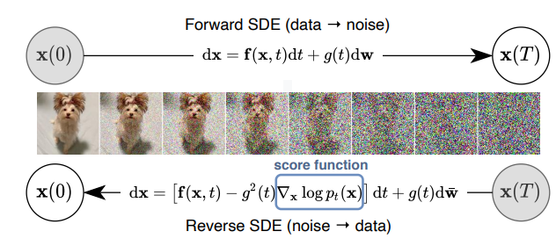

A full description of how the stable diffusion methodology works is given in Batzolis et. al. [12], and the Wikipedia article https://en.wikipedia.org/wiki/Stable_Diffusion .

Below are some examples of image process using stable diffusion, taken from [12] with permission. In the top row we see an original image x, followed by the same image with part removed y, and finally the image in which the removed part is restored using stable diffusion (a process called in-painting). This is done by finding the closest (i.e most likely) image from the training set, which is consistent with the data y. You can inspect this final image to decide how good it is. In the second row the original image x is blurred to give the image y, and then the original image restored using stable diffusion. In the final row the image x is processed so that only its outline remains. The original image is then restored. Note that this process has got the colour wrong! Similar diffusion based methods can be used to (for example) add in extra detail to a meteorological forecast of rainfall.

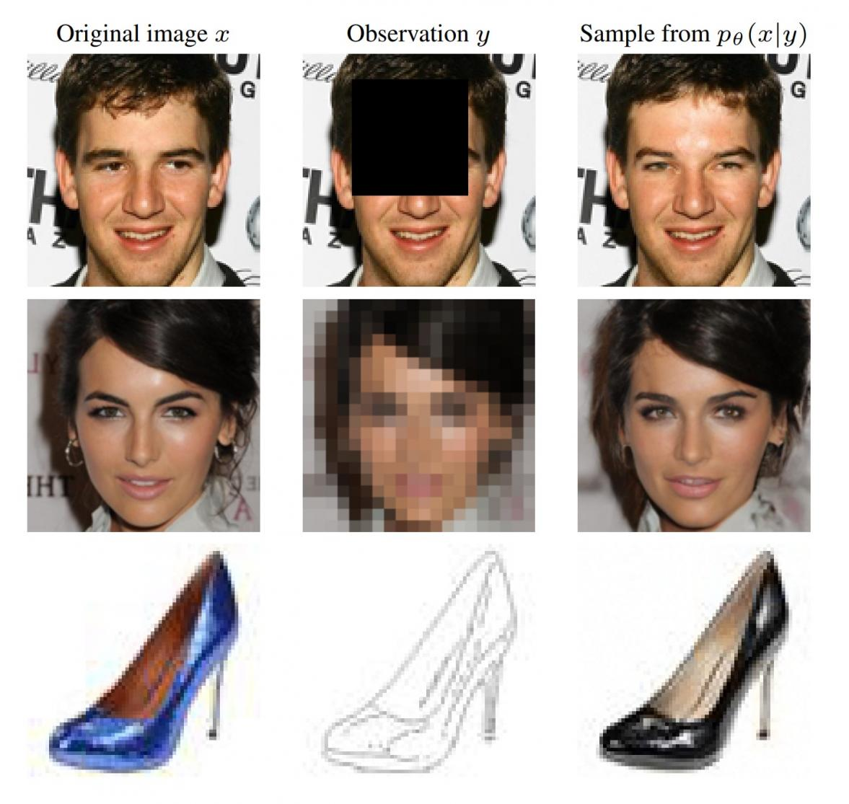

Stable diffusion methods are fast, and produce high quality photo-realistic ‘fake’ images from random seeds. Examples of these images (see [12] with permission) are shown below. Note that none of these images are real people.
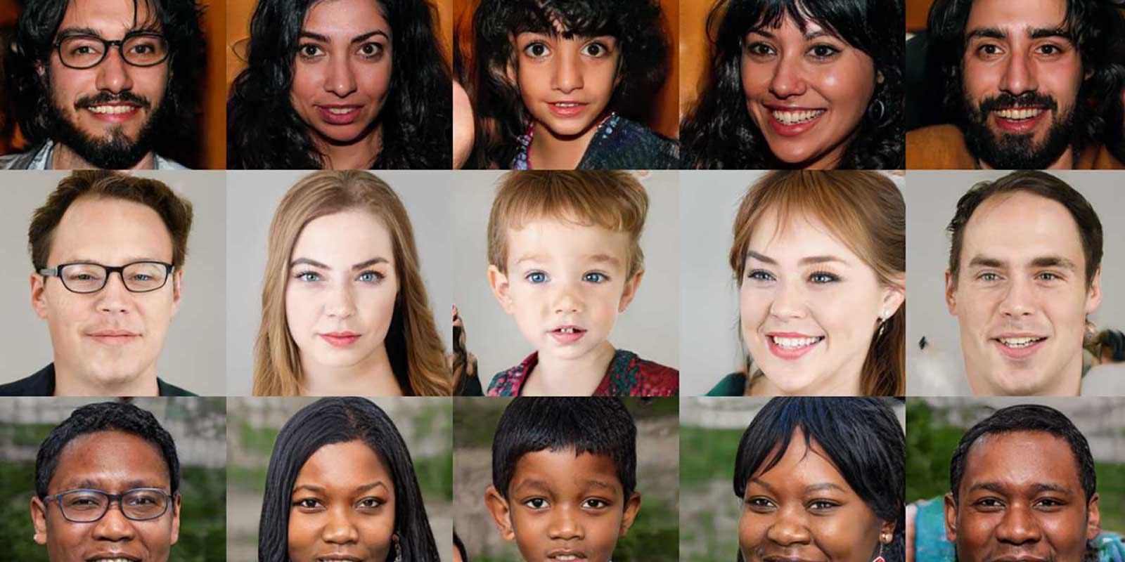

This procedure raises significant ethical issues about the use of generative AI to produce fake images as seen by this fake picture (taken from an outreach postcard produced by Maths4DL) of the late Pope in a Coat. Such issues are of concern to policy makers, the media, and well beyond.

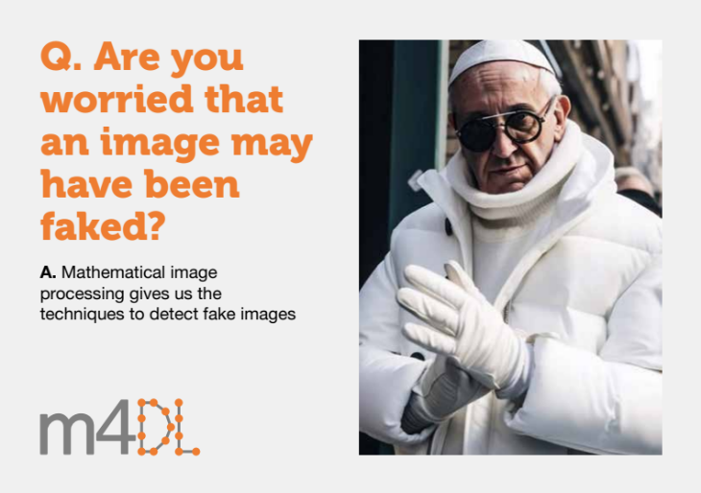

There is currently an ‘arms race’ between mathematical methods that can tell whether an image has been faked (by seeing the imprint of the machine learning algorithm), and the design of algorithms to produce images which cannot be detected as such. Generalised Adversarial Networks (GANs) build this into their architecture, simultaneously training and image generator and an image discriminator, to produce ‘undetectable’ realistic images. These work well, but we must be ever mindful of the ethical issues of using generative AI in this way.
- Machine Learning for Differential Equations I:
PINNS and the DRM

Differential equations have existed for over 400 years as a method for describing dynamical systems. From planetary and particle motion to robotics control and drug development, ODE’s and PDE’s have often been the language of choice to mathematically model the behaviours observed by scientists, engineers and others. For almost as long, numerical methods have existed as a way to approximate solutions to these questions when analytical methods fail.
The advent of the computer in the 20th century has rapidly accelerated the development of these methods, allowing numerical methods to solve problems over complex domains in two and three dimensions with strong guarantees on the accuracy of the approximated solution. These include, ODEs, boundary value problems and PDEs such as:
$$\frac{du}{dt}=u^{2}, u\left(0\right)=1;$$
$$-ε^{2}\frac{d^{2}u}{dx^{2}}+u =1, u\left(0\right)=u\left(1\right)= 0; iu_{t}+Δu+u{\left|u\right|}^{2} =0$$

We will first introduce three “classical” (non-machine learning based) methods which aim to solve ODE/PDE problems of the form
$$u_{t}=F\left(x,u,∇u,∇^{2}u\right)$$
with appropriate boundary conditions.
We will then introduce some machine learning based numerical solvers in particular PINNs (physics informed neural networks) and the DRM (Deep Ritz Method)
We will show how to use these methods, and give examples, before covering some of the theoretical literature surrounding their accuracy
3.1 Classical Numerical Methods
3.1.1 The Finite Difference Method
We first introduce the Finite Difference Method (FDM) which approximates the derivative as the difference between neighbouring grid points. By picking a finite number of points across our domain, $x_{i}, i∈\left[1,…,N\right]$, we can approximate the function at these points $u_{i}≈u\left(x_{i}\right)$. This allows us to make approximations of derivates of the function such as
$$u^{'}\left(x_{i}\right)≈\frac{u_{i+1}-u_{i}}{h}, h=x_{i+1}-x_{i}$$
Applying this logic to the heat equation given by $\frac{∂u}{∂t}=Δu$ we need to discretise in time and space which gives us the approximation $u_{i}^{n}=u\left(x_{i},t_{n}\right)$ which in turn would allow us to discretise the whole problem as:

$$\frac{u_{i}^{n+1}-u_{i}^{n}}{Δt}=\frac{1}{2}\left[\frac{u_{i+1}^{n}-2u_{i}^{n}+u_{i-1}^{n}}{Δx^{2}}+\frac{u_{i+1}^{n+1}-2u_{i}^{n+1}+u_{i-1}^{n+1}}{Δx^{2}}\right]$$

Here we have used the Crank-Nicholson method which uses the mean of the 2nd spatial derivative at timesteps $n$and $n+1$to evaluate the time derivative on the left side of the equation. This produces a scheme that is second-order accurate in time and unconditionally stable for diffusion-type problems, though it requires solving a linear system at each time step.
Error Estimates
The numerical error of FDM can be bounded and depends on the spatial and temporal step sizes together with a problem-dependent constant
$\left|\left|u_{i}^{n}-u\left(x_{i},t_{n}\right)\right|\right|<C\left(u\right)Δt^{p}Δx^{q}$.
This can be improved (i.e. reducing $C\left(u\right)$ and increasing $p$and $q$) by redefining our grid discretisation such as with adaptive methods. These become useful when the solution to the problem varies rapidly requiring a finer grid size in certain sections of the domain.
Extending to higher dimensions can however cause issues. As we have seen, FDM requires a structured grid - typically a uniformly spaced rectangular mesh. In higher dimensions this gives many points in the domain to solve for, and this can be further exacerbated by irregular or complicated geometries. Here, we require a grid that covers the domain leading us to solve for grid points that fall outside the boundary.
    - The Finite Element Method
Our next method will provide us with a way to deal with complicated domains and provide a solution approximation as a function compared to the finite set of points we encountered in the previous chapter. Finite element methods (FEM) aim to build a solution as a linear sum of simple basis function where each basis function acts over a subset of the domain and is zero elsewhere (known as local support). This gives us a solution approximation of the form
$$u\left(x,t\right)≈U\left(x,t\right)=\sum_{i=0}^{N}{U_{i}\left(t\right)ϕ_{i}\left(x\right)}$$
Where $ϕ_{i}\left(x\right)$ is zero everywhere except for $x∈\left[x_{i-1},x_{i+1}\right]$ and explicitly zero on the boundary (i.e. $ϕ_{i}\left(x_{i+1}\right)=0$). In the interior of this region it might look like a hat function (if the approximate solution was to be piecewise linear) which looks like:
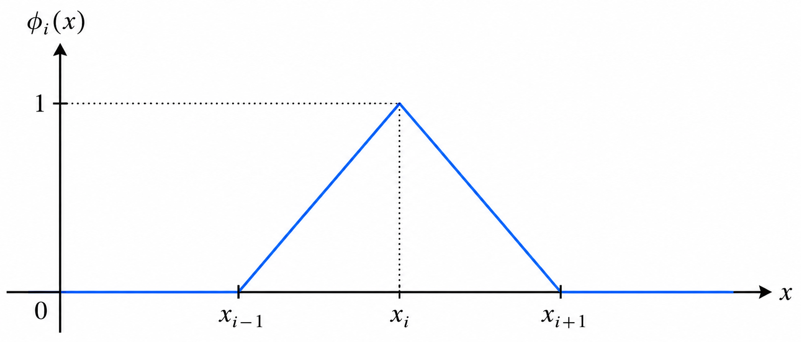
We can also make a different choice of basis functions, including higher-order polynomials and spline functions. In this chapter we restrict attention to piecewise linear basis functions for simplicity. The coefficients $U_{i}\left(t\right)$ represent the degrees of freedom of the approximation and are determined by solving a system of equations obtained from the weak formulation of the governing differential equation.
The Weak Formulation
To determine these coefficients we aim to minimise the energy
$$F\left(u\right)=\int_{Ω}^{ }{f\left(u,∇u,x\right)dx}$$
We can generate an energy like this by integrating the weak form of the PDE, that is to multiply the PDE through by a test function $v\left(x,t\right)$ and using integration by parts to shift derivatives onto the test function. By then replacing $u\left(x,t\right)$ with $U\left(x,t\right)$ we can set up a system of linear equations which when solved will minimise the energy.
Error Estimates
Overall, FEMs offer several advantages when solving PDEs on complex domains. The mesh can be adapted to the geometry of the problem, allowing irregular boundaries and local features such as boundary layers to be represented more naturally than with structured grids. A large ecosystem of mature software libraries also exists for FEM, making practical implementation straightforward.
In addition, theoretical results such as Céa’s Lemma described in Ciarlet [13] provide guarantees on the accuracy of the finite element approximation. In particular, the FEM solution is quasi-optimal in the sense that the error is bounded by the best approximation available in the chosen finite element space
$$\left|\left|u-U\right|\right|≤C\inf_{v_{h}∈V_{h}}\left|\left|u-v_{h}\right|\right|$$
This means that the finite element solution is, up to a constant factor C, as accurate as the best possible approximation that could be obtained using the chosen basis functions.
    - The Collocation Method
Our final classical method is the collocation method. As with the finite element method, we approximate the solution using a linear combination of basis functions. However, rather than enforcing the ODE in an integral sense, we require that the ODE is satisfied exactly at a finite set of points within the domain, known as collocation points.
We again write an approximation of the form $u\left(x,t\right)≈U\left(x,t\right)=\sum_{i=0}^{N}{U_{i}\left(t\right)ϕ_{i}\left(x\right)}$.
Here $ϕ_{i}\left(x\right)$ are chosen basis functions and $U_{i}\left(t\right)$ are coefficients that must be determined. Substituting this approximation into the governing differential equation produces a residual since the approximation will not satisfy the equation exactly everywhere.
In collocation methods we choose a set of points within the domain and require that the residual vanishes at these locations. For a general PDE , $L\left(u\right) = 0$ we therefore impose
$L\left(U\left(x_{j},t\right)\right) = 0, j = 1,…,N$.
This generates a system of equations for the unknown coefficients $U_{i}\left(t\right)$. Solving this system yields the approximate solution.
The choice of collocation points and basis functions plays an important role in the stability and accuracy of the method. With the correct choice of collocation points (often done adaptively), very high accuracy can be obtained. In practice, collocation is often used together with polynomial or spline basis functions, and in some cases spectral basis functions can be used to obtain very high accuracy for smooth solutions.

Error Estimates
Collocation methods also admit error bounds dependant on the number of basis functions used in the approximation. In particular, the error can often be bounded by
${\left|u-U\right|}_{C^{2}} ≤C\left(u\right)N^{-α}$,
where N is the number of basis functions and C(u) is a problem–dependent constant. By carefully choosing the collocation points it is often possible to reduce C(u) and increase$α$.
Collocation methods are widely implemented in numerical software for solving boundary value problems. For example, they form the basis of routines such as solve_bvp in Python’s SciPy library and related packages such as COLSYS. However, Collocation methods are not well defined in more than one dimension and therefore are of limited use for high dimensional problems, which is precisely where machine learning methods do a great job.

    - Issues with Classical Methods
As we have seen, classical numerical methods such as finite differences, finite elements and collocation are well established and supported by strong theoretical convergence results. However, the accuracy of these approaches depends heavily on the discretisation of the domain. In particular, the choice and placement of mesh or collocation points can have a significant impact on the quality of the approximation, and capturing local features such as sharp gradients or boundary layers often requires careful mesh design.
In addition, these methods can require considerable effort to implement effectively, particularly for complex geometries or higher dimensional problems. Although modern software frameworks such as Firedrake and other PDE libraries simplify many aspects of implementation, constructing suitable meshes and discretisation remains non-trivial. Another issue is that all three approaches suffer from aspects of the curse of dimensionality, as the number of degrees of freedom required to resolve the solution grows rapidly with the dimension of the problem.
3.2 Machine Learning Methods I: Physics Informed Neural Networks (PINNs)
We now introduce Physics Informed Neural Networks (PINNs) which are a new, machine learning (ML) based numerical solver proposed by Raissi et. el. in 2019 [14]. They were originally proposed as a “mesh-free” and self adaptive numerical method and therefore were less effected by the curse of dimensionality. Here we will give a brief introduction to them before moving onto the idea of a convergence theory, akin to the error estimates seen in the previous chapter and highlighting the current gaps in this theory.

3.2.1 What Are PINNs?
PINNs aim to solve differential equations of the form $Du=f$where $D$is a differential operator acting on $u$and $f$ is data function. If we consider the residual of this differential equation and take the norm of it
$$\left|\left|Du-f\right|\right|$$
we observe that this is minimised when $u$ is a solution to our original differential equation. Like with the classical methods we saw earlier we now want to approximate the solution to our differential equation with a different type of function. In the case of PINNs we will use a neural network, like we saw in the previous chapters, which we shall denote $u_{θ}$. The idea behind this is that there exists a multitude of theories (first and foremost the universal approximation theory, Cybenko [15]) which very roughly says that there exist neural networks that can well approximate any function we like.
To train our neural network we need a loss function which is where our differential equation residual comes in. Ideally we would like to plug our neural network into our residual norm making use of automatic differentiation to evaluate the differential operator on our and try to minimise it:
$$\tilde{L}\left(θ\right) = \min_{\left\{θ∈Θ\right\}}{} \left|Du_{θ}-f\right|$$
However, like other numerical methods we cannot evaluate our chosen function everywhere in the domain. Instead we evaluate the residual at a finite set of points within the domain and minimise the resulting loss over these locations. In this sense, PINNs closely resemble collocation methods, where the governing differential equation is enforced at a discrete set of collocation points. The key difference is that instead of approximating the solution using polynomial or spline basis functions, PINNs use a neural network to represent the solution. By doing this we obtain a loss function that looks like:
$$L\left(θ\right) = \sum_{j=1}^{N}{}{\left|Du_{θ}\left(x_{j} \right)-f\left(x_{j}\right)\right|}^{2}$$
We can treat boundary and initial conditions in the same way by considering the residual of an appropriate operator in those subdomains to obtain a full loss function of the form
$$L\left(θ\right) = \sum_{j=1}^{N}{}{\left|Du_{θ}\left(x_{j}\right)-f\left(x_{j}\right)\right|}^{2}+β\sum_{i=1}^{M}{{\left|Bu_{θ}\left(x_{i}\right)-f\left(x_{i}\right)\right|}^{2}}$$
Where we have $N$sampled collocation points within our domain and $M$collocation points on the boundary. For a 1 dimensional problem this would simplify down to $M=2$. The $β$ parameter here allows us to weight how much we want the boundary terms to bias our loss function and is often in practice chosen empirically based on the problem at hand.

3.2.2 Examples
To get a better understand of PINNs we will work through a few examples converting the differential equation problem statement into a loss function we can minimise.
Example 1: Two-Point Boundary Value Problem
Consider the regular two-point boundary value problem
$-u_{xx}=f\left(x,u,u_{x}\right), u\left(0\right)=a, u\left(1\right)=b x∈\left[0,1\right]$.
In a PINN approach, we approximate the solution using a neural network $u_{θ}\left(x\right)$, where $θ$ denotes the trainable network parameters. The differential equation residual is then
$r\left(x;θ\right)=∂_{xx}u_{θ}+f\left(x,u_{θ},∂_{x}u_{θ}\right)$.
The network is trained by minimising a loss function containing both the equation residual and the boundary errors:
$$L\left(θ\right)=\frac{1}{N_{r}}\sum_{i=1}^{N_{r}}{{\left|r\left(X_{i}^{r};θ\right)\right|}^{2}}+\frac{β}{2}\left({\left|u_{θ}\left(0\right)-a\right|}^{2}+{\left|u_{θ}\left(1\right)-b\right|}^{2}\right)$$
Where $X_{i}^{r}$ are collocation points in (0,1). The first term encourages the network to satisfy the differential equation inside the domain, while the second term penalises violations of the boundary conditions.
Example 2: Solving Parabolic PDE’s with PINNs
Consider the semilinear parabolic PDE
$$u_{t}=u_{xx}+f\left(x,u,u_{x}\right), u\left(0,t\right)=a, u\left(1,t\right)=b u\left(x,0\right)=u_{0}\left(x\right) x∈\left[0,1\right]$$
One approach for solving such problems with PINNs is to combine the neural network approximation with a classical time-stepping scheme. Suppose we discretise time using steps $t_{n}=nΔt$ and denote the approximate solution by
$U^{n}\left(x\right)≈u\left(nΔt,x\right)$.
Using an implicit time discretisation, the PDE becomes
$\frac{U^{n+1}\left(x\right)-U^{n}\left(x\right)}{Δt}=∂_{xx}U^{n+1}+f\left(x,U^{n+1},∂_{x}U^{n+1}\right)≡F\left(U^{n+1}\right)$.
We begin with the initial condition $U^{0}\left(x\right)=u_{0}\left(x\right)$, and at each time step train a neural network $u_{θ}\left(x\right)$ to approximate $U^{n+1}\left(x\right)$. The residual for the PINN is then
$r\left(x;θ\right)=u_{θ}\left(x\right)-U^{n}\left(x\right)-ΔtF\left(u_{θ}\right)$, where $F\left(u_{θ}\right)=∂_{xx}u_{θ}\left(x\right)+f\left(x,u_{θ},∂_{x}u_{θ}\right)$.
As in the previous examples, the network parameters $θ$ are determined by minimising a loss function based on the residual evaluated at collocation points:
$L\left(θ\right)=\frac{1}{N_{r}}\sum_{i=1}^{N_{r}}{{\left|r\left(X_{i}^{r};θ\right)\right|}^{2}}+\frac{1}{2}\left({\left|u_{θ}\left(0\right)-a\right|}^{2}+{\left|u_{θ}\left(1\right)-b\right|}^{2}\right)$,
where $X_{i}^{r}$ are collocation points in the spatial domain. Once the loss has been minimised, we set $U^{n+1}\left(x\right)=u_{θ}\left(x\right)$ and repeat the procedure for the next time-step.
An alternative strategy is to use a full PINN, where the neural network directly represents the solution as a function of both space and time, $u_{θ}\left(x,t\right)$. In this case the residual
$$r\left(x,t\right)=∂_{t}u_{θ}-∂_{xx}u_{θ}-f\left(x,u_{θ},∂_{x}u_{θ}\right)$$
is evaluated at collocation points in the space–time domain and the loss function incorporates both the PDE residual and the initial and boundary conditions. While this approach removes the need for explicit time-stepping, it can be more challenging in practice since the network must simultaneously learn behaviour in both space and time, which often have very different scales in parabolic problems.
3.3 A Convergence Theory for PINNs
As with the classical methods discussed earlier, we would like to understand how accurately a PINN approximation converges to the true solution of the underlying differential equation. While the theoretical understanding of PINNs is still developing, it is useful to decompose the total error into several distinct components. The figure below illustrates the relationship between these errors.
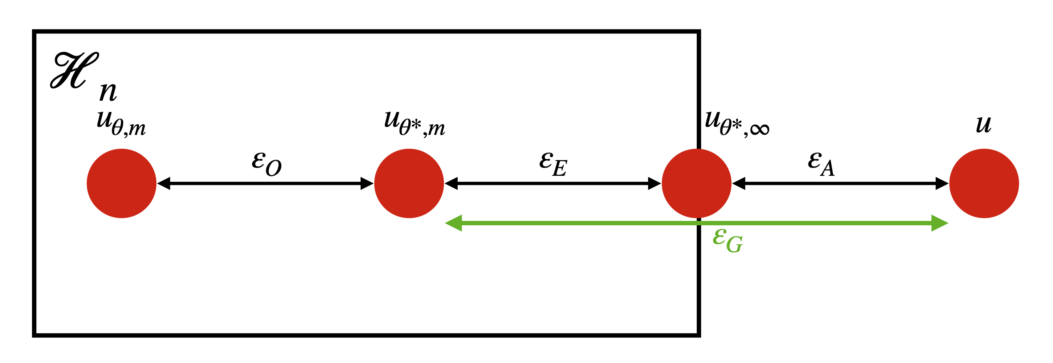
Let $u\left(x\right)$ denote the true solution of the differential equation. We consider a class of functions $H_{n}$ that can be represented by a neural network with n degrees of freedom. In practice, after training the network using a finite set of collocation points, we obtain an approximation $u_{θ,m}$. However, this approximation is influenced by several limitations in the learning process.
First, the training procedure may not find the optimal parameters within the chosen function class. The function $u_{θ,m}$ is therefore typically less accurate than the function $u_{θ^{*},m}$, which represents the result of perfect optimisation using the same finite set of collocation points. The difference between these two functions corresponds to the optimisation error.
Even if perfect optimisation were achieved, the use of a finite number of collocation points introduces another source of error. If the residual of the differential equation were enforced at infinitely many points, we would obtain an idealised solution $u_{θ^{*},∞}$. The difference between $u_{θ^{*},m}$ and $u_{θ^{*},∞}$ represents the estimation error arising from the finite sampling of collocation points.
Finally, the neural network itself may not be able to represent the true solution exactly within the chosen function class $H_{n}$. The difference between $u_{θ^{*},∞}$ and the true solution u is known as the approximation error, which reflects the expressive power of the neural network. The total error that we observe in practice can therefore be decomposed as
$\left|u_{θ,m}-u\right|$.
Theoretical work for PINNs has bounded both the approximation error and estimation error (often coupled together as the generalisation error) however, there does not exist a bound on the optimisation error which often dominates the total error observed in practice.
3.4 Why do PINNs sometimes fail?
Although PINNs provide a flexible framework for solving differential equations, their practical performance can differ significantly from the theoretical picture outlined in the previous section. In particular, the optimisation error introduced during training can dominate the overall error and prevent the network from converging to an accurate solution.
To illustrate this, consider the singularly perturbed boundary value problem
$-ε^{2}u_{xx}+u=1, u\left(0\right)=u\left(1\right)=0, 0<ε≪1$.
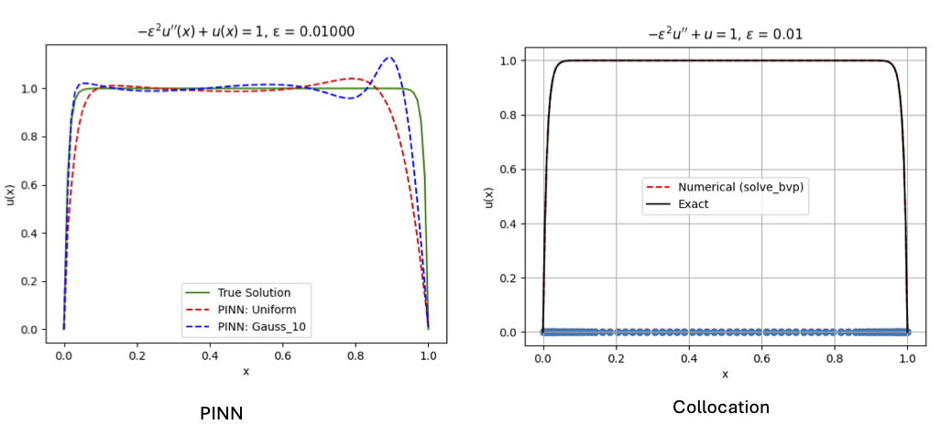
This problem exhibits boundary layers near x=0 and x=1 of width $O\left(ε\right)$. Below we observe the PINN failing to reproduce the boundary layers and instead developing oscillations. One thing to note is that this failure occurs regardless of the choice of collocation points; both uniformly distributed and Gauss-Legendre points produce similar behaviour. In contrast, a classical collocation solver resolves the boundary layers accurately.
This behaviour highlights one of the key issues with PINNs: although the neural network may have sufficient expressive power to approximate the solution accurately (i.e. the approximation error may be small), the training process may fail to locate this solution in practice. In terms of the error decomposition discussed previously, the optimisation error can therefore dominate the overall error. Another issue we are seeing here is one of spectral bias, that is the higher frequency terms (parts of the solution that change more rapidly) are not learnt as well. This issue is not specific to PINNs and can occur with other numerical methods however a direct resolution of this problem for PINNs requires an extra bit of problem knowledge built into our solver.
Recent research has identified several factors that contribute to these training difficulties alongside like for like comparisons of PINNs against classical methods such as FEM. Firstly, PINNs often struggle to learn functions containing high-frequency or multi-scale features. This phenomenon is the spectral bias of neural networks issue we encountered. Neural networks tend to learn low-frequency components of a solution before higher-frequency components. Secondly, the loss landscape associated with PINNs is highly non-convex, meaning that optimisation algorithms may become trapped in poor local minima or flat regions of parameter space.
One cause of this non-convexity is due to weights and biases in the network performing vastly different roles as part of our approximate solution. Adding in the activation function to the network then creates a very non-linear relationship between the network parameters and in turn the non-convexity we encounter.
These difficulties explain why, despite their theoretical expressivity, the optimisation error for PINNs cannot be bounded without adaptations made to the method. As a result, recent work has focused on improving the optimisation process, including the development of better training strategies, preconditioning techniques, and methods based on neural tangent kernels.
3.5 The Deep Ritz Method
We now introduce an alternative neural-network based approach for solving partial differential equations is the Deep Ritz Method (DRM), introduced in 2017 by E and Yu [16]. One benefit of the method is that we implicitly deal with spectral bias which was one of the issues we encountered with PINNs.
3.5.1 Definition and Motivation
Rather than minimising the residual of the differential equation as in PINNs, the Deep Ritz Method minimises an energy functional whose minimiser corresponds to the solution of the PDE.
Let $u\left(x\right)$ denote the solution of a variational problem defined through an energy functional
$F\left(u\right)=\int_{Ω}^{ }{f\left(u,∇u,x\right)dx}$.
Classically, many elliptic PDEs can be formulated as minimisation problems of this form. For example, the Poisson equation $-Δu=f$with suitable boundary conditions corresponds to minimising the functional
$F\left(v\right)=\int_{Ω}^{ }{\left(\frac{1}{2}{\left|∇v\right|}^{2}-f\left(x\right)v\right)dx}+β\int_{∂Ω}^{ }{{\left(v-u_{D}\right)}^{2}ds}$.

The Deep Ritz Method approximates the solution using a neural network $u_{θ}\left(x\right)$ and seeks
$u_{θ}^{*}=\arg{\min_{θ}{F\left(u_{θ}\right)}}$.
Where the integrals are numerically approximated through a set of quadrature points.
A key motivation for this formulation is that the optimisation is often better behaved than the PINN residual loss. The PINN loss involves multiple derivatives and multi-scale residual terms, which can lead to ill-conditioning and training difficulties. By instead minimising an energy functional, the Deep Ritz Method mitigates some of the optimisation issues associated with spectral bias and poor gradient flow observed in PINN training.
3.5.2 Comparison with FEM
Looking back to section 3.1.2 you may notice that the Deep Ritz Method is closely related to the classical FEM, since both approaches minimise an energy functional defined over a space of admissible functions. In FEM, the approximation space is typically a finite-dimensional linear space spanned by basis functions associated with a mesh. In contrast, DRM replaces this with a nonlinear function class defined by a neural network.
This change introduces both advantages and challenges. Neural networks can provide highly expressive approximations and may achieve good accuracy with relatively few degrees of freedom. They are also naturally mesh-free and can adapt to complicated geometries without requiring a structured discretisation of the domain.
However, the nonlinear parameterisation of the solution means that the optimisation problem becomes non-convex and often poorly conditioned. In contrast, many finite element discretisations lead to convex optimisation problems that can be solved reliably using linear algebra techniques. FEM also benefits from strong theoretical guarantees such as Céa’s Lemma, which bounds the approximation error in terms of the best approximation available in the chosen finite element space. No comparable general result currently exists for neural-network based methods such as the Deep Ritz Method.
As a result, while DRM can offer improved expressivity compared with classical discretisation's, it inherits many of the optimisation difficulties associated neural networks.

4. Machine Learning for Differential Equations II: Neural Operators and their applications

4.1 Overview

In the previous section we saw how we can use a ML network as a PINN or a DRM to find the pointwise solution of a differential equation using an unsupervised learning approach. The neural operator method takes a different approach. We describe this as follows.

Suppose that we have a (partial) differential equation which we solve from an initial time t = 0 to a final time t = T so that:

$$u_{t}=f\left(x,u,u_{x},u_{xx}\right), u\left(x,0\right)= u_{0}\left(x\right), u\left(x,T\right)= u_{T}(x).$$

The function u_{T}(x) is then a (possibly nonlinear and infinite dimensional) function F(u₀(x)) of the input function u₀(x).

We now assume that we have a (large) number of solutions $u_{T }^{i}\left(x\right)$ to the differential equation at time T for a large number of different initial conditions $u_{0}^{i}$ for I = 1… N giving a ‘solution pair’ Here the solutions are accurately computed in advance using (say) a finite element or spectral method. We then aim to use these solution pairs to train a neural network (called a Neural Operator) to emulate the numerical method and find the (infinite dimensional function) F. Then given a new initial condition u₀ as an input to the neural network it can find the future value u_{T} the solution without having to solve the differential equation explicitly. (In a crude way this can be thought of as interpolating the training data). Once so trained the neural operator is often very much faster in operation than the original numerical method. The advantage of this method over using a PINN is that it is trained on solutions of the differential equation with guaranteed error bounds. The disadvantages (shared with any ML method) are that the training process is slow and possibly unreliable, and that it is generally only accurate if the input u₀ is close to the training data. We will explore this later in this section, as well as showing how the use of additional physics can increase the accuracy of this method.

To be precise, suppose that we have a neural network N(u₀, $θ)$, with input (some finite dimensional representation of) the function u₀. Then we find the neural operator by training the parameters $θ$ to minimise the loss function L given by

$$L= \sum_{i}{∥ u_{T}^{i}}-N\left(u_{0}^{i} , θ\right) ∥$$

or similar. There are a number of ways of doing this which we will explore in this section.

4.2 Three examples of the Neural Operator Approach

- A linear ODE
Consider the linear ordinary differential equation
$$\frac{du}{dt}=A u, u\left(0\right)= u_{0} .$$
Where A is a constant matrix (we will meet this ODE later). This has the exact solution
$$u\left(t\right)= e^{At }u_{0},$$
Where $e^{A}$ = I + A + $\frac{A^{2}}{2!}+\frac{A^{3}}{3!}+…$ . Thus
$$u_{T}=B u_{0}= e^{AT}u_{0}.$$

If we can find the linear operator B then we can find u_{T} for a general input u₀ without having to solve the differential equation. This is a relatively straightforward application of the training procedure described above.
Important note A neural network is a nonlinear function of the input. Thus it will approximate the linear operator B by a nonlinear operator. This may not be optimal in practice. If you know in advance that the operator is linear then it is possible to use a more direct method, such as the Moore-Penrose pseudo inverse, to approximate B using the training data.

- The linear heat equation
The one-dimensional linear heat equation with periodic boundary conditions on the interval $[0,2π]$ is given by
${ u}_{t}$ = $u_{xx}$ , $u\left(0,x\right)= u_{0}\left(x\right).$
A typical solution for a top-hat initial function is given below.
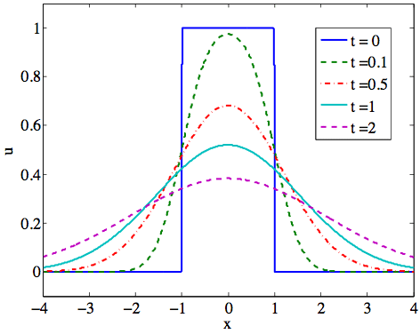

In this case we have that the solution at time T is given by a convolution (a global integral operator) of a Kernal function G(z) (in fact the error function) with the initial data, so that
$$u_{T}\left(x\right)=G*u= \int_{0}^{2π}{G(T,x-y}) u_{0 }(y) dy.$$
Again, once the function G has been determined (from training data as above) then we can find u_{T} from u₀ without having to solve the PDE.
There is a short cut to doing this which we will exploit presently. Suppose that u₀(t,x) has a Fourier Series given by:
$u_{0}\left(x\right)= \sum{c_{n} e^{inx}}$ then $u_{T}\left(x\right)= \sum{{e^{-n^{2}T}c}_{n} e^{inx}}$
It follows that the Fourier coefficients of u₀ and u_{T} are related by the simple map:
$c_{n} →$ ${e^{-n^{2}T}c}_{n}.$
Provided that we can find the Fourier coefficients of u₀ then we can easily learn this linear map from the training data. This observation motivates the FNO algorithm of the next section
- The Darcy problem
The Darcy problem describes the velocity u(x) of a fluid through a permeable rock layer of permeability k(x) subject to a forcing f(x). It is given by:
$-∇. \left(k\left(x\right) ∇ u\left(x\right)\right)=f\left(x\right).$
This is a linear elliptic partial differential equation for u(x), and for a given function a(x) can be readily solved using the Finite Element Method or similar. This means that u(x) is a (readily computable) nonlinear function N(k) of the input data k(x). As above, we can learn this function using a neural operator method such as the FNO described nex

4.3 The FNO method

There are now many method for computing a Neural Operator. One of the first of these was the Deep-O-Net method, Lu et. al. [17], which projects the input u₀ onto a lower dimensional space, then computes the Neural Operator in a latent space, before projecting back up. The popular Fourier Neural Operator (FNO) method introduced in 2021 by Li et. al. [18], and developed at CalTech, mimics the approach used to solve the linear heat equation by first sampling the input function at a set of special points to create a vector which is used as the input to a Neural Net.

The FNO architecture is based on the process of solving the linear heat equation, but also works for nonlinear problems. The FNO constructs a ’Neural Map’ Ψ acting on u₀ parametrised by θ, which is a deep NN of depth L, constructed as follows:

Ψ(u₀,θ). ≡ Q◦L_{L}◦...◦L₂◦L₁◦P(u₀) ≈ u_{T} =F(u₀),

With the operation at each level given by

L_{n}(v)(x,θ) = σ(W_{n} v(x)+b + K_{n}(v))

Here at each level W_{n} is a pointwise linear local map. K_{n}(v) is a global convolutional integral operator, with Kernal G_{n}(θ), and Q and P are projection operators

As in the case of the linear heat equation, the global operator K_{n}(v) is evaluated using an FFT via the operation:

FFT(K_{n}(v)) = FFT(G_{n}) FFT(v).

In this operation the FFT is restricted to M modes. Nonlinearity and higher order modes are introduced via the nonlinear activation function σ, usually taken to be ReLU.

The FNO is widely used, and well supported on GitHub with code, test problems, and training documentation. See https://github.com/neuraloperator/neuraloperator for example.

4.4 Convergence

As with PINNS there has been a lot of recent work studying the convergence of neural operator methods. The picture is similar, with the caveat that neural operator methods are attempting to approximate an infinite dimensional operator, which is always going to be problematic. Given a sufficiently rich neural network, it is possible to find a neural operator which accurately approximate the operator on a (compact) set containing the training data. As with the earlier discussion on ML methods, this result only applies if the training procedure has worked well enough to find the optimal solution. The effectiveness of the neural operator also depends heavily on the richness of the training set (which has to span a subset of an infinite dimensional set). In the original FNO paper the training set is taken to be a set of random functions. However, this is not often a good choice. Generating a good training set is crucial and can be slow. It is key to the success of the method that the training set should be as representative as possible of the required solutions. FNO struggles away from the training set in general. However an important application of FNO methods is for MCMC emulators used in Uncertainty Quantification where the input will always be close to the training set. For this they are the right tool for the job!

More generally more work has to be done to broaden its scope and extend the theorems on its convergence. For example, we observe poor learning of conservation laws at the moment. Also none of this theory applies, for example, to the nonlinear heat equation

u_{t} =u_{xx} +u², t = 0, T = 1,

which has a singular solution if ||u₀|| is sufficiently large. This which will not be detected if the Neural Operator is only trained on data with smaller norm.

4.5 Example: Weather forecasting using ML

An important application of Neural Operator, and other ML methods lies in weather forecasting.

In 2019 a meeting was held at Oxford to discuss whether AI systems could ever predict the weather ‘on their own’. The conclusion at the time was that this was not possible. Seven years later, the whole landscape has changed, with AI methods now playing an increasingly important role in weather forecasting.

The conventional ‘physics based’ method for weather forecasting comprises the following:

- A set of PDEs describing the oceans and atmosphere etc. is constructed using physical reasoning based on historic data. This is called the ‘dynamic core’. It is solved using a suitable numerical discretisation.

- A set of routines (also based on historic data) which provide extra physical information to the dynamic core which is often at a smaller scale than the grid used to solve the PDEs. These are called the parametrisations. An example being the calculation of cloud cover.

- An evolving set of data (say from satellites, or rain radar stations)

- A data assimilation process which combines the forecasts made in 1 and 2 above with the data in 3.

This procedure is used by the Met Office and other weather centres to produce their forecasts. An example being the HIRES forecast from ECMWF, the forecast of which over the last 40 years are archived in the ERA5 data set.
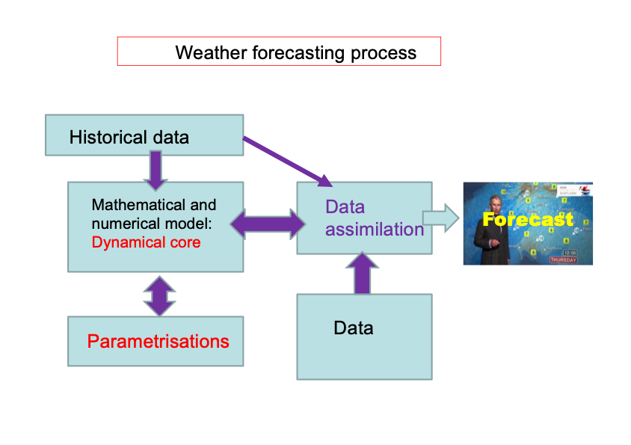

Scientific ML methods are now being used to augment and replace this process in a number of ways.

Firstly generative AI is used to increase the resolution of a forecast (often by including additional local knowledge) through the procedure of downscaling. By this means we can get more accurate local forecasts of wind and rainfall.

Secondly, the parametrisations in step 2 above (which are usually empirical models) can be replaced naturally using AI models trained on data. An example of this is cloud forecasting using the Met Office CARAMEL project https://weather.metoffice.gov.uk/learn-about/weather/types-of-weather/clouds.

Thirdly the dynamical core including the parametrisations, can be replaced by using a Neural Operator method. This method can trained on (say) the ERA5 data above, so that given (say) a good description of today and yesterday’s weather, it can forecast the weather for tomorrow. This procedure is used in the DeepMind GraphCast model by Lam et. al. [19] and the Met Office FastNet model. This procedure is very fast when trained but suffers from two disadvantages. Firstly it relies on having an accurate description of the weather today. This can be hard to obtain as it relies on learning the correct atmospheric state from limited data. Secondly the forecasts from these models tend to be good for ‘low resolution data’ such as pressure, and poor for high resolution data such as rainfall. However, the models have shown notable accuracy (skill) in predicting the weather for 10 days in advance and are better than (say) HIRES for doing this (when measured in a suitable error norm). One application of such methods is to make a forecast using the physics based approach to get the higher resolution data, and then, after (say) five days to ‘nudge’ it towards the prediction of the AI based method.

Fourthly It may be possible to replace all of the steps 1—4 so that the AI method predicts the weather purely from the satellite data. This is the claim of the recent AARDVARK model from Cambridge and the ATI , see Allen et. al. [20].

This is a subject of rapid evolution. Watch this space.

5. Scientific Machine Learning and dynamics.

In sections 3 and 4 we saw how ML methods can be used to find approximations to the solutions of differential equations. In this section we will look firstly at how differential equations can be used to simulate a ML architecture, and secondly how we can use ML to discover, and reproduce, the dynamics of a system from experimental data.

5.1 Simulating a ML architecture: Neural ODEs I

Neural ODES were introduced by Chen et. al. [ 21] and in their definition are differential equations that reproduced the ‘dynamics’ of a ML architecture. One of the problems with the conventional architecture is that of ‘vanishing derivatives’ where information (say on the effect of a change in the parameters) is lost (exponentially) from one layer to the next. This problem can be overcome in part by using a ‘ResNet’ architecture of the form:

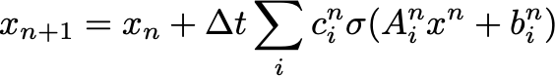

With input x₀ and output x_{L} .

Now, if we assume that $∆t$ is small, and the L is large, then we can see that this is the Forward Euler discretisation of the (Neural) ODE:

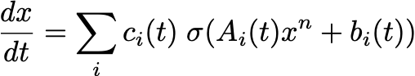

With input x(0) and output x(T). The ODE can then be solved by a numerical metho such as RK4 etc.

This ODE can then be trained to find appropriate x(T) given input x(0). An application of this is to use such methods to forecast the weather by replacing a Fourier Neural Operator by a Neural ODE. There are certain advantages in memory efficiency and back propagation for doing this, instead of using a deep neural network. However Neural ODEs can have problems separating tightly coupled data. To train such a Neural ODE we need to find suitable functions A(t), b(t), c(t). This is a well understood problem in optimal control theory and can be solved using adjoint methods.

5.2 Reconstructing dynamics: Neural ODES II

Suppose that we have some physical system, with an output/state x_{i} the time t_{i} and we record the measurements y_{i} = H(x_{i}) + e_{i} where e_{i} is a noisy error. A key question in science, is: can we find the process that gives us these measurements, and then can we use this process to predict the future behaviour of the system.

This question is as old as science (or indeed humanity) itself as we try to make sense of the world around us, given by the information provided to us by our senses, and other measurements. A very early example of this is the Ptolemaic model of the solar system
This took a model in which the Earth was at the centre, and the planets, and Sun, orbited on a series of small circles (epicycles) moving on larger circles centred on the Earth. Each such planetary orbit was then described by the size of the circles, the speed of rotation around the circle, and phase (6 parameters). Hence the whole solar system (of 7 heavenly bodies) could be represented by a model with 42 trainable parameters. This could be achieved with the techniques of the time. The Ptolemaic model, whilst rather inelegant (this was part of its problem) worked and was highly predictive for its time. However, it had to be abandoned when new data (from telescopes) came along of, for example the moons of Jupiter or the phases of Venus. This is classical example of a model failing to predict away from its training set. It is also a cautionary tale for all machine learning. Despite giving (for a time) the right answers, the Ptolemaic system got the physics completely wrong, and gave no understanding (unlike Kepler’s laws, or Newton’s law of gravitation) of what was really going on.

Suppose that we have a system which we think is driven by a differential equation (for example the Solar system) of the form

$\frac{dx}{dt}=F\left(x\right), x ∈ R^{n}, x\left(0\right)= x_{0, }y_{i}=H\left(x\left(t_{i}\right)\right)+ e_{i} , i=0 .. N$ (*)

We can attempt to model this differential equation using (what is also, but confusingly called) a Neural ODE of the form:

$\frac{dz}{dt}=f\left(z;θ\right), z\left(0\right)= z_{0}$ (**)

Where $F(y;θ)$ is a MLP or similar. This system can be solved using a standard numerical method and z(t_{i}) = z_{i} evaluated.

Given the set of data points as above, we can then train (**) using the loss function

$L= \frac{1}{N} \sum_{i=0}^{N}{| y_{i}-H\left(z_{i}\right)|}$²

Or similar.

As an example to demonstrate both the strengths and the weaknesses of this method we consider an example modified from the Matlab website on Neural ODES [22]

Let x satisfy the linear ODE

$$\frac{dx}{dt}=A x, x ∈ R^{2}, x\left(0\right)= x_{\begin{aligned}0 \\ \\ \end{aligned}} (*)$$
with
$$A= \left(\begin{matrix}-0.1 & -0.1 \\ 1 & -0.1\end{matrix}\right)$$

This has solutions which spiral into the origin for all initial data. An orbit for which x(0) = [1,-3] is given below, computed using RK4 over the interval t $∈[0,500]$ with 5000 data points at time intervals of 0.1

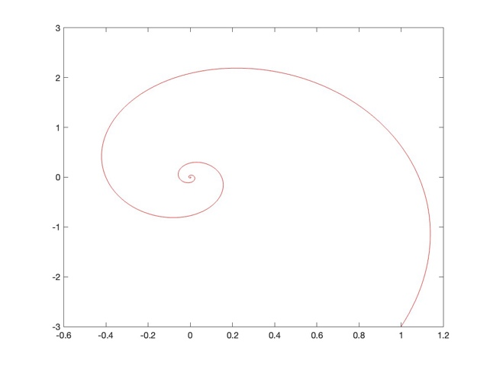

As a simple Neural Network we take a two-layer network with tanh activation given by:

$$f\left(z\right)= W\tanh\left(M z+b\right)+c$$

This is then trained by solving the neural ODE numerically and using the first 50 data points. If this is done then the trained neural net finds the rest of the orbit with reasonable ease as seen below, in which red is the original orbit, blue the computed orbit, and the crosses show the training points. Note the slight deviation as the trajectory extends:

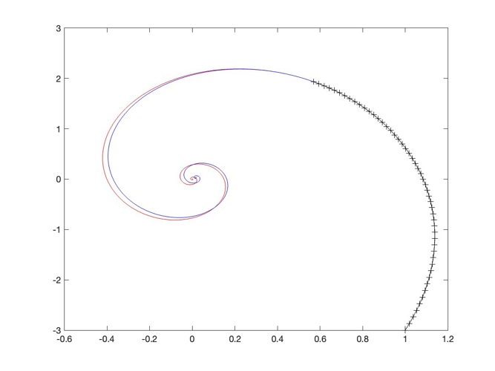

Similar good performance is also found if we start the neural ode at an initial state close to the training orbit.

However if we start the orbit further away from the training data then the loss rapidly increases. An example of this is Ilustrated below where we take (10,10) as the initial state, and show the difference between the true (red) and predicted (blue) orbits. We are not able to use the neural ode for a reliable prediction in this case.

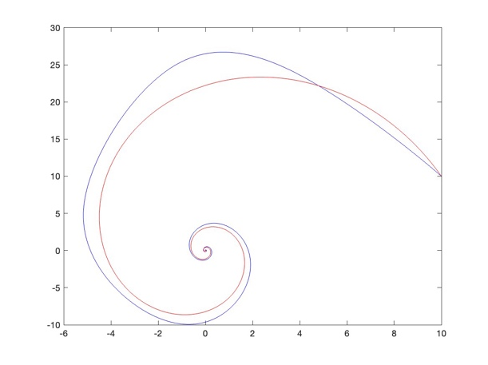
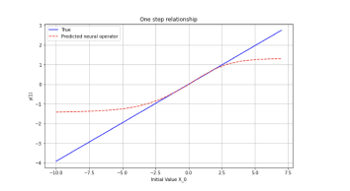

The reason for the degrading of the performance is simple. We are trying to approximate a linear function A x, with a nonlinear one (tanh). This is asking for trouble. Whilst tanh is approximately linear for part of its range (such as that close to the training values), it rapidly saturates. On the right we see a one-dimensional cross-section the approximation of Ax compared to that of the neural ode. The impact of the saturation of tanh function is plain. This is an example of stable system bias, where the neural network is biased to give results close to its original training data, but deviates away from this data.

There is a simple ‘fix’ to this ‘problem’. Instead of using a full neural net, use a bit of physical knowledge and consider the simple linear differential equation

$$\frac{dz}{dt}=B z, z ∈ R^{2}, z\left(0\right)= x_{0} (**)$$

We now try to find the best possible linear operator to fit the data. If we take only 100 points this estimate is given by:

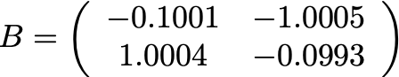

We can see that this is very close to the true value of A given above. Unlike the neural ODE the dynamics of the system (**) will be close to that of (*) for all initial data.

SINDY

The SINDY (Sparse Identification of Nonlinear Dynamics) by Brunton et. al. [23] approach to identifying an underlying dynamical system extends the linear system method described above. In the above example we used a linear function for f(x). In SINDY there is a ‘library’ of functions $Θ\left(x\right)$ (such as polynomials, exponentials, trigonometric functions etc. ) drawn on to construct f(x) and a best linear combination of these (parametrised by $Ξ)$is used to give a ‘sparse’ approximation (hence the name). In particular we have

and if we set

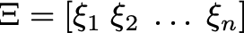

then the approximating ODE becomes
$$\frac{dz}{dt}= Θ\left(z\right) Ξ$$

As in the case of the Neural ODE this is trained by finding the best set of parameters to minimise the loss function as above.

An example of SINDy in operation is given in [23] for the Lorenz equations. Notably the Lorenz system has a quadratic right hand side, and also chaotic dynamics which explores a lot of the phase space. This leads to a rich training set, making the SINDy approach especially effective in this case. It is a paradox that chaotic systems are often much more predictable than regular ones.

In conclusion Neural ODEs are effective for

- Describing the flow through a NN
- Learning dynamics from data
- They inherently non smooth (or close to non smooth)
- They work best when informed by the physics

Section 6: A case study in PINNS

6.1 Introduction

This study will give you an introduction to PINNs and to PyTorch. It will give you an example of the use of PINNS to solve simple BVP and IVP differential equations in one-dimension. It will also allow us to study questions of the convergence and stability of the PINNS solver as a function of the architecture of the neural net and the location of the collocation points.

6.2 Solving a linear BVP

- Open a Colab notebook session or your favourite Python IDE. Check that it is working by asking a simple question such as what is 1 + 1.
- Copy the code PINNs Tutorial.py in the Python Examples Git-Hub folder into the Colab notebook. See

https://github.com/ChrisBudd123/Ai4Sci/blob/main/Python_examples/PINNs_Tutorial.py
- The code uses a simple 3-layer PINN to solve the linear BVP
$$-u^{''}\left(x\right) = f\left(x\right), u\left(-1\right)=α, u\left(1\right) = β$$
In the code $f\left(x\right), α, β$ are chosen such that we have the exact solution
$$u\left(x\right) = \tanh\left(x\right)$$The PINN is trained to minimise the residual
$$r\left(x\right)={\left(-u^{''}-f\left(x\right)\right)}^{2}$$
evaluated at, and summed over, a set of collocation points xi combined with the boundary conditions. The ADAM optimiser is used in training. It is then compared to the exact solution. Read through the code to make sure that you understand how it works.

- Run to code as given to check that it gives a sensible answer.
- Now modify the code so that our problem has the exact solution $u\left(x\right)=\tanh\left(ax\right)$ for varying values of $a$. Run this modified code to see how the PINN performs as the value of $a$ is increased.
Hint 1: Make sure to change the y true variable to plot $\tanh\left(ax\right)$.
Hint 2: $\frac{d^{2}}{dx^{2}}\left(\tanh\left(ax\right)\right) = -2a^{2}\tanh\left(ax\right)\cosh^{-2}\left(ax\right)$
- Experiment with changing the width of the PINN and the number of collocation points to see how the solution converges (or not) to the exact solution, and how this convergence rate depends on the value of $a$.
6.3 Solving a linear IVP
We will now use a PINN to solve the linear second order initial value problem
$$u^{''}+ω^{2}u=0, x∈\left[0,1\right] u\left(0\right)=0, u^{'}\left(0\right)=1$$
- Modify the previous example to solve this IVP for $x∈\left[0,1\right]$. Compare your solution with the exact solution for the case of $ω=5$. Investigate how the convergence depends on $ω$ the number of collocation points etc.
- Using the PINN trained over the interval [0,1] as above, apply it to solve our IVP for $x∈\left[0,10\right]$. Comment on your answer.
- If you wish you can experiment with the related nonlinear equation
$$u^{''}+ω^{2}\sin\left(u\right)=0, u\left(0\right)=0, u^{'}\left(0\right)=v$$for varying values of $v > 0$ and $ω>0$. Note that theoretically there is a change in the qualitative behaviour of the solution to this equation as $v$ increases through $v = 2ω$. Does the PINNs solution capture this?
6.4 Solving a nonlinear IVP
We will finally use a PINN to solve the nonlinear first order initial value problem
$$u^{'}=u^{2}, x∈\left[0,1\right], u\left(0\right)=γ$$
- Modify the previous example to solve this IVP for $x∈\left[0,1\right]$. Compare your solution with the exact solution for the case of $γ=\frac{1}{2}$.
- Now set $γ=2$. What is the exact solution in this case? What does the PINN give? Does this depend on the parameters of the PINN?

Coding solutions to these problems can be found on the same GitHub repository as the case study code.
https://github.com/ChrisBudd123/Ai4Sci/blob/main/Python_examples/PINNs_Tutorial.py

- Useful References

There is no good book that covers the whole of scientific machine learning. Indeed the subject is developing so rapidly that at the moment any such book would be out of date in six months or less. These references attempt to give a state of the art, but still accessible, overview.

Section 1: Introduction

[1] Stephen Lynch Python for scientific computing and artificial intelligence, (2023), CRC Press

A gold mine of useful information, and code, for a wide variety of applications.

[2] Francois Chollet, Deep learning with Python, (2018), Manning

[3] Catherine Higham and Desmond Higham Deep Learning: An introduction for applied mathematicians, (2019) SIAM Review 61.

An excellent introduction for a mathematical audience.

[4] Elaine Murphy et. al., Machine learning outperforms clinical experts in classification of hip fractures, Nature, Scientific Reports, 12, Article number: 2058 (2022).

shows how machine learning methods can be used reliably to make a medical diagnosis.

[5] Leon Bungert, Desmond Higham and Laura Thesing, Adversarial robustness of artificial intelligence, (2026), EJAM

This is a collection of articles on adversarial attack.

[6] Nicholas Carlini et al. Extracting training data from large language models. 30th USENIX Security Symposium (USENIX Security 21). 2021.

Section 2: Architectures

[7] Philipp Grohs, Gitta Kutyniok, Mathematical aspects of deep learning, (2022), Cambridge

Mathematically very solid account of the way that neural networks are effective in expressing solutions, and an error analysis of this.

[8] Iddo Drori, The science of deep learning, (2023), Cambridge.

This gives a comprehensive account of many of the architectures discussed.

[9] Joos Korstanje, Advanced forecasting with Python: With state-of-the-art-models including LSTMs, Facebook’s Prophet, and Amazon’s DeepAR. (2021), APress, New York.

[10] Ashish Vaswani et. al. , Attention is all you need, (2017), NEURIPS 2017.

A true classic introducing the transformer architecture!

[11] J ohannes Hertrich et. al. Learning Regularization Functionals for Inverse
Problems: A Comparative Study (2026) https://arxiv.org/pdf/2510.01755

[12] Georgios Batzolis, Jan Stanczuk, Carola-Bibiane Schönlieb, Christian Etmann,
Conditional Image Generation with Score-Based Diffusion Models, (2011)
https://arxiv.org/abs/2111.13606

See also. https://en.wikipedia.org/wiki/Stable_Diffusion

Section 3: PINNs

[13] Philippe Ciarlet, The Finite Element Method for Elliptic Problems, (1978), North-Holland.

[14] M. Raissi, P. Perdikaris, G. Kaniadakis, Physics-informed neural networks: A deep learning framework for solving forward and inverse problems involving nonlinear partial differential equations, (2019), Journal of Computational Physics 378, 686-707

[15] George Cybenko, Approximation by superpositions of a sigmoidal function, (1989), Mathematics of Control, Signals, and Systems 2(4), 303–314.

[16] Weinan E and Bing Yu, The Deep Ritz method: A deep learning-based numerical algorithm for solving variational problems, (2017), https://arxiv.org/abs/1710.00211

Section 4: Neural Operators and their applications

[17] Lu Lu, Pengzhan Jin, George Em Karniadakis, DeepONet: Learning nonlinear operators for identifying differential equations based on the universal approximation theorem of operators, (2019), https://arxiv.org/abs/1910.03193

[18] Zongyi Li et. al. Fourier Neural Operator for Parametric Partial Differential Equations, (2021), ICLR. https://arxiv.org/abs/2010.08895

[19] Remi Lam et. al. Learning skillful medium-range global weather forecasting, (2023), ScienceVol. 382, No. 6677

This paper introduces the GraphCast algorithm for weather forecasting

[20] Anna Allen et. al. End-to-end data-driven weather prediction, (2025),
Nature 641, 1172–1179 .

https://www.nature.com/articles/s41586-025-08897-0

This paper introduces the Aardvark algorithm for end-to-end weather forecasting.

Section 5: Dynamics

[21] Ricky T. Q. Chen, Yulia Rubanova, Jesse Bettencourt, David Duvenaud, Neural Ordinary Differential Equations, (2018), https://arxiv.org/abs/1806.07366

[22] Matlab tutorial on neural ODEs

https://www.mathworks.com/help/deeplearning/ug/dynamical-system-modeling-using-neural-ode.html

[23] Steven L. Brunton, Joshua L. Proctor, J. Nathan Kutz, Discovering governing equations from data: Sparse identification of nonlinear dynamical systems, (2015). https://arxiv.org/abs/1509.03580

This paper introduces the SINDy algorithm.

About the authors


Chris Budd OBE, FAcadMathSci

Chris Budd OBE, FAcadMathSci, is Professor of Applied Mathematics at the University of Bath and Director of Knowledge Exchange at the Bath Institute for Mathematical Innovation (IMI) which has a primary mission of taking mathematics out to the broader community. He has been involved in knowledge exchange all of his career, both in academia and industry. He has particular interests in mathematical, scientific computing, and machine learning, and works closely with many industries, especially the environmental, electronic, power generating, and food industries. He has been a strong supporter of study groups all over the world, attending his first in 1984. He was a founder member of V-KEMS which pioneered the use of virtual study groups (VSGs) as a very effective way of bringing mathematicians together to work on the challenges posed by COVID-19. He is a Super Champion of the KE Hub, and a Fellow of the Academy of the Mathematical Sciences
Chris Budd is the director of the UKRI programme Maths For Deep Learning (Maths4DL) https://maths4dl.ac.uk/ which is a joint research project between Bath, Cambridge, and UCL, developing the theory, methods, and applications of scientific machine learning methods. The aim of this programme is to make scientific machine learning methods more reliable, accurate, and trustworthy, so that they can become reliable tools for industrial applications.
A passionate advocate for outreach in mathematics, he is also Professor of Mathematics at the Royal Institution and a fellow of Gresham College.

Aengus Roberts



Aengus Roberts is a mathematics PhD student at the University of Bath through the SAMBa CDT. He completed his Masters in Mathematics and Physics in 2024, also at the University of Bath where he researched using machine learning to learn dynamical systems.

He now spends his PhD untangling and demystifying machine learning for use within scientific computing with a special interest in solving differential equations using neural networks (see chapters 3 and 4). When not debugging his code, Aengus spends his time baking overly technical bakes and teaching Scouts how not to get lost wandering the Bath countryside.

