**Mathematics in the 21st Century**

**Lecture Four: Great mathematical myths**

**Chris Budd OBE, University of Bath, UK**

**Gresham Professor of Geometry**

February 11th, 2020

*A myth is a female moth*

Student Bloopers

1. **Introduction**

When we think of mathematics, we tend not to think about myths. Myths are the stuff of legend and wonder. They may start with a factual story, which actually happened at some point in history, but by the time that they become myths, and truth has been left well behind. This arises through frequent retelling of the story, which passes from one generation to another, changing as it goes. Often myths change and grow because they carry hidden truths, which appeal to some need of the human psyche. For example the Cyclops is a creature of myth and legend, which bears no similarity to any modern animal. However it still has a powerful fear factor. Maths on the other hand, is coldly logical and has no room for doubt and error. The latter is certainly true (well maybe it’s not *coldly* logical) but it doesn’t mean that there is no room for mythology in the study of mathematics. What we see happening is much the same as happened with history. A mathematical truth, through retelling and a lack of some understanding, enters the public consciousness as a myth rather than a truth. This is especially the case if this also satisfies some underlying need for some order and pattern in life, the universe, and everything. It is mathematical myths that are frequently reported in the press and on TV. This is a great shame as mathematical truths are often far more exciting and surprising than any myth, and very much give us insight into the way that the universe works.

In this lecture I will look at a number of examples of mathematical myths. In each section we will look both at the myth and the underlying truth. I hope that I will convince you that the truth is often much stranger than fiction.

1. **Myths about maths**

Before we look at mathematical myths, it is fun to also look at some ancient myths, which have involved maths in some ways.

Perhaps the oldest of these is the story of the Minotaur. The main villain of this story is the Minotaur (illustrated below) who was a creature half man and half bull. Minotaur. The Minotaur was imprisoned at the heart of a labyrinth (also see below) under the palace of king Minos in Crete.

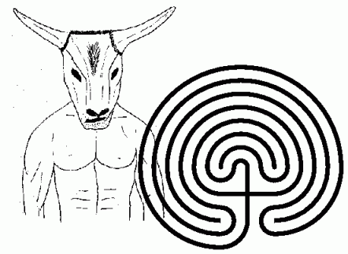

Following a defeat in a war, every nine years, seven young Greek men and women were sent to Crete where they entered the labyrinth, got trapped, and were devoured by the Minotaur. The Greek prince Theseus went to Crete with the intention of killing the Minotaur and rescuing the Greek hostages. On arrival he met (and fell in love with) the Cretan Princess, Ariadne. She gave him a method of solving the Labyrinth. Her method was to give Theseus a ball of twine, which he unravelled as he entered the Labyrinth. This way he could never get lost. Using this idea he entered the Labyrinth, killed the Minotaur and escaped successfully. Sadly he abandoned Ariadne on his way back to Greece, and, due to a mix up with the sails of his ship, caused the suicide of his father. This story is notable as not only does it describe a geometrical object, but it describes an algorithm to solve a mathematical puzzle (which is still in use in computers today).

A later myth written by Virgil in the Aenied involved Dido of Carthage. In this myth Dido is granted the right by the Gods to build a city in the area that she could cover with the hide of an Ox. Ever the resourceful Queen she took a knife and cut the hide into a thin ribbon.

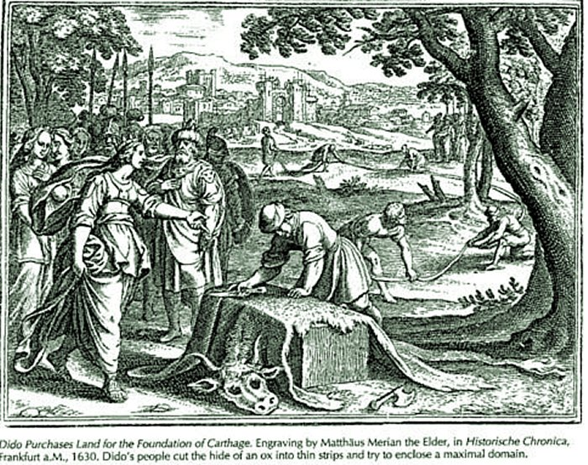

She then stretched out the ribbon into a semi-circle bounded by the coast. In the region bounded by the semi-circle she built her city. In doing this Dido showed great mathematical ability. She has realised that the largest area that could be enclosed between an arbitrary curve and a straight line was given when that curve was a semi-circle.

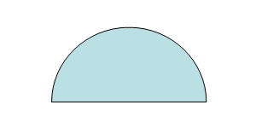

This is an example of an isoperimetric problem. Understanding this problem involved the mathematics of the *calculus of variations*. Techniques from the calculus of variations lie at the heart of modern quantum theory, as well as the finite element method, which is used to design bridges and aeroplanes as well as to forecast the weather.

A final set of myths which relate to maths but are not mathematical, are those which persist in maths education. Such as: there is a maths gene, there is a special phobia of maths, maths is useless, boys are somehow better than maths than girls, and that to do maths well you have be a social misfit, and that maths all mathematicians are evil, soulless, geeks.

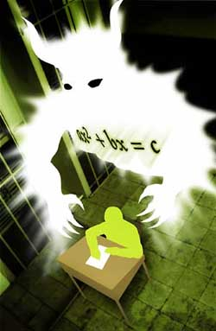

Nothing could be further from the truth in any of these assertions. However, like all they seem to persist, despite a lot of evidence to the contrary. For a fuller discussion see my earlier Gresham lecture [1].

Having looked at some myths involving maths, we will now look at some actual mathematical myths.

1. **The Golden Ratio**

For the first of these I will turn, probably somewhat controversially, to perhaps the biggest myth in maths itself. Like all myths it contains some truths, a lot of half truths and fiction, and a final truth which is stranger, and better, than all of the fiction.

**3.1 The bare facts**

Most of us will have heard of the *Golden Ratio*



It appears, for example, in the book/film the *da Vinci Code* and in many articles, books, and school projects, which aim to show how mathematics is important in the real world*.* Perhaps more myths are associated with this number than with any other concept in maths. It has been described by many authors (including the writer of the da Vinci Code) as the basis of all of the beautiful patterns in nature and that is therefore the *divine proportion*. It is claimed that much of art and architecture is dominated by having its features in proportions given by the Golden Ratio. For example it is claimed that both the Parthenon and the pyramids are in this proportion. It is also (apparently, see [2]) seen in many of the features of the human body, such as the ratio of the height of an adult to the height of their navel, or of the length of the forearm to that of the hand.

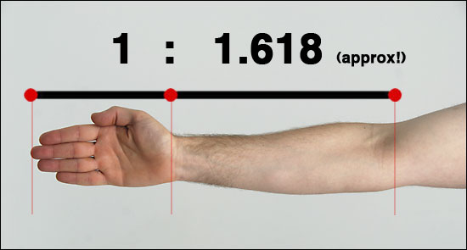

According to Mario Livio [3]

*Some of the greatest mathematical minds of all ages, from Pythagoras and Euclid in ancient Greece, through the medieval Italian mathematician Leonardo of Pisa and the Renaissance astronomer Johannes Kepler to present-day scientific figures such as Oxford physicist Roger Penrose have spent endless hours over this simple ratio and its properties. ... Biologists, artists, musicians, historians, architects, psychologists, and even mystics have pondered and debated the basis of its ubiquity and appeal. In fact, it is probably fair to say that the* ***Golden Ratio has inspired thinkers of all disciplines like no other number in the history of mathematics.***

So, is any of this really true, especially the last highlighted sentence in which seems to be quite a claim. Is phi really the most important number in the whole of mathematics?

**3.2 The basic mathematical properties of the Golden Ratio**

The Golden Ratio was first described in the famous textbook *the Elements* by Euclid on geometry, possibly the earliest and most important text book on mathematics ever written [4]. Euclid defined the Golden Ratio as the ratio of two numbers a and b with a greater than b so that



What this means is that if we draw a rectangle of sides a and b, and then add a square to this of side a, then the new extended rectangle has the same proportions as the original. The result is the so-called *Golden Rectangle.*

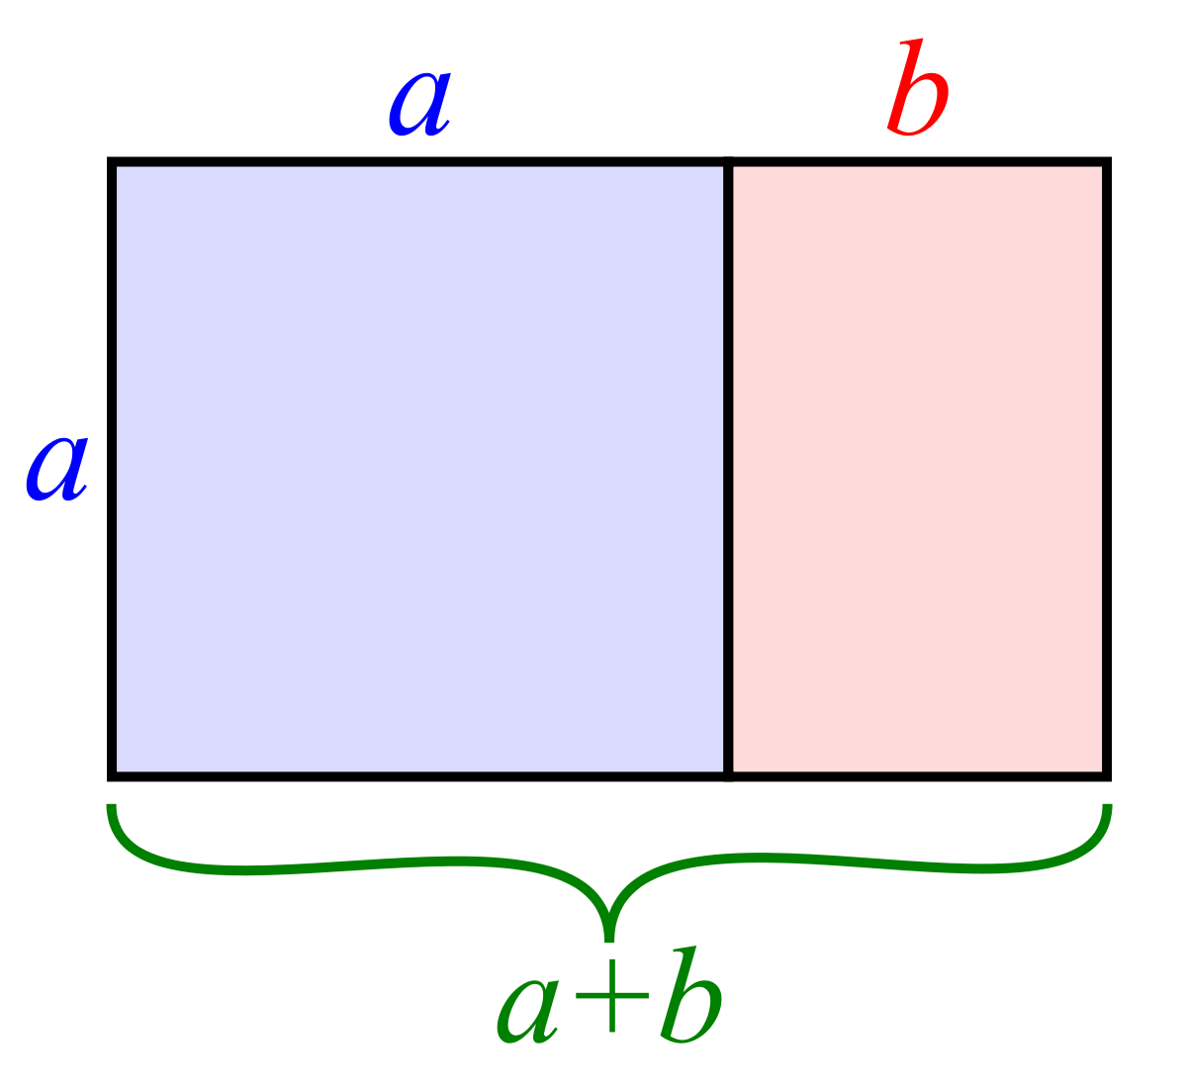

*Some algebra*



So, what is ? If we set then the equation above becomes



and multiplying by phi we get the quadratic equation



Using the equation for the solution of the quadratic, this equation has two solutions x and y given by:



As phi > 1, it follows that phi = x = 1.61803…

There are a number of other ways to define the Golden Ratio. One involves the famous Fibonacci sequence. This takes the form

1 1 2 3 5 8 13 21 34 55 89 144 …

In this sequence the next term is the sum of the two previous terms. It was introduced by Fibonacci as a way to understand the growth of populations of rabbits. It continues to play an important role in our understanding of the growth of populations. If we take the ratio of the successive terms above we get the values

1 2 1.5 1.6666 1.6 1.625 1.615 1.619 1.617 1.618 1.618 …

These ratios appear to be converging to a familiar number. Indeed the limiting ratio is precisely phi. This fact amazing fact was first discovered by Johannes Kepler, who also formulated Kepler’s laws of planetary motion.

To confirm this value we assume that in the limit, three values of the Fibonacci sequence are in the ratio



By the properties of the Fibonacci sequence we then must have



Which tells us that phi is the Golden Ratio.

In fact the n-th term of the Fibonacci sequence can be written explicitly in terms of phi and takes the form



*Some geometry*

There is a nice way to draw the Golden Rectangle using a pair of compasses. You start with a square (any square will do). Bisect the base. Now place the point of the compass on the point of bisection and extend it to the corner of the square. Draw a part of a circle from this point to the base and mark this point. The point that you get is then the corner of the Golden Rectangle.

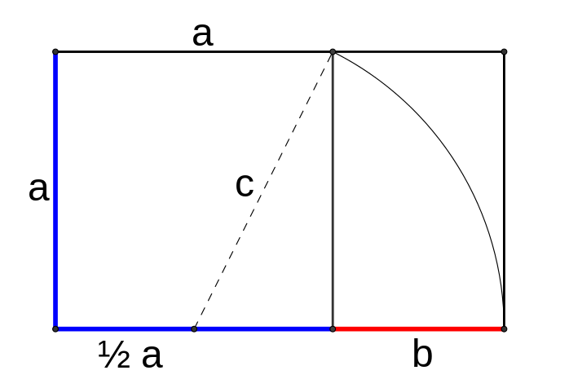

The reason that this construction works is that if the square has side length a, then the bisector is at the point ½ a. The distance c from it to the corner is, using Pythagoras’ theorem



So the point of intersection leads to a new line of length a + b = a/2 + c and thus



The Golden Ratio also has another lovely geometrical interpretation, which is part of its mystery.

Draw a regular pentagon with sides of length one. Now draw a diagonal as indicated below

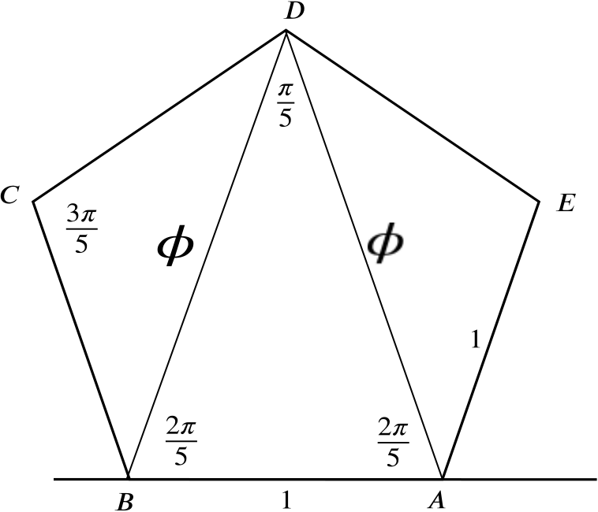

The length of the diagonal is (you guessed it) exactly phi. (Exercise: Show why. Hint: Consider similar triangles)

The two diagonals from any one point on the pentagon, together with the opposite side form an isosceles triangle, BDA above, with smallest angle 36 degrees (pi/5 radians), and sides of length 1, phi, phi. This is called the *Golden Triangle.* This triangle comes up frequently when looking at shapes with 5-fold symmetry. For example the stars on the American flag, and in also in the pentagram, which is made up of five Golden Triangles.

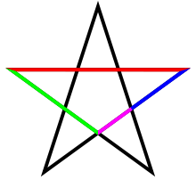

Another beautiful appearance of phi, and the Golden Triangle, comes in the subject of Penrose Tilings. These are shapes which can be used to tile the plane in a non-repeating manner. I will discuss these in much more detail in my next Gresham lecture on the links between maths and art. However in short, each of the Penrose tiles is made up of two Golden Triangles. Penrose tilings appear in certain quasi-crystals observed in nature.

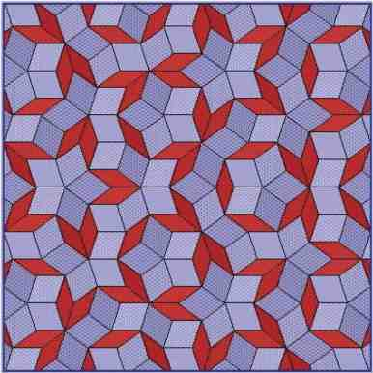

*Some more algebra*

Mathematically phi is what is called an *algebraic number* because it is the solution of a simple polynomial equation. It is also an *irrational number*. This means that there are no two whole numbers m and n so that



This is a very important property. It follows directly from the easily proved fact that the square root of 5 is also irrational. Another way to see that it must be irrational, is that if it were rational then we can construct a Golden Rectangle with integer sides m and n. It follows that the rectangle of sides n and m-n must also be a Golden Rectangle, as must one of sides m-n and 2n-m etc. We cannot continue this process indefinitely as eventually one of the sides will be zero or negative. This gives us a contradiction.

We will return to the irrationality of the Golden Ratio later in this section.

*Optimisation and computer science*

I will conclude this section my mentioning that the Golden Ratio has a couple of useful appearances in computer science. If you want to find the least value of a function, then a very efficient way to do this is to use the *Golden Search algorithm*. My first job in industry involved applying this to a problem in the design of radar systems. Another appearance comes in the secant method, which is an excellent way of solving the equation f(x) = 0. The errors in this method have the nice property that if e_n is the error at the nth stage of the method then:



This shows that the errors decrease quite rapidly. This is a nice result, which I use in my work. But for some reason it has never made it into the popular press.

* 1. **The myths**

I have, I hope shown, that the Golden Ratio is an interesting number with a variety of interesting properties. These make it worth studying, both in its own right, and also for a number of interesting applications. In terms of ‘numbers of interest to mathematicians’ I would put it in the Championship, but certainly not in the Premier League. However, as we have seen from the quote from Livio above, it seems to have obtained a position in the public consciousness, which goes well beyond these properties and has elevated it to one where it is given the name the *divine proportion*. I will now explore whether there is any real evidence for this. For further reading see the excellent survey by Keith Devlin [5].

*Geometry again*

I have shown that phi plays a useful role in geometry. So do many other numbers. One such is the square root of 2,



This (irrational and algebraic) number is the length of the diagonal of a unit square (a fact known to the ancient Babylonians). It is also the ratio of the sides of a sheet of A4 paper. Given the universality of both squares and of A4 paper, you are much more likely to encounter this number in applications than the number phi in the real world. The numbers 1,the square toot of 2, the square toot of 3, and 2 all appear in geometry far more often than phi. Here are some examples showing how the diagonals of the triangle, square, pentagon and hexagon involve the numbers above.

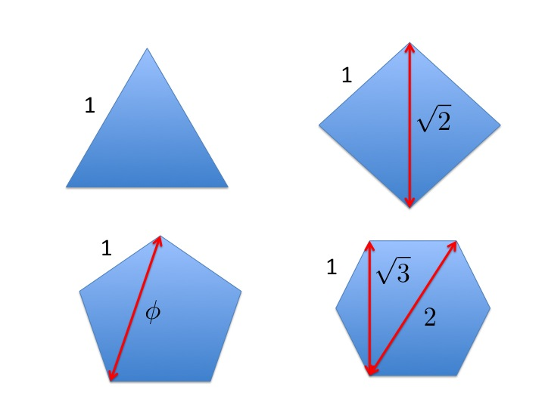

*Numbers in the Premier League*

I have said that the Golden Ratio is in the Championship league. If so, which numbers are in the Premier League? A clear contender for importance in both mathematics and the world is the number



In geometry, pi is the ratio of the circumference of a circle to its diameter. However it has applications far beyond geometry, indeed it appears in all areas of mathematics, from calculus to number theory, and from statistics to quantum mechanics.

Pi can be computed from the stunningly beautiful formula



An equally important role in mathematics as a whole, is played by the number



The number e cannot (easily) be expressed as the ratio of anything in geometry, but it is linked to anything which grows, and it is a fundamental building block of calculus. It has the definition.



It is fair to say that practically every formula in science and engineering involves either pi, or e or a combination of the two.

Mathematicians (and all other scientists I am sure) cannot imagine a universe which isn’t linked in some very close way to the numbers e and pi. For example any formula involving areas tends to involve pi, any formula which involves things growing involves e, and when you look at oscillations, ways and vibrations, you use both. In my own work I use these two numbers on practically every page of my notebook.

In contrast in my whole career of applying maths to the real world I have come across phi precisely twice. **Yes twice!**

Other numbers in the Premier League are 0, 1, -1, i (the square root of -1) , and (if you call it a number), infinity. Numbers which deserve an honourable mention are:

gamma= 0.57721163.., 163, 1729, and 47 (for Star Trek fans).

Perhaps the most important formula in the whole of mathematics is Euler’s fabulous formula



Which links all of the important numbers together in an expression of great beauty and even greater application.  *The Golden Ratio is nowhere in sight.*

All of this is very different from the myth that the Golden Ratio plays a major role in maths and science. This is simply not true. Certainly it plays a role, but not in the way that it is usually portrayed, and in no way is it important as pi and e. It remains a mystery to me that the latter two numbers, which really do lie at the heart of the universe, never seem to get a look in when it comes to maths popularisation, whilst the Golden Ratio gets all of the glory.

So, why has the Golden Ratio achieved the prominence that it has in the popular press. Like all true myths the reasons are a bit lost in history. But there are various possible explanations.

*Links of the Golden Ratio to nature*

There are various ways that we see phi appearing in nature. One is in the structure of certain crystals. For example Shechtman’s discovery in the 1980’s of quasi-crystals, some of which exhibit icosahedral symmetry involving pentagons, and hence of which feature ratios involving the Golden Ratio.

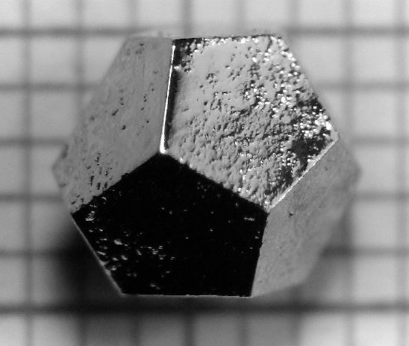

Much has been made of this in the popular literature. However, such crystals are comparatively rare when compared with cubic and hexagonal crystals, which have ratios which only involve the square roots of 2 and 3.

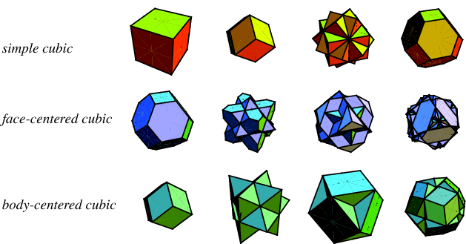

Furthermore, one of my favourite formulae involving crystals is that of the optimal crystal packing density (which also appears in the important subject of how many sweets we can pack into a jam jar). This is given by



We can see that this involves pi and the square root of 2. However the Golden Ratio is nowhere in sight!

We have shown that the Golden Ratio is closely linked to the Fibonacci sequence. This sequence certainly does appear in nature as it is both linked to the way that populations grow, and also to the way that shapes can be fitted together (as we saw in the example of the Penrose tilings). For example the sequence can be seen in the spirals on sun flowers which have to fit together in an ordered fashion, and in the leaves on some plants that need to be arranged to capture the most sunlight. As a result it is possible to observe ratios close to phi arising in certain natural phenomena. These include the distribution of drones to female bees in a bee-hive, which is linked to the way that bees reproduce over many generations, as illustrated below. So it is not unreasonable to see the Golden Ratio in the garden, and there are very good mathematical reasons for this. On the subject of bees, a typical honey comb is made up of hexagons. These shapes are closely related to the square root of 3. This number is much more significant to a bee than the Golden Ratio.

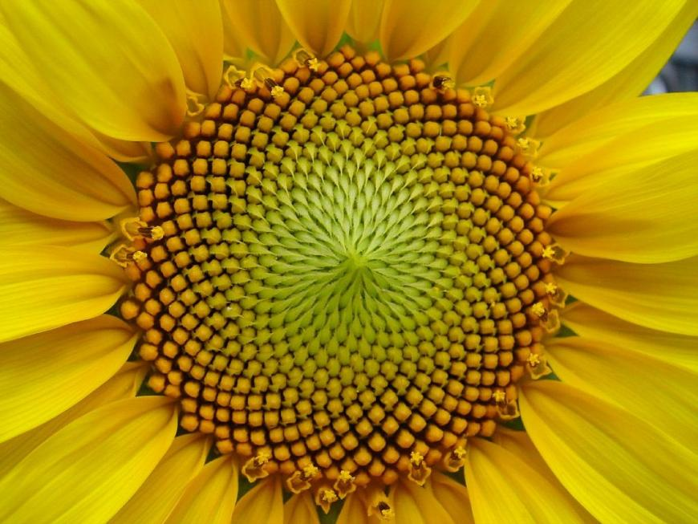

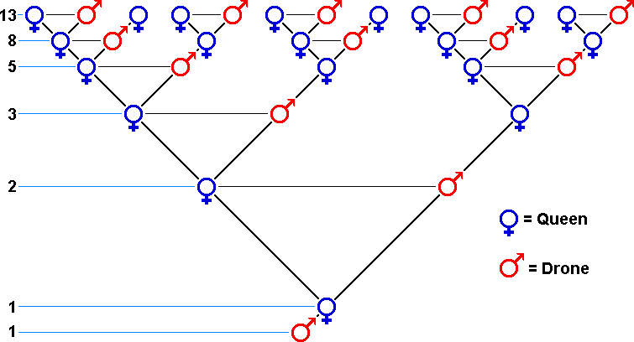

However, as we have already see, much, much more than that is claimed for phi. It is supposed to be at the heart of many of the proportions in the human body. These include the shape of the perfect face and also the ratio of the height of the navel to the height of the body. Indeed, it is claimed (see below) that just about every proportion of the perfect human face has a link to phi.

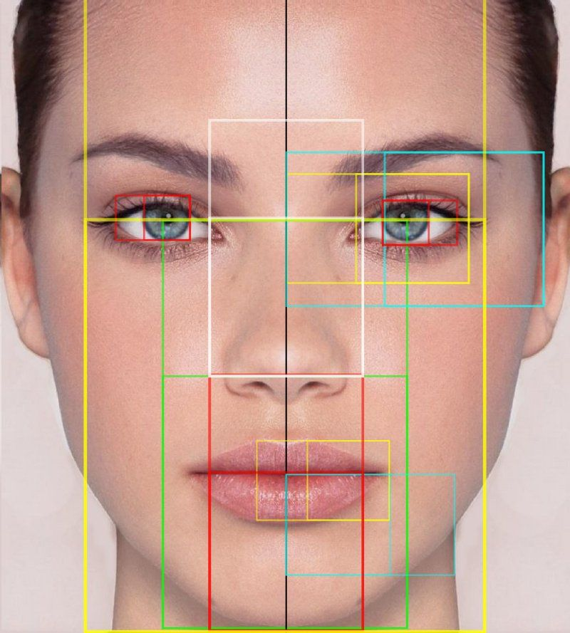

***However, none of this is true, not even remotely !!!***

The body has many possible ratios, lots of which lie somewhere between one and two. If you consider enough of them then you are bound to get numbers close to phi. This is especially true if none of the things that you are measuring are particularly well defined (as in the above picture) and it is possible to vary the definition I such a way as to get the proportions that you want to find. By the same reasoning the ‘perfect proportions in the body’ are also close to the 1.6, 5/3, 3/2, the square root of 2, 42/26, etc. etc. Indeed most numbers between 1 and 2 will have two parts of the body approximating them in ratio. Similar spurious patterns are also observed in the solar system (which also has lots of different ratios that you can choose from). Remember that as phi is an irrational number you will never see it exactly in any measurement.

All of this is an example of the way that the human brain finds spurious correlations. Indeed given enough data it is possible to find some patterns, which agree with almost any hypothesis. A good way to see this is to go outside on a nice sunny day and look at the clouds. Sooner or later you will find a cloud, which fits some novel pattern. As an example here is an example from a recent BBC News article in which a ‘warrior queen’ was observed in a cloud pattern.

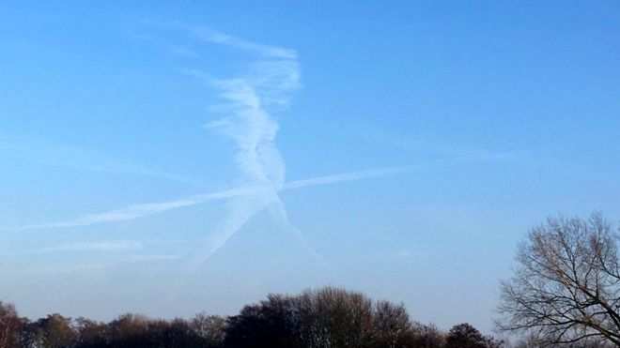

This phenomenon can actually be quite dangerous, when spurious correlations are found in data to prove a point. For example they can lead to false accusations and even to false convictions. For a lot of examples of spurious correlations see the website [6].

*Spirals Golden and Otherwise*

Linked to the Golden Ratio is a famous shape, which approximates a spiral. If you take an infinite sequence of progressively smaller Golden Rectangles and draw a circular arc in each one, then you get an approximate spiral (the Golden Spiral) with the following shape.

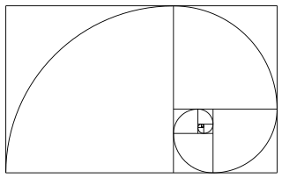

This shape is then described in many places as being found in nature and art. For example as the shape of a Nautilus Shell, the shape of a galaxy, the shape of a hurricane or even of a wave.

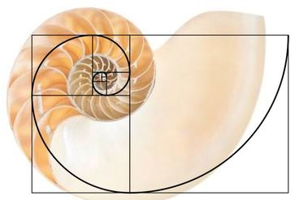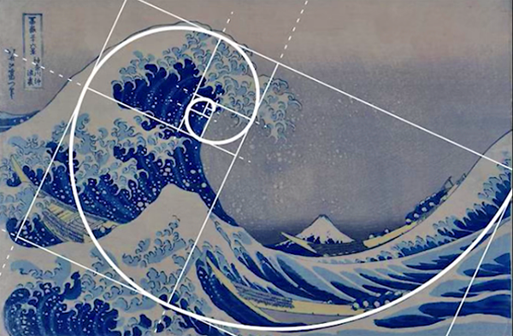

There are two problems here. Firstly the Golden Spiral isn’t a spiral. It is a sequence of circular arcs. As you go from one arc to another the curvature of the spiral jumps. It is most unlikely that in any natural phenomenon we would see such jumps. At best the Golden Spiral is an approximation to a true spiral. The form of spiral that it approximates is an example of a *logarithmic spiral*. Such spirals are very common in nature (and have the polar equation



where e is the Premier League number which we met earlier. In nature we see such spirals everywhere, with different values of b which depend upon the application. The reason that they are so common is that they have the property of *self-similarity.* This means that if you rotate the spiral by any fixed angle then you get a spiral which is a rescaling of the original. It is true for any value of b and has nothing to do with the Golden Ratio.

The Golden Spiral has the particular value of b (if the angle is measured in radians) given by



There is no reason at all why this number is in any way special. The Nautilus shell is a logarithmic spiral because the self-similarity property allows the shell to grow without changing shape. The values of b observed for the Nautilus shell bear no relation to value above, with the value of b = 0.18 seen most commonly in actual shells. See [Devlin] for a fuller discussion of this.

*Art and architecture*

We have to be careful here. It is certainly true that some artists, such as le Corbusier (in his Modulor system), have deliberately used the Golden Ratio in their art work. The reason for this is that it is claimed that the Golden Rectangle has somehow got proportions which are particularly pleasing to the human eye, and that the Golden Rectangle will be preferred aesthetically to all other rectangles. Thus it makes sense to use them in art works. It is then claimed that the Golden Ratio can be seen in just about every other work of art and architecture.

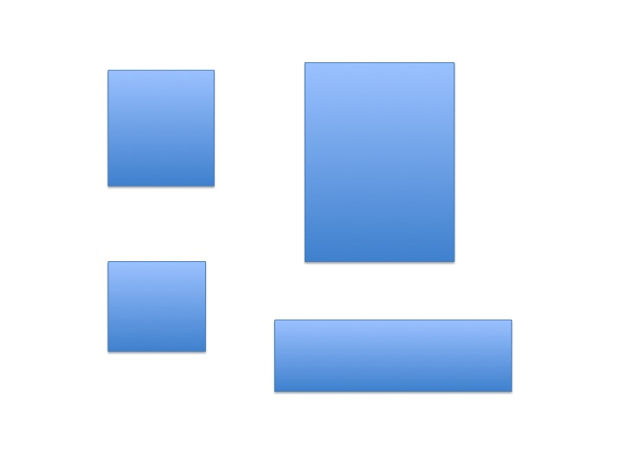The evidence for the Golden Rectangle being especially pleasing is itself pretty thin. Psychological studies showing different rectangles to groups of people seem to indicate that there was a wide range of preferences, with the ratio of the square root of two to one often being preferred over others. Test yourself on the rectangles below to see which you prefer.

According to Devlin [5] the idea that the golden ratio has any relationship to aesthetics at all comes primarily from two people, of which one was misquoted, and the other resorted to invention. The misquoted author was Luca Pacioli, who wrote a book called De Divina Proportione back in 1509, named after the Golden Ratio but which didn’t argue for a golden ratio-based theory of aesthetics as it should be applied to art and architectureThe golden ratio view was misattributed to Pacioli in 1799. Pacioli was close friends with Leonardo da Vinci, and it is often claimed that Da Vinci himself used the golden ratio in his paintings. There is no direct evidence of this. Perhaps the most famous of these examples is the *Vitruvian Man.* However the proportions in this do not match the Golden Ratio. Indeed Da Vinci did not say this himself, and only mentioned whole number ratios in his works. Examples of finding the Golden Ratio in his pictures are in the same class as those finding the ratio in nature.

The person Devlin attributes to the ‘popularisation’ of the Golden Ratio was Adolf Zeising [3] who was a 19th Century German psychologist who argued that the Golden Ratio was a universal law that described “*beauty and completeness in the realms of both nature and art… which permeates, as a paramount spiritual ideal, all structures, forms and proportions, whether cosmic or individual, organic or inorganic, acoustic or optical*.” This was simply an example (as above) of seeing spurious patterns. However, Zeising’s work went on to influence many others, and laid the foundations for much of the modern myth.

One aspect of this is that the Golden Ratio is frequently claimed to appear in the proportions of the Parthenon. See below

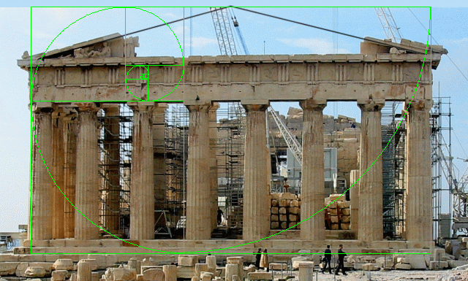

There is no evidence of this in Greek scholarship, and the idea that the Parthenon has proportions given by the Golden Ratio only dates back to the 1850s. Furthermore, the actual measurements of the Parthenon do not give proportions especially close to the Golden Ratio, unless you are careful with your choice of rectangles. In fact, the Parthenon takes its harmonious appearance from the clever deployment of lines that look parallel but in fact converge or curve, so it's virtually impossible to take measurements precise enough to give exact ratios. As the proportions of the Parthenon vary with its height it is simply not possible to find an overall proportion that agrees with the Golden Ratio

The same applies to the rest of Greek architecture, and there is no evidence whatsoever that the Greeks considered the golden ratio aesthetically pleasing, or used it in their art and architecture at all.

It also applies to music. It is claimed that phi is important in musical composition. There is little evidence of this. However what IS important in composition is the scale, and the scale is very closely linked to the twelfth root of 2. It is this latter number which lies at the heart of music, not the Golden Ratio.

There is very real danger in this. School children and many others are being duped into a false reality about the way that maths works. Sooner or later they will find that this reality is untrue, and will lose faith in the very real ability of maths to explain the world if used correctly.

**3.3 The great reality**

Having been rather dismissive about the Golden Ratio I would like to conclude this section on a note of triumph, to show what a really interesting number it is. Strangely this starring role that it has never seems to feature in the popular literature. However, it really does have an exceptional role to play in maths and science.

The property which really distinguishes phi and makes it different from other numbers (apart from numbers closely related to itself such as 1 + phi, 2*phi etc.) is its *irrationality.* Earlier I remarked that phi was irrational, meaning that it cannot be represented as a fraction, which makes it hard to see how it links to fractions in the human body. However it has the amazing property of being *the most irrational number*. This means that not only is it not possible to represent it exactly as a fraction, *it isn’t even possible to approximate it easily by a fraction*.

This is a very special property.

To explain what this means we have to remember that a fraction is a number of the form m/n where m and n are integers with no factors in common. For any number z and a number n then we can find the value of m which minimises the error e where

e = |z – m/n|

The value of e varies with n. If we plot it and see how quickly it tends to zero, then we can say just how irrational the number z is.

Here is a plot (on a logarithmic scale) of the graph of e when z = phi for 100 values of n. The dips in this curve represent values of n at which the approximation is particularly good.

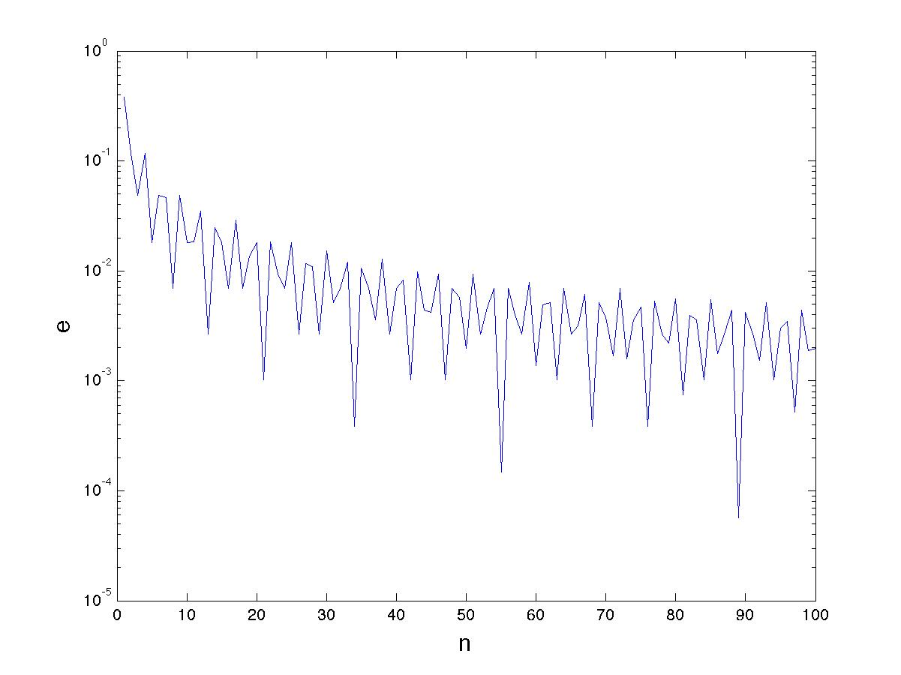

If you look carefully you will see that these values are given by:

n = 1, 1, 2, 3, 5, 8, 13, 21, 34, 55, 88, …

which might have a familiar look.

Now, let’s compare this plot with a similar plot taking z = pi. I’ve plotted two graphs,

one for z = the Golden Ratio in blue, and z = pi in red.

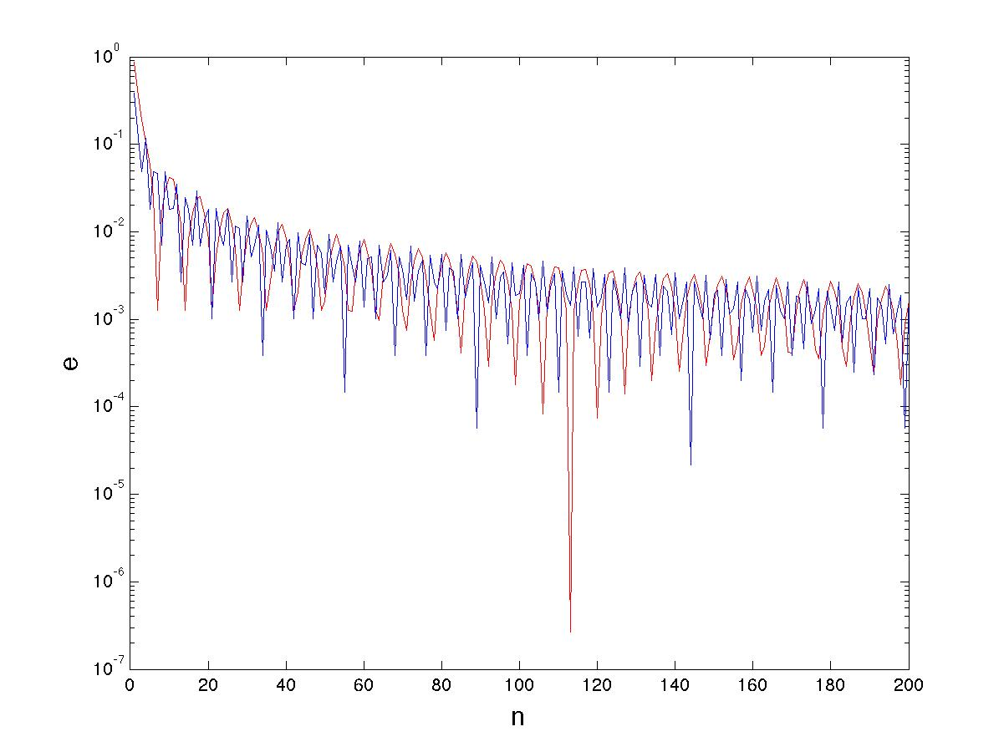

The red and blue curves are dramatically different. In this case the red curve for pi *drops down much further than the blue curve for ph*i. This shows that there are values of n for which the approximation of pi by a fraction are very good indeed. Two of the most notable of these are

n = 7

which gives the well known approximation of pi which is given by 22/7, and the spectacular

n = 113

which gives the approximation of pi given by 355/113, which was known to the Chinese.

We thus have a paradox. The Golden Ratio which is defined by a simple quadratic equation, seems much harder to approximate than pi which satisfies no such equation.

The curve that we have plotted for phi has the unique property that it converges slower than that for any other irrational number. This is truly remarkable. The reason for this is that phi has a special representation as a ‘continued fraction’. These remarkable objects deserve a lecture all to themselves. But in short, we can write the Golden Ratio in the form



The form of this continued fraction is a direct consequence of the identity



The continued fraction has an especially beautiful form, the key feature of which is that every term in it is the number 1. The fractions which approximate phi are obtained by terminating this expression at each term. The reason that the fractions converge slowly to phi are that the 1 values lead to large errors.

The continued fraction for pi in contrast looks like this. You can see that it has much larger numbers in it (such as 7, 15 and 292) than the expression for phi. These large numbers lead to much smaller errors between the continued fraction and pi.

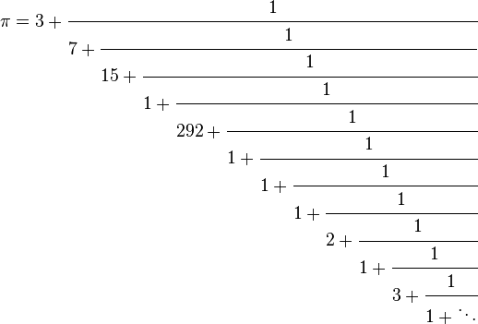

The difficulty of approximating phi by a fraction makes it a very useful number to mathematicians and scientists studying the process of *synchronisation.* This occurs when a system with a natural frequency of omega is forced by one of a different frequency, and adopts the forcing frequency. One example is the synchronisation of the human body to the daily frequency of sunlight. A second example is the Earth’s climate which synchronises to the natural cycles of the orbit around the sun.

However, synchronisation can itself be a problem, leading to unwanted resonances in a system (such as a suspension bridge vibrating severely if a marching band walks over it). By choosing two frequencies in the ratio of 1:phi we can avoid synchronisation due to the extreme irrationality of the Golden Ratio. This very useful property appears to be exploited by the brain and insect species as well as climate scientists and even people who manufacture aircraft.

So the Golden Ratio has a starring role, but not one that you often read about in the mythology associated with it. This is a great pity!

1. **The Monty Hall Problem**

The Monty hall problem is one of the most famous problems in mathematics and in its original form goes back to a Game Show hosted by Monty Hall himself. The contestants on the game show were shown three shut doors. Behind one of these is a high value prize, such as a car. Behind the other two is a low value prize, such as a goat. If the contestants open the correct door then they win the prize, otherwise they win nothing. The contestants were then asked to choose a door, and to tell the host which door they had chosen. This door remains shut for the time being. The host then opens a different door to reveal a goat behind it. The contestants are then given a choice. They can stay with the door that they have chosen, or they can swap to the remaining unopened door. The door they finally end up with is then opened, to reveal the prize car, or maybe just a goat.

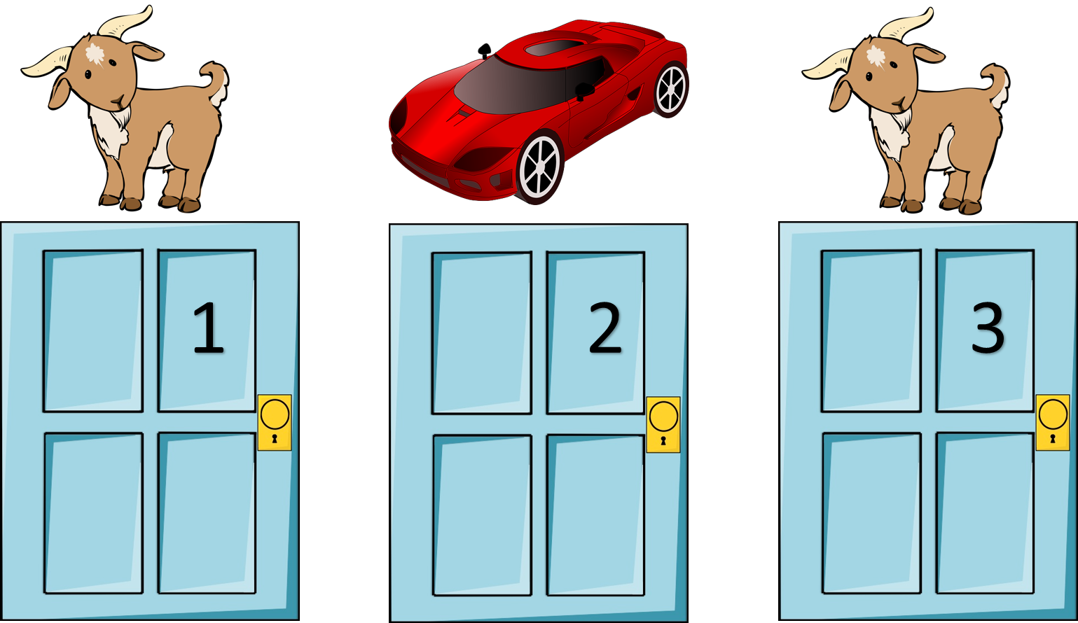

The question is: *should the contestant change their choice of door or not?*

The usual answer (the accepted myth) is: YES. In fact you double your chances of winning the prize if you change your choice. This answer was given in the gambling film *21* [7]. It is also advocated as a reason you should make changes in your choice of love [8].

It's now "common knowledge" that you should swap doors, because in doing so you increase your chance of being right from 1/3 to 2/3.

However it turns out that the usual answer is not always correct and is an example of loose thinking. In fact the answer to whether you switch doors or not depends entirely upon the host (and to some extent the contestant) and what they know, or don't know.

Let’s suppose in the first instance that we have a completely knowledgeable, and honest, host. This host will always open the door with the goat behind it and will tell the contestant in advance that this is what they will do. Now let the contestant choose a door. The probability that they choose one with a car behind is 1/3. The host then opens a door to reveal a goat. But you knew this in advance. Nothing has changed to alter your situation. So the chance of your door having a car behind it, is still 1/3. The chance of the other unopened door having a car behind it is now 2/3. So it certainly pays (handsomely) to switch doors.

But this isn't always the case. Another instance is that we have a neutral but unknowledgeable host, maybe they have a blindfold on. In this case they (with their eyes shut) choose a door and open it to reveal a goat. Should you change your door? Although the result (a door open with a goat behind) this case is very different from the last one. In advance of the host opening the door you had no prior knowledge that they would reveal a goat. So finding a goat actually changes the situation in this case. Essentially we are now in a situation where there is an equal chance of either the original door or the new door having a car. So in this case there is *no advantage in changing doors.*

(A more exact calculation is given by applying Bayes’ theorem to this problem [9]. In this the probability of the door having a car behind it *given* that the host has revealed a goat, is given by probability that the door has a car divided by the probability that the host reveals a goat. The probability the door has a car is 1/3. If the door has a car the probability that the host chooses a goat is 1, and if it doesn't (with probability 2/3) then the chance that the host chooses a goat is ½. So the probability that the host chooses a goat is 1/3*1 + 2/3*1/2 = 2/3

(which is less than the probability of 1 in the last example). It follows that the probability of the door having a car behind it *given* that the host has revealed a goat is given by 1/3 divided by 2/3 which is ½.)

The last instance arises when the host is mean, and knows that the contestant is familiar with the Monty Hall problem, but doesn't tell them.

If they choose the door with the car, then the host opens a door with a goat and challenges the contestant to change. Knowing the ‘answer to the Monty Hall problem’ the contestant changes. They then get a goat. If they first choose a door with a goat, then the host asks them to pick one of the other two doors, telling them that it will now be removed from the choice of three.  (No door will be opened by the host.) Having done that, they are then allowed to either stick or swap to the remaining door.  In this case, there is a chance of ½ that the door they excluded was the one with the car, so it doesn't matter if they stick or swap doors, they won't win the car. So with these rules the chance of getting a goat is 1/3*1 + 2/3*1/2 = 2/3. The mean host wins!

(I am indebted to Rob Eastaway, the Director of Maths Inspiration, for telling me about this way of playing the Monty Hall problem.)

So much for the myth!

For much more information on the mathematics behind the Monty Hall problem, see [10].

1. **The Four Colour Theorem**

Following Brexit we are faced with the worry of the possible break up of the United Kingdom. Suppose that Scotland and Wales become independent, but the Northern Island does not? How will this alter the map? Well one of the things that will happen is that the map of the British Isles will no longer be colourable with four colours! How can this be true you ask? Surely we all know that any map can be coloured with at most four colours. Well almost. But this statement all depends upon what you mean by a map. This is not so much a myth, more a misquotation.

In the 1800s maps started to be produced of different countries. To distinguish between different countries it was useful to colour them in different colours. A simple rule for doing this was that any two countries which shared a border, other than meeting at a point, should have different colours. Now, it costs money to print a coloured map, so map makers aimed to find the smallest number of colours needed to colour the map with the ‘no touching condition’. It was found experimentally that all of the maps considered only needed four colours to colour them in. Here is an example of a map of the USA, and the outside region, coloured with exactly four colours with no adjacent states having the same colour.

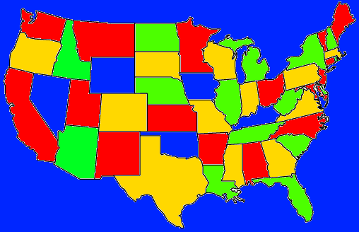

This discovery led the mathematicians of the day to conjecture that every map on the plane needed at most four colours to colour it with the above rules. This conjecture was first proposed in 1852by Francis Guthrie, who was trying to colour the map of counties of England. A first ‘proof’ was given by Alfred Kempe in 1879. This proof was later shown to be incorrect, but was modified at the time to give a proof that any planar map could be coloured with at most five colours. However this did not solve the original problem, despite the attempt of many mathematicians to prove it. The four colour conjecture rapidly became one of the most celebrated problems in mathematics.

The four colour theorem was finally proved in 1976 by Kenneth Appel and Wolfgang Haken. The proof itself was remarkable and gained a great deal of notoriety because it was the first major theorem to be proved using a computer. (Essentially a mathematical analysis reduced the problem to a large, but finite, number of maps, each of which was then checked by a computer to see if it could be four coloured). Initially, this proof was not accepted by many mathematicians, because it was impossible to check by hand. However I think quite the opposite. I believe that this proof has ushered in a new way of doing mathematics. Indeed it has led the way to many other ‘proofs by computer’ including some of my own work. The result is also important in modern Wi Fi technology. Imagine different Wi Fi transmitters, all using different frequencies. To avoid interference we have a rule that no two adjacent Wi Fi transmitters should use the same frequency. The question we then ask is ‘how many frequencies are needed to give a non-interfering network’.

It doesn’t take much imagination to see that this is exactly the same as the four colour theorem. So we only need four frequencies. Easy. Well no. In fact we need more. Possibly many more. The problem arises, for example, in an office block, when different Wi Fi transmitters are assigned to different companies, and the company wants all of its transmitters to share the same frequency. This rapidly increases the number of frequencies that we need.

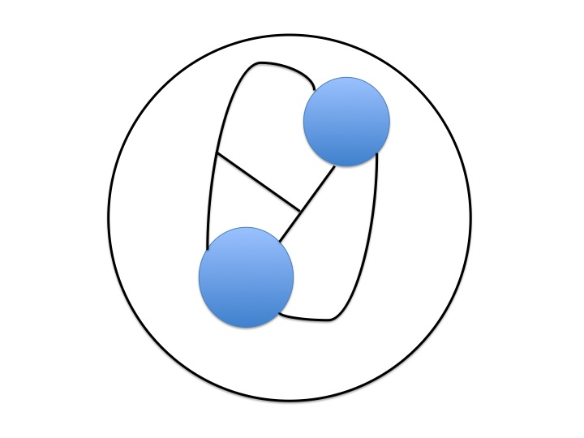The same issue arises when we try to colour a map. By this I mean exactly what I say. A map. The sort of map that you would find in an Atlas. The issue arises in maps when countries have regions which are separated, or are possibly part of an Empire. These regions introduce an extra thing to consider when colouring the map, as they all have to have the same colour. The British Empire for example had all of its territories coloured red on the map. It also arises when the map has lakes and seas. Not unreasonably all of these should be coloured blue. Below is an example of a map with two lakes. These I have coloured blue. The boundaries between the countries are indicated by black lines.

I challenge all of you to find a way to colour this map in four colours, whilst keeping the lakes blue. It can’t be done, and five colours are needed.

So, how does this affect the map of the British Isles? If there is independence of the home nations, then they will no doubt adopt their traditional colours of white for England, red for Wales, and dark blue for Scotland. The British Isles is surrounded by the light blue sea. Although Wales and Scotland do not touch they need different colours as the Welsh (and English) will need an embassy in Scotland which will need to be coloured the same colour as the nation. The question is: what is the colour of Ireland? If the home nations all have an embassy in Ireland with their own colour, then Ireland must have a different colour again (green of course). So we need five colours (at least).

So what is the myth? Well the four colour theorem as carefully stated (for non contiguous planar graphs) is certainly true. But one thing it does not apply to is an actual map.

1. **Cutting a Cake**

Whole books have been written about how to cut a cake in a fair way [12]. This may seem like a trivial problem, after all does it really matter who gets the most birthday cake. But in fact it is very serious if instead of cake we think of someone’s assets. Divorcing couples have to hire (very) expensive lawyers to ensure that their assets are divided up fairly. Similarly in a proportional representational form of voting (see my recent lecture) all sides want to see that the representation that they have is a fair reflexion of the votes cast.

Crucial to this process is a careful definition of what we mean by *fair*. Suppose that the cake (or the assets) has been divided into two (not necessarily equal halves) and each party receives on of the halves. For both cutting a cake, and diving up assets, fair (for two parties) generally means that each party thinks that their received half is at least ½ of the original amount. See below for a fairly cut cake on the left, and an unfairly cut cake on the right.

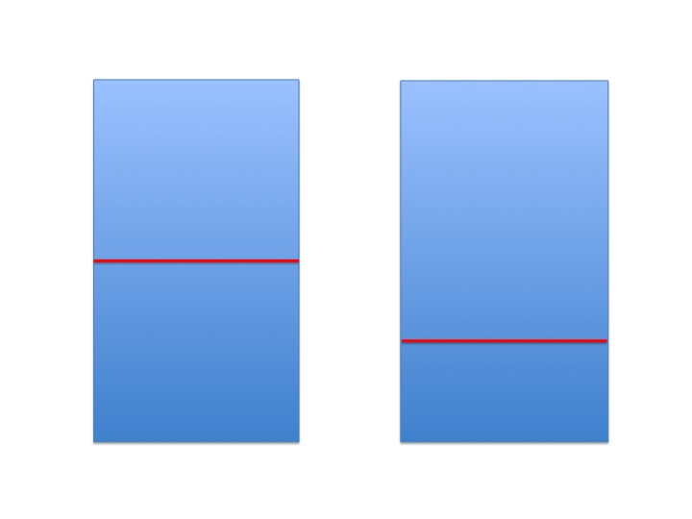

It there are n parties, then this generalises to each party being satisfied that the received portion is at least 1/n of the original amount.

So, how do we cut up the cake to make sure that this happens fairly? I will assume here that the cake cutting is done by the human beings involved, and not by a super precise machine that can cut the cake exactly in half to the nearest atom.

The generally accepted method is called the *‘you cut, I choose’* algorithm. The way that this works is that one party divides up the cake as fairly as they can. The second party then has the first choice. The reasoning behind this algorithm is that it is clearly in the interests of the first party to cut the cake as fairly as possible. That way, no matter how the second party choses, the remaining piece will be as close to ½ of the original as it is possible to get.

Have a think about this to decide to yourself whether this is a fair method or not. As I said this is a widely accepted method for fair cake cutting.

Algorithms for cutting a cake amongst n parties are usually generalisations of the above, see [12]. Although this algorithm is widely accepted, I do not think that it is actually a fair way of cutting a cake. I believe this to be a ‘mathematical myth’. Indeed I think that in general it gives an overwhelming advantage to *the person who has the first choice.*

My reasoning goes as follows. Suppose that the cake cutter is blind. Despite all of their best efforts to cut the cake fairly, it is very likely that they will cut it into two unequal pieces. The chooser then chooses the largest piece. This situation will always arise if the ability of the chooser to decide which piece is larger, is greater than the ability of the cutter to divide the cake into two equal pieces.

So, can we do better? Is it possible to find a way in which even a blind cutter can cut a cake fairly into two equal halves? The answer, as in many computational procedures, uses a process of iteration.

Let’s assume that we have a rectangular cake (it doesn't need to be in the proportions of the Golden Ratio). The first person makes a cut across the cake as shown. It now has two portions. Assuming that the cutter is not an expert (maybe they are blind) one piece will be smaller than the other

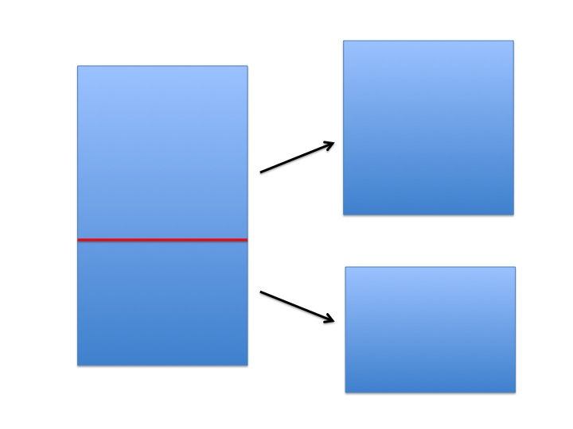

First cut

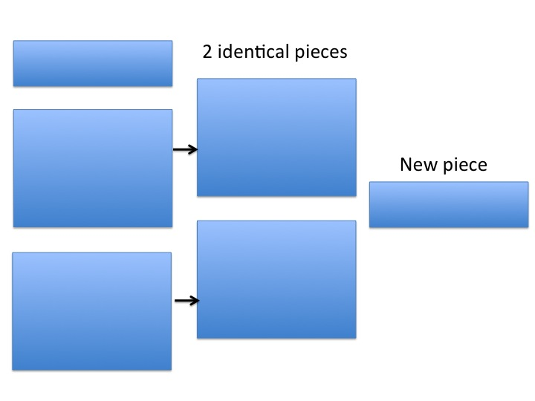

Second cut

It is easy to see which piece is smaller. We just compare one with the other. Putting the two together it is then easy to cut off the part of the larger piece, which is larger than the smaller piece. This then gives us two pieces, which are exactly the same size, plus a new small piece. You give each party one of the two identical pieces. Each is satisfied as the pieces have to be the same size. Now you have a much smaller cake to divide. You simply repeat the process on the new piece, giving two (much smaller) identical pieces plus an even smaller piece. Just continue with this process until only the crumbs are left. Bingo!

*A mathematician named Hall,*

*Once went to a fancy dress ball,*

*They thought they would risk it,*

*And go as a biscuit,*

*But a dog ate them up, crumbs and all.*

**References**

[1] Chris Budd, (2019), *How will we learn maths in the future?*, Gresham Lecture

[2] Adolf Zeising, (1855), A New Theory of the proportions of the human body, developed from a basic morphological law which stayed hitherto unknown, and which permeates the whole nature and art, accompanied by a complete summary of the prevailing systems.

[3] Mario Livio, (2003), *The Golden Ratio: The Story of Phi, the World's Most Astonishing Number,* Broadway Books.

[4] Euclid, *The Elements*

[5] Keith Devlin, (2007), *Devlin’s angle: The myth that won’t go away*,

https://www.maa.org/external_archive/devlin/devlin_05_07.html

[6] *Spurious Correlations*. https://tylervigen.com/page?page=1

[7] The film 21, (2008), https://en.wikipedia.org/wiki/21

# [8] A Point of View: Why embracing change is the key to happiness

# https://www.bbc.co.uk/news/magazine-23986212.

[9] Bayes’ Theorem article:

https://en.wikipedia.org/wiki/Bayes%27_theorem

### [10] Jason Rosenhouse, (2009), *The Monty Hall problem*, Oxford

[11] Robin Wilson, (2002), *Four Colours suffice: How the map problem was solved,* Allen Lane

[12] Ian Stewart, (2006), *How to cut a cake and other mathematical conundrums*, OUP

Chris Budd, Feb 2020