SQL Project

1.1) Write a query that lists all Customers in either Paris or London. Include Customer ID, Company Name and all address fields.

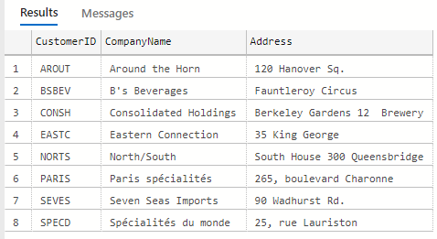

1.2) List all products stored in bottles.

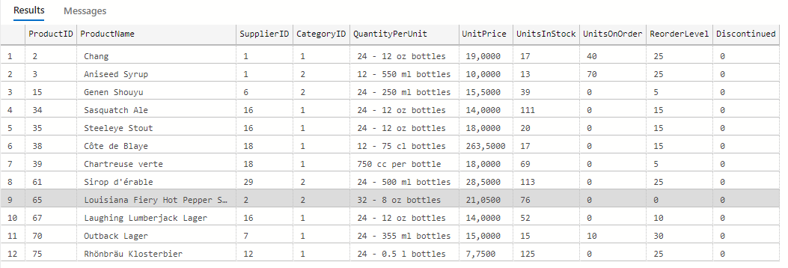

1.3) Repeat question above, but add in the Supplier Name and Country.

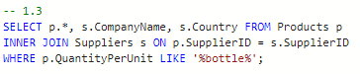

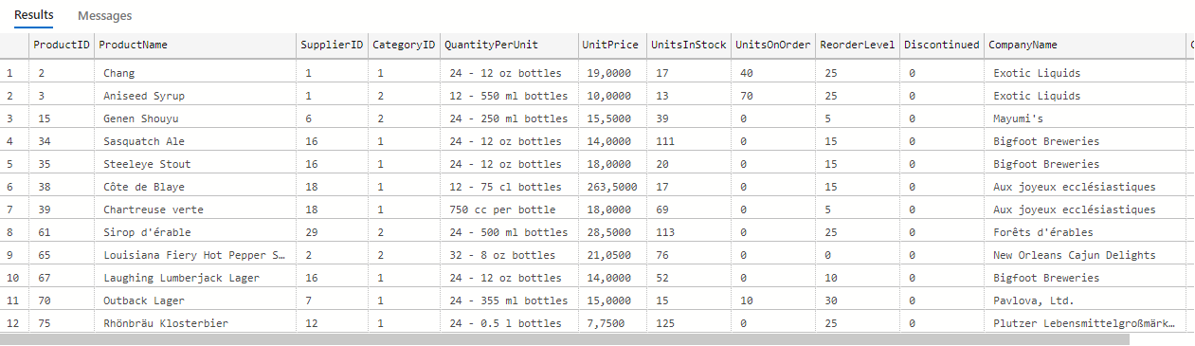

1.4) Write an SQL Statement that shows how many products there are in each category. Include Category Name in result set and list the highest number first.

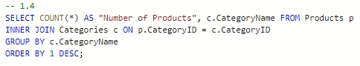

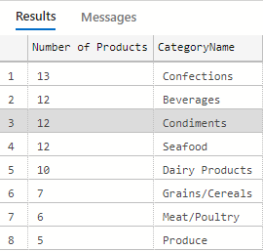

1.5) List all UK employees using concatenation to join their title of courtesy, first name and last name together. Also include their city of residence.



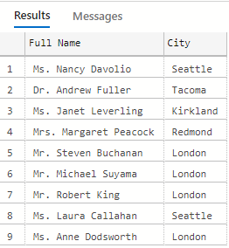

1.6) List Sales Totals for all Sales Regions (via the Territories table using 4 joins) with a Sales Total greater than 1,000,000. Use rounding or FORMAT to present the numbers.

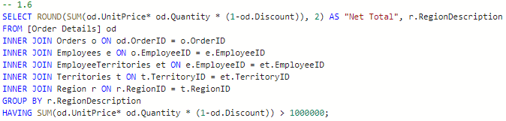

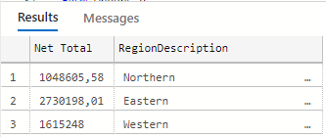

1.7) Count how many Orders have a Freight amount greater than 100.00 and either USA or UK as Ship Country.

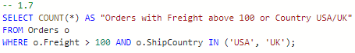

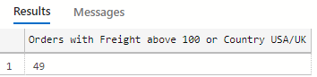

1.8) Write an SQL Statement to identify the Order Number of the Order with the highest amount(value) of discount applied to that order.

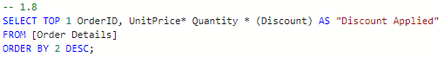

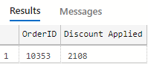

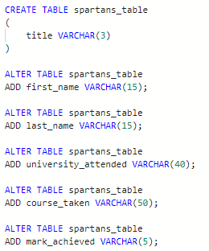2.1) Write the correct SQL statement to create the following table:

Spartans Table – include details about all the Spartans on this course. Separate Title, First Name and Last Name into separate columns, and include University attended, course taken and mark achieved. Add any other columns you feel would be appropriate.



2.2) Write SQL statements to add the details of the Spartans in your course to the table you have created.

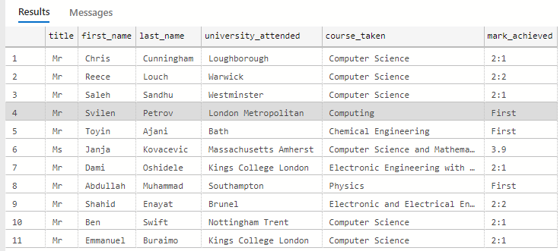

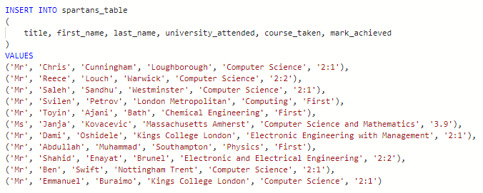

3.1) List all Employees from the Employees table and who they report to. No Excel required.



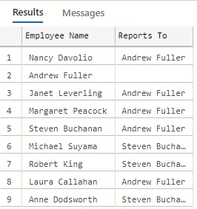

3.2) List all Suppliers with total sales over $10,000 in the Order Details table. Include the Company Name from the Suppliers Table.

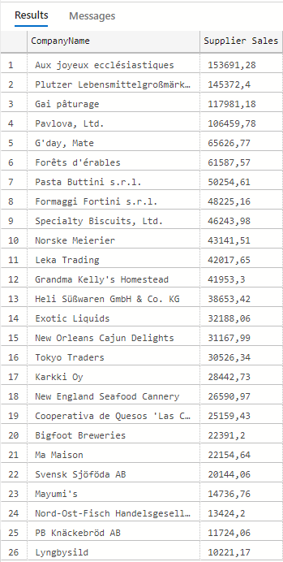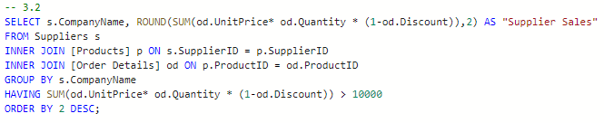

3.3) List the Top 10 Customers YTD for the latest year in the Orders file. Based on total value of orders shipped. No Excel required.

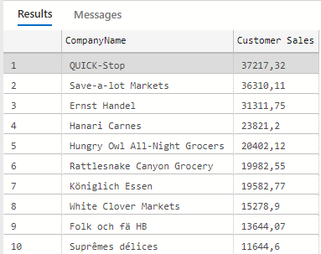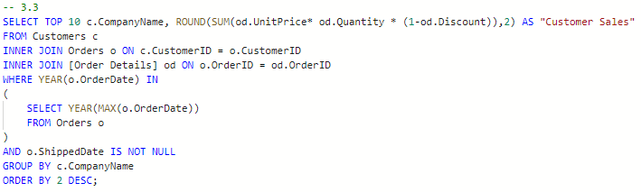

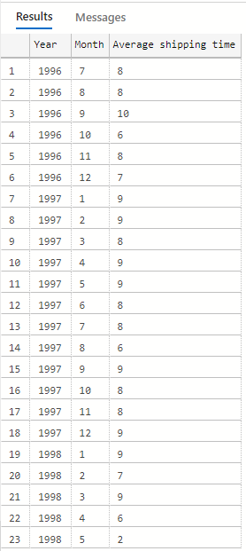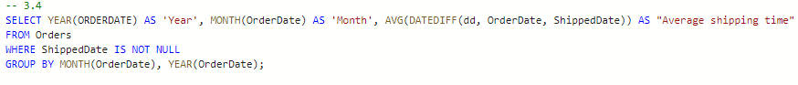3.4) Plot the Average Ship Time by month for all data in the Orders Table.