Histogram

Let me start by saying that I went with the original unedited version of this file from the project brief.

• Are young and old populations more vulnerable (because they have more deaths)?

You are unable to tell by the histogram because it is snowing count of occurrences.

• Are there any age groups that have no deaths?

You are unable tell because this shows only count of occurrences of deaths.

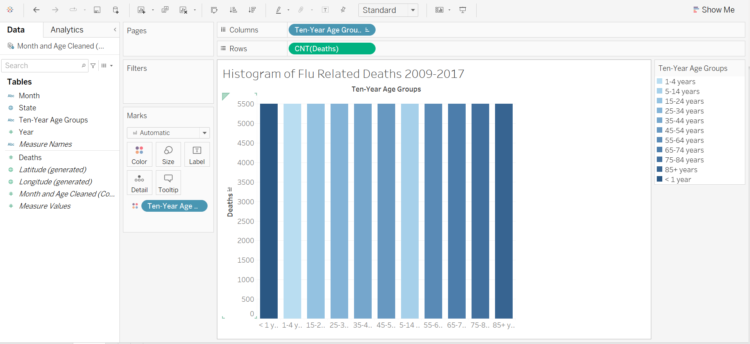

• Explain what the box plot tells you that the histogram can’t.

The boxplot shows the analysis of the data points versus the count of the occurrence of them. You see the differences of the data points versus how many times they happen. We are then able to distinguish the differences between deaths in the age categories to see that as age increases, the average deaths increase and for the most part, the variance also increases. There is so much more data and information on the data being displayed with the box chart.

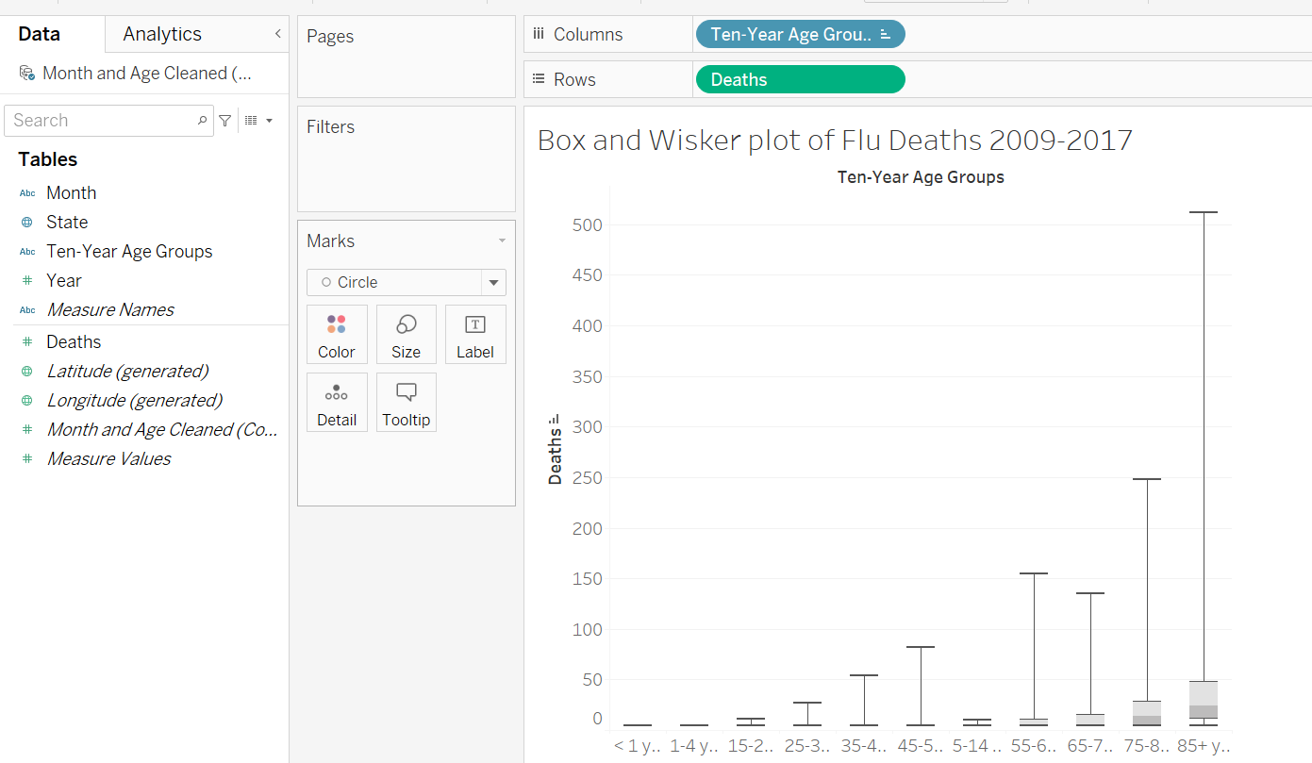

Links: https://public.tableau.com/app/profile/chris.charles.arnold