Scatterplot

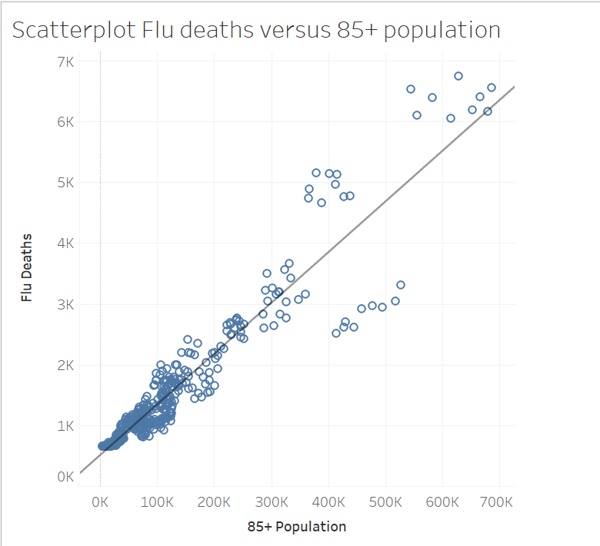

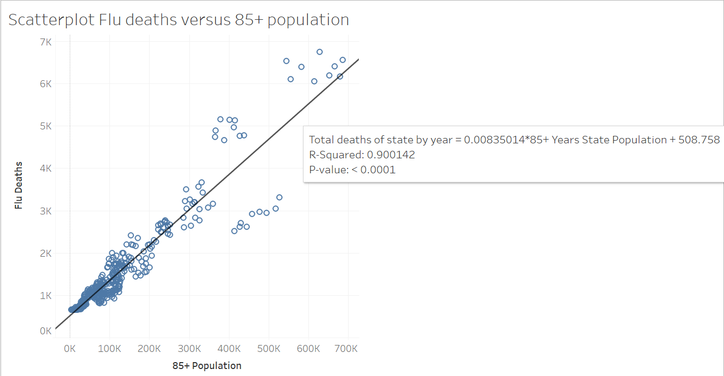 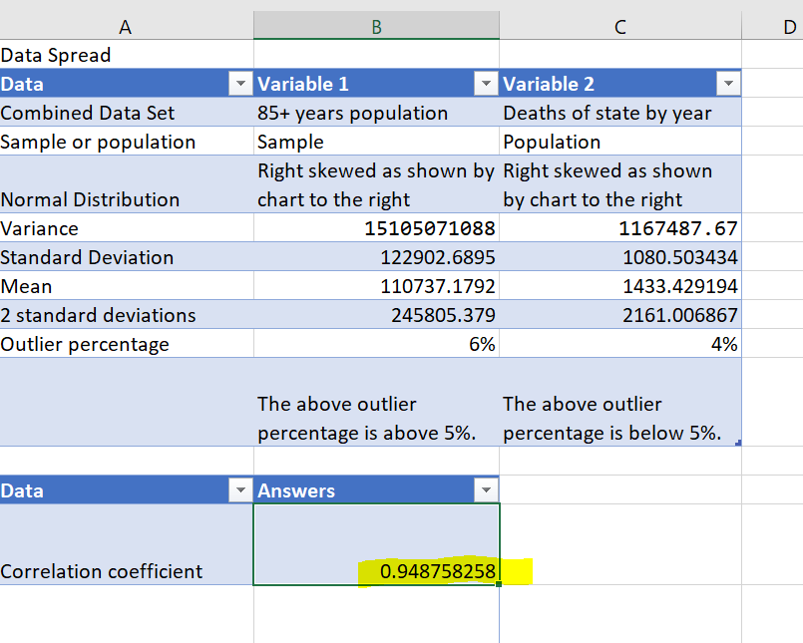

The coefficient matches in both exercises so we check out with our calculations.

* Are all the data values tightly clustered around the trend line or are there a few extreme values?

The values are pretty tight with some moving away as the values get bigger. The highest outliers have more deaths than the trendline which would support the need for more staffing in those locations.

Bubble Chart

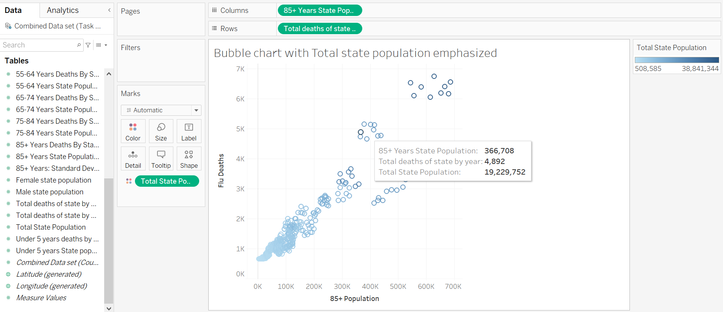

This chart is nice because it shows that the higher populated states have higher populations of 85+. This would tell us that more digging is needed in the data because while the scatter plot shows a correlation between flu deaths and 85+ population, when the total state population is added in it shows that really the deaths align with population in general. I originally came to this conclusion which is why I moved the age bracket to 65+ which shows a little better picture. I will redo this chart with 65+ when finishing this project up.

Tableau link

https://public.tableau.com/app/profile/chris.charles.arnold