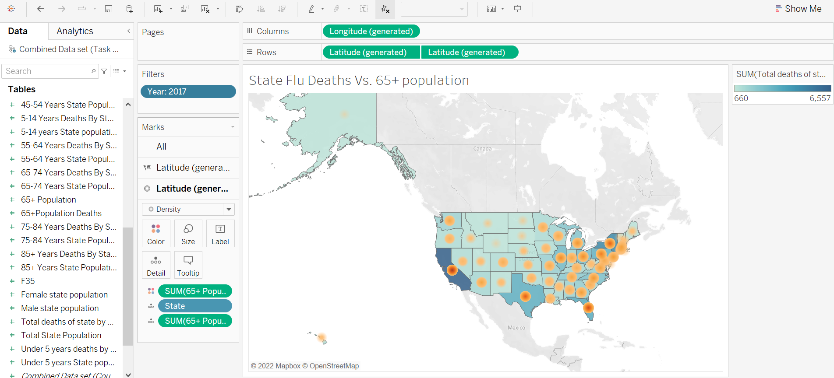

* What states or regions are the highest? The lowest?

California and New York are showing to have the highest amount of flu deaths and their 65+ population is also near the highest in the US.

Alaska and DC have the lowest 65+ population and the lowest flu deaths.

* How does time impact those trends?

When shifting through the years 2009-2017 year by year, the highest and lowest states seem to stay pretty close to the same visually.

Link:

https://public.tableau.com/app/profile/chris.charles.arnold/viz/Task2_7MappingVisual/Sheet1?publish=yes