**Experimental Process**

Part 1: Test the theoretical relationship (that you already derived)

The relationship that we derived was that the downward acceleration of the hanging mass would equal the acceleration of the sliding mass in the direction of the string. While we proved this through equations and free body diagrams, we felt it was more easily recognized in a real world scenario. First we tied the IOLab to a string with the other end tied to a hook for weights. Using an Atwood Machine apparatus, we compared the acceleration of the IOLab sliding across the surface and the weights that fell. Data was gained from the weights based on their mass and an assumed 9.8 m/s^2 acceleration due to gravity. The acceleration was measured from the acceleration of the wheel built into the IOLab. The following data was gathered from the results of the three trials.

Figure 1:

Trial 1

|  |  |  |
| --- | --- | --- |
| **Time (s)** | **Force (N)** | **Wheel - Acceleration (m/s^2)** |
| 0.0 | 0.0 | 0.0 |
| 0.5 | 0.2 | -2.5 |
| 1.3 | 0.2 | -2.5 |
| 1.4 | 1.0 | 14 |
| 1.6 | 0.60 | 0.0 |
| 4.5 | 0.61 | 0.0 |

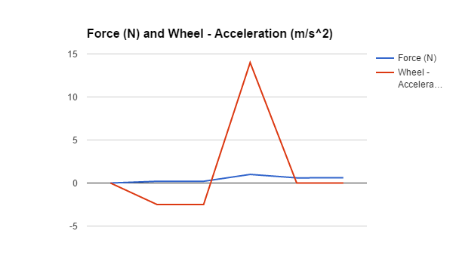

Trial 2

|  |  |  |
| --- | --- | --- |
| **Time (s)** | **Force (N)** | **Wheel - Acceleration (m/s^2)** |
| 0.0 | 0.0 | 0.0 |
| 0.3 | 0.10 | -2.5 |
| 1.5 | 0.10 | 0.0 |
| 1.6 | 0.70 | 10 |
| 1.7 | 0.90 | 5.0 |
| 1.8 | 0.45 | 0.0 |
| 2.7 | 0.50 | 0.0 |

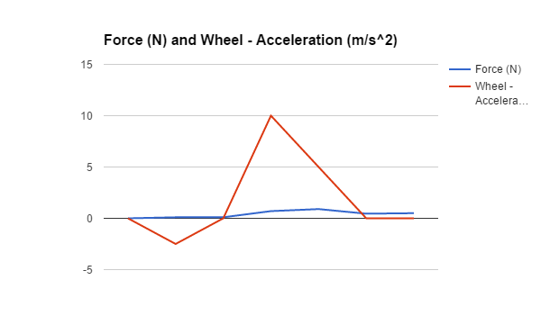

Trial 3

|  |  |  |
| --- | --- | --- |
| **Time (s)** | **Force (N)** | **Wheel - Acceleration (m/s^2)** |
| 0.0 | 0.0 | -0.10 |
| 0.5 | -0.18 | -0.10 |
| 1.6 | -0.18 | -0.10 |
| 1.7 | 0.10 | 0.0 |
| 2.0 | 0.0 | 5.0 |
| 2.2 | 0.0 | 0.0 |
| 4.5 | 0.01 | 0.0 |

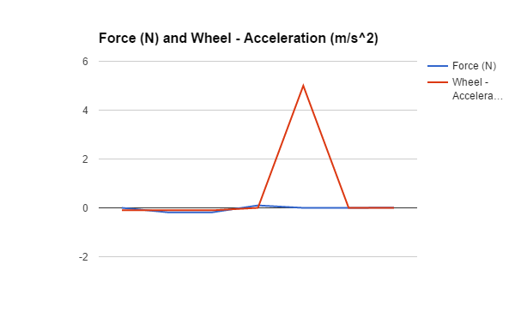

Part 2: Add friction to the model (re-analyze your data)

If friction were to be added to the theoretical model, then the predicted acceleration will be decreased, because the force of friction will be acting against the moving object. We can find the ideal acceleration across the system, then comparing it to the acceleration given. This in turn will give us our net force which will end up being smaller than the ideal force, and the difference between the ideal and the actual will be the frictional force, for which we can solve for the coefficient of friction.

We are given three corresponding accelerations for three corresponding masses, 14 m/s^2 for 70 kg, 10 m/s^2 for 50 kg, and 5 m/s^2 for 20 kg. This is what our actual (not theoretical curve) would look like.

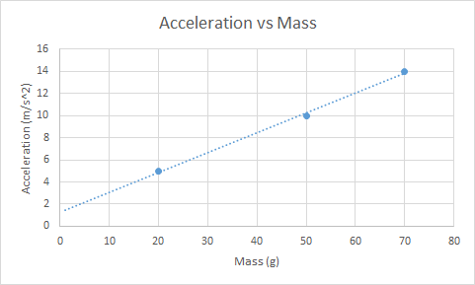

Part 3: Reflecting on a ‘massless’ and ‘stretchless’ string:

Due to the fact that nothing can be massless, when working with problems that assume a certain component of the system is ‘massless’, it is important to understand what can and cannot be considered massless. In the world of chemistry, 10% or less is considered to be negligible. However, 10% of the mass of this system would most likely have a significant impact on the disparity between the results and the calculations for acceleration. In order to be massless, the mass of the system without the string should have an insignificant difference from that of the system with the string. Due to the mass of string on the horizontal and vertical portions of the system changing with time, it is also important to keep the mass of the string very small, otherwise the error could compound.

If the string had a mass that was large enough to consider as part of the experiment, several things would need to be taken into account. The mass of the system would have to include the mass of the string in any calculations. Once the system is in motion, the falling mass would increase due to more of the rope being in a freefall like state. If the velocity and mass density of the rope are known, a simple integral calculation could solve the increasing mass problem. Likewise, the mass being accelerated by the falling mass would be decreasing, and the opposite integral could be used to account for this change.

The stretch of the string should be small enough that Hooke’s law or a similar properties do not absorb some of the force applied by the falling mass. If the string had spring-like properties, some of the work done by the falling mass would be used to stretch the string, and the overall acceleration of the system, as measured in the frame of reference of the sliding mass, would be lower than expected. The stretch of the spring should be low enough that a negligible difference in force is perceived in the system.

**Experimental Data**

Figure 2: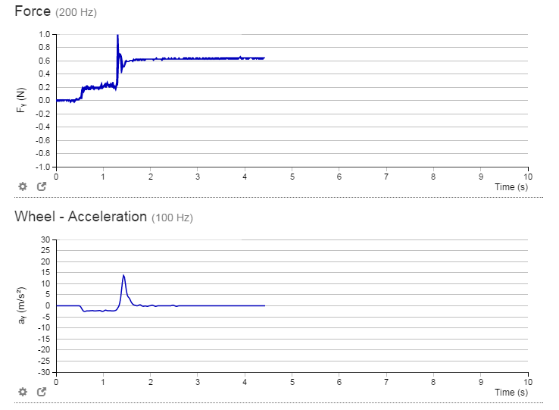

Figure 3: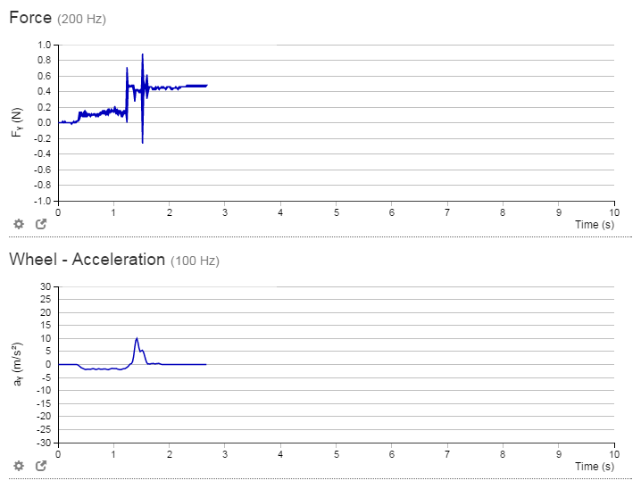

Figure 4: