**P23**

GBN Largest window: W<2^k so (2^k)-1

SR Largest window: <= (k/2)

**P27**

A Seq num = 207 sourceport= 302 dest port = 80

B ACK num = 247 sourceport= 80 dest port = 302

C ACK num =127

D 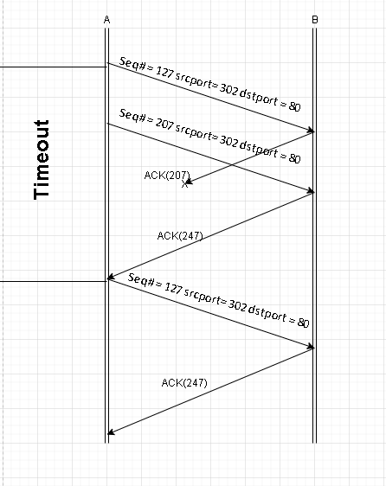

Made with draw.io

**P32**

A

EstimatedRTT ­1= SampleRTT1

EstimatedRTT 2= .9SampleRTT1 + .1SampleRTT2

EstimatedRTT3 = .9(9SampleRTT1 + .1SampleRTT2) + .1SampleRTT3

EstimatedRTT4 = .9(.9(9SampleRTT1 + .1SampleRTT2) + .1SampleRTT3) + .1SampleRTT4

B

EstimatedRTTn = EstimatedRTT(n-1) + SampleRTTN

C

I can see why this is the exponential moving average as it takes .9 of the previous and adds .1 of the current SampleRTT. No where does this get smaller and as the number grows larger there is a growth that starts happening and it will be an exponential growth

**P37**

A

GBN: A sends 9 packets

B 8 acks 1 3 4 5 2 3 4 5

SR: A sends 6 packets

B 5 acks 1 3 4 5 2

TCP: A sends 6 packets

B 5 acks 1 2 2 2 6

B

GBN: Already sends the most ACKS so not this one

SR or TCP

TCP is faster because it only sends acks for the one it needs and doesn’t wait

**P40**

A 1-6 and 23-26

B 6-16 and 17-22

C Triple dup ACK

D Timeout

E 32 since it is the default value

F 21 42/2

G 14 29/2 = 14 rounded down

H 7th round (1+2+4+7+16+32) = 62 in the 6th round so 70th is in the 7th

I Assuming the congestion window at 26 is currently 8 so the new window and ssthresh would be 4. (8/2 = 4)

J

Ssthresh: 4

Window size: 4

(drops to one on 17,18 would be 2, 19 would be 4)

K

It starts slow start so (1+2+4+7+16 + 32) = 62 segments

**P1**  A

|  |  |
| --- | --- |
| Destination | Interface |
| H3 | 3 |

B No

**P4**

Minimum number of time slots is 3 according to the image below the problem based on the input ports.

The max would be the number of input slots so still 3 according to the image

**P8**

A (match the most bits possible in the beginning to determine where it goes)

|  |  |
| --- | --- |
| Prefix Match | Link interface |
| 11100000 00 | 0 |
| 11100000 01000000 | 1 |
| 11100000 01 | 2 |
| 11100001 0 | 2 |
| Other | 3 |

B

The first datagram would be sent to 3 since the first 8 bits doesn’t match anything therefore it falls under other category and sent to link interface 3

The second datagram would fall under 1 since the first and second 8 bit segments match and then it is sent to link interface 1

The third datagram would be sent to other since it doesn’t match any of the segments