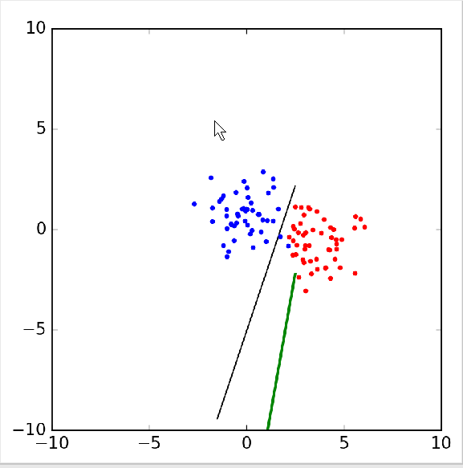

Sometimes the data is not linearly spereable. In this case linear regression will offer the best line that it can fit, while the perceptron will run indefinitely trying to find the best line.

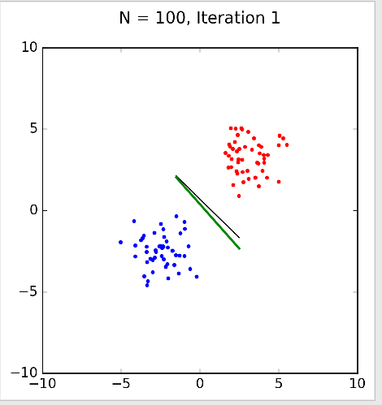

In this case the perceptron found the best H on it’s first iteration and it closely matches that of the linear regressions method.

