Chris Cordaro

AI Final

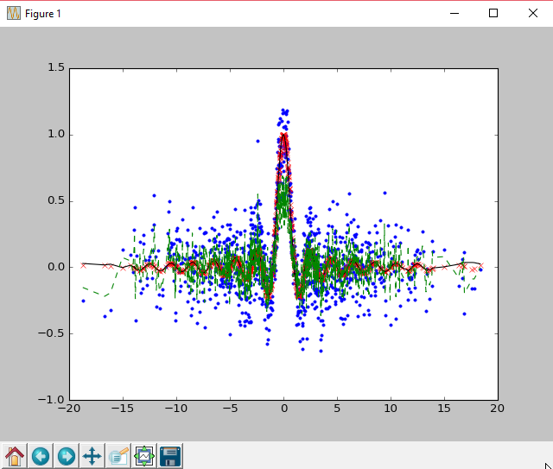

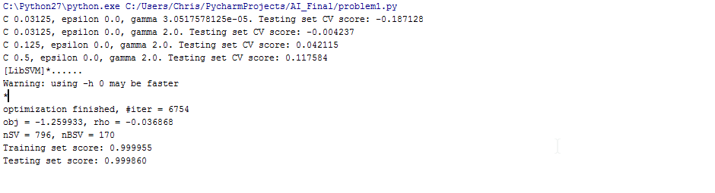

D) It seems that for larger values of C the SVM will pick a smaller margin for how the hyperplane will classify or misclassify the data. Which follows that for smaller values of C such as .03125 or .125, the data is being misclassified by the hyperplane even if it is linear separable. It seems that the smaller the C value, the more errors reported, while the higher the C values, the better CV score outputted. However, C is a regularization parameter so it follows that when C becomes large, the amount of regularization occurring is less. Because of this, it seems that the SVM runs a risk of over fitting the data and producing “false” good CV scores. I think that’s why when the program finishes it produces a training and testing score at .99. There seems to be a happy medium where you can lower the amount of error, and have a good classification hyper plane, without the detrimental effects of over fitting. It also seems that you need to take into account any future data that will be added into the data set because the distance that C will look to classify points of error. But tuning C to fit a data set seems to still be under research. There doesn’t seem to be a connection between C and epsilon, as epsilon stays at 0.0 even when C changes.

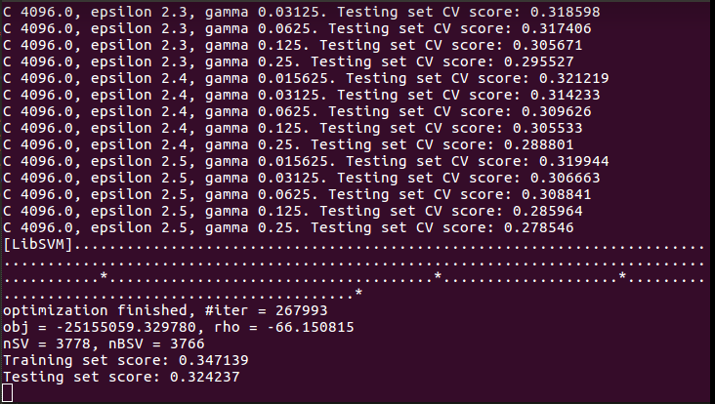

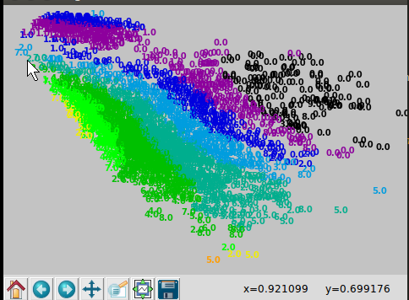

In the 10 fold cross validation SVM it seems that the parameters follow the same function as problem 1, however, due to the given data set their influence changes slightly. The CV finishes optimizing after almost 27000 iterations and only produces a score of .34. In problem two, C, or the penalty factor remains constant through the iterations and it seems that only epsilon and gamma are effecting the CV score. Although, it is difficult to recognize a pattern between the two variables, as they produce a wide variety of CV scores when they are both low, both high, and when one is a lower value and one is a higher value. There is a pattern that exists within each subgroup of epsilons. For example, for the 4 iterations where epsilon is at 2.3, as gamma increases the testing CV decreases. This holds true for the groupings of epsilons at 2.4 and 2.5. As gamma increases for a given epsilon and C, the CV value of the training set exists in an indirect relationship and decreases.

