Chris Cordaro
Midterm

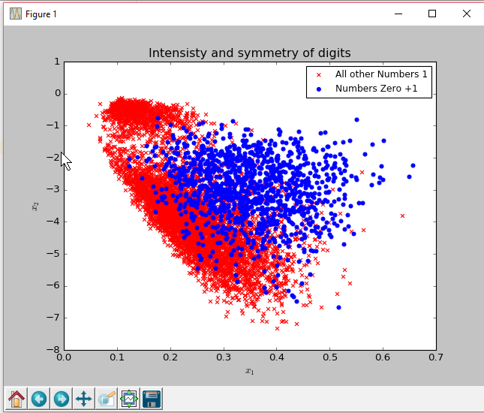

This is the plot of the features.csv file. This will clearly not be able to be solved by the perceptron since the data is not linearly separable.

The first array shown below represents the weight of each line calculated by the perceptron. As shown, the weights jump from relatively close to zero to almost reaching one. The second array demonstrates the pocket algorithms ability to only draw a new perceptron line if the new line scores a better weight than the previous line. Because the data above is not linearly separable, the perceptron would continue forever, however, there is a statement that claims if the iteration count goes above 30, the program will stop. The second array repeats the value weight of .16 because that is the best weight it found and no future iteration ever scored below that second iterations weight.

[0.16376354409546015, 0.8362364559045399, 0.16376354409546015, 0.8362364559045399, 0.16376354409546015, 0.8362364559045399, 0.16376354409546015, 0.23069537786311892, 0.8362364559045399, 0.16376354409546015, 0.8362364559045399, 0.8362364559045399, 0.16376354409546015, 0.16540940886023864, 0.8362364559045399, 0.16376354409546015, 0.27019613221780275, 0.16376354409546015, 0.8362364559045399, 0.16376354409546015, 0.8362364559045399, 0.16376354409546015, 0.8362364559045399, 0.16376354409546015, 0.8362364559045399, 0.8362364559045399, 0.16376354409546015, 0.8362364559045399, 0.16376354409546015, 0.8362364559045399, 0.16376354409546015]

[1.0, 0.16376354409546015, 0.16376354409546015, 0.16376354409546015, 0.16376354409546015, 0.16376354409546015, 0.16376354409546015, 0.16376354409546015, 0.16376354409546015, 0.16376354409546015, 0.16376354409546015, 0.16376354409546015, 0.16376354409546015, 0.16376354409546015, 0.16376354409546015, 0.16376354409546015, 0.16376354409546015, 0.16376354409546015, 0.16376354409546015, 0.16376354409546015, 0.16376354409546015, 0.16376354409546015, 0.16376354409546015, 0.16376354409546015, 0.16376354409546015, 0.16376354409546015, 0.16376354409546015, 0.16376354409546015, 0.16376354409546015, 0.16376354409546015, 0.16376354409546015]
[ 31.]

Process finished with exit code 0

Below demonstrates that the pocket algorithm will keep the same perceptron line unless the weight of the iteration has improved. The line is the same between iteration 7 and 12 because the weight of the line was not improved between those iterations.

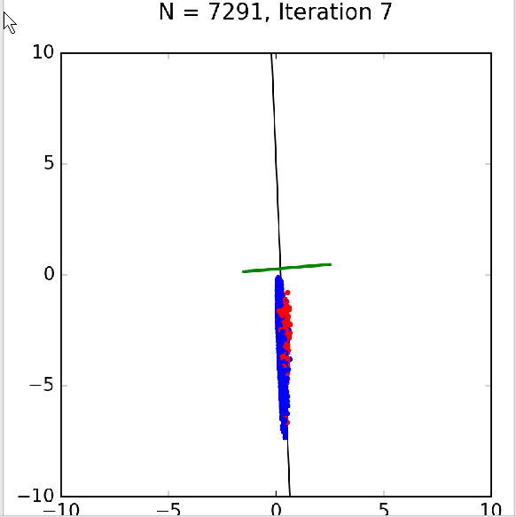
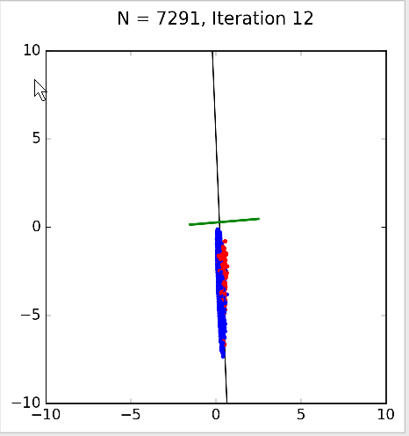

For linear regression, the best fit line is calculated through a transposition of the two matrices. This allows a line to be drawn that will best fit data even though it may not be linearly separable, like the data above. In this case, linear regression will calculate the best line and draw it, disregarding any requirement of it being linearly separable.

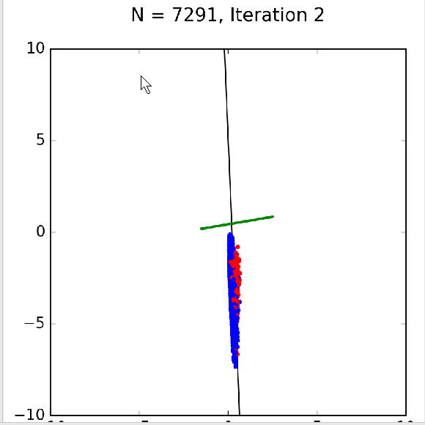

The black line represents the linear regression answer. Since the data cannot be separated it just calculates the best weight line and plots it. Unlike the perceptron or the pocket algorithm, linear regression only “runs” one time, where it calculates the best line and plots it, it removes any iterative nature of the perceptron algorithm.

Problem 1 part 2. With y[y<>1] = -1 y[y==1] = +1

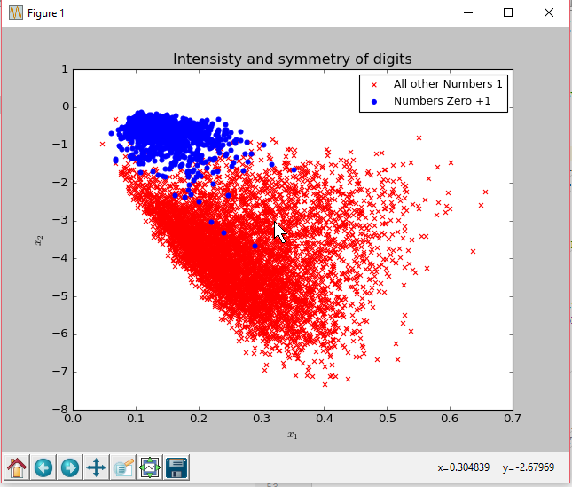
This data set with the modified y values creates a plot of points where much more of them exist as red, or unclassified.

a)Against these two arrays represent the pocket algorithm. Where the top one is the standard recording of line weights, while the bottom represents the pockets algorithms ability to only update the perceptron line if it scores a lower weight.
[0.13784117405019888, 0.13784117405019888, 0.04183239610478672, 0.8621588259498011, 0.1371553970648745, 0.11068440543135373, 0.05472500342888493, 0.01892744479495268, 0.12604580990261965, 0.02962556576601289, 0.03250582910437526, 0.03662049101632149, 0.022356329721574544, 0.026745302427650528, 0.06926347551776163, 0.02551090385406666, 0.06789192154711288, 0.026059525442326155, 0.04498697023727884, 0.03566040323686737, 0.020573309559731176, 0.041969551501851596, 0.015772870662460567, 0.04292963928130572, 0.015635715265395693, 0.033054450692634754, 0.04114661911946235, 0.031271430530791386, 0.03044849814840214, 0.036757646413386365, 0.016595803044849814]

[1.0, 0.13784117405019888, 0.13784117405019888, 0.04183239610478672, 0.04183239610478672, 0.04183239610478672, 0.04183239610478672, 0.04183239610478672, 0.01892744479495268, 0.01892744479495268, 0.01892744479495268, 0.01892744479495268, 0.01892744479495268, 0.01892744479495268, 0.01892744479495268, 0.01892744479495268, 0.01892744479495268, 0.01892744479495268, 0.01892744479495268, 0.01892744479495268, 0.01892744479495268, 0.01892744479495268, 0.01892744479495268, 0.015772870662460567, 0.015772870662460567, 0.015635715265395693, 0.015635715265395693, 0.015635715265395693, 0.015635715265395693, 0.015635715265395693, 0.015635715265395693]
[ 31.]
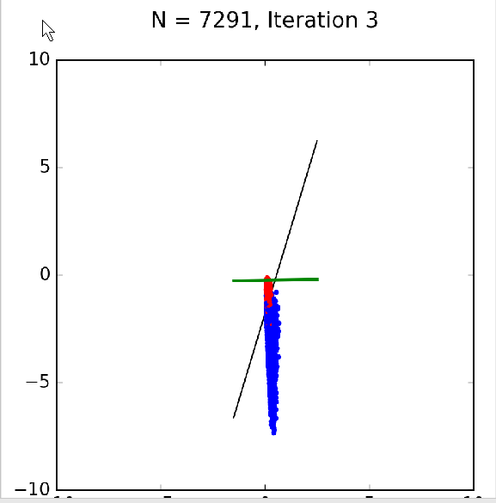

The above graph shows the perceptron and linear regression line being drawn on the data set. The linear regression line represents the best fit line based of its matrix transposition calculation while the perceptron is continuing to iterate the find the best hypothesis. However, since the data is not linearly separable it would run forever (or until my computer runs out of memory) which is why the break statement is needed.

Running this 10 times (because 30 takes too long to save the pngs) produces this pocket array of line weights
[1.0, 0.13784117405019888, 0.13784117405019888, 0.133315045947058, 0.05170758469345769, 0.021533397339185297, 0.021533397339185297, 0.021533397339185297, 0.01700726923604444, 0.01700726923604444, 0.01700726923604444]
By iteration 7/8 the line fits into the best weight that it can and no longer will update itself.

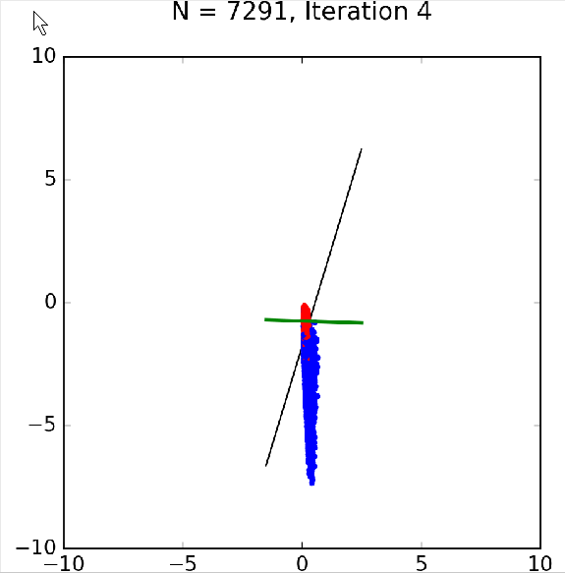
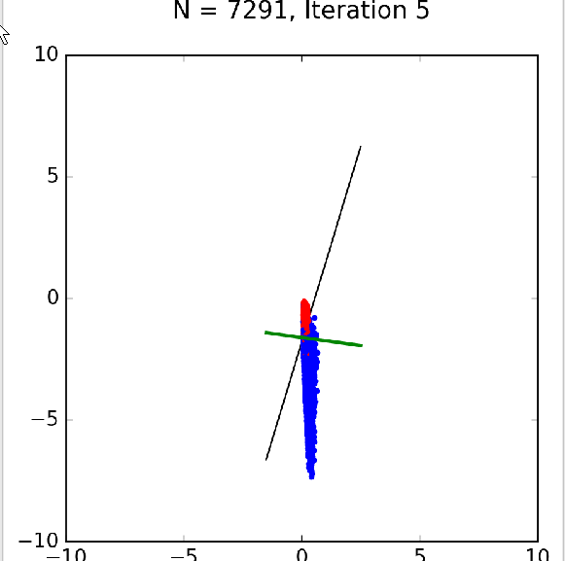
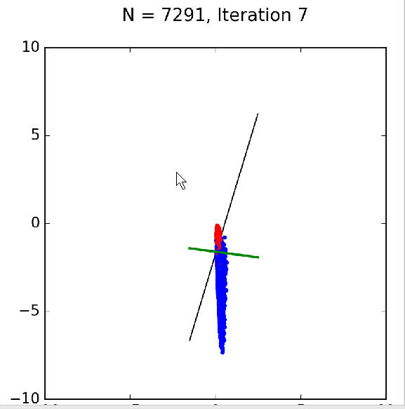

By iteration 5, the pocket algorithms updates are so small that it is hard to see on the graphs above. However, the concept is displayed that as the array of weights levels off to the smallest line error the pocket produces, the graphs reflect that.

If you run the pocket algorithm starting from the line generated by the linear regression, the pocket algorithm will try and continue to iterate to find a lower weighted line, however, since the linear regression is the best fit line and the data is not linearly separable, the algorithm will break after the set amount of iterations. If the data was linearly separable however, the pocket algorithm will start on the linear regression line and be complete, since the linear regression line would already exist as the best fit line. Setting p.pla(line = True) allows the pocket algorithm to be started on the regression line.

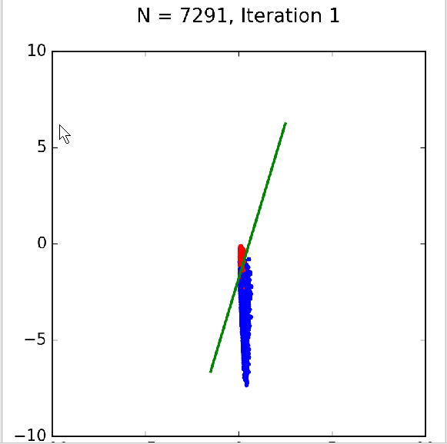
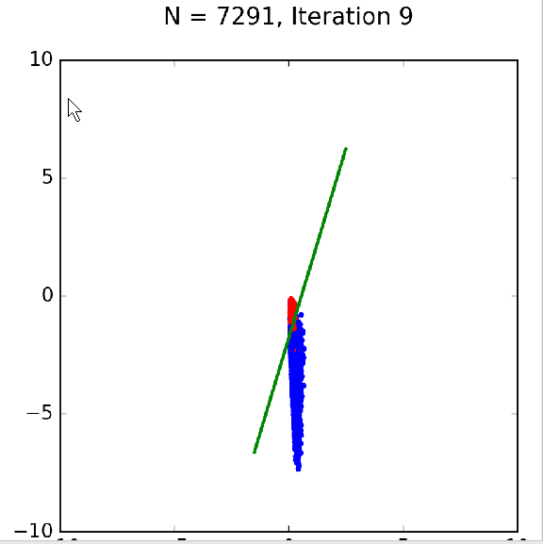

The perceptron starts from the line that linear regression calculated and will fail to update itself since it already exists on the best fit line.

Overall it seems that the linear regression algorithm is the most efficient since it establishes the best fit line from the start instead of having to iteration through potentially hundreds or thousands of different lines.

Question 2
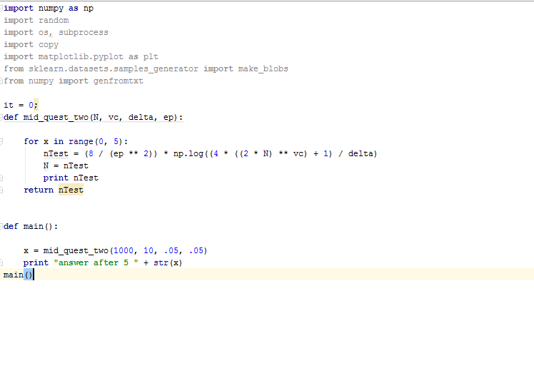
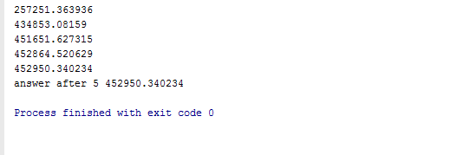

This recursively calculates N after 5 iterations. I picked 5 because after the 3rd and 4th iterations the numbers become increasingly close to each other.

