origional
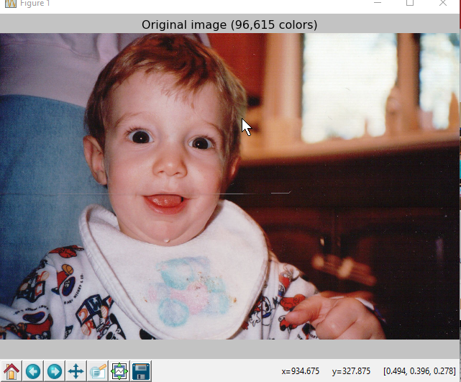

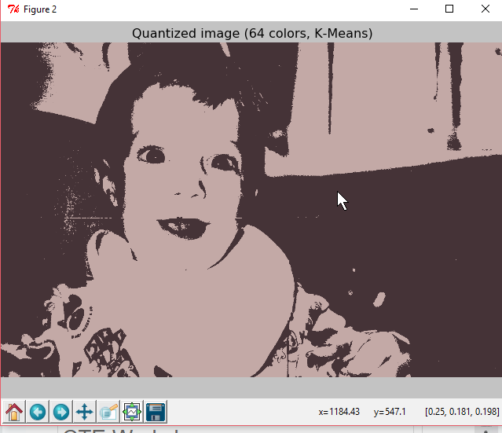
2 colors

10 colors
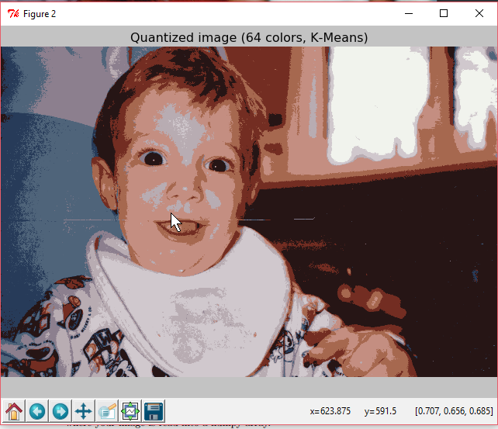

30 colors

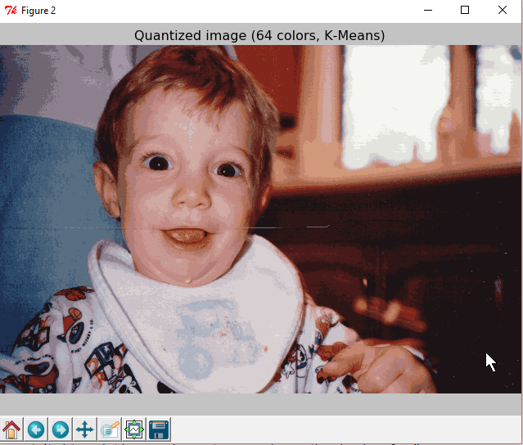

50 colors
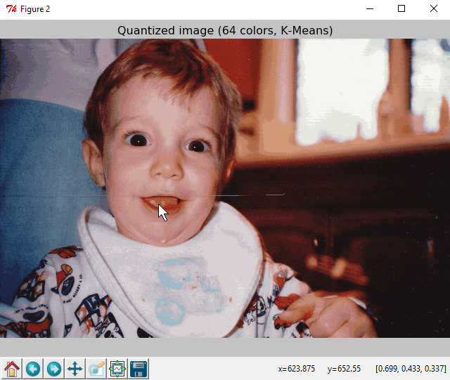

As the amount of colors increases, the picture approaches how the original photo looks. This sort of compression/color quantization could maybe be used in recognizing certain patterns in other images. Instead of having to recognize an exact pattern, it would be able to recognize a general sort of image that could possibly be used in detecting medical conditions in an xray.

The picture is ‘funny’ since it clusters around the most dominant colors and seems to ignore the fine details, but you can still make out the content of the picture.

Mlp results

