Chris Cordaro

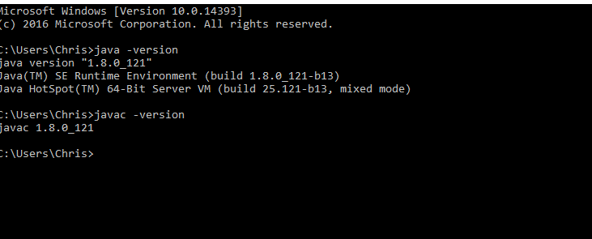

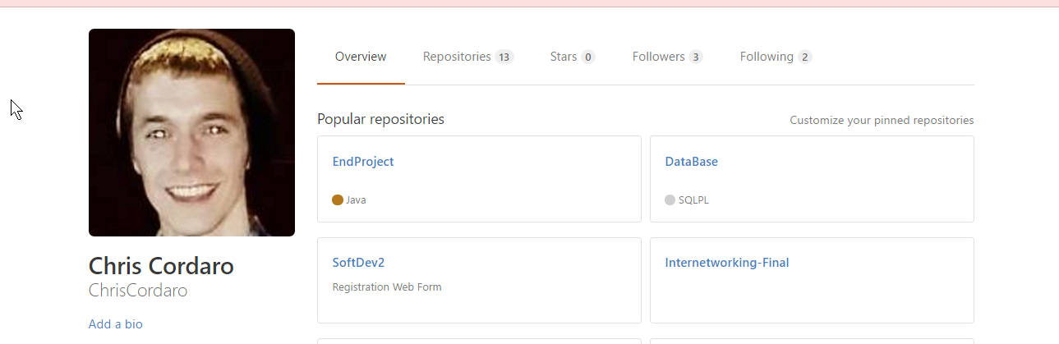

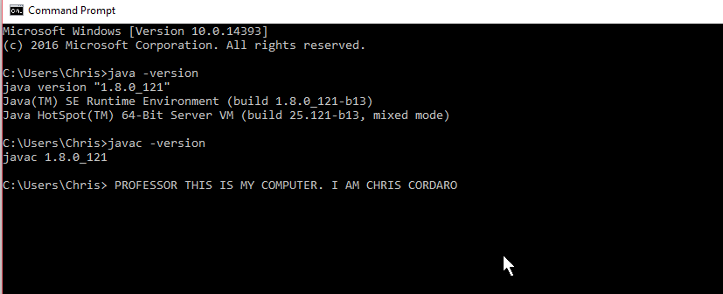
https://github.com/ChrisCordaro/cmpt440_Cordaro.git

