Assessing Prey Fish-Seascape Relationships Through Spatially Nested Models

Supplemental Material Background File

Christopher Crowder^{1,2}, Pedro F. Quintana-Ascencio¹, Meagan Schrandt³ Kerry Flaherty Walia⁴, Marcus Beck⁴, Geoffrey S. Cook¹
¹Department of Biology, University of Central Florida
²Wildlife Division, Nebraska Game and Parks Commission
³Fish and Wildlife Research Institute, Florida Fish and Wildlife Conservation Commission
⁴Tampa Bay Estuary Program

Data Availability and Additional Resources
Habitat maps from the Southwest Florida Water Management District are available at https://www.swfwmd.state.fl.us/ . Florida Wildlife Research Institute fisheries-independent monitoring data are available at https://data.florida-seacar.org/programs/details/69 . Subsequent supplemental materials include sample size and GIS information in supplemental document 1; raw modeling estimates in supplemental material document 2; corrected modeling estimates in supplemental material document 3; logistic regression observed vs. posterior plotting in supplemental material document 4; and generalized linear regression observed vs. posterior plotting in supplemental material document 5. The code for all models is available within the 2 R-scripts for the grouped prey fish models (supplemental material code 1) and the code for prey taxa specific models (supplemental material code 2). Please contact the corresponding author regarding modeling output files. Modeling output will be made available on reasonable and agreeable request. Please refer to the Rethinking by Richard McElreath (https://www.rdocumentation.org/packages/rethinking/versions/2.13) and Rstan (https://mc-stan.org/rstan/articles/rstan.html) package manuals for more information regarding the construction of model analyses and output for interpretation of raw estimates. Corrected estimates are provided in supplemental material document 3.

Supplemental Material Codes/Labels and Additional Results
Model Designation
Model designations include a number and a letter. The number corresponds to the spatial complex hypothesis found in figure 3 in the manuscript. The letter corresponds to the variable combination found in table 2 in the manuscript.
Abiotics
Water abiotic measurements were handled by utilizing the eigenvalues from a principal component analysis. The coordinate points along the x-axis are represented by the coded value “b1”. The coordinate points along the y-axis are represented by the coded value “b2”. The first two components of the ordination of the four abiotic measures, DO, pH, salinity, and water temperature, accounted for a large portion of their joint variation (~68%; Figure1). The scores of this ordination were used to characterize the abiotic variation in our models.
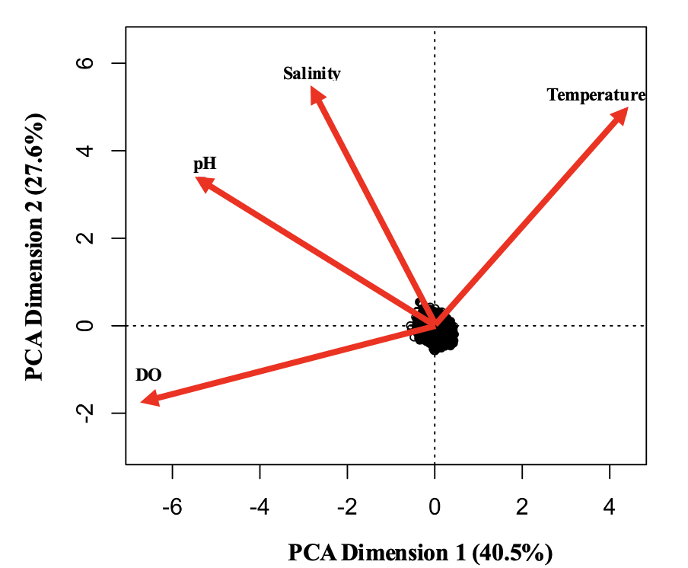
Figure 1. Principal component analysis biplot for water abiotic measurements: temperature, salinity, pH, and dissolved oxygen (DO).

Habitat
More details related to intertidal habitats and coastal wetlands coverage are available through the land use and land cover maps produced by the Southwest Florida Water Management District. These data were not used to classify FIM data to habitat types. This was to minimize potential incompatibility between maps as the land use and land cover maps are not produced at the same time nor on the same interval as the habitat maps. Additionally, the gear selected do not primarily target the habitat types specifically noted by the land use land cover maps.
Habitat was analyzed in two classification schemes. Habitat classification 1 classified habitats by submerged aquatic vegetated habitats (SAV) or non-submerged aquatic vegetated habitats (non-SAV). Habitat classification 2 was more specific and included intertidal zone/tidal flats, sandy beaches/bottom, open water, and SAV. The table below notes the codes to the corresponding habitat types noted in the estimate tables. The c1 habitat is included in the intercept when observing the estimate tables.
Habitat Classification 1
Coded Value | Habitat Type
c1 | Non-SAV
c2 | SAV
Habitat Classification 2
Coded Value | Habitat Type
c1 | Intertidal zone/tidal flats
c2 | Sandy beaches and bottom
c3 | Open water
c4 | SAV

Spatial Complex Location
Spatial complexes follow the grouping observed found in figure 3 in the manuscript. Each spatial complex grouping, except for model 1 which analyzes each sample independently, follows this pattern “HC” plus the number that represents the location noted in the map. The “sigmaHC” represents the overall standard deviation of spatial complex analysis. More detailed information regarding the area of each complex and the rationale of each spatial complex construction for each model can be found in supplemental material document 1.
Gear Type
There were three gear types considered in this study. Small seine net samples are represented by the coded value “g1” which is included in the intercept when viewing the estimate tables. Large seine net samples are represented by the coded value “g2”. Otter trawl samples are represented by the coded value “g3.” Addition notes about gear bias in relation to each taxa and model quality results for each gear type for both models can be found in supplemental material documents 4 and 5. The number of samples utilizing each gear type for each year considered within the study are found in supplemental material document 1. The number of individuals caught by each gear type are listed in supplemental material document 1.
Year
Year was coded numerically based on the ordering of the year in the study. Below is a table that includes the coded value for the corresponding year of sampling. The “sigmaYear” represents the overall standard deviation of spatial complex analysis.
Coded Value | Year
YEAR1 | 1998
YEAR2 | 2000
YEAR3 | 2003
YEAR4 | 2005
YEAR5 | 2007
YEAR6 | 2009
YEAR7 | 2011
YEAR8 | 2013
YEAR9 | 2015
YEAR10 | 2017
YEAR11 | 2019
YEAR12 | 2021

Zero-Inflated Model Coding
The zero-inflated model also includes a “Z” at the end of the coded value. These estimates represent the probability of absence due to the corresponding variable. To get the corrected estimate of this value, you must take the inverse logit of that value. The formula for each model can be found in the supplemental code documents. Please note that habitat and gear type are handled as dummy variables, so gear “g1” and habitat “c1” are included in the intercept. Other variables may be added/subtracted to the intercept (a) to find the estimate based on the variable combination of interest. Corrected estimates can be found in the supplemental material 3 document.
Logistic Regression Coding
Estimates in the logistic regression represent the probability of presence due to the corresponding variable. To get the corrected estimate of this value, you must take the inverse logit of that value. The formula for each model can be found in the supplemental code documents. Please note that habitat and gear type are handled as dummy variables, so gear “g1” and habitat “c1” are included in the intercept. Other variables may be added/subtracted to the intercept (a) to find the estimate based on the variable combination of interest. Corrected estimates can be found in the supplemental material 3 document.
Generalized Linear Model Count Regression
Estimates from the generalized linear model are abundance estimate due to the corresponding variable. To get the corrected estimate of this value, you must take the exponential of that value. The formula for each model can be found in the supplemental code documents. Please note that habitat and gear type are handled as dummy variables so gear “g1” and habitat “c1” are included in the intercept. Other variables may be added/subtracted to the intercept (a) to find the estimate based on the variable combination of interest. Corrected estimates can be found in the supplemental material 2 document.

Coding Challenges
We initially used a zero-inflated Poisson generalized linear models to attempt to disentangle the contribution of these absences to our estimates. However, we were concerned about overdispersion in the abundance model portion but were unable to build a zero-inflated negative binomial model. Alternatively, we examined estimated absence frequency between the zero-Poisson models and logistic regression models where data was maintained if equal zero but transformed to 1 if larger than zero. Because of the limited number of absences associated to the abundance data we proceed to use the occurrence estimates from the logistic regression model (0/1; data >0 =1) and to independently to evaluate abundance data > 0 assuming a negative binomial generating distribution. Using only samples with presence data, abundance data were evaluated as a function of the predictors with generalized linear models with logarithmic transformed data and negative binomial errors. Our approach failed to correctly parse the contribution of the two processes, the logistic regression and the negative binomial, to the estimate for zero counts-occurrences. We follow this approach because: (1) The amount of zeros associated to the distribution of the abundance data were relatively few; (2) Zero-inflated Poisson models did not capture the variation in the abundance data as well as our alternative specification; (3) we were not able to set a negative-binomial zero inflated model in the Bayesian framework (below) and did not find a viable option in the web workflow that fitted our data; (4) the models from these two step procedure were able to reasonably predict the data as evidenced by visual inspections and correlations of predicted and observed abundance data.

Additional Discussion/Conclusion Topics and Considerations
While grouping prey fish together might be useful in the determination of the most informative spatial scaling and environmental characteristics used to describe their abundance, future evaluations should also assess the quality of the taxa specific models to understand how potential varying behavioral, or life history characteristics may impact absence and abundance and therefore model accuracy. To give prey taxa specific example, model quality for pinfish were high; model predicted absence when 0 fish were observed, presence when 1 fish was observed, and presence when a count of more than 20 was observed in the logistic regression model (supplemental material 3 and 4). Conversely, silversides and related prediction estimates were weak. For silversides, the logistic regression widely predicted the absence of silversides even when 1 and more than 20 individuals were observed. In a linear model, comparison of the trend lines indicated the model was unable to reasonably predict the abundance of silversides (supplemental material 3 and 5). We further divided these results by gear type. Certain species were better selected for certain gear types. We reviewed this gear bias and concluded that otter trawls poorly sampled our selected taxa with small seines providing the best sampling. We encourage readers to review supplemental material documents 4 and 5 to read more about this topic and our evaluation of gear to specific taxa. When reviewing the observed counts from the FIM data compared to the logistic regression for absence/presence, and abundance from the generalized linear model, the following taxa would be acceptable choices when utilizing this approach: Mullet, Mojarra, Silver Perch, Pinfish, and Pigfish. While the following taxa would not be acceptable choices (given with existing data frame and current model format): Herring, Anchovies, and Silversides. These three taxa may require different predictor variables or spatial complex scaling not considered within the Tampa Bay case study to better describe their presence/absence and abundance.

