|  |  |
| --- | --- |
| SISTEM PENGURUSAN PUSAT GYM  Oleh : Christopher Chong Wu Xian 2KPD2 | **LATIHAN AMALI K2 KPD 4024**  PANDUAN PENGGUNA  PANDUAN KOD SUMBER |

**DOKUMENTASI KOD SUMBER BAGI SISTEM PENGURUSAN GYM**

|  |  |  |
| --- | --- | --- |
| **Versi** | **Tarikh Diluluskan** | **Pemilik** |
| 1.0 | 06/08/2018 | Christopher Chong |

1. **Tujuan**

Dokumentasi ini bertujuan sebagai keperluan untuk mengurus kod sumber, memastikan kawalan versi, mengurus dokumen berkaitan dan mengawal risiko kehilangan kod sumber.

1. **Maklumat Asas**
2. **Sistem**

|  |
| --- |
| * Windows XP dan versi baru daripadanya * PC * Bekalan elektrik * Kemudahan PC ( tetikus, papan kekunci, sbg ) |

1. **Rujukan Projek**

|  |
| --- |
| * <https://www.fitnessfirst.com.my/> * Sistem Inventori Asrama * Sistem Camels Carry |

1. **Hubungi**

|  |
| --- |
| Pengurus sistem – Christopher Chong Wu Xian : [chongchris@hotmail.com](mailto:chongchris@hotmail.com) , 012-4431312 |

1. **Kod Sumber**

|  |  |
| --- | --- |
| Config.php | <?php  $query=mysql_connect("localhost","root","123456");  mysql_select_db("sistemgym",$query);  ?> |
| Login.php | <!DOCTYPE html>  <html>  <head>  <meta charset="utf-8">  <meta name="viewport" content="width=device-width, initial-scale=1">  <style>  body, html {  height: 100%;  font-family: Arial, Helvetica, sans-serif;  }  * {  box-sizing: border-box;  }  /* Background for the page */  html {  background: url(bg.jpg) no-repeat center center fixed;  background-size: cover;  height: 100%;  overflow: hidden;  }  /* Add styles to the form container */  .container {  position: absolute;  right: 0;  margin: 100px;  max-width: 300px;  padding: 25px;  background-color: white;  }  /* Full-width input fields */  input[type=text], input[type=password] {  width: 100%;  padding: 15px;  margin: 5px 0 22px 0;  border: none;  background: #f1f1f1;  }  input[type=text]:focus, input[type=password]:focus {  background-color: #ddd;  outline: none;  }  /* Set a style for the submit button */  .btn {  background-color: #4CAF50;  color: white;  padding: 16px 20px;  border: none;  cursor: pointer;  width: 100%;  opacity: 0.9;  }  .btn:hover {  opacity: 1;  }  </style>  </head>  <body>  <form id="form" method="post" action="pros_login.php">  <div class="container">  <center><img src="logogym.png" style="width:200px;height:200px;"></center>  <h1>Log in</h1>  <label for="user_name"><b>Nama</b></label>  <input type="text" placeholder="Masukkan nama anda di sini" name="nama" required>  <label for="user_pass"><b>Katalaluan</b></label>  <input type="password" placeholder="Masukkan katalaluan anda di sini" name="ktlaluan" required>  <button type="submit" class="btn">Log in</button><br>  </div>  </form>  </body>  </html> |
| Pros_login.php | <html>  <head>  <title>log in</title>  </head>  <body>  <?php  session_start();  $nama =$_POST['nama'];  $ktlaluan =$_POST['ktlaluan'];  if($nama && $ktlaluan)  {  $server='localhost';  $userid2='root';  $password2='123456';  $dbname='sistemgym';  $conn=mysql_connect("$server","$userid2","$password2");  mysql_select_db("$dbname",$conn) or die (mysql_error());  $query=mysql_query("select*from ahligym where nama='$nama'");  $numrows=mysql_num_rows($query);  if($numrows!=0)  {  while($row=mysql_fetch_assoc($query))  {  $dbnama=$row['nama'];  $dbktlaluan=$row['ktlaluan'];  }  if($nama==$dbnama&&$ktlaluan==$dbktlaluan)  {  $_SESSION['nama']=$nama;  header('Location:home.php');  } else  { echo"Incorrect Password !!<a href='login.php'> Click here to sign in again</a>";}  }// if 2  else  die("That user doesn't exist");  }//if 1  else  {  echo"Please enter userid and password!!<a href='login.php'>Click here to sign in again</a>";  }  ?>  </body>  </html> |
| Home.php | <!DOCTYPE html>  <html lang="en">  <head>  <title>home.php</title>  <meta charset="UTF-8">  <meta name="viewport" content="width=device-width, initial-scale=1">  <link rel="stylesheet" href="https://cdnjs.cloudflare.com/ajax/libs/font-awesome/4.7.0/css/font-awesome.min.css">  <style>  * {  box-sizing: border-box;  }  /* Style the body */  body {  font-family: Arial;  margin: 0;  }  /* Style the top navigation bar */  .navbar {  overflow: hidden;  background-color: #333;  }  /* Style the navigation bar links */  .navbar a {  float: left;  display: block;  color: white;  text-align: center;  padding: 14px 20px;  text-decoration: none;  }  /* Right-aligned link */  .navbar a.right {  float: right;  }  /* Change color on hover */  .navbar a:hover {  background-color: #ddd;  color: black;  }  /* Column container */  .row {  display: -ms-flexbox; /* IE10 */  display: flex;  -ms-flex-wrap: wrap; /* IE10 */  flex-wrap: wrap;  }  /* Create two unequal columns that sits next to each other */  /* Sidebar/left column */  .side {  -ms-flex: 30%; /* IE10 */  flex: 30%;  background-color: #f1f1f1;  padding: 20px;  }  /* Main column */  .main {  -ms-flex: 70%; /* IE10 */  flex: 70%;  background-color: white;  padding: 20px;  }  /* Footer */  .footer {  padding: 20px;  text-align: center;  background: #ddd;  }  /* Responsive layout - when the screen is less than 700px wide, make the two columns stack on top of each other instead of next to each other */  @media screen and (max-width: 700px) {  .row {  flex-direction: column;  }  }  /* Responsive layout - when the screen is less than 400px wide, make the navigation links stack on top of each other instead of next to each other */  @media screen and (max-width: 400px) {  .navbar a {  float: none;  width: 100%;  }  }  </style>  </head>  <body>  <div class="navbar">  <a href="home.php">Home</a>  <a href="form.php">Tambah Ahli</a>  <a href="login.php">Log out</a>  </div>  <div class="row">  <div class="side">  <h2>Logo</h2>  <h5>Sistem Pengurusan Pusat Gym, JB</h5>  <img src="logogym.png" style="height:200px;width:200px;">  <p>hanya di Malaysia.</p>  </div>  <div class="main">  <h2>Gym kita</h2>  <h5>Chris, Ogos 6, 2018</h5>  <img src="gym1.jpg" style="height:250px;width:300px;"><img src="gym2.jpg" style="height:250px;width:300px;"><img src="gym3.jpg" style="height:250px;width:300px;">  <p>Membina badan yang mahu di sini !</p>  </div>  </div>  <div class="footer">  <h2>Hak Cipta Chris</h2>  </div>  </body>  </html> |
| Form.php | <!doctype html>  <html>  <meta name="viewport" content="width=device-width, initial-scale=1">  <link rel="stylesheet" href="https://www.w3schools.com/w3css/4/w3.css">  <head>  <style>  h1, h2 {  color: white;  }  table {  border-collapse: collapse;  border-spacing: 0;  background-color: white;  width: 100%;  border: 1px solid black;  }  th, td {  text-align: left;  padding: 16px;  background-color: white;  border: 1px solid black;  }  </style>  </head>  <body bgcolor="#42404B">  <form id="form" method="post" action="pros_insert.php">  <center><h1>Sistem Pengurusan Pusat Gym, JB</h1><h2>Form Barang Tambah Ahli Baru</h2></center>  <center><table>  <tr>  <td>Nama  <td><input name="nama" class="w3-input w3-border" value="" size="50"/>  </tr>  <tr>  <td>Kata laluan  <td><input name="ktlaluan" class="w3-input w3-border" value="" size="50"/>  </tr>  <tr>  <td><td><center><input type="submit" value="Hantar"></button>  <input type="reset" value="Isi semula"></button></center>  </tr>  </table></center></form>  </body>  </html> |
| Pros_insert.php | <?php  include ('config.php');  $nama=$_POST['nama'];  $ktlaluan=$_POST['ktlaluan'];  echo"<br>";  $query="insert into ahligym values  ('$nama','$ktlaluan')";  if(mysql_query($query)){  header("Location:home.php");}  else  header('location:form.php');  ?> |

Paparan setiap Halaman

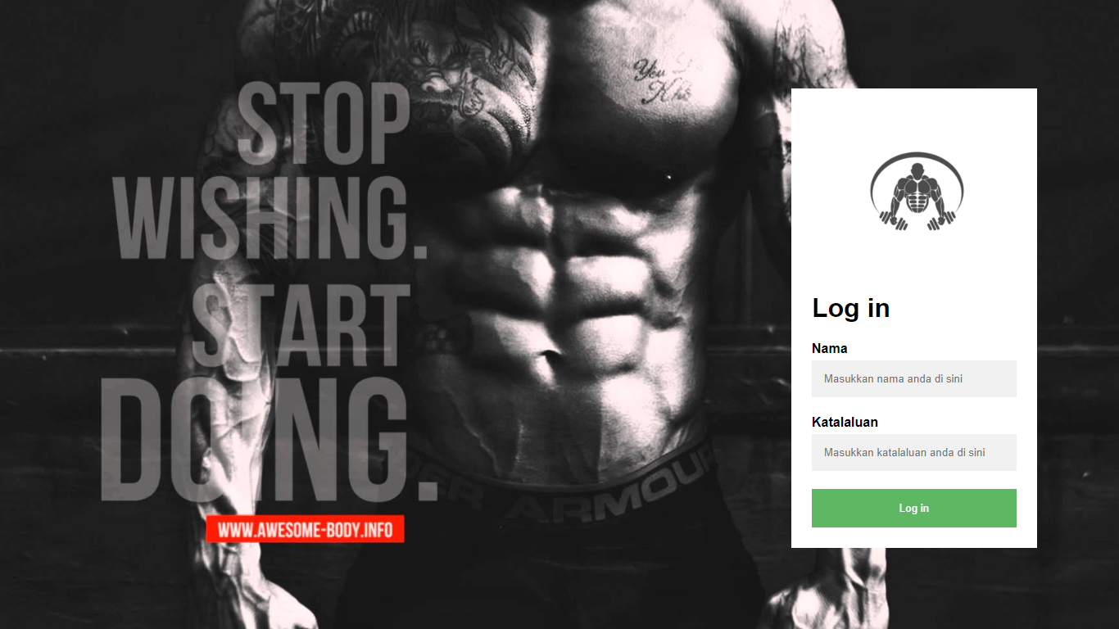

Paparan 1 – login.php, pros_login.php

Input box = Nama dan Katalaluan

Butang = Log in

Masukkan nama dan katalaluan yang ditetapkan oleh admin, kemudian menekan butang login untuk ke halaman sistem ini.

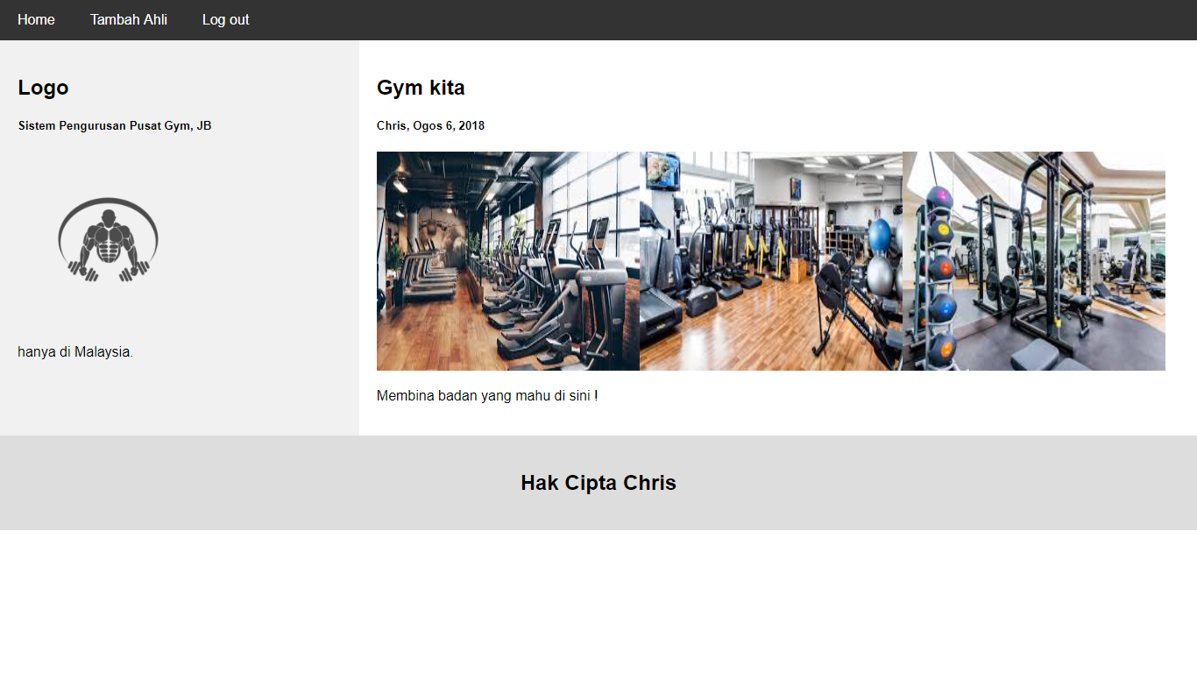

Paparan 2 – home.php

navigation bar/ link / butang = Tambah Ahli, Log out

Untuk menambah ahli tekan butang tambah ahli di navigation bar. Paparan form akan keluar disitu.

Untuk log out, tekan butang Log out dan halaman Log in akan dipaparkan.

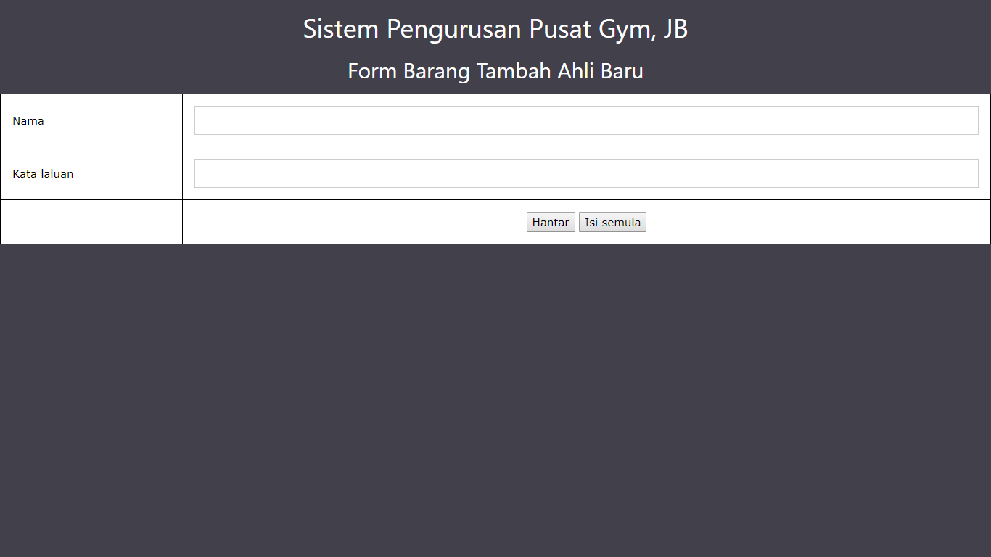

Paparan 3 – form.php, pros_insert.php

Input box = Nama, Katalaluan

Butang = Hantar, Isi semula

Isikan maklumat yang ingin dimasukkan ke dalam pangkalan data dan tekan butang Hantar untuk simpan data anda.

Butang Isi semula digunakan untuk memadam data yang telah anda isi.