1. Imaginary Users
   1. Programmer – This user is involved in creating the program for certain people in the Biology department of UMW to use to study mice patterns through visualization tools. There will be data sets to upload and choose from and mapping tools, such as vector and heat maps, to track each pattern that the mice take in an enclosed space.
   2. Professor – Since we are working with not only Dr. Polack but also Dr. Waters from Biology, they would be involved in studying the patterns after they are displayed in the program and deciding what to do with the data they are presented.
   3. Students – This would apply to biology students, but they would likely be the ones using the program to map out the patterns for the professors, basically doing the grunt work needed to get the results they are looking for.
2. This program is mostly for the Biology professor at UMW that oversees mice visualization. The goal of the program is to take data through tracking devices and map out the results in a visual representation, such as a vector or heat map, so you know where each mouse has been and can use that data how they see fit.
   1. Primary Function Chosen -> Heat Mat Generation. Question: How do you think a heat map will be generated for this project? Answers paraphrased after explaining what the project does:
      * Person 1 – It will be generated through data points given by the professors that you can use to generate the heat map using the numbers given.
      * Person 2 – Not sure, maybe through inserting something into the program to create it?
      * Person 3 – Created automatically by the program when you start.
      * Person 4 – You’re given data points, so I assume you create a heat map based from that, although not sure how detailed it’s going to be.
   2. The heat map will be generated using the data sets entered into the program, which will then be automatically created and pulled up when you select that option in the program.
3. Priority List:
   * + Data Set Functions -> Program will not work without the data set parsing!
     + Visualization -> 2nd priority, since there’s not much point in doing the parsing if nothing will be shown. This is for the mapping and other visualization effects used.
     + Gui Scaffold -> Middle priority, since it is required but not completely necessary for final  
       project, but not really something to cut out.
     + Export/Save -> I also consider this hard to cut, but could be since saving the results would be very helpful
     + Windows/Mac Support -> Easy thing to scrap if time is cut short, as it’s a requirement but does not impede the program very much
     + Style Improvements -> Making the program look fancy. Simply bells and whistles which would be nice to have but not necessary for the working program.
     + Help assistance -> While very helpful, not detrimental to the program but nice to have if we get around to it.

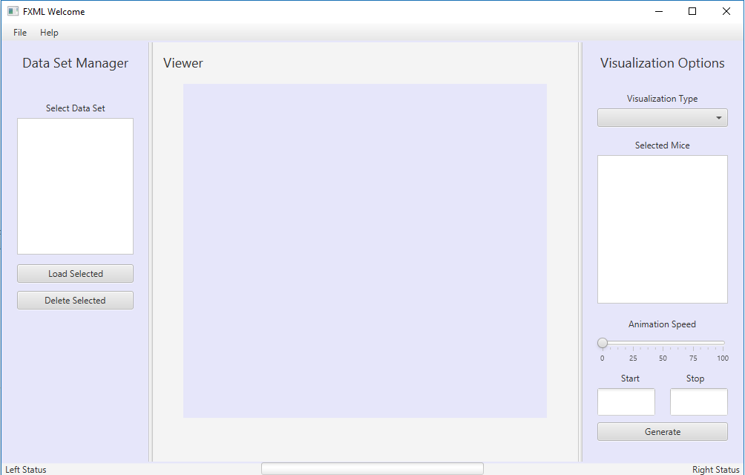

1. GUI Comments:
   * + Person 1 – Well, you have a file menu, so I assume you can open a file or create a new file for a data set. I don’t suppose you create new data sets in the program though. Once you have that, you select it from the drop-down box?
     + Person 2 – Other than the ugly color, it seems pretty simple and easy to use!
     + Person 3 – I like how there’s a help button in case the user cannot figure something out. I’d like to see how you get the animation speed bar working.
     + Person 4 – Well, it’s easier when there is a picture, so I can guess that you choose a data set on the left, select the mice on the right, and then it generates whatever map you can make.

The interface mostly aligned to the comments in #5, not necessarily in #2 since seeing a picture is much easier to describe how things would work compared to blindly explaining the program to people. Due to a lot of programs having a file or help tab for instance, it’s easy to guess what those will do.

1. Changed planned is the color of the GUI for one, as it’s just a prototype replica that will most likely be modified in the future as the project moves forward. The start and stop, and the animation speed will probably be removed or changed, depending on time allotted.