**Placement Cell**

**Abstract**

Placement Cell is an online-based software application created in the Windows system so that the university site can provide the important points of their students in a database so that the companies obtain a suitable means of employment. begin the session.

The Placement Cell contains all information regarding students. The device stores all of your students’ personal information, such as your personal details, your added scars, your experience and your specialized skills that may be required in the CV that will be provided to a company.

**Introduction**

The main objective of Placement Management System is to develop software which manages placement activities in college makes a interactive GUI where TPO can manage details of all students on his console, he can send mails to students informing about placement activities. Although such a project has a very wide scope, this project contains the most important part i.e. displaying the personal and academic information of a student and company. The students and companies are also provided with the facility of editing some fields like username and password. The project also allows a Data Base Administrator to enter the information of a student and company which is then stored in the corresponding tables in the main database .He can also delete the student and company information after placement is over from the main database

**Existing system**

* Filling of forms by students
* Here a form is given to students in which he/she has to fill with some details such as his name, roll number, contact details, percentages(from first year to till date), Intermediate particulars(name of institution, place, year of pass, percentage), SSC particulars(name of institution, place, year of pass, percentage).
* Collecting marks from green book Marks of each student are collected from green book (a book containing marks and other details maintained by each department in college).
* Preparing excel sheet From the data collected through filled-forms and green book, excel sheets are prepared. These excel sheets are used to prepare a list of students who full-fill the requirements of a company visiting the campus and these students are eligible to attend the campus placement

**Proposed System**

In the proposed system the Admin(Placement officer) need not do all the hectic work. he will be provided with an interface with which he can easily get his work done. The following are the facilities that are provided by the system to the Admin.

**Notice generation**

Here Admin(Placement officer) has to provide information to the system about company name, date and venue at which campus drive might take place. With this information the system will generate a notice which can be seen on students’ account to intimate students about placement drive.

**Student list generation**

Here the Admin has to provide information to the system about the requirements of the company (such as, cut off percentage, number of backlogs allowed etc.).

**View student profile**

Here the Admin is able to view a student’s profile of his interest by giving the student’s roll number as input.

**Advantages of proposed system:**

The system proposed has many advantages.

1. The proposed system is highly secured, because for login the system it requires the username and password which is different for each.

2. It maintains records for all the Students.

3. Manages placement announcements.

4. The application can be put online easily and will be assessable throughout the globe.

System Modules:

The proposed project contains mainly three modules they are

* Admin module
* Student module
* Announcement module

Admin/Placement Officer Module features:

* Login
* can add announcement
* can view students
* can manage students
* can delete student
* can update password

Student’s Module Features

* Login
* Can update details
* Can look for campus drives on a single glance

System Design :

**ER Diagram for Placement Cell**

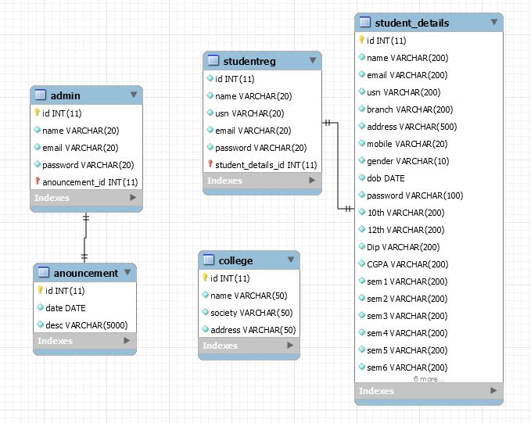

**System Requirements**

**Software Requirements:**

* Windows XP/7/8/10
* Browsers Chrome/Firefox/EDGE (For best view preferred browser is Chrome)
* Netbeans IDE 8.2(frontend)
* PhpMyi.e, MySQL(backend)
* Internet Connectivity(must required)

**Hardware Requirements:**

* Hard Disk Drive(HDD) 10GB
* RAM 1GB
* Processor 1.2GHz

**Language Used**

HTML,CSS,Javascript,PHP(main functionality),MYSQL.

**NOTE:**

* In PhpMyfirst create a database by name "gym" then import database contents by clicking on Import- browse-local disk:C-xampphtdoc/GymManagement/gym.sql click Go. Complete gym database will be created.
* Internet connectivity is required.