When looking at the census data, one of the questions that we wanted to figure out was, how many employees identified as only Hispanic or only non-Hispanic and compare them to the total sample size. We utilized the characteristics of business data; from the data we can see that about 15% of the employees in the firms are Hispanic and about 17% of the employees identify as non-Hispanic. We are issuing a caution when using these numbers because there are people who identify their ethnicity as ‘Equally Hispanic/non-Hispanic’, which are not included in calculating the 15% and 17%. This could be seen in the bar chart below.

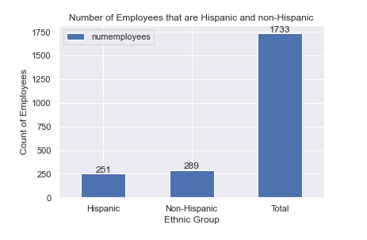

As a group we also wanted to know which NAICS (North American Industry Classification System) had the most employees. For this question we used the characteristics of business data and took out entries that were labeled “Industries not classified”. From the horizontal bar chart below, we can find out the top 3 industries with the highest number of employees which are “Professional, scientific, and technological services”, “Retail trade”, and “Manufacturing”. Also, we can see the industries with the lowest number of people which are “Utilities”, “Agriculture, forestry, fishing, and hunting”, and “Management of companies and enterprises”.

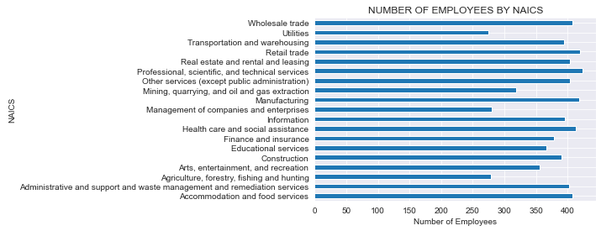

Another finding we wanted to know was whether there was a correlation between the number of employees and the number of owners. What we found is that there is a positive correlation between the two attributes, so as number of employees increase the number of owners increase. The data points looks like it could be modeled by a first order linear regression model. The scatter plot also shows that most firms have around 200000 owners and 200000 employees. These finds can be shown in the scatterplot below.

