- mike@dore.com
- Get a new org and login (free)
  - Go to : https://developer.salesforce.com/signup
  - Sign up for a new org
  - Activate account
  - Set password
  - Set security question
- Configure remote access to not require a token
  - In Salesforce
i. Go To Setup

ii. In the upper left of setup type *Network Access*
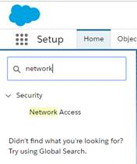

iii. Click on Network Access
iv. Click New
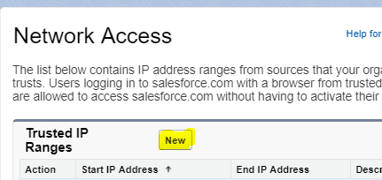
v. Create a new entry with your public IP Address on each side (Get this from WhatIsMyIP.org)
vi. 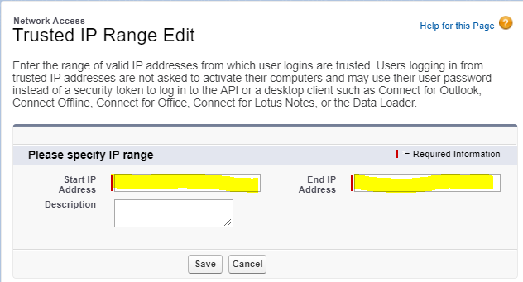
vii. Click Save
- Open DBSchema
  - My Version is:
i.
  - Project
  - New
  - 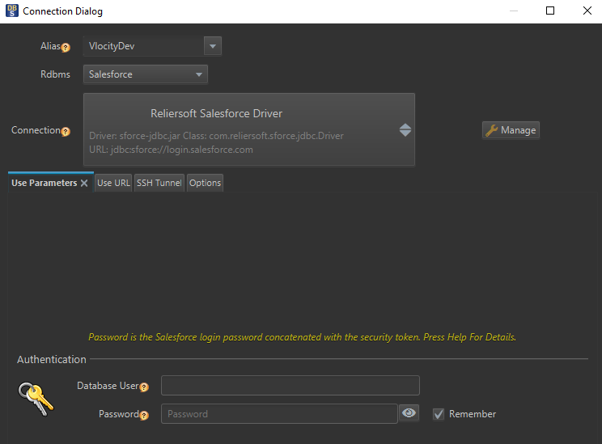

  - Database User = Salesforce.com user name
  - Password = Salesforce.com password
i. NOTE: There is no need to use a salesforce token at the end of the password
  - URL Tab – check off use JDBC URL
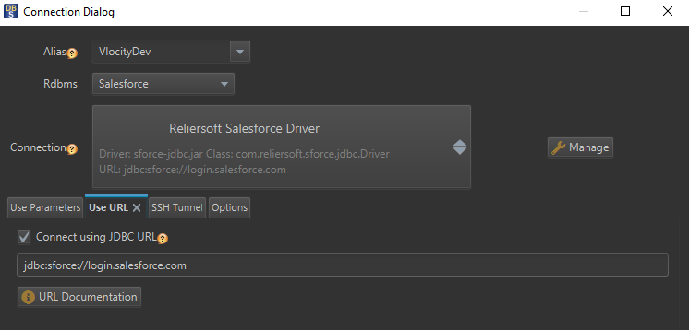

  - No changes on SSH tab
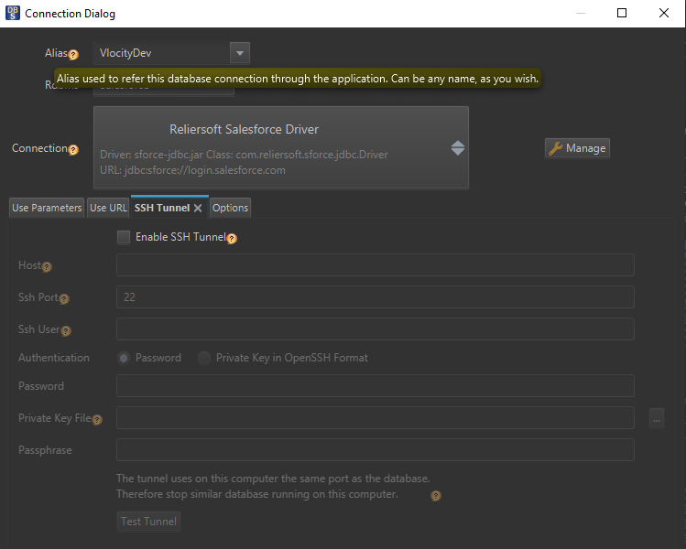
  - No changes on options tab
  - 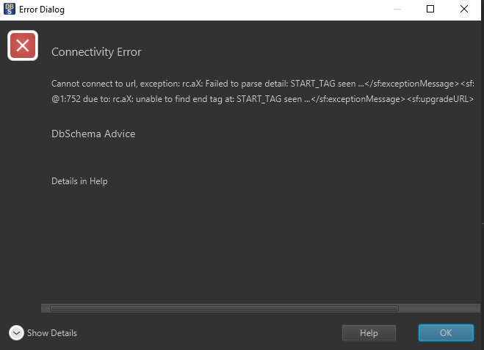
  - Click Connect
  - Get Failure

- Now prove that the error type is not credential related
  - Login to SFDC
  - Go to setup
  - Type *Login History* in the upper left
  - Click on *Login History*
Compare to a successful UI login
  - 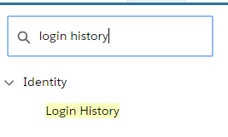

Please let me know if you need any help reproducing.

