[Title]

SOR1232 – Hypothesis Testing

Supervised by Dr. David Suda

Chris Frendo (439600L) (Computer Science 1st Year)

Manwel Bugeja (454000L) (Computer Science 1st Year)

Domenico Agius (6500H) (Computer Science 1st Year

Table of Contents

1 Introduction 3

2 Aims and Objectives 4

3 Descriptive Statistics & Illustrations 5

3.1 Measurements of Location 5

3.1.1 Rating 5

3.1.2 Reviews 7

3.1.3 Size 9

3.2 Frequencies 11

3.2.1 Installs 11

3.2.2 Type 12

3.2.3 Content_Rating 13

3.3 Boxplots 14

3.3.1 Rating vs Installs 14

3.3.2 Rating vs Size 15

3.3.3 Rating vs Content_Rating 16

3.4 Scatterplots 17

3.4.1 Rating vs Reviews 17

3.4.2 Rating vs Size 18

4 Hypothesis Testing 19

4.1 Rating vs. Installs 19

4.2 Rating vs Content Rating 22

4.3 Rating vs. Type 25

4.4 Correlations 28

4.4.1 Rating vs Reviews 28

4.4.2 Rating vs Size 29

5 Modelling 30

6 Appendix 31

6.1 References 31

# Introduction

The chosen dataset has to do with Google Play Store applications. It can be found at the following link: <https://www.kaggle.com/lava18/google-play-store-apps>. This dataset was chosen because it contains data that can provide actionable insight on what makes an application successful on this platform. This dataset contains data on around 10,000 Play Store applications which were scraped from the Google Play Store itself. The original dataset contains 13 attributes that describe each application however for the purpose of this assignment only 6 of these were kept. The variables that were used are listed below:

* Rating (Covariate and Dependent variable)
* Reviews (Covariate)
* Size (Covariate)
* Installs (Factor)
* Type (Factor)
* Content_Rating (Factor)

The variable that is of most interest is *Rating* as it gives the best indication on how successful an app is. The *Reviews* attribute indicates how many reviews (positive or negative ones) an app has. The *Size* variable holds the size in kilobytes for each app. The *Installs* factor is used to indicate how many installs (based on a range) the app has. The *Type* factor indicates if the app is *Free* or *Paid* and the *Content_Rating* factor indicates for which age group the app is targeted.

# Aims and Objectives

The objective of this assignment was to figure out if there were any correlations between the *Rating* and any of the other variables. This would be useful to identify what makes an application successful on the Google Play Store. Hypothetically it makes sense to assume that an application which is paid should have a higher rating. Moreover, if an application has a large number of installs it also makes sense to expect a higher rating. Also, through the tests the ideal demographical target of an app should be found by finding which factor in the *Content_Rating* variable has the highest rating. Regarding *size* there are two possibilities, either an application with a large size gets a higher rating due to its better quality or else small sized apps get a higher rating because they do not take up as much of the space on their device (which can often be limited).

# Descriptive Statistics & Illustrations

## Measurements of Location

This section will explain the measurements of locations obtained for the covariate variables and the frequencies obtained for the factors.

### Rating

|  |  |  |  |  |
| --- | --- | --- | --- | --- |
| Rating | Mean | | 3.622 | .0145 |
| 95% Confidence Interval for Mean | Lower Bound | 3.594 |  |
| Upper Bound | 3.651 |  |
| 5% Trimmed Mean | | 3.751 |  |
| Median | | 4.200 |  |
| Variance | | 2.293 |  |
| Std. Deviation | | 1.5142 |  |
| Minimum | | .0 |  |
| Maximum | | 5.0 |  |
| Range | | 5.0 |  |
| Interquartile Range | | .8 |  |
| Skewness | | -1.765 | .024 |
| Kurtosis | | 1.561 | .047 |

Table Descriptives for Rating

Table 1 contains the measurements of location for the *Rating* covariate. The range, minimum and maximum clearly indicate that this rating ranges from 0 to 5. The average rating is 3.622 which shows that more applications in the dataset have a higher rating. In fact, this can be verified by the median which is 4.200 and by the skewness which is -1.765.

This negative skewness shows that the distribution of ratings is skewed to the right: towards the higher values. The kurtosis value (1.561) shows that people prefer to give either a very high or a very low rating instead of a medium rating. The 5% trimmed mean is 3.751 which shows that there is a higher number of lower rated extreme cases since this trimmed mean is greater than the actual mean. The standard deviation is relatively high considering the small range which shows that the ratings are also quite spread.

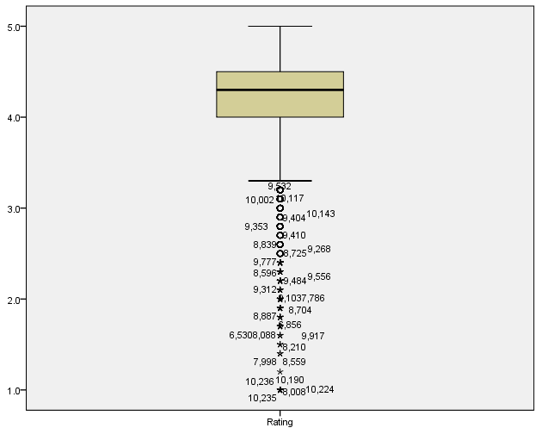Figure 1 shows the box plot for the *Rating* covariate. The line inside the box represents the median which also lies around 4.2 and shows that the data is skewed since it is not equidistant from the hinges. It is negatively skewed since it closer to the 75th percentile. The box plot shows that there are many outliers or possible outliers in this dataset.

Figure Boxplot for Rating

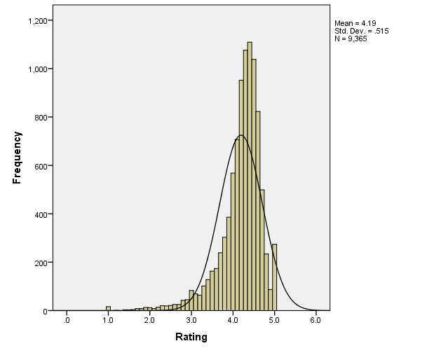The histogram for *Rating* can be seen in figure 2. It also shows the negative skewness towards the higher rating. The kurtosis of the histogram confirms that people prefer giving higher ratings that medium ones.

Figure Histogram for Rating

### Reviews

|  |  |  |  |  |
| --- | --- | --- | --- | --- |
| Reviews | Mean | | 444193.87 | 28122.928 |
| 95% Confidence Interval for Mean | Lower Bound | 389067.79 |  |
| Upper Bound | 499319.95 |  |
| 5% Trimmed Mean | | 80483.37 |  |
| Median | | 2094.00 |  |
| Variance | | 8572554850856.179 |  |
| Std. Deviation | | 2927892.561 |  |
| Minimum | | 0 |  |
| Maximum | | 8E+007 |  |
| Range | | 78158306 |  |
| Interquartile Range | | 54760 |  |
| Skewness | | 16.449 | .024 |
| Kurtosis | | 341.029 | .047 |

Table Descriptives for Reviews

Immediately it is noticeable that there is a large number of extreme cases within the *Reviews* covariate from the difference between the mean (444193.87) and the 5% trimmed mean (80483.37). The median continues to show the extreme cases because based on the median the average application has 2094 reviews whilst with the 5% trimmed mean the average application has 80483 reviews.

The range, as expected, is very large because there are applications that get no reviews and very popular applications that get millions of reviews from people all around the world. However, the skewness indicates that there are more applications that get few reviews than ones that get many reviews since the skewness value (16.449) is quite high: the distribution is shifted to the left. The Kurtosis (341.029) further amplifies the presence of outliers because it is very high which indicates that most of the values are found on the tails of the distribution curve.

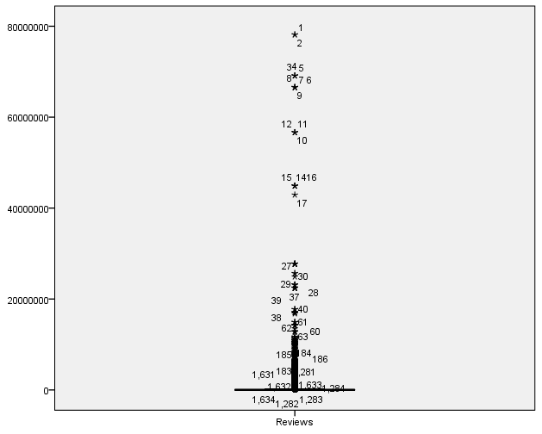Figure 2 shows the boxplot for the *Reviews* covariate. The box itself is not visible due to the scale of the plot however one can easily see the large number of outliers present by the amount of points outside the whiskers.

Figure Boxplot for Reviews

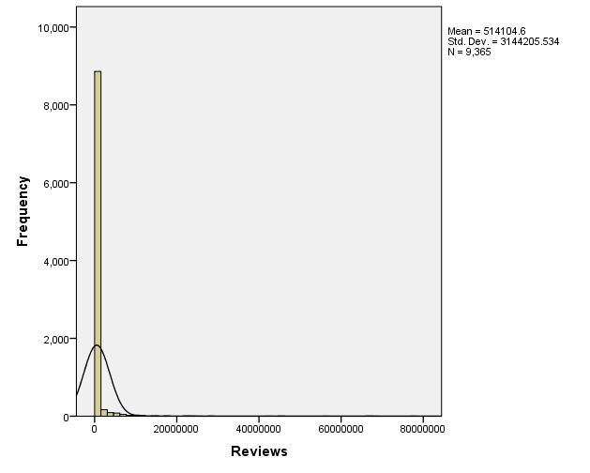Again, due to the large range of the *Reviews* covariate the scale of the histogram makes it very difficult to obtain an ideal curve. From figure 4 it is evident that there is positive skewness and hence there are more apps that receive fewer reviews.

Figure Histogram for Reviews

### Size

|  |  |  |  |  |
| --- | --- | --- | --- | --- |
| Size | Mean | | 18147.60 | 213.003 |
| 95% Confidence Interval for Mean | Lower Bound | 17730.08 |  |
| Upper Bound | 18565.13 |  |
| 5% Trimmed Mean | | 15452.56 |  |
| Median | | 9200.00 |  |
| Variance | | 491768450.859 |  |
| Std. Deviation | | 22175.853 |  |
| Minimum | | 0 |  |
| Maximum | | 100000 |  |
| Range | | 100000 |  |
| Interquartile Range | | 23400 |  |
| Skewness | | 1.704 | .024 |
| Kurtosis | | 2.508 | .047 |

Table Descriptives for Size

The mean size for the applications in this dataset is around 18Mb[1]. When the extreme cases are trimmed the average size drops to around 15Mb (5% trimmed mean) which shows that there are more outliers with larger sizes. The median is approximately 9.2Mb which is a better representation of the expected size of an application due to the great number of outliers in this dataset which comes from its relatively large size.

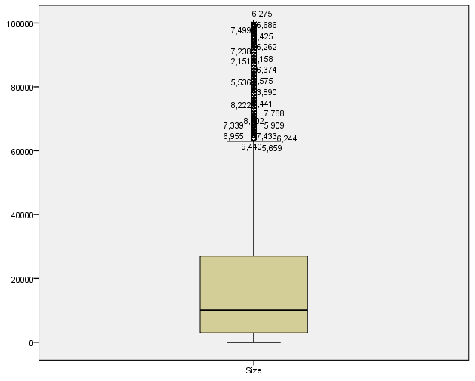Application sizes vary from less than 1Mb to around 100Mb based on the range. The skewness shows that the distribution of the sizes is shifted to the left since it is positive (1.704) which implies that there are more applications with a small size than large applications. The kurtosis lies at 2.508 which indicates that there is some distribution of sizes along the tails, but it is not too great.

The Boxplot for the size variable shows the positive skewness of this distribution since the median is shifted towards the 25th percentile. It also confirms that there are more outliers with larger sizes.

Figure Boxplot for Size

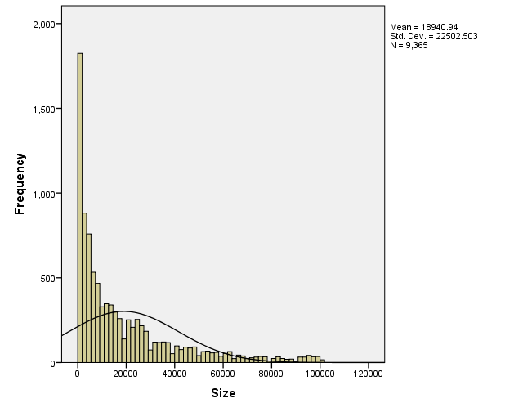Figure 6 shows the histogram for the *Size* covariate. Just like the other histograms before, it does not follow a normal distribution. In this case it has more of an exponential decay because the size of apps rapidly decreases (i.e. there are much fewer large apps). The curve complements the skewness value obtained previously.

Figure Histogram for Size

## Frequencies

### Installs

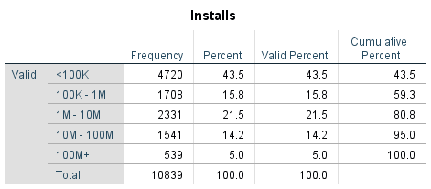

Figure Frequencies for Installs

As can be observed in figure 7, to some extent, the frequency and the number of installs is inversely proportional, i.e. in the data set there are more applications that have a small number of downloads. This is somewhat contradicting, intuitively one would think that if an application has more downloads it would have a higher chance of being selected in this dataset, but the chosen applications do not depend on the installs as they were chosen randomly. This result shows that there are much more applications that have a lower number of installs, while those with a higher number of installs appear more scarcely. These findings can be seen visually in the bar chart below.

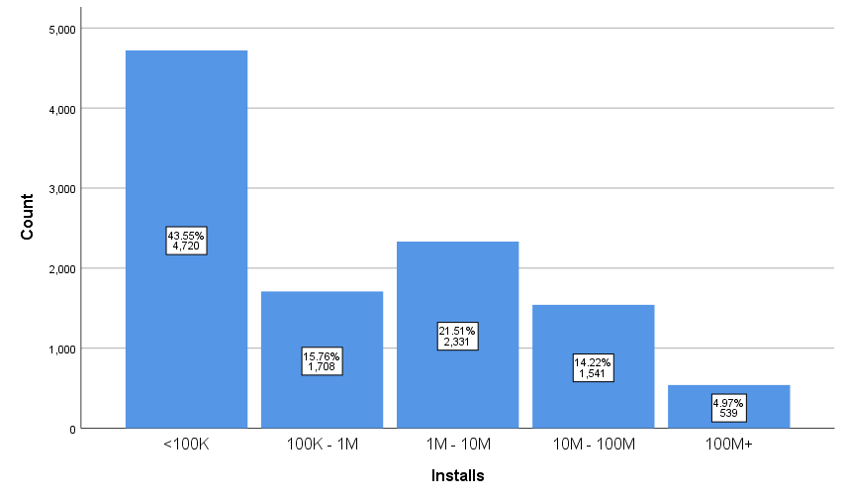

Figure Bar chat for Installs factor

### Type

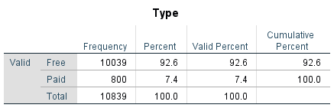

Figure Frequencies for Type

In figure 9 the frequency of the number of free and paid applications is observed. As expected, free applications have a much higher frequency than paid ones because developers know that more people will use a free app with advertisements rather than pay for one. They overbalance them with a tremendous 92.6 percent compared with the 7.4 percent for paid applications. The pie chart below gives a visual representation of these frequencies.

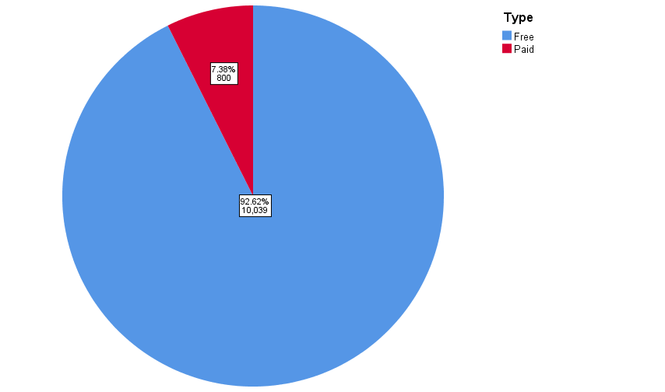

Figure Pie chart for Type factor

### Content_Rating

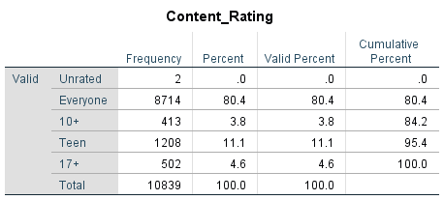

Figure Frequencies for Content_Rating

Figure 11 contains the frequencies for the *Content_Rating* factor. 'Everyone' has the highest frequency with 'Teen' being a distant second. This means that applications rated for 'Everyone' are the most common within the Google Play Store based on this dataset. Similarly, applications rated 'Teen' are the second most common with '10+' and '17+' being even more uncommon. However, this is still a lot compared to the mere two applications which are not rated. This data can also be seen in the bar chart below.

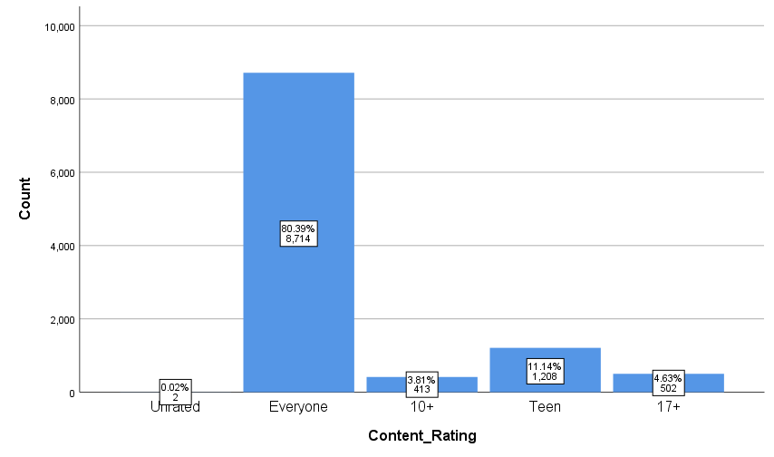

Figure Bar chart for Content_Rating factor

## Boxplots

This section will explain the obtained boxplots. Only boxplots that have to do with the dependent variable (Rating) are discussed because they are the most relevant.

### Rating vs Installs

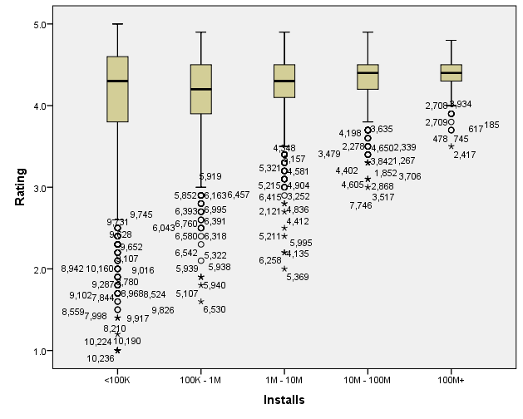

Figure Rating vs Installs Boxplots

Figure 13 shows the boxplot for *Rating* for each category in the *Installs* factor. The median rating always lies in the same general area for all categories however apps that have between 100k and 1 million installs fall slightly behind. There are more outliers for applications that have fewer installs and for the larger number of installs, the range in ratings decreases. This shows that applications with a higher number of installs have a higher average rating. The interquartile range also decreases as the number of installs increases showing that ratings are more condensed and less spread out.

### Rating vs Size

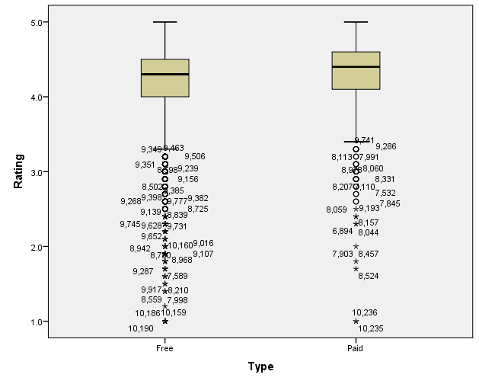

Figure Rating vs Type Boxplots

Figure 14 shows the boxplot for *Rating* for each both categories of the *Type* factor. There is no significant difference between the two categories. The Paid boxplot has a slightly higher median and less outliers that the Free boxplot but not by a large margin. This was not expected because it makes more sense to expect apps that are paid for to have a higher rating than free applications. However, the number of outliers supports this expectation because the Free boxplot has much more outliers on the lower end of the rating scale.

### Rating vs Content_Rating

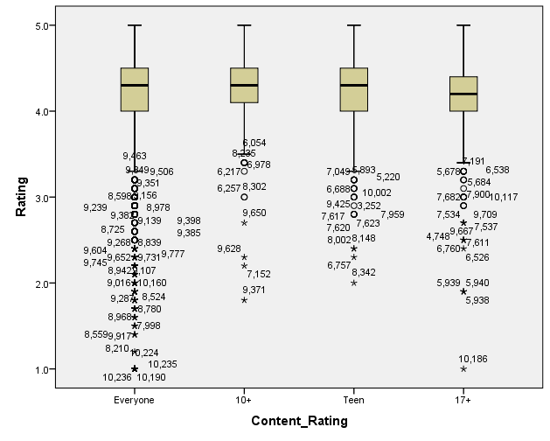

Figure Rating vs Content_Rating Boxplots

Figure 15 shows the boxplot for *Rating* for each both categories of the *Content_Rating* factor. The medians, interquartile ranges and ranges are quite similar for all categories of the *Content_Rating* factor. The Everyone category has many more outliers than the rest, but this is because the majority of the applications reside in this category as can be seen in figure 12.

## Clustered Bar Charts

This section will explain the information gathered from the clustered bar charts that were created between the *Installs* and the other two factors.

### Installs vs Type

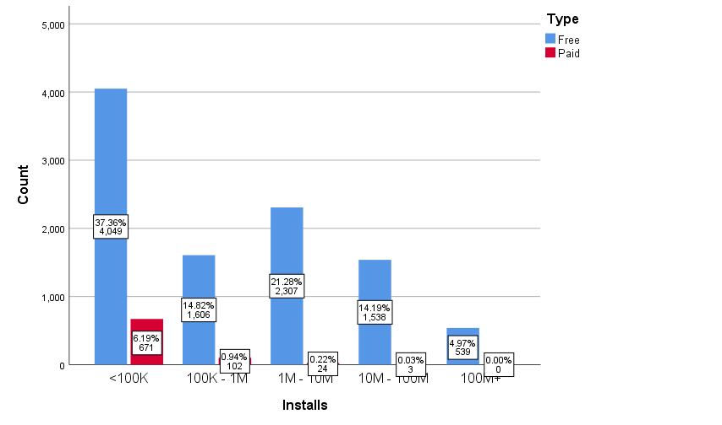

Figure Installs vs Type Clustered Bar Chart

In figure 16 free and paid apps are compared for different amounts of installs. It can be observed that there are much more installs for free applications and the highest count of installed apps which are paid for lies in the <100K range. This shows that not many people but applications on the Google Play Store.

### Installs vs Content_Rating

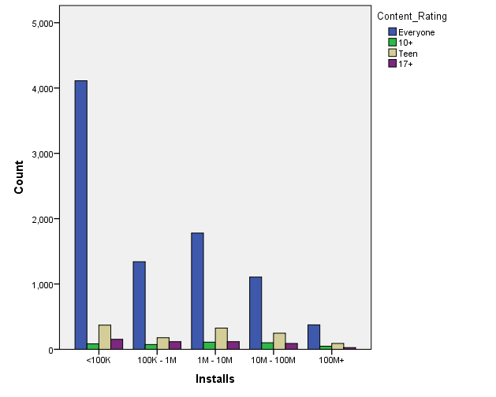

Figure Installs vs Content_Rating Clustered Bar Chart

Figure 17 shows the count of the ratings for different quantities of installs l. The rating for ‘Everyone’ decreases for larger amounts of installs (except for the 100K-1M). On the contrary the other ratings, decrease at a much smaller rate. From this chart it is evident that applications with a content rating ‘Everyone’ have a larger share of the Google Play Store.

## Scatterplots

The following section will describe how scatterplots were used to visually inspect the data, to see if any relationships between the dependent variable being observed (i.e. *Rating*) and the other covariates (i.e. *Reviews* and *Size*) exist.

### Rating vs Reviews

In this case, the *Rating* variable (on the y-axis) is plotted against the *Reviews* variable (on the x-axis), along with a line of best fit and the output is given as follows:

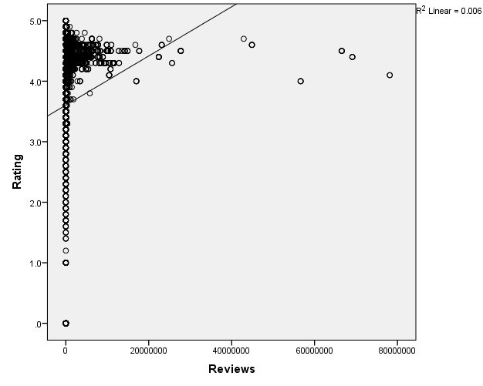

Figure 18: Scatterplot of Ratings against number of reviews.

The output seen in the figure above suggests that a linear regression model might not be a good fit for the data, since many data points seem to deviate from the line of best fit. In fact, the scatterplot suggests that a quadratic model would be more adequate for the data in question. However, this has yet to be determined when performing regression modelling on the data (see Section 5). It is also of note that data points which have a larger number of reviews seem to be quite sparse when compared to those having much less reviews, which may suggest that they are outliers. Moreover, a lot of variability can be observed in the data when the app has no (or little) reviews. This is because when an app has very few reviews, each one has a lot more weight on the final rating of the app. Hence, a single bad or good review can cause the rating of the app to spike or plummet immediately. Nevertheless, as the number of reviews increases, the range of ratings that the app can have can be seen to decrease, usually lying somewhere in the range between 4 and 5.

### Rating vs Size

In this case, the *Rating* response variable (on the y-axis) is plotted against the *Size* variable (on the x-axis) along with a line of best fit, to check for any relationships between the two variables. The output is given as follows:

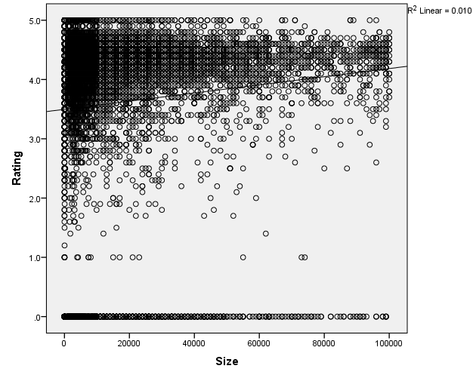

Figure 19 Scatterplot of Rating against Size (in megabytes).

As in the previous case, the above scatterplot also suggests that a linear regression model would not fit the data well, given that more points than before seem to deviate from the line of best fit. Moreover, just as before, this scatterplot also seems to show a quadratic relationship between the variables. However, as one might expect, the correlation between the two variables seems to be far less strong, which is made obvious by the fact that the data points are much more scattered when compared to the data points in the previous scatterplot. Yet, it can still be observed that as the file size of the application increases, the ratings seem to reduce down to a smaller range around the larger ratings, similarly to the previous scatterplot. In addition, it can also be seen that there is a large variability in size for applications with a low rating. Though there does not seem a very clear reason why this would be the case, one possible cause would be lack of correlation between the variables due to reasons such as inflated file sizes, or limited storage capacity on devices making it impossible for users to download the app etc.

# Hypothesis Testing

In this section, parametric/non-parametric tests are used to see if any of the fixed factor variables (i.e. *Installs*, *Type*, and *Content_Rating*) have any significant impact on the mean (or median) of the variable of interest (i.e. the *Rating* variable).

## Rating vs. Installs

For the first test, the effect of the *Installs* variable on the mean (or median) of the *Rating* variable is tested. Since the *Installs* variable has five categories, all of which are independent from each other, only the *One-Way ANOVA* or *Kruskal Wallis* test could be used for this purpose; to determine which one to use, the data is tested to see if it respects the assumptions of the *One-Way ANOVA* test:

1. For each group, the response variable must be normally distributed.
2. The variances of the groups must be equal.

The first assumption is tested using the *Kolmogorov-Smirnov* and *Shapiro-Wilk* tests, both of which test the following hypotheses:

**H0:** *Rating* follows a normal distribution for the given group of the *Installs variable*

**H1:** *Rating* does not follow a normal distribution for the given group of the *Installs variable*

The outputs of the tests were computed in SPSS and can be seen below:

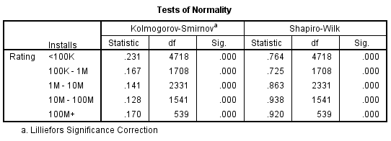

Figure Outputs of Normality tests for each different ‘Installs’ category.

For every category, the p-value of both tests is zero, which is far less than the level of significance (which is 0.05). Hence, the null-hypothesis is rejected for all cases, and the response variable does not follow a normal distribution for any category. This can also be confirmed by looking at the *Q-Q plot charts*, which shows that the data points for each category deviate a lot from the expected normal distribution:

Given that one of the assumptions of the *One-Way ANOVA* test is not upheld, the non-parametric version of the test (i.e. Kruskal Wallis) must be used to check the influence of the *Installs* variable on the *Rating*. In this case, the following hypotheses are tested:

Figure Q-Q plots of all the 'Install' categories

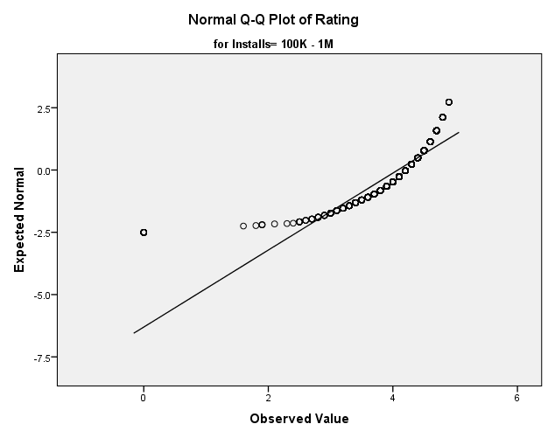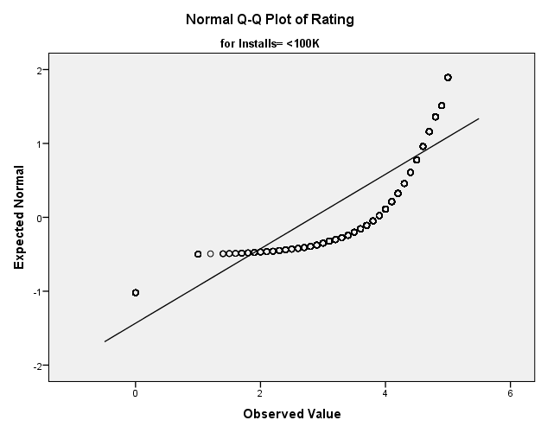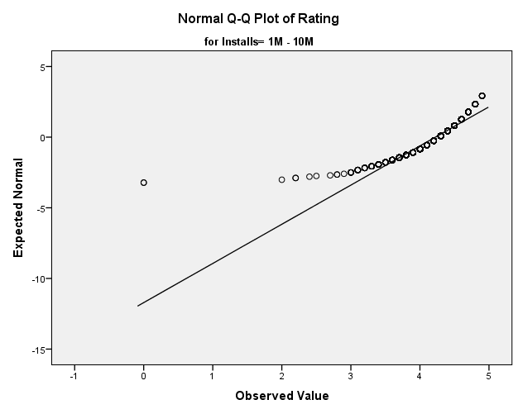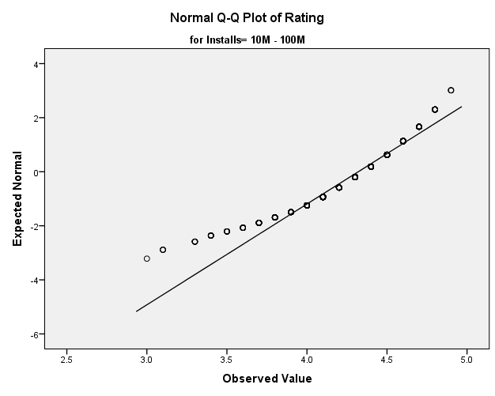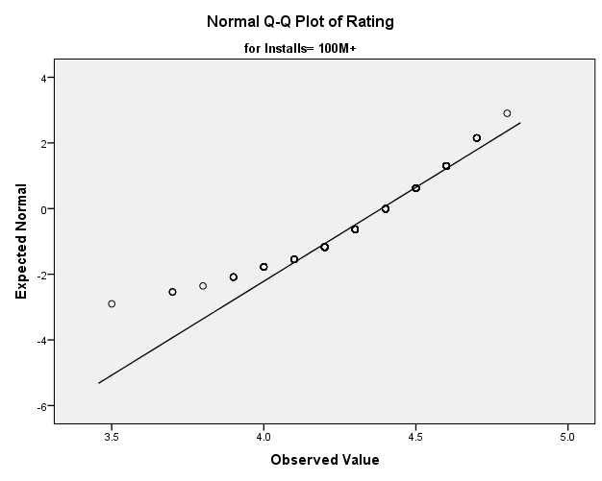

**H0:** The median values of *Rating* are the same for all categories of *Installs*

**H1:** The median values of *Rating* are different for the categories of *Installs*

The test is performed in SPSS and it gives the following outputs:

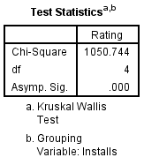

Figure Outputs of the Kruskal Wallis test

As be seen above, the p-value of the test, which is zero, is much less than the level of significance (0.05). Hence, the null-hypothesis is rejected, and the median *Rating* of the different groups are not the same. Now, since the medians of the groups are different from each other, a Post-Hoc analysis is conducted to verify where these differences lie. Each pairwise comparison consists of a *Mann-Whitney* test which tests the following hypotheses:

**H0:** The median ratings of the *Rating* of the two groups are the same.

**H1:** The median ratings of the *Rating* of the two groups are different.

The test is conducted in SPSS and the following output is obtained:

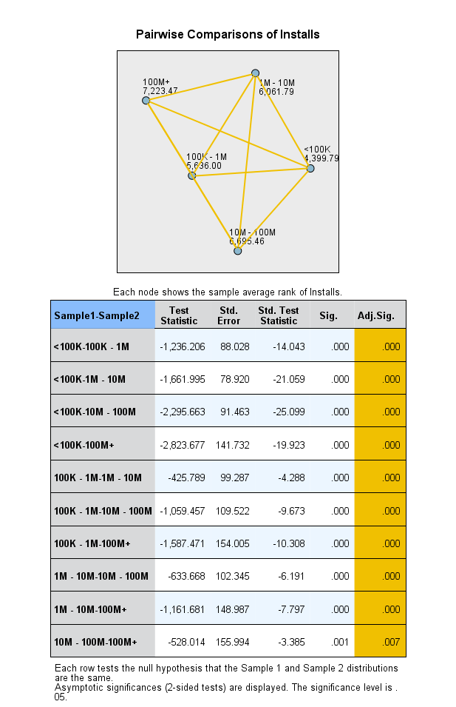

Figure Post-hoc pairwise comparisons of each 'Install' category

Each of the tests conducted above can be seen to have a p-value far below the level of significance (0.05). Hence, for each pairwise comparison, the null-hypothesis is rejected, and each interval of the *Installs* variable has a distinct median value of the *Rating* variable.

Next, to confirm the result found above, the sample mean and median *Rating* of each group were computed:

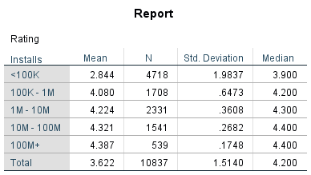

Figure 24 Sample means and medians of each category in 'Installs'

The output above confirms the results found using the Post-hoc analysis, suggesting that as the number of installs increases, the rating of the application also increases.

## Rating vs Content Rating

In the second test, the effect of the *Content Rating* variable on the mean (or median) of the *Rating* variable is tested. Similarly to the previous test, since the *Content Rating* variable has four independent categories, either the *One-Way ANOVA* or *Kruskal Wallis* test should be used; the choice between the two is once again made by checking if the data fits the assumptions necessary to use the *One-Way ANOVA* test.

To check if the *Rating* variable is normal for each group in *Content Rating*, the *Kolmogorov-Smirnov* and *Shapiro-Wilk* tests are used to verify the following hypothesis:

**H0:** *Rating* follows a normal distribution for the given group of the *Installs variable*

**H1:** *Rating* does not follow a normal distribution for the given group of the *Installs variable*

The output of the tests given by SPSS can be seen below:

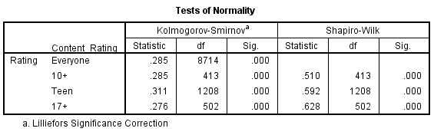

Figure Output of normality tests for each group of the 'Content Rating' variable

The output above shows that none of the categories have a p-value above the level of significance (0.05). Therefore, the null-hypothesis is rejected, and the *Rating* variable does not follow a normal distribution for any of the *Content Rating* variable’s groups. To confirm this result, the *Q-Q plot* charts for the different categories were also created:

In the images above, the data points for all groups can be seen to deviate from the expected normal distribution, hence the result given by the *Kolmogorov-Smirnov* and *Shapiro-Wilk* tests is confirmed.

Figure Q-Q plot charts for the different categories of 'Content Rating'

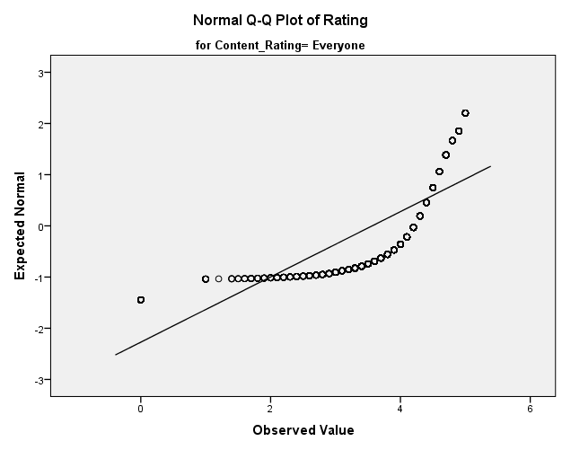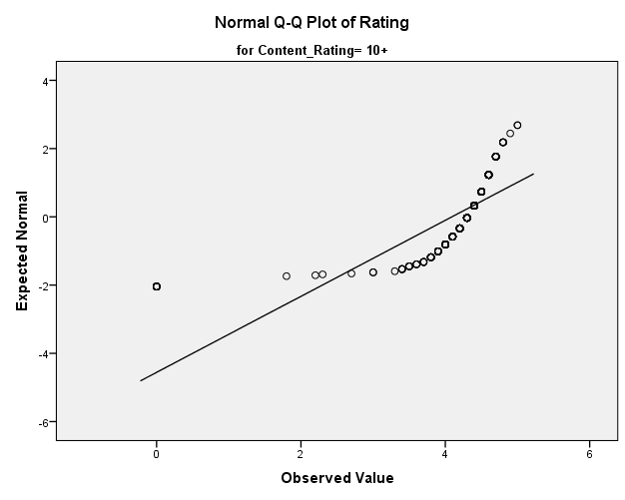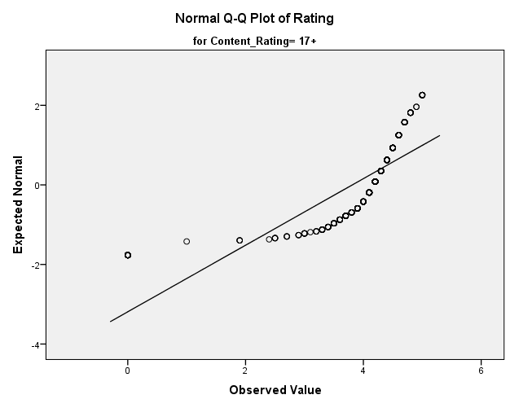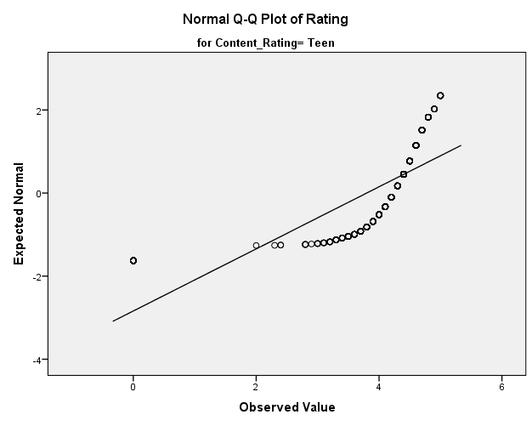

Hence, since one of the assumptions necessary for the *One-Way ANOVA* test is not upheld, the *Kruskal Wallis test* must be used to test if there is any significant difference between the medians of the different dependent variables. The *Kruskal Wallis test* verifies the following hypotheses:

**H0:** The median values of *Rating* are the same for all categories of *Content Rating*

**H1:** The median values of *Rating* are different for the categories of *Content Rating*

The output for the test can be seen in the image below:

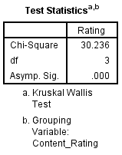

Figure 27 Outputs of Kruskal Wallis test

Since the test gives a p-value of zero, at a level of significance of 0.05 the null-hypothesis is rejected. Thus, the median *Rating* is different for the categories of the *Content Rating* variable. To check where the discrepancies in *Rating* lie specifically, a Post-hoc analysis is performed, and the medians of each group were compared in a pairwise manner using the *Mann Whitney* test. For each pair of groups, the following hypothesis were tested:

**H0:** The median ratings of the *Rating* of the two groups are the same.

**H1:** The median ratings of the *Rating* of the two groups are different.

When the tests are performed in SPSS, the following output is given:

The output above shows that at a 0.05 level of significance, only the tests considering the difference between the ‘*10+’* category and some other category reject the null-hypothesis. Hence, only the median of the ‘*10+’* category seems to have any significant difference from the other variables. On the other hand, the categories ‘*Everyone*’, ‘*Teen’* and ‘*17+*’ all seem to have the same median.

Figure Output of the Post-Hoc analysis for each group in 'Content Rating'

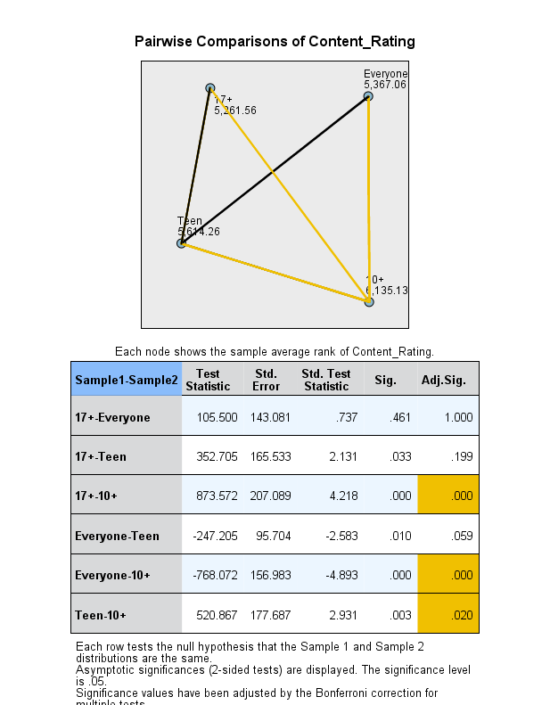

To confirm these findings, the sample means and medians for all the independent groups have been calculated in SPSS, and can be seen in the image below:

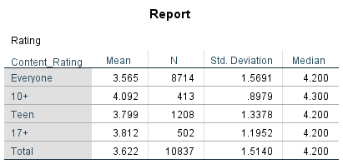

Figure Means and medians of all the categories in 'Content Rating'

The output shown in the above table seems to confirm the results of the Post-Hoc analysis; for the means and medians of the ‘*Everyone*’, ‘*Teen’* and ‘*17+*’ categories all appear to be similar to each other. Moreover, the mean and median of the ‘10+’ category is in fact higher than the other categories, further confirming the results found previously. In addition, this output also suggests that mobile applications targeting to this demographic may achieve a higher rating than if it were to target any other demographic of phone users.

## Rating vs. Type

In the third and final test, the data was to be verified to see if there is any difference in the mean (or median) *Rating* of paid and free apps, where ‘paid’ and ‘free’ are categories in the fixed factor variable called *Type*. Given that *Type* has only two independent categories, this could be done using either the *Independent Samples T-test* or the *Mann-Whitney* test; to determine which one was needed, the data was verified to see if it upheld the assumptions of the *Independent Samples T-test*, which include the following:

1. Both samples must come from normal populations.
2. Both populations must have equal variances.

The first assumption was verified by performing the *Kolmogorov-Smirnov* and *Shapiro-Wilk* tests on the *Rating* variable for both ‘paid’ and ‘free’ apps. The following hypotheses were tested:

**H0:** *Rating* follows a normal distribution for the given type of app (free or paid)

**H1:** *Rating* does not follow a normal distribution for the given type of app (free or paid)

The results are computed in SPSS and can be seen in the following table:

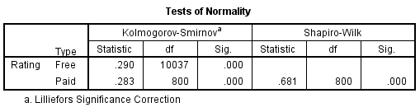

Figure Outputs of Normality tests for 'paid' and 'free' apps

In this case we can observe that both sets of p-values are significantly less than the level of significance (0.05). Hence, the null-hypothesis is rejected, and the *Ratings* variable does not follow a normal distribution for ‘free’ and ‘paid’ apps. To confirm this result, the *Q-Q plot charts* of the two categories were also created:

Figure Q-Q plot charts for free and paid apps.

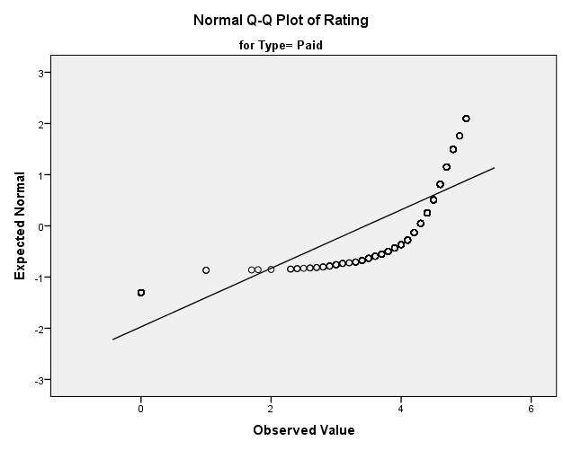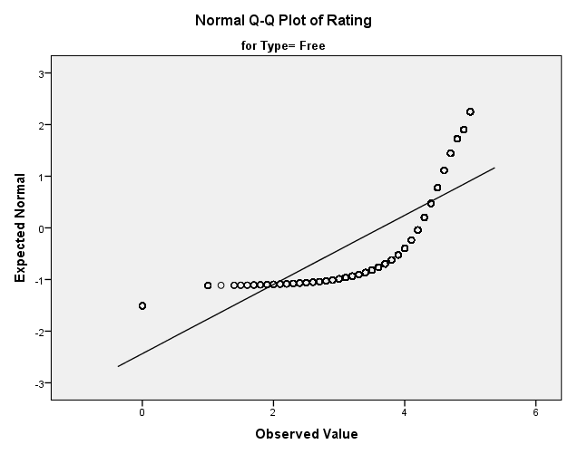

As can be seen in the figure above, the data points deviate significantly from the expected normal distribution, confirming the results found by the *Kolmogorov-Smirnov* and *Shapiro-Wilk* tests.

Therefore, since one of the assumptions of the *Independent Samples T-test* is not upheld, to test if there is any difference between the medians of the two groups, the *Mann-Whitney* test must be used. The *Mann-Whitney* test checks for the following hypotheses:

**H0:** The median *Rating* of free and paid apps are the same.

**H1:** The median *Rating* of free and paid apps are different.

The results of the test are computed in SPSS, and are given as follows:

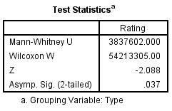

Figure Outputs for the Mann-Whitney test

Since the p-value (0.037) of the test is less than the level of significance (0.05), the null-hypothesis is rejected, and the median *Rating* of free and paid applications is not the same.

To verify the results of the hypothesis test, the sample means and medians of free and paid apps were calculated in SPSS:

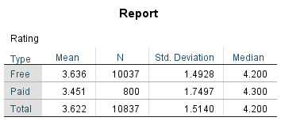

Figure Table containing sample mean and median of paid and free apps.

Comparing the two medians, it is apparent that they are not the same, and that the median of paid apps is larger, confirming the result found by the *Mann-Whitney* test. However, when comparing the sample means, the mean of free apps is the highest, which contradicts the results of the test as well as the sample medians. As such, the output does not make it clear if a free or paid application is preferable to obtain a higher rating.

## Correlations

This section deals with correlations between the dependent variable (Rating) and the other covariate variables. Pearson’s correlation was not used because from the scatter plots in Section 3 it is evident that there is not a linear relationship between these variables. Therefore, the Spearman correlation was used. For both of the following cases the following hypothesis tests were used:

**H0:** Variables are independent – r = 0

**H1:** A relationship exists between the variables and can be modelled by some monotonic function – r ≠ 0

### Rating vs Reviews

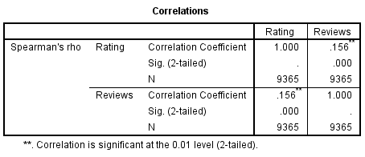

Figure Rating vs Reviews Correlation

Figure 34 shows that the Spearman’s correlation coefficient between *Rating* and *Reviews* is 0.156 which indicates that there is a weak monotonic relationship between the two variables since the p value is < 0.05 (**H0** is rejected).

### Rating vs Size

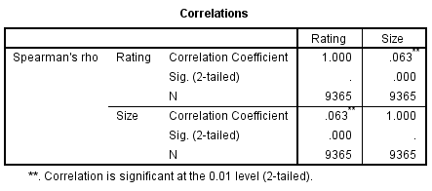

Figure Rating vs Size Correlation

Figure 35 shows that the correlation coefficient between *Rating* and *Size* is 0.063 which indicates that there is a weak monotonic relationship between the two variables since the p value is < 0.05 (**H0** is rejected).

# Modelling

# Appendix

## References

M. B. Inguanez, F. Sammut, D. Suda , *Statistical analysis using SPSS and R software*, pages 108-111

1. Results are in Kb