## Task 1

1. User input
2. 2 numbers
3. Addition

## Task 2

Start

Declarations  
num number1  
num number2

num sum  
sum = number1 + number2

output "Enter number 1 "

input number1

output "Enter number 2 "

input number2

output "Sum is: " + sum

stop

## Task 3

|  |  |  |  |
| --- | --- | --- | --- |
| Input | Expected Output | Actual Output | Description |
| 42  8 | Enter number 1  Enter number 2  Sum is 50 | 42  8  50 | Testing the method's main logic, it should ask for two inputs, and then output the sum of the entered numbers. |

## Task 4

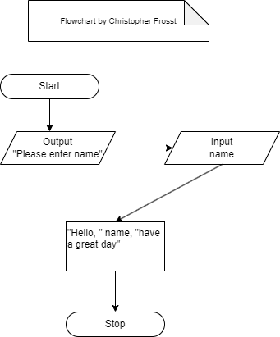

## Task 5

