Pre-Lab 03

Task 1

Vehicle Identification Number (VIN): String

Mileage (km): num

Invoice Price (Dollars): num

[1] J. Unrau, “How to read a VIN (vehicle identification number),” YourMechanic Advice, https://www.yourmechanic.com/article/how-to-decode-a-vin-vehicle-identification-number-by-jason-unrau (accessed Mar. 5, 2024).

Task 2

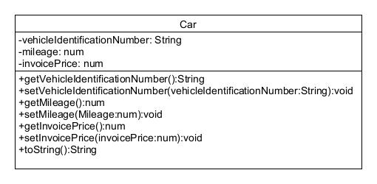

Task 3

getMileage()

return mileage

setMileage(num mileage)

this.mileage = mileage

return

/\*Mileage should be formatted to 1 decimals, Invoice price should be formatted to 2 decimals, Invoice price should start with ‘$’ char, ‘(km)’ string should be placed after Mileage\*/

toString()

Declarations

String report

report = vehicleIdentificationNumber + “ “ + Mileage + “(km), “$” + invoicePrice

return report

Task 4

