**Table of Contents**

**Phase I- Project Planning**

Pg 2. Letter of Consent

Pg 3. Organization Description

Pg 4. Organizational Chart

Pg 5. System Request

Pg 7. Feasibility Analysis

Pg 9. Project Time Frame

Pg 10. Project Tasks

Pg 11. Team Member Responsibilities

Pg 12. Work Breakdown

Pg 13. Work Sequence (Gnatt Chart)

Pg 14. Team Roles

Pg 15. Project Charter

Pg 16. Project Standards

Pg 17. Risk Assessment

Pg 19. Interview Questions

Pg 20. Survey Questions

Pg. 21 Competition

**Phase II- System Analysis**

Pg 22. Key Stakeholders

Pg 23. Crew Interviews

Pg 25. Customer Survey Results

Pg 27. Detailed Work Processes

Pg 29. Use Case: Customer at Check-in

Pg 30. Context Diagram Normal Course

Pg 31. Context Diagram Alternative Course

Pg 32. Data Flow Diagram

Pg 33. Entity Relationship Diagram

Pg 34. Project Gantt Chart

**Phase III- System Design**

Pg 36. System Acquisition Strategy

Pg 37. GUI Design

Pg 50. Storyboard Design

Pg 52. Report Design

Pg 53. Application Logical Design

Pg 55. Structure Chart

Pg 56. Program Specifications

Pg 65. Pseudocode

Pg 68. Application Environment

Pg 70. Application Architecture

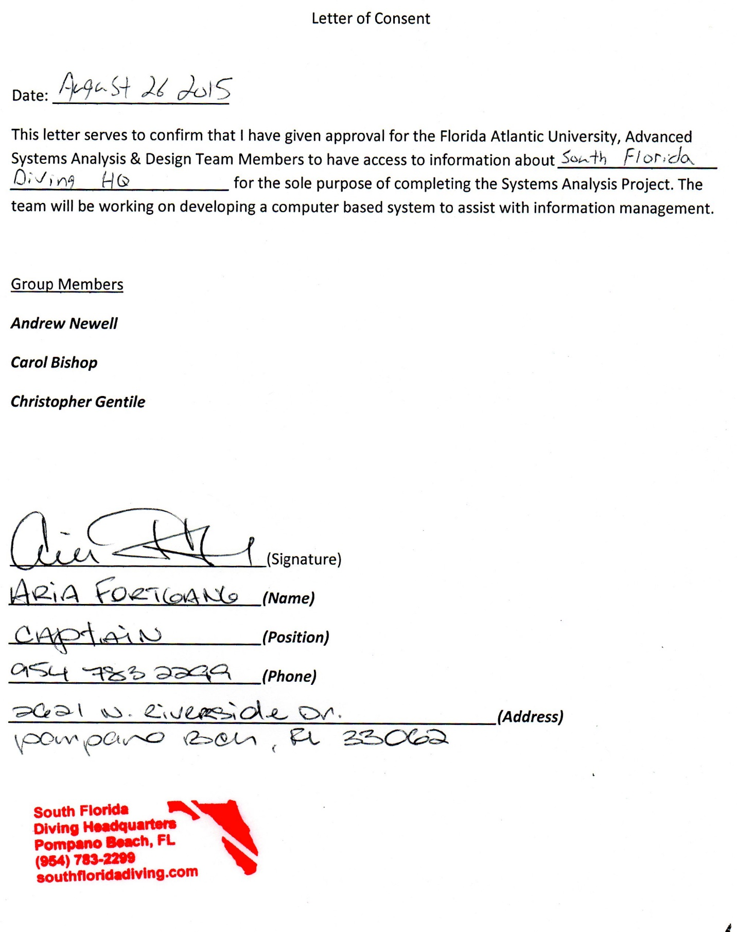

**About South Florida Diving Headquarters**

South Florida Diving Headquarters (SFDH) began operation in the early 90’s. The owner, Jeff Torode, and his partner, Mike Rourbaugh, began with a single boat and over the years grew the company into one of the biggest dive charters in South Florida. As a dive charter the company provides boat trips for scuba divers and snorkelers. The dive sites are reefs and shipwrecks and range in depth from 15 feet to over 200 feet. Located just south of the Hillsboro inlet in Pompano Beach, the dive shop has dock space closer to the open ocean than any other shop in the area. This convenience is a large push factor that helps Jeff fill over 80 reservations, on three boats, twice a day.

The biggest goal for the company is to offer a safe and enjoyable trip for its customers. This process starts when customers show up to check in. Every customer has to fill out a liability waiver, decide if they need any rental equipment, pay, and be directed to the appropriate boat for the trip they reserved.

**Organizational Chart**

At SFDH there are 5 key positions operating in 3 lines of work. All of which is overseen by the owner, Jeff Torode.

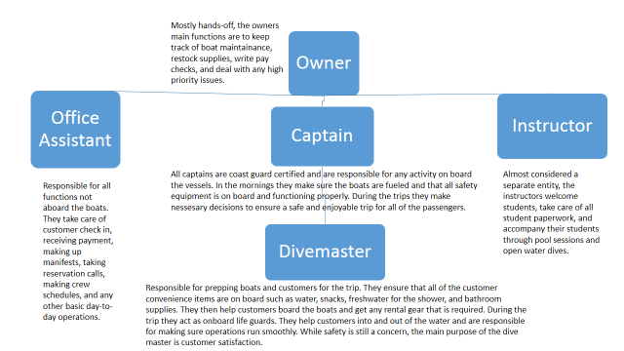

**System Request**

Our observations of the business processes at SFDH have lead us to believe that there are some processes that could improve with the help of a new system. Therefore, the following system request has been procured.

**Sponsor:** Aria Fortgang, Captain

**Business Need:** With an excess of 100 customers on the dock at times, the system needed should help smooth out the check in process. Customers and crew are often overwhelmed during boarding times and a system to help automate the check in process and keep track of equipment rentals is much needed.

**Business Requirements:**

* Tablet based system
* Electronic signature for waivers
* Step by step check in with prompts for gear rental, boat assignment, and payment
* Should forward needed rental gear and boat assignment to a display that can be seen by crew
* Automatically generated manifest
* Payment should automatically sync with quickbooks or similar program

**Business Value:** This system will benefit the company by:

* Allowing crew to be more efficient
* Helping the office assistant manage check in
* Improving customer satisfaction
* Ensuring all customers receive the gear and services they pay for
* Keeping more accurate records of manifests to reduce liability
* Saving money on ink, paper, other basic supplies

**Special Issues:**

* Any hardware needs to be somewhat weather resistant
* Software must be compatible with current finance software
* Any program should be extremely user friendly and available with multiple languages, particularly English and Spanish
* Software should be easily customized to accommodate changing services

**Feasibility Analysis**

Before moving forward we must analyze the feasibility of this project. We have determined there is a need for a new system and in this section we will ask the questions “Can we build it?” “Should we build it?” and “If we build it, will they come?”

**Technical Feasibility:**

Familiarity with the applications: The applications that will be used to create this system are deigned to be user friendly. Almost everyone has some experience dealing with a tablet based business system. They are becoming increasingly popular in restaurants and similar businesses. Most customers should have no problem going through the steps that are prompted by the system. As analysts, this software has become somewhat main stream and is designed to be easy to implement. Few issues should occur by either the analysts or the users.

Familiarity with technology: While the company is not familiar with this technology it should cause minimal disruption for the crew. The technology is well established and user friendly by design. Most of the crew is use to adapting to new policies and procedures so this system should not interfere with any business operation.

Project size: This project is a fairly small one. With little new hardware required and using applications that are readily available, the project requires very little investment of money or time. Therefore the size presents little risk.

Compatibility: At the moment SFDH has little established technology. All financial entries are done by hand, manifests are created in excel, all waivers are hand signed, and most of the time any gear needed is communicated only orally. With no major systems to have to integrate into the new one, compatibility presents little risk.

**Economic Feasibility:**

Cost:

The hardware required is two tablets (iPads), a display for the crew, card readers, and any other small hardware. The cost would be around $1000.

The system will require a couple of applications to run on the tablets and to integrate current computer systems and should not cost more than $500.

Installation and setup costs would be no more than $500.

Benefit:

Most of the benefit of this system will not be of monetary value. But we will assign value to the following on a monthly basis:

Savings on office supplies: $100

Increased employee efficiency: If the system saves the office assistant 1 hour a day it is worth about $300 a month.

Increased customer satisfaction: If the company gets 1 extra customer a week, either returning because of good service or a new customer that read a good review, it is worth about $200 a month.

The total benefit per month of this project would be roughly $600.

Operating Costs: Most of the software would require annual subscriptions. Initial research shows that the annual cost would be around $1000. Depreciation on the equipment could be calculated to around $200 a year. (Based on a 5 year life for all hardware.)

ROI: 125% in the first year.

**Organizational Feasibility:** This project is highly feasible from an organization standpoint. The owner has to put forth very little upfront investment for a large return.

The system should be easily accepted by all of the staff because they are always looking for new ways to improve work conditions and increase customer satisfaction.

The users of this system are mostly the customers. Because it will be designed with users in mind, they should have no problem accepting this change either.

Overall this system has almost no risk. With its ease of integration and the lack of up-front investment, it should be very easy for every stakeholder to take advantage of it.

**Project Time Frame**

This project will be divided into 4 phases as seen below. The total estimated time for the project, including planning and implementation, is around 6.5 weeks.

|  |  |  |  |  |
| --- | --- | --- | --- | --- |
|  | Planning  Phase | Analysis  Phase | Design  Phase | Implementation  Phase |
| Estimates based on actual planning phase time (in weeks) | **Actual:**  2 | **Estimated:**  3 | **Estimated:**  1 | **Estimated:**  .5 |

**Project Tasks**

|  |  |  |  |  |  |  |  |
| --- | --- | --- | --- | --- | --- | --- | --- |
| Rank  # | Name of Task | Collaboration Needs | Resource Needs | Start/  Due Date | Anticipated Obstacle(s) | Estimated Time | Actual Time |
|  | Obtain two mobile tablets | Coordinate with SFDH on preferred tablets | Funds to purchase tablets | 10-1/  10-2 | Disagreements on a preferred operating system | 1 hour |  |
|  | Determine which applications to use/install | Discuss with SFDH on what would suite their needs | Knowledge on business related applications/  Development | 10–2/  10-6 | Time on deciding which technology to utilize | 48 hours (2 days non-continuous) |  |
|  | Install application on tablets | Analysts’ work together for smooth installation | Technical knowledge dealing with installation methods | 10-7/  10-7 | Unseen technical difficulties | .5 – 1 hour |  |
|  | Customize application to SFDH specifications | Discuss with SFDH sign in processes and waiver procedures | Knowledge on current SFDH business procedures | 10-8/  10-10 | Learning curve of the new application | 8 hours (throughout 2 day period) |  |
| 5. | Test application | Take the necessary time with SFDH staff to test all possible outcomes | Time allotted by employees to help test application | 10-10/  10-14 | This will be the most time consuming part of planning phase | 24 hours |  |
| 6. | Implement New Application! | | | | | | |

The following tasks all need to be completed before implementation can occur. The name, needs, estimated activity time, and possible obstacles for each task are listed.

**Team Member Responsibilities**

Each team member is responsible for the following duties.

|  |  |
| --- | --- |
| Christopher Gentile | Research applications SFDH will most benefit from, oversee proper installation, test application, train SFDH employees on app usage after implementation |
| Andrew  Newel | Work with SFDH and design application UI best suited for business, oversee proper installation, application tester, train SFDH employees on app usage after implementation |

**Work Breakdown**

The following is a breakup of each task needed for the entire project from planning to product delivery.

|  |  |  |
| --- | --- | --- |
| Work Break Down Structure | Start Day | Time |
| I.) Acquire the specifics of current problem   1. Meet with Aria Fortgang (Captain) 2. Meet with SFDH employees before peak business hours 3. Monitor business operations during peak hours 4. Monitor the current system being used 5. Take note on why a new system needs to occur while deciding if any current procedures are worth keeping 6. Identify main problems dealing with operations inefficiency 7. Meet with Aria and review conclusions 8. Research mobile business applications best suited for SFDH operations | **1/3**  **1/3**  **1/4**  **1/4**  **-**  **1/6**  **1/8**  **1/11**  **-**  **1/12** | **2.0 hours**  **1.0 hours**  **2.0 days**  **2.0 days**  **-**  **2.0 days**  **3.0 days**  **3.0 hours**  -  **2.0 days** |
| II.) Implement New System   1. Acquire tablets and check in monitor 2. Install application software onto tablets 3. Customize application UI based on SFDH business needs 4. Sync application output with monitors so crew is able to see customer inputs for gear rentals 5. Sync application with SFDH QuickBooks | **1/14**  **1/14**  **1/15**  **1/17**  **1/17** | **1.0 hours**  **1.0 hours**  **2.0 days**  **-**  **4.0 hours**  **4.0 hours** |
| III.) Test New System   1. Test UI interface and ease of use 2. Test gear rental input syncing 3. Test QuickBooks Syncing 4. Test System as a whole | **1/18**  **1/18**  **1/18**  **1/18** | **1.0 days**  **1.0 days**  **1.0 days**  **2.0 days** |
| IIII.) Deploy New System   1. Deploy new application for public use 2. Monitor system and be sure of success | **1/20**  **1/20** | **1.0 days**  **2.0 days** |

**Work Sequence**

A graphical representation of when each of the tasks in the previous diagram will be completed.

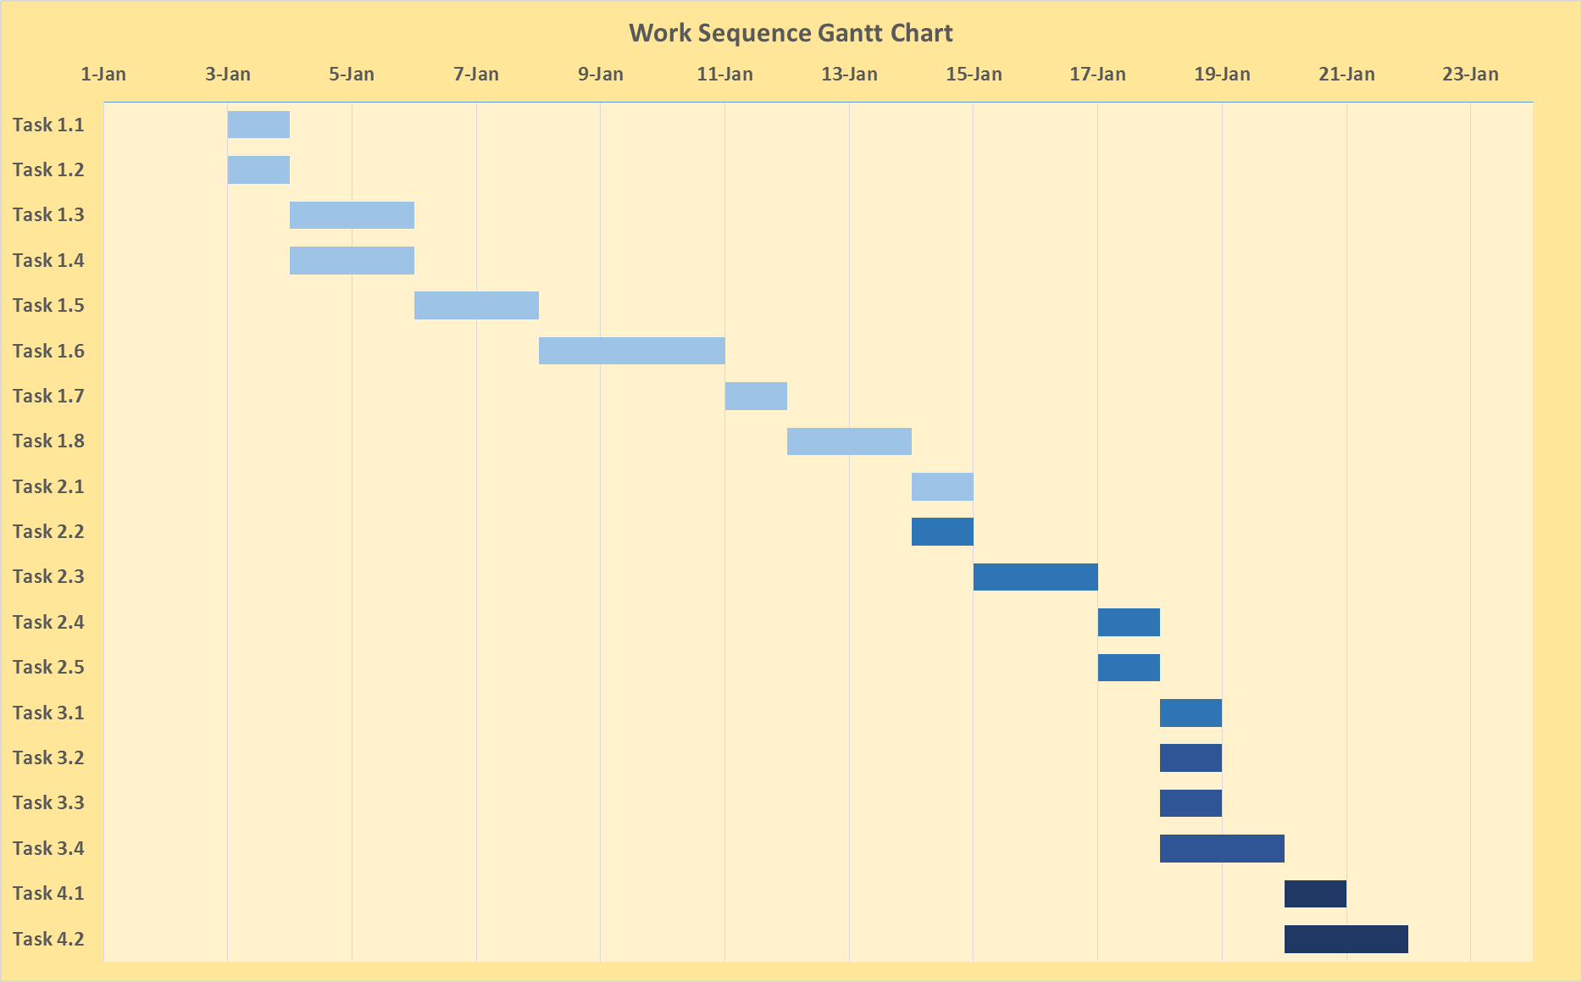

**Team Roles**

To ensure the most efficient production of this system, the following roles will be assigned to each project member. Dividing up work and assigning these duties will help keep members on task and making progress within their respective areas.

|  |  |  |
| --- | --- | --- |
| Project Manager | Christopher Gentile | Oversee the project as a whole to ensure that tasks are being completed on time and with the proper quality. |
| Infrastructure analyst | Andrew Newell | Ensure that the proposed system will fit with the company’s current infrastructure. |
| System Analyst | Christopher Gentile | Design the information system |
| System Analyst | Andrew Newell | Design the information system |

**Project Charter**

As a basic set of rules we have developed the following project charter. While roles and responsibilities may be flexible, this is the overall goal and expectations for the team.

**Objective**: To create an information system to aid SFDH in the check-in process and in keeping more accurate records. The system should also help improve overall customer satisfaction.

**All team members will:**

-Answer email and other communication in a timely manner

-Have any changes to documents or designs approved by the other team members

-Lend help to other team members in the interest of staying within time limits

|  |  |
| --- | --- |
| Communication  Standards | * All project specific problems should be communicated in writing through email * All emails pertaining to the project will Cc: Aria, Andrew, and Christopher * Phone calls for quick inquiries are permitted, as long as it is documented in a project call log for reference on what was discussed |
| Procedural  Standards | * Weekly progress project meetings on Wednesdays between Andrew and Christopher * Bi-weekly progress project meetings on Wednesdays with Aria, Andrew, and Christopher * Record each task’s completion as soon as they are completed * If a task arises, becomes obsolete, or needs refinement during the life of the project, a decision for that task must be thought through by Andrew and Christopher, and be agreed upon by Aria. * All notes on operations taken during planning should be kept together in an organized fashion based on date and times taken |
| Hardware/Software  Standards | * Apple iPad will be the tablets used for this project * If SFDH agrees, warrantees should be purchased as well * Most current iOS will be installed and utilized for this project * iPads will be locked solely for business use * SFDH application will be the only application, outside of the pre-packaged applications, installed on the iPads * iPads will be housed in the most protective, weather-resistant casing available |
| Application Design  Standards | * Application will be ocean themed – lots of vibrant blues to appeal to users entering their data * Data entry will be available in both English and Spanish * User will be prompted first for their name, age, and email address * User will then be prompted for gear rental information and payment information * User will confirm all information is accurate * User will be informed on the application of which boat they are assigned to * All this information will be transferred to SFDH crew members * Payment information will sync with SFDH QuickBooks and/or a database to enter into QuickBooks at the end of the day |
| Security Standards | * All information will be accessible only through virtual private networks * iPads will be set up to ensure in the event of theft, iPads will be disabled * Only management should know the pass codes to unlock the iPads * iPad passcodes should not be simple passcodes (no numbers, worded passwords instead) * Wi-fi password should be changed every month to further increase security for sensitive customer data |

**Project Standards**

In order to ensure that the project is not hindered at any point the following standard are to be put in place. These standards will set the foundation for the quality of work that will be seen in the final product

**Risk Assessment**

Lastly, before the project can move forward, a thorough risk assessment must be completed. Below are 5 potential threats that could occur once the system is up and running. Each threat (or risk) is accompanied by a likelihood rating, potential impacts, and ways to address the problem.

|  |
| --- |
| RISK #1: Loss of Internet |
| Likelihood of risk: moderately low |
| Potential impact on the project: If internet were to go out, the application would be useless for syncing information for the time there is no internet. It would defeat the purpose of letting the SFDH crew know the needs of their customers for gear as well. Major loss of efficiency for the crew after getting use to the ease of data syncing for gear rentals. |
| Ways to address this risk: Have a data log specifically meant for manually logging information in the event that there is no internet. |
| RISK #2: iPad Theft |
| Likelihood of risk: low |
| Potential impact on the project: Loss of money not only by theft, but having to buy a replacement for the stolen iPad. Potential security issues resulting from theft. |
| Ways to address this risk: Monitor iPad usage and only allow the tablets to be used in store. Utilize SFDH security cameras in case of theft. iPad will be disabled if theft occurs. |
| RISK #3: Damaged/malfunctioning iPad |
| Likelihood of risk: Moderately low |
| Potential impact on the project: If carelessness of an employee or customer occurs, depending on the level of damage, the damaged iPad could be useless until fixed or replaced. If it needs to be replaced and iPad is out of warrantee, loss of money would also occur. Loss of efficiency would be present for as long as it takes to fix or replace the damaged iPad. |
| Ways to address this risk: Obtain the best protection cases on the market. In the event that an iPad is broken, under warrantee, fixing would not be an issue. Out of warrantee, there are still plenty of low cost businesses that fix iPads that are broken. |

|  |
| --- |
| RISK #4: Application Malfunction |
| Likelihood of risk: Moderate |
| Potential impact on the project: If malfunctioning occurs, it could potentially affect both iPads. Even if only one is affected, operations for that day with slow down considerably. |
| Ways to address this risk: It’s important SFDH employees are trained and are comfortable with this application. If they cannot troubleshoot the issue, the application’s help desk will have to be contacted. |
| RISK #5: Security breach of SFDH customer information |
| Likelihood of risk: Very low |
| Potential impact on the project: If a security breach were to occur, the results could be pretty harmful to both SFDH and its customers. |
| Ways to address this risk: To ensure maximum security, employees will be able to access customer information through a virtual private network. Wi-Fi passwords could also be changed on a monthly basis for added security. |

**Interview Questions**

Part of developing a useful and worth-while system is to know how the stakeholders in the company feel about it. Gathering employee input will ensure a system that addresses as many of their concerns as possible. We will ask some of the employees at SFDH the following questions to see how our system can help them.

1. What part of the day is hardest to deal with?
2. What is the biggest mistake made during check-in?
3. How do customers respond to a busy dock?
4. What would be the most helpful in eliminating confusion on the dock?
5. How often are manifests incorrect before departure?
6. Do customers ever not get what they ask for because of miscommunication?
7. Would you see the benefit in an integrated check in system?
8. How much do you think customer satisfaction would increase with a new check-in process?
9. How would that benefit you personally?
10. How would the company as a whole benefit?

**Survey Questions**

Perhaps the most important stakeholder in a service industry such as dive charters is the customers. The following questions will be distributed to get a customer point of view on how well the shop functions and to see how our system can help them better enjoy their experience at SFDH.

1. What was the least enjoyable part of your day?
2. What was the most enjoyable part of the day?
3. What was your impression of crew on the dock?
4. How would you feel about a new check-in process?
5. What is the most important factor when choosing a dive shop to dive with?

**Competition**

Competition is important to note when developing a new system for a company. With a new system comes the opportunity to set yourself apart. Looking at how other companies in the industry operate will help us better analyze what features we can add to make SFDH stand out from other dive operators in the area.

SFDH is the biggest dive operator in the area. The closest dive shop is Pompano Dive Center and their customer capacity is still about half of SFDH. Pompano Dive center uses a similar paper check in process. However, other smaller operators such as Scuba Tyme and Diversity Dive Charter have started using tablets and portable credit card systems to keep track of customers. It far more efficient and there is less to keep track of for operators that don’t have office space to keep records. This process would greatly benefit the larger operators as well they have just not been forced to use a system like this yet.

**Key Stakeholders**

To get a better understanding of how this new system can help the business processes at SFDH, we first need to identify all of the stakeholders that would be effected.

**Owner:**

Because the company is a sole proprietorship, the owner is the most effected stakeholder. He oversees all internal and external operations and would benefit from a more efficiently operating business. The owner also has to deal with customers who have complaints or concerns. Much of this could be eliminated with the new check-in system.

**Captain:**

The captains at SFDH are responsible for all of the passengers on board the vessels. They oversee all operations while on board. The biggest benefit of the new system for the captains is to ensure that all passenger manifests are correct before departure. Although they do not interact with the new system directly, it still effects how efficiently they can manage passengers on board.

**Dive Master:**

The dive masters do most of the customer interaction. They also have very little direct interaction with the new system. However, they would see one of the biggest benefits while setting up the boats and preparing customers for departure.

**Office Assistant:**

The office assistant would be the only employee directly interacting with the new system on a daily basis. This system would help them streamline check-in, ensure accurate head counts and manifests, and to focus on doing other administrative activities for the company.

**Customer:**

The customers are the most important stakeholder in SFDH. Without them the business would fail and, therefore, their satisfaction is of the upmost importance. This new system would make check-in a much less time consuming event and would also ensure that each customer would have what they requested (gear, tanks, ect.) before the vessel departs the dock.

Before moving forward with the system design, we asked some of the crew a series of interview questions to better understand some of their concerns and desires for the product. We interviewed crew that has experience in all of the different jobs on the dock.

**Captain/ Office Assistant: Dave Heaney**

1. **What part of the day is hardest to deal with?**

The transition from morning to afternoon trips. With over 100 customers at our pretty small facility everything gets crazy. To start the traffic and parking are both a nightmare. And trying to get all of the afternoon guests checked in while dealing with log books, future reservations, t-shirt sales, and questions from the morning guests is just too much to do in an hour.

1. **What is the biggest mistake made during check in?**

Putting guests on the wrong manifest.

1. **How do customers respond to a busy dock?**

It all depends on the crew. If the office team has a sense of humor and personal interaction with the guests they don’t seem to mind. The same is true with the crew. Professionalism and a sense of island lightheartedness goes a long way to create a happy mood, even when the dock is packed and nothing is on time. It all starts with the face in the window.

1. **What would be most helpful in eliminating confusion on the dock?**

Ensuring that everyone knows their responsibilities and is attending to them. While it’s great to have fun, we need to ensure that our guests are being cared for. Not only will it eliminate confusion, it will lead to a happy dock and in turn, happy customers.

1. **How often are manifests incorrect before departure?**

More often than we would like to admit! That is why it is important for the office to remain calm and cool and to have a set of procedures in place during check in. While it may take more time, the manifests will be correct. Also having too many people in the office leads to confusion and incorrect manifests.

1. **Do customers ever not get what they asked for because of miscommunication?**

Yes! Sometime when trips get combined due to an insufficient number of guests, people end up on the wrong trip. Also, reservations, instructional needs, and other requests can be overlooked leading to guests not receiving what they asked for.

1. **Would you see the benefit in an integrate check in system?**

Yes. I could see the system being useful in eliminating mathematical mistakes.

1. **How much do you think customer satisfaction would increase?**

I believe customer satisfaction would decrease. I think it would feel too much like a self checkout line at the super market.

1. **How would you benefit personally?**

I would not personally benefit from this system.

1. **How would the company benefit as a whole?**

Having said what I did in the previous question, there are some team members who would benefit from this system because it would keep them busy and not goofing off.

**Dive Master: Nicole Perry**

1. **What part of the day is hardest to deal with?**

Afternoon trip transfer. When you arrive back at the dock (often times with less than an hour to swap trips) and have to break down and set up again for another trip. Sometimes there seems to be no order (especially if the crew and office are not on the same page about the trips).

1. **What is the biggest mistake made during check-in?**

Not validating appropriate certification and incorrect spelling of names on manifest. When the office does not check certification cards and places and open water diver on a deep dive or even an uncertified diver on the boat. I also think it is a huge problem that names are not correctly spelled on the manifest. We should be competent if there is a problem on the boat and we have to give a correct name to give to emergency officials.

1. **How do customers respond to a busy dock?**

Most of the time they are excited to get onto the boat and get their gear set up. Sometimes they get a little impatient waiting for help or to load onto the boat. We have the occasional customer that gets a little overwhelmed but for the most part I think they deal with the busy chaos rather well.

1. **What would be the most helpful in eliminating confusion on the dock?**

If at check-in people who purchased rental gear were given some sort of colored chip that indicated all of the gear they need. There would be a lot less confusion when someone needs a full gear set up or just two tanks.

1. **How often are manifests incorrect before departure?**

Overall, I would say 1/3 of the time the manifest is incorrect as far as missing or incorrect passengers. Every manifest has incorrect (misspelled) names.

1. **Do customers ever not get what they ask for because of miscommunication?**

Sometimes customers will sit on the boat waiting for the DM to come around and ask them specifically if they need something and as we are leaving the dock they mention that they were never given weights or tanks or something that they did rent.

1. **Would you see the benefit in an integrated check in system?**

I could see the benefit if the divers were required to enter their name, certification number, and organization before they proceed Once they have entered their certification they could have a check list of rental gear they will need (something very simple and user friendly) specific to divers or snorkelers. There will always be communication issues but if the customer was able to see the options I think they would be more likely to receive everything they need.

1. **How much do you think customer satisfaction would increase with a new check-in process?**

I think there would be some hesitation at first but as the system streamlined I think it would be very easy especially for instructors to enter their information and then create accounts (open water students or anyone who had never been to the shop) for their students by simply entering their student name and it would help ease the process when they come in the morning and could simply pull up all record of those diving in the group based on everyone's birthday (code) which would be on the waiver.

1. **How would that benefit you personally?**

I would love to have the confidence that the office has ensured that everyone on my boat is actually qualified to be on the trip we are doing. I would also really enjoy having everyone's name spelled correctly.

1. **How would the company as a whole benefit?**

It could streamline the check in process by requiring the diver to do the majority of information inputs so they office team would ensure that the divers name and appropriate information (already inputted) made it onto the appropriate manifest.

We also wanted to get the opinion of recent SFDH customers. We distributed a questionnaire via Google forms with the following questions:

1. What is your certification level?
2. How would you rate your overall experience with SFDH? (1-10)
3. How organized was the crew prior to departure? (1-10)
4. What did the crew do well?
5. What could the crew improve on?
6. What factors do you look at when choosing a dive charter?
7. How would you respond to an automated check in system?

There was a total of 8 responses, 3 open water, 1 advanced open water, and 4 dive master/ instructors. Based on certification level the average overall experience can be seen as follows:

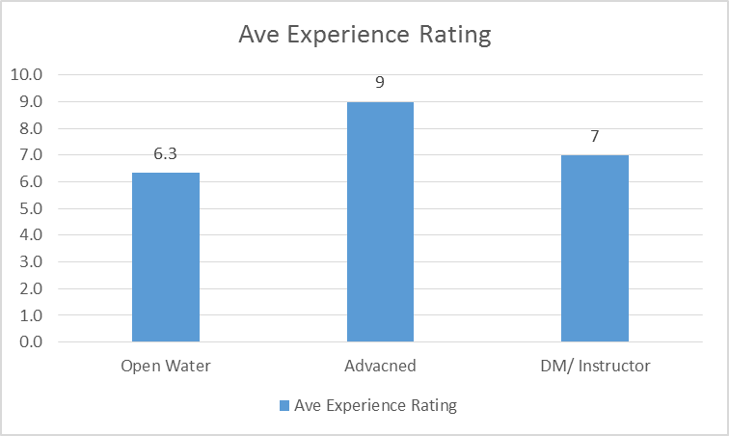

Overall the average rating was a 7/10. As you can see from the chart, new divers tended to rate the company slightly lower than average. They do not have the patience more experienced divers do when it comes to dock function and therefore new divers would be the people primarily effected by a new check in system.

The average rating when asked how organized the crew was before departure was around 6.2/10. Because this is below the average of the overall experience we can conclude that at least some of the customer’s frustration can be attributed to check-in and boarding procedures.

Most of the responses agreed that what the crew does well is creating a lively and fun environment to dive. Customers said the crew “kept the trip lively”, had a “positive and friendly attitude”, and “created a comfortable and fun atmosphere.”

When asked what the crew could improve on, the top responses were: “departing on time” and “better assistance with gear.” This customer consensus is crucial because our system is going to be designed with those specific grievances in mind.

To get an understanding of what motivates customers to come to SFDH initially and what motivated them to return we asked them what factors are important to them when choosing a dive charter. While only 2 of the responses mentioned price, all but one said that the competence and skill of the captain and crew was a deciding factor. This is important because with a new system in place to help with customer control, the crew would be more available to help the guests. This would help them come across as more professional and competent.

Lastly we asked the customers how they would respond to an automated check in system. Again all but one person responded favorably to the idea. One customer said “it would definitely make loading and transitioning to afternoon trips much easier.”

Although the customer sample was relatively small, we can conclude the following:

Dock function is a source of customer dissatisfaction

The crew could benefit from help during the check in process

Most customers would be happy to try a new check-in system

**Work Processes**

On the weekends a dive masters day starts at 6:30AM. Each dive master is assigned to one of three boats for the day. They start by tying to boat up in the “docked” position from the “overnight” position it was put in the day before. In the next 30 minutes the dive master ensures his/her boat has trash cans, rinse buckets with fresh water, enough dive flags for the trip, fresh drinking water, a full freshwater tank for the shower, ice in the coolers, any other convenience items such as toilet paper and paper towels, and any lines or equipment needed to tie in to various dive locations.

After the boat has been set up the captains usually start arriving. While the dive master sets up their scuba gear (for jumping ship wrecks or in preparation for emergencies), the captains check all of the boat’s functions and safety equipment. They check the fuel and the oil, ensure the marine radio is working properly, check for all life vests and fire extinguishers, pick up and inspect the O2 kit and AED as well as the first aid kit, and finally start the engines to check for unexpected problems.

It is usually about 7:15 when all this is finished and then the customers start to arrive. Sometimes upwards of 80 or 90 customers can be on the dock at once. They each go through check in at the office. Each person must hand sign a waiver of liability, determine if they need any gear, pay for their trip, and make their way to their assigned boat where they can meet their crew for the day. The dive masters work together to grab any gear a customer has requested while they fill tanks and handle any last minute operations.

The boats depart at 8AM for their assigned trips. While on board a briefing is given by the dive master, divers are split into groups, and throughout the trip there are a few times roll is called any other site briefings are given.

Boats usually return to the dock between 12 and 12:30PM. This leaves as little as 30 minutes to get up to 35 divers off the boat and to get 35 new divers on board. At capacity there are over 150 people on the dock. While the captains take control of prepping the boat for the afternoon trip, the dive masters go back to helping customers. Most of the rental gear from the morning has to be rinsed and given out again, tanks need to be filled, people need help getting gear on and off the boats, and check in becomes even more confusing.

Afternoon manifests are messed up a lot because each customer is only required to fill out one waiver per day. In the morning the waivers are used to generate manifests and are then put into a filing cabinet. When these customers go to get back on the boat for the afternoon they are often left off the manifests because they did not fill out another waiver.

The boats depart again at 1PM and the cycle on board is the same as it was for the morning trips.

After the boats return around 5PM each boat is unloaded, scrubbed, rinsed, and tied up in the “overnight” position. All of the trash is disposed of and anything valuable is locked away in the office for the night. Before anyone goes home all of the rental gear is cleaned and locked up and every tank is filled and put away. Lastly, each night one person must remember to turn on the compressor so that the air banks are full to fill tanks the next day.

Any items that are running low (fuel, oil, toilet paper, water, ect) is put on a list and is taken care of the next morning during set up.

Occasionally there are night dives that depart at 6PM. The only difference this makes is it adds one more cycle of unloading and loading passengers. These trips usually return between 10 and 10:30PM and all of the same break down tasks must be completed.

|  |  |  |
| --- | --- | --- |
| Check in at SFDH | | |
| Actor | Dive charter customer | |
| Scenario | The customer is checking in for an AM trip and needs full rental gear | |
| Trigger | Customer approaches the check in window | |
| Preconditions | Office assistant is present  All hardware is working correctly | |
| Normal course | | Information for steps |
| 1. Customer is asked “how can I help you” 2. Customer fills out waiver 3. Customer is asked for certification card 4. Customer is asked about rental gear 5. Customer asked for payment 6. Customer is assigned to a boat 7. Office assistant inputs info onto manifest 8. Customer finds assigned crew member 9. Customer asks for the gear requested 10. Customer finds a seat on the boat 11. Crew member brings gear | | Reservation info  Address, date, emergency contact  Certification info  Rental gear needs  Payment info  Boat assignment  Rental gear needs  Size requirements |
| Alternative course | | Information for steps |
| 1. Customer is prompted by system to select trip and reservation 2. Customer e-signs waiver and enters certification info to verify qualifications 3. Customer is prompted about rental gear 4. Customer is prompted for payment 5. Customer follows systems direction to the assigned boat and finds a seat 6. System places customer info on appropriate manifest 7. System displays gear requests on crew monitor 8. Crew members bring gear to customers as requested | | Reservation info if made prior to arrival  Certification info  Rental gear needs |
| Postconditions | Customer is on the boat and on the corresponding manifest  Customer has all required gear  Waivers are signed and payment is collected | |
| Exceptions | Students are not required to have a certification card, but an instructor. | |

**Use Case**

To get an idea of how the check in process will be changed, please refer to the following use case describing the current check in process and alternative. Although the alternative course does not seem much more streamlined, the lack of human communication will ensure that information stays accurate throughout the process.

**Context Diagram Normal Course**

The following diagram depicts the process occurring in the use case above. This will show how many times information changes hands and has the possibility as miscommunication using the current check-in procedures.

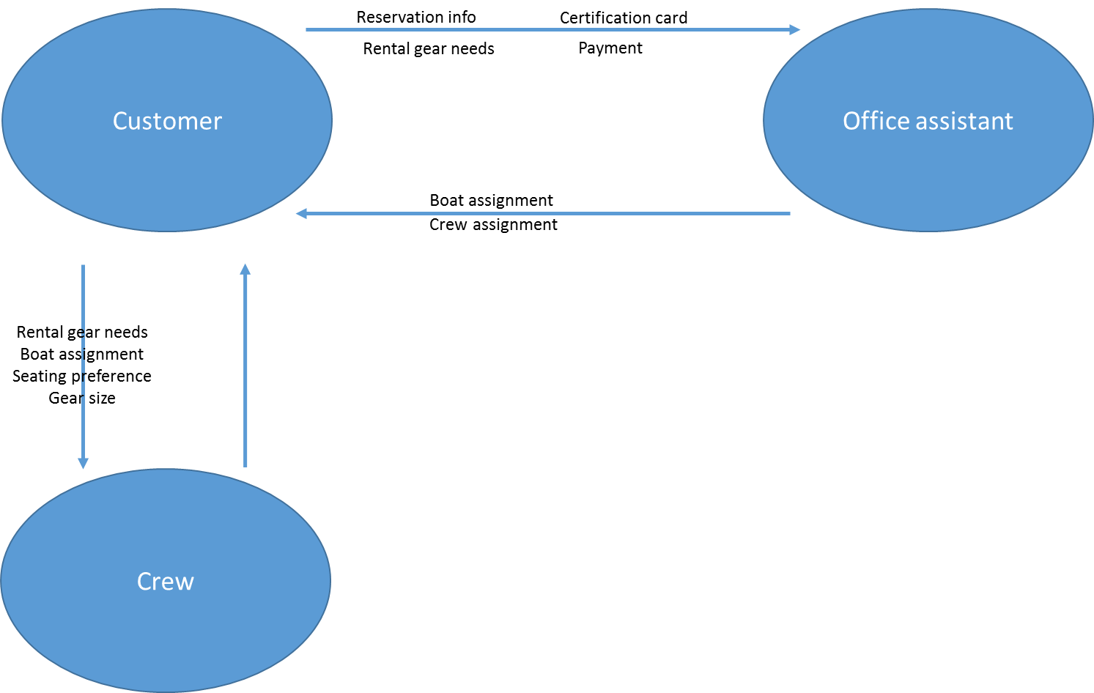

With the current procedures, customers are communicating their gear requirements twice. Once with the office and then again with the crew. They are also being given more information by the office that is important to communicate to the crew when asking for gear. With the proposed system in place the communication would be one time between the customer and the office. From their all of the communication to the crew would be done by the system. Eliminating the possibility for miscommunication.

**Context Diagram Alternative Course**

Using the proposed system we have developed a second context diagram that shows the information put in by the customers and how it is dispersed throughout the application infrastructure. While the diagram may seem more confusing and more prone to error at first, a closer look reveals that while information may change location more times, it is always a direct result of what is inputted by the customers. Therefore there is almost no chance for error.

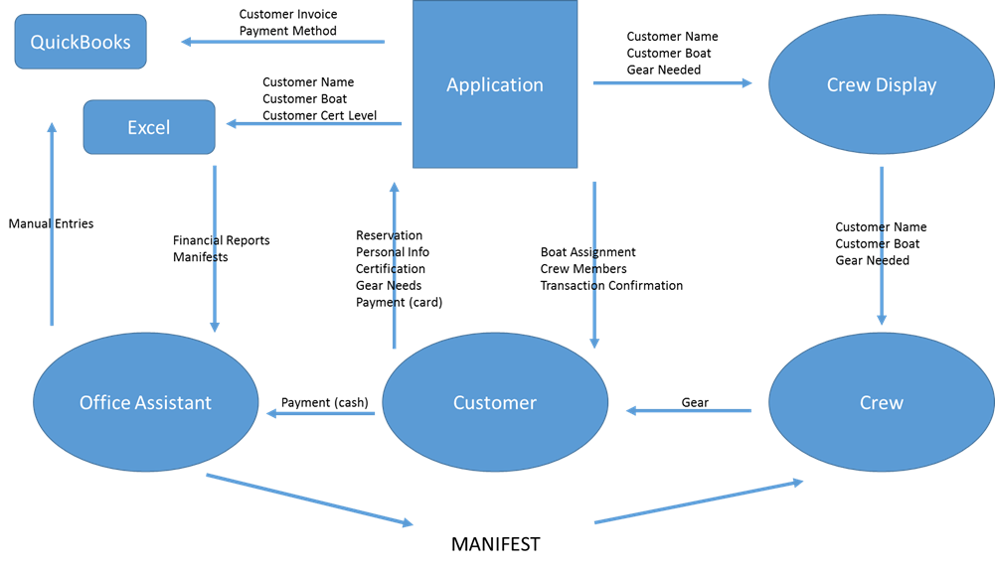

**Dataflow Diagram**

The next diagram shows what data is transferred where similar to the previous table. However, in this diagram the transfer of information is represented by the processes in which the data is transferred.

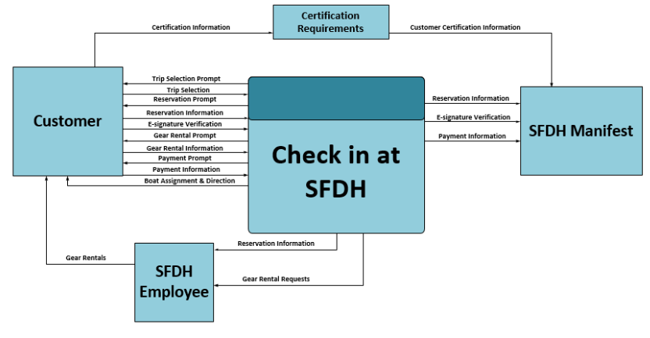

**Entity Relationships**

To further explore how all of the processes at SFDH work together we created the following ER Diagram.



The diagram is read using relationship sentences. These define the relationships and will help ensure understanding of the data and processes used. The relationship sentences are as follows:

Each TRIP must be staffed by one or more CREW

Each CREW may staff one and only one TRIP

Each TRIP may be populated by one or more SALES

Each SALE must populate one and only one TRIP

Each SALE may pay for one or more CUSTOMERS

Each CUSTOMER must be paid for by one and only one SALE

Each CUSTOMER may use one or more ITEMS RENTED

Each ITEM RENTED may be used by one and only one CUSTOMER

**Project Gantt Chart**

This Gantt Chart illustrates a detailed schedule to assure the project stays on track. Milestones are included to assist in progress reports and efficient time management.

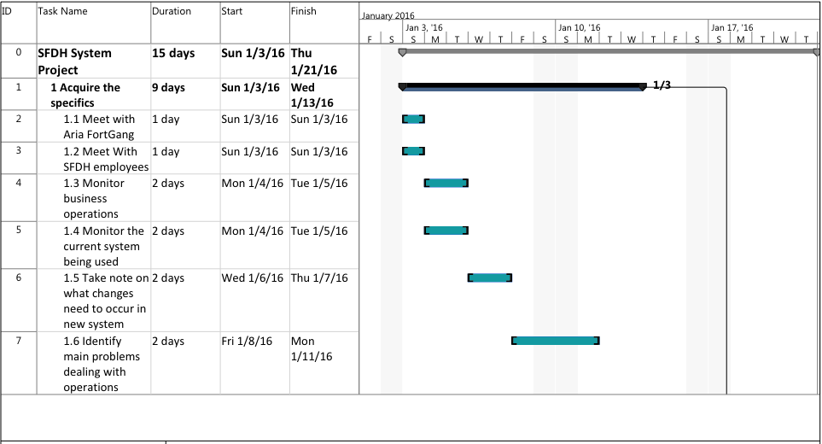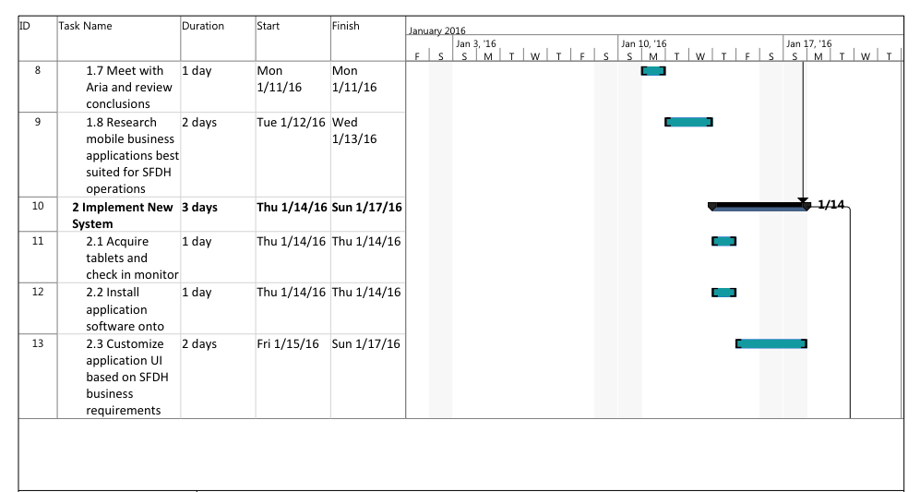

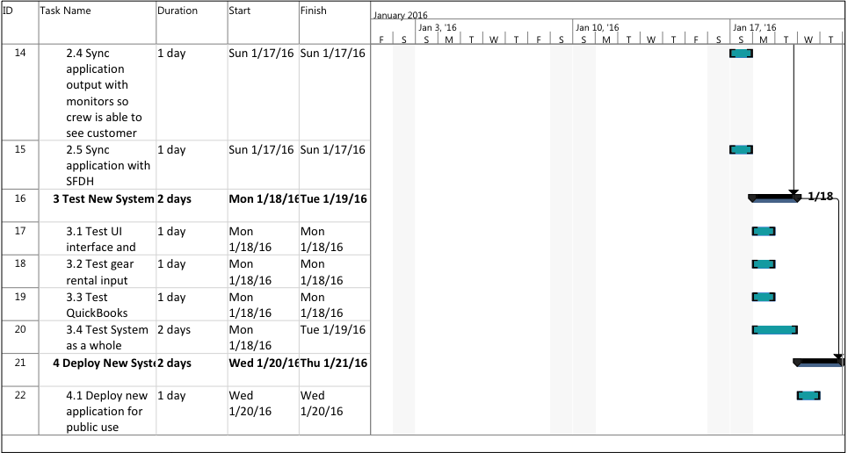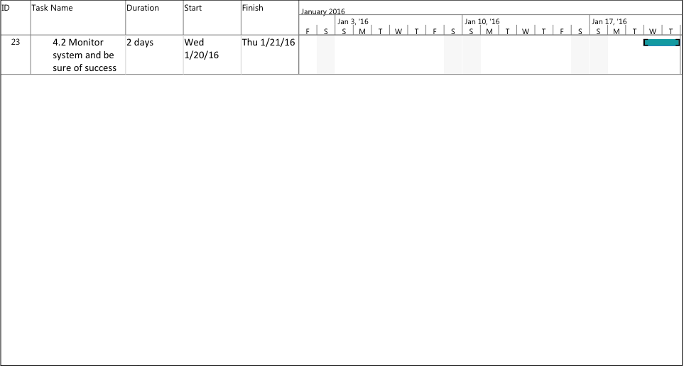

**System Acquisition Strategy**

As it is, SFDH could either download pre-existing software for their application or have a custom application developed. This Software Acquisition gives the advantage and disadvantages of both their options.

|  |  |
| --- | --- |
| **Advantages** | **Disadvantages** |
| Pre-existing Software Purchase | |
| * Existing application with significant amount of documentation * Technical support easily accessible * Management could easily change whatever they want to without needing to know how to look through code * Time and cost efficient * Product has been extensively tested and has been proven to work exactly as required | * Could prove to lack certain customization that SFDH management may want or require * Possible problems integrating to system as opposed to a customized application for SFDH’s purposes * At the mercy of the company who developed the application when it comes to future updates and fixes |
| Custom Application Development | |
| * Brand new application built specifically for SFDH * SFDH would have much more customization options * SFDH would have its very own application * It would be unique to SFDH and not resemble any other application | * Would cost SFDH more than pre-existing software * Could take a significant amount of time to develop * Could take a while to sort out all of the coding bugs * SFDH could have a significantly harder time trying to change their application if needed |

**Graphical User Interface Design for SFDH Application**

**This is the sign in prompt that begins SFDH’s sign in process.**

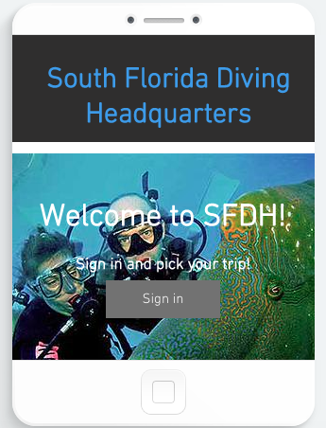

**This is the prompt that obtains SFDH customer’s trip selection. The user can select multiple trips or one trip multiple times and the application will keep a running total behind the scenes for later use.**

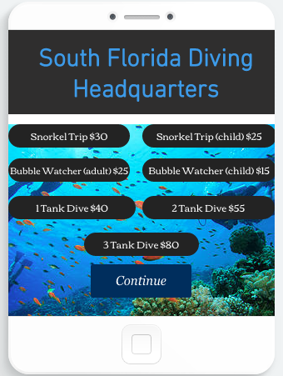

**SFDH customer will enter their first and last name. This will pull their remaining reservation information from SFDH’s manifest.**

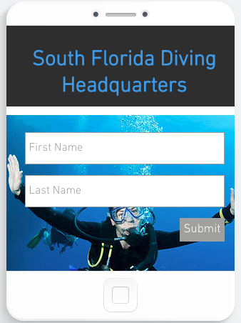

**SFDH customer will then be prompted whether or not this information is correct. If it is not correct, user will simply re-enter their information.**

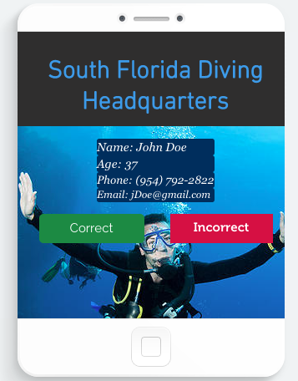

**SFDH customer is prompted for an e-signature and an acceptance stating they understand typing in their signature constitutes as legal tender.**

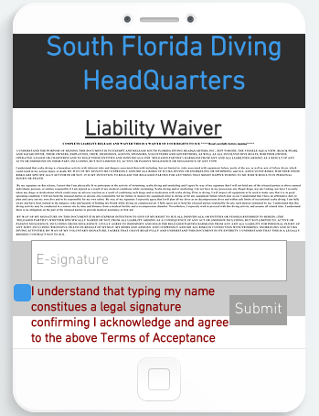

**User must enter both e-signature and agree to the e-signature terms. If either requirement is not met, SFDH customer will continue to see this page until both requirements are fulfilled.**

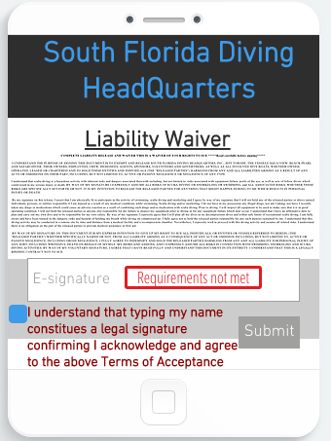

**This page is similar to trip selection in terms of format and function. User can select multiple gear rentals and is also able to select one gear rental multiple times. Again, a gear running total is kept behind the scenes.**

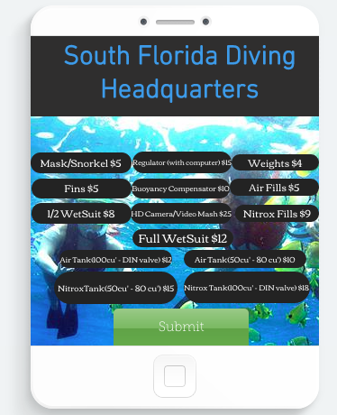

**User will see their total cost for the trip. This includes their trip(s) and gear rental(s), if any. Both trip and gear rental totals are added up to come to this amount. User can opt for cast payment or credit payment.**

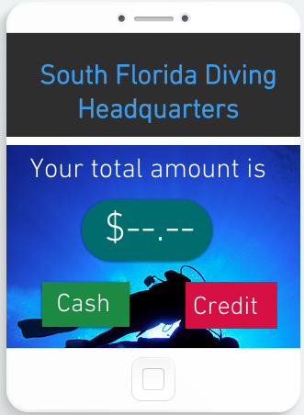

**If SFDH customer elects to pay cash, they are prompted to see an employee to pay cash. Once they do that, they continue on in the application.**

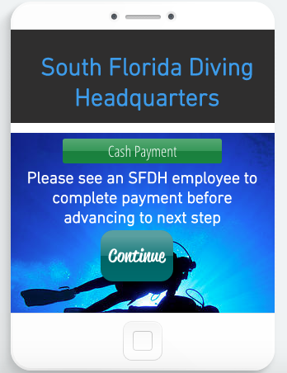

**If SFDH customer wishes to pay credit, they are prompted for the name on the card they are using, the card number, the card’s expiration date, the user’s billing address, and the card’s security code. Once they input their data, they push pay and continue.**

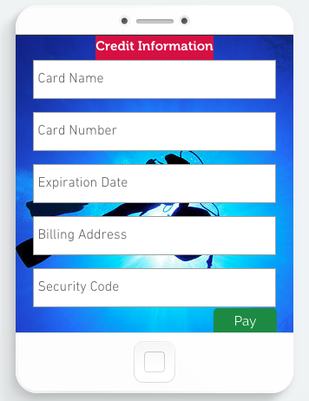

**If the user selecting a Scuba trip, they will be assigned to the Aqua View. They are told this and how to locate the Aqua View.**

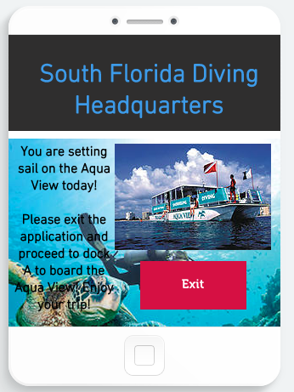

**If the user selecting a Snorkel trip, they will be assigned to the Black Pearl. They are told this and how to locate the Black Pearl.**

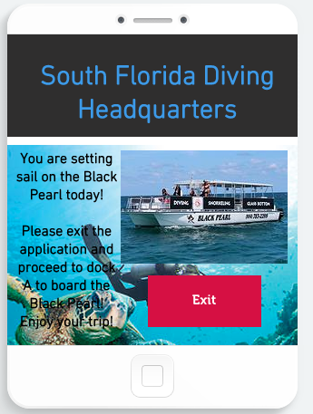

**If the user selecting a Bubble Watcher trip, they will be assigned to the Safari Diver. They are told this and how to locate the Safari Diver.**

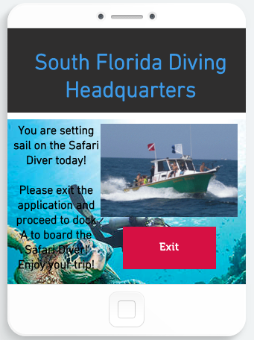

**Storyboard Design**

This story board is a graphical design that SFDH could use to model their application after. It also serves a purpose of giving a programmer a depiction to go off of when developing the application.

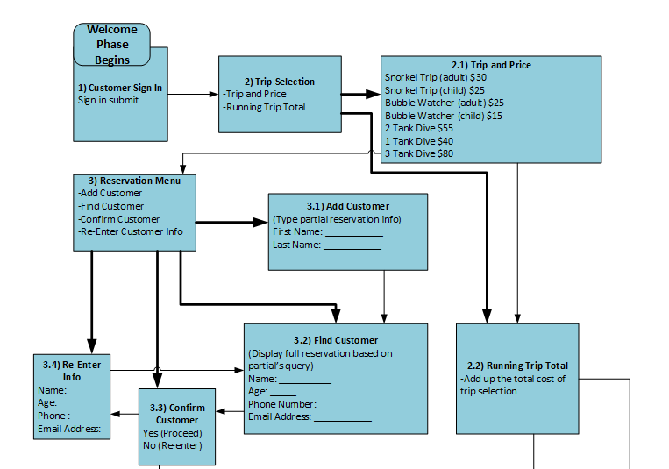

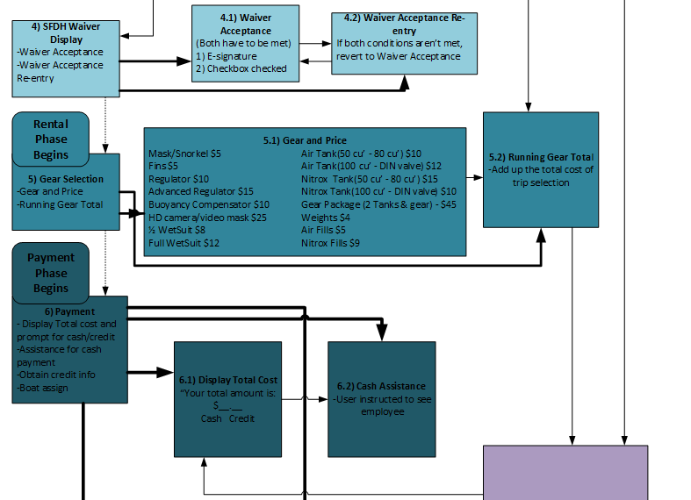

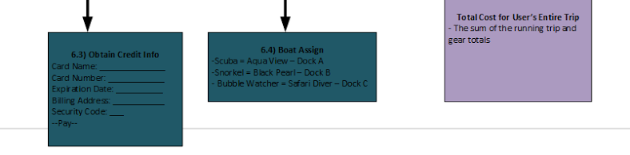

**Report Design**

SFDH report design will be comprised of their customers last and first names, phone numbers, trips, gear rentals and total amount the customer is paying. Pictured below is what SFDH employees will be able to see. They will easily be able to manage customers, trips, and gear selections.

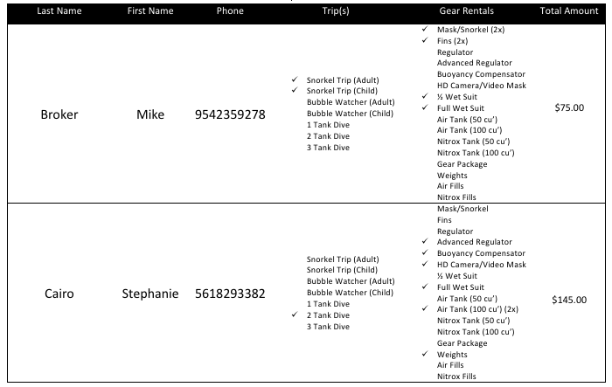

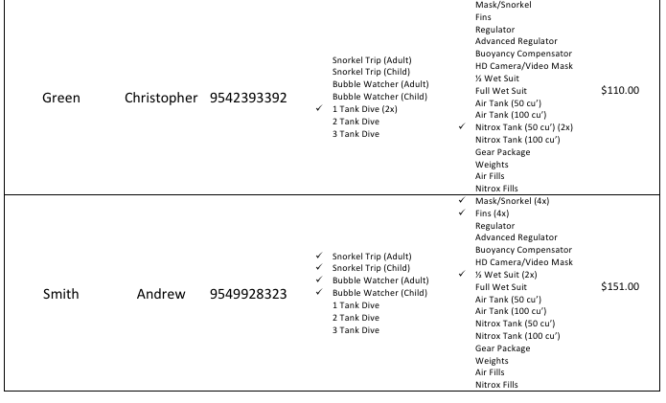

**Application Software Logical Design**

Pertaining to a system’s software development phase, it is crucial to have a well thought out logical design for the applicable software. Essentially, an application’s logical design are directions for developers to follow when creating the software. It’s best to make them as detailed and thorough as possible. This is South Florida Diving Headquarters application software logical design for their check-in application.

1) Welcome Phase of SFDH Application

1. Application starts with SFDH welcoming screen
2. User is prompted to select trip with Sign in submit button
   1. Each trip will have a checkbox and display the cost
      * Snorkel Trip (adult) - $30
      * Snorkel Trip (child) - $25
      * Bubble Watcher (adult) - $25
      * Bubble Watcher (child) - $15
      * 2 Tank Dive - $55
      * 1 Tank Dive - $40
      * 3 Tank Dive - $80
        + Running total is kept to later be added on to total cost of trip
        + User can select an option multiple times
3. Once trip is selected prompt for partial reservation information
   1. First Name
   2. Last Name
4. User is prompted for confirmation of correct reservation information
   1. Display Full reservation information
      * First Name
      * Last Name
      * Age
      * Phone Number
      * Email Address
   2. Ask user “Is this information correct?”
      * “Correct” Button and ”Incorrect” Button
        + If the user presses yes, proceed to next step
        + If the user presses no, prompt user with “Re-enter Information button”
        + If the user decides to re-enter, revert application back to step b of welcome phase
5. SFDH Waiver is displayed
   1. Under waiver, user is Prompted to type name
   2. Under name, there will be a checkbox and next to it, in red it should say – “I understand that typing my name constitutes a legal signature confirming I acknowledge and agree to the above Terms of Acceptance.
   3. User types name and pushes a submit button
      * If name or checkbox is not pushed, “requirements not met”
      * If requirements are met proceed to Rental Gear Phase

2) Rental Gear Phase of SFDH Application

1. Prompt user on what gear they wish to rent for the trip and display gear and price of each – Each item will be a button
   * Mask / Snorkel - $5
   * Fins - $5
   * Regulator (with computer) -$15
   * Regulator - $10
   * Buoyancy Compensator - $10
   * HD Camera / Video Mask - $25
   * ½ WetSuit - $8
   * Full WetSuit - $12
   * Air Tank (50 cu’ – 80 cu-) - $10
   * Air Tank (100 cu’ – DIN valve) - $12
   * Nitrox Tank (50 cu’ – 80 cu’) - $15
   * Nitrox Tank (100 cu’ – DIN valve) - $18
   * Gear Package (2 tanks & gear) - $45
   * Weights - $4
   * Air Fills - $5
   * Nitrox Fills - $9
2. Each button adds that dollar amount to the total value – application will keep a running total that is added to the trip cost from the welcoming phase. User can select something more than once.
3. Submit button to confirm and proceed to Payment Phase

3) Payment Phase of SFDH Application

1. Total amount of user’s trip and rental will display
2. User is prompted for Cash or Credit
   * 1. If user selects Cash, alert – “See SFDH employee”
     2. If user Selects Credit, prompt for credit info
        1. Name on Card
        2. Card Number
        3. Expiration Date
        4. Billing Address
        5. Security code
     3. Submit button saying – “Pay” that proceeds to next step

User will be told the boat they are assigned to base on their trip with directions

* + 1. If it is Aqua View – “Please exit application and proceed to Dock A to board the Aqua View! Enjoy your trip!”
    2. If it is Black Pearl– “Please exit application and proceed to Dock B to board the Black Pearl! Enjoy your trip!”
    3. If it is Safari Diver– “Please exit application and proceed to Dock C to board the Safari Diver! Enjoy your trip!”

1. Submit button saying – “Exit” for user to push to exit the application
2. Upon exit, application loops back to the Welcome Phase

**Structure Chart**

This structure chart shows how each part of SFDH’s application would be organized. This makes the programmer’s job easier in determining how to go about the development process. It’s a valuable starting point.

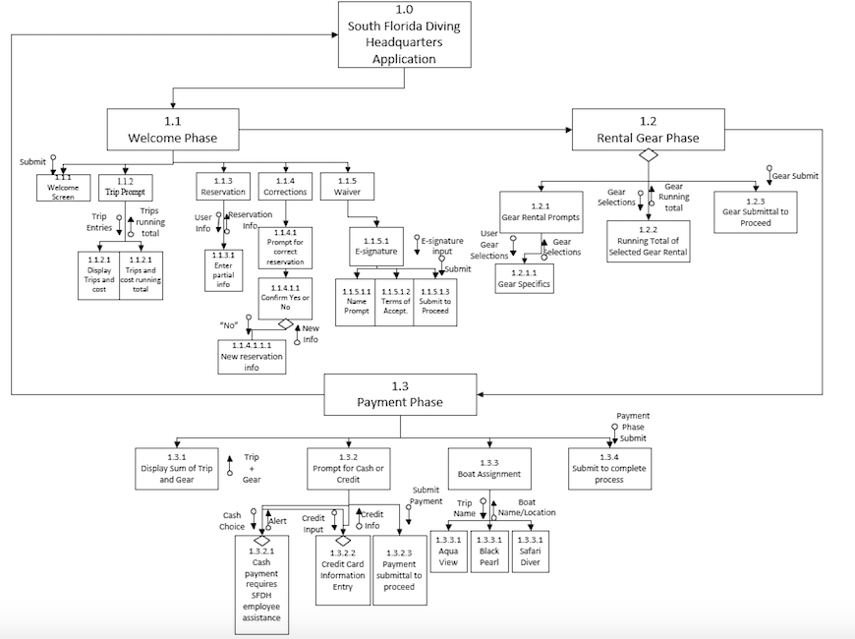

**Program Specification**

The program specification coincides with the structure chart and the flow of SFDH’s application. It gives instructions and breaks up the application into individual programs.

Program Specification 1.1.1 for SFDH Application

**Name:** Welcome_Screen

**Purpose:** Display sign in screen

**Programmer(s):** Christopher Gentile, Andrew Newell

**Date due:** 1/14/16

**Technologies to be used:** MeteorJS (JavaScript Framework)

**Events:**

* Display sign in screen for user
* Sign in button is pushed

|  |  |  |  |
| --- | --- | --- | --- |
| **Input Name** | **Type** | **Used by** | **Notes** |
| Sign in | Submit element | Program 1.1 |  |

**Pseudocode:**

If (SignIn === true)

Proceed to 1.1.2

Program Specification 1.1.2 for SFDH Application

**Name:** Trip_Prompt

**Purpose:** Prompt user on the trip(s) they are taking part in

**Programmer(s):** Christopher Gentile, Andrew Newell

**Date due:** 1/14/16

**Technologies to be used:** MeteorJS (JavaScript Framework)

**Events:**

* Buttons displaying the various trips and costs mentioned in the logical design documentation are shown
* User will select at least one trip and each trip selected will add

|  |  |  |  |
| --- | --- | --- | --- |
| **Input Name** | **Type** | **Used by** | **Notes** |
| Trip Entry | Button element | Program 1.1 |  |

|  |  |  |  |
| --- | --- | --- | --- |
| **Output Name** | **Type** | **Used by** | **Notes** |
| Trip total | variable | Program 1.1 | 2 decimal places maximum |

**Pseudocode:**

While (tripEntry < 1)

User selects which trip(s) they want to pay for

Var total = total number of trips selected by user

Program Specification 1.1.3 for SFDH Application

**Name:** Reservation_Name

**Purpose:** Find user in database based on their name

**Programmer(s):** Christopher Gentile, Andrew Newell

**Date due:** 1/14/16

**Technologies to be used:** MeteorJS (JavaScript Framework)

**Events:**

* User enters their first and last name

|  |  |  |  |
| --- | --- | --- | --- |
| **Input Name** | **Type** | **Used by** | **Notes** |
| User Information | String variable | Program 1.1 |  |

|  |  |  |  |
| --- | --- | --- | --- |
| **Output Name** | **Type** | **Used by** | **Notes** |
| Reservation Information | String array | Program 1.1 |  |

**Pseudocode:**

For (var i = 0; i < reservationArray; i++) {

If (fullName === reservationArray[i])

Return reservationArray[i]

}

Program Specification 1.1.4 for SFDH Application

**Name:** Corrections_Confirmation

**Purpose:** User confirms if their reservation information is correct

**Programmer(s):** Christopher Gentile, Andrew Newell

**Date due:** 1/14/16

**Technologies to be used:** MeteorJS (JavaScript Framework)

**Events:**

* Display reservation information pulled from the array
* User confirms if reservation information is accurate
* If accurate, program proceeds to 1.1.5, else user re-enters information and then proceeds to 1.1.5

|  |  |  |  |
| --- | --- | --- | --- |
| **Input Name** | **Type** | **Used by** | **Notes** |
| Corrections | Boolean variable | Program 1.1 |  |

|  |  |  |  |
| --- | --- | --- | --- |
| **Output Name** | **Type** | **Used by** | **Notes** |
| New Reservation Information | String Array | Program 1.1 | New information will be put in array |

**Pseudocode:**

As user if it is correct

If (yes) {

Proceed

}

else {

have user fix information

}

Program Specification 1.1.5(including its subsections) for SFDH Application

**Name:** Waiver_Display

**Purpose:** Display waiver and have user sign

**Programmer(s):** Christopher Gentile, Andrew Newell

**Date due:** 1/14/16

**Technologies to be used:** MeteorJS (JavaScript Framework)

**Events:**

* User Inputs their name signifying an e-signature
* User also has to agree to the terms of acceptance checkmark
* User does this until both name and check box are completed

|  |  |  |  |
| --- | --- | --- | --- |
| **Input Name** | **Type** | **Used by** | **Notes** |
| Signature | String variable | Program 1.1 |  |
| Confirm | Check box element |  |  |
| Submit | Submit element |  |  |

**Pseudocode:**

While (signature !== username && checkBox !== true) {

Input signature

push checkBox

**}**

Proceed to 1.2

Program Specification 1.2.1/1.2.1.1 for SFDH Application

**Name:** Gear_Rental_Prompt

**Purpose:** Prompt user if they want to rent gear

**Programmer(s):** Christopher Gentile, Andrew Newell

**Date due:** 1/14/16

**Technologies to be used:** MeteorJS (JavaScript Framework)

**Events:**

User is prompted if they would like to rent gear

|  |  |  |  |
| --- | --- | --- | --- |
| **Input Name** | **Type** | **Used by** | **Notes** |
| User Gear Selections | Submit buttons | Program 1.2 |  |

|  |  |  |  |
| --- | --- | --- | --- |
| **Output Name** | **Type** | **Used by** | **Notes** |
| Gear Selections | Floating variable | Program 1.2 | 2 decimal places |

**Pseudocode:**

If (user selects 1 or more selections) {

return selections chosen;

}

Program Specification 1.2.2 for SFDH Application

**Name:** Gear_Rental_Total

**Purpose:** Total the amount of gear the user wants to rent

**Programmer(s):** Christopher Gentile, Andrew Newell

**Date due:** 1/14/16

**Technologies to be used:** MeteorJS (JavaScript Framework)

**Events:**

* User’s choices are inputted and the output is the resulting total cost of all of the gear rented

|  |  |  |  |
| --- | --- | --- | --- |
| **Input Name** | **Type** | **Used by** | **Notes** |
| Gear Selections | Floating point variable | Program 1.2 |  |

|  |  |  |  |
| --- | --- | --- | --- |
| **Output Name** | **Type** | **Used by** | **Notes** |
| Gear Running Total | Floating point variable | Program 1.2 | 2 decimal places |

**Pseudocode:**

If (user selects 1 or more selections) {

gearTotal = sum of selections;

}

Program Specification 1.2.3 for SFDH Application

**Name:** Gear_Submittal

**Purpose:** Submits all of the gear and total value

**Programmer(s):** Christopher Gentile, Andrew Newell

**Date due:** 1/14/16

**Technologies to be used:** MeteorJS (JavaScript Framework)

**Events:**

* User submits their gear

|  |  |  |  |
| --- | --- | --- | --- |
| **Input Name** | **Type** | **Used by** | **Notes** |
| Gear Submit | Submit Element | Program 1.2 |  |

**Pseudocode:**

If (Gear_Submit){

Proceed to 1.3

}

Program Specification 1.3.1 for SFDH Application

**Name:** Trip_Gear_Total

**Purpose:** Display the total cost of user’s trip(s) and gear rental(s)

**Programmer(s):** Christopher Gentile, Andrew Newell

**Date due:** 1/14/16

**Technologies to be used:** MeteorJS (JavaScript Framework)

**Events:**

* Total cost is displayed for user to see

|  |  |  |  |
| --- | --- | --- | --- |
| **Output Name** | **Type** | **Used by** | **Notes** |
| Total Sum | Floating point variable | Program 1.3 | 2 decimal places |

**Pseudocode:**

Alert(TotalSum)

Program Specification 1.3.2 for SFDH Application

**Name:** Payment_Prompt

**Purpose:** Prompt user payment

**Programmer(s):** Christopher Gentile, Andrew Newell

**Date due:** 1/14/16

**Technologies to be used:** MeteorJS (JavaScript Framework)

**Events:**

* User is prompted for how they want to pay for transaction

|  |  |  |  |
| --- | --- | --- | --- |
| **Input Name** | **Type** | **Used by** | **Notes** |
| Display Prompt | Prompt | Program 1.3 |  |

**Pseudocode:**

Prompt(Pay Credit or Cash ?)

Program Specification 1.3.2.1 for SFDH Application

**Name:** Cash_Payment

**Purpose:** Notify they have have to see an SFDH employee to pay cash

**Programmer(s):** Christopher Gentile, Andrew Newell

**Date due:** 1/14/16

**Technologies to be used:** MeteorJS (JavaScript Framework)

**Events:**

* User is instructed to see an SFDH employee to pay cash

|  |  |  |  |
| --- | --- | --- | --- |
| **Input Name** | **Type** | **Used by** | **Notes** |
| Cash Choice | Radio element | Program 1.3 |  |
|  |  |  |  |
|  |  |  |  |

|  |  |  |  |
| --- | --- | --- | --- |
| **Output Name** | **Type** | **Used by** | **Notes** |
| Assistance alert | JavaScript alert | Program 1.3 |  |
|  |  |  |  |
|  |  |  |  |

**Pseudocode:**

if( paymentType === “cash”){

alert(“Please see SFDH employee for assistance”)

}

Program Specification 1.3.2.2 for SFDH Application

**Name:** Credit_Card_Info

**Purpose:** Obtain user’s credit card information

**Programmer(s):** Christopher Gentile, Andrew Newell

**Date due:** 1/14/16

**Technologies to be used:** MeteorJS (JavaScript Framework)

**Events:**

* User enters in their credit card information for payment

|  |  |  |  |
| --- | --- | --- | --- |
| **Input Name** | **Type** | **Used by** | **Notes** |
| Credit Input | String and numerical variables | Program 1.3 |  |

|  |  |  |  |
| --- | --- | --- | --- |
| **Output Name** | **Type** | **Used by** | **Notes** |
| Credit Information | Array | Program 1.3 |  |

**Pseudocode:**

If (paymentType === “credit”){

User’s creditName = prompt(“Enter name on credit card”);

User’s cardNumber = prompt(“Enter card number”);

User’s expirationdate = prompt(“Enter expiration date”);

User’s billingAddress = prompt(“Enter billing address”);

User’s securityCode = prompt(“Enter security code”);

UserCard array = all above info

}

Program Specification 1.3.2.3 for SFDH Application

**Name:** Payment_Submittal

**Purpose:** User submits and proceeds to 1.3.3

**Programmer(s):** Christopher Gentile, Andrew Newell

**Date due:** 1/14/16

**Technologies to be used:** MeteorJS (JavaScript Framework)

**Events:**

* User proceeds to next program

|  |  |  |  |
| --- | --- | --- | --- |
| **Input Name** | **Type** | **Used by** | **Notes** |
| Payment Submit | Submit element | Program 1.3 |  |

**Pseudocode:**

If (paymentSubmit){

Proceed to 1.3.3

}

Program Specification 1.3.3(including its subsections) for SFDH Application

**Name:** Boat_Assignment

**Purpose:** Inform user the boat and location of the boat they will be on

**Programmer(s):** Christopher Gentile, Andrew Newell

**Date due:** 1/14/16

**Technologies to be used:** MeteorJS (JavaScript Framework)

**Events:**

* User is told the boat they are assigned based on their trip and its location

|  |  |  |  |
| --- | --- | --- | --- |
| **Input Name** | **Type** | **Used by** | **Notes** |
| Trip Name | String Variable | Program 1.3 |  |

|  |  |  |  |
| --- | --- | --- | --- |
| **Output Name** | **Type** | **Used by** | **Notes** |
| Boat Name | String variable | Program 1.3 |  |
| Boat location | String variable | Program 1.3 |  |

**Pseudocode:**

If (userTrip === “Scuba”) {

Aqua view + directions

} else if(userTrip === “Snorkel”) {

Black Pearl + directions

}else {

Safari Diver + directions

}

Program Specification 1.3.4 for SFDH Application

**Name:** Payment_Submit

**Purpose:** Final submit to end program and return to main page

**Programmer(s):** Christopher Gentile, Andrew Newell

**Date due:** 1/14/16

**Technologies to be used:** MeteorJS (JavaScript Framework)

**Events:**

* User submits to terminate their session and return to welcome screen

|  |  |  |  |
| --- | --- | --- | --- |
| **Input Name** | **Type** | **Used by** | **Notes** |
| Payment Submit | Submit element | Program 1.3 |  |

**Pseudocode:**

If (paymentSubmit) {

Terminate program

Return to welcome

}

**Pseudocode**

The Pseudocode below is much more relatable to a programmer and will make the programmer’s job easier for developing the application. With a mix of code syntax and everyday English, it’s a guideline that will be utilized in developing the final application.

1)User prompted with 7 trips in a switch statement. Must have at least one selection.

While loop to make sure user has at least one selection.

if (signIn) {

while (choice < 1) {

switch (choice) {

case 1:

"Snorkel Trip - $30"

break;

case 2:

"Snorkel Trip (children under 12) - $25"

break;

case 3:

"Bubble Watcher (adult) - $25"

break;

.... etc for rest of choices

}

}

}

2) User's trip name and total trip made into variables for later usage

var userTrip = choice;

var tripValue = totalChoiceValue;

3) Prompt User for reservation information

var firstName = prompt("Enter first name");

var lastName = prompt("Enter last name");

var fullName = firstName + lastName;

4) User reservation data pulled from database(reservation Array)

for (var i = 0; i < reservationArray.length; i++) {

if (fullName === reservationArray[i]){

return reservationArray[i];

}

}

5) User confirms this data is correct

var confirmation = confirm("Is + " reservationArray[fullName] + " correct");

if (yes) {

proceed

}

else {

user fixes data

}

6) Display SFDH waiver and have user e-sign it and check the acceptance agreement

-display waiver-

while(signature !== userName && checkBox !== true) {

alert("Please enter signature and check the acceptance agreement");

}

7) Prompt user to rent gear if they require it - use switch format similar to trips

user submits when they are done

var gearRental = prompt("Select gear you wish to rent");

switch(gearRental) {

case 1:

"Mask/Snorkel - $5"

break;

case 2:

"Fins - $5"

break;

... etc for rest of choices

}

if(user selects 1 or more selections){

gearTotal = sum of all selections;

}

if(Gear_submit) {

proceed

}

8) Display the total cost of the trip and the gear

var userTotalCost = (tripValue + gearTotal);

alert(userTotalCost);

9) Prompt user for Cast or Credit

var paymentChoice = prompt("Pay Credit or Cash?");

10) If user opts for cash payment instruct to see an SFDH employee to

complete transaction

if(paymentType === cast){

alert("Please see SFDH employee for assistance");

}

11) If user opts for credit payment, obtain user's credit card info and store in array

If (paymentType === “credit”){

User’s creditName = prompt(“Enter name on credit card”);

User’s cardNumber = prompt(“Enter card number”);

User’s expirationDate = prompt(“Enter expiration date”);

User’s billingAddress = prompt(“Enter billing address”);

User’s securityCode = prompt(“Enter security code”);

var userCard = [creditName, cardNumber, expirationDate, billingAddress,

securityCode];

12) Have user Submit information to proceed to boat assignment

if(paymentSubmit)

Proceed to boat assignment

13) Inform user of their boat and the location of the boat they will board

for the day

If (userTrip === “Scuba”) {

Aqua view + directions

} else if(userTrip === “Snorkel”) {

Black Pearl + directions

}else {

Safari Diver + directions

}

14) User submits and ends the payment phase terminating their session but

looping back to welcome page for next user.

if (paymentSubmit){

Terminate program

Sign In

}

**Application Environment**

Now that the logical design has been put in place, next we need to determine what technology hardware and software we will need to implement the application as designed.

To begin we have developed a visual reference for the application environment.

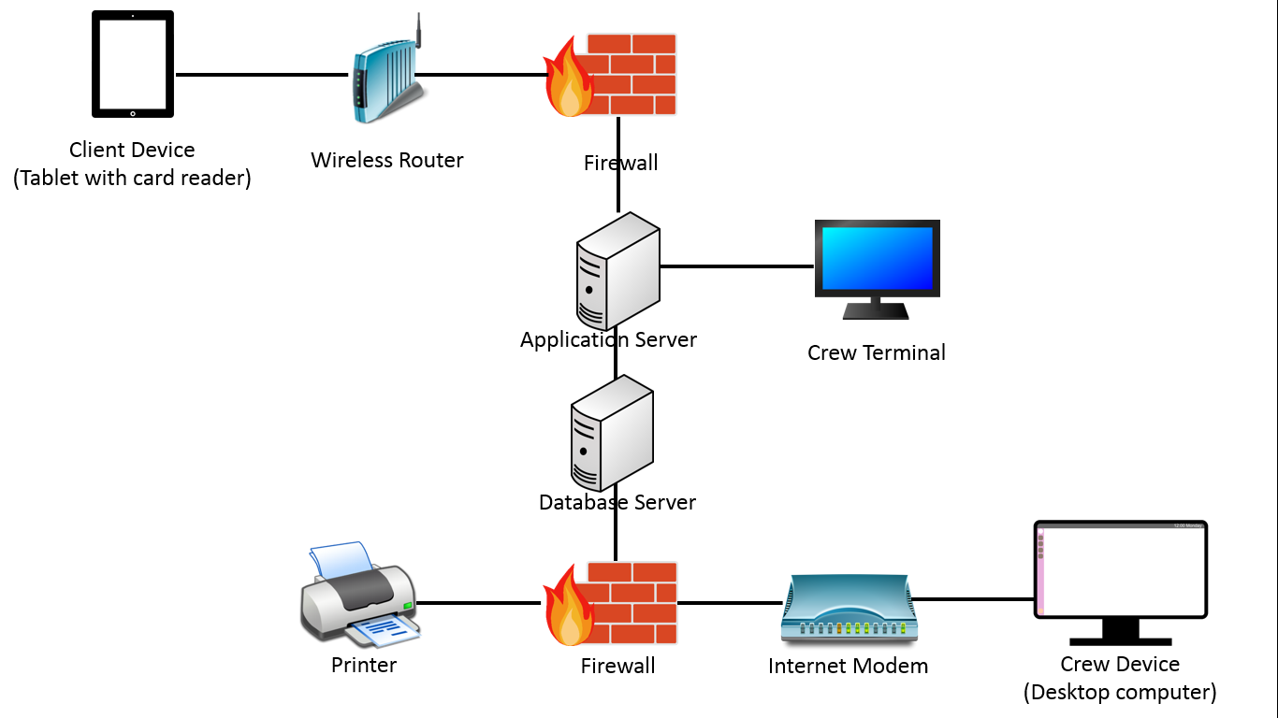

In the image above each line connects two entities and is represents a hard wire connection with the exception of the wireless connection the client device has with the wireless router.

Except for the firewall software being visualized in this diagram, we still need to add any software requirements that the system needs to operate properly.

The following chart includes all hardware and software for the system and an example or description for each item.

|  |  |
| --- | --- |
| Item | Description |
| Firewall | To protect business information and the well-being of the system.  Ex. Norton Antivirus, ESET Smart Security |
| Operating System | Microsoft Windows, Apple iOS |
| Communication Protocol | Ensuring that the transfer of data between devices and servers is secure.  Ex. HTML, TCP/IP |
| Web Browser | For crew use when making reservations and use for other general inquiries that may require the internet.  Ex. Google Chrome, Mozilla Firefox |
| Application Software | Quick Books, Java, Database Management System |
| Tablet | For the customers to input information at check in.  Ex. iPad, Samsung tablet |
| Card Reader | For customers who wish to pay with credit or debit card  Ex. Square, PayPal |
| Wireless Router | For the tablets to be able to connect to the internet. |
| Internet Modem | A hardwired device to connect the desktop and servers with the internet. |
| Desktop Computer | For crew use to print manifests, manually enter transactions if necessary, and other general business functions requiring a computer.  Ex. Macbook, HP |
| Printer | Used to print manifests and other paperwork. |
| Crew Terminal | A display used to show crew equipment required by customers.  Ex. TV, Computer monitor |
| Application Server | Used to manage business processes while the application is in use. Transmits data from customer input into usable forms for manifests and storage of waivers. |
| Database Server | Where information from the application server is archived so that it can be accessed at a later point for various reasons. |

**Application Architecture**

To further analyze the structure of the application we will break down the design by requirements. The requirements to be analyzed are the operational requirements, performance requirements, security requirements, and cultural and political requirements.

Operational Requirements

|  |  |  |
| --- | --- | --- |
| Requirement | Definition | Application Specs |
| Technical environment | Special hardware, software, and network requirements | -Will communicate with internet via app server  - App server will have always on connection that updates real time from website |
| System Integration | Extent to which the app will communicate with other systems | -Should be able to generate excel spreadsheet from customer information  -Should communicate with invoicing software such as QuickBooks. |
| Portability | Extent that the app will operate in other environments | n/a  system will only need to be accessible on location |
| Maintainability | Expected business changes to which system should be able to adapt | -New services should be able to be added when necessary |

Performance Requirements

|  |  |  |
| --- | --- | --- |
| Requirement | Definition | Application Specs |
| Speed | The time in which the system must perform its functions | -Spots remaining on a trip must be updated in real time  -All inputs should be processed in a few seconds or less |
| Capacity | Total and peak number of users and volume of data | -There will be no more than 3 users at a time  -There will be no more than 350 users per day |
| Availability and Reliability | Extent to which the system will be available and the permissible failure rate due to errors | -The system will be available during business hours  -The system should always be linked to the website except during maintenance  - The system should generate accurate records (manifests and invoices) 100% of the time with exception of human error. |

Security Requirements

|  |  |  |
| --- | --- | --- |
| Requirement | Definition | Application Specs |
| System Value Estimates | Business value of system and its data | -The system is not critical to business success  - A system loss could result in lost **profit** of no more than $750 per month  - Total system loss would cost around $1500 to replace |
| Access Control | Limitation of who can access what data | -Anyone can view pricing, reservation schedules, and available equipment  -Changes to pricing, scheduling, and equipment will be password protected  -All personal information will only be available for viewing and editing by the individual and the office manager |
| Encryption and Authentication | What data will be encrypted and where authentication will be required | -All credit card information will be encrypted  -All options to make changes to the system will need authentication from authorized crew member  -Users making reservations online will need authentication |
| Virus Control | Control the spread of viruses | ESET Smart Security screens all incoming files |

Political and Cultural Requirements

|  |  |  |
| --- | --- | --- |
| Requirement | Definition | Application Specs |
| Multilingual | Languages that the system will operate in | -English and Spanish  - Anyone who can’t read or write in English or Spanish will be referred to the office assistant for help |
| Customization | What aspects of the system can by changed by local users | -Pricing and schedules  -Updates to the liability waiver  -Updates to the services offered  -Updates to customer information gathered during check in |
| Making Unstated Norms Explicit | Explicitly stating assumptions that differ from country to country | -Date will be Day/Month/Year  -Weight will be in pounds  -Shoe size will be US standard  -Any measure of length will be in feet and inches |
| Legal | Laws and regulations that impose certain requirements on the system | -Any personally identifiable information will be kept confidential  -Phone numbers and other contact information will not be released without consent  -All e-signing of documents will meet or exceed legal standards |