Lab 8 Activity 1 Docker Commands
Chris Gharfine | ccg04

1 Listing containers
docker ps -a
Lists all containers, including running and stopped containers. The snapshot uses --format to display the container ID, image, status, and name.
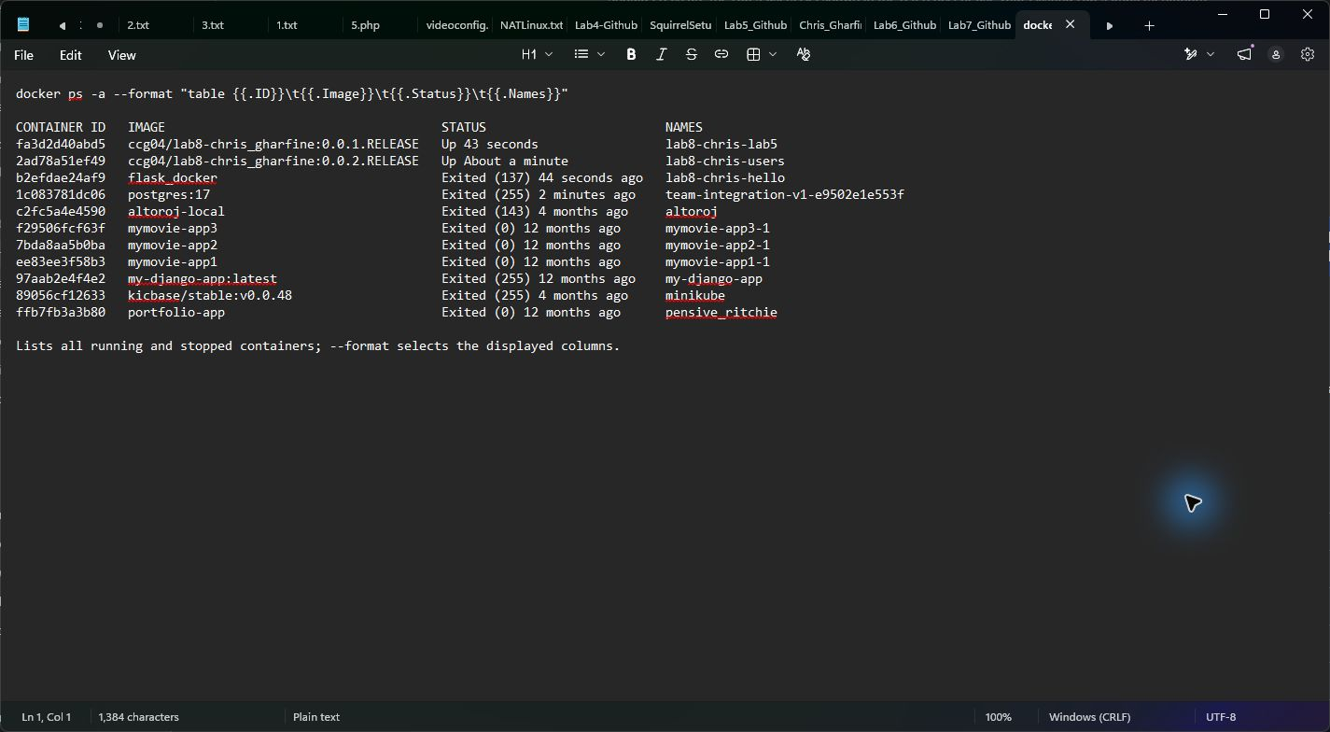

2 Stopping a container
docker stop lab8-chris-hello
Stops the specified running container by sending a termination signal. If it does not exit before the timeout, Docker forcefully stops it. The returned name confirms which container was stopped.
The argument is a container name or ID, rather than an image name.
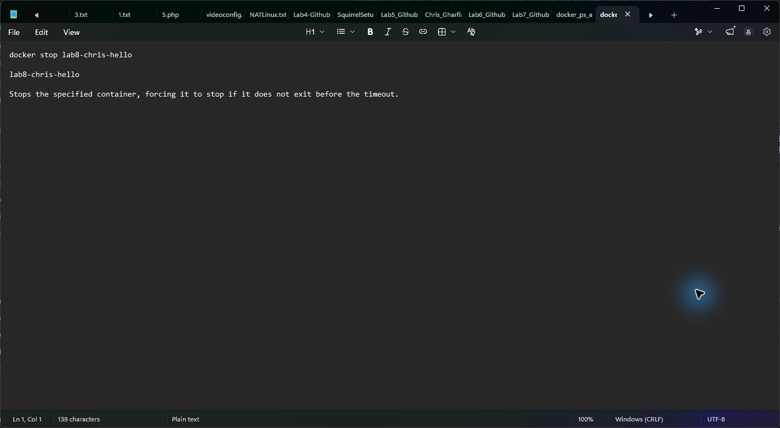

3 Viewing container logs
docker logs lab8-chris-hello
Displays the container's standard output and standard error, including logs retained after it stops. The snapshot shows Flask startup messages and a successful HTTP GET request with status 200.


