Individual Track Project

Web Application - Writeo

|  |
| --- |
| **Date : 15/10/2020** |
| **Version : 1.2** |
| **Author : Kristian Hadzhikolev** |

# Entity Relation Diagram

# 

# High-Level Architecture

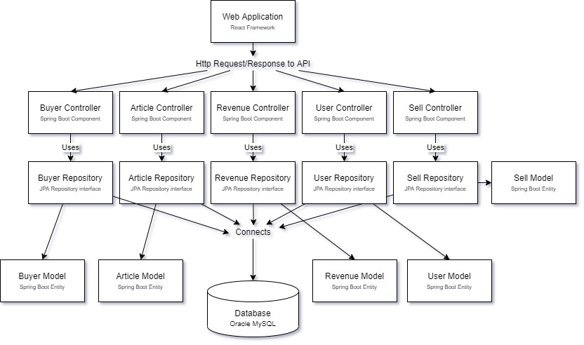

# Design Decisions

The following ICT research methods were used to decide:

Benchmark creation(to list the possibilities), literature study(to read online about each one of the possibilities), trend analysis(to see, which one possibility has the best community is suitable for modern solution), context mapping(to decide, which possibility is most suitable for the project);

## Frontend

React framework will be used for the front-end of the web application. It was chosen, because it is one of the best frameworks on the market along with Vue and Angular. Other Pros are the flexibility, the developer community and the detailed documentation.

## Backend

Spring Boot framework will be used for the backend of the web application. It was chosen, because as react it offers good documentation and it has many functions that make the process of developing faster and much more efficient.