**Exploring the Design Space of Tangible Interfaces**

**Christopher Heiden**

Student ID: 120249

# Abstract

Creating music often depends on having a professional music instrument and the knowledge of how to interact with it to create music. Analog music instruments like a guitar can be used to create guitar music. The instrument itself cannot adapt to a situation, or if the player wants to play a different instrumental sound with a guitar, for example. On the other hand, a digital piano can do so and can stimulate different instruments; however, the digital piano itself does not change its shape or layout depending on the situation. By using the token and constraints approach of tangible user interfaces, it is possible to change the look and sound of instruments. This has been tried to do in this semester project at the Bauhaus University in Weimar. Therefore, different approaches of tangible interaction and how such a system can be built theoretically and practically to simulate different sounds and instruments have been experienced. Therefore, users’ advice has been used to find out how people interact with a different object, and how they imagine the interaction sound.

**Keywords**

Human-Computer Interaction, Tangible User Interfaces, Tokens & Constraints, Interaction, Sound Generation, Bodystorming

# INTRODUCTION

Common two-dimensional user interfaces are used in a wide range of applications. To interact with these kinds of applications, screen and input devices like a keyboard or a mouse or both together are used. On the other hand, humans are not used to interacting within a two-dimensional space because, in the real world, humans are surrounded by three-dimensional objects. So, there is a mismatch between working on digital services in the two-dimensional workspace and three-dimensional interaction with objects in real life. Still, people became used to work in a two-dimensional space over the years.

The idea of changing this standard and using three-dimensional spaces instead is not new. This project tries to explore the three-dimensional workspace by finding possibilities to create modular music.

# RELATED Studies

There are many approaches to design and build three-dimensional interaction and tangible user interfaces; however, all approaches share the same idea. All agree that a physical object represents data and changing its object state changes the value of the object it represents.

One approach to build a tangible user interface is using tokens and constraints. Tokens are physical objects with an identifier, so a digital system can identify and handle the token that stores information. On the other hand, a constraint is an area that restricts the user from doing specific interaction gestures like moving the token to one specific position or rotating it. Therefore, B. Ullmer, H. Ishii, and R. J. K. Jacob present grammar that can be used to explain interactions with the token and what users would expect from the system.[1]

B. Ullmer, H. Ishii, and R. J. K. Jacob state that token and constraint systems are used to interact with abstract and digital information that has no inherent physical representation, nor any intrinsic physical language for its manipulation. They draw on our basic knowledge about the behavior of the physical world and change the understanding of the relationship between physical tokens and constraints. Therefore, two interactions are defined, association, and manipulation.[1]

First, there is the association which means that the user can place a token in or on the constraint, so the system can identify the token.[1]

Second, manipulation is the movement of a token like rotation or shifting.[1]

Adding multiple tokens at once is possible, so multiple tokens can be used on one constraint, or even nested tokens could be possible.[1]

To describe the mapping of physical relationships to digital interpretations, a grammar table has been presented (see Table 1).

|  |  |  |
| --- | --- | --- |
| Physical Relationship | Interaction Event | Digital Interpretations |
| presence | Add remove | binding |
| Position | move | Scalar |
| Sequence | Order change | Query ordering |
| Proximity | Proximity change | Relationship strength |
| Connection | Connect/disconnect | Logical flow |
| Adjacency | Adjacent/ no- Adjacent | Boolean, axes |
| nesting | nesting | grouping |

*Table 1 shows a smaller grammar list that has been defined by authors B. Ullmer, H. Ishii, and R. J. K. Jacob. These grammars are used for the mapping of physical relationships to digital interpretations.[1]*

A similar paper that tries to find an approach to handle tangible user interactions and their interaction methods is called “The TAC Paradigm: Specifying Tangible User Interfaces”. In this paper written by O. Shaer, N. Leland, E. H. Calvillo-Gamez and R. J. K. Jacob discuss the TAC paradigm, challenges for tangible interaction systems, and how to evaluate them. [2]

The TAC paradigm “identifies the common components and properties sufficient for specifying the structure and functionality of a wide range of TUIs.”[2, p. 6] Therefore, tangible interaction systems are defined as a set of physical objects and digital information. This concept has five key properties. [2]

First, coupling is used to couple digital information and a physical object, so it can be defined as a token. A toke is a physical object that represents digital information.[2]

Second, there is a relative definition between a token and a constraint that limits the behavior of the token or both.[2]

Third, a “TAC is created when a token is physically associated with a constraint”.[2, p. 11]

Fourth, interaction and manipulation of the physical object are interpreted. This process is automated regards to its constraint (computational interpretation).[2]

Fifth, manipulation can happen “discretely, continuously or in both ways.”[2, p. 12]

Besides, other keys of a TAC system are presented.

For example, the “system [should] allow[.] users to design the information architecture”[2, p. 15]. Therefore, simultaneous, and cooperative work can be explored. Furthermore, it should “allow[.] users to construct a structure”[2, p. 16] that visualizes information graphically on a display. The structure is built upon blocks. Each block is aware of its neighbors. The tokens and their constraints use physical constraints “to express, manipulate[,] and visualize parameterized database queries.”[2, p. 17] By manipulation, tangible feedback works by a remote user.[2]

Though these two papers focus only on tokens and constraints and how to handle them, other approaches are also used in tangible interaction.

One is called “MCRpd-pattern” that has been explained in the paper “Emerging Frameworks for Tangible User Interfaces.” This paper discusses the technological extension of an object and how it is coupled to other its object. Therefore, it introduces MCRpd-pattern.

”M” stands for model and is the underlying digital database of information. “C” is the controller that is the input device. This is directly linked to rep-p (physical representations) that is “computationally coupled to underlying digital information (model)”[3, p. 2]and “[t]he physical representations are perceptually coupled to actively mediated digital representations (rep-d)”[3, p. 3].

In addition to this, the paper points out many examples and explains how the tokens are coupled. Furthermore, the paper explains in detail why and how these tokens are coupled, and categorized projects by using names like Spatial, Constructive, Relational, and Associative. [3]

Coupling in this context means that additional information are shown around or next to the token. [3]

Spatial in this context means that tokens have a relationship to each other and express this relationship by their special position to each other. So, not the absolute position in a world is important, the relative position to another token is.[3]

The constructive approach is the “middle ground between spatial and relational approaches”[3, p. 3]. It involves modular elements that can be used together. [3]

Relational, means that tokens can be linked together and the sequence, how these tokens are linked is important and change the outcome of the system.[3]

Finally, the associative group binds all other tangible user interfaces that cannot be linked to the other three groups.[3]

Another paper that has been written by Steve Harrison, Deborah Tatar, and Phoebe Sengers and is called “The Three Paradigms of HCI”. These parameters are called Human-Factors, Classical Cognitivism/Information Processing Based, Third/Phenomenologically-Situated Paradigm. The authors split the paradigms and defined all of them and explained how thinking can improve the tangible interface.[4]

The Human-Factor paradigm has the goal to optimize the interaction between the human and the computer. So, the shape of the props, the possible interaction methods, and how to avoid errors are defined.[4]

In the Classical Cognitivism/Information Processing Based paradigm that test the actual system and try to improve it by research.[4]

Last but not least, the Phenomenologically-Situated Paradigm adds some emotional and cultural perspectives into the system. So here, the focus is not the system itself but rather than where and who is using it at some point.[4]

# Prototyping Methods

To get in touch with prototyping methods in human-computer interaction and tangible user interfaces, methods like video prototyping, bodystorming, and prototyping with clay have been exercised.

Clay has been used to get started with prototyping methods. Therefore, vocabulary and juxtapositions have been defined that had to be presented in an object that has been build out of clay in several minutes (see Figure 1). An example of this is resolution or on and off.

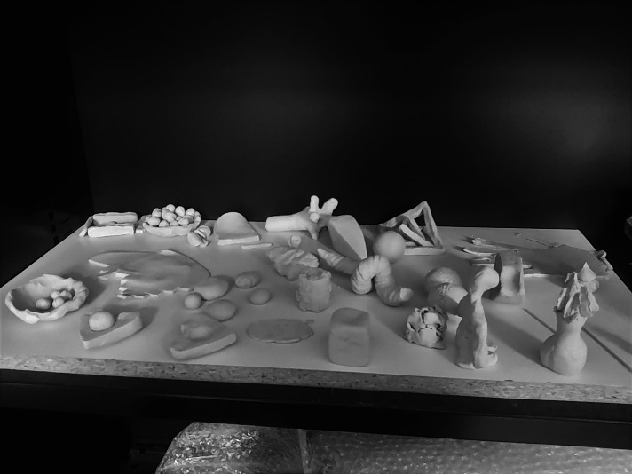

*Figure 1 shows the outcome of the clay prototyping session.*

Besides prototyping with clay, video prototyping has been explored. Therefore, two groups have been defined. They have been claimed to find ideas that can be presented in a video prototype (see Figure 2).

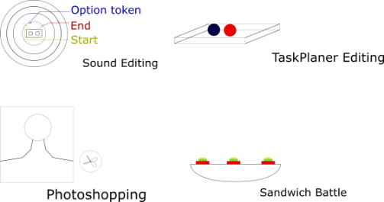

*Figure 2 shows some ideas one group had in the idea and design process for the tangible interaction video prototype that has to be filmed later. These images have been created with Adobe XD[5].*

One idea of one group was sound editing and how to make it tangible. The main difficulty of sound editing is that it is difficult to work cooperatively and simultaneously with other people. There is usually only one mouse and keyboard that is linked to a computer that can be used as an input device. Therefore, it is difficult to work simultaneously. The idea is to improve this by using tokens and constraints.

Another idea was to improve work-life-balance in companies and how it can be visualized. Therefore, a heart symbolizes the amount of work, and balls are used to define tasks that can be placed around the heath. According to the number of balls, the heath shape changes. Moreover, the balls change their colors if the deadline comes closes.

Finally, there was a game idea. It was about robots that can be programmed with puzzle parts. The task in the game is to find a door to leave a maze. Therefore, at least two players are needed. In the game, the first player programs the maze and how it looks like. The second player programs the movement of the robot that is inside the maze. Programming can be done by puzzle parts. The puzzle parts are color-coded that define the height level of a maze, borders, or the code structure like red puzzle parts are used to define a loop.

In the decision process, what every group wanted to video prototype, tops, and hints were given by the tutor. For one group, it was the Sound Editing-idea. The other group decided to build a tangible traffic planer on the streets.

To film their ideas, the groups had to cut wood pieces, buy papers, print out icons, and used clay. After this preparation, they filmed the interaction with the system they want to show and its functionalities. Later, the video prototypes had to be presented.

Last but not least, bodystorming has been introduced. Bodystorming is a method to find new inspiration and ideas for prototyping. This approach uses role-play elements to interact with an object, a prop, or the actual prototype to gather information about how people use the device. The underlying relationships between the human, the surrounding, and the object will be explored. [6]

# Project ideas

For the upcoming project, ideas had to be found on how to improve a specific topic with tangible interaction. Therefore, every participant had to find some inspirations and presented them. Three of them were the group’s favorite.

The first favorite idea was a sword game. Two or more players draw cards that show a specific element like water or fire. These card tokens are placed on the handle of the sword. The sword can be used to attack the other players. According to the elements and the place where the player hits the enemy's sword, the player makes different damage.

The sword is divided into three areas (attack, defense, and void). Depending on the players’ hit, the opponent points are reduced. At some point, the element gets destroyed, and a new element must be drawn. If the play does not have any card tokens anymore, the other player has won.

The second idea was an abstract music instrument that can generate music with daily used objects. So, users can use everyday objects that they already know and know how to interact with to generate sound even without having an instrumental background. In this approach, the daily used objects get an augmented music meaning. To generate sound, tokens are added to daily objects. Then it can detect the motion. According to the daily object and the tokens, sounds are created. This construction makes it modular to generate sound since there is a wide range of objects that can be attached to the system, and tokens can define the sound ton.

The last idea that was in the pool of favorites was a forest sound idea. Therefore, plants that have a token attached can be placed on a cupboard. Depending on where the plant comes from, different forest music is played. If the user wants to change the volume, he/she can rotate the shelve.

To decide which of the favorites ideas was the best, the potential of each project has been discussed. Finally, the group decided to build and implement the music instrument idea (see Figure 3).

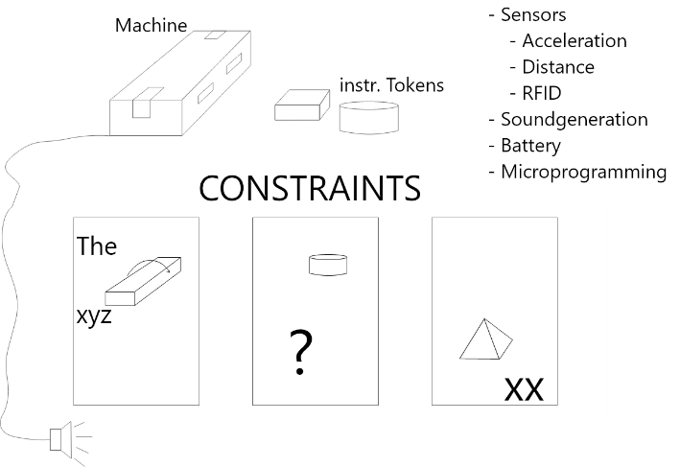

*Figure 3 shows sketches of the music machine/sensor module with its instrument tokens, and how the sensor module and how the instrument tokens could look like. Furthermore, it has been written down what hardware and software must be thought-about to generate sound. This image has been created with Adobe XD and the original image can be found in the Sensor_Module_Design_Process folder.*

To develop such a system, the project can be split into four parts. First, there is the system that must be developed to detect motion. Secondly, sound must be generated based on the motion. Thirdly, a proper design for hiding the electronics must be found, and last but not least, inspiration for what kind of daily objects the system should build has to be found by a bodystorming session.

# 1. Programming

To define sensors that should be used to detect interactions to create music, a short bodystorming session has been held. This one is not the final bodystorming session in which daily objects and their sounds are defined, but it helped to understand what kind of sensors are usually needed for motion detection.

After thinking about objects and how people could use them, the group mapped this experience and interaction gestures with sensors that can detect these specific movements. For most motions, an accelerometer[7,8], a distance[9], and an orientation sensor[10,11]are needed.

In addition to these sensors, a wireless connection to the sound generator should be accomplished since cable would restrict the interaction of the user, so a wireless connection has been prioritized.

For the project, a microcontroller must be programmed to receive distance, acceleration, and orientation. Moreover, UDP should be used to send motion data wirelessly.

To program these functionalities, the LSM303DLHC[12]and the VL53L1X[13]chips are used. This specific acceleration chip (LSM303DLHC) that has used can also detect the orientation. The distance to an object can be detected by the VL53L1X chip. Furthermore, the microcontroller has been programmed, so RFID tags can be detected by an RFID[1] reader (RFID-RC522[14]). At the beginning, the idea was that users can use modifiers to change the alter sound by filters. However, to do so, at least two RFID readers would have been needed. However, after a discussion, it has been agreed that the focus of the first prototype should lie on detecting the daily used object, so only one RFID reader and a tag is used.

After coding and testing every sensor separately, the microcontroller and the sensors have been soldered. Therefore, a circuit board, an RFID reader, the LSM303DLHC, and a VL53L1X sensor has been linked together (see Figure 4). As a microcontroller, an ESP8266 has been used for developing.

|  |  |
| --- | --- |
|  |  |

*Figure 4 shows the first soldering of a NodeMCU 1.0 with an RFID reader, an LSM303DLHC, a VL53L1X sensor, and a circuit board. The image that showes the sketch of the wiring has been created with Fritzing*[15]*.*

Because of some problems with receiving UDP packages by the sound generating software, two microcontrollers have been used. One that is a server and just waits for motion data and the other one sends the data. Therefore, another ESP8266 is used. This one was directly linked to a computer. The server, that is linked to the abstract instrument shares its data with a client. The client is linked to a computer, so the music generation software can receive serial output. The whole code logic can be found in Figure 5.

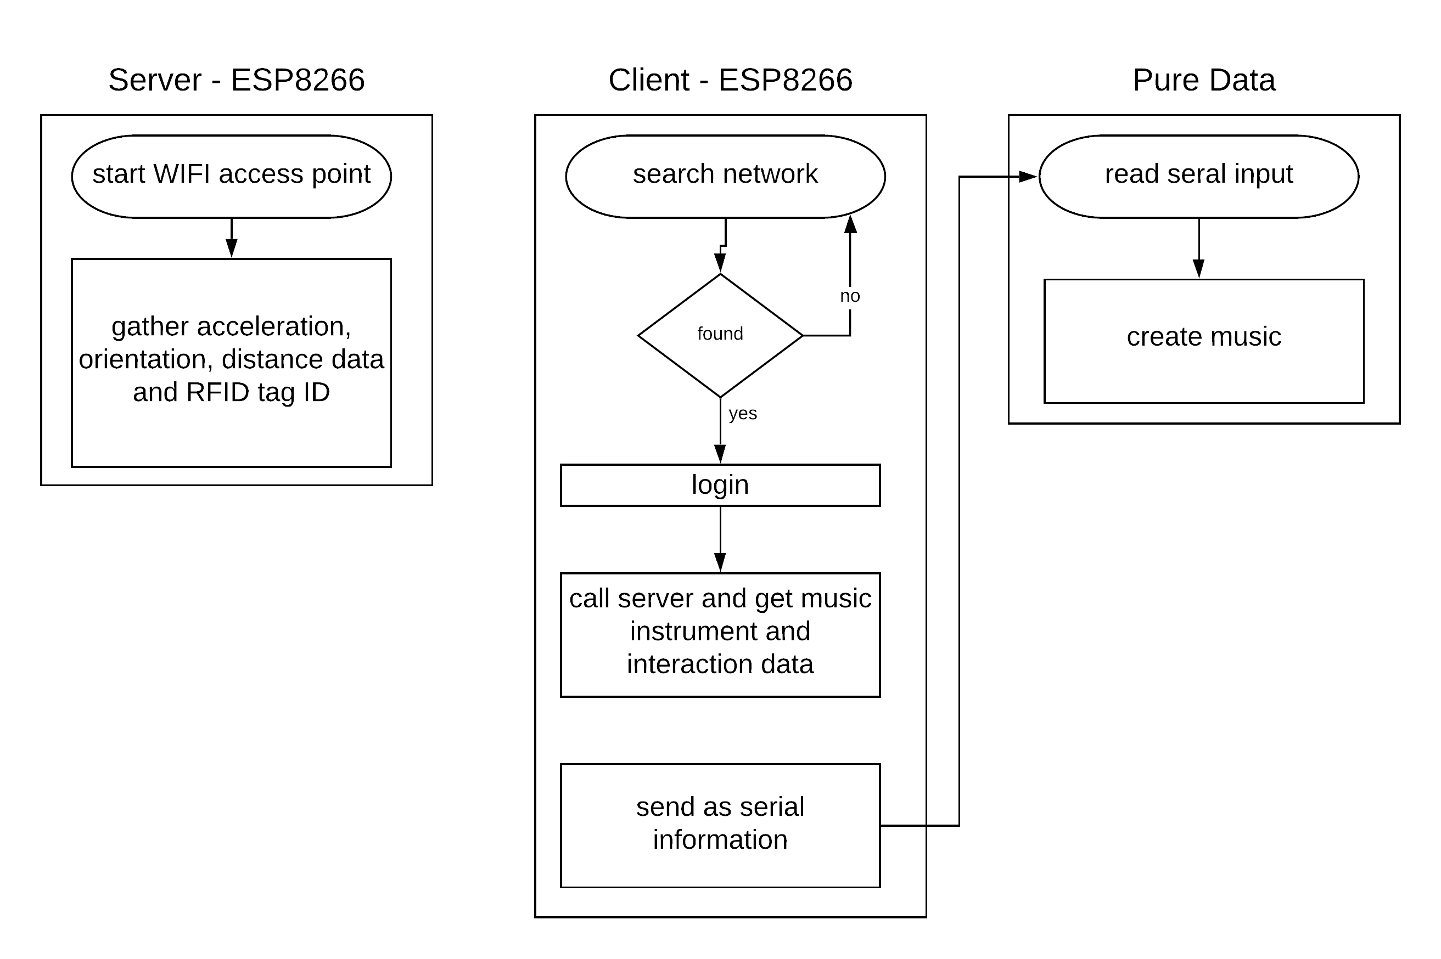

*Figure 5 shows the interaction between programs. The server gathers the acceleration, orientation. and distance values. Furthermore, it creates a wireless network. If the Client is connected to the network, it calls for the interaction data and processes them, so Pure Data can use the data to generate music. This figure and further code logic images have been created with Lucidchart.*[16]

The communication between the client, the server, and the code processing took around five seconds. Also, an anther microcontroller (the ESP32) could not fix the problem. Without the RFID reader, the client can read the server messages faster; however, the delay was still around two seconds long.

With a delay of two or five seconds, the wireless network is no option. That is why a serial connection was used instead. Only one microcontroller has been used at the end of the project. This one receives distance, orientation, and acceleration data. The RFID reader has been linked to the microcontroller again, so it can detect RFID and NFC tags. Furthermore, the RFID tag is only read if a button[17] is pressed. Only if the Button has been pushed once, the RFID reader reads the tag on the object. Besides, a USB module has been wired to the ESP8266. Therefore, a USB TTL Serial cable[18] has been used. For uploading code and receiving serial information over this TTL Serial Cable, another USB driver has been installed[19]. After wiring and adding everything in the sensor module (see Figure 6), it has been noticed that NFC tags cannot be recognized by the RFID reader anymore. The distance between the reader and the NFC tag is too large. That is why RFID cards must be used to identify the abstract instruments instead.

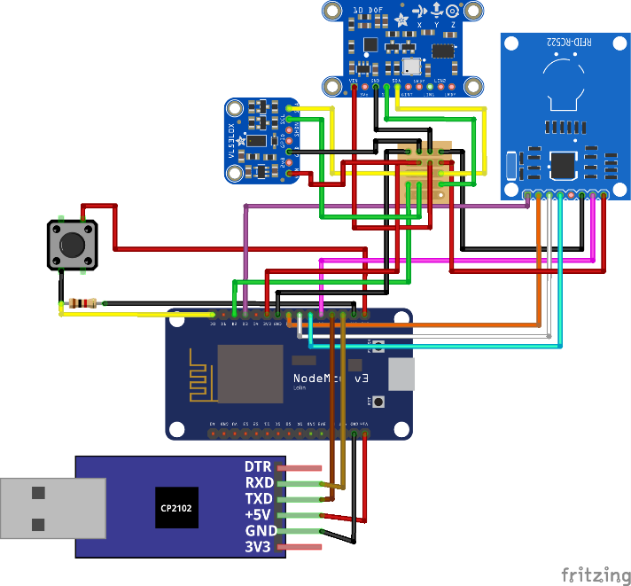

*Figure 6 shows the final wiring of the NodeMCU 1.0 with TTL USB, RFID reader, LSM303DLHC (acceleration and orientation sensor), VL53L1X (distance sensor), a button, and a circuit board. This image has been created with Fritzing*[15]*.*

The final code logic can be found in Figure 7***Figure 6***. If the button is pressed the RFID reader is called and tries to read tag ID. If a tag has been found it sends specific music data according to the tag ID to the music generation software.

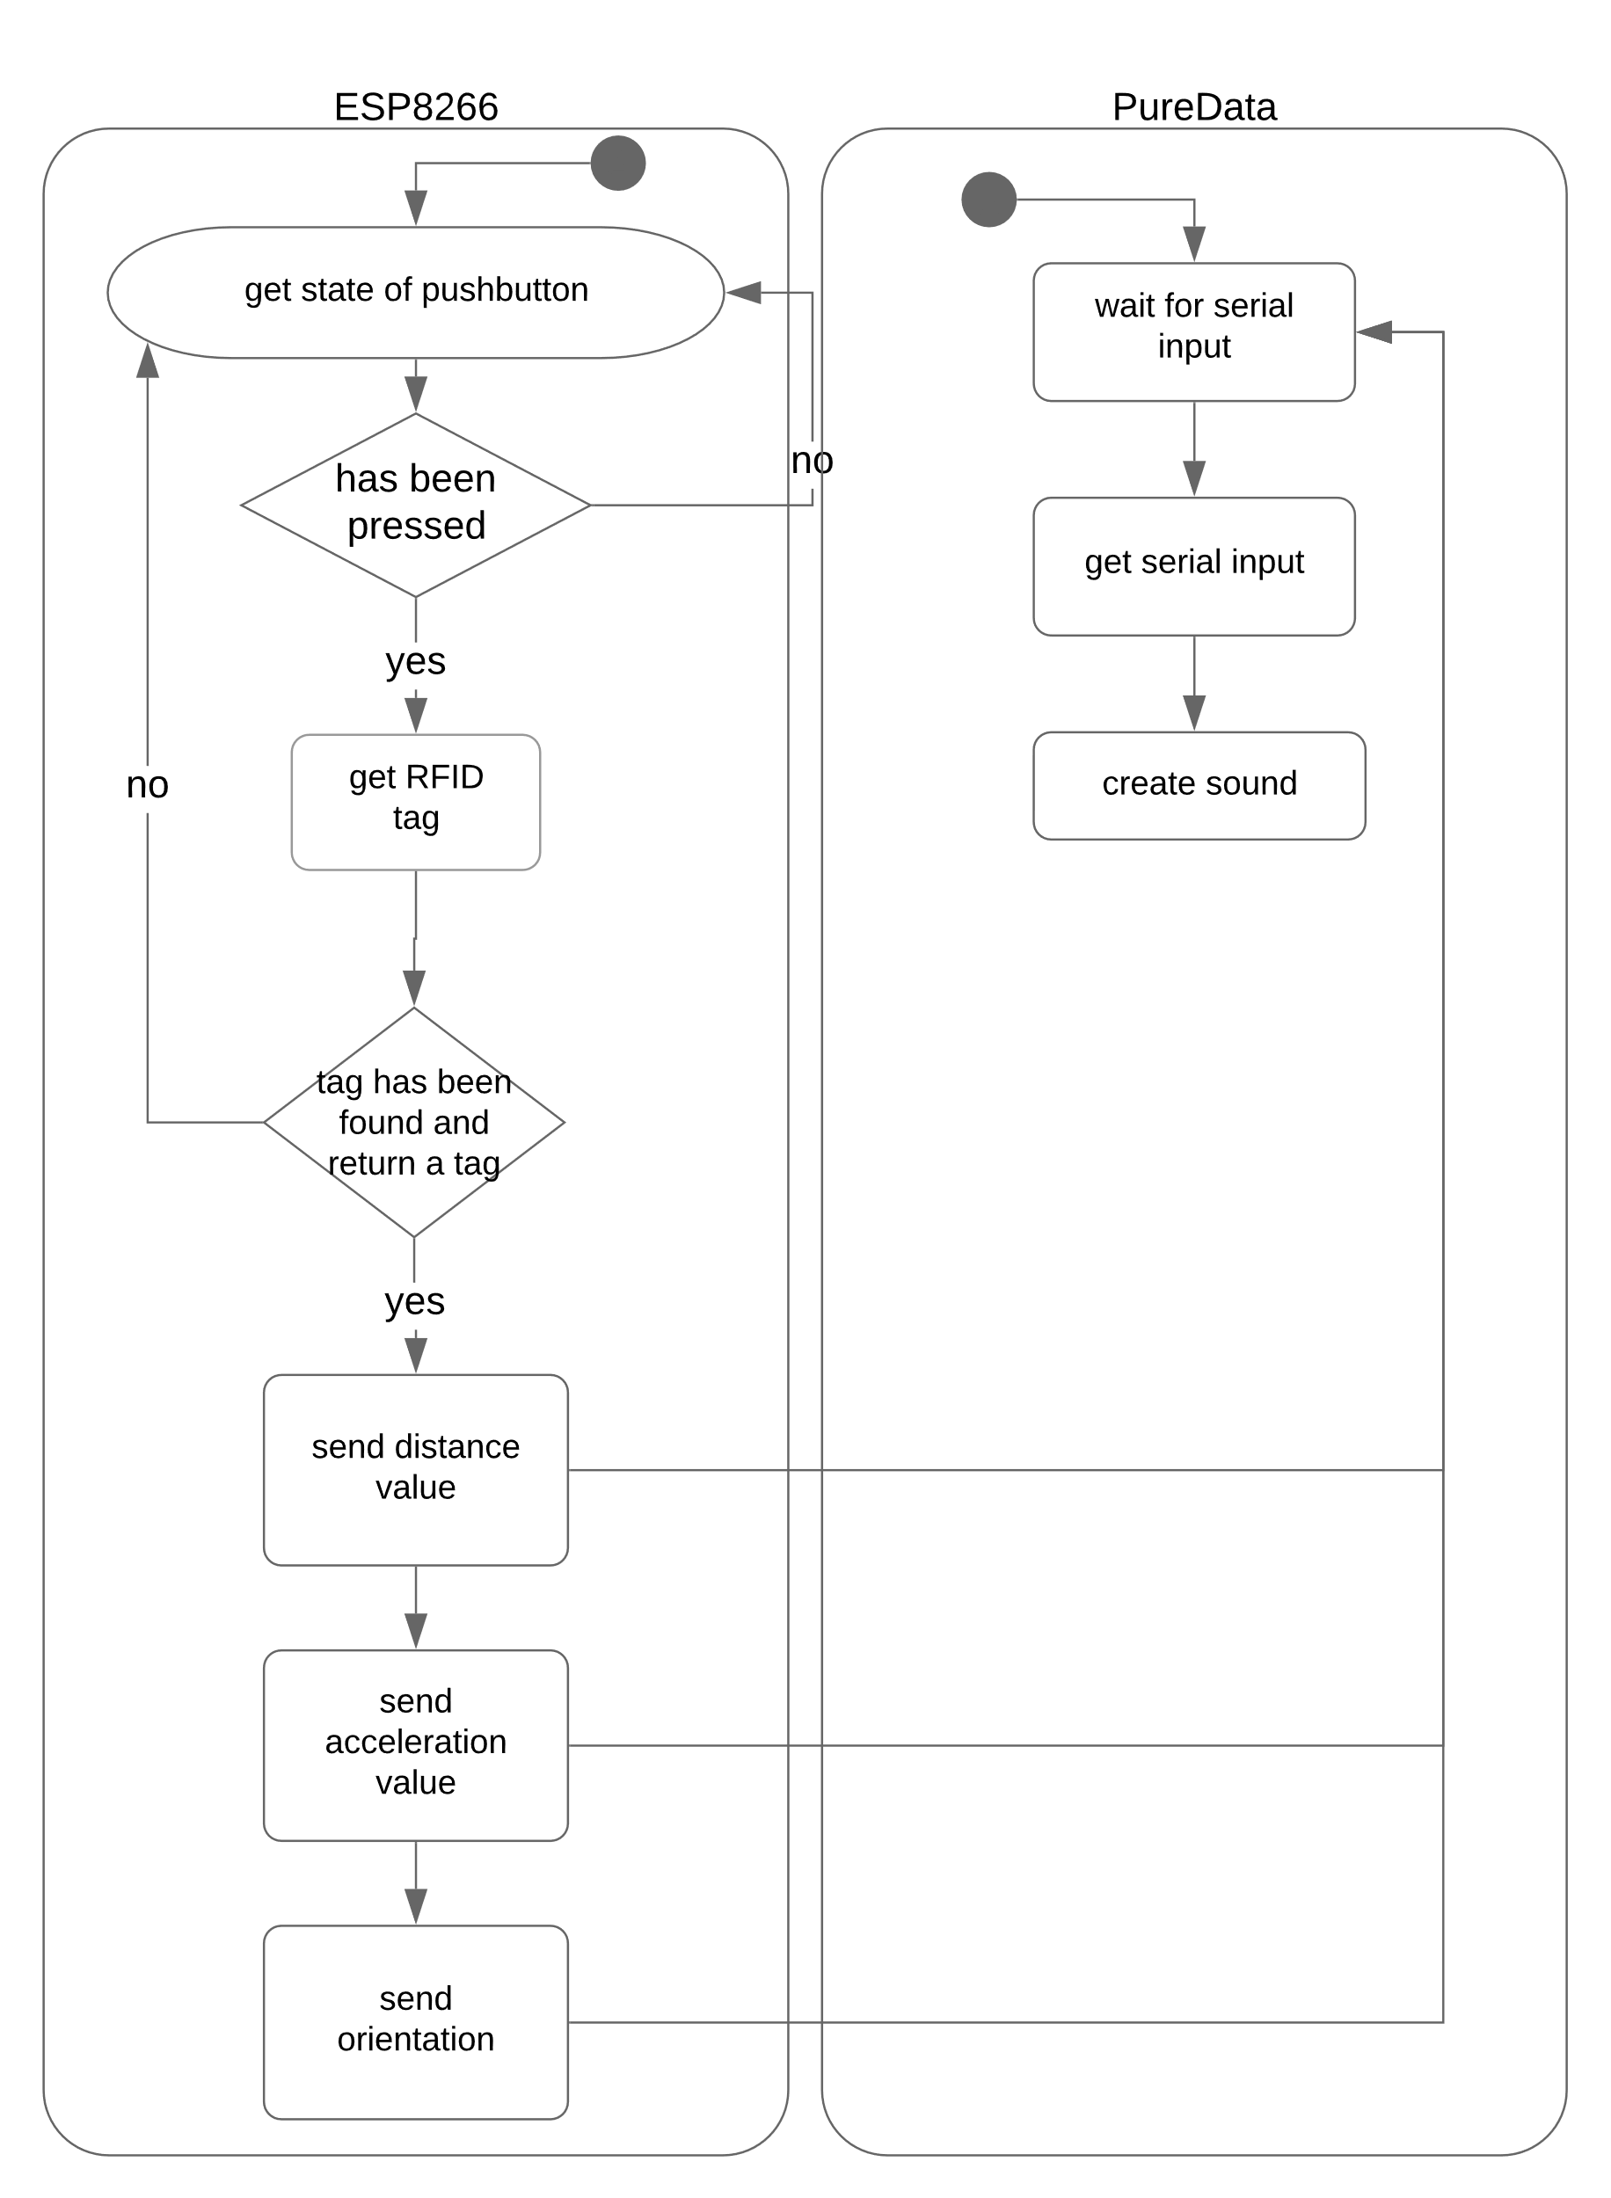

*Figure 7 shows the code processing. One microcontroller is linked to all sensors and chips. If the button is pressed, the RFID reader reads the tag ID. According to the ID, the different interaction values are sent.*

Supporting images, UMLs, and the code for programming the prototype can be found on Github.[20]The changes can that have been made over time can be found on Github as well.[21]

# 2 Sound generation

To understand sound waves and how sound can be created with software, an introduction to generate sound has been given. Therefore, the open-source platform Axoloti[22]has been used. In this session, filters, pitches, and envelope mode, for example, has been discussed and explained (see Figure 8).

|  |  |
| --- | --- |
|  |  |
| *Figure 8 shows the music generation session. It included the Axoloti and how to program sound generation with the Axoloti hardware.* | |

In the project, the sound generation has been programmed with Pure Data[23]. A software solution has been prioritized since it felt more natural to the group using it since all group members have a background in programming. A hardware solution like the Axoloti was also discussed; however, this would add another hardware device users would need to buy. Instead, Pure Data is for free and open source.

At the beginning of the project, a wireless network between a microcontroller and Pure Data needed to be programmed. Wireless was the prioritized communication method since this would help to use the microcontroller with all necessary sensors freely. To develop such a network, the patch MrPeach[24] has been tried to add. However, the group could not find out how the patch can be integrated.

Because of this problem, a wireless connection between Pure Data and a microcontroller like the ESP8266 could not be created, so a direct wireless connection was not possible. That is why another microcontroller has been added to this project. However, since the communication between the microcontrollers took at least two seconds, a wired solution for transferring data has been used. To receive serial information, the patch Comport[25] has been loaded into Pure Data.This patch can be used to receive raw serial data, so this data can be used for music creation. However, this did not work because of the amount of data that has to be sent at once.

That is why another patch has been used to read data from the serial port. The object that can be used in Pure Data to receive MIDI data is called notein[26]. MIDI has been used because it was the only way Pure Data could receive information from a microcontroller. However, the user of the system must download and install two programs, LoopMIDI and Hairless.

LoopMIDI is going to create a virtual MIDI device. There is a default software in Windows that does it, but it often crashes and LoopMIDI is more stable.

The program Hairless is going to take the serial data and send it to the MIDI device.

In addition to these problems, there was another one that came up when instrument sounds needed to be added to the project. Abstract sounds like a sine wave sound were not difficult to generate; however, to generate instrument sounds, vst-files must be added in Pure Data. Those files are audio files that are used to simulate piano, cello, violin, and flute sounds, for example. To play vst-files, plugins must be used. A plugin for Pure Data has been found and some example vst-files as well; however, the files could not be run.

As the last step, the final abstract sound files had to be programmed and tweaked for a specific daily object. Therefore, the final abstract instruments had to be defined.

# 3 Design thinking

In the meanwhile, a case for the electronics had to be designed. Therefore, designs have been developed and discussed in meetings. The shape but also the connection between the module and the instrument has been debated (see Figure 9).

|  |  |
| --- | --- |
|  |  |

*Figure 9 shows sketched ideas of how the sensor module could look like and the favorite idea.*

The design should not have a common shape like a rectangle or a cylinder. Instead, it should look interesting, so people want to interact and experience what it is. At the end of the meeting, it has been decided to design an abstract form of a brain. The brain concept is not linked to music. Instead, it has the meaning of including everything necessary to generate the sound. This, at least, was the intention and the metaphor as a concept. The daily objects and the tokens can get attached to this module.

Also, the connection between the module and the constraints were discussed. Two ideas were prioritized.

The first one was that magnets are used to connect the module with the daily object. This idea has a positive aspect that no connections must be shown. However, this also is the biggest drawback because people would not know how to link everything (affordance issues). Furthermore, the magnets must have a big magnetic effect; otherwise, the module would lose the connection to the object when the user is doing some fast movements.

Because of this problem, other linking mechanisms were tried to be found. Hook-and-loop fastener[2] was another idea. This not only provides the user a hint about how to connect devices, but the connection is also very strong, so even faster movements should not be difficult to handle. However, also there the direction of how to connect the constraint with the module is not defined.

To model the abstract brain idea, a 3D program like Fusion 360[27] or Maja[28] can be used. Fusion 360 is very useful since the program can easily be used to model 3D printing models. The model can later be exported into a 3D printer readable file. A first version can be found in Figure 10.

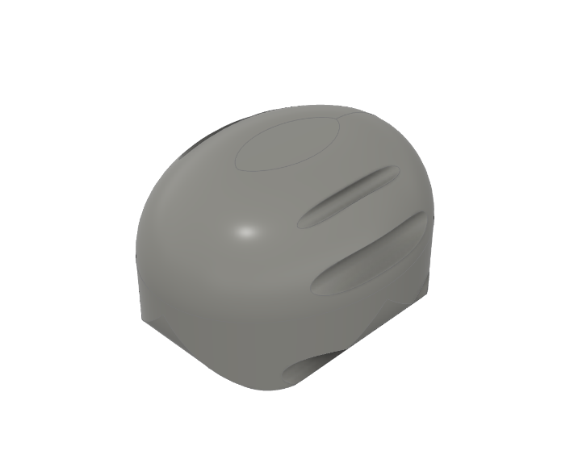

*Figure 10 shows the first version of a 3D model of the sensor module.*

The main problem with this model is that it is symmetry. This leads to the problem that users do not know how to connect it to an object. Since only one distance sensor is used, the direction of the module is important; otherwise, the observation of the user’s interaction will be interpreted wrong.

To hold everything in place in place, an asymmetric design must be found, so the users automatically know how to place the module. Therefore, a base must be modeled. This can, for example, be connected to the interaction object and the sensor module via cable ties.

To be more efficient with space and the case dimensions, the first model has been flattened, so the height of the overall model shrinks. Furthermore, more space for the sensors has been added, so all devices fit in the sensor module. In addition, an opening and closing mechanism have been added, so the device can be debugged if needed (see Figure 11).



*Figure 11 shows the second iteration of the abstract form of a brain.*

In a third iteration of the sensor module design, some space has been added to the top, so the RFID chip could also be added there. This version has been 3D printed. The whole process can be found in Table 2.

|  |  |
| --- | --- |
|  |  |
|  |  |

*Table 2 shows the first 3D printing process.*

After printing out the sensor model, sensors have been checked if the sensors fit; some space could be removed. This led to a shrunken model. Furthermore, some sensors did not fit, so some bigger holes have been added. The sensors did not fit because there was a misunderstanding in the width and height values of some sensors. The datasheets used inches and not centimeters or millimeters. In addition, holes for the Micro-USB cable have been added. So, the battery that is linked to the microcontroller can be charged. Also, the space on the back of the top has been added again because the group decided to have the RFID reader on the ground.

In addition, the connection base (see Figure 12) that connects the object with the sensor module has been designed. However, it has not been printed because a new printer had to be found first. The other one used a material that is too heavy. This base has four holes. These are used to wire the base to the instrument. Furthermore, a slider bar has been added. This holds the sensor model in place even if users move the model fast.

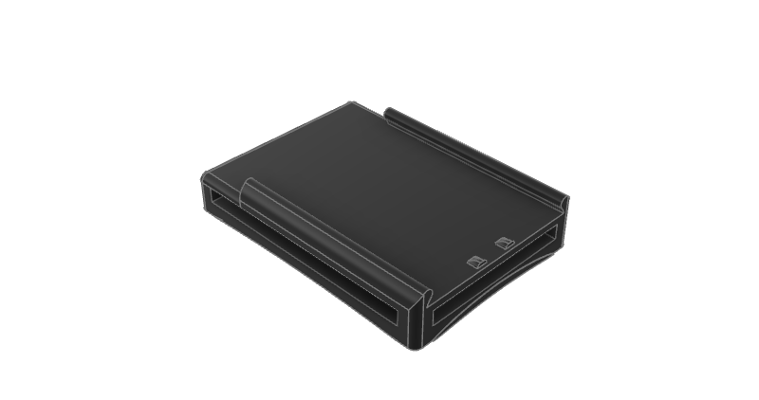

*Figure 12 shows the base model that has been designed to lock the sensor module. So, the module cannot move after locking it on the base.*

Because of using a server-client wireless network for the communication between two ESP8266 microcontrollers, a receiver module had to be designed. The client is placed in the inside of it. Later, the client is linked to the computer by a USB cable (see Figure 13).

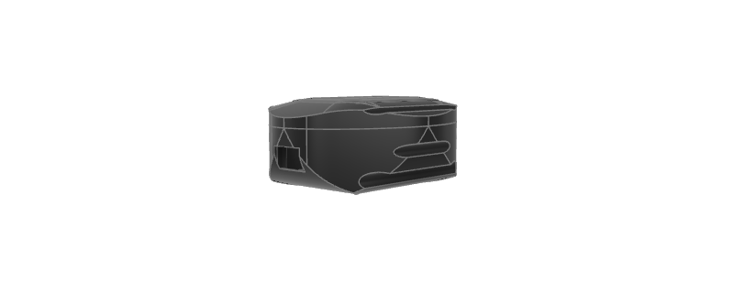

*Figure 13 shows the receiver module for the ESP8266 client that is spired by the sensor module’s case but around half the size.*

However, after all these changes in the programming part (see 1. Programming) and what kind of communication is used, the receiver module does not need to be printed.

The sensors module is printed with some slight changed. First and foremost, the top of the module is not around anymore. The reason for this is the new printer that has been used. It would be difficult for the printer and the outcome would probably look bad, so a flat top is printed instead. Some smaller changes in the body of the sensor module have been done as well. In printing process can be found in Figure 14.

|  |
| --- |
| *Figure 14 shows the final printing process.* |

The printer uses Polylactide (PLA)[29]. This material shape changes if the temperature is higher than around max. around 50°C. The final sensor module can be seen in Figure 15.

|  |  |
| --- | --- |
|  |  |

*Figure 15 shows the final sensor module’s case with the ESP8266 that is linked to the acceleration sensor, distance sensor, and orientation sensor.*

# 4. BodySTorming

In order to get more inspiration on how to use the prototype and to find more constraints, a bodystorming session has been held. Like mentioned before, a bodystorming session has been done before; however, only the group participated to find out what kind of data must be gathered to detect motion. This time, new inspiration has been found from people who have different backgrounds. They had the task to find daily objects that can be linked to the system and what kind of sound the interaction should make.

In total, three students from the Bauhaus University have participated, two males and one female. The average age of these three people was 31.3. The first participant studies Human-Computer Interaction but also has a background in Design. The second, on the other hand, is studying Media Arts and Design and has a background in Music. The third participant is also studying Media Arts and Design. The bodystorming session has been held between 1 and 3 pm. The Human-Computer Interaction Lab in the Karl-Haußknecht Strasse 7 has been chosen to hold the session. In the lab, participants can find a wide range of devices and interaction properties.

A brief introduction to the project has been given. Sensors have been defined, so the participants knew what kind of interactions are possible. In addition, the sensor module has been presented and explained how it works and how it can be used to generate sound. An example has been used to explain bodystorming, and how the device can be used.

Afterward, every participant had three sessions of 10 minutes. In this period, they had the chance to look around and use every object that is in the labor. These devices are later used to describe how they would interact with the object to create music. Furthermore, they tried to describe a sound the sensor module should create. After this time, the participants and the observer talked about their ideas (see Figure 16). 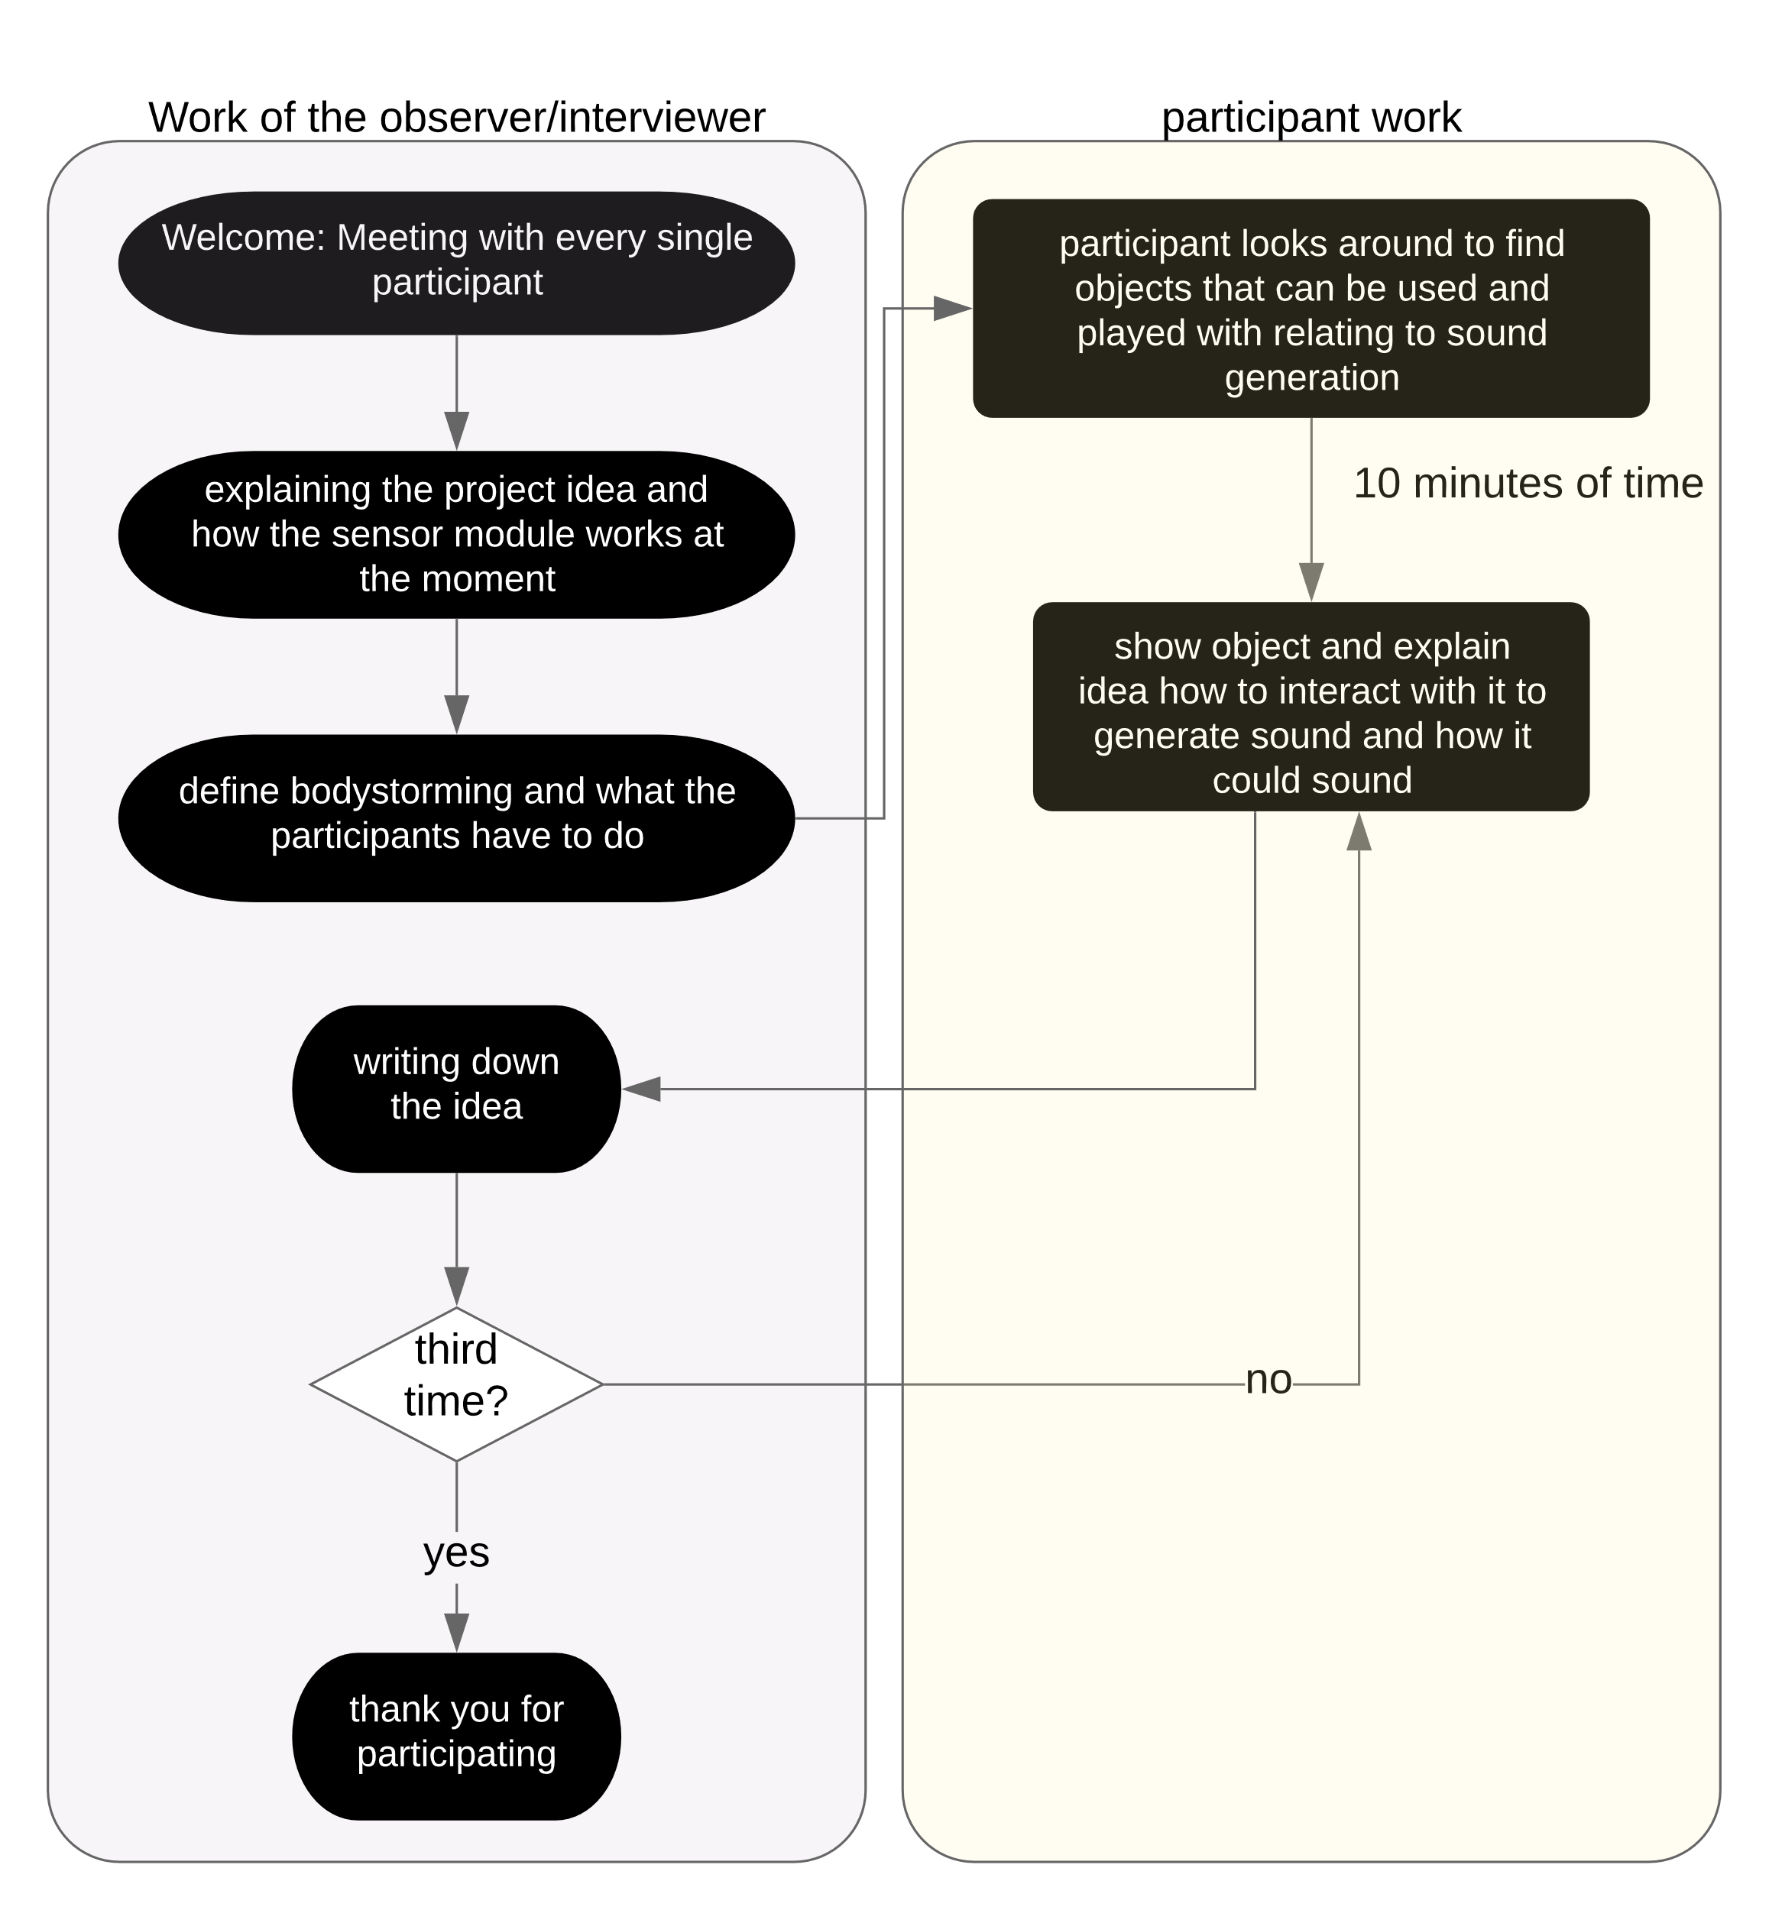

*Figure 16 shows an overview of how the bodystorming session for every participant was structured.*

The outcome of the bodystorming session can be found in Table 3 in the Appendix. In general, some new ideas and inspiration have been found. For example, the first participant mentioned a rope that is used by two people. These create waves with the rope by swinging it. Moreover, there was the idea of playing the sensor module in a ball that is attached to a string and the other end of the string is attached to a paddle. The second participant, on the other hand, had an idea where the sensors that are inside the sensor module actually, are placed inside the surface or floor; however, the project is based around the fact that the sensor module is mobile and the data is gathered by the sensor modules movement, so it did not fit in the original idea of the project. Another idea from the third participant which was out of our project scope is to use vibrations. For this, an additional sensor must be included.

Some other ideas that have been mentioned by the participants have also been mentioned in the first bodystorming session of the group. For example, the sensor module can be placed inside a ball, and by throwing it, it creates a sound. Furthermore, some inspiration has been found in the guitar hero game. Another idea was when a sensor module is inside a stress ball and that ball can be squeezed or thrown around.

# conclusion

In this project, many problems occur when programming the music generation or the microcontroller: the RFID could be used with I2C[30], wireless connections between microcontrollers took too long, MrPeach could not receive UDP packages, and the loading of vst-files.

The RFID-RC522 reader can technically be used via three different serial protocols (UART[31], I2C, and SPI[32]). All protocols have been tried but none of them worked with the ESP32 Feather. After connecting every pin correctly, the RFID reader did not respond. After two weeks of working on it, all agreed that the ESP32 should not be used anymore. Instead, the NodeMCU ESP8288 is used. With this microcontroller, everything worked well. The mistake that has been made was never found.

The sound generation over WIFI stopped the group for a long time as well. The MrPeach patch could not be included properly, so a second microcontroller has been added as a receiver. A wireless network between the ESP that was attached to the constraint/instrument and the ESP that is directly linked to the computer has been implemented to solve this problem. In this client-server network, the client received the interaction values from the server. The client sends serial data over a cable. However, the Comport patch that should have been used for this purpose cannot handle these numbers of data at once, so the notein object has been used. Later the wireless network has been removed because the delay was too long.

The problem that kept us from using a wireless connection was the communication delay. The client needed too much time to receive the interaction data from the server. To solve the problem, the ESP32 has been used as a client; however, there was no improvement. In the end, a longer cable has been used to transfer the information. However, there are ways to overcome this problem.

One of these solutions could be code/ software. Perhaps the used libraries are slow because it should not take so long. Libraries like ESP8266WiFi.h[33], ESP8266WiFiMulti.h[34] and ESP8266HTTPClient.h[35] should be included and tested. Also, the ESPAsyncWebServer library[36] could be tried out.

Another solution to this problem could be a different sensor. The NRF24L01 chip[37] could be tested, for example.

Adding vst-files to Pure Data was a major problem, and several days had to be used to find the problem without much success. A solution to this problem was never found; otherwise, there have been found some instructions on the Internet.

However, even with these many problems, the aim could be reached, and a working prototype could be developed.

# rEFLECTION

The class and its final project were interesting, the group agreed. The author came across many different topics and problems that had to be solved in a given time. Before working on the project, the class helped to learn more about tangible user interaction and Human-Computer Interaction. Still, the author would say that the project should start sooner by finding the final project idea and working on it. Before working on this project, the project meetings were not as productive as they could be. Still, this also gave time to get to know each other and build a group. A solution for this could be a project that includes two semesters. Then more theory could be taught and more time for a proper idea is given. In a class called “Idea meets technology”, students had a whole semester to find a good idea. Finding good ideas are very difficult, and there should not be any hurry. This additional time could be used to read about tangible user interaction approaches and design theory and also about finding an idea.

The project idea was never a question. We all agreed which this was the best idea, so there was no disagreement in this group. Also, another discussion like the design discussion was discussed friendly and with respect. This shows the good communication the team had.

In this project, the author had the chance to touch many different topics at once, like 3D printing, music generation, and how it works and programming of different microcontrollers and sensors.

Every week and near to the deadline every day they could talk about their achievements and what they did. Splitting the team is sufficient; however, this also creates a problem because no one knows everything about the project.

Working in a project like this allowed us to have valuable experiences not only in situations where everything worked as planned but also in some bad cases whereas things were happening not as expected and how we faced those problems.

Most problems with the electronics could be fixed even if it took a bit of time. Soldering all sensors and devices should be done later in the project. Changes in the sensors or which microcontroller use which sensors appears often in the middle of the project and if the sensors are soldered already, it takes a long time to unsolder everything. However, this gave me more practice. The group could deal with problems well and always tried to find a solution by themselves first. Still, not every problem could be fixed sufficiently.

The wireless network was a big problem in the programming process. The delay of around five seconds could not be shrink to an immediate response of the system. Regarding the documentation, the time delay should have been tested more precisely. Therefore, the function millis()[38] should have been used to test the HTTP response time.

The number of participants with different backgrounds in a bodystorming session was too low. There was not too much overlap in their opinions; however, we could find out many different aspects and ideas to generate the sound. Still, the bodystorming session gave the group some further inspiration for attachments and constraints. However, three participants are perhaps not enough and more different participants with different backgrounds.

# REFERENCES

[1] B. Ullmer, H. Ishii, and R. J. K. Jacob, “Token+constraint systems for tangible interaction with digital information,” 2005.

[2] O. SHAER, N. LELAND, E. H. CALVILLO-GAMEZ, and R. J. K. JACOB, “The TAC Paradigm: Specifying Tangible User Interfaces,” 2004.

[3] B. Ullmer and H. Ishii, “Emerging Frameworks for Tangible User Interfaces,” Cambridge, 2000.

[4] S. Harrison, D. Tatar, and P. Sengers, “The Three Paradigms of HCI,” Blacksburg, Ithaca, 2007.

[5] “XD als Teamplayer.,” *Adobe*, 2020. [Online]. Available: https://www.adobe.com/de/products/xd.html?sdid=91BF525M&mv=search&ef_id=Cj0KCQjwtLT1BRD9ARIsAMH3BtXoi04SQG7o8yGwBr-gqhCmw2sMZ6IwMQ97p8UOYOM9oXjKs5R9AlQaAnn8EALw_wcB:G:s&s_kwcid=AL!3085!3!394597829420!e!!g!!adobe xd. [Accessed: 02-May-2020].

[6] “UXD Method 11 of 100: Bodystorming,” *Typepad*, 2011. [Online]. Available: https://dux.typepad.com/dux/2011/04/uxd-method-11-of-100-bodystorming.html. [Accessed: 24-Feb-2020].

[7] “How Accelerometer works? Interface ADXL335 with Arduino,” *Last Minute Engineers*, 2020. [Online]. Available: https://lastminuteengineers.com/adxl335-accelerometer-arduino-tutorial/. [Accessed: 20-Feb-2020].

[8] Dejan, “MEMS Accelerometer Gyroscope Magnetometer & Arduino,” *howtomechatronics*, 2018. [Online]. Available: https://howtomechatronics.com/how-it-works/electrical-engineering/mems-accelerometer-gyrocope-magnetometer-arduino/. [Accessed: 20-Feb-2020].

[9] “Ultrasonic Ranging Module HC - SR04,” *Elecfreaks*. [Online]. Available: https://cdn.sparkfun.com/datasheets/Sensors/Proximity/HCSR04.pdf. [Accessed: 09-Jan-2020].

[10] Dejan, “Arduino and MPU6050 Accelerometer and Gyroscope Tutorial,” *howtomechatronics*, 2019. [Online]. Available: https://howtomechatronics.com/tutorials/arduino/arduino-and-mpu6050-accelerometer-and-gyroscope-tutorial/. [Accessed: 20-Feb-2020].

[11] Cbenson, “Arduino 5 Minute Tutorials: Lesson 7 - Accelerometers, Gyros, IMUs,” *Robotshop*, 2019. [Online]. Available: https://www.robotshop.com/community/tutorials/show/arduino-5-minute-tutorials-lesson-7-accelerometers-gyros-imus. [Accessed: 20-Feb-2020].

[12] “Ultra-compact high-performance eCompass module: 3D accelerometer and 3D magnetometer,” *STMicroelectronics*, 2014. [Online]. Available: https://www.st.com/resource/en/datasheet/DM00027543.pdf. [Accessed: 09-Jan-2020].

[13] “A new generation, long distance ranging Time-of-Flight sensor based on ST’s FlightSenseTM technology,” *STMicroelectronics*, 2018. [Online]. Available: https://www.st.com/resource/en/datasheet/vl53l1x.pdf. [Accessed: 09-Jan-2020].

[14] “Security Access using MFRC522 RFID Reader with Arduino,” *Random Nerd Tutorials*, 2020. [Online]. Available: https://randomnerdtutorials.com/security-access-using-mfrc522-rfid-reader-with-arduino/. [Accessed: 19-Feb-2020].

[15] “Fritzing,” *Fritzing*. [Online]. Available: http://fritzing.org/home/. [Accessed: 21-Dec-2019].

[16] “Professionelle Diagramme,” *© 2019 Lucid Software Inc.*, 2019. [Online]. Available: https://www.lucidchart.com/pages/de. [Accessed: 22-Jul-2019].

[17] F. Schäffer, *Sensoren am Arduino*, 1.Auflage. Elektor-Verlag GmbH, 2016.

[18] “FTDI Cable – USB to RS232 Converter,” *Components 101*, 2018. [Online]. Available: https://components101.com/cables/ftdi-cable-usb-to-rs232-converter. [Accessed: 22-Feb-2020].

[19] “Delock USB 2.0 to Serial TTL Converter with 6 open wires 1.8 m (3.3 V),” *Delock*, 2020. [Online]. Available: https://www.delock.com/produkte/G_83117/merkmale.html. [Accessed: 12-Mar-2020].

[20] C. Heiden, “Final Documentation,” *GitHub*, 2020. [Online]. Available: https://github.com/ChrisHeiden/Doc_Tangible_Interaction. [Accessed: 23-Mar-2020].

[21] C. Heiden, “Projectflow,” *GitHub*, 2020. [Online]. Available: https://github.com/ChrisHeiden/Tangible_Interfaces_Project. [Accessed: 23-Feb-2020].

[22] “Axoloti,” *Axoloti*, 2020. [Online]. Available: http://www.axoloti.com/. [Accessed: 15-Jan-2020].

[23] “Welcome To The Pure Data Site!,” *Institute of Electronic Music and Acoustics*, 2020. [Online]. Available: https://puredata.info/. [Accessed: 04-Jan-2020].

[24] “Mr.Peach,” *PureData*, 2020. [Online]. Available: https://download.puredata.info/mrpeach. [Accessed: 19-Feb-2020].

[25] “Comport,” *PureData*. [Online]. Available: https://puredata.info/downloads/comport. [Accessed: 08-Feb-2020].

[26] “Midi,” *PureData*, 2020. [Online]. Available: http://write.flossmanuals.net/pure-data/using-midi/. [Accessed: 19-Feb-2020].

[27] “Fusion 360 - Integrierte CAD-, CAM- und CAE-Software.,” *Autodesk*, 2019. [Online]. Available: https://www.autodesk.de/products/fusion-360/overview#banner. [Accessed: 05-Dec-2019].

[28] “Maja - Software für Animation, Modellierung, Simulation und Rendering in 3D,” *Autodesk*, 2020. [Online]. Available: https://www.autodesk.de/products/maya/overview. [Accessed: 15-Jan-2020].

[29] R. G. HILL, “Biomaterials, Artificial Organs and Tissue Engineering,” *Science Direct*. [Online]. Available: https://www.sciencedirect.com/topics/medicine-and-dentistry/polylactide. [Accessed: 20-Feb-2020].

[30] “I2C Info – I2C Bus, Interface and Protocol,” *i2c.info*, 2020. [Online]. Available: https://i2c.info/. [Accessed: 23-Mar-2020].

[31] Jimblom, “Serial Communication UARTs,” *Sparkfun*, 2020. [Online]. Available: https://learn.sparkfun.com/tutorials/serial-communication/uarts. [Accessed: 23-Mar-2020].

[32] MIKEGRUSIN, “Serial Peripheral Interface (SPI),” *Sparkfun*, 2020. [Online]. Available: https://learn.sparkfun.com/tutorials/serial-peripheral-interface-spi/all. [Accessed: 23-Mar-2020].

[33] I. Grokhotkov, “ESP8266WiFi.h,” *GitHub*, 2019. [Online]. Available: https://github.com/esp8266/Arduino/blob/master/libraries/ESP8266WiFi/src/ESP8266WiFi.h. [Accessed: 23-Mar-2020].

[34] M. Sattler, “ESP8266WiFiMulti.h,” *GitHub*, 2019. [Online]. Available: https://github.com/esp8266/Arduino/blob/master/libraries/ESP8266WiFi/src/ESP8266WiFiMulti.h. [Accessed: 23-Mar-2020].

[35] Jeroen88, “BasicHttpClient.ino,” *GitHub*, 2018. [Online]. Available: https://github.com/esp8266/Arduino/blob/master/libraries/ESP8266HTTPClient/examples/BasicHttpClient/BasicHttpClient.ino. [Accessed: 25-Jul-2019].

[36] “ESPAsyncWebServer,” *GitHub*, 2019. [Online]. Available: https://github.com/me-no-dev/ESPAsyncWebServer. [Accessed: 23-Mar-2020].

[37] “nRF24 Series,” *Nordic Semiconductor*, 2020. [Online]. Available: https://www.nordicsemi.com/Products/Low-power-short-range-wireless/nRF24-series. [Accessed: 23-Mar-2020].

[38] “millis(),” *Arduino.cc*, 2019. [Online]. Available: https://www.arduino.cc/reference/en/language/functions/time/millis/. [Accessed: 23-Mar-2020].

[39] M. Bolic, D. Simplot-Ryl, and I. Stojmenovic, *RFID Systems: Research Trends and Challenges*. Wiley, 2010.

[40] C. K. Haley, L. A. Jacobsen, and S. Robkin, *Radio Frequency Identification Handbook for Librarians*. Libraries Unlimited, 2007.

# Appendix

|  |  |  |  |
| --- | --- | --- | --- |
| ideas / Users | User 1 | User 2 | User 3 |
| 1 | Attaching the sensor module to a rope and two people will hold the rope on each end. They will generate waves, like a Sine wave, on the rope which will trigger sound generation | The sensor module is inside a ball that is attached to a string. The user can roll the ball on a surface or spin the string in a circular motion to wrap it around one's arm | The sensor module is attached to a steel drum and a brush is used to strike the drum. The vibrations caused will trigger the sensor module and also the distance of the brush from the sensor module will be taken into account when generating sound |
| 2 | Having two sensor modules, one will be on a stick which will be used as a guitar and the other one will be in the user’s hand. Every time the two modules touch, it would generate sounds. The idea was inspired by Guitar Hero | The sensor module is inside a ball, and the ball is held in place by using a cup-like object. This allows the ball to be rotated like a trackball | The sensor module is inside a ball and the ball will be covered in bubble wrap. The popping of the bubble wrap will activate the sensors and generate sound |
| 3 | The sensor module will be inside a small and light ball, which would be thrown around using sticks with a net, similar to lacrosse, and depending on speed/acceleration of the ball, the sensor module would generate different sounds. | The sensor module is inside a ball which is similar to a stress ball. Users can squeeze it and throw it which will bounce back. | The sensor module is attached to a chalkboard and the vibration that is generated while writing with chalk will be used to create sensor modules. |
| 4 | The sensor module is inside a ball and the ball is attached to a string. The other end of the string is attached to a paddle, similar to a table tennis paddle. The aim is to hit the ball in the target which could be the center of the paddle, which would generate certain sounds and every time the user hits the ball on the other part of the paddle, the generated sound is different | Install the sensors on a surface or floor and when an object rolls on it, or someone steps on it, it triggers the vibration sensor. The intensity will dictate how the sound is generated |  |

Table 3 shows the idea of the participants in every session.

1. Radio-frequency identification (short RFID) refers to a technology that is capable of sending information wirelessly via radio waves.[39], [40]
2. Hook-and-loop fasteners consist of two components. Two lineal fabric strips can be attached to each other’s surfaces. The first component features tiny hooks, the second features smaller loops, so if they are connected, they are bind temporarily.