OWL Corridor Economic Pulse
  - Regional Labor Market Analytics & Trend Reports
Great Lakes Center for Economics
July 2026

Executive Summary
This regional brief highlights the post-pandemic structural labor market dynamics across the OWL Corridor (Oakland, Washtenaw, and Livingston counties). Utilizing data integrated dynamically via the Local Area Unemployment Statistics (LAUS) program, these metrics reflect localized labor force shifts and regional stability.
The latest updated metrics in this report reflect data through May 2026.

Unemployment Rate Trajectories
The chart below outlines the structural normalization of the regional unemployment rate. The green line establishes the baseline for Oakland County, while Navy and Orange represent Washtenaw and Livingston Counties respectively.

Unemployment Visualization
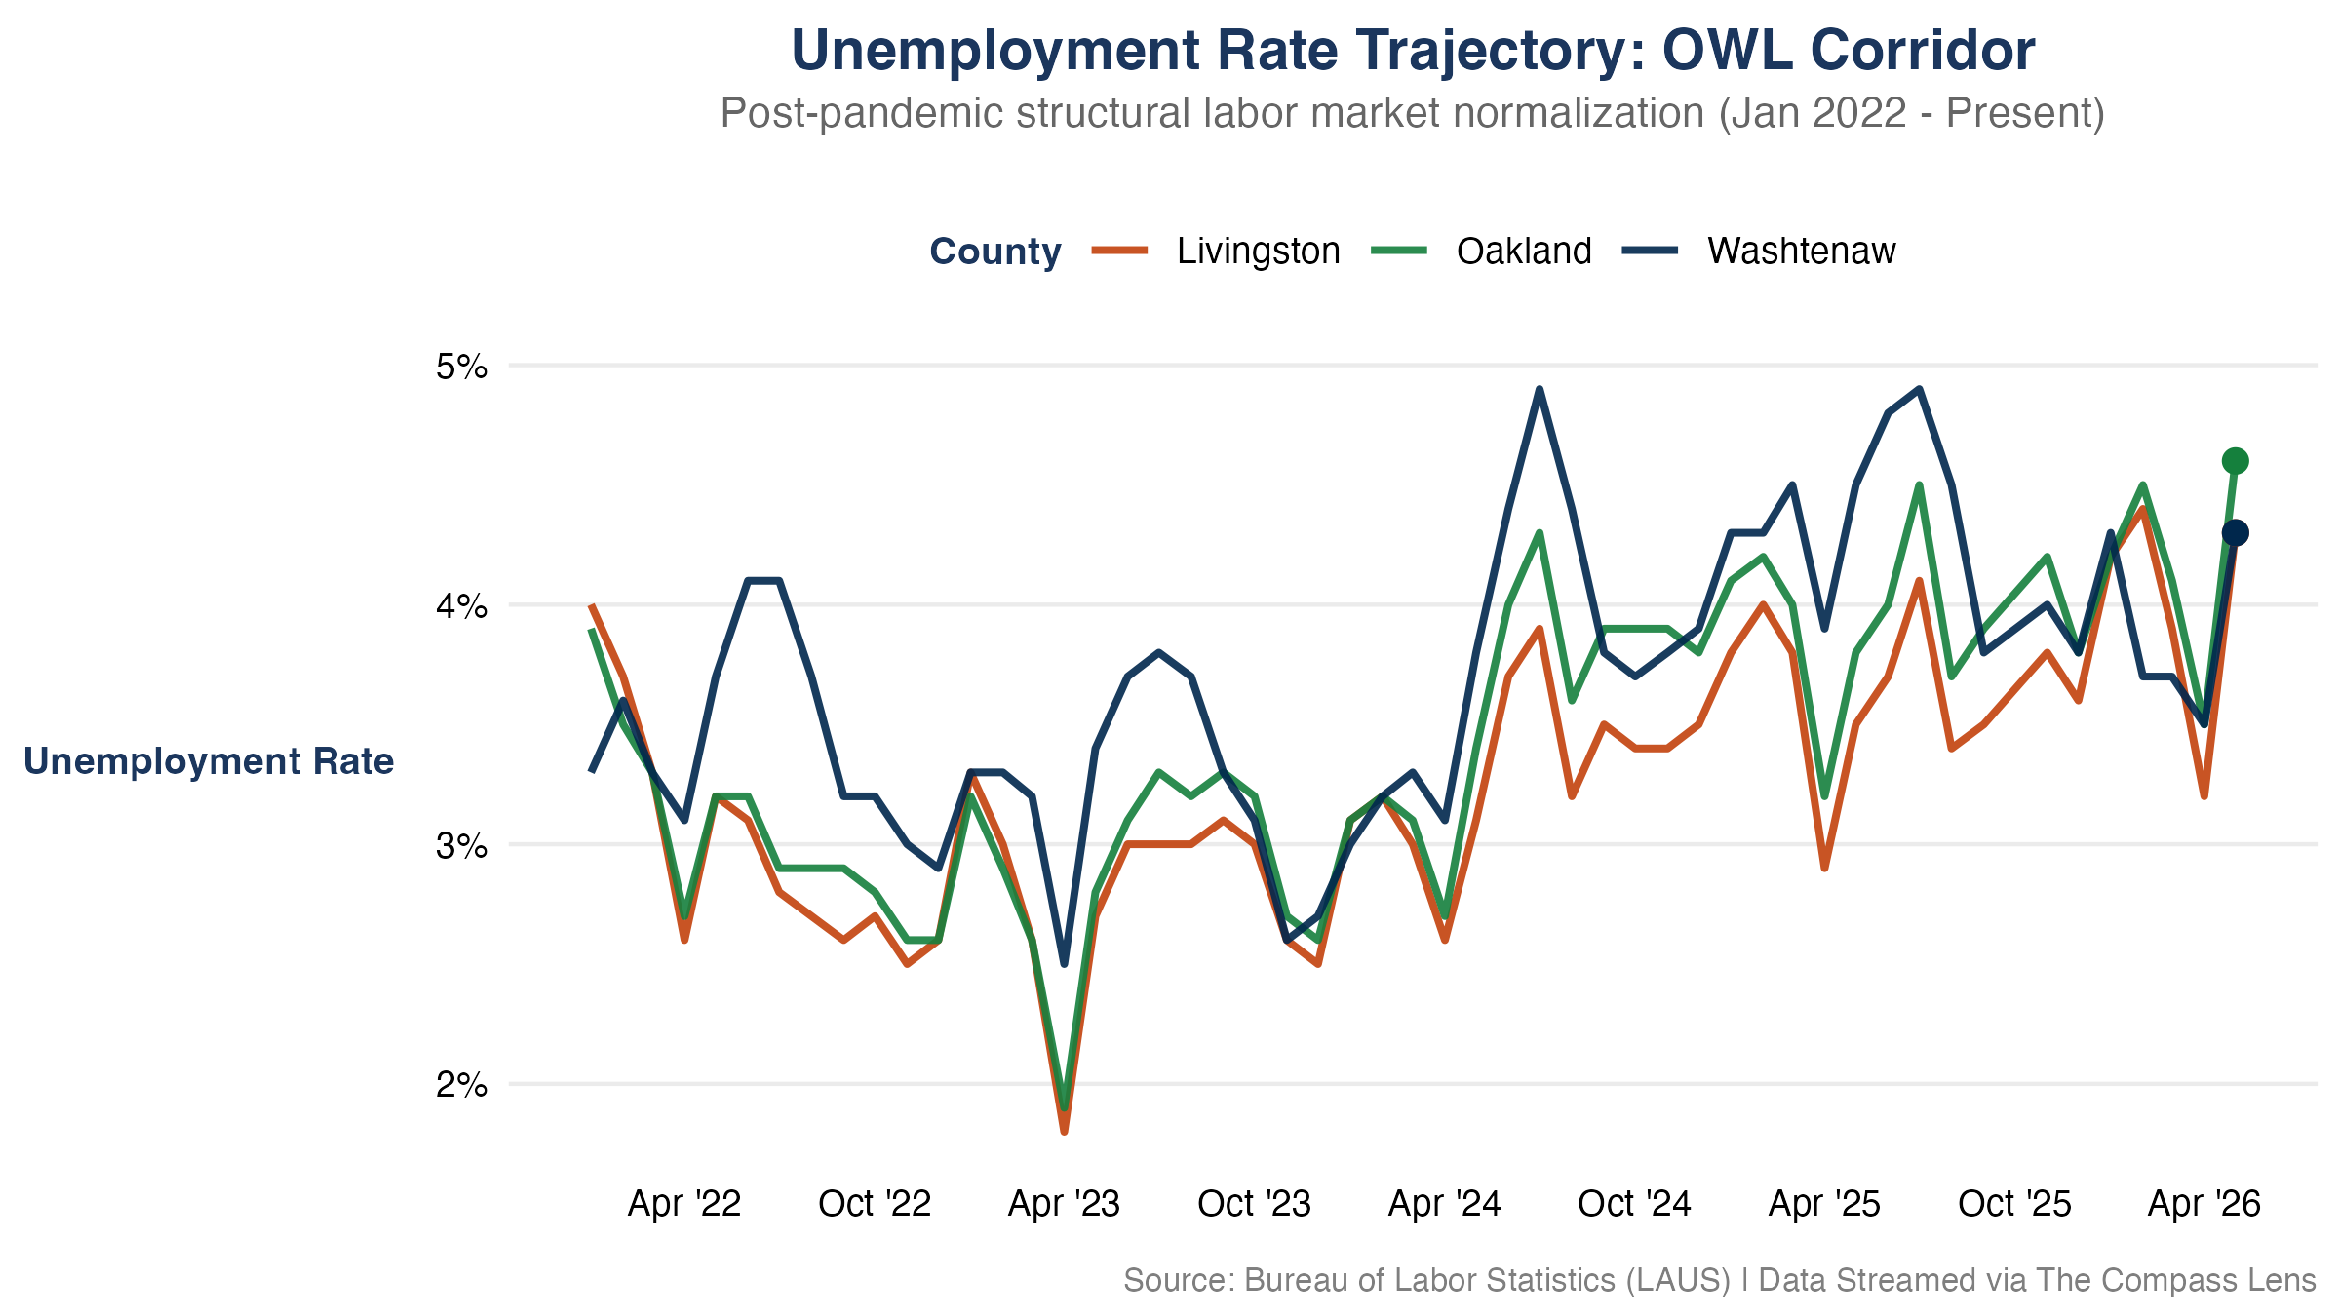
Figure 1: Unemployment Rate Horizon: Post-pandemic normalization across the OWL Corridor.

Core Unemployment Takeaways
- Structural Stabilization: Regional unemployment rates continue to trend near historical baselines, moving out of post-pandemic fluctuations into long-term equilibrium.
- Corridor Alignment: The tight distribution among the three primary counties highlights deep economic integration within the regional transit and employment corridors.

Labor Force Capacity & Growth Scales
To observe true relative resource scaling, local labor supply capacities are indexed to a baseline of January 2022 = 100. This removes pure absolute scale differences (such as Oakland’s larger raw population) to trace true expansion velocities.

Labor Force Visualization
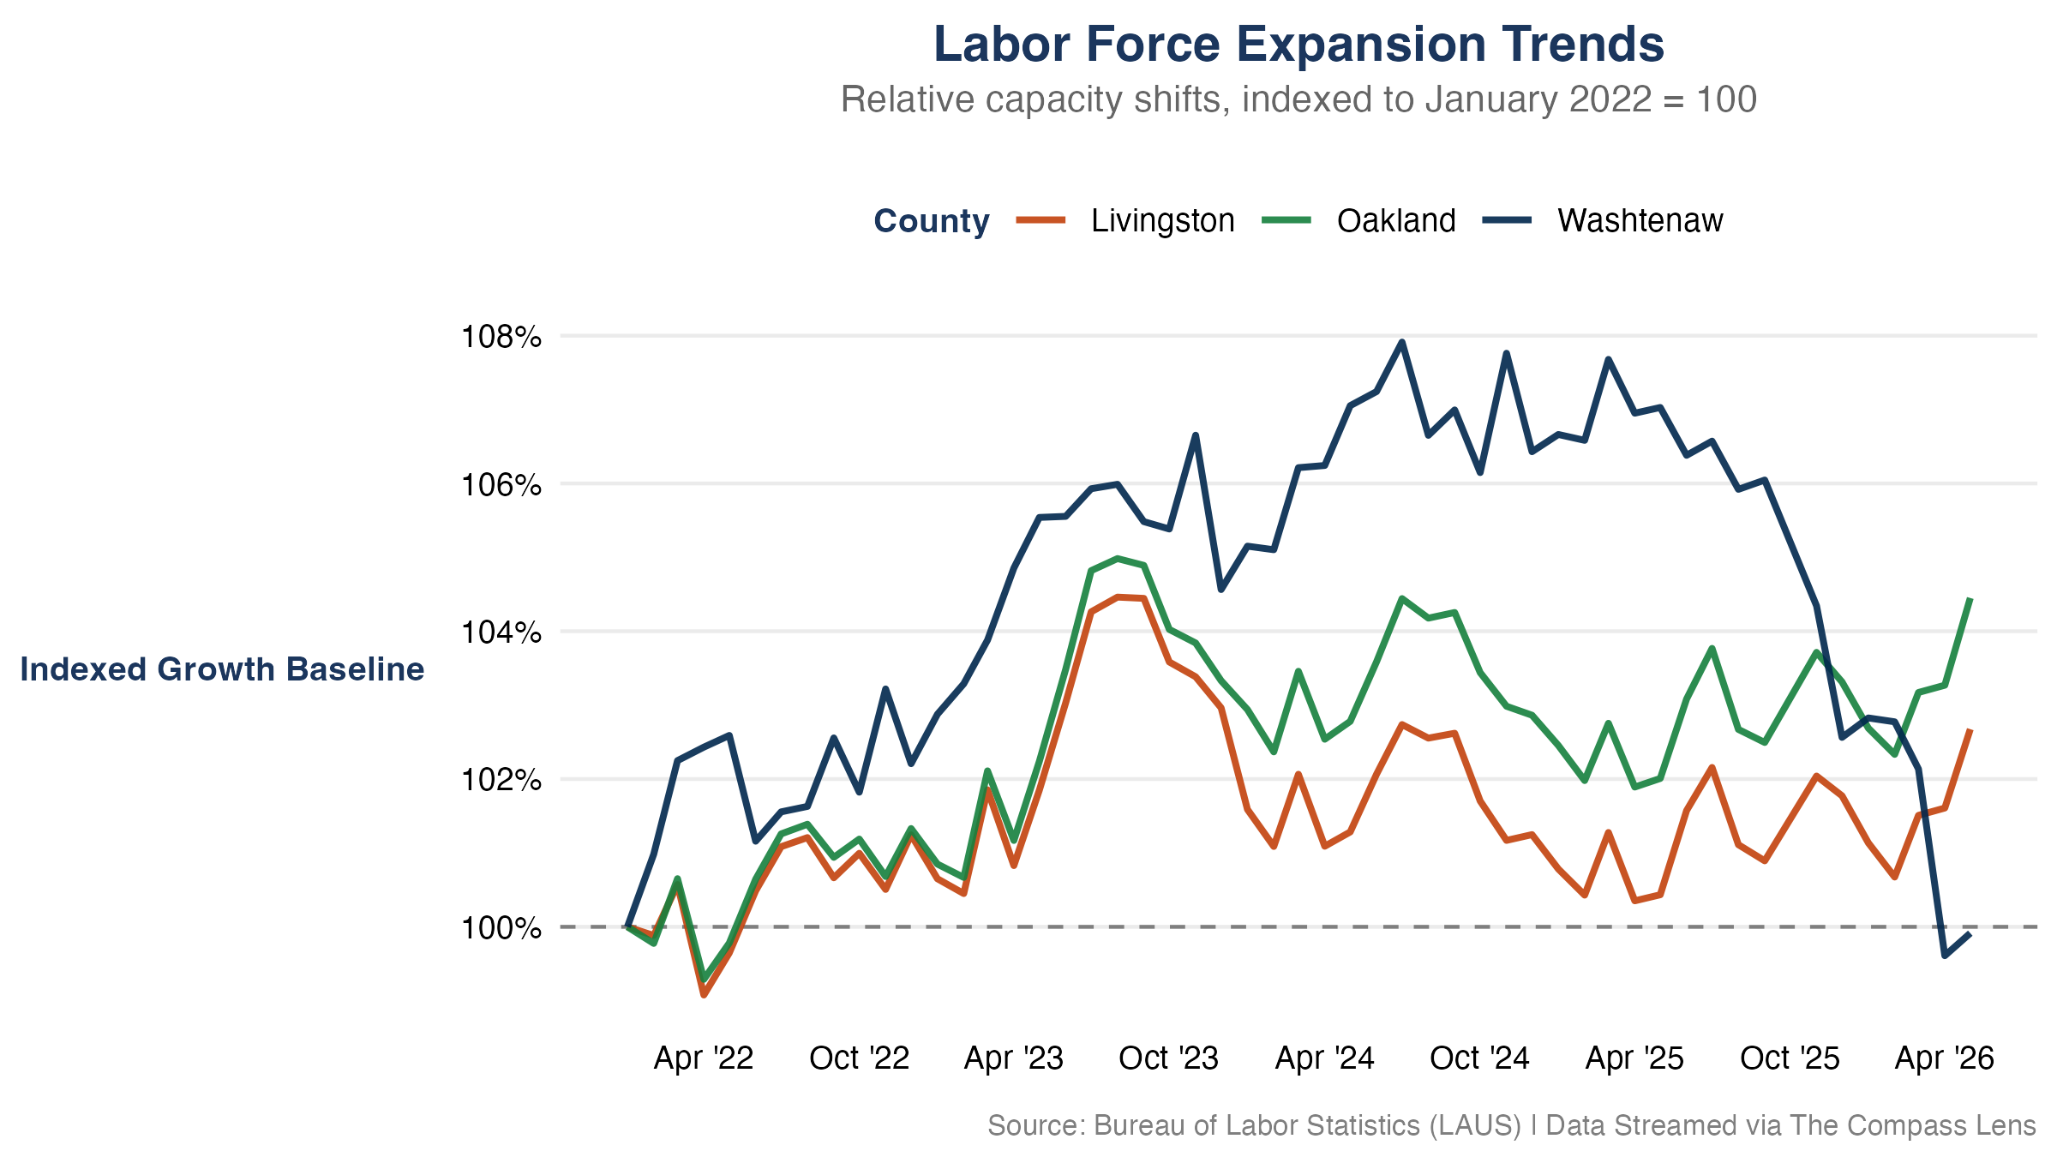
Figure 2: Labor Force Capacity: Indexed growth trends relative to the January 2022 baseline.

Core Labor Force Takeaways
- Indexed Growth: All three counties have experienced a net expansion in labor force capacity since January 2022, with Washtenaw County displaying a distinct trajectory relative to the rest of the corridor.
- Relative Velocity: Washtenaw County’s labor force growth has outpaced the other counties up until Septemer 2025 when it experienced a downturn. Estimates in May 2026 shows the labor force has increased marginally and resumes tracking the progress in neighboring counties in the OWL Corridor.
Methodological Note: An indexed baseline of 100 means a metric value of 104 represents a clean 4% expansion in the total available labor supply pool since January 2022, regardless of raw population counts.

Data Note: Metrics reflect official LAUS/BLS benchmarks as of July 25, 2026. Historical series incorporate all revised estimates released through May 2026. In October 2025, a federal government shutdown which prohibited the collection of LAUS data. There is no LAUS data for October 2025.

Data Provenance & Reliability
Data streams are ingested directly from primary federal and state reporting nodes. Technical calculations, data processing, and visualization builds are automated programmatically by The Compass Lens core data architecture to eliminate transcription vulnerabilities.
All data, analysis, and views presented herein are independent work products of Great Lakes Center for Economics.
Metric Component | Primary Source Agency | Spatial Resolution | Update Cadence
Local Area Unemployment | Bureau of Labor Statistics (LAUS) | County Level | Monthly
Consumer Sentiment | University of Michigan | National Baseline | Monthly

