2014/2015

Modelado y síntesis de sistemas electrónicos digitales

PrÁctica Laboratorio

christopher HYDE PEINADO 09046047D

1. **CNT_EPP**

**1.1.1.-** Código VHDL de la entidad ***cnt_epp*** y del banco de pruebas utilizado en su simulación.  
También se debe proporcionar el código de la entidad *epp_device*.

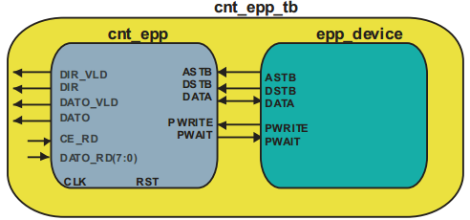

**A)** Código VHDL de la entidad ***cnt_epp***:

library IEEE;

use IEEE.STD_LOGIC_1164.ALL;

entity cnt_epp is

port (

CLK : in std_logic;

RST : in std_logic;

ASTRB : in std_logic;

DSTRB : in std_logic;

DATA : inout std_logic_vector(7 downto 0);

PWRITE : in std_logic;

PWAIT : out std_logic;

DATO_RD : in std_logic_vector(7 downto 0);

CE_RD : out std_logic;

DIR : out std_logic_vector (7 downto 0);

DIR_VLD : out std_logic;

DATO : out std_logic_vector (7 downto 0);

DATO_VLD : out std_logic);

end ;

architecture rtl of cnt_epp is

signal S1:std_logic;

signal S11:std_logic;

signal Q:std_logic;

signal S2:std_logic;

signal S22:std_logic;

signal Q2:std_logic;

begin

------------------ADDRESS---------------------------------

AddrBiestableD1:process (CLK,RST)

begin

if (RST='1') then

Q <= '0';

elsif (CLK'event and CLK='1')then

Q <= ASTRB;

end if;

end process;

S1<= ASTRB and not Q;

S11<=S1 and not PWRITE;

AddrBiestableD2:process (CLK,RST)

begin

if (RST='1') then

DIR_VLD <= '0';

elsif (CLK'event and CLK='1')then

DIR_VLD <= S11;

end if;

end process;

AddrBiestableD3:process (CLK,RST,S11)

begin

if (RST='1') then

DIR <= (others=>'0');

elsif (CLK'event and CLK='1')then

if (S11='1') then

DIR <= DATA;

end if;

end if;

end process;

-----------------DATA------------------------------------

DataBiestableD1:process (CLK,RST)

begin

if (RST='1') then

Q2 <= '0';

elsif (CLK'event and CLK='1')then

Q2 <= DSTRB;

end if;

end process;

S2<= DSTRB and not Q2;

S22<=S2 and not PWRITE;

DataBiestableD2:process (CLK,RST)

begin

if (RST='1') then

DATO_VLD <= '0';

elsif (CLK'event and CLK='1')then

DATO_VLD <= S22;

end if;

end process;

DataBiestableD3:process (CLK,RST,S22)

begin

if (RST='1') then

DATO <= (others=>'0');

elsif (CLK'event and CLK='1')then

if (S22='1') then

DATO <= DATA;

end if;

end if;

end process;

--tristate buffer

DATA<= DATO_RD when ((PWRITE= '1') and (DSTRB='1')) else (others => 'Z');

PWAITbiestableD:process (CLK,RST,ASTRB,DSTRB,PWRITE)

begin

if (RST='1') then

PWAIT <= '0';

elsif (CLK'event and CLK='1')then

if ((PWRITE='0') and (ASTRB='0')) or ((PWRITE='0') and (DSTRB='0')) or ((PWRITE='1') and (DSTRB='0')) then

PWAIT <= '1';

else

PWAIT <= '0';

end if;

end if;

end process;

CE_RDbiestableD:process (CLK,RST,PWRITE)

begin

if (RST='1') then

CE_RD <= '1';

elsif (CLK'event and CLK='1')then

if (PWRITE='1') then

CE_RD <= DSTRB;

end if;

end if;

end process;

end rtl;

**B)** Código VHDL de la entidad ***epp_device*** modificado para realizar 3 escrituras y una lectura:

Process

procedure epp_cicle ( address : in std_logic_vector(7 downto 0);

data_io : inout std_logic_vector(7 downto 0);

r_w : in character) is

begin

wait until clk_epp = '1';

PWRITE <= '0';

wait until clk_epp = '1';

ASTRB <= '0';

data <= address;

wait for T_clk_epp*EPP_cicle_length;

ASTRB <= '1';

wait until clk_epp = '1';

data <= (others => 'Z');

PWRITE <= '1';

wait until clk_epp = '1';

wait for T_clk_epp*EPP_cicle_length;

--------------------------------------------------------------------------

if r_w = 'w' then -- write cicle

PWRITE <= '0';

data <= data_io;

end if;

--------------------------------------------------------------------------

wait until clk_epp = '1';

DSTRB <= '0';

wait for T_clk_epp*EPP_cicle_length;

--------------------------------------------------------------------------

if r_w = 'r' then -- read cicle

data_io:= data;

end if;

--------------------------------------------------------------------------

DSTRB <= '1';

wait until clk_epp = '1';

data <= (others => 'Z');

PWRITE <= '1';

wait until clk_epp = '1';

end procedure;

library ieee;

use ieee.std_logic_1164.all;

use ieee.numeric_std.all;

use std.textio.all;

use ieee.std_logic_textio.all;

entity epp_device is

port (

DATA : inout std_logic_vector(7 downto 0);

PWRITE : out std_logic;

DSTRB : out std_logic;

ASTRB : out std_logic;

PWAIT : in std_logic);

end epp_device;

architecture sim of epp_device is

constant T_clk_epp : time := 100 ns; -- Internal clock period.

signal clk_epp : std_logic := '0'; -- Internal clock signal.

signal read_value : std_logic_vector(7 downto 0) := (others => '0');

constant dir_frec : std_logic_vector( 7 downto 0) := x"F0";

constant dir_dpram1 : std_logic_vector( 7 downto 0) := x"A1";

constant dir_dpram2 : std_logic_vector( 7 downto 0) := x"A2";

constant EPP_cicle_length: natural:= 10;

begin

-- internal clock signal generation.

clk_epp <= not(clk_epp) after T_clk_epp/2;

file arch_in : text ;

variable bf : line;

variable dato : std_logic_vector(7 downto 0);

variable dir : std_logic_vector(7 downto 0);

begin

--inicialización

data <= (others => 'Z');

PWRITE <= '1';

DSTRB <= '1';

ASTRB <= '1';

dir := (others => '0');

-----------------first write values----------

wait for 130 ns;

DIR:=dir_dpram1;

DATO:=X"34";

epp_cicle ( address => dir,

data_io => dato,

r_w => 'w');

-----------------second write values----------

wait for 130 ns;

DIR:=dir_dpram2;

DATO:=X"44";

epp_cicle ( address => dir,

data_io => dato,

r_w => 'w');

-----------------third write values----------

wait for 130 ns;

DIR:=dir_frec;

DATO:=X"54";

epp_cicle ( address => dir,

data_io => dato,

r_w => 'w');

-----------------first read values----------

wait for 130 ns;

DIR:=X"FF";

epp_cicle ( address => dir,

data_io => dato,

r_w => 'r');

read_value<=dato;

wait for 1 us;

report "FIN CICLO R/W" severity failure;

end process;

end sim;

**C)** Código VHDL del **testbench** de simulación ***cnt_epp_tb:***

BEGIN

-- Instantiate the Unit Under Test (UUT)

uut: cnt_epp PORT MAP (

CLK => CLK,

RST => RST,

ASTRB => ASTRB_comm,

DSTRB => DSTRB_comm,

DATA => DATA_comm,

PWRITE => PWRITE_comm,

PWAIT => PWAIT_comm,

DATO_RD => DATO_RD_comm,

CE_RD => CE_RD,

DIR => DIR,

DIR_VLD => DIR_VLD,

DATO => DATO,

DATO_VLD => DATO_VLD

);

eppDevice:epp_device

port map(

DATA=>DATA_comm,

PWRITE=>PWRITE_comm,

DSTRB=>DSTRB_comm,

ASTRB=>ASTRB_comm,

PWAIT=>PWAIT_comm

);

-- Clock process definitions

CLK_process :process

begin

CLK <= '0';

wait for CLK_period/2;

CLK <= '1';

wait for CLK_period/2;

end process;

RST_process :process

begin

wait for 5 ns;

RST <= '0';

end process;

END rtl;

LIBRARY ieee;

USE ieee.std_logic_1164.ALL;

ENTITY cnt_epp_tb IS

END cnt_epp_tb;

ARCHITECTURE rtl OF cnt_epp_tb IS

-- Component Declaration for the Unit Under Test (UUT)

COMPONENT cnt_epp

PORT(

CLK : IN std_logic;

RST : IN std_logic;

ASTRB : IN std_logic;

DSTRB : IN std_logic;

DATA : INOUT std_logic_vector(7 downto 0);

PWRITE : IN std_logic;

PWAIT : OUT std_logic;

DATO_RD : IN std_logic_vector(7 downto 0);

CE_RD : OUT std_logic;

DIR : OUT std_logic_vector(7 downto 0);

DIR_VLD : OUT std_logic;

DATO : OUT std_logic_vector(7 downto 0);

DATO_VLD : OUT std_logic

);

END COMPONENT;

COMPONENT epp_device

port (

DATA : inout std_logic_vector(7 downto 0);

PWRITE : out std_logic;

DSTRB : out std_logic;

ASTRB : out std_logic;

PWAIT : in std_logic);

END COMPONENT;

signal ASTRB_comm:std_logic;

signal DSTRB_comm:std_logic;

signal PWRITE_comm:std_logic;

signal PWAIT_comm:std_logic;

signal DATA_comm:std_logic_vector(7 downto 0);

--cnt_epp

signal DATO_RD_comm :std_logic_vector(7 downto 0):=x"AA";

signal CE_RD :std_logic;

signal DIR :std_logic_vector(7 downto 0);

signal DIR_VLD : std_logic;

signal DATO :std_logic_vector(7 downto 0);

signal DATO_VLD :std_logic;

-- Clock period definitions

constant CLK_period : time := 10 ns;

signal clk : std_logic;

signal rst : std_logic:='1';

**1.1.2-** Razonamiento de por qué se ha adoptado la solución presentada.

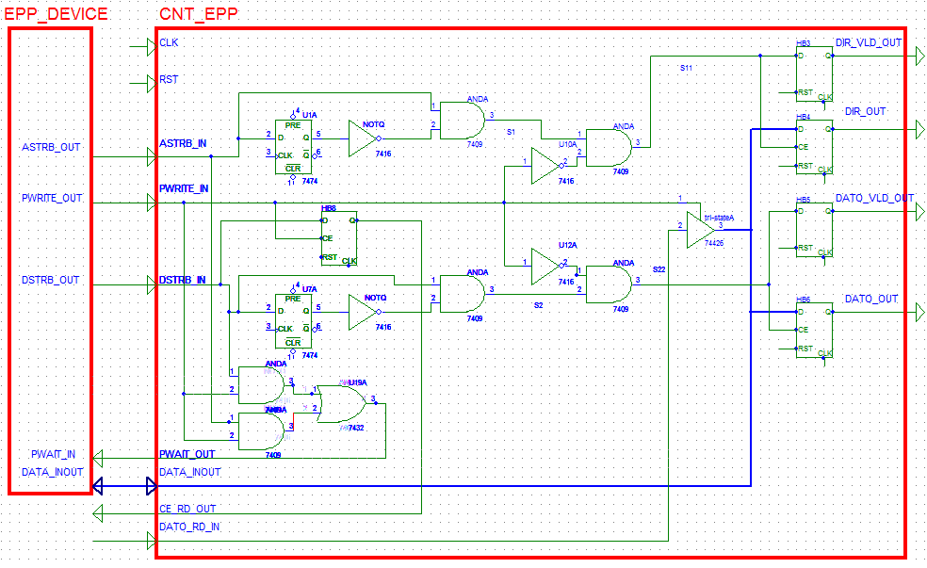El código presentado anteriormente es la implementación del siguiente esquema:

Gracias a este circuito se ha podido llegar a una solución óptima para el diseño del módulo ***cnt_epp***.

Éste módulo recibe los datos de temporización del ***epp_device*** y proporciona las salidas de Dir y Dato y Dir y Dato válidos, junto con señales de pwait y CE_rd.

El modulo está controlado por el reloj del sistema CLK, luego se trata de un módulo con sincronismo.

**1.1.3.-** Pantallazo de simulación donde se refleje que la entidad ***cnt_epp*** funciona correctamente. Para ello se realizarán tres ciclos de escritura, uno en cada uno de las direcciones que se van a utilizar en el diseño (*dir_frec*, *dir_dpram1* y *dir_dpram2*) y una operación de lectura en la dirección a elegir por el alumno.

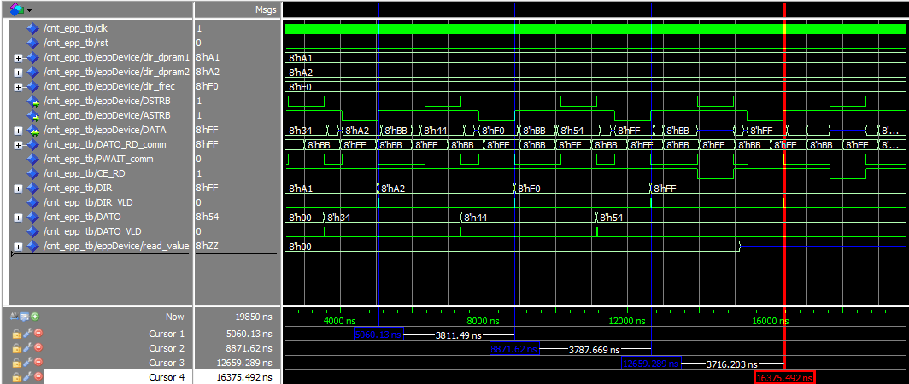

Las tres barras divisoras de color azul de la figura muestra los momentos de de escritura. Se puede ver como el primer caso escribe en la dirección A1h (*dir_dpram1*) el dato 34h, la segunda división escribe en la posición A2h (*dir_dpram2*) el dato 44h y el tercer divisor azul escribe en la posición F0h (*dir_frec*) el dato 54.

Por último el divisor de color rojo, indica un ciclo de lectura, en este caso lee de la posición FFh.

**1.2.1.-** Tabla donde se incluya los recursos utilizados para la implementación del controlador del  
puerto EPP. Los datos anteriores serán extraídos del informe de síntesis.

|  |  |  |  |  |  |
| --- | --- | --- | --- | --- | --- |
| **Device Utilization Summary** | | | | | [**[-]**](?&ExpandedTable=DeviceUtilizationSummary) |
| **Slice Logic Utilization** | **Used** | **Available** | **Utilization** | **Note(s)** | |
| Number of Slice Registers | 21 | 54,576 | 1% |  | |
| Number used as Flip Flops | 21 |  |  |  | |
| Number used as Latches | 0 |  |  |  | |
| Number used as Latch-thrus | 0 |  |  |  | |
| Number used as AND/OR logics | 0 |  |  |  | |
| Number of Slice LUTs | 20 | 27,288 | 1% |  | |
| Number used as logic | 20 | 27,288 | 1% |  | |
| Number using O6 output only | 19 |  |  |  | |
| Number using O5 output only | 0 |  |  |  | |
| Number using O5 and O6 | 1 |  |  |  | |
| Number used as ROM | 0 |  |  |  | |
| Number used as Memory | 0 | 6,408 | 0% |  | |
| Number of occupied Slices | 8 | 6,822 | 1% |  | |
| Number of MUXCYs used | 0 | 13,644 | 0% |  | |
| Number of LUT Flip Flop pairs used | 20 |  |  |  | |
| Number with an unused Flip Flop | 1 | 20 | 5% |  | |
| Number with an unused LUT | 0 | 20 | 0% |  | |
| Number of fully used LUT-FF pairs | 19 | 20 | 95% |  | |
| Number of unique control sets | 1 |  |  |  | |
| Number of slice register sites lost         to control set restrictions | 3 | 54,576 | 1% |  | |
| Number of bonded [IOBs](C://Users/christopher/Dropbox/workspace/modelado14/cnt_epp/cnt_epp_map.xrpt?&DataKey=IOBProperties) | 41 | 218 | 18% |  | |
| IOB Flip Flops | 1 |  |  |  | |
| Number of RAMB16BWERs | 0 | 116 | 0% |  | |
| Number of RAMB8BWERs | 0 | 232 | 0% |  | |
| Number of BUFIO2/BUFIO2_2CLKs | 0 | 32 | 0% |  | |
| Number of BUFIO2FB/BUFIO2FB_2CLKs | 0 | 32 | 0% |  | |
| Number of BUFG/BUFGMUXs | 1 | 16 | 6% |  | |
| Number used as BUFGs | 1 |  |  |  | |
| Number used as BUFGMUX | 0 |  |  |  | |
| Number of DCM/DCM_CLKGENs | 0 | 8 | 0% |  | |
| Number of ILOGIC2/ISERDES2s | 0 | 376 | 0% |  | |
| Number of IODELAY2/IODRP2/IODRP2_MCBs | 0 | 376 | 0% |  | |
| Number of OLOGIC2/OSERDES2s | 1 | 376 | 1% |  | |
| Number used as OLOGIC2s | 1 |  |  |  | |
| Number used as OSERDES2s | 0 |  |  |  | |
| Number of BSCANs | 0 | 4 | 0% |  | |
| Number of BUFHs | 0 | 256 | 0% |  | |
| Number of BUFPLLs | 0 | 8 | 0% |  | |
| Number of BUFPLL_MCBs | 0 | 4 | 0% |  | |
| Number of DSP48A1s | 0 | 58 | 0% |  | |
| Number of ICAPs | 0 | 1 | 0% |  | |
| Number of MCBs | 0 | 2 | 0% |  | |
| Number of PCILOGICSEs | 0 | 2 | 0% |  | |
| Number of PLL_ADVs | 0 | 4 | 0% |  | |
| Number of PMVs | 0 | 1 | 0% |  | |
| Number of STARTUPs | 0 | 1 | 0% |  | |
| Number of SUSPEND_SYNCs | 0 | 1 | 0% |  | |
| Average Fanout of Non-Clock Nets | 3.36 |  |  |  | |

**1.2.2.-** Medida del retardo entre el flanco activo de la señal de reloj y la activación de los puertos DIR_VLD y DATO_VLD. Se debe mostrar el resultado a través de pantallazos de simulación utilizando, para ello, dos cursores.

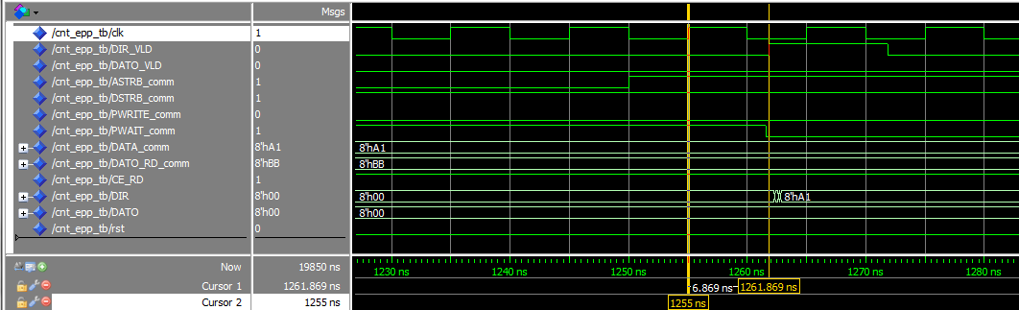

La figura anterior muestra el retardo entre el flanco activo de la señal de reloj y la activación del puero DIR_VLD, como se aprecia hay un cierto retardo de 6.869 ns.

En el siguiente caso se muestra el retardo entre el flanco activo del reloj y DATO_VLD el cual es de 7.362 ns, un poco mayor que el caso anterior.

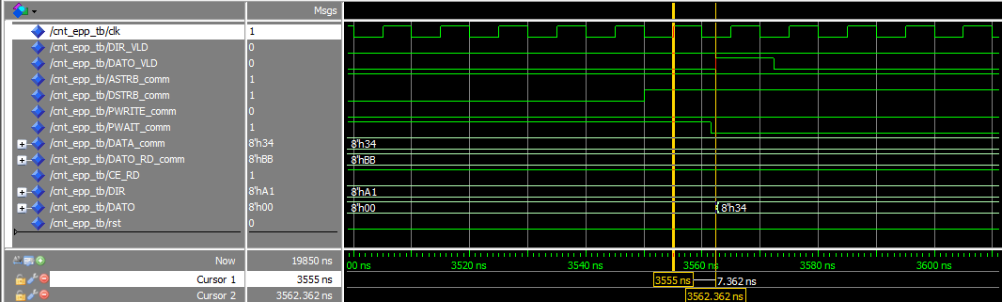

**1.2.3.-** Pantallazo de simulación donde se refleje el que la entidad cnt_epp función correctamente.

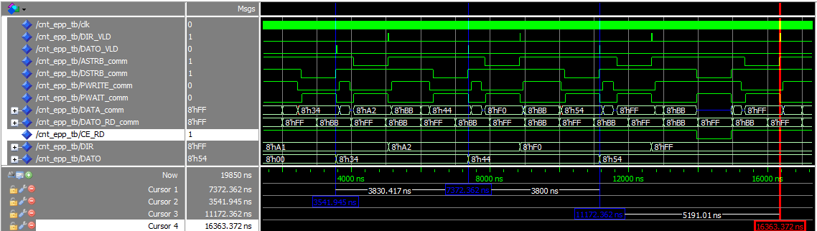

En la simulación temporal se puede apreciar la misma conducta que ocurría en la simulación funcional, luego se deduce que el comportamiento sigue siendo correcto, sólo que en ersta ocasión se incluyen retardos provocados por el hardware.

1. **TOP_SYSTEM1**

**2.1.1.**- Especificación en VHDL de los modelos *top_system1* y el correspondiente banco de  
pruebas *top_sytem1_tb.*

**A)** Código VHDL de la entidad ***top_system1***:

entity top_system1 is

port (

CLK : in std_logic;

RST : in std_logic;

ASTRB : in std_logic;

DSTRB : in std_logic;

DATA : inout std_logic_vector(7 downto 0);

PWRITE : in std_logic;

PWAIT : out std_logic;

SWITCHES_I : in std_logic_vector(7 downto 0);

PSH_BUTTON : in std_logic;

LEDS_O : out std_logic_vector(7 downto 0)

);

end top_system1;

architecture Behavioral of top_system1 is

component cnt_epp

port (

CLK : in std_logic;

RST : in std_logic;

ASTRB : in std_logic;

DSTRB : in std_logic;

DATA : inout std_logic_vector(7 downto 0);

PWRITE : in std_logic;

PWAIT : out std_logic;

DATO_RD : in std_logic_vector(7 downto 0);

CE_RD : out std_logic;

DIR : out std_logic_vector (7 downto 0);

DIR_VLD : out std_logic;

DATO : out std_logic_vector (7 downto 0);

DATO_VLD : out std_logic);

end component ;

signal DATO_RD_comm : std_logic_vector(7 downto 0);

signal CE_RD_comm : std_logic;

signal DIR_comm : std_logic_vector (7 downto 0);

signal DIR_VLD_comm : std_logic;

signal DATO_comm : std_logic_vector (7 downto 0);

signal DATO_VLD_comm : std_logic;

signal DIR_REG : std_logic_vector (7 downto 0);

signal DATO_REG : std_logic_vector (7 downto 0);

begin

cntEpp:cnt_epp

port map(

CLK=>CLK ,

RST=>RST ,

ASTRB=>ASTRB ,

DSTRB=>DSTRB ,

DATA=>DATA ,

PWRITE=>PWRITE ,

PWAIT=>PWAIT,

DATO_RD=>DATO_RD_comm,

CE_RD=>CE_RD_comm,

DIR=>DIR_comm,

DIR_VLD=>DIR_VLD_comm,

DATO=>DATO_comm,

DATO_VLD=>DATO_VLD_comm

);

AddrBiestableD:process (CLK,RST,DIR_VLD_comm)

begin

if (RST='1') then

DIR_REG <= (others=>'0');

elsif (CLK'event and CLK='1')then

if (DIR_VLD_comm='1') then

DIR_REG <= DIR_comm;

end if;

end if;

end process;

DataBiestableD:process (CLK,RST,DATO_VLD_comm)

begin

if (RST='1') then

DATO_REG <= (others=>'0');

elsif (CLK'event and CLK='1')then

if (DATO_VLD_comm='1') then

DATO_REG <= DATO_comm;

end if;

end if;

end process;

LEDS_O <= DATO_REG when (PSH_BUTTON='0') else DIR_REG;

CE_RDbiestableD:process (CLK,RST)

begin

if (RST='1') then

DATO_RD_comm <= (others=>'0');

elsif (CLK'event and CLK='1')then

if (CE_RD_comm='1' and DIR_comm=x"32") then

DATO_RD_comm <= SWITCHES_I;

end if;

end if;

end process;

end Behavioral;

**B)** Código VHDL del banco de pruebas la entidad ***top_system1_tb***:

eppDevice:epp_device

port map(

DATA=>DATA_comm,

PWRITE=>PWRITE_comm,

DSTRB=>DSTRB_comm,

ASTRB=>ASTRB_comm,

PWAIT=>PWAIT_comm

);

-- Clock process definitions

CLK_process :process

begin

CLK <= '0';

wait for CLK_period/2;

CLK <= '1';

wait for CLK_period/2;

end process;

RST_process :process

begin

wait for 5 ns;

RST <= '0';

end process;

PSH_BUTTON_process :process

begin

PSH_BUTTON_comm <= '0';

wait for 400ns;

PSH_BUTTON_comm <= '1';

wait for 400ns;

end process;

END;

ENTITY top_system1_tb IS

END top_system1_tb;

ARCHITECTURE behavior OF top_system1_tb IS

-- Component Declaration for the Unit Under Test (UUT)

COMPONENT top_system1

PORT(

CLK : IN std_logic;

RST : IN std_logic;

ASTRB : IN std_logic;

DSTRB : IN std_logic;

DATA : INOUT std_logic_vector(7 downto 0);

PWRITE : IN std_logic;

PWAIT : OUT std_logic;

SWITCHES_I : IN std_logic_vector(7 downto 0);

PSH_BUTTON : IN std_logic;

LEDS_O : OUT std_logic_vector(7 downto 0)

);

END COMPONENT;

COMPONENT epp_device

port (

DATA : inout std_logic_vector(7 downto 0);

PWRITE : out std_logic;

DSTRB : out std_logic;

ASTRB : out std_logic;

PWAIT : in std_logic);

END COMPONENT;

signal ASTRB_comm:std_logic;

signal DSTRB_comm:std_logic;

signal PWRITE_comm:std_logic;

signal PWAIT_comm:std_logic;

signal DATA_comm:std_logic_vector(7 downto 0);

signal SWITCHES_I_comm : std_logic_vector(7 downto 0) := x"CA";

signal PSH_BUTTON_comm : std_logic := '0';

signal LEDS_O_comm : std_logic_vector(7 downto 0);

-- Clock period definitions

constant CLK_period : time := 10 ns;

signal CLK : std_logic;

signal RST : std_logic:='1';

BEGIN

-- Instantiate the Unit Under Test (UUT)

uut: top_system1 PORT MAP (

CLK => CLK,

RST => RST,

ASTRB => ASTRB_comm,

DSTRB => DSTRB_comm,

DATA => DATA_comm,

PWRITE => PWRITE_comm,

PWAIT => PWAIT_comm,

SWITCHES_I => SWITCHES_I_comm,

PSH_BUTTON => PSH_BUTTON_comm,

LEDS_O => LEDS_O_comm

);

**2.1.2.-** Pantallazos de la simulación funcional de los modelos anteriores donde se demuestre que funcionan correctamente.

En el esquema cuando PUSH_BUTTON esta a nivel alto los leds muestran la dirección registrada (cursor rojo), con un nivel bajo muestra el dato registrado (cursor amarillo).

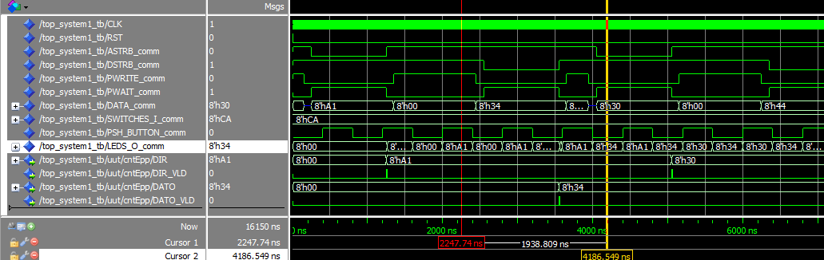

La entrada de los 8 switches programados en el testbench con un valor de CAh pasara a DATO_RD cuando se realice una lectura de la posición 32h (cursor azul)

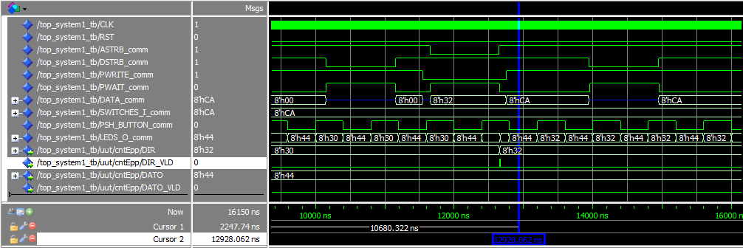

**2.1.3.-** Pantallazos de la simulación temporal de los modelos anteriores donde se demuestre que funcionan correctamente. En este caso se deberá añadir una tabla donde se reflejen los recursos utilizados en su implementación.

1. Pantallazos simulación temporal

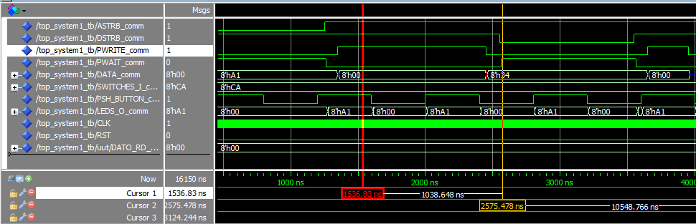

Esta tabla muestra la simulación temporal y como se siguen cumpliendo los eventos que se cumplían en la simulación funcional anteriormente explicada. De igual manera sucede para la simulación temporal donde se busca la escritura en la dirección 32h.

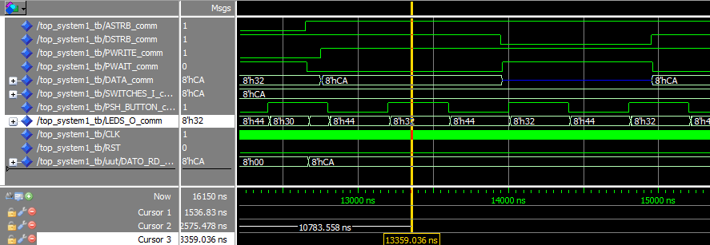

**B)** Tabla donde se incluya los recursos utilizados para la implementación del controlador del  
puerto EPP. Los datos anteriores serán extraídos del informe de síntesis.

|  |  |  |  |  |  |
| --- | --- | --- | --- | --- | --- |
| **Device Utilization Summary** | | | | | [**[-]**](?&ExpandedTable=DeviceUtilizationSummary) |
| **Slice Logic Utilization** | **Used** | **Available** | **Utilization** | **Note(s)** | |
| Number of Slice Registers | 45 | 54,576 | 1% |  | |
| Number used as Flip Flops | 45 |  |  |  | |
| Number used as Latches | 0 |  |  |  | |
| Number used as Latch-thrus | 0 |  |  |  | |
| Number used as AND/OR logics | 0 |  |  |  | |
| Number of Slice LUTs | 13 | 27,288 | 1% |  | |
| Number used as logic | 9 | 27,288 | 1% |  | |
| Number using O6 output only | 3 |  |  |  | |
| Number using O5 output only | 0 |  |  |  | |
| Number using O5 and O6 | 6 |  |  |  | |
| Number used as ROM | 0 |  |  |  | |
| Number used as Memory | 0 | 6,408 | 0% |  | |
| Number used exclusively as route-thrus | 4 |  |  |  | |
| Number with same-slice register load | 4 |  |  |  | |
| Number with same-slice carry load | 0 |  |  |  | |
| Number with other load | 0 |  |  |  | |
| Number of occupied Slices | 14 | 6,822 | 1% |  | |
| Number of MUXCYs used | 0 | 13,644 | 0% |  | |
| Number of LUT Flip Flop pairs used | 43 |  |  |  | |
| Number with an unused Flip Flop | 2 | 43 | 4% |  | |
| Number with an unused LUT | 30 | 43 | 69% |  | |
| Number of fully used LUT-FF pairs | 11 | 43 | 25% |  | |
| Number of unique control sets | 6 |  |  |  | |
| Number of slice register sites lost         to control set restrictions | 3 | 54,576 | 1% |  | |
| Number of bonded [IOBs](C://Users/christopher/Dropbox/workspace/modelado14/top_system1/top_system1_map.xrpt?&DataKey=IOBProperties) | 31 | 218 | 14% |  | |
| Number of LOCed IOBs | 31 | 31 | 100% |  | |
| IOB Flip Flops | 1 |  |  |  | |
| Number of RAMB16BWERs | 0 | 116 | 0% |  | |
| Number of RAMB8BWERs | 0 | 232 | 0% |  | |
| Number of BUFIO2/BUFIO2_2CLKs | 0 | 32 | 0% |  | |
| Number of BUFIO2FB/BUFIO2FB_2CLKs | 0 | 32 | 0% |  | |
| Number of BUFG/BUFGMUXs | 1 | 16 | 6% |  | |
| Number used as BUFGs | 1 |  |  |  | |
| Number used as BUFGMUX | 0 |  |  |  | |
| Number of DCM/DCM_CLKGENs | 0 | 8 | 0% |  | |
| Number of ILOGIC2/ISERDES2s | 0 | 376 | 0% |  | |
| Number of IODELAY2/IODRP2/IODRP2_MCBs | 0 | 376 | 0% |  | |
| Number of OLOGIC2/OSERDES2s | 1 | 376 | 1% |  | |
| Number used as OLOGIC2s | 1 |  |  |  | |
| Number used as OSERDES2s | 0 |  |  |  | |
| Number of BSCANs | 0 | 4 | 0% |  | |
| Number of BUFHs | 0 | 256 | 0% |  | |
| Number of BUFPLLs | 0 | 8 | 0% |  | |
| Number of BUFPLL_MCBs | 0 | 4 | 0% |  | |
| Number of DSP48A1s | 0 | 58 | 0% |  | |
| Number of ICAPs | 0 | 1 | 0% |  | |
| Number of MCBs | 0 | 2 | 0% |  | |
| Number of PCILOGICSEs | 0 | 2 | 0% |  | |
| Number of PLL_ADVs | 0 | 4 | 0% |  | |
| Number of PMVs | 0 | 1 | 0% |  | |
| Number of STARTUPs | 0 | 1 | 0% |  | |
| Number of SUSPEND_SYNCs | 0 | 1 | 0% |  | |
| Average Fanout of Non-Clock Nets | 2.39 |  |  |  | |

**2.2.1.-** Pantallazos como el de la Figura 28 donde se refleje que la entidad top_system1  
correctamente para las distintas operaciones.

CAPTURA DIGILENT 1

CAPTURA DIGILENT 2

1. **CNT_DAC**

**3.1.1.**- Código VHDL del módulo de control de los DACs y del banco de pruebas utilizado en su  
simulación.

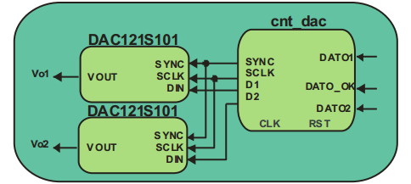

**A)** Código VHDL de la entidad ***cnt_dac:***

gen_clk : process (clk, rst)

begin -- process gen_clk

if rst = '1' then

SCLKaux <= '0';

prescaler <= (others => '0');

elsif (clk'event and clk='1') then -- rising clock edge

if prescaler = X"1" then

prescaler <= (others => '0');

SCLKaux <= not SCLKaux;

else

prescaler <= prescaler + "1";

end if;

end if;

end process gen_clk;

SCLK <= SCLKaux;

counter:process(rst,CEcounter,clk)

begin

if(rst = '1') then

muxSelect <= 0;

muxSelectTX<=(others=>'0');

elsif (clk'event and clk='1') then

if (CEcounter='1') then

if (muxSelect = 3 ) then

muxSelect <= 0;

muxSelectTX<=muxSelectTX+1;

else

muxSelect <= muxSelect+1;

end if;

else

muxSelectTX<=(others=>'0');

muxSelect <= 0;

end if;

end if;

end process;

library ieee;

use ieee.std_logic_1164.all;

use ieee.numeric_std.all;

entity cnt_dac is

port (

CLK : in std_logic;

RST : in std_logic;

DATO1 : in std_logic_vector(7 downto 0);

DATO2 : in std_logic_vector(7 downto 0);

DATO_OK : in std_logic;

SYNC : out std_logic;

SCLK : out std_logic;

D1 : out std_logic;

D2 : out std_logic);

end cnt_dac;

architecture RTL of cnt_dac is

type state_type is (

s0, --HOLDING STATE

s1, --TRANSMISSION STATE

s2 --WAITING STATE

);

signal state: state_type; --current and next state declaration.

type mux_fsm is (

mx0, --HOLDING STATE

mx1,mx2

);

signal mxstate: mux_fsm; --current and next state declaration.

signal SCLKaux: std_logic;

signal muxSelect: integer range 0 to 3;

signal muxSelectTX: unsigned (3 downto 0);

signal CEcounter: std_logic;

signal DATO_1_16bits: std_logic_vector(15 downto 0);

signal DATO_2_16bits: std_logic_vector(15 downto 0);

signal endTx: std_logic;

constant countLimit : integer:=64;

constant sclkPulseValue : unsigned:="1";

signal sclkPulseCounter: integer range 0 to 1;

signal prescaler : unsigned(0 downto 0);

BEGIN

DATO_1_16bits<="0000"&DATO1&"0000";

DATO_2_16bits<="0000"&DATO2&"0000";

mux:process (muxSelectTX,DATO_1_16bits,DATO_2_16bits)

begin

endTx <= '0';

case muxSelectTX is

when x"0"=> D1 <= DATO_1_16bits(15);

D2 <= DATO_2_16bits(15);

when x"1"=> D1 <= DATO_1_16bits(14);

D2 <= DATO_2_16bits(14);

when x"2" => D1 <= DATO_1_16bits(13);

D2 <= DATO_2_16bits(13);

when x"3" => D1 <= DATO_1_16bits(12);

D2 <= DATO_2_16bits(12);

when x"4" => D1 <= DATO_1_16bits(11);

D2 <= DATO_2_16bits(11);

when x"5" => D1 <= DATO_1_16bits(10);

D2 <= DATO_2_16bits(10);

when x"6" => D1 <= DATO_1_16bits(9);

D2 <= DATO_2_16bits(9);

when x"7" => D1 <= DATO_1_16bits(8);

D2 <= DATO_2_16bits(8);

when x"8" => D1 <= DATO_1_16bits(7);

D2 <= DATO_2_16bits(7);

when x"9" => D1 <= DATO_1_16bits(6);

D2 <= DATO_2_16bits(6);

when x"A"=> D1 <= DATO_1_16bits(5);

D2 <= DATO_2_16bits(5);

when x"B"=> D1 <= DATO_1_16bits(4);

D2 <= DATO_2_16bits(4);

when x"C"=> D1 <= DATO_1_16bits(3);

D2 <= DATO_2_16bits(3);

when x"D"=> D1 <= DATO_1_16bits(2);

D2 <= DATO_2_16bits(2);

when x"E"=> D1 <= DATO_1_16bits(1);

D2 <= DATO_2_16bits(1);

when x"F"=> D1 <= DATO_1_16bits(0);

D2 <= DATO_2_16bits(0);

endTx <= '1';

when others => D1 <= '0';

D2 <= '0';

end case;

end process;

fsm_proc:process(clk, rst,endTx,DATO_OK)

begin

if(rst = '1') then

state <= S0;

SYNC<='1';

CEcounter<='0';

elsif (clk'event and clk = '1') then

case state is

when s0 =>

if (DATO_OK='0') then

SYNC<='1';

CEcounter<='0'; else --if DATO_OK=1

state <= s1;

end if;

when s1 =>

CEcounter<='1';

SYNC<='0';

if(endTx = '1') then

CEcounter<='0';

SYNC<='1';

state <= s2;

end if;

when s2 =>

SYNC<='1';

state <= s0;

end case;

end if;

end process;

smMux_proc:process(clk, rst,muxSelectTX)

begin

if(rst = '1') then

endTx <= '0';

mxstate <= mx0;

elsif (clk'event and clk = '1') then

case mxstate is

when mx0 =>

endTx <= '0';

if (muxSelectTX=x"F") then

mxstate <= mx1;

end if;

when mx1 =>

if (muxSelectTX=x"F") then

mxstate <= mx2;

else

mxstate <= mx0;

end if;

when mx2 =>

mxstate <= mx0;

endTx <= '1';

end case;

end if;

end process;

end RTL;

**B)** Código VHDL del testbench de la entidad ***cnt_dac_tb***:

clk_process :process

begin

clk <= '0';

wait for clk_period/2;

clk <= '1';

wait for clk_period/2;

end process;

rst_process :process

begin

wait for 100 ns;

rst <= '0';

end process;

-- Stimulus process

stim_proc: process

begin

-- hold reset state for 100 ns.

wait for 800 ns;

DATO1 <=std_logic_vector(to_unsigned(5, 8));

DATO2 <=std_logic_vector(to_unsigned(10, 8));

DATO_OK<='1';

wait for 20 ns;

DATO_OK<='0';

wait for 800 ns;

DATO1 <=std_logic_vector(to_unsigned(30, 8));

DATO2 <=std_logic_vector(to_unsigned(40, 8));

DATO_OK<='1';

wait for 20 ns;

DATO_OK<='0';

wait for 800 ns;

DATO1 <=std_logic_vector(to_unsigned(85, 8));

DATO2 <=std_logic_vector(to_unsigned(95, 8));

DATO_OK<='1';

wait for 20 ns;

DATO_OK<='0';

wait;

end process;

END;

ENTITY cnt_dac_tb IS

END cnt_dac_tb;

ARCHITECTURE behavior OF cnt_dac_tb IS

component cnt_dac

port (

CLK : in std_logic;

RST : in std_logic;

DATO1 : in std_logic_vector(7 downto 0);

DATO2 : in std_logic_vector(7 downto 0);

DATO_OK : in std_logic;

SYNC : out std_logic;

SCLK : out std_logic;

D1 : out std_logic;

D2 : out std_logic);

end component ;

component DAC121S101

port (

VOUT : out real range 0.0 to 3.5;

SYNC : in std_logic;

SCLK : in std_logic;

DIN : in std_logic);

end component ;

--Inputs

signal CLK : std_logic := '0';

signal RST : std_logic := '1';

signal DATO1 : std_logic_vector(7 downto 0):=x"00";

signal DATO2 : std_logic_vector(7 downto 0):=x"00";

signal DATO_OK : std_logic := '0';

--Outputs

signal VOUT1 : real;

signal VOUT2 : real;

signal SYNC_comm : std_logic;

signal SCLK_comm : std_logic;

signal D1_comm : std_logic;

signal D2_comm : std_logic;

-- Clock period definitions

constant CLK_period : time := 10 ns;

BEGIN

cntdac:cnt_dac

port map(

CLK=>CLK ,

RST=>RST ,

DATO1=>DATO1 ,

DATO2=>DATO2 ,

DATO_OK=>DATO_OK,

SYNC=>SYNC_comm ,

SCLK=>SCLK_comm,

D1=>D1_comm,

D2=>D2_comm

);

DAC1: DAC121S101

port map (

VOUT =>VOUT1,

SYNC =>SYNC_comm,

SCLK =>SCLK_comm,

DIN => D1_comm);

DAC2: DAC121S101

port map (

VOUT =>VOUT2,

SYNC =>SYNC_comm,

SCLK =>SCLK_comm,

DIN=> D2_comm

);

**3.1.2**- Razonamiento de por qué se ha adoptado la solución presentada.

En el diseño de este módulo se han dos contadores, un modificador de frecuencia de reloj un multiplexor y dos maquina de estados.

El primer contador se usa para contar flancos de subida de reloj. La salida del contador es usada por el modificador de frecuencia para crear la señal SCLK.

El segundo contador es usadoa incrementar la cuenta de selección del multiplexor.

El multiplexor es el encargado de serializar en la salida el valor del dato de entrada.

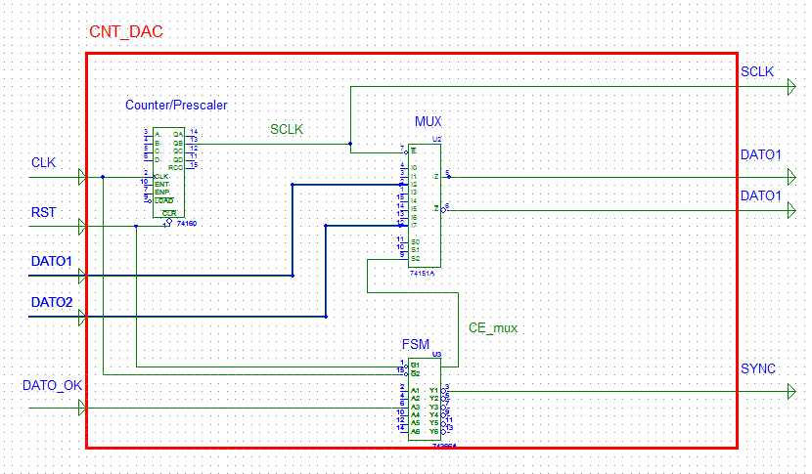

FSM:

Dato_ok=1

End_tx=1

Espera/

SYNC=0

TX/

SYNC=0

Reposo/

SYNC=1

End_tx=0

Dato_ok=0

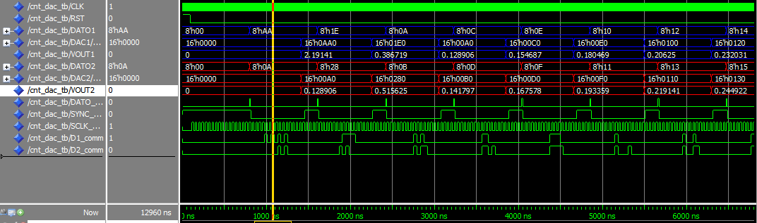**3.1.3.**- Pantallazo de simulación funcional donde se refleje que le mencionado circuito funciona  
correctamente. Para ello en el banco de pruebas deberá incluir los estímulos necesarios para  
comprobar que para todas las operaciones el módulo funciona correctamente.

En el esquema anterior se ve como los datos de entrada DATO1 y DATO2 son serializados en D1_comm y D2_comm y tras pasar por los DAC121S101 la salida en se produce por VOUT con un valor decimal analógico. El paso de datos del cnt_dac a los DAC se pueden ver con los valores de dato_bin que coincide con la entrada de datos de cnt_dac.

**3.2.1.**- Tabla donde se incluyan los recursos utilizados para la implementación.

|  |  |  |  |  |  |
| --- | --- | --- | --- | --- | --- |
| **Device Utilization Summary** | | | | | [**[-]**](?&ExpandedTable=DeviceUtilizationSummary) |
| **Slice Logic Utilization** | **Used** | **Available** | **Utilization** | **Note(s)** | |
| Number of Slice Registers | 9 | 54,576 | 1% |  | |
| Number used as Flip Flops | 9 |  |  |  | |
| Number used as Latches | 0 |  |  |  | |
| Number used as Latch-thrus | 0 |  |  |  | |
| Number used as AND/OR logics | 0 |  |  |  | |
| Number of Slice LUTs | 15 | 27,288 | 1% |  | |
| Number used as logic | 15 | 27,288 | 1% |  | |
| Number using O6 output only | 13 |  |  |  | |
| Number using O5 output only | 0 |  |  |  | |
| Number using O5 and O6 | 2 |  |  |  | |
| Number used as ROM | 0 |  |  |  | |
| Number used as Memory | 0 | 6,408 | 0% |  | |
| Number of occupied Slices | 7 | 6,822 | 1% |  | |
| Number of MUXCYs used | 0 | 13,644 | 0% |  | |
| Number of LUT Flip Flop pairs used | 15 |  |  |  | |
| Number with an unused Flip Flop | 6 | 15 | 40% |  | |
| Number with an unused LUT | 0 | 15 | 0% |  | |
| Number of fully used LUT-FF pairs | 9 | 15 | 60% |  | |
| Number of unique control sets | 2 |  |  |  | |
| Number of slice register sites lost         to control set restrictions | 7 | 54,576 | 1% |  | |
| Number of bonded [IOBs](C://Users/christopher/Dropbox/workspace/modelado14/cnt_dac/cnt_dac_map.xrpt?&DataKey=IOBProperties) | 23 | 218 | 10% |  | |
| Number of RAMB16BWERs | 0 | 116 | 0% |  | |
| Number of RAMB8BWERs | 0 | 232 | 0% |  | |
| Number of BUFIO2/BUFIO2_2CLKs | 0 | 32 | 0% |  | |
| Number of BUFIO2FB/BUFIO2FB_2CLKs | 0 | 32 | 0% |  | |
| Number of BUFG/BUFGMUXs | 1 | 16 | 6% |  | |
| Number used as BUFGs | 1 |  |  |  | |
| Number used as BUFGMUX | 0 |  |  |  | |
| Number of DCM/DCM_CLKGENs | 0 | 8 | 0% |  | |
| Number of ILOGIC2/ISERDES2s | 0 | 376 | 0% |  | |
| Number of IODELAY2/IODRP2/IODRP2_MCBs | 0 | 376 | 0% |  | |
| Number of OLOGIC2/OSERDES2s | 0 | 376 | 0% |  | |
| Number of BSCANs | 0 | 4 | 0% |  | |
| Number of BUFHs | 0 | 256 | 0% |  | |
| Number of BUFPLLs | 0 | 8 | 0% |  | |
| Number of BUFPLL_MCBs | 0 | 4 | 0% |  | |
| Number of DSP48A1s | 0 | 58 | 0% |  | |
| Number of ICAPs | 0 | 1 | 0% |  | |
| Number of MCBs | 0 | 2 | 0% |  | |
| Number of PCILOGICSEs | 0 | 2 | 0% |  | |
| Number of PLL_ADVs | 0 | 4 | 0% |  | |
| Number of PMVs | 0 | 1 | 0% |  | |
| Number of STARTUPs | 0 | 1 | 0% |  | |
| Number of SUSPEND_SYNCs | 0 | 1 | 0% |  | |
| Average Fanout of Non-Clock Nets | 2.29 |  |  |  | |

**3.2.2.-** Pantallazo de simulación donde se refleje que el controlador de los DACs funciona  
correctamente.

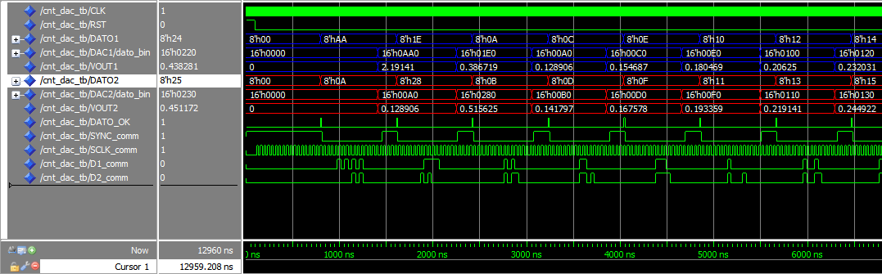

La anterior grafica muestra un comportamiento similar a la simulación funcional, pero se ha tenido que modificar el tiempo del pulso de DATO_OK ya que en esta simulación con 10 ns no tenia tiempo para modificar valores.

1. **DPRAM_MEM**

**4.1.1.**- Código VHDL del módulo y del banco de pruebas utilizado en la simulación.

**A)** Código VHDL de la entidad ***dpram_mem* B)** Código VHDL testbench ***dpram_mem_tb***

library ieee;

use ieee.std_logic_1164.all;

use ieee.numeric_std.all;

entity dpram_mem is

port (

DIN : in std_logic_vector(7 downto 0);

ADDR_IN : in std_logic_vector(7 downto 0);

ADDR_OUT : in std_logic_vector(7 downto 0);

DOUT : out std_logic_vector(7 downto 0);

WE : in std_logic;

CLK : in std_logic;

RST : in std_logic);

end entity;

architecture rtl of dpram_mem is

type memory is array (256 downto 0)

of std_logic_vector(7 downto 0);

signal mem_pos: memory;

begin

process(clk)

begin

if (clk'event and clk = '1') then

if (WE = '1') then

mem_pos(to_integer(unsigned(ADDR_IN))) <= DIN;

end if;

end if;

end process;

process(clk)

begin

if (clk'event and clk = '1') then

DOUT <= mem_pos(to_integer(unsigned(ADDR_OUT)));

end if;

end process;

end rtl;

LIBRARY ieee;

use ieee.std_logic_1164.all;

use ieee.numeric_std.all;

ENTITY dpram_mem_tb IS

END dpram_mem_tb;

ARCHITECTURE behavior OF dpram_mem_tb IS

COMPONENT dpram_mem

PORT(

DIN : IN std_logic_vector(7 downto 0);

ADDR_IN : IN std_logic_vector(7 downto 0);

ADDR_OUT : IN std_logic_vector(7 downto 0);

DOUT : OUT std_logic_vector(7 downto 0);

WE : IN std_logic;

CLK : IN std_logic;

RST : IN std_logic

);

END COMPONENT;

signal DIN : std_logic_vector(7 downto 0) := (others => '0');

signal ADDR_IN : std_logic_vector(7 downto 0) := (others => '0');

signal ADDR_OUT : std_logic_vector(7 downto 0) := (others => '0');

signal WE : std_logic := '0';

signal CLK : std_logic := '0';

signal RST : std_logic := '1';

signal pulseCounter: integer range 1 to 5;

signal DOUT : std_logic_vector(7 downto 0);

constant CLK_period : time := 10 ns;

BEGIN

uut: dpram_mem PORT MAP (

DIN => DIN,

ADDR_IN => ADDR_IN,

ADDR_OUT => ADDR_OUT,

DOUT => DOUT,

WE => WE,

CLK => CLK,

RST => RST

);

clk_process :process

begin

clk <= '0';

wait for clk_period/2;

clk <= '1';

wait for clk_period/2;

end process;

rst_process :process

begin

wait for 100 ns;

rst <= '0';

end process;

we_process :process

begin

we<='1';

wait for 10 ns;

we<='0';

wait for 10 ns;

end process;

**B)**Continuacion testbench ***dpram_mem_tb***

din_process:process (we,rst)

begin

if (rst='1') then

DIN <= x"09";

elsif (we'event and we='1')then DIN<=std_logic_vector(unsigned(DIN) + x"01");

end if;

end process;

addressIn_process:process (we,rst)

begin

if (rst='1') then

ADDR_IN <= x"00";

elsif (we'event and we='1')then ADDR_IN<=std_logic_vector(unsigned(ADDR_IN) + x"01");

end if; end process;

addressOut_process:process (clk,rst)

begin

if (rst='1') then

ADDR_OUT <= x"00";

elsif (clk'event and clk='0')then

if(pulseCounter = 5)then

pulseCounter <= 1;

ADDR_OUT<=std_logic_vector(unsigned(ADDR_OUT) + x"01");

else

pulseCounter<=pulseCounter+1;

end if;

end if; end process;

END;

**4.1.2**- Estudio detallado del funcionamiento de la memoria dual port.

La memoria dual port para el ciclo de escritura recibe datos por el puerto DIN y direcciones por el puerto ADDR_IN. Cuando se activa la señal WE el dato recibido se almacena en un array bidimensional de 256 direcciones de 8 bits cada dirección, en la dirección especifica por ADDR_IN.

Para el ciclo de lectura recibe la dirección a través del puerto ADDR_OUT y DOUT envía el dato almacenado en el array correspondiente a esa dirección.

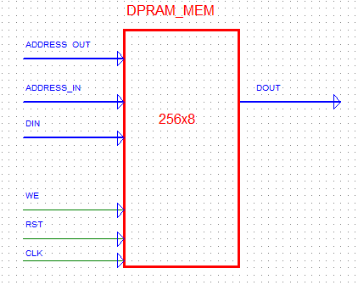

**4.1.3.**- Pantallazo de simulación donde se refleje que el mencionado circuito funciona  
correctamente. Para ello en el banco de pruebas deberá incluir los estímulos necesarios para  
comprobar que el módulo funciona correctamente.

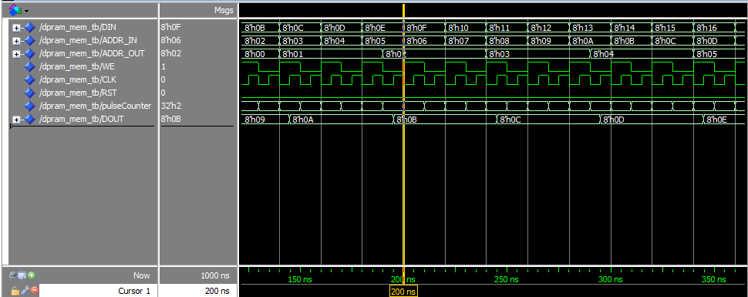

La gráfica anterior muestra la simulación funcional de la memoria ram ***dpram_mem.*** En el se puede ver como a la salida DOUT tiene el dato que se ha introducido en ADDR_IN pero la salida se produce con un desplazamiento en el tiempo respecto a la entrada.

**4.2.1.**- Tabla donde se incluyan los recursos utilizados para la implementación.

|  |  |  |  |  |  |
| --- | --- | --- | --- | --- | --- |
| **Device Utilization Summary** | | | | | [**[-]**](?&ExpandedTable=DeviceUtilizationSummary) |
| **Slice Logic Utilization** | **Used** | **Available** | **Utilization** | **Note(s)** | |
| Number of Slice Registers | 0 | 54,576 | 0% |  | |
| Number of Slice LUTs | 0 | 27,288 | 0% |  | |
| Number of occupied Slices | 0 | 6,822 | 0% |  | |
| Number of MUXCYs used | 0 | 13,644 | 0% |  | |
| Number of LUT Flip Flop pairs used | 0 |  |  |  | |
| Number of bonded [IOBs](C://Users/christopher/Dropbox/workspace/modelado14/dpram_mem/dpram_mem_map.xrpt?&DataKey=IOBProperties) | 34 | 218 | 15% |  | |
| Number of RAMB16BWERs | 0 | 116 | 0% |  | |
| Number of RAMB8BWERs | 1 | 232 | 1% |  | |
| Number of BUFIO2/BUFIO2_2CLKs | 0 | 32 | 0% |  | |
| Number of BUFIO2FB/BUFIO2FB_2CLKs | 0 | 32 | 0% |  | |
| Number of BUFG/BUFGMUXs | 1 | 16 | 6% |  | |
| Number used as BUFGs | 1 |  |  |  | |
| Number used as BUFGMUX | 0 |  |  |  | |
| Number of DCM/DCM_CLKGENs | 0 | 8 | 0% |  | |
| Number of ILOGIC2/ISERDES2s | 0 | 376 | 0% |  | |
| Number of IODELAY2/IODRP2/IODRP2_MCBs | 0 | 376 | 0% |  | |
| Number of OLOGIC2/OSERDES2s | 0 | 376 | 0% |  | |
| Number of BSCANs | 0 | 4 | 0% |  | |
| Number of BUFHs | 0 | 256 | 0% |  | |
| Number of BUFPLLs | 0 | 8 | 0% |  | |
| Number of BUFPLL_MCBs | 0 | 4 | 0% |  | |
| Number of DSP48A1s | 0 | 58 | 0% |  | |
| Number of ICAPs | 0 | 1 | 0% |  | |
| Number of MCBs | 0 | 2 | 0% |  | |
| Number of PCILOGICSEs | 0 | 2 | 0% |  | |
| Number of PLL_ADVs | 0 | 4 | 0% |  | |
| Number of PMVs | 0 | 1 | 0% |  | |
| Number of STARTUPs | 0 | 1 | 0% |  | |
| Number of SUSPEND_SYNCs | 0 | 1 | 0% |  | |
| Average Fanout of Non-Clock Nets | 1.03 |  |  |  | |

**4.2.2.-** Pantallazo de simulación donde se refleje que el módulo funciona correctamente.

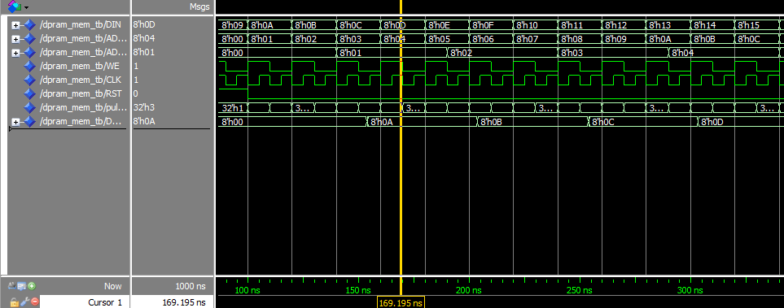

Como se puede ver en la simulación temporal, el comportamiento de la memoria es igual a la simulación funcional pero con algunos retardos en la inicialización y en la transición de las señales provocadas por el hardware.

1. **CNT_DPRAM**

**5.1.1.**- Código VHDL del módulo y del banco de pruebas utilizado en la simulación.

**A)** Código VHDL de la entidad ***cnt_dpram***

ADDRESS<=counter;

fsm_proc:process(clk, rst,DIR_VLD,DIR,DATO_VLD,DATO)

begin

if(rst = '1') then

state <= s0;

CEcounter<='0';

we_dp1<='0';

we_dp2<='0';

dirPrev<=(others=>'0');

dirActual<=(others=>'0');

clearCounter<='0';

elsif (clk'event and clk = '1') then

case state is

WHEN s0 =>

we_dp1<='0';

we_dp2<='0';

clearCounter<='0';

dirActual<=DIR;

if(DIR_VLD= '1' and (DIR=dir_dpram1 or DIR=dir_dpram2))then

state<=s1;

end if;

WHEN s1 =>

if (DATO_VLD= '1' and dirActual=dirPrev)then

state<=s2;

elsif(DATO_VLD= '1' and dirActual/=dirPrev) then

state<=s3;

end if;

WHEN s2 =>

CEcounter<='1';

state<=s4;

WHEN s3 =>

clearCounter<='1';

state<=s4;

WHEN s4 =>

if(DIR=dir_dpram1)then

we_dp1<='1';

elsif (DIR=dir_dpram2) then

we_dp2<='1';

end if; dirPrev<=DIR; CEcounter<='0'; clearCounter<='0'; state<=s0;

end case;

end if;

end process;

end RTL;

library ieee;

use ieee.std_logic_1164.all;

use ieee.numeric_std.all;

entity cnt_dpram is

port (

CLK : in std_logic;

RST : in std_logic;

DIR : in std_logic_vector (7 downto 0);

DIR_VLD : in std_logic;

DATO : in std_logic_vector (7 downto 0);

DATO_VLD : in std_logic;

ADDRESS : out std_logic_vector(7 downto 0);

DATA : out std_logic_vector(7 downto 0);

WE_DP1 : out std_logic;

WE_DP2 : out std_logic);

end cnt_dpram;

architecture RTL of cnt_dpram is

constant dir_dpram1 : std_logic_vector( 7 downto 0) := x"A1";

constant dir_dpram2 : std_logic_vector( 7 downto 0) := x"A2";

type state_type is (

s0, --HOLDING STATE

s1, --WAIT DATA STATE

s2, --CLOCK ENABLE STATE

s3, --CLEAR STATE

s4 --WE_DP ENABLE STATE

);

signal state: state_type

signal dirActual: std_logic_vector(7 downto 0);

signal dirPrev: std_logic_vector(7 downto 0);

signal CEcounter: std_logic;

signal clearCounter: std_logic;

signal addressTX: std_logic_vector(7 downto 0);

signal counter: std_logic_vector(7 downto 0);

begin -- RTL

DATA<=DATO;

counter_proc:process(clk,rst,CEcounter,clearCounter)

begin

if (rst='1')then

counter<=(others=>'0');

elsif (clk'event and clk = '1') then

if(CEcounter='1') then

if(counter=x"FF")then

counter<=x"00";

else

counter<=std_logic_vector(unsigned(counter) + 1);

end if; elsif(clearCounter='1') then counter<=(others=>'0');

end if;

end if;

end process;

**B)** Código VHDL del testbench entidad ***cnt_dpram_tb***

DATO_process :process

begin

if(rst='1')then

DATO<=(others=>'0');

wait for 500 ns;

end if;

DATO <= x"55";

DATO_VLD<='1';

wait for 10 ns;

DATO_VLD<='0';

wait for 490 ns;

DATO_VLD<='1';

DATO <= x"69";

wait for 10 ns;

DATO_VLD<='0';

wait for 490 ns;

DATO_VLD<='1';

DATO <= x"85";

wait for 10 ns;

DATO_VLD<='0';

wait for 490 ns;

DATO_VLD<='1';

DATO <= x"42";

wait for 10 ns;

DATO_VLD<='0';

wait for 490 ns;

DATO_VLD<='1';

DATO <= x"65";

wait for 10 ns;

DATO_VLD<='0';

wait for 490 ns;

DATO_VLD<='1';

DATO <= x"00";

wait for 10 ns;

wait;

end process;

begin

if(rst='1')then

DIR<=(others=>'0');

wait for 250 ns;

end if;

DIR <= x"a2";

DIR_VLD<='1';

wait for 10 ns;

DIR_VLD<='0';

wait for 490 ns;

DIR_VLD<='1';

DIR <= x"a1";

wait for 10 ns;

DIR_VLD<='0';

wait for 490 ns;

DIR_VLD<='1';

DIR <= x"a1";

wait for 10 ns;

DIR_VLD<='0';

wait for 490 ns;

DIR_VLD<='1';

DIR <= x"a2";

wait for 10 ns;

DIR_VLD<='0';

wait for 490 ns;

DIR_VLD<='1';

DIR <= x"a1";

wait for 10 ns;

DIR_VLD<='0';

wait for 490 ns;

DIR_VLD<='1';

DIR <= x"a1";

wait for 10 ns;

wait;

end process;

LIBRARY ieee;

USE ieee.std_logic_1164.ALL;

ENTITY cnt_dpram_tb IS

END cnt_dpram_tb;

ARCHITECTURE behavior OF cnt_dpram_tb IS

COMPONENT cnt_dpram

PORT(

CLK : IN std_logic;

RST : IN std_logic;

DIR : IN std_logic_vector(7 downto 0);

DIR_VLD : IN std_logic;

DATO : IN std_logic_vector(7 downto 0);

DATO_VLD : IN std_logic;

ADDRESS : OUT std_logic_vector(7 downto 0);

DATA : OUT std_logic_vector(7 downto 0);

WE_DP1 : OUT std_logic;

WE_DP2 : OUT std_logic

);

END COMPONENT;

--Inputs

signal CLK : std_logic := '0';

signal RST : std_logic := '1';

signal DIR : std_logic_vector(7 downto 0) := (others => '0');

signal DIR_VLD : std_logic := '0';

signal DATO : std_logic_vector(7 downto 0) := (others => '0');

signal DATO_VLD : std_logic := '0';

--Outputs

signal ADDRESS : std_logic_vector(7 downto 0);

signal DATA : std_logic_vector(7 downto 0);

signal WE_DP1 : std_logic;

signal WE_DP2 : std_logic;

-- Clock period definitions

constant CLK_period : time := 10 ns;

BEGIN

uut: cnt_dpram PORT MAP (

CLK => CLK,

RST => RST,

DIR => DIR,

DIR_VLD => DIR_VLD,

DATO => DATO,

DATO_VLD => DATO_VLD,

ADDRESS => ADDRESS,

DATA => DATA,

WE_DP1 => WE_DP1,

WE_DP2 => WE_DP2

);

CLK_process :process

begin

CLK <= '0';

wait for CLK_period/2;

CLK <= '1';

wait for CLK_period/2;

end process;

RST_process :process

begin

wait for 20 ns;

RST <= '0';

end process;

**5.1.2**- Razonamiento de por qué se ha adoptado la solución presentada.

Este módulo es el controlador de las memorias dual port. Su misión es indicar que dirección de la memoria debe ser accedida dada el modulo de memoria a donde se quiera acceder.

Por ejemplo; si se desea acceder el modulo de memoria A1h repetidas veces, este modulo se encarga de escribir indicar posiciones distintas de escritura dentro del mismo modulod de memoria A1h

El modulo esta compuesto por un contador y un una maquina de estados.

El funcionamiento de la maquina de estados regula el funcionamiento general del sistema.

La maquina de estados se encarga de estudiar cuando se ha recibido una nueva dirección y comprueba si es una dirección para el mismo modulo o para el modulo asignado la ejecución anterior.

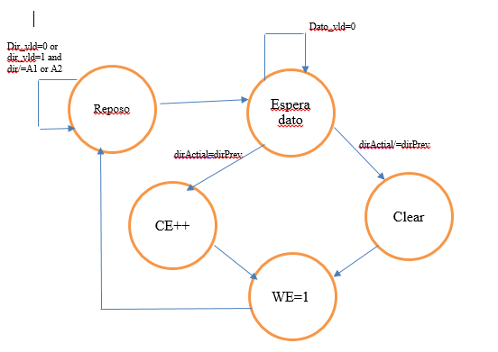

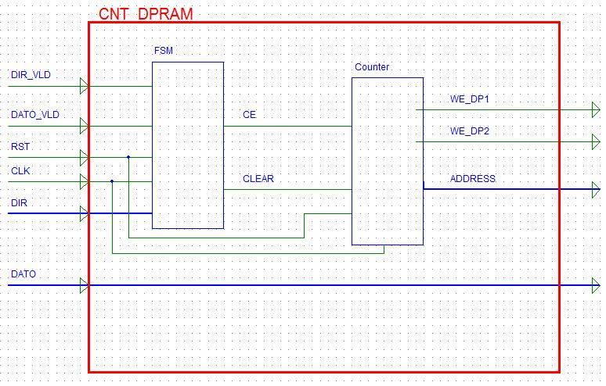

**5.1.3.**- Pantallazo de simulación donde se refleje que el mencionado circuito funciona  
correctamente. Para ello en el banco de pruebas deberá incluir los estímulos necesarios para  
comprobar que el módulo funciona correctamente.

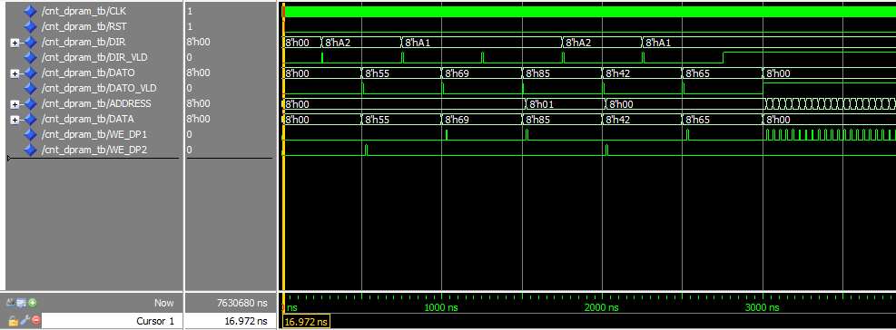

Esta grafica muestra el funcionamiento del modulo.

El proceso se inicializa con DIR=A2 y una vez que se recibe DATO_VLD la salida ADDRESS escribe un 0 ya que es la primera vez que se escribe en la memoria A2. El siguiente paso de DIR es A1, y se aprecia como ADDRESS mantiene el valor 0 ya que también es la primera vez que se accede la memoria A1. El siguiente ciclo vuelve a ser DIR=A1, como esta es la segunda referencia consecutiva a esta memoria ADDRESS es ahora 01h.

**5.2.1.**- Tabla donde se incluyan los recursos utilizados para la implementación.

|  |  |  |  |  |  |
| --- | --- | --- | --- | --- | --- |
| **Device Utilization Summary** | | | | | [**[-]**](?&ExpandedTable=DeviceUtilizationSummary) |
| **Slice Logic Utilization** | **Used** | **Available** | **Utilization** | **Note(s)** | |
| Number of Slice Registers | 31 | 54,576 | 1% |  | |
| Number used as Flip Flops | 31 |  |  |  | |
| Number used as Latches | 0 |  |  |  | |
| Number used as Latch-thrus | 0 |  |  |  | |
| Number used as AND/OR logics | 0 |  |  |  | |
| Number of Slice LUTs | 21 | 27,288 | 1% |  | |
| Number used as logic | 21 | 27,288 | 1% |  | |
| Number using O6 output only | 15 |  |  |  | |
| Number using O5 output only | 0 |  |  |  | |
| Number using O5 and O6 | 6 |  |  |  | |
| Number used as ROM | 0 |  |  |  | |
| Number used as Memory | 0 | 6,408 | 0% |  | |
| Number of occupied Slices | 10 | 6,822 | 1% |  | |
| Number of MUXCYs used | 0 | 13,644 | 0% |  | |
| Number of LUT Flip Flop pairs used | 34 |  |  |  | |
| Number with an unused Flip Flop | 4 | 34 | 11% |  | |
| Number with an unused LUT | 13 | 34 | 38% |  | |
| Number of fully used LUT-FF pairs | 17 | 34 | 50% |  | |
| Number of unique control sets | 4 |  |  |  | |
| Number of slice register sites lost         to control set restrictions | 1 | 54,576 | 1% |  | |
| Number of bonded [IOBs](C://Users/christopher/Dropbox/workspace/modelado14/cnt_dpram/cnt_dpram_map.xrpt?&DataKey=IOBProperties) | 38 | 218 | 17% |  | |
| Number of RAMB16BWERs | 0 | 116 | 0% |  | |
| Number of RAMB8BWERs | 0 | 232 | 0% |  | |
| Number of BUFIO2/BUFIO2_2CLKs | 0 | 32 | 0% |  | |
| Number of BUFIO2FB/BUFIO2FB_2CLKs | 0 | 32 | 0% |  | |
| Number of BUFG/BUFGMUXs | 1 | 16 | 6% |  | |
| Number used as BUFGs | 1 |  |  |  | |
| Number used as BUFGMUX | 0 |  |  |  | |
| Number of DCM/DCM_CLKGENs | 0 | 8 | 0% |  | |
| Number of ILOGIC2/ISERDES2s | 0 | 376 | 0% |  | |
| Number of IODELAY2/IODRP2/IODRP2_MCBs | 0 | 376 | 0% |  | |
| Number of OLOGIC2/OSERDES2s | 0 | 376 | 0% |  | |
| Number of BSCANs | 0 | 4 | 0% |  | |
| Number of BUFHs | 0 | 256 | 0% |  | |
| Number of BUFPLLs | 0 | 8 | 0% |  | |
| Number of BUFPLL_MCBs | 0 | 4 | 0% |  | |
| Number of DSP48A1s | 0 | 58 | 0% |  | |
| Number of ICAPs | 0 | 1 | 0% |  | |
| Number of MCBs | 0 | 2 | 0% |  | |
| Number of PCILOGICSEs | 0 | 2 | 0% |  | |
| Number of PLL_ADVs | 0 | 4 | 0% |  | |
| Number of PMVs | 0 | 1 | 0% |  | |
| Number of STARTUPs | 0 | 1 | 0% |  | |
| Number of SUSPEND_SYNCs | 0 | 1 | 0% |  | |
| Average Fanout of Non-Clock Nets | 3.13 |  |  |  | |

**5.2.2.-** Pantallazo de simulación donde se refleje que el módulo de representación funciona  
correctamente.

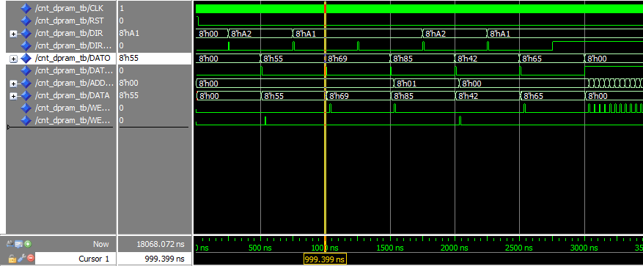

El comportamiento de la simulación temporal es similar a la simulación funcional. El funcionamiento sigue siendo correcto.

1. **GEN_DIR**

**6.1.1.**- Código VHDL del módulo y del banco de pruebas utilizado en la simulación.

**A)** Código VHDL de la entidad ***gen_dir***

library ieee;

use ieee.std_logic_1164.all;

use ieee.numeric_std.all;

entity gen_dir is

generic ( N : integer := 68 );

port (

CLK : in std_logic;

RST : in std_logic;

DIR : in std_logic_vector (7 downto 0);

DIR_VLD : in std_logic;

DATO : in std_logic_vector (7 downto 0);

DATO_VLD : in std_logic;

ADDR_OUT : out std_logic_vector(7 downto 0);

DATO_OK : out std_logic);

end gen_dir;

architecture rtl of gen_dir is

constant dir_frec : std_logic_vector( 7 downto 0) := x"F0";

type state_type is (

s0, --HOLDING STATE

s1 --WAIT DATA STATE

);

signal state: state_type; --current and next state declaration.

signal valor_freq: std_logic_vector( 7 downto 0);

signal cnt: std_logic_vector( 15 downto 0);

signal valor_freq_comm: std_logic_vector( 15 downto 0);

signal CE: std_logic;

signal prescalerCounter: unsigned(6 downto 0); --7 bits to cover generic 68

signal dato_ok_trigger: std_logic;

begin

prescaler_proc:process (CLK,RST)

begin

if (RST='1') then

CE <= '0';

prescalerCounter<=(others=>'0');

elsif (CLK'event and CLK='1')then

CE <= '0';

prescalerCounter<=prescalerCounter+1;

if (prescalerCounter = N)then

CE <= '1';

prescalerCounter<=(others=>'0');

end if;

end if;

end process;

fsm_proc:process(clk, rst,valor_freq,DIR_VLD,DIR,DATO_VLD)

begin

if(rst = '1') then

state <= s0;

valor_freq<=(others=>'0');

elsif (clk'event and clk = '1') then

case state is

WHEN s0 =>

if(DIR_VLD= '1' and DIR=dir_frec)then state<=s1; end if;

WHEN s1 =>

if (DATO_VLD= '1')then

valor_freq<=DATO;

state<=s0;

end if;

end case;

end if;

end process;

valor_freq_comm<=std_logic_vector(unsigned(valor_freq) + unsigned(cnt));

registro:process (clk,rst,valor_freq_comm,CE)

begin

if (rst='1') then

cnt <= (others=>'0');

elsif (clk'event and clk='1')then

if (CE = '1')then

cnt<=valor_freq_comm;

end if;

end if;

end process;

ADDR_OUT<=cnt(15 downto 8);

dato_ok_trigger<='1' when (cnt /= x"0000") else ('0');

data_ok_proc:process (clk,rst,prescalerCounter)

begin

if (rst='1') then

DATO_OK<='0';

elsif (clk'event and clk='1')then

if (prescalerCounter = 1)then

DATO_OK<='1';

else

DATO_OK<='0';

end if;

end if;

end process;

end rtl;

**B)** Código VHDL del testbench de la entidad ***gen_dir_tb***

LIBRARY ieee;

USE ieee.std_logic_1164.ALL;

ENTITY gen_dir_tb IS

END gen_dir_tb;

ARCHITECTURE behavior OF gen_dir_tb IS

COMPONENT gen_dir

PORT(

CLK : IN std_logic;

RST : IN std_logic;

DIR : IN std_logic_vector(7 downto 0);

DIR_VLD : IN std_logic;

DATO : IN std_logic_vector(7 downto 0);

DATO_VLD : IN std_logic;

ADDR_OUT : OUT std_logic_vector(7 downto 0);

DATO_OK : OUT std_logic

);

END COMPONENT;

--Inputs

signal CLK : std_logic := '0';

signal RST : std_logic := '1';

signal DIR : std_logic_vector(7 downto 0) := (others => '0');

signal DIR_VLD : std_logic := '0';

signal DATO : std_logic_vector(7 downto 0) := (others => '0');

signal DATO_VLD : std_logic := '0';

--Outputs

signal ADDR_OUT : std_logic_vector(7 downto 0);

signal DATO_OK : std_logic;

-- Clock period definitions

constant CLK_period : time := 10 ns;

BEGIN

-- Instantiate the Unit Under Test (UUT)

uut: gen_dir PORT MAP (

CLK => CLK,

RST => RST,

DIR => DIR,

DIR_VLD => DIR_VLD,

DATO => DATO,

DATO_VLD => DATO_VLD,

ADDR_OUT => ADDR_OUT,

DATO_OK => DATO_OK

);

CLK_process :process

begin

CLK <= '0';

wait for CLK_period/2;

CLK <= '1';

wait for CLK_period/2;

end process;

RST_process :process

begin

wait for 10 ns;

RST <= '0';

end process;

DIR_VLD_process :process

begin

if(rst='1')then

DIR<=(others=>'0');

wait for 250 ns;

end if;

DIR <= x"a2";

DIR_VLD<='1';

wait for 10 ns;

DIR_VLD<='0';

wait for 490 ns;

DIR_VLD<='1';

DIR <= x"a1";

wait for 10 ns;

DIR_VLD<='0';

wait for 490 ns;

DIR_VLD<='1';

DIR <= x"F0";

wait for 10 ns;

DIR_VLD<='0';

wait for 490 ns;

DIR_VLD<='1';

DIR <= x"a2";

wait for 10 ns;

DIR_VLD<='0';

wait for 490 ns;

DIR_VLD<='1';

DIR <= x"a1";

wait for 10 ns;

DIR_VLD<='0';

wait for 490 ns;

DIR_VLD<='1';

DIR <= x"F0";

wait for 10 ns;

DIR_VLD<='0';

wait for 490 ns;

DIR_VLD<='0';

DIR <= x"00";

wait for 10 ns; wait;

end process;

END;

DATO_process :process

begin

if(rst='1')then

DATO<=(others=>'0');

wait for 500 ns;

end if;

DATO <= x"55";

DATO_VLD<='1';

wait for 10 ns;

DATO_VLD<='0';

wait for 490 ns;

DATO_VLD<='1';

DATO <= x"69";

wait for 10 ns;

DATO_VLD<='0';

wait for 490 ns;

DATO_VLD<='1';

DATO <= x"85";

wait for 10 ns;

DATO_VLD<='0';

wait for 490 ns;

DATO_VLD<='1';

DATO <= x"42";

wait for 10 ns;

DATO_VLD<='0';

wait for 490 ns;

DATO_VLD<='1';

DATO <= x"65";

wait for 10 ns;

DATO_VLD<='0';

wait for 490 ns;

DATO_VLD<='1';

DATO <= x"00";

wait for 10 ns;

DATO_VLD<='0';

wait for 490 ns;

DATO_VLD<='0';

DATO <= x"00";

wait for 10 ns;

wait;

end process;

**6.1.2**- Razonamiento de por qué se ha adoptado la solución presentada.

Siguiendo el esquema proporcionado, se han creado los siguientes componentes;

Un prescaler con un factor de división de 68 pulsos de CLK.

Una maquina de estados que espera a una dirección valida y un dato valido. Un vez recibido ambos valores validos, comprueba a su vez que la DIR introducida corresponde con la dirección F0h. Si es asi el valor del puerto DATO de entrada se suma al valor que sale del biestable.

El biestable mantiene el valor del DATO durante un ciclo del prescaler y retorna el valor al sumador para sumarlo con un nuevo valor de entrada.

Por ultimo se ha diseñado un sistema secuencial en el cual, cuando el contador del prescaler alcanza el valor 1 y la salida de cnt es distinto al inicio (“0000”h) se activa la salida DATO_OK.

Se ha tomado el inicio en 0h de cnt porque es un valor que tras ser sumado repetidas veces dos cualesquiera nunca originara el valor 0h.

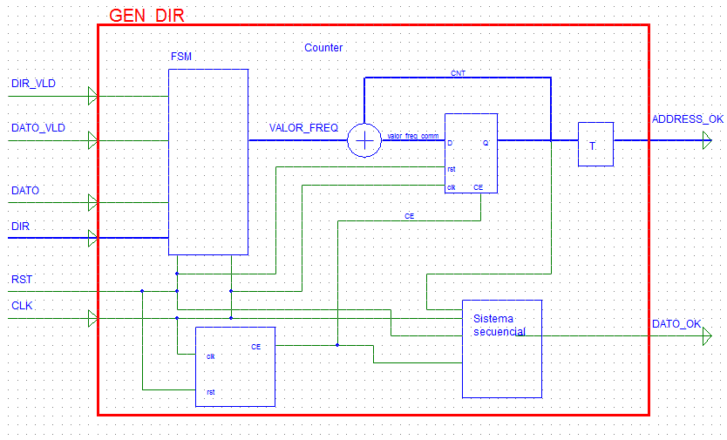

**6.1.3.**- Pantallazo de simulación donde se refleje que el mencionado circuito funciona  
correctamente. Para ello en el banco de pruebas deberá incluir los estímulos necesarios para  
comprobar que el módulo funciona correctamente.

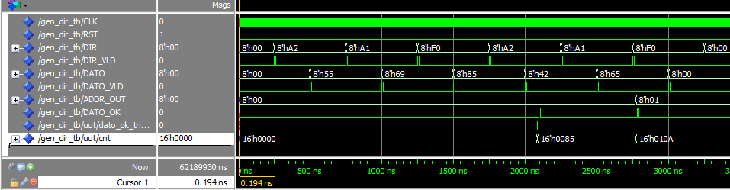

En la gráfica anterior cuando llega una dirección en DIR igual a F0h y se detecta un dato valido (DATO_VLD=1) y la salida para el primer caso de ADDR_OUT es igual a 00h.

**6.2.1.**- Tabla donde se incluyan los recursos utilizados para la implementación.

|  |  |  |  |  |  |
| --- | --- | --- | --- | --- | --- |
| **Device Utilization Summary** | | | | | [**[-]**](?&ExpandedTable=DeviceUtilizationSummary) |
| **Slice Logic Utilization** | **Used** | **Available** | **Utilization** | **Note(s)** | |
| Number of Slice Registers | 34 | 54,576 | 1% |  | |
| Number used as Flip Flops | 34 |  |  |  | |
| Number used as Latches | 0 |  |  |  | |
| Number used as Latch-thrus | 0 |  |  |  | |
| Number used as AND/OR logics | 0 |  |  |  | |
| Number of Slice LUTs | 32 | 27,288 | 1% |  | |
| Number used as logic | 31 | 27,288 | 1% |  | |
| Number using O6 output only | 22 |  |  |  | |
| Number using O5 output only | 7 |  |  |  | |
| Number using O5 and O6 | 2 |  |  |  | |
| Number used as ROM | 0 |  |  |  | |
| Number used as Memory | 0 | 6,408 | 0% |  | |
| Number used exclusively as route-thrus | 1 |  |  |  | |
| Number with same-slice register load | 0 |  |  |  | |
| Number with same-slice carry load | 1 |  |  |  | |
| Number with other load | 0 |  |  |  | |
| Number of occupied Slices | 14 | 6,822 | 1% |  | |
| Number of MUXCYs used | 16 | 13,644 | 1% |  | |
| Number of LUT Flip Flop pairs used | 40 |  |  |  | |
| Number with an unused Flip Flop | 8 | 40 | 20% |  | |
| Number with an unused LUT | 8 | 40 | 20% |  | |
| Number of fully used LUT-FF pairs | 24 | 40 | 60% |  | |
| Number of unique control sets | 3 |  |  |  | |
| Number of slice register sites lost         to control set restrictions | 6 | 54,576 | 1% |  | |
| Number of bonded [IOBs](C://Users/christopher/Dropbox/workspace/modelado14/gen_dir/gen_dir_map.xrpt?&DataKey=IOBProperties) | 29 | 218 | 13% |  | |
| Number of RAMB16BWERs | 0 | 116 | 0% |  | |
| Number of RAMB8BWERs | 0 | 232 | 0% |  | |
| Number of BUFIO2/BUFIO2_2CLKs | 0 | 32 | 0% |  | |
| Number of BUFIO2FB/BUFIO2FB_2CLKs | 0 | 32 | 0% |  | |
| Number of BUFG/BUFGMUXs | 1 | 16 | 6% |  | |
| Number used as BUFGs | 1 |  |  |  | |
| Number used as BUFGMUX | 0 |  |  |  | |
| Number of DCM/DCM_CLKGENs | 0 | 8 | 0% |  | |
| Number of ILOGIC2/ISERDES2s | 0 | 376 | 0% |  | |
| Number of IODELAY2/IODRP2/IODRP2_MCBs | 0 | 376 | 0% |  | |
| Number of OLOGIC2/OSERDES2s | 0 | 376 | 0% |  | |
| Number of BSCANs | 0 | 4 | 0% |  | |
| Number of BUFHs | 0 | 256 | 0% |  | |
| Number of BUFPLLs | 0 | 8 | 0% |  | |
| Number of BUFPLL_MCBs | 0 | 4 | 0% |  | |
| Number of DSP48A1s | 0 | 58 | 0% |  | |
| Number of ICAPs | 0 | 1 | 0% |  | |
| Number of MCBs | 0 | 2 | 0% |  | |
| Number of PCILOGICSEs | 0 | 2 | 0% |  | |
| Number of PLL_ADVs | 0 | 4 | 0% |  | |
| Number of PMVs | 0 | 1 | 0% |  | |
| Number of STARTUPs | 0 | 1 | 0% |  | |
| Number of SUSPEND_SYNCs | 0 | 1 | 0% |  | |
| Average Fanout of Non-Clock Nets | 2.97 |  |  |  | |

**6.2.2.-** Pantallazo de simulación temporal donde se refleje que el módulo de representación funciona  
correctamente.

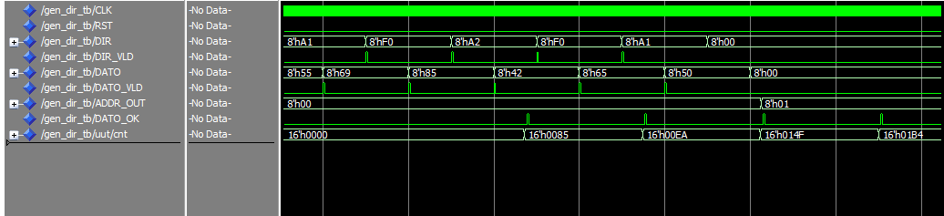

Analizando la simulación temporal se veque con la primera lectura de DRI=F0 se obtine el dato 85h, los bits de mayor peso pasan a ADDR_OUT, es decir el valor será de 0h y se activa el DATO_OK. El segundo valor de lectura para F= es 65h sumando ambos se obtiene EAh. En ADDR_OUT de nuevo solo pasan los de mayor peso luego sigue siendo 0h. Una vez pasado el periodo del prescaler, como no hay una entrada valida nueva se mantiene el valor anterior (65h) que sumado al valor anterior EAh resulta en 014F. Este nuevo valor provoca en la salida ADDR_OUT el valor de 01h ya que solo coge los de mayor peso del bus CNT.

1. **GEN_FUNCIONES**

**7.1.1.**- Código VHDL del banco de pruebas utilizado para su simulación. La entidad *gen_funciones* se proporciona con el enunciado.

**A)** Código VHDL de la entidad ***gen_funciones_tb***

LIBRARY ieee;

USE ieee.std_logic_1164.ALL;

ENTITY gen_funciones_tb IS

END gen_funciones_tb;

ARCHITECTURE behavior OF gen_funciones_tb IS

COMPONENT gen_funciones

PORT(

RELOJ : IN std_logic;

RST : IN std_logic;

ASTRB : IN std_logic;

DSTRB : IN std_logic;

DATA : INOUT std_logic_vector(7 downto 0);

PWRITE : IN std_logic;

PWAIT : OUT std_logic;

SYNC : OUT std_logic;

SCLK : OUT std_logic;

D1 : OUT std_logic;

D2 : OUT std_logic

);

END COMPONENT;

COMPONENT epp_device1

port (

DATA : inout std_logic_vector(7 downto 0);

PWRITE : out std_logic;

DSTRB : out std_logic;

ASTRB : out std_logic;

PWAIT : in std_logic);

END COMPONENT;

COMPONENT DAC121S101

port (

VOUT : out real range 0.0 to 3.5;

SYNC : in std_logic;

SCLK : in std_logic;

DIN : in std_logic);

end COMPONENT;

--Inputs

signal RELOJ : std_logic := '0';

signal RST : std_logic := '1';

signal ASTRB : std_logic := '0';

signal DSTRB : std_logic := '0';

signal PWRITE : std_logic := '0';

--BiDirs

signal DATA : std_logic_vector(7 downto 0):=x"00";

--Outputs

signal VOUT1 : real range 0.0 to 3.5;

signal VOUT2 : real range 0.0 to 3.5;

signal PWAIT : std_logic;

signal SYNC : std_logic;

signal SCLK : std_logic;

signal D1 : std_logic;

signal D2 : std_logic;

-- Clock period definitions

constant RELOJ_period : time := 10 ns;

BEGIN

-- Instantiate the Unit Under Test (UUT)

uut: gen_funciones PORT MAP (

RELOJ => RELOJ,

RST => RST,

ASTRB => ASTRB,

DSTRB => DSTRB,

DATA => DATA,

PWRITE => PWRITE,

PWAIT => PWAIT,

SYNC => SYNC,

SCLK => SCLK,

D1 => D1,

D2 => D2

);

eppDevice:epp_device1

port map(

DATA=>DATA,

PWRITE=>PWRITE,

DSTRB=>DSTRB,

ASTRB=>ASTRB,

PWAIT=>PWAIT

);

dac1:DAC121S101

port map(

VOUT => VOUT1,

SYNC => SYNC,

SCLK => SCLK,

DIN =>D1);

dac2:DAC121S101

port map(

VOUT=> VOUT2,

SYNC => SYNC,

SCLK => SCLK,

DIN =>D2);

-- Clock process definitions

RELOJ_process :process

begin

RELOJ <= '0';

wait for RELOJ_period/2;

RELOJ <= '1';

wait for RELOJ_period/2;

end process;

RST_process :process

begin

wait for 100 ns;

RST <= '0';

end process;

END;

**7.1.2.**- Pantallazo de simulación donde se refleje que el mencionado circuito funciona correctamente. Para ello en el banco de pruebas deberá incluir los estímulos necesarios para  
comprobar que el módulo funciona correctamente.

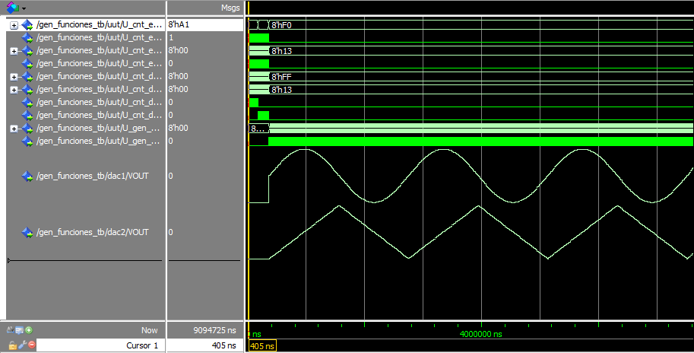

La primera señal muestra la entrada de las direcciones que dirigen el funcionamiento del sistema y se ve como empieza en A1. En esta posición guarda un numero de datos, y posteriormente hace los mismo para A2. Por ultimo con F0 comienzan a leerse los datos e interpretarse como señales senoidales.

**7.2.1.**- Tabla donde se incluyan los recursos utilizados para la implementación

|  |  |  |  |  |  |
| --- | --- | --- | --- | --- | --- |
| **Device Utilization Summary** | | | | | [**[-]**](?&ExpandedTable=DeviceUtilizationSummary) |
| **Slice Logic Utilization** | **Used** | **Available** | **Utilization** | **Note(s)** | |
| Number of Slice Registers | 94 | 54,576 | 1% |  | |
| Number used as Flip Flops | 94 |  |  |  | |
| Number used as Latches | 0 |  |  |  | |
| Number used as Latch-thrus | 0 |  |  |  | |
| Number used as AND/OR logics | 0 |  |  |  | |
| Number of Slice LUTs | 68 | 27,288 | 1% |  | |
| Number used as logic | 67 | 27,288 | 1% |  | |
| Number using O6 output only | 46 |  |  |  | |
| Number using O5 output only | 7 |  |  |  | |
| Number using O5 and O6 | 14 |  |  |  | |
| Number used as ROM | 0 |  |  |  | |
| Number used as Memory | 0 | 6,408 | 0% |  | |
| Number used exclusively as route-thrus | 1 |  |  |  | |
| Number with same-slice register load | 0 |  |  |  | |
| Number with same-slice carry load | 1 |  |  |  | |
| Number with other load | 0 |  |  |  | |
| Number of occupied Slices | 35 | 6,822 | 1% |  | |
| Number of MUXCYs used | 16 | 13,644 | 1% |  | |
| Number of LUT Flip Flop pairs used | 105 |  |  |  | |
| Number with an unused Flip Flop | 16 | 105 | 15% |  | |
| Number with an unused LUT | 37 | 105 | 35% |  | |
| Number of fully used LUT-FF pairs | 52 | 105 | 49% |  | |
| Number of unique control sets | 9 |  |  |  | |
| Number of slice register sites lost         to control set restrictions | 10 | 54,576 | 1% |  | |
| Number of bonded [IOBs](C://Users/christopher/Dropbox/workspace/modelado14/gen_funciones/gen_funciones_map.xrpt?&DataKey=IOBProperties) | 18 | 218 | 8% |  | |
| Number of LOCed IOBs | 18 | 18 | 100% |  | |
| IOB Flip Flops | 1 |  |  |  | |
| Number of RAMB16BWERs | 0 | 116 | 0% |  | |
| Number of RAMB8BWERs | 2 | 232 | 1% |  | |
| Number of BUFIO2/BUFIO2_2CLKs | 1 | 32 | 3% |  | |
| Number used as BUFIO2s | 1 |  |  |  | |
| Number used as BUFIO2_2CLKs | 0 |  |  |  | |
| Number of BUFIO2FB/BUFIO2FB_2CLKs | 1 | 32 | 3% |  | |
| Number used as BUFIO2FBs | 1 |  |  |  | |
| Number used as BUFIO2FB_2CLKs | 0 |  |  |  | |
| Number of BUFG/BUFGMUXs | 1 | 16 | 6% |  | |
| Number used as BUFGs | 1 |  |  |  | |
| Number used as BUFGMUX | 0 |  |  |  | |
| Number of DCM/DCM_CLKGENs | 1 | 8 | 12% |  | |
| Number used as DCMs | 1 |  |  |  | |
| Number used as DCM_CLKGENs | 0 |  |  |  | |
| Number of ILOGIC2/ISERDES2s | 0 | 376 | 0% |  | |
| Number of IODELAY2/IODRP2/IODRP2_MCBs | 0 | 376 | 0% |  | |
| Number of OLOGIC2/OSERDES2s | 1 | 376 | 1% |  | |
| Number used as OLOGIC2s | 1 |  |  |  | |
| Number used as OSERDES2s | 0 |  |  |  | |
| Number of BSCANs | 0 | 4 | 0% |  | |
| Number of BUFHs | 0 | 256 | 0% |  | |
| Number of BUFPLLs | 0 | 8 | 0% |  | |
| Number of BUFPLL_MCBs | 0 | 4 | 0% |  | |
| Number of DSP48A1s | 0 | 58 | 0% |  | |
| Number of ICAPs | 0 | 1 | 0% |  | |
| Number of MCBs | 0 | 2 | 0% |  | |
| Number of PCILOGICSEs | 0 | 2 | 0% |  | |
| Number of PLL_ADVs | 0 | 4 | 0% |  | |
| Number of PMVs | 0 | 1 | 0% |  | |
| Number of STARTUPs | 0 | 1 | 0% |  | |
| Number of SUSPEND_SYNCs | 0 | 1 | 0% |  | |
| Average Fanout of Non-Clock Nets | 3.52 |  |  |  | |

**7.2.2.-** Pantallazo de simulación donde se refleje que el sistema funciona correctamente.