Date
Company Name
Address

Attention: Full Name
Hello First Name and thank you for the opportunity to assist you and the team at Company. We would like to be part of your development and future success with all plans and strategies moving forward. As a group of individuals with a wealth of knowledge and experience within central Alberta and beyond, we know the relationship and proactive approach would benefit all of you at Company.
With Raven Silica Solutions (RSS) and Pantheon Financial (PF), we have been part of the silica, commodities, geology and fracking knowledge with greater than 50 years experience and we want to be partners in business with you. If there’s an area of improvement, ideas around getting better results, commodity and supply, or communications around possibly organizing the products, personnel, site, ambient temperature-logistics, etc. we are open to any of these.
Raven/PF stats and pictures and dimensions.
Capable of unloading 42 ton Super b’s in 5 – 8 minutes consistently.
- Feed rate to the Blender is 20 tonne/min.
- System is spec’d out for hot sand. Currently handling sand as hot as 110 – 120 degrees Celsius.
  - Competitors cannot handle heated sand. Wayfinder is sending sand out at 70-80 degrees Celsius. We handle it effortlessly. Most plants have to slow down and causes the trucks to be held up.
- Dust collection system is attached to sand plant. (Plant is virtually dustless)
- Layout of the plant can be configured in various ways as needed.
- Most wearable components are changeable in 2 – 3 hrs.
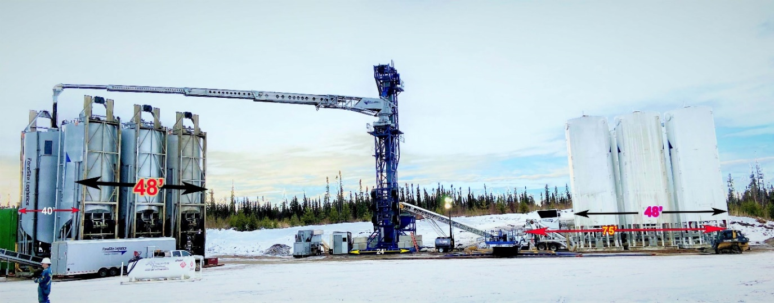

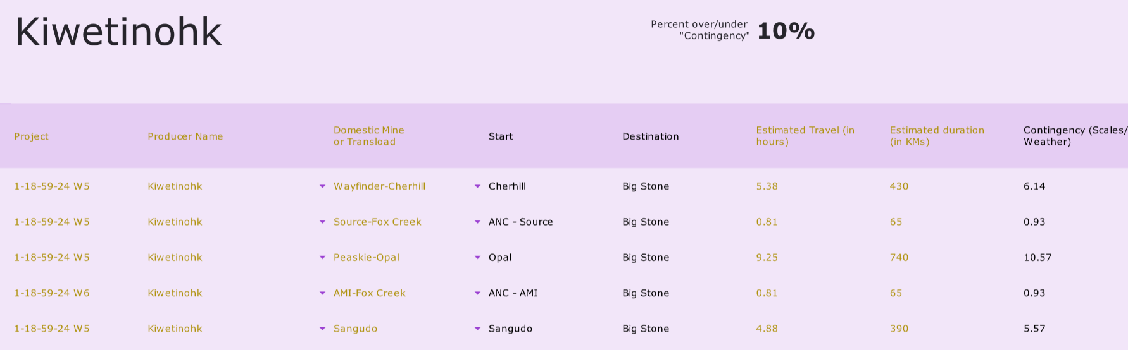
*Need to include loading and unloading charges.
*Sangudo is only for reference at this time, as we approach 2026.

**if we see cost savings after 1 or 2 days of hauling and working with the circumstances out the logistics, we would be transparent and adaptable. 10 days of pumping. We would revisit it with you to show you and the team the differences.
**Weather, roads and other factors could contribute cost overruns
RSS standby terms will be based on 6 hours at $750/day daily minimums per truck. If a truck sits for 7.5 hours and then rolls towards the end of its shift, there would be no standby. Load pay afterwards. If we don’t roll after 10 hours, the $1500/day daily minimum would occur.
- Competitors standby terms which are $1500/day daily minimums per truck. If a truck sits for 8 - 10 hours and then rolls towards the end of its shift there would be no standby.
Raven Silica Advantages and Differences from others
RSS/FLI Flexibility of the Plant. Can be configured in different layouts (lesser footprint and adaptable to the size of storage and access).
- Has the ability to add additional storage if needed.
- Not as much site prep needed as the competition. We use ½ the rig mats…25% of gravel used.
- Fastest sand plant in the industry. Unloads Super b’s (42 Ton on average) in 5 – 8 minutes consistently.
- Virtually dustless and have technology to assist
- Automated delivery to the Blender
- Storage is all on electronic load scales. Live real time scaled inventory and quantifiable.
- Newer Equipment
- Smaller Company – more personalized service. Custom designs, transparent, key lines of communications, open to improvements and environmentally conscious.
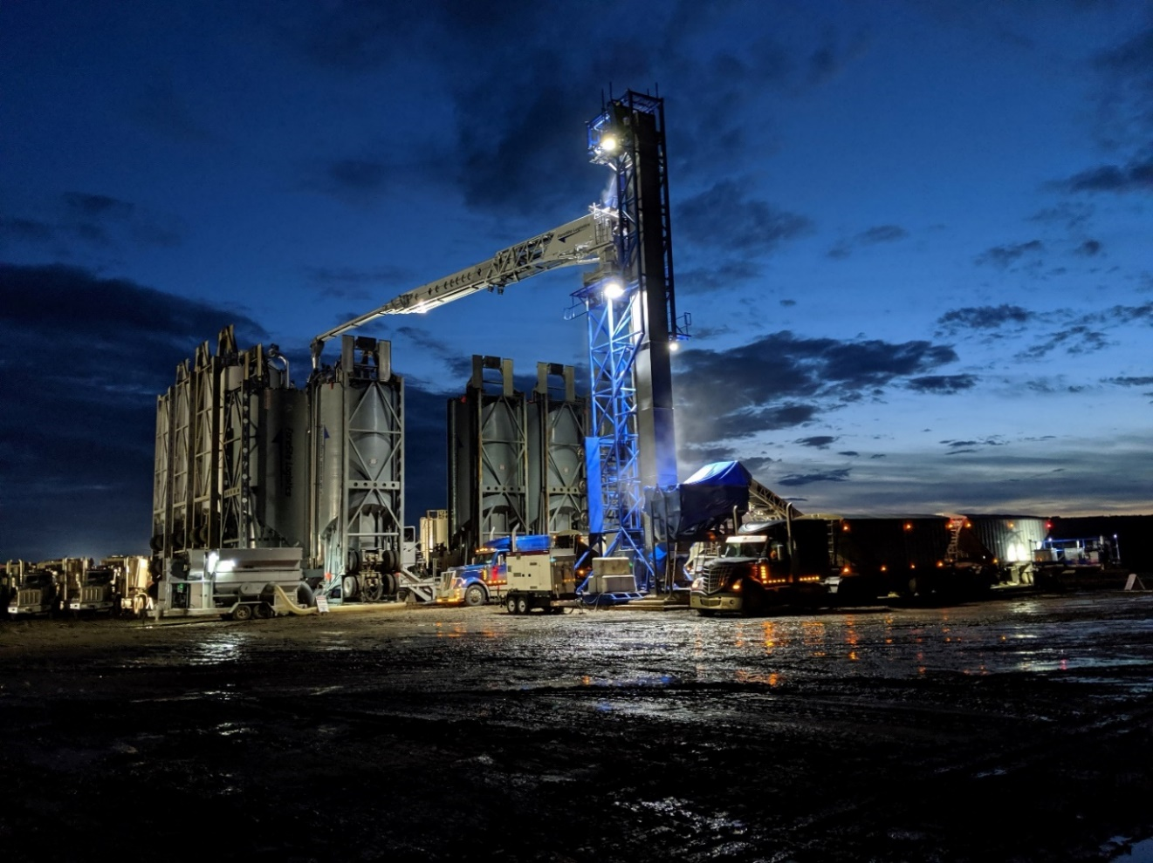
*Double drive over configuration
In Summary
Raven Silica will provide, the hauling, storage, plant, data, communications and transparency for the 27000 and/or 20,000 (or others) ton pads that are upcoming in Q1 and the future of 2025. If it be premium white provided by others or domestic sand provided by others or ourselves, we are willing to assist at any or all levels of the project. If any additional charges, unforeseen events or circumstances occur, we as RSS will discuss it and explain all aspects with you and the team. We look forward to being Partner’s in Progress with Company.

David Brough, CEO and Managing Partner
Raven Silica Solutions
403.710.2720
Appendices
Following the KEC Core Values and Business focus

ESG leadership through stakeholder inclusion
At Kiwetinohk we recognize that the fortunes of our stakeholders are inseparable. In the long term, for any to benefit, all must be engaged and contribute. We acknowledge these stakeholders and the duty to address the reasonable desires of each:
People, everywhere, who seek to protect the environment want us to reach beyond compliance and find ways to lead the energy industry in reducing the environmental impact of our activities, restoring disturbed land and reducing greenhouse gas emissions intensity
Governments and regulators want us to comply with all laws and regulations and to advise them of changes that would enable the industry to better serve society
Communities most impacted by the Company’s activities, including Indigenous communities, want to participate in planning, building and operating projects and in promptly restoring the land when the projects are done
Industry partners want us to honor our arrangements and reasonably accommodate change and adaptation
Customers want us to reliably deliver our products at the specifications and in the amounts that we forecast
Suppliers and service providers want an opportunity to compete for our business, to be paid promptly and fairly, and to contribute to the evolution of our business
Employees want an energizing, inclusive, happy work environment where everyone is treated with dignity and respect, to be compensated fairly and a safe and healthy workplace
Capital Providers want strong returns on their investment, effective communication, and management of risks; financial, environmental and reputational
We at Kiwetinohk see ourselves in the business of serving our stakeholders and together, with them, we will strive to produce energy. By engaging all our stakeholders openly and honestly and by encouraging their participation in our business we expect to best serve each of them. This goal of building a better enterprise by stakeholder engagement and accommodation is our prime directive. The pursuit of this objective is the foundation of all Kiwetinohk’s management conduct policies.

