# Part 2 Written problem solving:

Consider a state space where the start state is number 1 and each state k has two successors: numbers 2k and 2k+1

1. **State space for states 1 to 15.**

1. Goal State(11)

Sequential nodes using **Breadth-First Search**

1->2->3->4->5->6->7->8->9->10->11

Sequential Node using Dept**-limited Search with limit=3**

1->2->4->8->9->5->10->11

Sequential nodes user **Iterative Dept-First Search**

**Dept-1:** 1->2->3

**Dept 2:** 1->2->4->5->3->6->7

**Dept3:** 1->2->4->8->9->5->10->11

1. Bidirectional Search

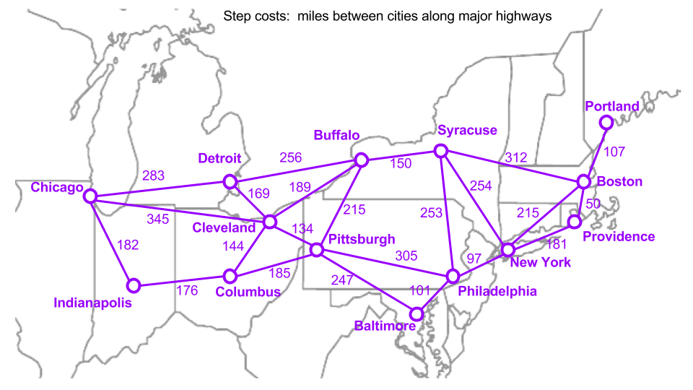

* Breadth First search: **Chicago to Boston**

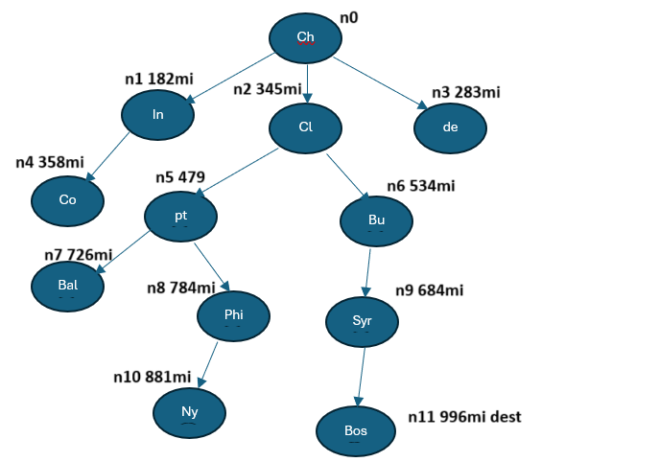

**Solution:** Chicago->Cleaveland->Buffalo->Syracuse->Buston

**Total Route Cost**: 996 miles

**Optimality:**  Solution is Optimal

* Depth First Search **Chicago to Buston**

**Solution:** Chicago->Indianapolis->Columbus-> Pittsburg->Baltimore->Philadelphia->newYork->Providence->Boston

**Total Route Cost:** 1220 miles

**Optimality:** solution not optimal

Uniform Cost search **Chicago to Boston**

**Solution:** Chicago->Detroit->Buffalo->Syracuse->Boston

**Total Route cost:** 1001 miles

**Optimality:** Solution not Optimal

**A Star Search:** **Heuristic=Euclidian**

Euclidian Distance graph

A Star Search from **Chicago to Boston**

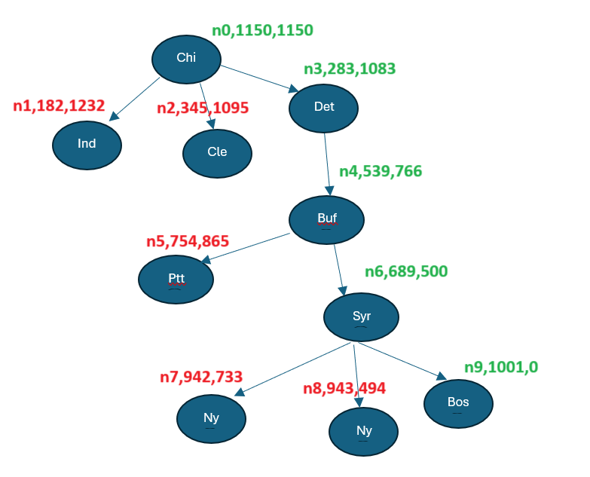

**Solution:** Chicago->Detroit->Buffalo->Syracuse->Boston

**Total Route cost:** 1001 miles

**Optimality:** Solution not Optimal

Challenges Uniform Cost search:

The uniform cost search runs, with small medium and large maze but stay east and stay west is invoked, it doesn’t work.

Debugging: To debug issues, I used the print function to which sections of the code is not being accede. At one time this really helped as I was just inserting infinitely into the queue and never breaking out of the loop which caused the system to run out of memory and freeze up.

Lessons learned: I really rusty and need to get myself together for the upcoming classes which are expected to increase in difficulty