Table of Contents
How to log-in Ariba 1
Basic Navigation of Ariba 1
Customized Settings & Personalization of Ariba 4
How to Log-in to Icertis 6
Basic Navigation of Icertis 6
Customized Settings & Personalization of Ariba 9
Glossary of Terms 12
Additional Resources for Ariba 13
Additional Resourcs for Icertis 14

How to Log-in to Ariba
- Navigate to your preferred web browser. Within the web browser enter the URL: Ariba website. Enter your (SSO) Single Sign On ID and password. Click “Login”

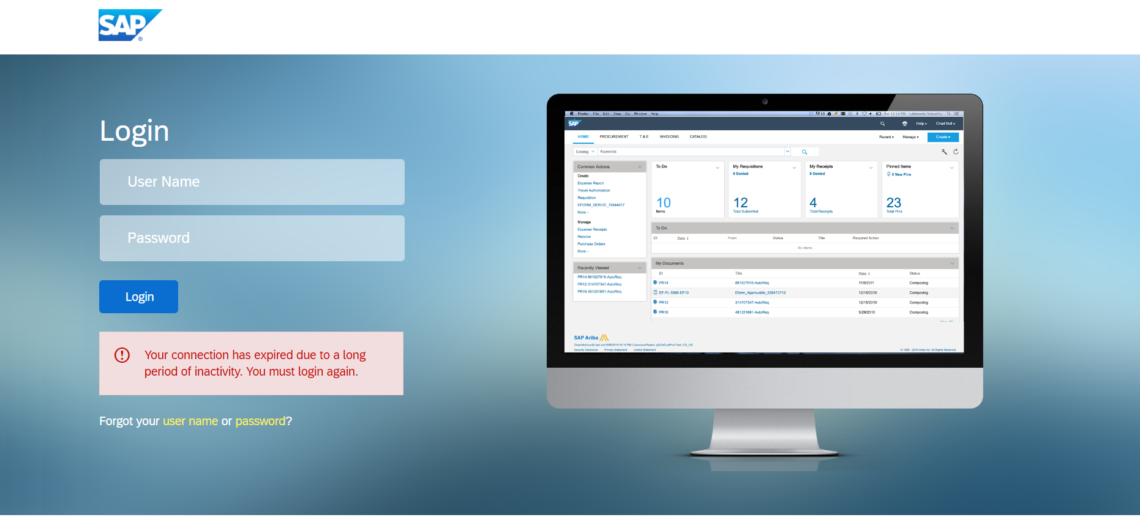

Basic Navigation of Ariba

The features available to you depend on the functionality you are authorized to access in your SAP Ariba Procurement solutions. For example, if you are only authorized to create invoices, you cannot create purchase orders and expense reports.

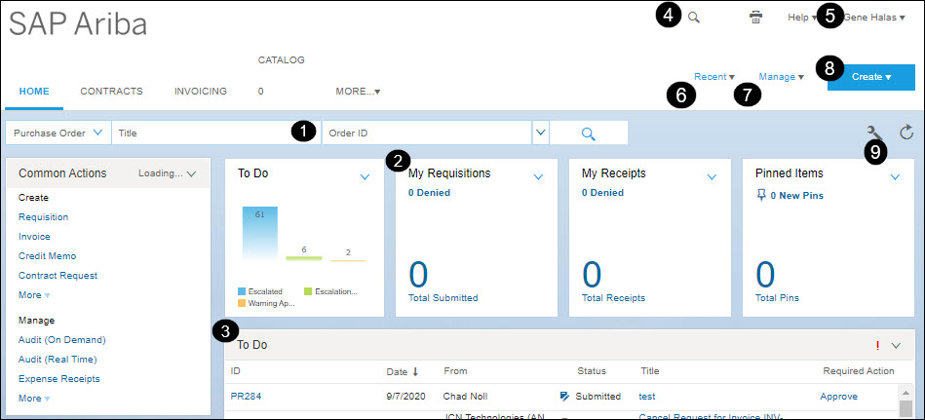
- Search: The Search bar includes a dropdown of searchable items, such as contract or invoice, to filter your search. In a separate dropdown you can also search using saved searches and labels (quick search filters).
- Action tiles: Dashboard action tiles display important information about users' day-to-day tasks. Action tiles always appear as a horizontal row either at the top of the dashboard or, if the dashboard includes a News content item, right below News. Action tiles automatically refresh at the same rate as other dashboard content: every 20 minutes unless you manually refresh the dashboard.
- Content items: Content items, such as My Documents and To Do provide users access to their content.
- Search, Print, and Help: Click the search icon () to conduct a search using one of the filters, the print icon (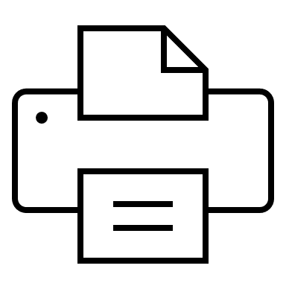) to print the current page, and Help to view the Help menu.
- Preferences and Logout: Click your user name in the upper right corner of the dashboard to view the Logout link, view your preferences, or to switch to a different theme (dark, light, or black).
- Recent: Click the Recent menu to view all of your recently viewed items.
- Manage: Click the Manage menu to access My To Do, Personal Workspace, Prepackaged Reports, Administration, and Core Administration (depending on your SAP Ariba cloud solutions and user permissions).
- Create: Click the Create menu to create new items, including requisitions, invoices, contracts, projects, sourcing events, and suppliers (depending on your SAP Ariba cloud solutions and user permissions).
- Configure Tabs and Refresh Content: Click the configuration icon (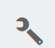) to see the options for managing content on your dashboard. Click the refresh icon () to refresh your dashboard.

Area of focus to view assigned tasks: Within your dashboards look for a “To Do” list located on the right side of your screen (refer to the highlighted area in the image below to help guide you to the “To Do” list). The “To Do” section is important to focus on for your daily tasks for your workstream.

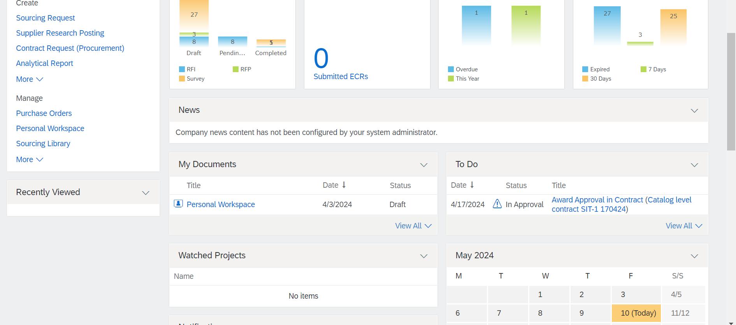

Customization Settings & Personalization of Ariba

- Customizing the SAP Ariba interface: In SAP Ariba, personalization means efficiency. Navigate to your profile icon at the top right of the screen to view your list of settings. Here, you can customize your interface, such as language preference, theme color, and the layout of your home screen.

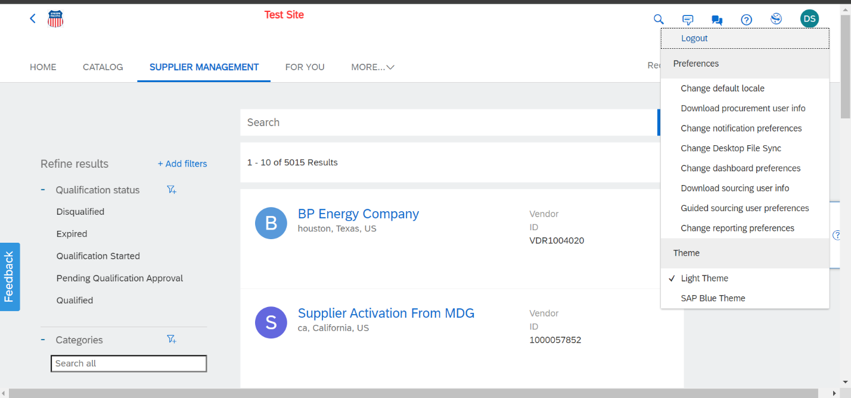

- Customizing Notifications: Navigate to your user icon in the top right of your screen. Then select “Change notification preferences” in the drop down menu.

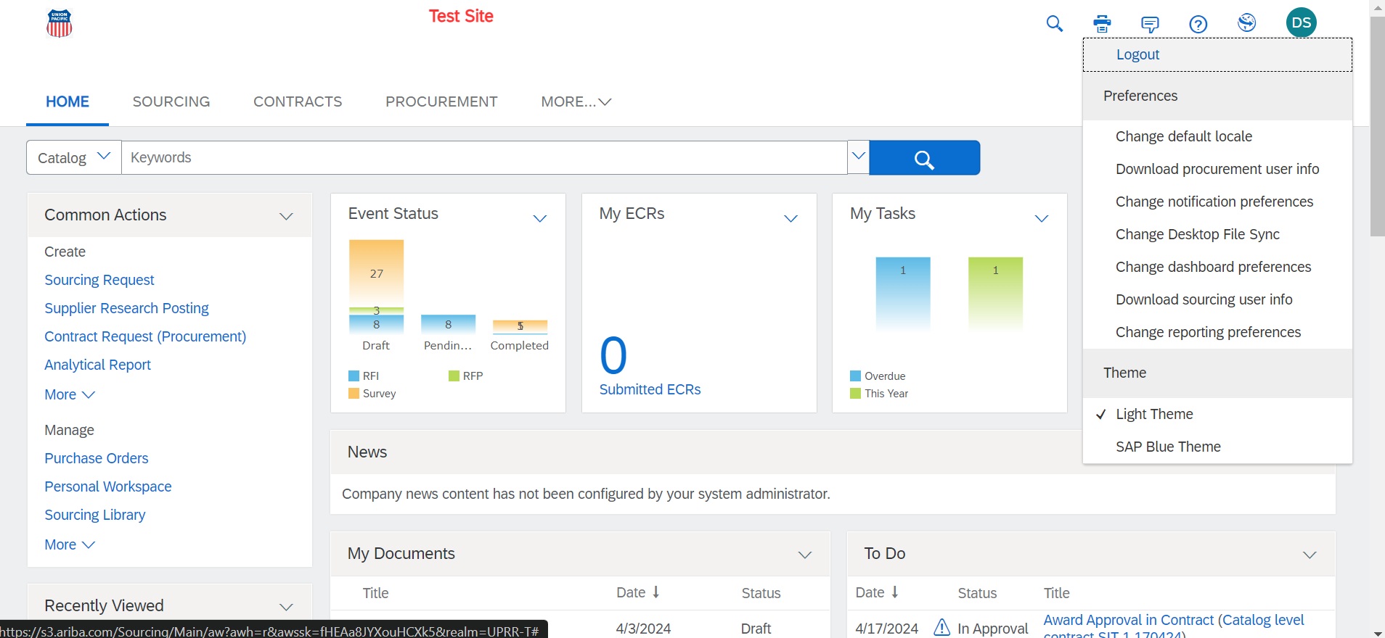

Once you select “Change notification preferences” a new page will appear with a list of options to change your notification preferences. Once you have selected the preferences that meet your needs select the “OK” button.

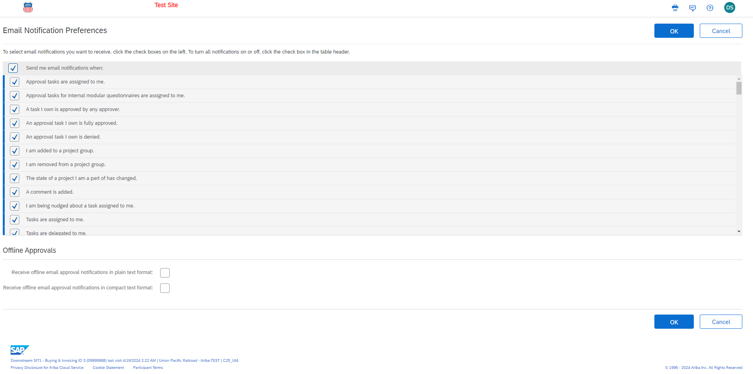

- Configure your dashboard: To further customize the layout of your dashboard select the wrench icon (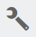) within the configuration tab area underneath your user icon in the top right of the screen. Within the drop-down menu of the configuration tab you will see the various ways to adjust your dashboard views.

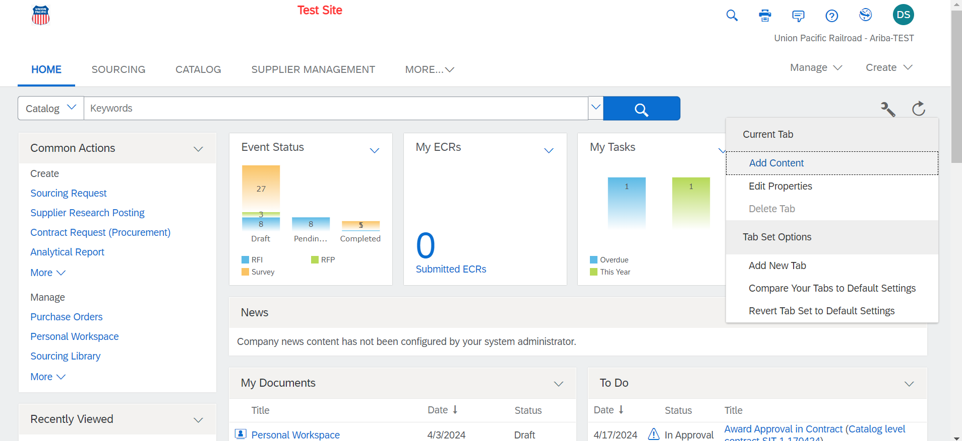

If you would like to add more content to your dashboard select “Add Content” under the configure tab (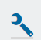). Once “Add Content” is selected you will see an additional menu of options to add to your dashboard. Please select the content that will be most useful to you and your workflow.

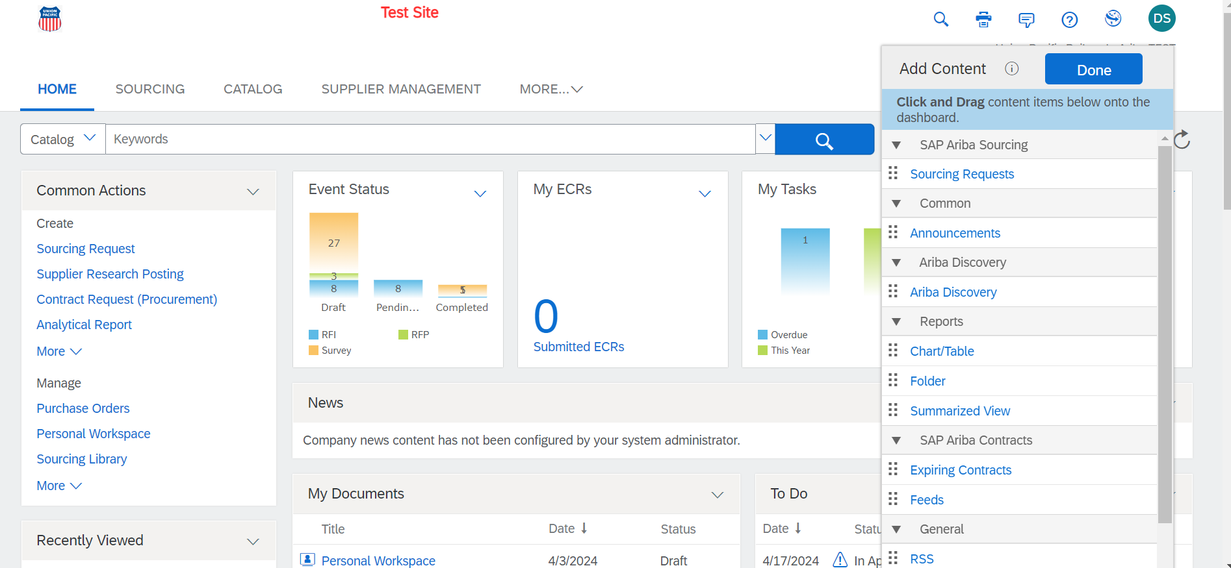

- Search tasks: The tasks assigned to you can be found within the drop down menu under “Manage”. The “Manage” tab can be found in the right hand corner of your screen under your user profile icon. Once the “Manage” tab has been selected click on “My Tasks” within the drop down menu.

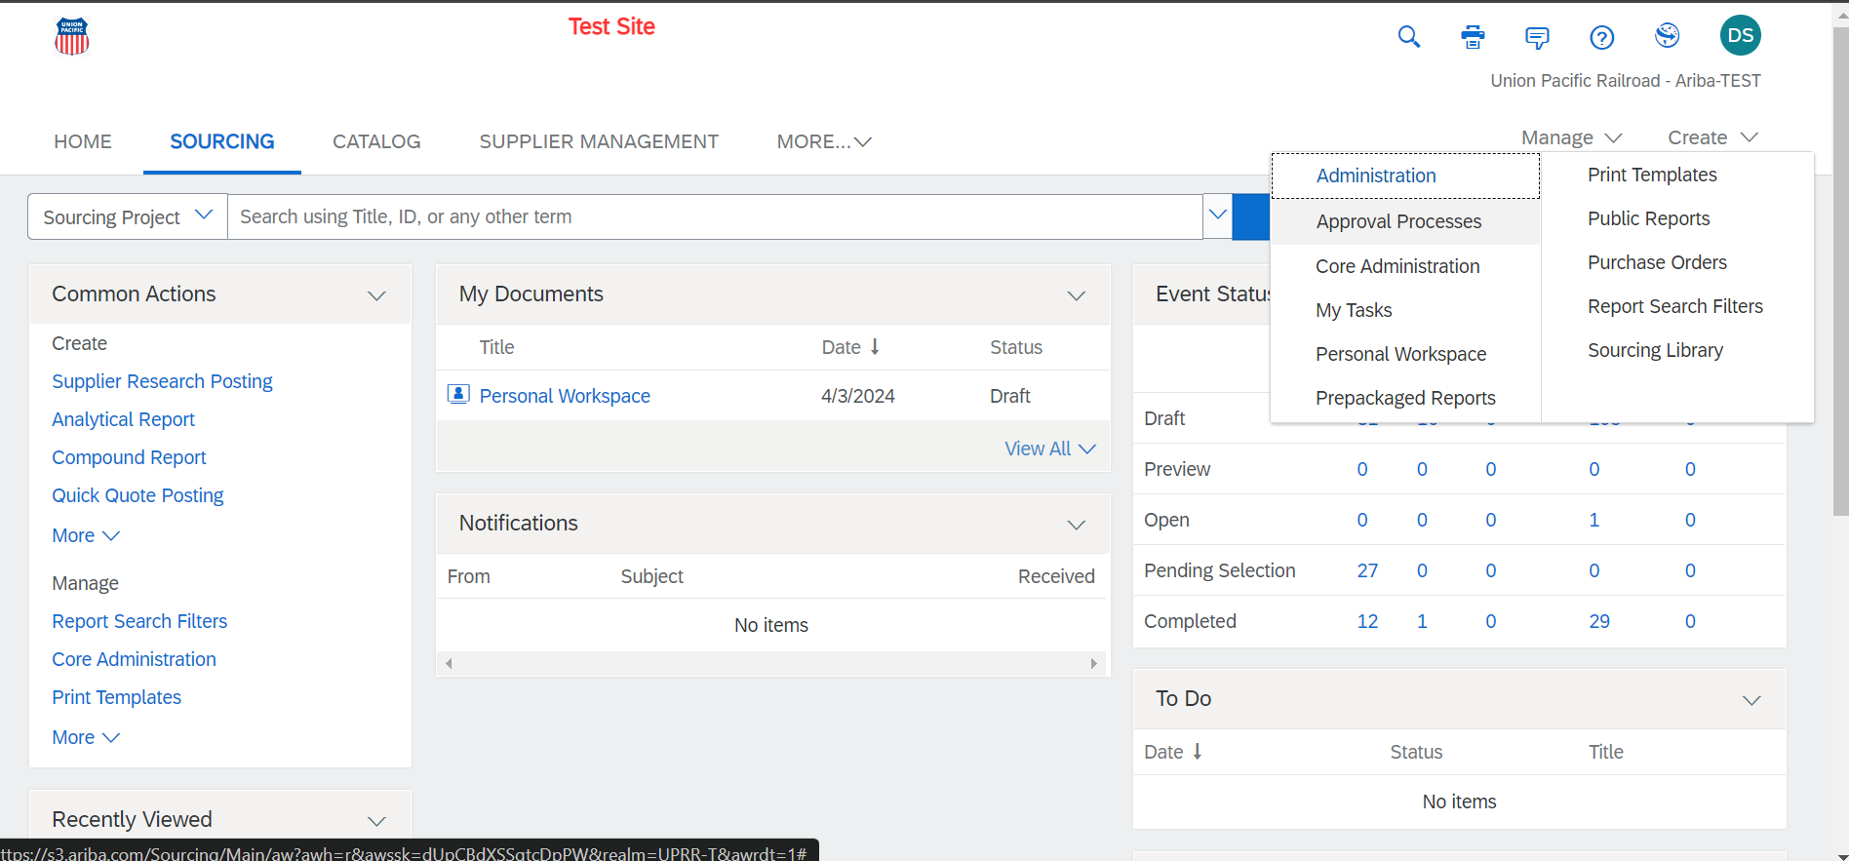

Once you are on the “My Tasks” page you can easily find specific tasks assigned to you by using the filters highlighted in the image below. This feature can be helpful when you have a lot of tasks assigned to you and need to quickly find a project.

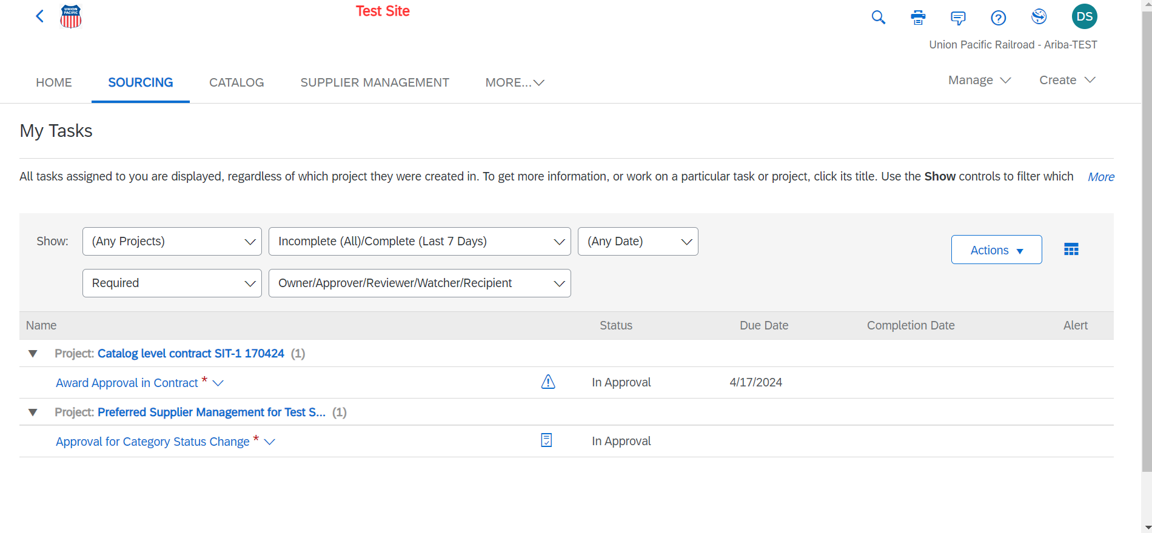

- Saving search filters: Once you are in your task tab locate the search bar below the main tabs at the top of your screen. On the far right side of the search bar you will see an arrow that will show a drop down menu once selected. Within this dropdown menu select the search type you would like view.

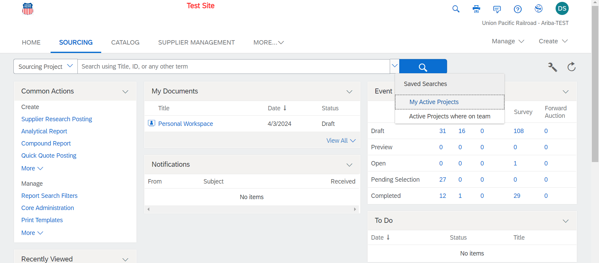

Once on the search page locate the “Search Filter” section. Here you can enter a search you would like to save. Once the text you want to search select the “search” button to generate a search. Once you have your search complete you can the click the “Save Search” button. If you want to add additional filters into your search select the “+” icon to the right of the search bar.
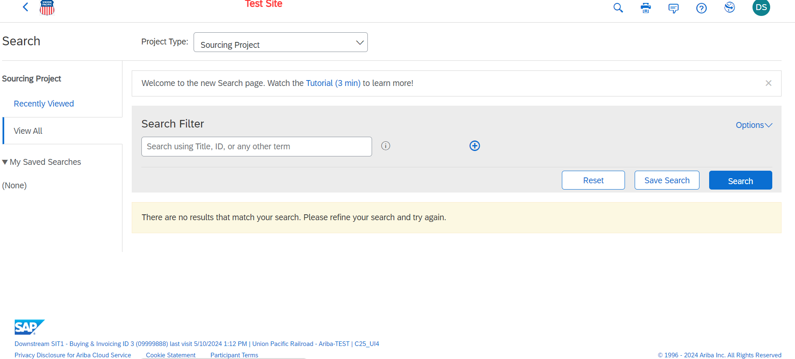

If you want to add additional filters to your search there will be a list of tags and a text field that populates once the “+” icon is selected. You can continue to add more filters if needed or remove any filters if needed by selecting the “+” or “-“ icons located directly to the right of the text box for filters. Once you have all the search IDs entered then select “Search” button and then “Save Search” to save your search.

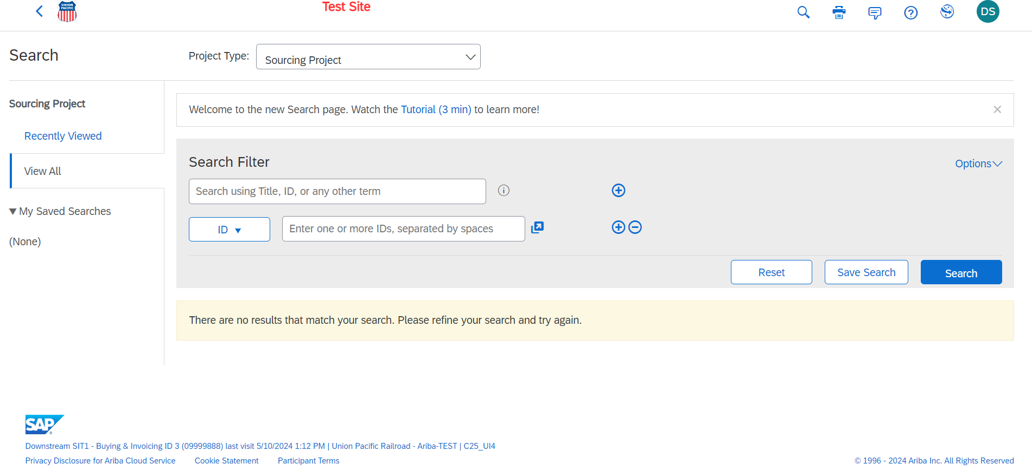

There are a number of search tags that can be used in your saved search by clicking on the dropdown field to the left of the text field.

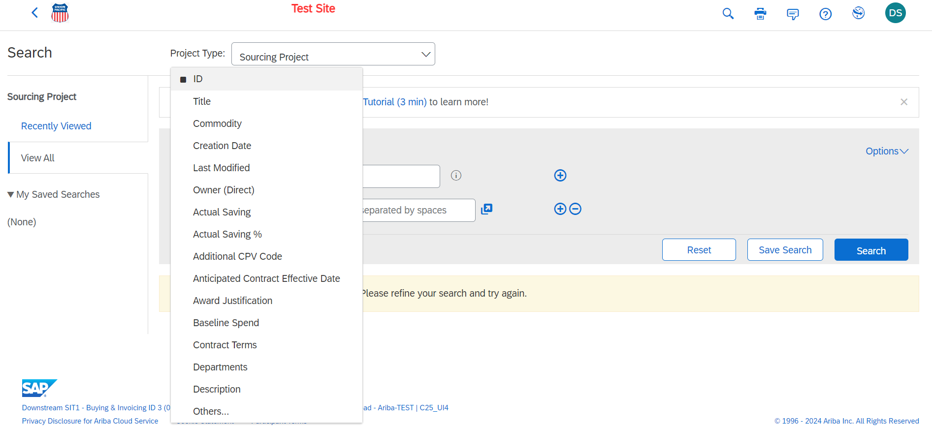

How To Log In To Icertis
- Open Icertis by entering Icertis into your browser and log in with your SSO (Single Sign On) credentials.

Basic Navigation for Icertis
- The tiles menu is a collapsible unit, allowing you more visual space when required. Click the arrow to hide (or show) the main menu.

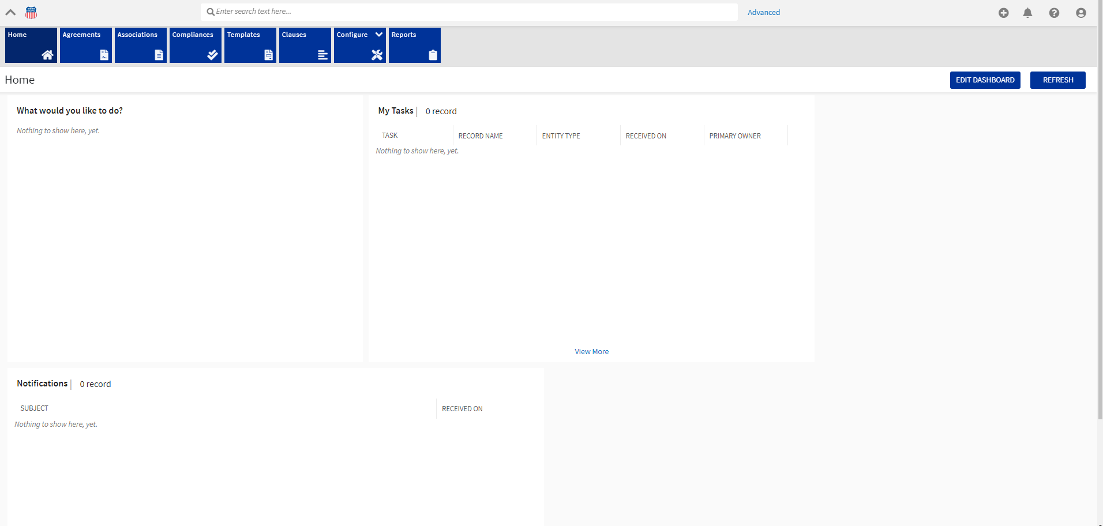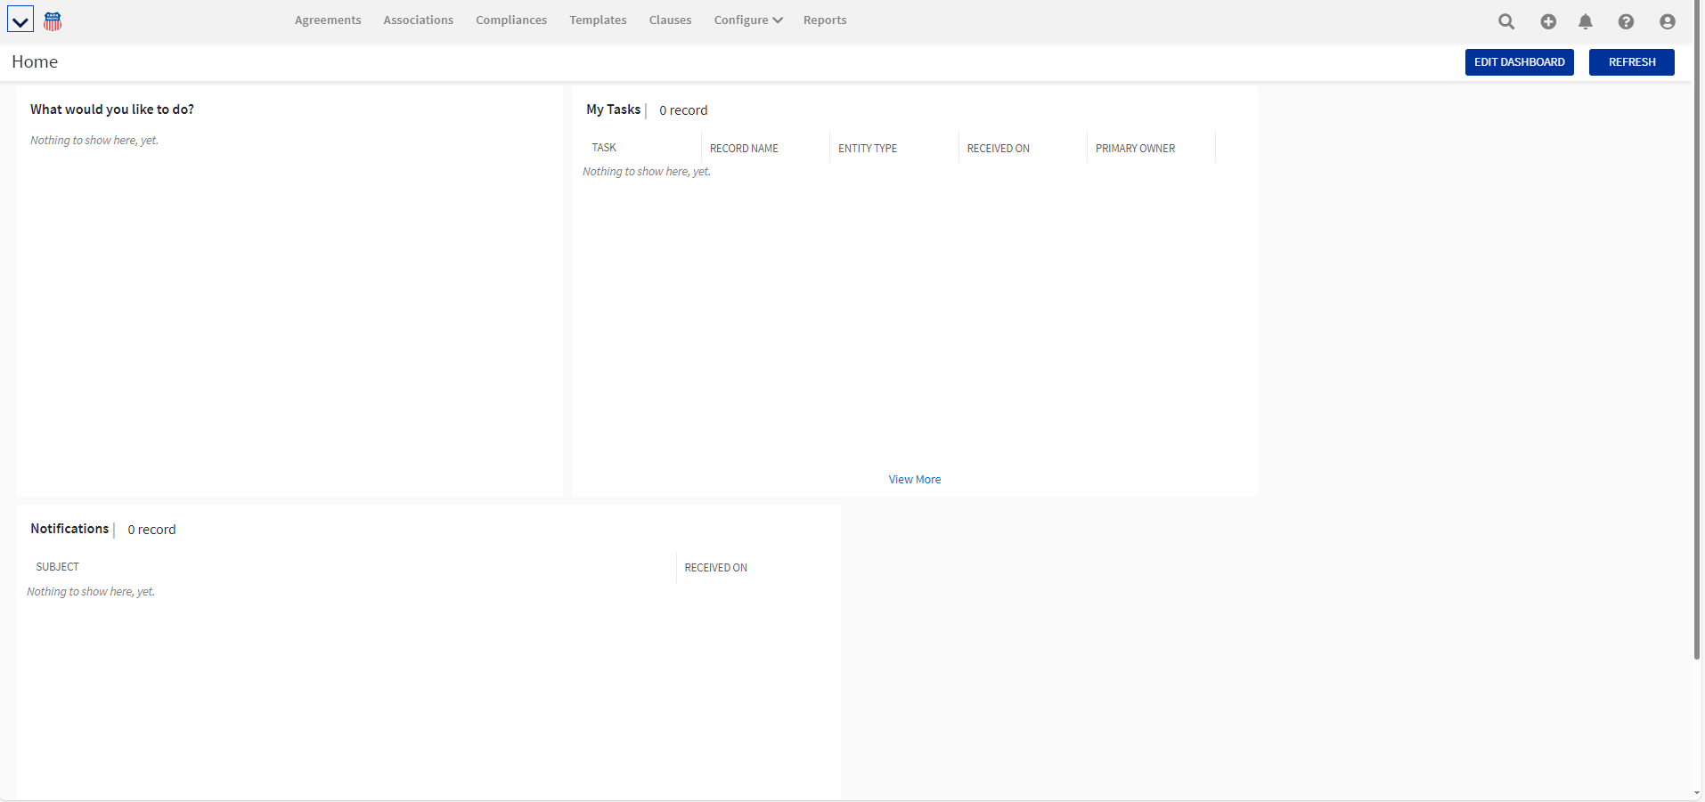

- The search bar is displayed when the main menu is set to Show Menu.

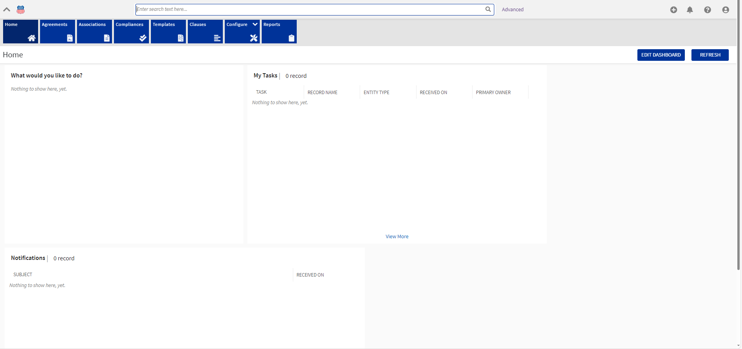

When the main menu is collapsed, only a search icon is displayed alongside the other top-right menu options. Clicking this search icon displays the search bar.

Here, you can enter a search term and press enter or click the search icon to view the context of the specific term entered. Just about anything word based can be entered here, including document terms and UP terms.

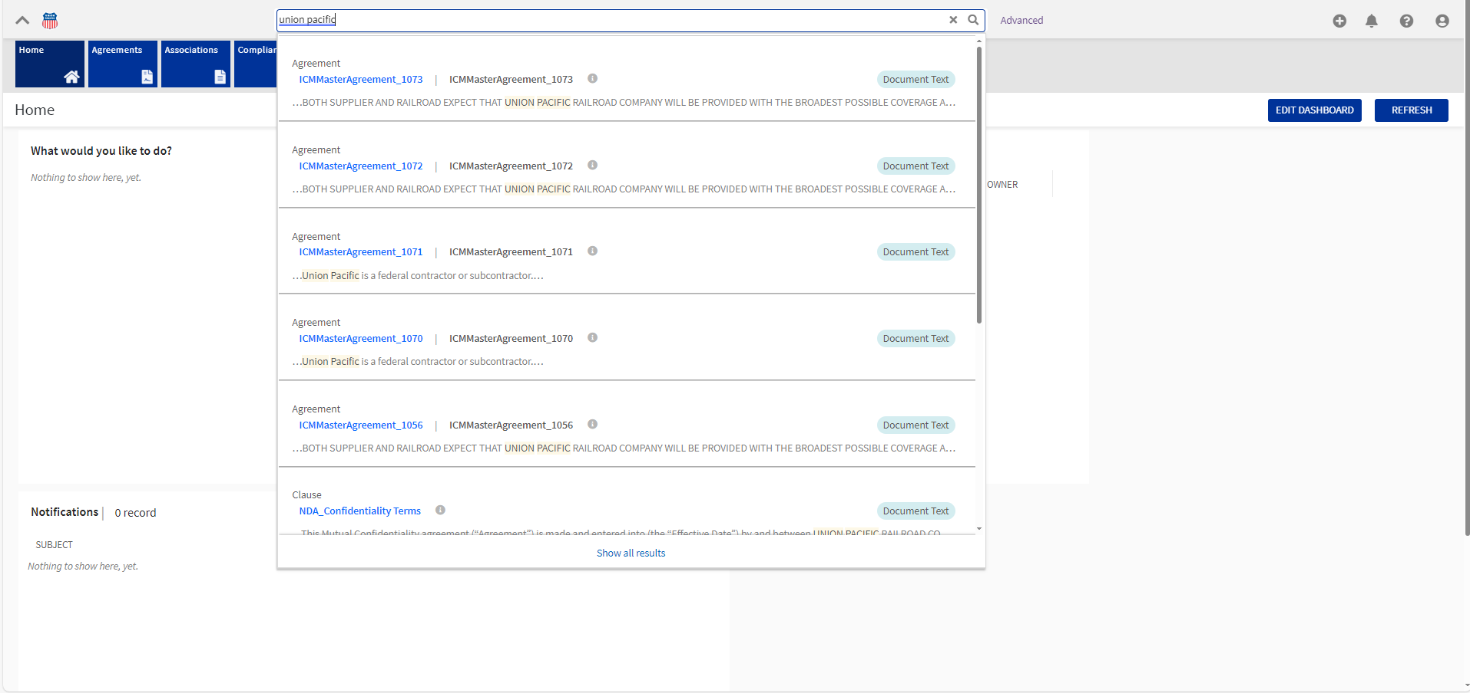
Thi
- Top-right menu icons

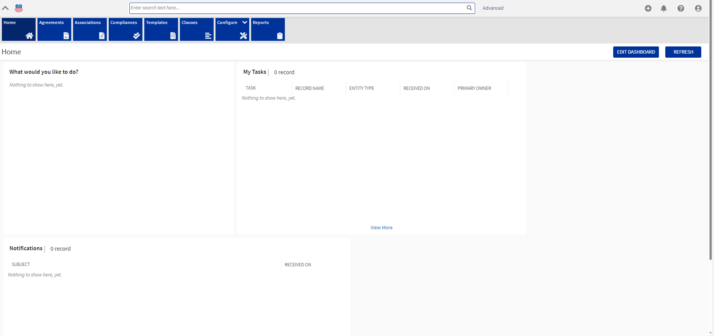
: The Create icon on the Icertis Home page gives you quick access to create all kinds of entities such as agreements, associations, clauses, templates, and rules. Administrators can also add reason, currencies, and even provision users from this menu.
: The Notifications icon with a red dot signifies unread messages, and clicking the icon directs you to the Notifications dashboard.
: The Activity icon indicates the Activity Panel, which opens a drawer and can be refreshed to reflect the latest activities.
: Clicking the Help icon opens the product help link in a new tab.
: Clicking the User Settings icon opens a drawer menu for users to update their preferences such as theme color and time-zone

Customized Settings & Personalization of Icertis
- Personalizing the Icertis Dashboard: Once logged in, go to your dashboard. You can add, remove, and rearrange elements to suit your workflow preferences.

Once you select “Edit Dashboard” you have the ability to “Add Widgets”, “Auto Arrange”, “Save” changes or “Cancel” your customized dashboard. Widget is a general term Icertis uses in reference to the various dashboard sections you can add. Selecting “Auto Arrange” will automatically align all Widgets (sections) if the Widgets are out of alignment once manually moved.
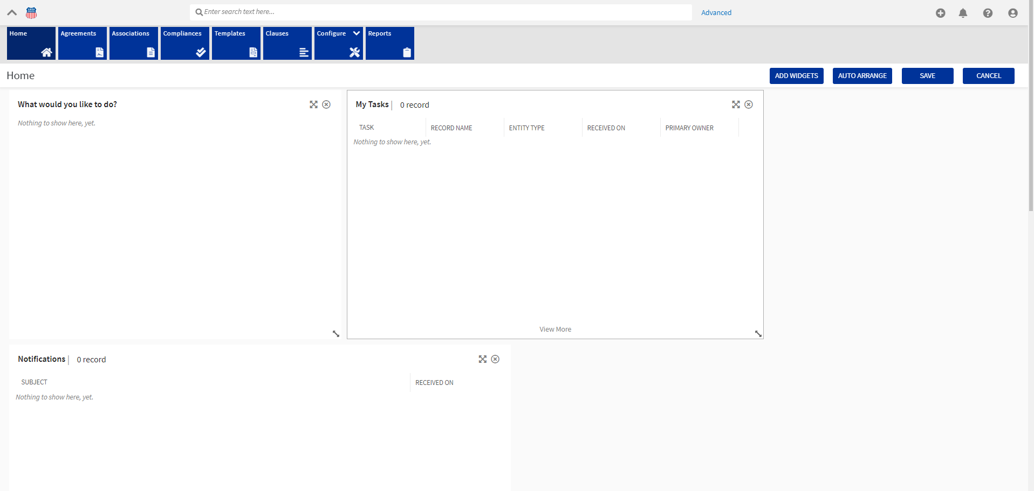

- Adding a Widget: Once the “Add Widget” button is selected you will see a list of items to select from to add to your dashboard. You can also search Widgets using the search bar located in the “Add Widgets” selection screen or scroll to find the Widget you are looking for.

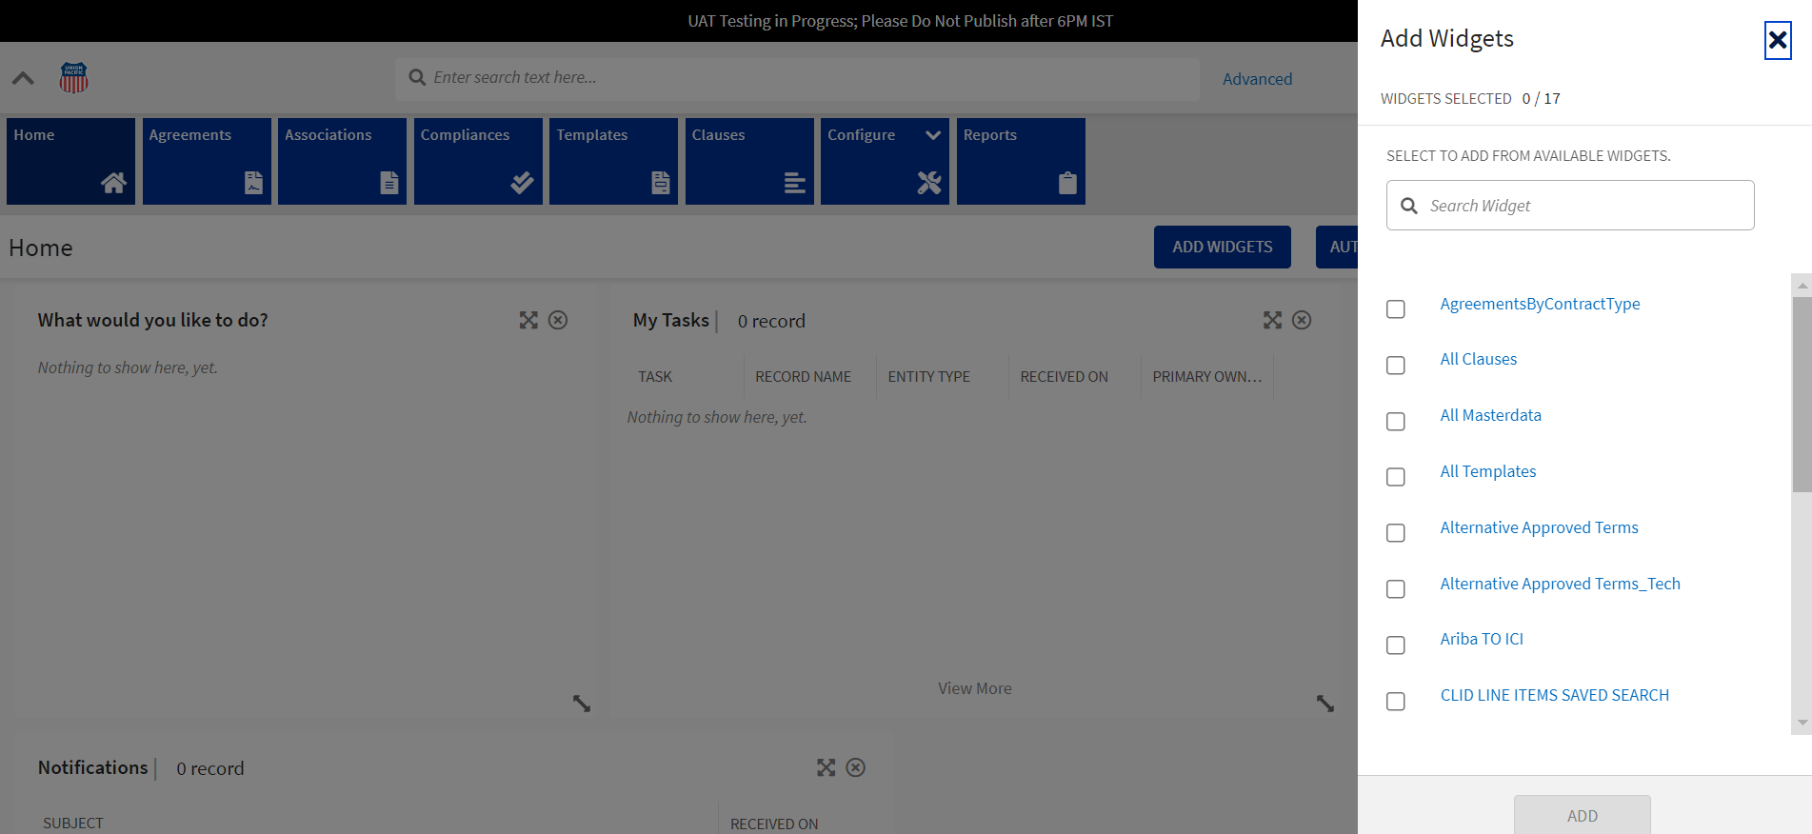

- Adjusting dashboard (widget) items: To reposition a Widget (section) select the ( 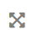) icon. The () icon allows you to move the entire Widget (section) anywhere you want on the page. If you would like to make one section bigger or smaller select the (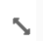) icon to resize the Widget (section). If you would like to remove a section all together select the () icon.

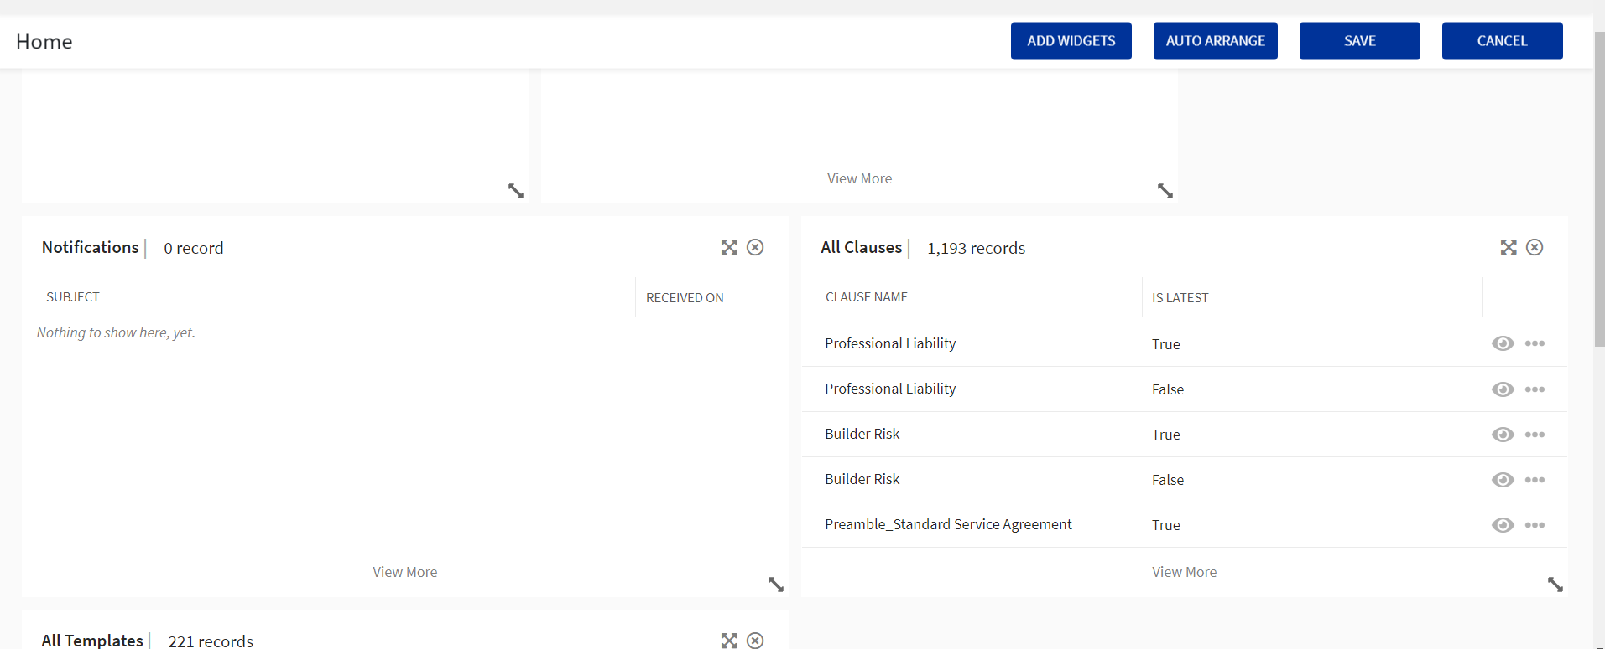

- Adjusting Contract Views and Notifications: Adjust your contract views under your user icon.

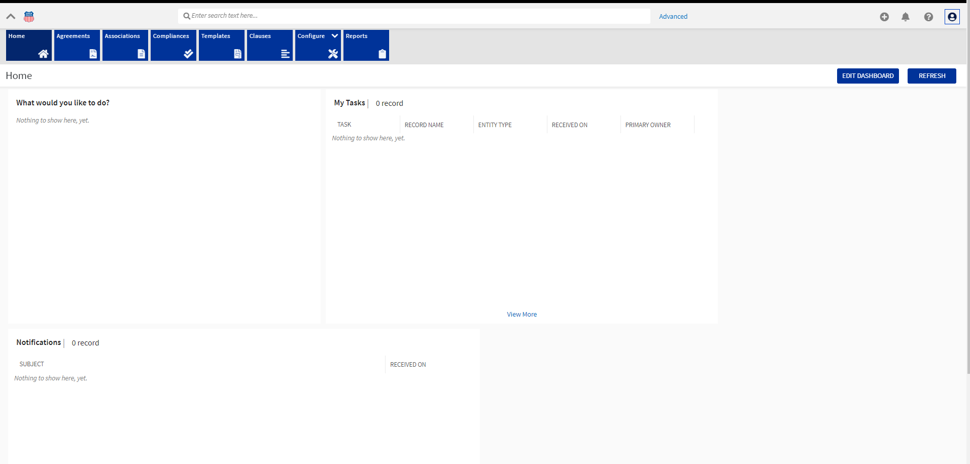

Next select “Preferences”

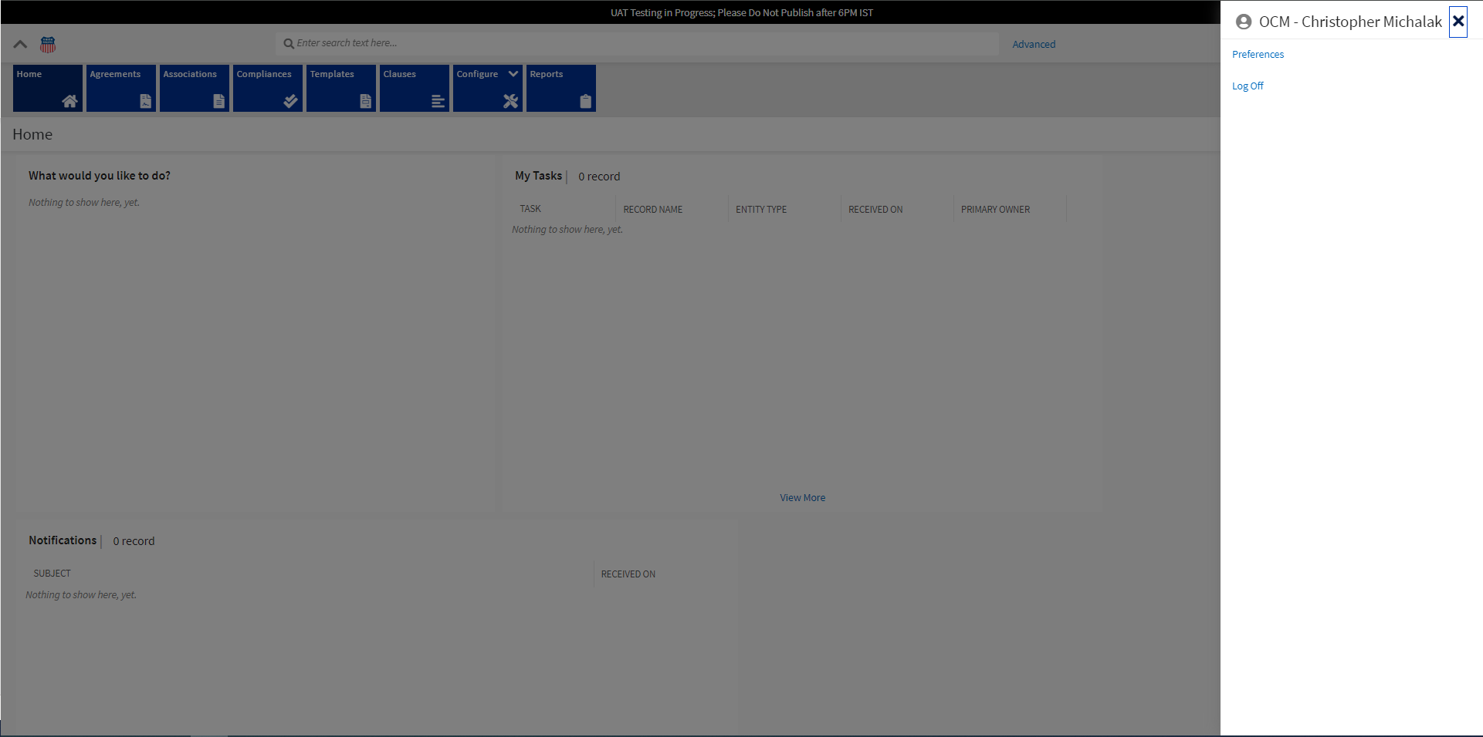

Here you can select your layout preferences, how many records per page, menu view as well as themes. Make your desired changes and click “Save”.

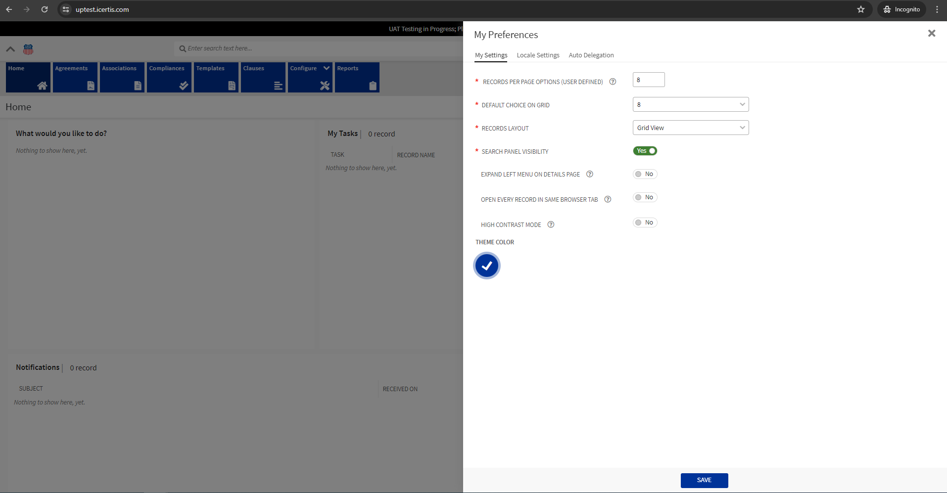

- Filter Notification Views: Select the bell icon in the top left of the screen. Once the notification window has opened on the left side of the screen select the notification type that you are interested in and how many days worth of messages you would like to view.

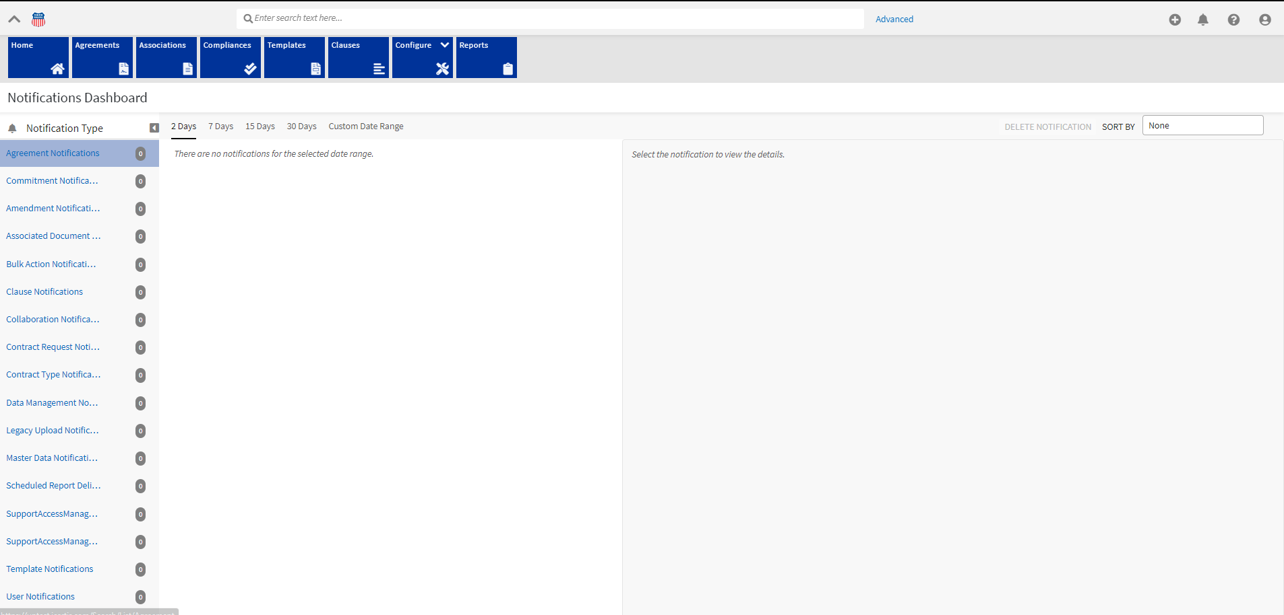

Glossary

System | Glossary
- Ariba | SAP Ariba Glossary | SAP Help Portal
- Icertis | Glossary - ICIHelp8.2 (icertis.com)
- S4 | Terms and Glossary | SAP Help Portal
- MDG | SAP Master Data Governance | SAP Help Portal
- Tasks Notifications | E-mail notices sent according to the type of task and the configuration of the task notifications. There's a default notification profile that sends a notice when the task is ready to start, another when the task is overdue (if a due date is provided) and when the task is complete. A custom notification profile can be configured for use with tasks.
- Bid Notifications | Notices that are sent to buyers or suppliers when specific actions occur to bids during an event. For example, bid submitted, bid deleted, bid collision, or a bid triggers overtime
- Message Board | A collection of messages for a workspace or event. Users can create topics (messages), add replies to messages, and label messages for filtering.

Additional Resources for Ariba
For additional help on any topic that is not covered in the reference guide please utilize the “Help Center” built into the Ariba platform.

- While in Ariba locate the “Help Center” under the “?” icon found in the top right navigation bar.

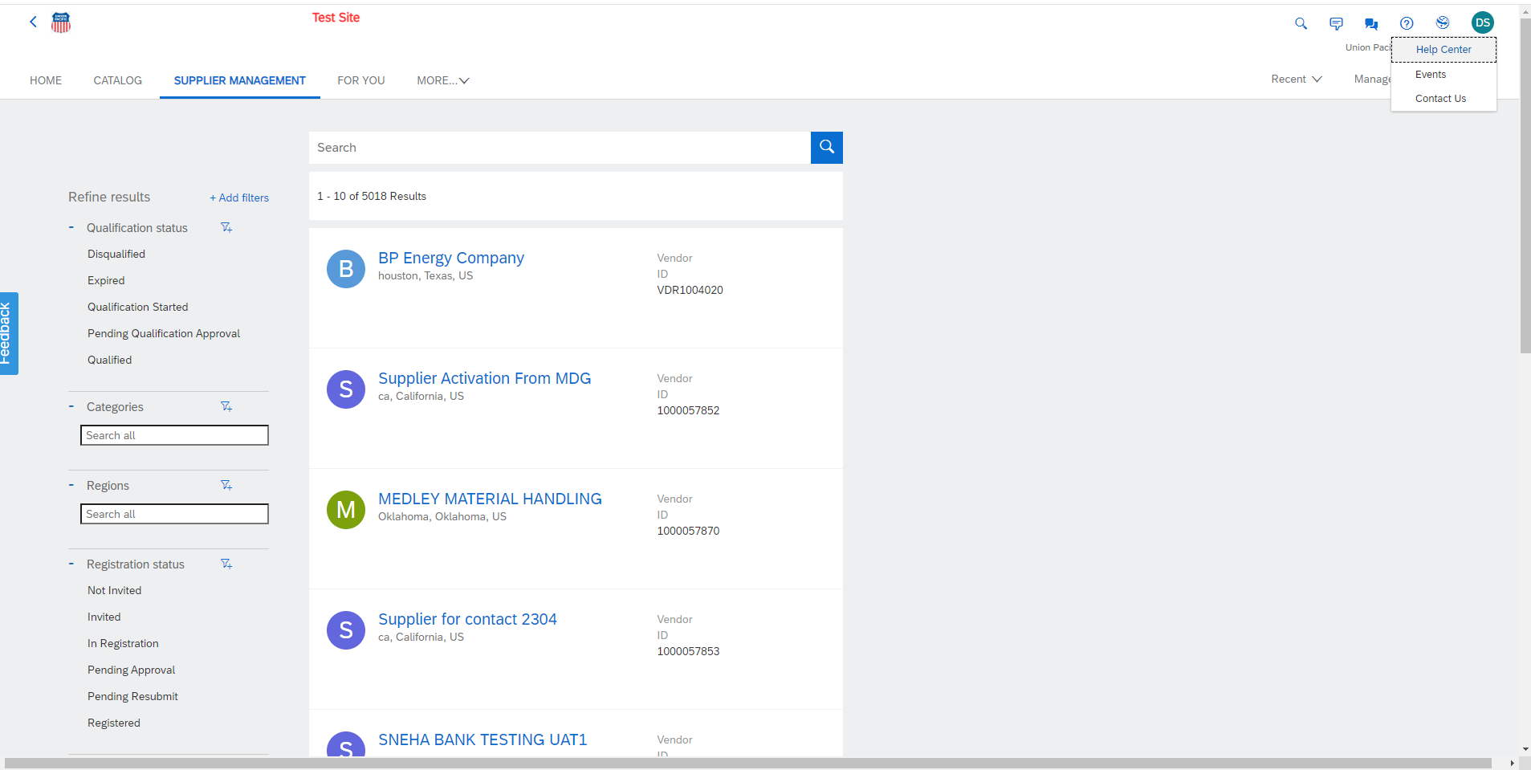

- Within “Help Center Home” you will find a search bar to help guide you towards answers for any additional questions you might have.

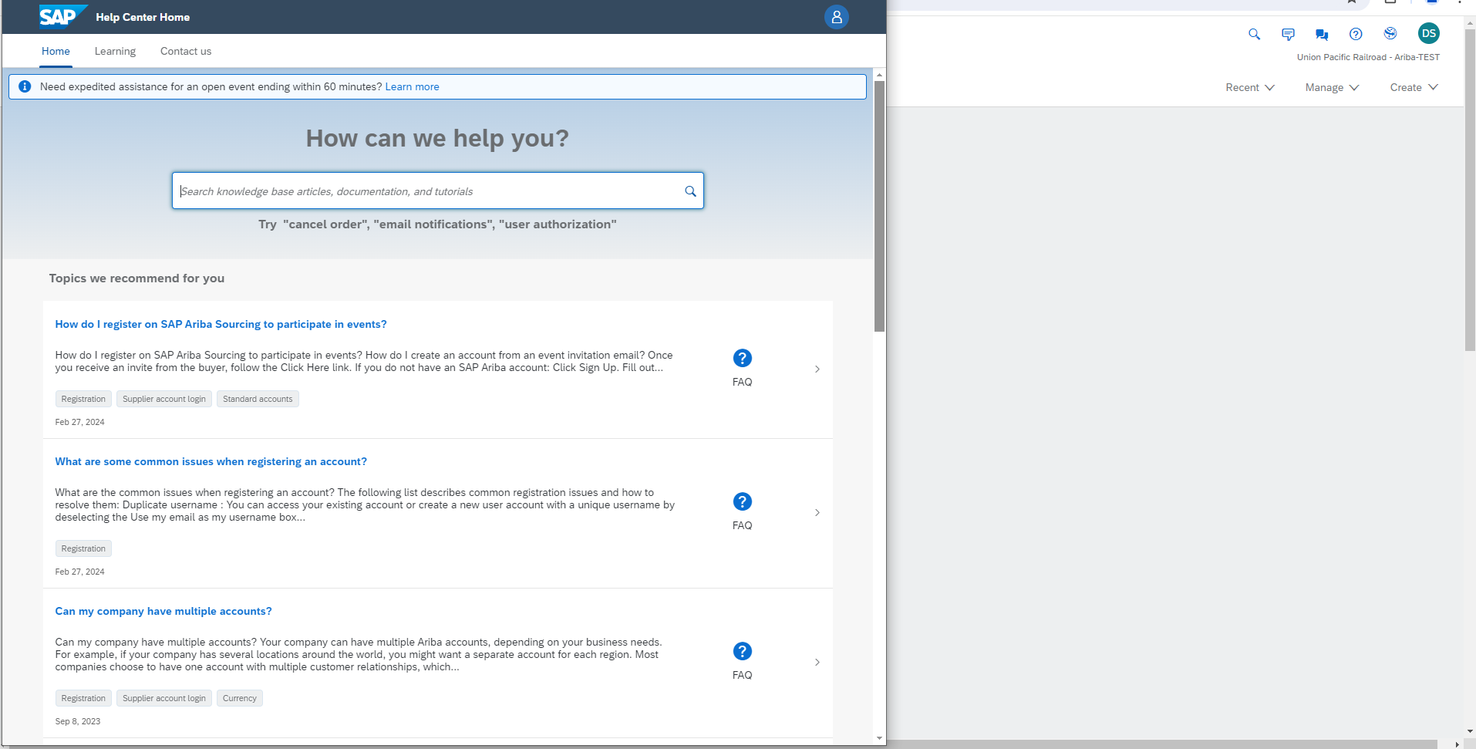

- To get more in depth training or to discover training by category select the “Learning” section within “Help Center Home”.

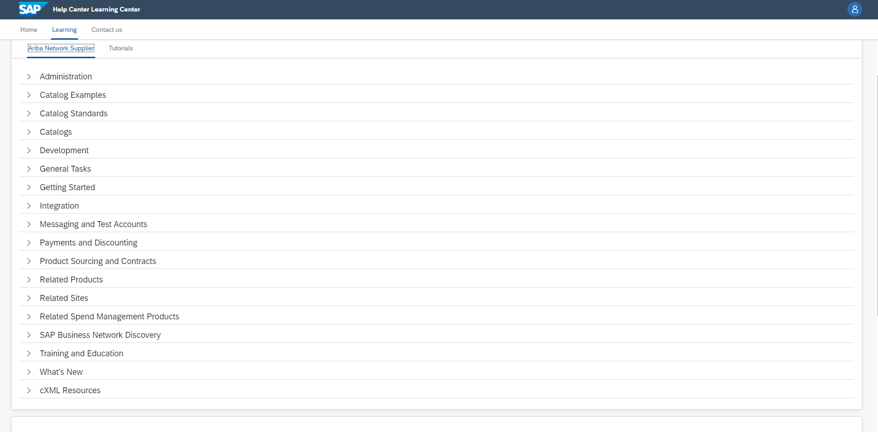

Additional Resources for Icertis
- Select the “?” icon for additional resources on any questions you have that were not covered in this document.
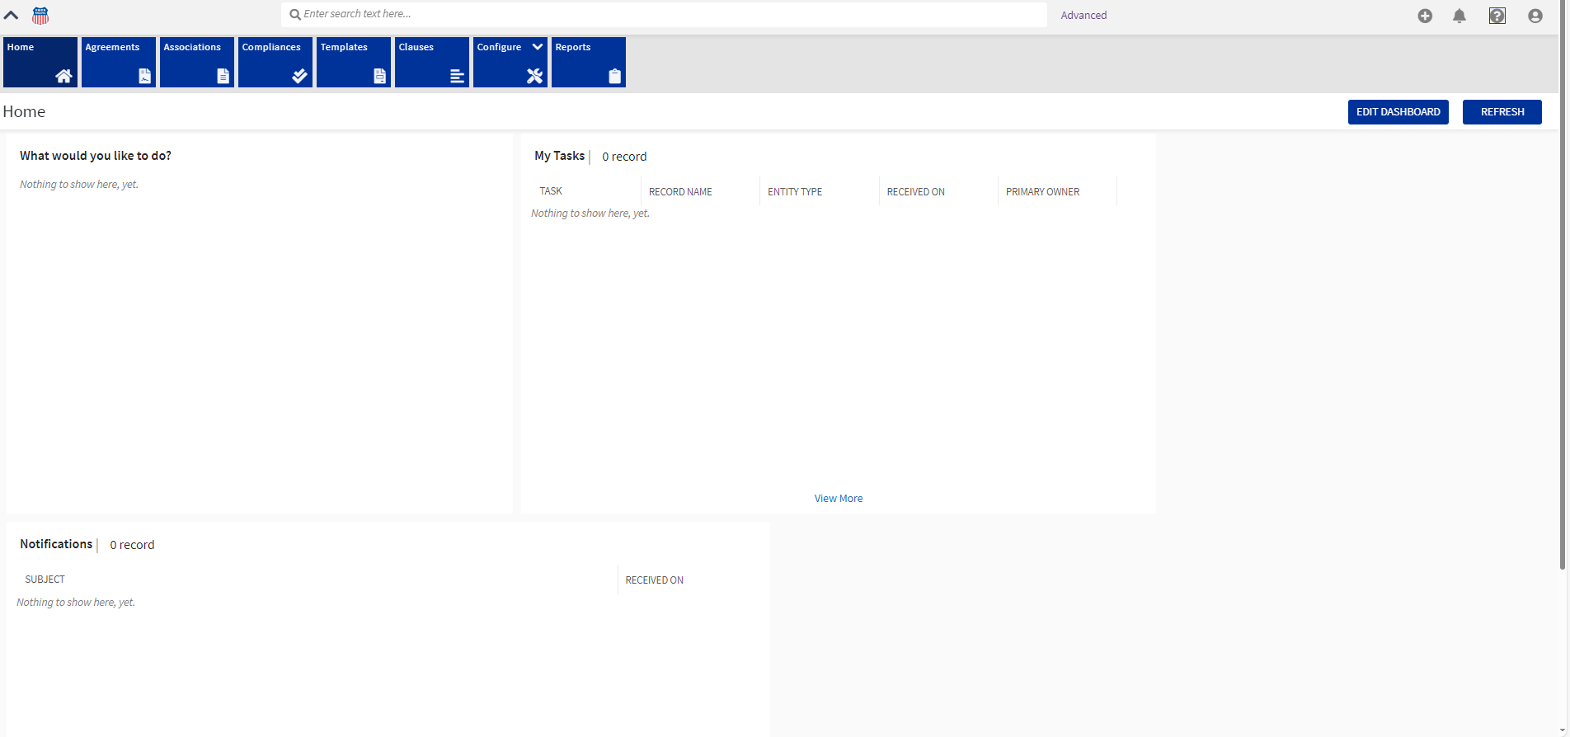

- Next an Icertis help web page will load with resources to help with any additional questions you might have. There is a search bar for specific questions with help on customization, navigation, preferences and search filters.

