Review of Water Thresholds - Gnangara

Christopher Kavazos, Grant Buller, Pierre Horwitz, Ray Froend

September 18 2019

# Executive Summary

[SUMMARY TABLE OF OUTCOMES]

# Introduction

This report details an analysis that reviews the ecological impacts of revised proposed water level thresholds for wetlands in the Gnangara mound.

Full analysis can be found at (<https://github.com/ChrisKav/DWER-Thresholds-2019>)

[OUTLINE OF REPORT STRUCTURE]

[TABLE OF WETLANDS <- THE DUNE COMPLEX THEY BELONG TO, WHETHER VEG/INVERT MONITORING, COORDINATES ]

# Methods

## Vegetation monitoring

## Aquatic invertebrate monitoring

## Statistical analyses and monitoring

## Managerial obligation assessment

# General observations

# Individual wetland descriptions

## Melaleuca Park 173

Melaleuca Park 173 (EPP 173) is located within the Bassendean North Vegetation Complex and represents a regionally significant wetland (HILL 1996). Normally, the site represents a permanently filled lake that is fed from a series of springs along the western margin of the basin [Invert REPORT & FROEND ref]. The waters supported a rich macro invertebrate community and an endemic population of the black-striped minnow (*Galaxiella nigrostriata*). There have been dramatic decreases in surface and groundwater levels in recent decades, to the point where the lake is almost dry during the summer months. Declining water levels are thought to be attributed to the local extinction of the black-striped minnow and degradation of fringing vegetation.

### Hydrology

There has been a prolonged decline in surface water levels since 1990 that show similar trends with fluctuations in ground water levels (Figure ). Surface water level measurements are now unreliable at staff 6162628 due to water levels usually being below the minimum level of the staff. Since 2011, there has been a slight but non-significant increase in groundwater levels. Mean maximum and minimum water levels have decreased by 0.8 m and 0.5 m, respectively, since 1994 (Table ). The latest 5 year period (2014-2019) suggests that ground waters are reaching annual minimums earlier in the year than in previous seasons.

### Vegetation dynamics

Vegetation monitoring has been occurring at Melaleuca Park from 1997 to 2018. There has been marked changes in vegetation composition along the transect during this monitoring period (Figure ). In 2014, *Baumea articulata* was absent from the transect, however, due to a wet season which saw Plot A and B submerged in 2018, *B. articulata* was recorded in low abundance. Similar changes have been observed for *Astartea scoparia*, which prior to 2018 was recorded wither dead or in poor condition. Since 2018, many of the *A. scoparia* plants were observed with new shoots. Other important vegetation components in Plot A include *Lepidosperma longitudinale* and *Leptocarpus scariosus*, both of which are also present in Plot B, whilst the former is present throughout the transect.

The long-term decline in water levels has had an adverse effect on the health of the *Melaleuca preissiana* population. Generally, this important canopy forming species has been declining in health, despite slight increases in plant health for 2018. The slight increase in *M. preissiana* health can be attributed to the recent stabilisation of ground water in levels.

Ordination reveals distinct shifts in community composition since 1997 (Figure ). Although Plot A is distinct, in terms of vegetation cover abundances, to Plots B, C and D, all plots display an upwards trajectory along the second axis (LV2). For Plot A, this the shift in composition is likely due to the loss of *B. articulata* from the plot. Modeling compositional changes in vegetation with changes in groundwater levels suggests a number of species which are likely to increase in cover abundance with declining ground water levels (Figure ). These species, such as *Xanthorrhoea preissii*, are likely to become abundant in Plot A under a scenario of continuing declining ground water levels.

### Aquatic Invertebrates

### Revised water level threshold effects

COMMENT ON REVISED WATER THRESHOLDS HERE> WHAT ARE THE PREDICTIONS> HOW WILL IT IMPACT VEG AND INVERTS. OTHER IMPACTS. MANAGMENT OBJECTIVES?

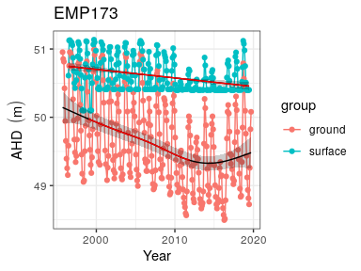

Ground and surface water levels for Melaleuca Park 173 recorded at bore 61613213 (red) and staff 6162628 (blue). The minimum recordable water level for the staff gaugue is 50.4 mAHD. Blue dots at 50.4 mAHD represent water levels below the minimum level measurable by the staff. Red segments on fitted line represent statistically significant periods of declining water levels.

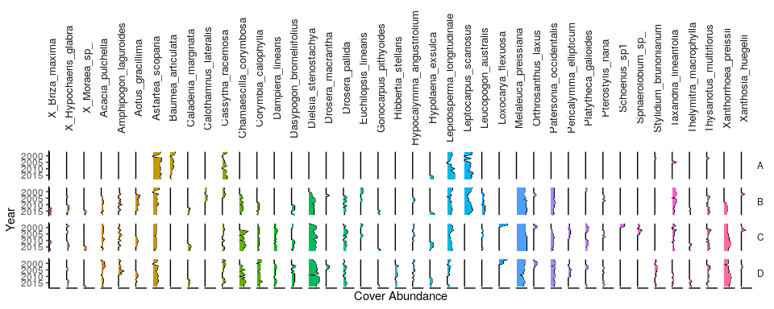

Cover abundances for each species across the four plots (A, B, C, D) at the Melaleuca Park 173 transect recorded for the survey period. Invasive species are denoted by ‘X’. Only the most common species are included.

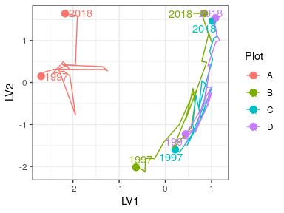

Unconstrained ordination based on the latent variable model for each surveyed year for Melaleuca Park 173. Plots are represented as different colours and consecutive years are joined by a line with first and last survey years labeled.

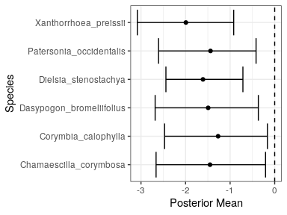

Estimated mean regression coefficients (dots) and 95% credible intervals (bars) for effect of ground water levels at Melaleuca Park 173 on vegetation species cover abundances based on Bayesian Regression Analysis (HUI REF 2015). Species with a negative mean posterior value are likely to increase in cover abundance as water levels decline. Only those species with coefficients significanlty different to zero are shown.

Ecological consequences of revised thresholds in terms of compliance of stated site values and site management objectives at Melaleuca Park 173.

|  |  |  |
| --- | --- | --- |
|  | Likely effect of 2030 revised thresholds | Future Compliance |
| **Site values** |  |  |
| * Unique hydrology |  |  |
| * High vertebrate and macro invertebrate species richness |  |  |
| * Contains most northern population of black stripe minnow (*Galaxiella nigrostriata*) |  |  |
| **Site management objectives** |  |  |
| * Maintain wildlife and landscape values of the wetlands |  |  |
| * Maintain the existing areas of wetland and stream vegetation they support |  |  |
| * To protect invertebrate communities dependent on the wetland and stream |  | No |
| * To protect the fish species, *Galaxiella nigrostriata* |  | No |

## Melaleuca Park 78

Melaleuca Park 78 (also referred to as EPP 78 or Dampland 78) is located north-west of the Lexia wetlands in the southern area of Melaleuca Park. The site is approximately 6.7 ha in area and represents a regionally significant wetland (HILL 1996). Melaleuca Park 78 is classified as a Dampland habitat, meaning the basin has seasonally waterlogged soils that are not often inundated with surface waters [See Semeniuk & Semeniuk - The Geomorphic Classification of Wetlands in Hill et al 1996]. The site is an important habitat for a unique assemblage of phreatophytic vegetation which provides important habitat for native populations of fauna.

### Hydrology

Water levels at the site have been declining since the beginning of monitoring in 1999 until 2014, although absolute minimum levels were recorded in 2016. Bore 61613231 indicates that ground waters in the dampland may have declined by about 1.3 m since 1999, although there has been a recent increase in ground water levels since 2016 due to increased rainfall (Figure ). Current 5 year mean maximum and minimum ground water levels in the bore are about 1 m lower than when monitoring began in 1999, with peak levels occurring in October/November and minimums occurring between April-May (Table ).

### Vegetation dynamics

The vegetation transect has been monitored at Melaleuca Park 78 since 1997 and was last surveyed in 2018 (Figure ). The site is largely dominated by native species that include a dense understorey of *Beaufortia elegans*, *Pultenea reticulata* and *Kunzea glabrescens*. The overstorey is largely composed of *Melaleuca preissiana* throughout the transect and *Banksia attenuata*, *Banksia ilicifolia* and *Banksia menziesii* in the higher parts of the basin. In 2006, the transect was heavily affected by a fire but the vegetation has since made some recovery. *Baumea articulata* disappeared from the transect during this period. A number of tree deaths were reported following the fire but there is evidence of recovery, particularly for low-lying stands of *M. preissiana*. Trajectories of compositional change provide further evidence for post-fire recovery as recent plot assemblages are becoming more similar to those recorded before the fire (Figure ).

Bayesian regression modelling revealed a number of species associated with low ground water levels (Figure ). In particular, some natives, including *B. attenuata*, *Hibbertia subvaginata* and *M. preissiana*, are likely to increase in cover abundance under a scenario of further decreasing ground waters. The cover abundance of exotics, including *Aira caryophyllea*, *Briza maxima*, *Ehrharta calycina*, *Hypochaeris glabra*, *Poa annua*, *Sonchus oleraceus* and *Ursinia anthemoides*, are also likely to increase in cover abundance withd declining ground waters. It is also likely that the richness of exotic species will increase with ground water decline as the site is invaded by exotics not currently recorded at the site.

### Aquatic invertebrates

### Revised water level threshold effects

Melaleuca Park 78 has been non-compliant with absolute minimum water level criteria since 2012.

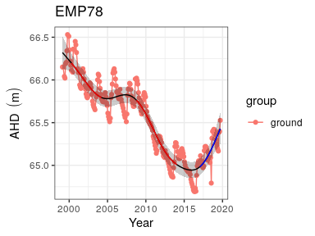

Ground water levels recorded at bore 61613231 in the vicinity of the Melaleuca Park 78 wetland. Red segments on fitted line represent statistically significant periods of decline and blue represent statistically significant periods of increasing water levels.

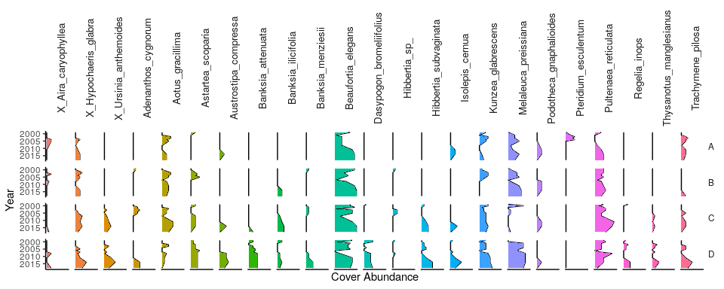

Cover abundances for each species across the four plots (A, B, C, D) at the Melaleuca Park 78 transect. Invasive species are denoted by ‘X’. Only the most common species are included.

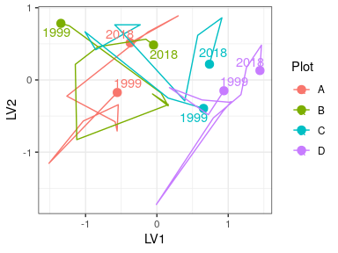

Unconstrained ordination based on the latent variable model for each surveyed year for Melaleuca Park 78. Plots are represented as different colours and consecutive years are joined by a line with first and last survey years labeled.

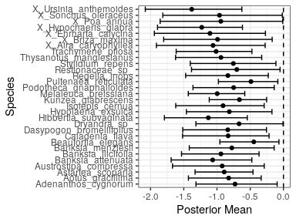

Estimated mean regression coefficients (dots) and 95% credible intervals (bars) for effect of ground water levels at Melaleuca Park 78 on vegetation species cover abundances based on Bayesian Regression Analysis (HUI REF 2015). Species with a negative mean posterior value are likely to increase in cover abundance as water levels decline. Only those species with coefficients significanlty different to zero are shown.

Ecological consequences of revised thresholds in terms of compliance of stated site values and site management objectives at Melaleuca Park 78.

|  |  |  |
| --- | --- | --- |
|  | Likely effect of 2030 revised thresholds | Future Compliance |
| **Site values** |  |  |
| * Supports wetland vegetation |  |  |
| **Site management objectives** |  |  |
| * Maintain wildlife and landscape values of the wetlands |  |  |
| * Maintain the existing areas of wetlands and wetland vegetation |  |  |

## Gingin Brook

Gingin Brook is a new proposed in the Gingin water allocation plan (draft expected 2023). There is currently no baseline vegetation data for the site. [WHAT IS THIS SITE? A DAMPLAND< SUPALND LAKE ETC? THERE MUST BE SOME MORE INFORMATION I CAN INCLUDE]

### Hydrology

Ground waters at this site have significantly declined during the period between 1989 and 2015 by approximately 2.5 m (Figure ). Mean seasonal maximum and minimum ground water levels have also decreased by 1.8 since 1994, with current monthly minimums generally occurring earlier in the year than in between 1994 and 1999 (Table ).

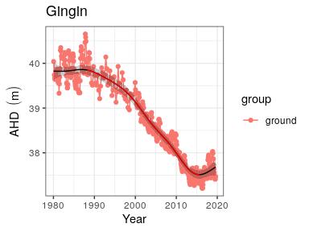

Ground water levels recorded at bore 61710078 that represent fluctuations in ground waters at Gingin Brook. Red segments on fitted line represent statistically significant periods of declining ground water levels.

## Lake Goollelal

Lake Goollelal, located within the Yellagonga Regional Park, is recognised as an important waterbird habitat and drought refuge (FROEND 2006) as well as habitat for the Swan River Goby (*Pseudogobius olorum*) and the Western Pygmy Perch (*Edelia vittata*) (WAWA 1995). The permanent deep waters found in the lake not only provides significant habitat for fauna and fringing vegetation, but also hold significant value as a place of public enjoyment. [COMMENT ON SURROUNDING URBANISATION?]

### Hydrology

Surface water levels recorded at Lake Goollelal reveal peak levels generally occur between September and November and lowest water levels between March and May (Table ). There has been a consistent range of about 0.7 m in annual water level during this period. There has been a general trend of decreasing surface water levels since 1995, although recent increases since 2016 show surface waters at a similar depth to 1990 levels. Surface water levels show similar trends to groundwater levels at a nearby bore (61611870) as the lake is largely fed by groundwater (Figure ). Although the preferred minimum threshold of 26.2 mAHD has not been breached, it is likely the threshold is set too low as acidification of waters in the lake is a concern (Quintero Vasquez 2018).

### Vegetation dynamics

The composition of vegetation at Lake Goollelal has been assessed 14 times between 1997 and 2014 at four plots along an established transect [I NEED TO READ THE 2014 VEG REPORT]. Plot A represents fringing *Melaleuca rhaphiophylla*/*Eucalyptus rudis* vegetation and a stable community of the native sedges, *Baumea articulata* and *Lepidosperma gladiatum*. The *M. rhaphiophylla*/*E. rudis* complex continues throughout the transect, which has also remained relatively stable in terms of cover abundance since 2002. There is a high richness of exotic vegetation species present at the lake. Generally, these exotic species have increased in abundance during the survey period (Figure ).

Ordination reveals that Plot A has a distinct assemblage to the other plots but has displayed similar shifts in vegetation composition during the monitoring period (Figure ). All plots show an initial shift in community cover abundance from the 1997 survey and a return to 1997-like composition in the recent survey years. Plot D displays a different pattern, probably due to the record of *B. articulata* in 1997 [SHOULD CONFIRM THIS WITH GRANT] and the high cover abundance of exotic species. Bayesian regression analysis predicts many species to increase in cover abundance with declining surface water levels, while *B. articulata* is predicted to decrease significantly in cover abundance (Figure ). Native species thought to increase in cover abundance with declining surface water levels include *Pennisetum clandestinum*, and *Microtis media*, while cover abundance of *M. rhaphiophylla* and *E. rudis* will likely remain stable or only increase slightly. Many exotic species are likely to increases in cover abundance under a scenario of declining surface waters, including *Briza maxima*, *Fumaria capreolata*, *Setaria palmifolia* and *Sparaxis bulbifera*.

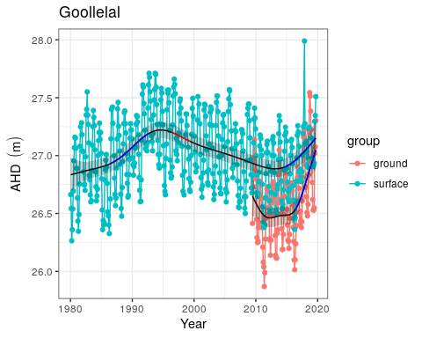

Ground and surface water levels recorded at bore 61611870 (red) and staff 6162517 (blue) for Lake Goollelal. Red segments on fitted line represent statistically significant periods of declining water levels and blue segments represent statistically significant periods of increasing water levels.

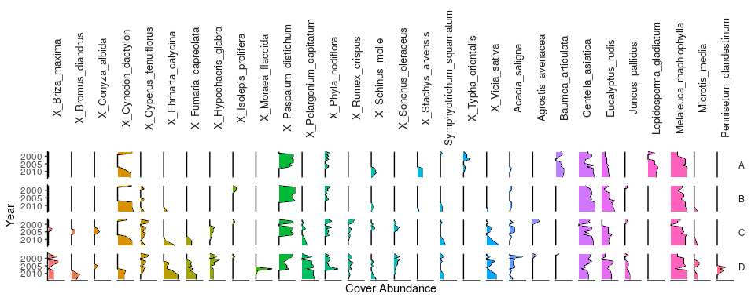

Cover abundances for each species across the four plots (A, B, C, D) at the Lake Goollelal transect. Invasive species are denoted by ‘X’. Only the most common species are included.

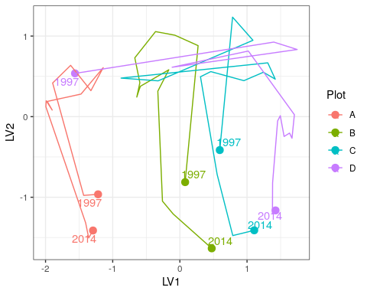

Unconstrained ordination based on the latent variable model for each surveyed year for Lake Goollelal. Plots are represented as different colours and consecutive years are joined by a line with first and last survey years labeled.

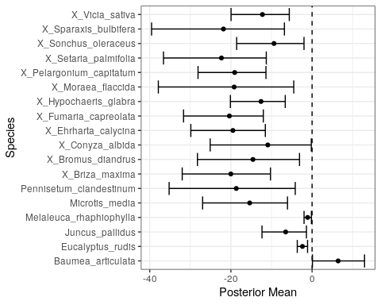

Estimated mean regression coefficients (dots) and 95% credible intervals (bars) for effect of ground water levels at Melaleuca Park 78 on vegetation species cover abundances based on Bayesian Regression Analysis (HUI REF 2015). Species with a negative mean posterior value are likely to increase in cover abundance as water levels decline while species with positive posterior values are likely to increase in cover abundance with increasing water levels. Only those species with coefficients significanlty different to zero are shown.

### Aquatic invertebrates

### Revised water level threshold effects

Ecological consequences of revised thresholds in terms of compliance of stated site values and site management objectives at Lake Goollelal.

|  |  |  |
| --- | --- | --- |
|  | Likely effect of 2030 revised thresholds | Future Compliance |
| **Site values** |  |  |
| * Waterbird habitat and drought refuge |  |  |
| * Supports good populations of native fish species, Swan River goby (*Pseudogobius olorum*) and the western pygmy perch (*Edelia vittata*) |  |  |
| **Site management objectives** |  |  |
| * Conservation and public enjoyment of natural and modified landscapes |  |  |
| * Protect and if possible enhance, fringing wetland vegetation including woodland and sedge vegetation |  |  |
| * Maintain permanent, deep water for waterbird habitat and as a drought refuge |  |  |
| * Maintain permanent water for fish and other dependent species |  |  |
| * Maintain the landscape amenity values of the wetland |  |  |

## Lake Gwelup

Lake Gwelup is a shallow groundwater system located in the highly urbanised area of Gwelup/Karrinyup. The lake is permanently inundated and provides important habitat to a variety of fauna and fringing vegetation. The wetland is not currently a Ministerial criteria site.

### Hydrology

Lake water levels were first monitored in 1960, but regular monitoring has occurred between 1967 and 1988, and from 1999 until the present. Lake levels in the 1970s and 1980s were 1m to 2m higher than in the 2000s (Figure ). They have risen again since 2013 following a reduction in nearby public water supply abstraction, and levels are currently similar to levels in the 1980s and 1990’s (Table ). Nearby bore 61610032 has been monitored since 1972. Water levels at the bore have declined by around 4 meters since the start of monitoring. Levels have been reasonably stable since the early 2000s and have trended slightly upwards since 2011.

### Vegetation dynamics

Vegetation monitoring at Lake Gwelup began in 2013 and was last conducted in 2017. The start of the transect was inundated by approximately 0.7 m of surface water during the 2017 survey. The wetland is dominated by exotic species such as *Cynodon dactylon* and *Ehrharta calycina* despite exotic cover abundance declining in the later surveys (Figure ). The overstorey is dominated by the natives *Eucalyptus rudis* and *Maleleuca rhaphiophyla* which is in good health (BULLER REPORT 2017). There was a dramatic shift in community composition between 2014 and 2017 due to inundation of the plots (Figure ). Bayesian regression analysis reveals that a number of exotic species will continue to decrease in cover abundances with the higher water levels (Figure ).

### Revised water level threshold effects

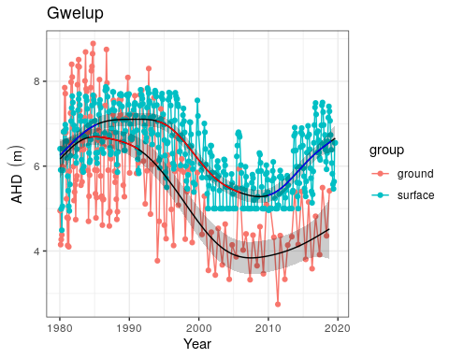

Ground and surface water levels for Lake Gwelup recorded at bore 61610032 (red) and staff 6162504 (blue). The minimum recordable water level for the staff gaugue is 5.0 mAHD. Blue dots at 5.0 mAHD represent water levels below the minimum level measurable by the staff. Red segments on fitted line represent statistically significant periods of decline and blue represent statistically significant periods of increasing water levels.

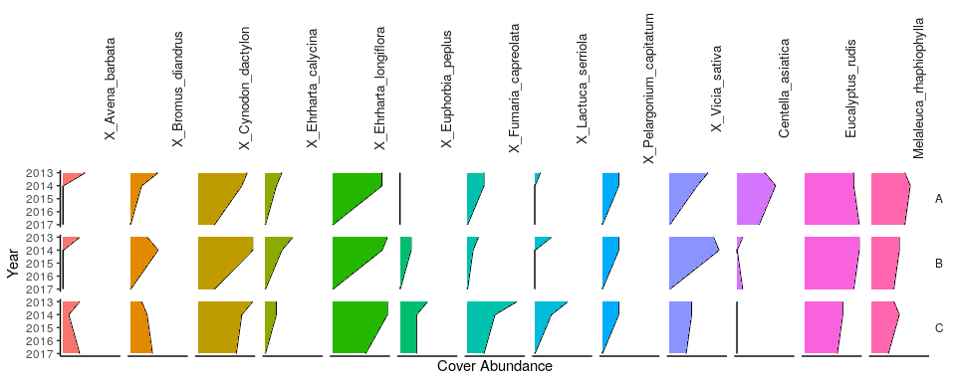

Cover abundances for each species across the four plots (A, B, C, D) at the Lake Gwelup transect. Invasive species are denoted by ‘X’. Only the most common species are included.

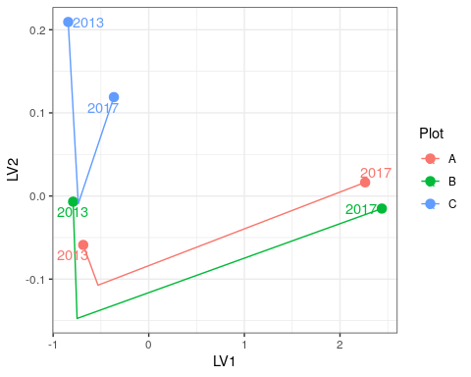

Unconstrained ordination based on the latent variable model for each surveyed year for Lake Gwelup. Plots are represented as different colours and consecutive years are joined by a line with first and last survey years labeled.

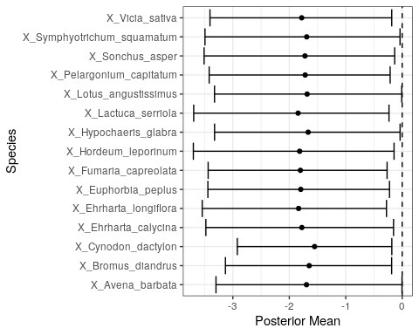

Estimated mean regression coefficients (dots) and 95% credible intervals (bars) for effect of ground water levels at Lake Gwelup on vegetation species cover abundances based on Bayesian Regression Analysis (HUI REF 2015). Species with a negative mean posterior value are likely to increase in cover abundance as water levels decline. Only those species with coefficients significanlty different to zero are shown.

Ecological consequences of revised thresholds in terms of compliance of stated site values and site management objectives for Lake Gwelup.

|  |  |  |
| --- | --- | --- |
|  | Likely effect of 2030 revised thresholds | Future Compliance |
| **Site management objectives** |  |  |
| * To maintain permanent water for fauna habitat and for visual amenity, to maintain fringing vegetation. |  |  |

## Lake Jandabup

Lake Jandabup is an artificially watered wetland that supports the most diverse sedge and macrophyte vegetation communities in the Bassendean Dune wetlands (FROEND 2004). Low rainfall and groundwater abstraction impacts are thought to have caused an acidification event in 1998 and 1999 but restoration of water levels as returned the pH to normal levels (GMEMP 2019). Lake Jandabup has a high conservation value as it is one of the few ‘eastern circular wetlands’ to not be be permanently acidic. The waters usually have low levels of nutrients which and clear waters that supports a diverse aquatic invertebrate community. The abundance of invertebrates and fringing vegetation habitats also allow the wetland to support high numbers of resident and visiting water birds (BAMFORD AND BAMFORD 2003 - See chap 5).

### Hydrology

Surface water levels of Lake Jandabup have only declined slightly since 1980 (Figure ). Mean maximum seasonal water levels are now 0.2m lower than in 1994-1999 but mean minimum seasonal water levels are 0.1m higher than 1994-1999 levels and since 2009, the period of annual maximum to minimum water levels has increased (Table ).

### Vegetation dynamics

The Lake Jandabup wetland consists of a diverse community of native vegetation. In the 2017-2018 season, 43 native species were recorded with only 14% of the total cover abundance belonging to exotic species (BULLER 2018 VEG REPORT). There are four overstorey species present at the wetland, including *Banksia attenuata*, *Banksia ilicifolia*, *Banksia menziesii*, *Eucalyptus rudis* and *Maleleuca preissiana* (Figure ), all of which have been increasing in health. A dense understorey of *A. scoparia*, *B. elegans* and *H. angustifolium* exists at plots A and B.

There has been a continual shift in community composition of Lake Jandabup throughout the monitoring period that reflects changes in invasive species cover abundances (Figure ). A number of species are predicted to increase in cover abundance with increasing water levels, particularly *Euchilopsis linearis* which is present in the lower parts of the basin (Figure ).

### Aquatic invertebrates

### Revised water level threshold effects

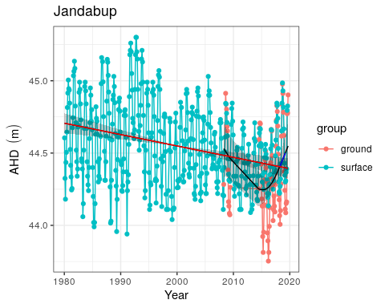

Ground and surface water levels for Lake Jandabup recorded at bore 61611850 (red) and staff 6162578 (blue). Red segments on fitted line represent statistically significant periods of declining water levels and blue segments represent periods of increasing water levels.

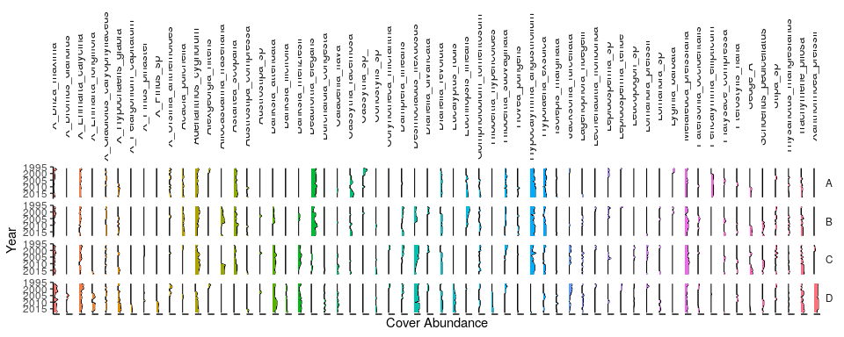

Cover abundances for each species across the four plots (A, B, C, D) at the Lake Jandabup transect. Invasive species are denoted by ‘X’. Only the most common species are included.

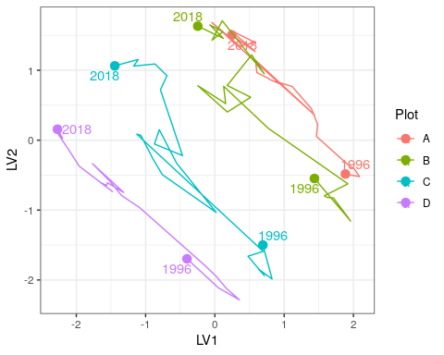

Unconstrained ordination based on the latent variable model for each surveyed year for Lake Jandabup. Plots are represented as different colours and consecutive years are joined by a line with first and last survey years labeled.

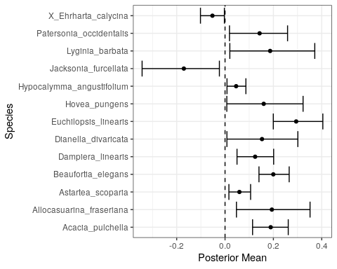

Estimated mean regression coefficients (dots) and 95% credible intervals (bars) for effect of ground water levels at Lake Jandabup on vegetation species cover abundances based on Bayesian Regression Analysis (HUI REF 2015). Species with a negative mean posterior value are likely to increase in cover abundance as water levels decline while species with positive values are likely to increase in cover abundance as water levels increase. Only those species with coefficients significanlty different to zero are shown.

Ecological consequences of revised thresholds in terms of compliance of stated site values and site management objectives for Lake Jandabup.

|  |  |  |
| --- | --- | --- |
|  | Likely effect of 2030 revised thresholds | Future Compliance |
| **Site values** |  |  |
| * Most diverse sedge and macrophyte vegetation of all Bassendean dune wetlands, including unusual species |  |  |
| * Supports wide range of waterbirds, especially waders |  |  |
| * Extremely good water quality with low nutrients |  |  |
| **Site management objectives** |  |  |
| * Conservation of flora and fauna |  |  |
| * Maintenance of the current extent of wading bird habitat |  |  |
| * No expansion in the areas of sedge vegetation, but maintenance of existing areas |  |  |
| * Removal of mosquito fish from the lake |  |  |
| * Maintenance of high species richness of aquatic macroinvertebrates, macrophytes and sedge vegetation |  |  |

## Lake Joondalup

At 611.5 ha, Lake Joondalup is the largest GMEMP monitored wetland and is managed by the Department of Biodiversity, Conservation and Attractions. The lake is an important habitat and drought refuge for water birds, and in conjunction with Lake Goollelal, is managed to support the full range of avian habitats (WAWA 1995). Other management objectives include the conservation of diverse wetland vegetation communities, including sedge beds, fringing woodlands and aquatic macrophytes, and the maintenance or enhancement of aquatic fauna in the lake. Lake Joondalup supports an important population of Pygmy Perch (*Edelia vittata*) and Swan River Goby (*Pseudogobius olorum*) and the fringing woodlands and bushland support a variety of significant mammal species.

### Hydrology

Lake Joondalup has remained permanently inundated at the staff gauge [HOW DO I FIND THIS OUT] since 1986 (REFERENCE Chapter 5 Horwitz et al). However, vast regions of the basin dry most summers. Historically, groundwater levels at monitoring bore 61610661 declined significantly from 19.3 to 18.1 mAHD from 1970 to 2002 (Figure ). Currently, groundwater levels at this bore, as well as bore 61611423 (likely to better reflect lake surface water variation), have been increasing since 2015 to levels similar to the early 1990s. Recent monitoring of surface water levels at the staff gauge 6162572 remained relatively stable from 2002 but have been increasing from 16.4 mAHD to approximately 17.2 mAHD in 2019. Five-year summaries of hydrological regimes at Lake Joondalup also reveal the higher mean minimum and maximum surface water levels in the latest period compared to earlier periods, as well as an increase in the number of days to reach seasonal minimum water levels (Table ).

### Vegetation Dynamics

The recent increases in surface water levels has increased the pH from 6.8 in 2016 to 8.4 in 2018 and increased alkalinity to 206 mg/L. Recent nutrient levels have been decreasing. [I NEED THIS DATA TO ANALYSE TRENDS] Vegetation surveys have been conducted along a northern (Figure ) and southern (Figure ) transect at Lake Joondalup. Both the northern and southern transects were established in 1996 and were last surveyed in 2015. *Melaleuca raphiophylla* dominates the overstorey of plots in the northern transect while exotic species are abundant in the understory vegetation. There has been an increasing trend in cover abundance of the exotics *Bromus diandrus*, *Ehrharta longiflora*, *Euphorbia terracina*, *Fumaria muralis* and *Peargonium capitatum* in recent years. Fires in 2003 reduced the canopy condition and abundance of *M. raphiophylla* in the southern transect, and despite the slightly higher cover abundance of native species, native and exotic species richness is equal along the transect. The site also contains healthy stands of *Baumea articulate* in the submerged regions of the transect.

All plots in both transects have displayed similar trends in community compositional change during the survey periods (Figure ). In the southern transect, latent model ordination reveals separation of the plots along the first axis, with a general temporal trend along the second axis, except for a period around 2003 - 2006 where there was a hiatus. This hiatus may be associated with the 2003 bushfire and represents a recovery period where species composition changed little. The trajectory for plot A is different, however, as the trend away from the original 1996 survey has reversed and the contemporary community is now becoming more like the 1996 communities. Similar patterns have been observed in the northern transect despite the transect not being impacted by the 2003 fire event.

[DESCRIBE SPECIES ASSOCIATIONS WITH WATER LEVELS] (Figure )

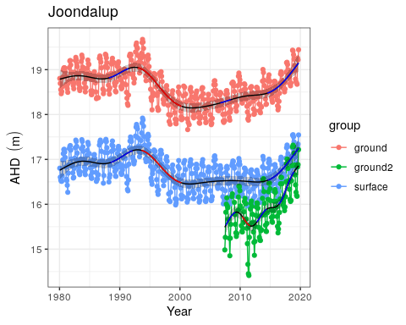

Ground and surface water levels recorded at bore 61610661 (red), bore 61611423 (green) and staff gauge 6162572 (blue) for Lake Joondalup.

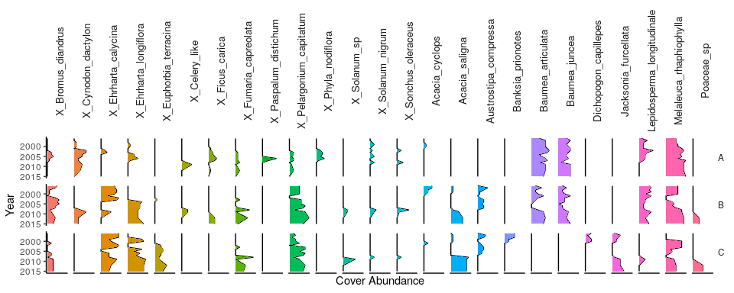

Cover abundances for each species across the four plots (A, B, C, D) at the northern Lake Joondalup transect. Invasive species are denoted by ‘X’. Only the most common species are included.

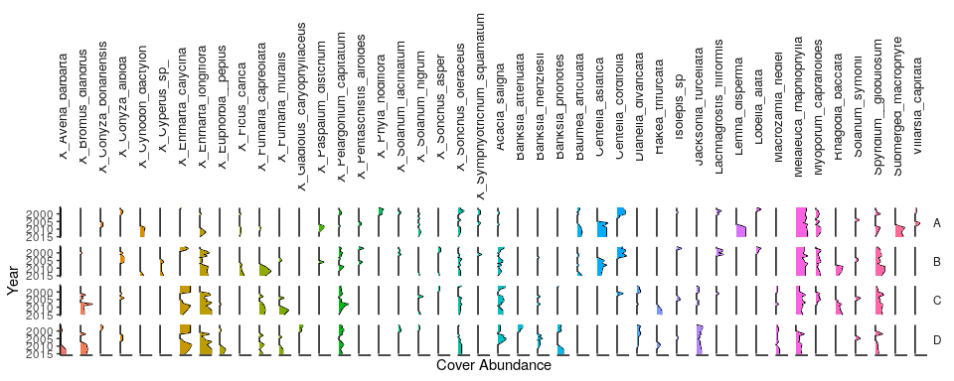

Cover abundances for each species across the four plots (A, B, C, D) at the southern Lake Joondalup transect. Invasive species are denoted by ‘X’. Only the most common species are included.

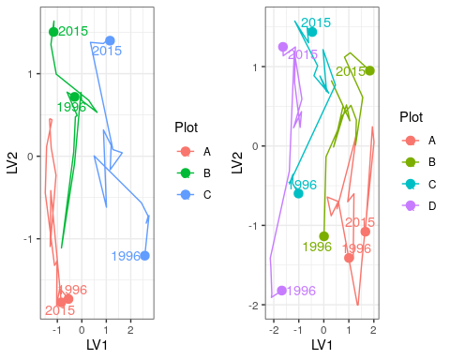

Unconstrained ordination based on the latent variable model for each surveyed year for the northern (left) and southern (right) Lake Joondalup transects. Plots are represented as different colours and consecutive years are joined by a line with first and last survey years labeled.

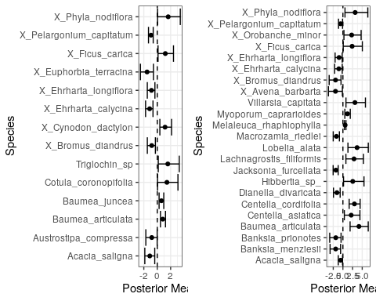

Estimated mean regression coefficients (dots) and 95% credible intervals (bars) for effect of ground water levels at the northern (left) and southern (right) Lake Joondalup transects on vegetation species cover abundances based on Bayesian Regression Analysis (HUI REF 2015). Species with a negative mean posterior value are likely to increase in cover abundance as water levels decline and species with positive values are likely to increase in cover abundance when water levels increase. Only those species with coefficients significanlty different to zero are shown.

### Aquatic Invertebrates

Aquatic invertebrates have been sampled from Lake Joondalup every year since 1996. During this period, 16-30 families of aquatic invertebrates have been recorded per sampling event, except for the latest round in 2018 where family richness was only nine. This exceptionally low family richness was likely due to the lack of insects and associated parasitic mites among the sampled communities. The phreatoicid isopod *Amphisopus palustris* was also absent in 2018 despite being collected every spring in Lake Joondalup (expect 2004). Furthermore, this reduced richness occurred during a period of relatively high surface water levels, suggesting other anthropogenic factors may be responsible for the decline of insect fauna within the lake. Otherwise, the lake hosts abundant populations of Ceinidae (amphipods), *Palaemonetes australis* (crustacean), *Calanoid copepods* and Cyprididae (ostracods). [ANALYSE INVERTS HERE]

### Revised water level threshold effects

[Insert plot of future changes in groundwater]

The water levels in the vicinity of Lake Joondalup are expected to increase up to 2.1m by 2030 from 2013 levels based on the revised groundwater allocations. This increase in water level will continue the increasing trend being observed in the lake’s surface water levels since 2015. Maintaining surface water levels above 16.2mAHD at staff 6162572 will ensure permanent water habitat for fauna and flora and the visual amenity of the area. The diverse macrophytes inhabiting plot A and B of both transects are likely to persist and continue to provide a rich habitat for aquatic vertebrates. Although important native macrophytes and wetland species are likely to continue at relatively high cover abundances under the future scenario, there is a high proportion of exotic taxonomic richness at these sites that the model presented here does not associate with groundwater levels. The contribution of exotic species is likely associated with climatic factors and landscape changes and under the 2030 proposed groundwater thresholds, they will likely to continue contributing a large proportion of the taxonomic richness to the Lake Joondalup vegetation community. Further vegetation monitoring is required at these transects to determine vegetation compositional changes since 2015 to understand if the trajectory in compositional change is continuing.

Ecological consequences of revised thresholds in terms of compliance of stated site values and site management objectives for Lake Joondalup.

|  |  |  |
| --- | --- | --- |
|  | Likely effect of 2030 revised thresholds | Future Compliance |
| **Site values** |  |  |
| Water bird habitat and drought refuge | The proposed increases in groundwater levels around the lake will ensure the site remains an important water bird habitat. The proposed increases will also ensure the lake is permanently inundated, which will ensure the lake is a drought refuge for water birds. | Yes |
| Diverse range of macrophytes | The current diversity of macrophytes, including *B. articulata*, *B. juncea* and *L. longitudinale*, will continue. There is the possibility of these species extending into current terrestrial regions of the lake. | Yes |
| **Site management objectives** |  |  |
| Conservation and public enjoyment of natural and modified landscapes |  | Yes |
| Conserve existing wetland vegetation, including sedge beds, fringing woodland and aquatic macrophytes | The predicted increases in groundwater levels will ensure the current wetland at a state similar to 2015. It is possible that sustained increases in groundwater levels will extend the range of these species around the lake by ‘migrating’ up slope. | Yes |
| Maintain and if possible, enhance the aquatic fauna of the lake |  |  |
| In conjunction with Lake Goollelal, to support the full range of habitats for avian fauna | The maintenance of permanent surface water and wetland vegetation will continue to provide a diverse habitat for different avian species. [NEED TO COMMENT ON AQ INVERTS AS FOOD] | Yes |
| Ensure the landscape and amenity values of the lake are maintained, except under very low rainfall climatic conditions |  | Yes |

## Lexia 186

The Lexia system of wetlands is composed of three separate wetlands, Lexia 86, Lexia 94 and Lexia 186. Lexia 186 was normally a seasonally waterlogged basin (Dampland), however, prolonged decline of ground water levels mean water levels are below the level of the basin all year. There has been dramatic shifts in fringing vegetation health and composition as the basin sediments dry and oxidise. The wetland is has a high conservation value (FROEND 2004).

### Hydrology

There has almost been a continual decline in ground water levels at Lexia 186 from 1996 to 2015 by approximately 1 m and a significant increases in water levels since 2015 by 0.5 m (Figure ). Nonetheless, current mean maximum and minimum water levels are 1.2 and 0.8 m below 1994-1999 levels and seasonally minimums are occurring earlier in the year (Table ).

### Vegetation dynamics

Vegetation monitoring has been occurring at Lexia 186 since 1997 with the last survey conducted in 2018 (Figure ). Overall canopy health has remained stable with most *Melaleuca preissiana* in good or excellent condition and most *Banksia ilicifolia* with average condition (BULLER 2018 REPORT). Exotic richness is very low at Lexia 186 and natives account for approximately 90 % of total cover abundance at the transect. Ordination reveals similar trajectories in compositional change for each plot that reflect the continual changes in cover abundances of species (Figure ). Regression analyses did not reveal significant effects of ground water levels on any of the species present at Lexia 186 (Figure ). This result suggests that community composition is changing due to other factors that are independent of ground water. This is surprising given the significant declines in ground water at the site. (NOT SURE IF THERE IS ANY Baumea AT THE SITE AND WHETHER IT HAS DECLINED OR DISAPPEARED - PERHAPS WORTH A COMMENT) (ARE THERE ANY OTHER DRAMTIC CHANGES WITH THE DECLINING WL?).

### Revised water level threshold effects

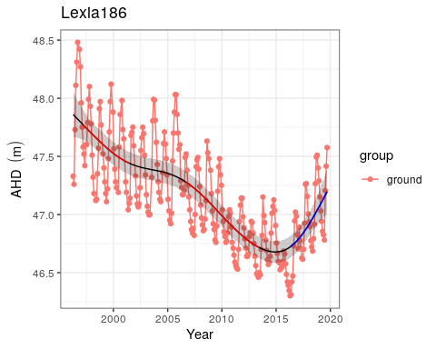

Ground water levels recorded at bore 61613214 that represent water level fluctuations at Lexia 186. Red segments represent periods of significant decline in water levels while blue segments represent periods of significant increase in water levels.

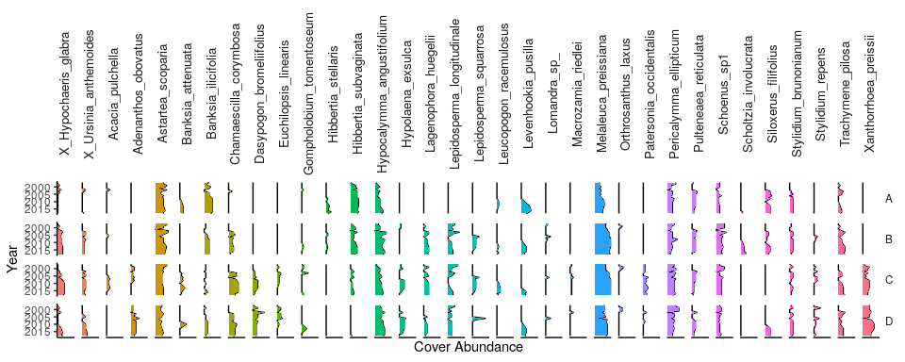

Cover abundances for each species across the four plots (A, B, C, D) at the Lexia 186 transect. Invasive species are denoted by ‘X’. Only the most common species are included.

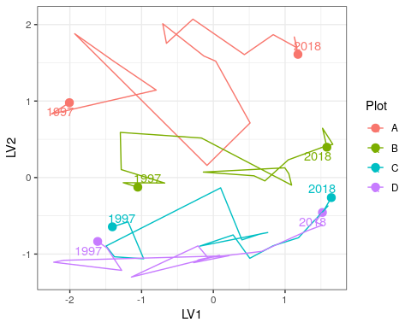

Unconstrained ordination based on the latent variable model for each surveyed year for Lexia 186. Plots are represented as different colours and consecutive years are joined by a line with first and last survey years labeled.

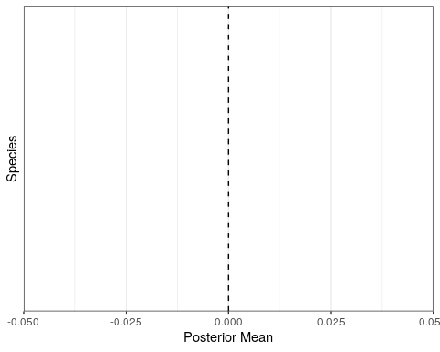

Estimated mean regression coefficients (dots) and 95% credible intervals (bars) for effect of ground water levels at Lexia 186 on vegetation species cover abundances based on Bayesian Regression Analysis (HUI REF 2015). Species with a negative mean posterior value are likely to increase in cover abundance as water levels decline. Only those species with coefficients significanlty different to zero are shown.

Ecological consequences of revised thresholds in terms of compliance of stated site values and site management for Lexia 186.

|  |  |  |
| --- | --- | --- |
|  | Likely effect of 2030 revised thresholds | Future Compliance |
| **Site values** |  |  |
| * Undisturbed by typical impacts |  |  |
| * Supports diverse vegetation |  |  |
| * Significant fauna habitat |  |  |
| **Site management objectives** |  |  |
| * Conserve ecological values |  |  |
| * Protect vegetation assemblages in and fringing the wetland |  |  |
| * Protect invertebrate communities dependent on the wetland |  |  |

## Loch McNess

Loch McNess, located in Yanchep National Park, is a relatively undisturbed wetland with large areas of intact Herdsman Complex vegetation, relatively good water quality and important habitat for water birds and other aquatic fauna (FROEND 2004). Permanent water is required to support a local Rakali (*Hydromys chrysogaster*) population and resident and visiting populations of water birds and waders. The southern lake at Loch McNess is one of the few wetlands known to contain the nightfish *Bostokia porosa* and has one of the most rich aquatic macroinvertebrate communities of the Swan Coastal Plain. Loch McNess is a wetland of high conservation value because of its intact vegetation, largely unaltered aquatic processes and important populations of fauna (FROEND 2004).]

### Hydrology

Since early 2011, readings for the staff gauge at Loch McNess have frequently been below the gauge’s limit. It is therefore likely the decline in surface water levels have continued pasted the levels shown in Figure . Nonetheless, surface water, which were remarkably stable before 2003 at 7 mAHD, have declined at least 1.5 m to present levels. These declines have been mirrored in surrounding bores (Figure ). Mean maximum and minimum seasonal water levels have decline by 0.9 m since 1994-2004 levels (Table ). Changes in seasonal patterns are difficult to interpret due to staff gauge 6162564 being mostly dry since 2014, but during the period 2009-2014, minimum water levels were not being reached until May, compared to March in the decade 1994-2004 before water levels began to decline. A recent increase in water level, as seen in surrounding wetlands during the last few seasons, has not been observed at Loch McNess (GMEMP 2019 REPORT). The dramatic decline in water levels is causing the terrestrialisation of the lake as much of the lake bed is now undergoing recruitment by fringing vegetation.

### Vegetation dynamics

A vegetation ,monitoring transect was established in 2004 with three plots (A, B, and C) with an additional up-slope plot in 2009 (Plot D) and a plot down-slope of Plot A in 2010 (Plot E; Figure ). The fringing vegetation is largely comprised of a *Melaleuca rhaphiophylla*/*Eucalyptus rudis* complex. Most trees are in average to good health (BULLER 2019). *Baumea juncea* is found in Plots A -D at relatively constant cover abundance. *Baumea articulata*, however, disappeared from Plot A in 2005 and was present in the new down-slop plot (Plot E) until 2014. (REASON FOR DISAPEARANCE?)

Plots A and B have shifted in community composition dramatically during the monitoring period as the vegetation responds to lower surface water levels in the lake and the impact of fire in 2004 and 2009 (BULLER 2018 REPORT) (Figure ). Regressional analysis reveal that the exotic *Avena barbata* and the native *Tricoryne elatior* will increase the most as water levels in the lake decline (Figure ). The natives, *Carex fascicularis* and *Triglochin centrocarpa* are most likely to decline dramatically at the wetland under a scenario of continuing declining water levels.

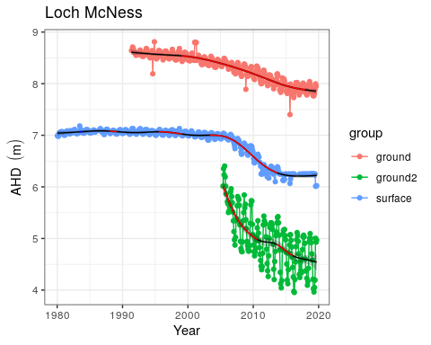

Ground and surface water levels recorded at bores 61612104 (red) and 61640108 (green) and staff gauge 6162564 (blue) that represent changes in water levels at Loch McNess. Segments in red represent periods of significant decline in water level.

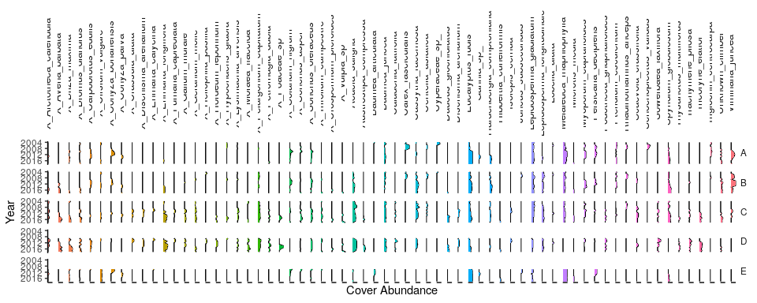

Cover abundances for each species across the five plots (A, B, C, D and E) at the Loch McNess transect. Plot D was established up-slope from Plot C in 2009. Plot E was established down-slope of Plot A in 2010. Invasive species are denoted by ‘X’. Only the most common species are included.

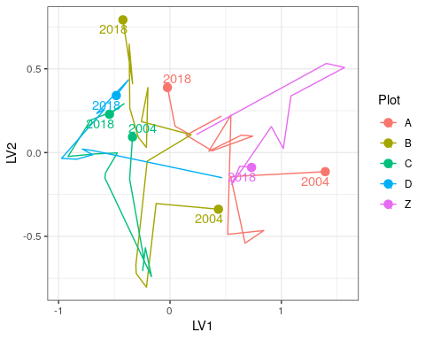

Unconstrained ordination based on the latent variable model for each surveyed year for Loch McNess. Plots are represented as different colours and consecutive years are joined by a line with first and last survey years labeled.

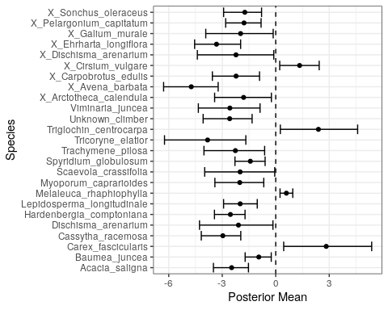

Estimated mean regression coefficients (dots) and 95% credible intervals (bars) for effect of ground water levels at Loch McNess on vegetation species cover abundances based on Bayesian Regression Analysis (HUI REF 2015). Species with a negative mean posterior value are likely to increase in cover abundance as water levels decline while species with positive values are predicted to increase in cover abundance with water increasing water levels. Only those species with coefficients significanlty different to zero are shown.

Ecological consequences of revised thresholds in terms of compliance of stated site values and site management objectives for Loch McNess.

|  |  |  |
| --- | --- | --- |
|  | Likely effect of 2030 revised thresholds | Future Compliance |
| **Site values** |  |  |
| * Undisturbed wetland |  |  |
| * Unusual hydrologic regime |  |  |
| * Rich aquatic fauna |  |  |
| * Vegetation largely intact, provides a range of habitat types |  |  |
| * Supports good populations of water birds and acts as a drought refuge |  |  |
| * Excellent water quality |  |  |
| **Site management objectives** |  |  |
| * Maintain the environmental quality of the lake |  |  |
| * Maintain North Loch NcNess’ pristine state |  |  |
| * Continue to use south Loch McNess for low key recreation |  |  |
| * Maintain east Loch McNess in a natural state, to restore, where possible, natural flow |  |  |
| * Maintain the existing hydrological regime |  |  |

## Lake Mariginiup

Lake Mariginiup has a high conservation value (FROEND 2004 REPROT). There are a number of wader birds present at the lake that require the shallow water during the summer, however, high water levels are required to prevent vegetation encroachment into these habitats. The dramatic decline in surface and ground waters has likely diminished this important component of the system. Sediment processes have been altered as soils dry and water quality is deteriorating due to acidification (GMEMP 2009).

### Hydrology

Lake Mariginiup is a groundwater dependent wetland (FROEND 2004 REPORT). Since 1997, Lake Mariginiup has frequently dried or been dry at the staff gauge 6162577 during the summer. Interpretations of seasonal patterns therefore need to be made with caution and perhaps it is more reliable to use ground water levels at the nearby bore 616100685 as a proxy (Figure ). Nonetheless, mean season maximum water levels have declined from 42.0 m to 41.4 m since the 1994-1999 period (Table ). Maximum water levels usually occur in September/October.

### Vegetation dynamics

Vegetation composition and shifts in composition are similar along the length of the transect at Lake Mariginiup which was established in 1996 (Figure ). *Baumea articulata* was present at high cover abundance throughout the transect until the early 2000’s, but has since disappeared as surface water levels declined. *Eucalyptus rudis* has declined in the lower parts of the plots and *Melaleuca rhaphiophyla* is no longer present at the transect. There has been a general increase in the cover abundances of exotics throughout the monitoring period. There was a shift in community composition at all three plots around 2005 which was driven by increases in *Exocarpus sparteus* and *Jacksonia furcellata* and some exotics, such as *Ehrharta calycina*, *Ehrhatah longiflora*, *Lotus suaveolens* and *Ursinnia anthemoides*. Regression analysis reveals a number of native species that will decline or disappeared from the transects as water levels decline, including *Angianthus* sp., *Epilobium billardierianum*, *Isolepis cernua*, *Juncus* sp., *Lepyrodia muirii*, *Lobelia alata* and *Villarsia capitata* (Figure ). Other natives, including *Acacia cyclops*, *Acacia saligna* and *E. sparteus*, are likely to increase in cover abundance as water levels decline.

### Aquatic invertebrates

### Revised thresholds

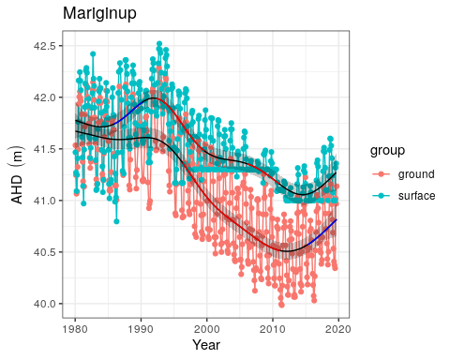

Ground and surface water levels recorded at bore 61610685 (red) and staff gauge 6162577 (blue) that represent changes in water levels at Lake Mariginiup.

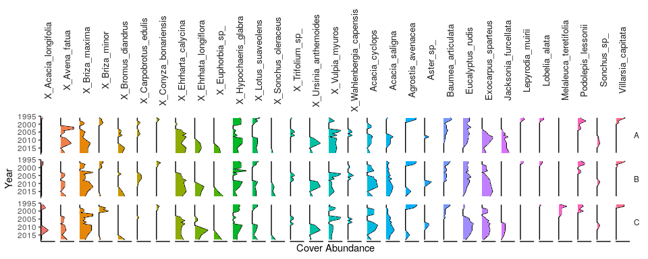

Cover abundances for each species across the three plots (A, B, C) at the Lake Mariginiup transect. Invasive species are denoted by ‘X’. Only the most common species are included.

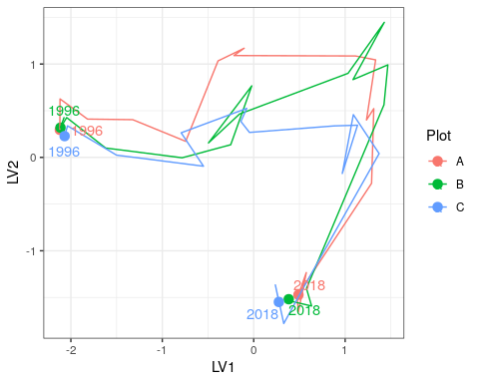

Unconstrained ordination based on the latent variable model for each surveyed year for Lake Mariginiup. Plots are represented as different colours and consecutive years are joined by a line with first and last survey years labeled.

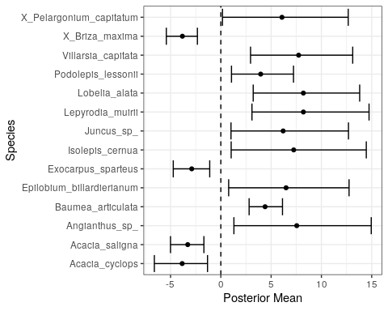

Estimated mean regression coefficients (dots) and 95% credible intervals (bars) for effect of ground water levels at Lake Mariginiup on vegetation species cover abundances based on Bayesian Regression Analysis (HUI REF 2015). Species with a negative mean posterior value are likely to increase in cover abundance as water levels decline and species with positive values are predicted to increae in cover abundance with increasing water levels. Only those species with coefficients significanlty different to zero are shown.

Ecological consequences of revised thresholds in terms of compliance of stated site values and site management objectives for Lake Mariginiup.

|  |  |  |
| --- | --- | --- |
|  | Likely effect of 2030 revised thresholds | Future Compliance |
| **Site values** |  |  |
| * Rich aquatic fauna (Swan River Goby, *Pseudogobius olorum*) |  |  |
| * Wading bird habitat |  |  |
| * Good water quality |  |  |
| **Site management objectives** |  |  |
| * Conservation of flora and fauna |  |  |
| * Maintenance of the existing areas of fringing sedge vegetation |  |  |
| * Maintain invertebrate diversity through some lake bed drying in summer |  |  |
| * Maintain and if possible, enhance fringing woodland vegetation |  |  |

## MM59B - Whiteman Park East

(I DON"T KNOW ANYTHING ABOUT THIS SITE)

### Hydrology

Ground water levels at MM59B have fluctuated between 18 and 19 mAHD since 1980. There was a significant decline in groundwater levels in the early 1990’s from 19.1 mAHD to approximately 18.2 mAHD in 2000 (Figure ). Since 2000, ground water levels have steadily increased to similar levels to 1980-1990. Mean maximum water levels are currently similar to 19994-1999 levels while mean minimum levels are currently 0.4 m higher (Table ). Highest water levels generally occur between September and October.

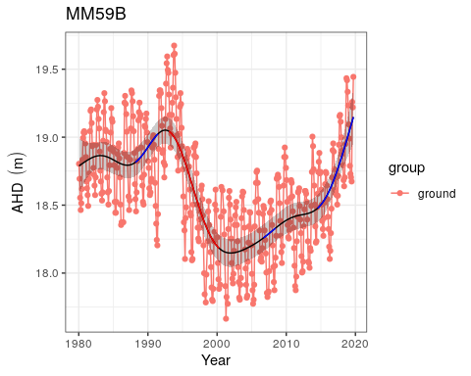

Ground water levels recorded at bore 61610661 in the vicinity of MM59B. Red segments represent periods of significant decline in ground water level while blue segments represent periods of significant increase in ground water level.

Ecological consequences of revised thresholds in terms of compliance of stated site values and site management objectives for MM59B.

|  |  |  |
| --- | --- | --- |
|  | Likely effect of 2030 revised thresholds | Future Compliance |
| **Site values** |  |  |
| * Selected to represent water levels over area of undisturbed phreatophytic vegetation |  |  |
| * Banksia woodland <8m depth to groundwater |  |  |
| **Site management objectives** |  |  |
| * To protect terrestrial vegetation |  |  |

## Lake Nowergup

### Hydrology

### Vegetation Dynamics

### Macroinvertebrates Dynamic

### Revised Thresholds

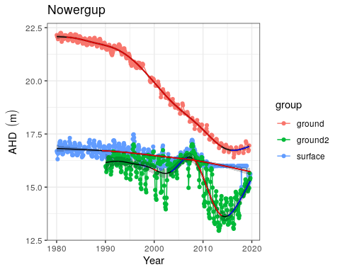

Ground and surface water levels for Lake Nowergup recorded at bores 61610601 (red) and 61611247 (green) and staff gauge 6162567 (blue). The minimum recordable water level for the staff gaugue is 16.0 mAHD. Blue dots at 16.0 mAHD represent water levels below the minimum level measurable at the staff gaufe. Red segments on fitted line represent statistically significant periods of declining water levels and blue segments represent periods of increasing water levels.

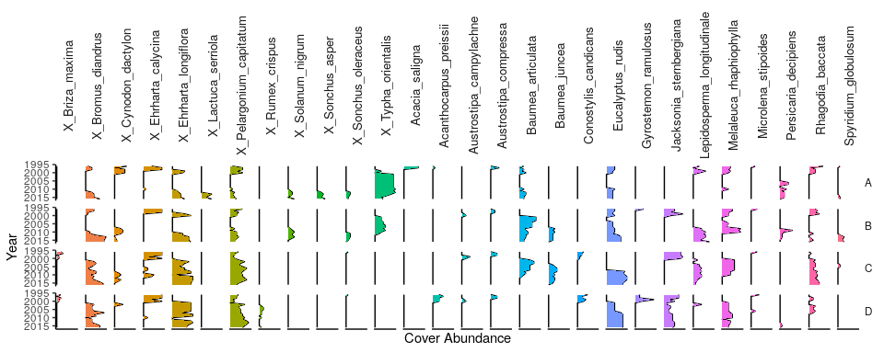

Cover abundances for each species across the four plots (A, B, C, D) at the northern Lake Nowergup transect. Invasive species are denoted by ‘X’. Only the most common species are included.

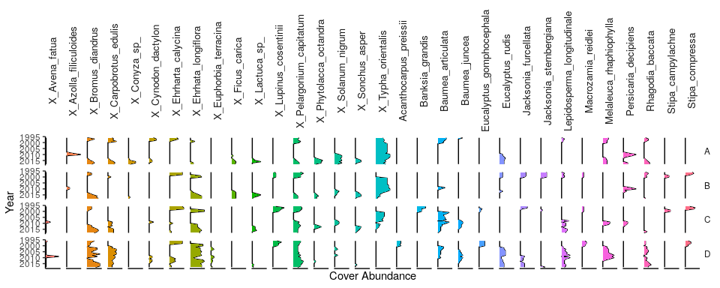

Cover abundances for each species across the four plots (A, B, C, D) at the souther Lake Nowergup transect. Invasive species are denoted by ‘X’. Only the most common species are included.

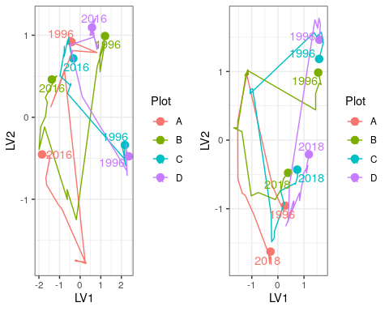

Unconstrained ordination based on the latent variable model for each surveyed year for the northern (left) and southern (right) Lake Nowergup transects. Plots are represented as different colours and consecutive years are joined by a line with first and last survey years labeled.

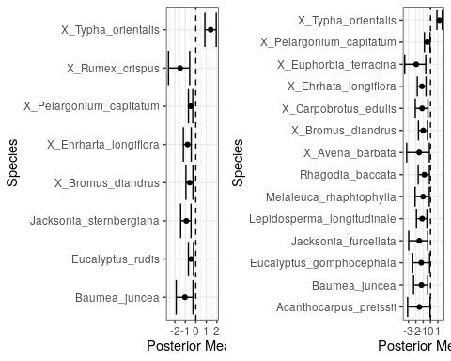

Estimated mean regression coefficients (dots) and 95% credible intervals (bars) for effect of ground water levels at the northern (left) and southern (right) Lake Nowergup transects on vegetation species cover abundances based on Bayesian Regression Analysis (HUI REF 2015). Species with a negative mean posterior value are likely to increase in cover abundance as water levels decline and species with positive values are likely to increase in cover abundance when water levels increase. Only those species with coefficients significantly different to zero are shown.

Ecological consequences of revised thresholds in terms of compliance of stated site values and site management objectives for Lake Nowergup.

|  |  |  |
| --- | --- | --- |
|  | Likely effect of 2030 revised thresholds | Future Compliance |
| **Site values** |  |  |
| * As a permanent deep-water wetland acts as a major drought refuge for waterbirds |  |  |
| * Supports dependent invertebrates and fish species (one native, Swan River Goby (*Pseudogobius olorum*); and one exotic, Mosquito fish (*Gambusia holbrooki*) |  |  |
| * Large areas of sedges minimize impact of nutrient enrichment on aquatic fauna |  |  |
| **Site management objectives** |  |  |
| * Wildlife and conservation, scientific study and preservation of features of archaeological, historic or scientific interest |  |  |
| * Maintain the existing areas of fringing sedge vegetation |  |  |
| * Maintain deep, permanent water as a bird habitat and drought refuge and to protect aquatic invertebrates and fish dependent on permanent water |  |  |
| * Maintain the existing extent of *Baumea* fringe between *Typha* stands and the fringing woodland |  |  |
| * Provide some area of wading bird habitat at the end of summer, although it is recognized that this is limited by the shape of the wetland. |  |  |

## Pipidinny Swamp

Vegetation damaged by a fire in 2005. Macroinvertebrate and water quality monitoring occurred in the 2000s but ceased in 2011 as the wetland was atypical and had little water.

### Hydrology

There has been at least a 2 m decline in surface water levels at Pipidinny Swamp since the mid 1990’s, although measurements at the staff gauge were frequently below the minimum recordable level in the mid-late 2000’s to 20019 despite the gauge being moved in 2010 (Figure ). Mean maximum seasonal surface waters are at least 1.2 m lower now than in the 19994-1999 seasons (Table ). Records of minimum levels are difficult due to the water levels frequently being below the staff gauge. Ground water levels at the nearby bore 61611872 suggest that water levels at the swamp are no longer in decline, however this conclusion assumes ground water levels at the bore and surface water levels at the staff gauge are related (Figure ). It is not possible to verify this assumption as ground water measurements have only been made while the surface water levels have been below detection limits for the staff gauge.

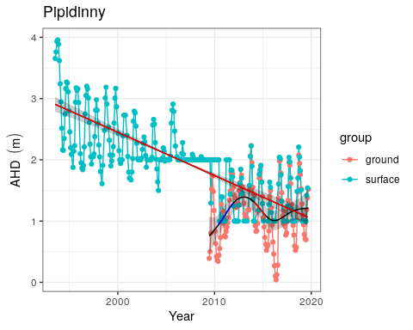

Ground and surface water levels recorded at bore 61611872 (red) and staff gauge 6162624 (blue) that represent fluctuations in water levels at Pipidinny Swamp. Surface water levels were initially only recordable above 2 mAHD and later above 1 mAHD. Red segments of trend line represent periods of significant decline in water levels while blue segments represent periods of significant increases in water levels.

Ecological consequences of revised thresholds in terms of compliance of stated site values and site management objectives for Pipidinny Swamp.

|  |  |  |
| --- | --- | --- |
|  | Likely effect of 2030 revised thresholds | Future Compliance |
| **Site values** |  |  |
| **Site management objectives** |  |  |
| * Improve groundwater levels to increase area of permanent deep water habitat for fauna |  |  |
| * Improve groundwater levels to maintain fringing vegetation to support a range of habitat types for macroinvertebrates |  |  |

## PM9 - Pinjar North

“Water levels at PM9 have been monitored since 1976 and have fallen approx. 7 meters over this time. It is assumed that vegetation at this site is now no longer able to access groundwater. The nearest vegetation monitoring transect is ‘P50’, located near the Water Corporation’s P50 production bore east of Lake Pinjar, approximately 2.2 km away to the south-west. The P50 transect has been subjected to different influences over the years, including (previous) pumping of the P50 production bore and widespread deaths of vegetation following a succession of high temperatures in the early 1990s, and several fires. There has been an increase in the frequency and cover of species that prefer ‘broad’ site conditions, and an increase in the relative proportion of cover from introduced species. There is a consistent decline on the transect in species preferring excessive wetness.”

WHERE IS VEGETARTION TRANSECT AT P50?

### Hydrology

Ground water at PM9 have almost continually been in decline since 1980 from approximately 59 mAHD to 2016 levels around 53 mAHD (Figure ). The most significant rate of decline has been occurring since 1995 to 2016. Maximum and minimal seasonal water levels are 4 and 5 m lower now than in the 1994-1999 period, respectively (Table ). Since 2016, no measurements at bore 61610804 have been made due to the operation of a nearby rifle range. It is unknown if ground water levels have continued to decline since 2016 because no measurements have been recorded due to safety concerns regarding access to the bore. If the observed decline has continued, ground water levels at the site may currently be below 52 mAHD, representing more than a 7 m decline since 1980.

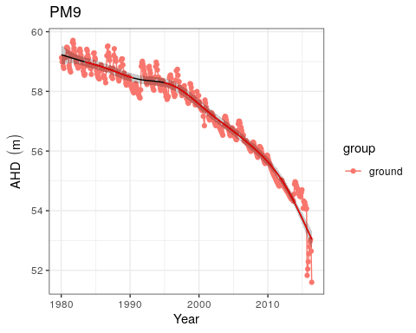

Ground water levels recorded at bore 61610804 in the vicinity of PM9. Red segments along trendline indicate preiods of significant decline in ground water levels.

## Quin Brook

Quin Brook is a base flow system where surface flow, riparian vegetation and habitat maintenance all depend on ground water (See FROEND 2014 82422). The series of interconnected ponds that occur along Quin Brook are of high conservation value because of the pristine nature of the fringing vegetation and the aquatic associated fauna likely to inhabit the surface waters and riparian zones.

### Hydrology

The hydrology of Quin Brook is not well understood. Stretches of the brook are dry most of the year and may have previously been supported by groundwater (JOHNSON 2000 - see report 97075). Near the confluence with Gingin Brook, flow is maintained throughout the year by ground water with winter discharge an important source of fill for Lake Yeal (see report tp-1413). Ground water levels at bore 61710060 have been in constant decline since the early 1980’s from approximately 59.5 mAHD to current levels at 53.8 m AHD (Figure ). Mean maximum and minimum ground water levels are now nearly 5.0 m below 1994-1999 levels with seasonal patterns almost indistinguishable (Table ).

### Vegetation dynamics

Vegetation at Quin Brook is dominated by some key wetland species, including *Melaleuca rhaphiophyla*, *Eucalyptus rudis*, *Banksia littoralis* and *Melaleuca preissiana*. Vegetation monitoring, which began in 2009, indicates that the *Melaleuca* species have declined significantly in cover abundance to the point where it is no longer present in the higher levels of the transect (Figure ). Cover abundance of *E. rudis* has remained relatively stable despite the health of individual trees declining (BULLER 2018 REPORT). Other abundant species at the site include *Astartea scoparia*, *Hypocalymna angustifolium* and *Kunzea glabrescens*. All plots along the vegetation monitoring transect have shifted in composition since 2009, mainly due to the decline in *M. rhaphiophyla* and *M. preissiana* (Figure ). Many species are likely to increase in cover abundances with ground water level decline, including an exotic grass, the exotic *Sonchus asper* and *Lotus angustissimus* (Figure ). Some natives associated with lower ground water levels include *Senecio* sp., *Pteridium esculentum* and *Hypolaena exsulca*.

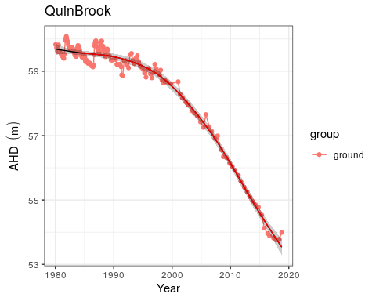

Ground water levels recorded at bore 61710060 in the vicinity of Quin Brook. Red segments along trendline indicate preiods of significant decline in ground water levels.

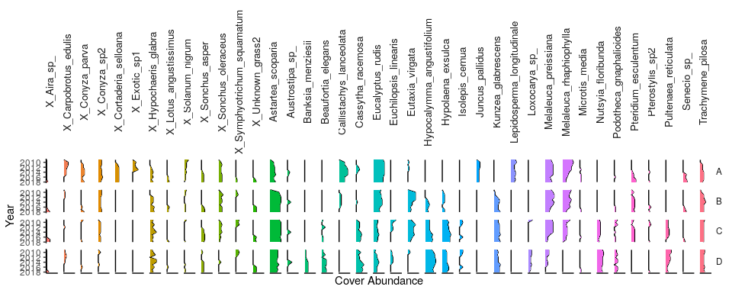

Cover abundances for each species across the five plots (A, B, C, D and E) at the Quin Brook transect. Invasive species are denoted by ‘X’. Only the most common species are included.

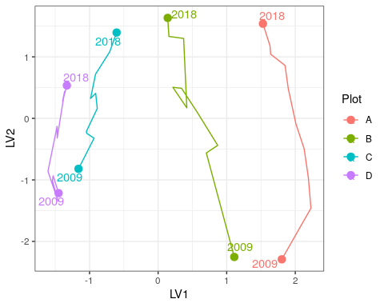

Unconstrained ordination based on the latent variable model for each surveyed year for Quin Brook. Plots are represented as different colours and consecutive years are joined by a line with first and last survey years labeled.

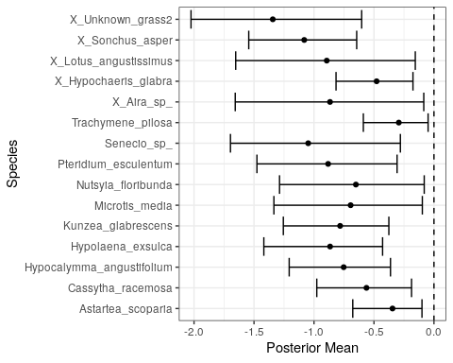

Estimated mean regression coefficients (dots) and 95% credible intervals (bars) for effect of ground water levels at Quin Brook on vegetation species cover abundances based on Bayesian Regression Analysis (HUI REF 2015). Species with a negative mean posterior value are likely to increase in cover abundance as water levels decline while species with positive values are predicted to increase in cover abundance with water increasing water levels. Only those species with coefficients significanlty different to zero are shown.

## Lake Wilgarup

Lake Wilgarup is a high conservation, seasonally inundated dampland located in the southern area of Yanchep National Park. The basin covers an area of 16 ha in a limestone depression that experiences discharge from rising ground waters. There are extensive peat deposits in the lake bed that suggest the sediments have been saturated for a long period. Surface waters have not been recorded in the basin since 1998 and peats are now dry and vulnerable to combustion.

### Hydrology

Ground water levels have been recorded at the nearby bore 61618500 since 1997 (Figure ). There has been a significant decline in ground water levels throughout this monitoring period from 4.75 to 3.25 mAHD despite recent increased annual rainfall. Maximum and minimum seasonal ground water levels have decreased by 1.6 and 1.2 m, respectively (Table ). Maximum water levels have consistently occurred during September-October, but minimum water levels are now occurring later in the year with the site experiencing a longer period of drying.

### Vegetation dynamics

A vegetation monitoring transect was established at Lake Wilgarup in 1997 and was last surveyed in 2012. Two additional sites were added to the transect in 2009 down-slope of Plot A. The sedges, *Baumea articulata*, *Baumea juncea* and *Baumea vaginalis* have all disappeared from the wetland during the monitoring period (Figure ). Tuart trees (*Eucalyptus gomphocephala*) migrated down slope during the monitoring period and were recorded in Plot A in 2005. Plots A, B and C display similar shifts in community composition during the monitoring period, while Plot D displayed a significant change in composition in 2004-2005 in response to fire (Figure ). Under a scenario of continuing groundwater decline, regressional analysis reveals that a number of exotic species, including *Ehrharta longiflora* and *Bromus diandrus*, are likely to increase in cover abundances (Figure ).

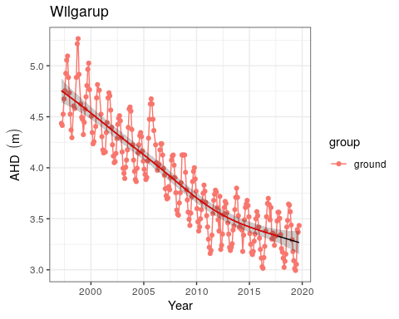

Ground water levels recorded at bore 61618500 in the vicinity of Lake Wilgarup. Red segments along trendline indicate preiods of significant decline in ground water levels.

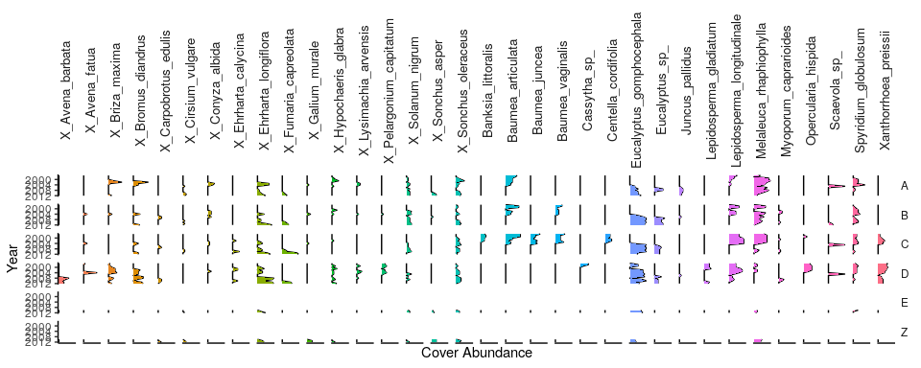

Cover abundances for each species across the four plots (A, B, C, D) at the Lake Wilgarup transect. Invasive species are denoted by ‘X’. Only the most common species are included.

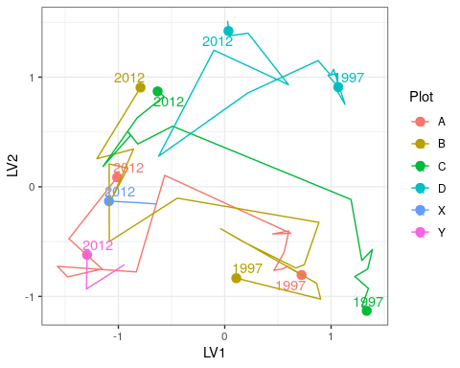

Unconstrained ordination based on the latent variable model for each surveyed year for Lake Wilgarup. Plots are represented as different colours and consecutive years are joined by a line with first and last survey years labeled.

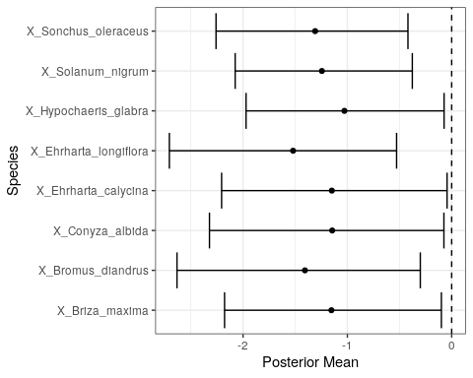

Estimated mean regression coefficients (dots) and 95% credible intervals (bars) for effect of ground water levels at Lake Wilgarup on vegetation species cover abundances based on Bayesian Regression Analysis (HUI REF 2015). Species with a negative mean posterior value are likely to increase in cover abundance as water levels decline. Only those species with coefficients significanlty different to zero are shown.

Ecological consequences of revised thresholds in terms of compliance of stated site values and site management objectives for Lake Wilgarup.

|  |  |  |
| --- | --- | --- |
|  | Likely effect of 2030 revised thresholds | Future Compliance |
| **Site values** |  |  |
| * One of few remaining undisturbed wetlands within the region |  |  |
| * Rich and unusual vegetation (dense monospecific stands of sedges) |  |  |
| * Likely to support diverse fauna |  |  |
| **Site management objectives** |  |  |
| * Maintain the environmental quality of Lake Wilgarup |  |  |
| * Maintain the existing extent and variety of wetland vegetation |  |  |

## WM1 - Pinjar

WM1 is located east of Lake Pinjar in the Chitty Road Bushland within the Bassendean north vegetation complex. Water levels at WM1 have been non-compliant since 2001.

### Hydrology

Ground water levels at WM1 have declined up to 4.0 m since 1980, although recent rainfall has increased levels from 54.4 to 55.5 mAHD since 2015 (Figure ). Current mean maximum and minimum water levels are 2.0 and 1.7 m lower than 1994-1999 levels (Table ). Maximum water levels generally occur in October and minimum water levels are now occurring later in the year than previously.

### Vegetation

There has been reported a number of dead *Banksia attenuata* and *Eucalyptus pauciflora* as well as a decline in the condition of *Banksia ilicifolia* and *Banksia menziesii* that has caused a thinning of the understorey (REPORT 86043 and 82392). Vegetation condition around the site has declined, probably due to water stress. *Eucalyptus todtiana* and *Corymbia calophylla* have also been reported to be declining in health in 2008 (REPORT 82392). Eleven years have passed since the last vegetation monitoring (REPORT 82392) at the site which has experienced a further decrease in ground water by 1.5 m. It is likely vegetation composition has shifted to species preferring drier conditions despite recent increases in ground water levels due to rainfall.

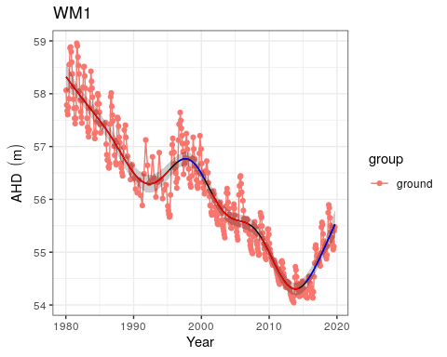

Ground water levels recorded at bore 61610833 in the vicinity of WM1. Red segments along trendline indicate preiods of significant decline in ground water levels and blue segments represent significant increases in ground water level.

Ecological consequences of revised thresholds in terms of compliance of stated site values and site management objectives for WM1.

|  |  |  |
| --- | --- | --- |
|  | Likely effect of 2030 revised thresholds | Future Compliance |
| **Site values** |  |  |
| * Selected to represent water levels over area of undisturbed phreatophytic vegetation |  |  |
| * *Banksia* woodland <8m depth to groundwater |  |  |
| **Site management objectives** |  |  |
| * To protect terrestrial vegetation |  |  |
| * Maintain the existing extent and variety of wetland vegetation |  |  |

## WM2 - Melaleuca Park North

Located in Melaleuca Park in the Bassendean north vegetation complex, the area represents an area of undisturbed phreatophytic vegetation, including *Banksia* woodlands (REPORT 82392).

### Hydrology

There has been periods of significant decline in ground water levels from 68.8 mAHD in 1980 to 66.4 mAHD in 2014 (Figure ). Since 2015, there has been an increase in ground water to slightly above 67 mAHD. Mean maximum and minimum seasonal water levels are now 1.5 and 0.9 m lower than the period 1994-1999. Maximum levels have consistently been reached in October, on average (Table ).

### Vegetation dynamics

There are reports of declining vegetation condition and density nearby the site in 2008 (REPORT 82392). Although current ground water levels are presently similar to 2008 levels, it is likely the vegetation was subjected to ground water levels up to 0.5 m lower than when the assessment was made. This suggests that vegetation in the region that is ground water dependent has deteriorated further since 2008.

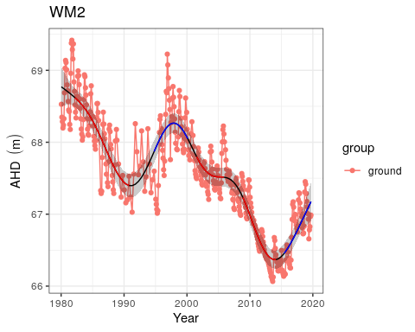

Ground water levels recorded at bore 61610908 in the vicinity of WM2. Red segments along trendline indicate preiods of significant decline in ground water levels and blue segments represent significant increases in ground water level.

Ecological consequences of revised thresholds in terms of compliance of stated site values and site management objectives for WM2.

|  |  |  |
| --- | --- | --- |
|  | Likely effect of 2030 revised thresholds | Future Compliance |
| **Site values** |  |  |
| * Selected to represent water levels over area of undisturbed phreatophytic vegetation |  |  |
| * *Banksia* woodland <8m depth to groundwater |  |  |
| **Site management objectives** |  |  |
| * To protect terrestrial vegetation |  |  |
| * Maintain the existing extent and variety of wetland vegetation |  |  |

## WM8 - Melaleuca Park

The WM8 monitoring bore is located in Melaleuca Park within the Bassendean north vegetation complex and represents native vegetation that may be affected by abstraction from the Lexia ground water scheme. There has been no reported change in vegetation at the site, although no monitoring or transects have been established here.

### Hydrology

Ground water levels began to decline in 2000 at WM8 from approximately 66 mAHD to 64.6 mAHD in 2015 (Figure ). Since 2015, there has been an increase in ground water levels to approximately 65.5 mAHD. Mean maximum and minimum seasonal water levels have declined by 1.3 and 1.0 m, respectively (Table ). Maximum levels are generally reached in December while minimum levels are reached in July.

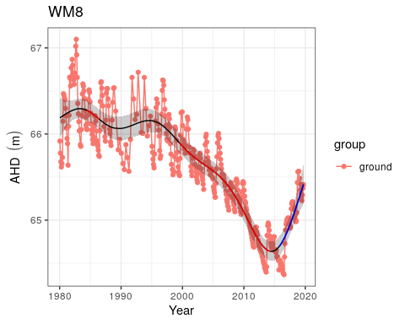

Ground water levels recorded at bore 61610983 in the vicinity of WM8. Red segments along trendline indicate preiods of significant decline in ground water levels and blue segments represent significant increases in ground water level.

Ecological consequences of revised thresholds in terms of compliance of stated site values and site management objectives for WM8.

|  |  |  |
| --- | --- | --- |
|  | Likely effect of 2030 revised thresholds | Future Compliance |
| **Site values** |  |  |
| * Selected to represent water levels over area of undisturbed phreatophytic vegetation |  |  |
| * *Banksia* woodland <8m depth to groundwater |  |  |
| **Site management objectives** |  |  |
| * To protect terrestrial vegetation |  |  |
| * Maintain the existing extent and variety of wetland vegetation |  |  |

## Lake Yonderup

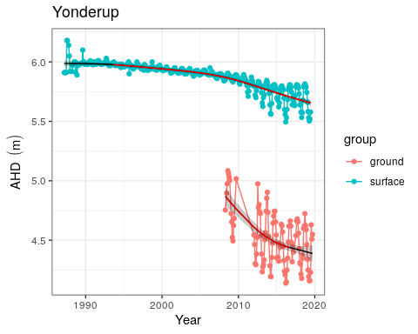

Ground water levels recorded at bore 61611840 (red) and staff gauge 6162565 (blue) in the vicinity of Lake Yonderup. Red segments along trendline indicate preiods of significant decline in ground water levels and blue segments represent significant increases in ground water level.

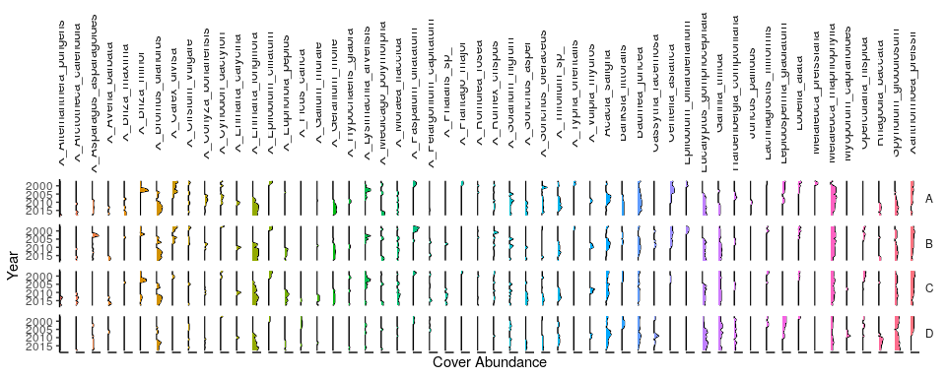

Cover abundances for each species across the four plots (A, B, C, D) at the Lake Yonderup transect. Invasive species are denoted by ‘X’. Only the most common species are included.

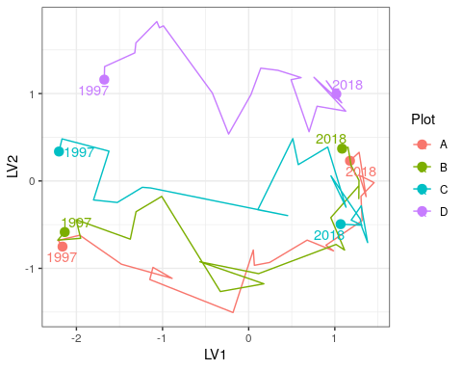

Unconstrained ordination based on the latent variable model for each surveyed year for Lake Yonderup. Plots are represented as different colours and consecutive years are joined by a line with first and last survey years labeled.

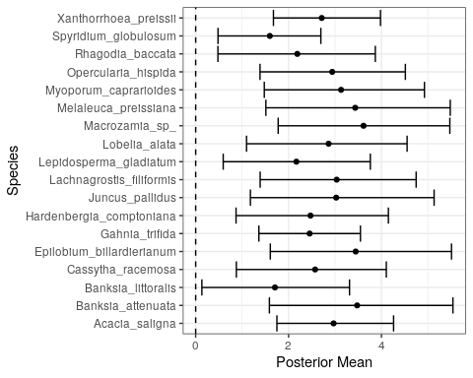

Estimated mean regression coefficients (dots) and 95% credible intervals (bars) for effect of ground water levels at Lake Yonderup on vegetation species cover abundances based on Bayesian Regression Analysis (HUI REF 2015). Species with a negative mean posterior value are likely to increase in cover abundance as water levels decline. Only those species with coefficients significanlty different to zero are shown.

# Summary

## Overview

## Vegetation

## Aquatic Invertebrates

## Management objectives

## Conclusions

(COMMENT ON MELALEUCA QUINQUENERVIA? MARIGINIUP) # References

#Appendix