**How to Make cloud project**

Notes from IT: *Google Earth Engine wants to create a project in a default location that our organization does not allow. Instead, you'll have to preemptively create a project (specifically in the "Experimental Projects" folder, and then search for that project when you setup Google Earth Engine.”*

**Steps**

* To make a cloud project with your ncsu.edu email address, navigate to your cloud projects [home page](https://console.cloud.google.com/projectselector2/home/dashboard?organizationId=760982978602&supportedpurview=project) (or google google cloud and click).
* Click “Cloud overview”, then click “Create Project” on the left hand side
* When creating a new project, give a name with numbers, select ncsu as the organization and change the location to be in the folder “Experimental Projects”.

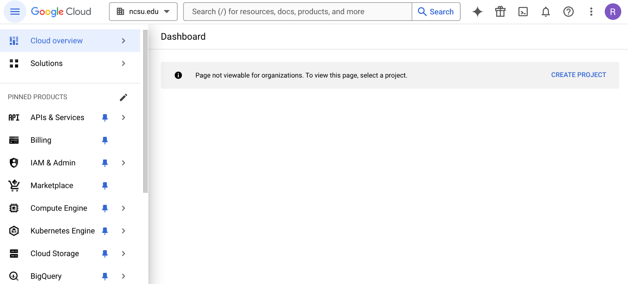

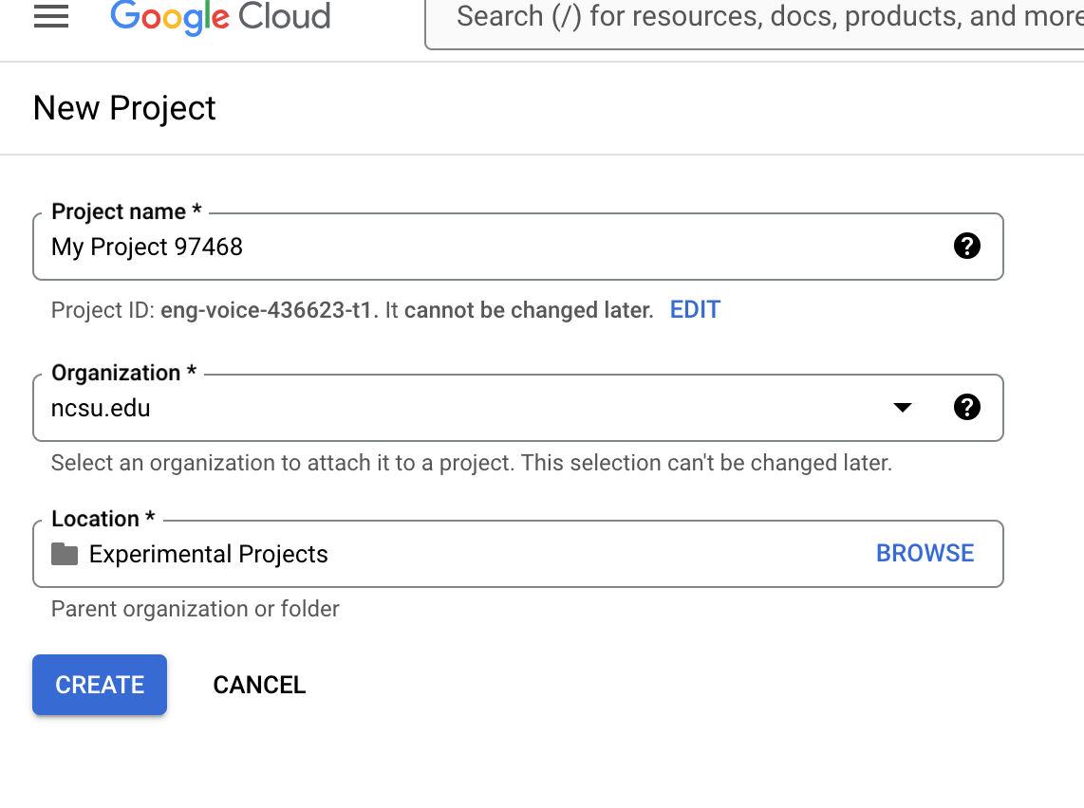

Named the project, ee-rc-tutorial1

**Mac Notes**

-In terminal navigate to folder OR copy the ee.yml file into your Downloads folder, use cd "Downloads" to navigate to that folder.

-Then activate the environment (>20 minutes)

-Followed [instructions](https://cloud.google.com/sdk/docs/install) to download gcloud (checking python and computer version), then unzipped in Downloads folder.

-Then ran this line at end of instructions - ./google-cloud-sdk/bin/gcloud init

-This line of code prompted me to sign in and select a cloud project

You must sign in to continue. Would you like to sign in (Y/n)? Y

Pick cloud project to use:

[1] ee-hughlynch-g4g24

[2] ee-rc-tutorial1

[3] Enter a project ID

[4] Create a new project

**activate ee environment, then type in authenticate earthengine

-Worked!