Northeastern University

Department of Electrical and Computer Engineering

# EECE 4638: **Wireless Design and Simulation**

Lecturer: ***Rahman Doost-Mohammady***

TAs:

**Subhramoy Mohanti**

Homework # 1 : Socket Programming

Group:

*Taylor Skilling (001171439)*

*Chris Kenyon (001112428)*

Semester: Summer II 2015

Date: August 3rd, 2015

Lab Session: *Monday-Thursday, 3:20 PM*

##### Lab Location: 429 Dana Research Lab, Northeastern University, Boston, MA 02115

##### Content Page

##### Introduction / Objective 3

##### Design Approach 4

##### Results and Analysis 5

1. **Introduction / Objectives**

The intent of this experiment is to examine the properties of mobile networks and how variables such as distance between the base station and end user, as well as power emitted from the base station, affect the connection and statistical data. Specifically, we will be creating an LTE network with position and mobility options, as well as configurable transmission power. The intent is to analyze the LTE network and examine the SINR and DlRlc statistics as they change with the change of the variables within the simulation, and connect that information with the ideas in practice in current cellular networks.

1. **Design Approach**

We will design this simulation using NS3 along with the help of some provided libraries. For setting up the LTE simulation, the LteHelper class from *ns3/lte-module.h* will be essential and allow us to configure the *PathlossModel* for analyzing loss over distance. The *config-store.h* and *mobility-module.h* will also be essential to set up the power and mobility variables of the network. *Ns3/radio-bearer-stats-calculator.h* provides methods for collecting the data from running the simulation. Specifically, we will be calling EnablePhyTraces() and EnableRlcTraces().

To set up the simulation, we will use two ENB nodes to represent the stations, as well as two UE nodes to represent the end users. Position allocators and mobility allocators will be made for each node, and then net devices will be made for each and installed. For changing the power, the ns3::LteEnbPhy::TxPower default value must be configured to a different value for one of the ENB nodes to simulate a different power. The UE nodes must then be attached to one of the ENB nodes, the data radio bearer needs to be activated, the data traces are enabled, and finally the simulation is run.

Changing the values and running waf to build the program will simulate the network and produce text files with the statistics.

1. **Results and Analysis**

From analyzing the data, we immediately see that there are very clear relationships between the distance, power, signal-to-noise-plus-interference ratio, and the number of bytes received per packet (throughput).

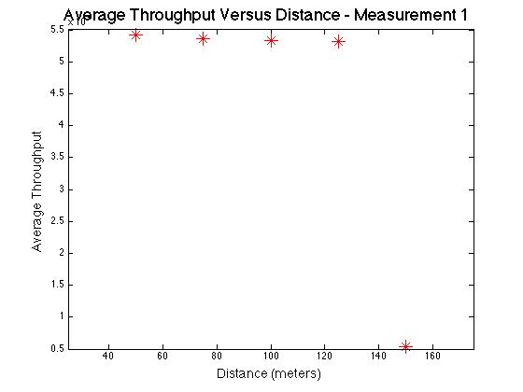

**Figure 1**

In the first simulation, we used a constant default TxPower of 20 and constant ENB positions of 0 and 250, yet varied the position on the first UE node. We ran the simulation 5 times, incrementing the position from 50m to 150m by 25 each time. From Figure 1, we see that there is a slight but noticeable decline in the average throughput of the data. At a distance of 150 m, there is a complete drop in the received bytes to 0. This is where the threshold of being able to receive the data lies, and the drop-off is very rapid considering the square relationship in the distance to the free-space path loss.

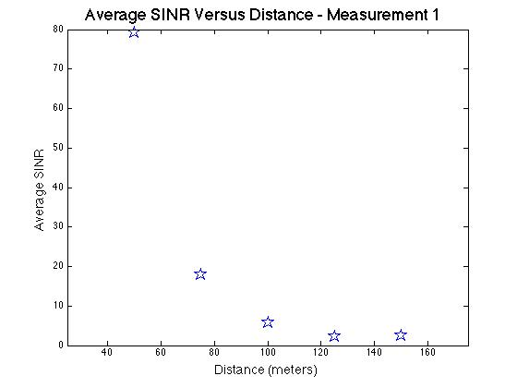

**Figure 2**

We also collected the SINR data from the first experiment. From Figure 2, we see that there is a direct relationship between the SINR and the distance between the ENB and UE nodes. Approaching 150 m, the SINR approaches 0, which explains the relationship we found from Figure 1.

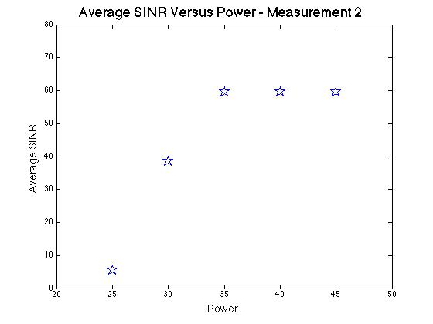

**Figure 3**

In the second simulation, we used a constant position on the first UE node and constant ENB positions of 0 and 250, yet varied default TxPower. We ran the simulation 5 times, incrementing the power from 25W to 45W, incrementing by 5 each time. From Figure 3, we see that the SINR increases about linearly with the power, but only up to an average value of 60 at a power of 35. This implies that increasing the power can only help to a certain degree where the SINR is not significantly improved beyond.

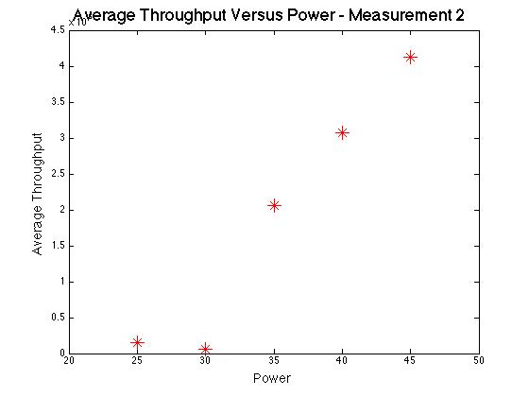

**Figure 4**

While the SINR may not increase significantly beyond 35W, the average throughput of the system consistently increases. It seems that there is a threshold where the number of packets being sent constantly increases, which we see at 30W in our data.