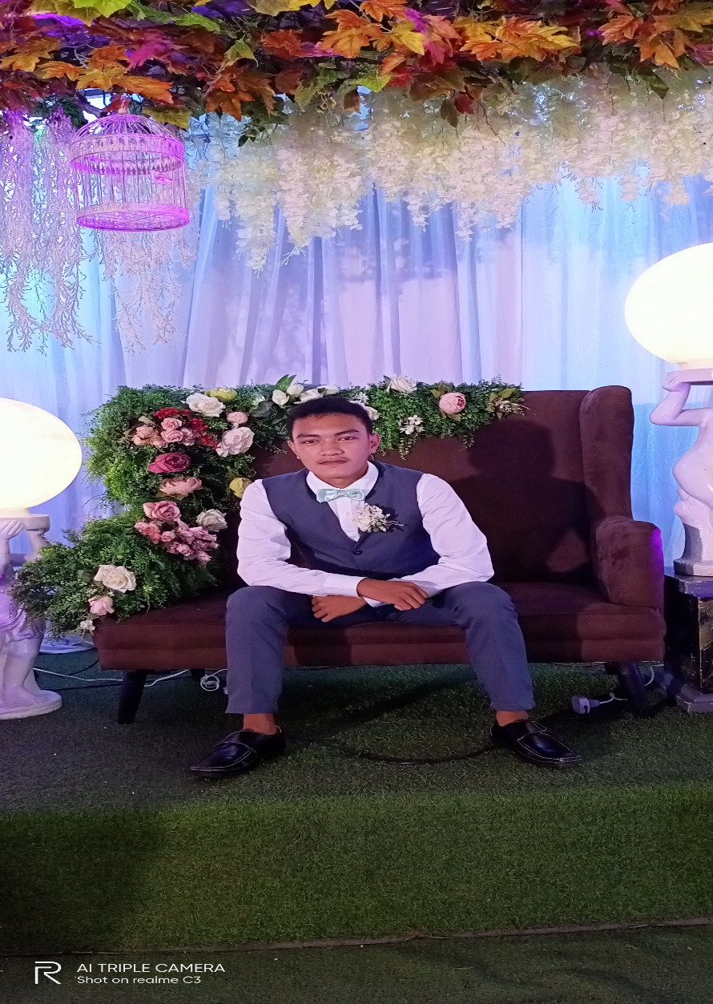Name: Christian Kit V. Rotairo

Address: Jugaban Carigara,Leyte

Hobbies: Playing Guitar