**Web Design and Development Project: Lavin’s Pet Essentials**

**Christopher Lavin**

Wireframes

(All subject to change)

**Mobile Home Page**

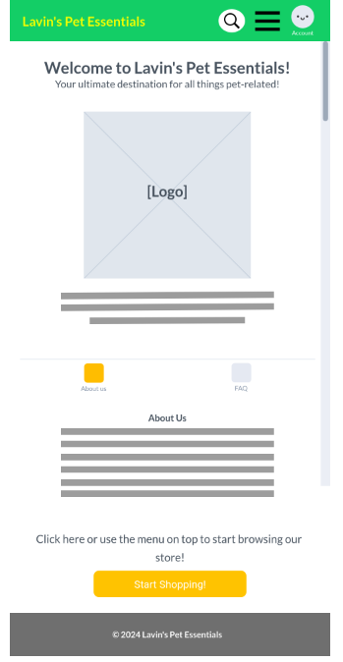

**

**Mobile Store Page**

**Desktop Store Page**