CST-310: Computer Graphics
Project 9: Advanced Shaders 1
Scene Composition, Basic Shaders, and Keyboard Camera Control

Christopher Luciano
College of Engineering and Technology, Grand Canyon University
CST-310: Computer Graphics
Instructor Name
August 4, 2026

Theoretical Background
Project 9 extends the checkerboard-scene starter kit into a composed OpenGL 4.1 scene containing all four required primitives — a checkerboard ground plane, a sphere, a cylinder, and a cube — each generated procedurally rather than loaded from a model file, plus a keyboard-driven virtual camera for inspecting the scene. The central theoretical idea running through the project is that a 3D surface, however organic it eventually looks, begins as a small closed-form parametric function: a plane is two linear parameters, a sphere is spherical coordinates, a cylinder is a single angular parameter swept along an axis, and a cube is six flat parameter squares. Sampling each function on a regular grid and connecting the samples with triangles is the whole of “mesh generation” for these shapes.
On top of the geometry, the project introduces basic per-object shading: instead of one placeholder material shared by every object, the sphere, cylinder, and cube each carry a distinct lightweight shading technique (a Fresnel-style rim, procedural bump mapping, and a procedural panel pattern respectively) that previews the more advanced version of the same idea Project 10 will implement in full. Finally, the camera is reworked from continuous free-fly polling into a discrete, keyboard-event-driven position-and-orientation model, matching the Project 9 Resource Guide's control scheme exactly so that every keystroke corresponds to one predictable, fixed change in the view.
Esthetically, the scene was composed with deliberate depth and spacing — objects staggered front-to-back and left-to-right rather than lined up in a row, with a static fractal-tree prop anchored well behind the three primitives — so that the navigation video demonstrates genuine spatial inspection rather than a flat, one-plane arrangement.

Mathematical Functions and Models

Checkerboard Plane
The ground plane is a single flat quad spanning ±size on X and Z at Y = 0, with UV coordinates scaled by 8 so the checkerboard pattern (computed later, in the fragment shader) repeats 8×8 times across its surface:
corners = { (-s,0,-s), (s,0,-s), (s,0,s), (-s,0,s) } where s = 8.0
normal = (0, 1, 0) for every vertex (flat, facing up)
uv = corner × 8.0 (tiled 8x for the checker repeat)
The pattern itself is procedural, computed per-fragment rather than from a texture: a fragment belongs to a “light” or “dark” tile depending on the parity of floor(u) + floor(v):
tile = (floor(u) + floor(v)) mod 2 < 1 → light tile, else dark tile

Sphere — Latitude/Longitude Parameterization
For stack index i ∈ [0, stacks] and slice index j ∈ [0, slices], the sphere sweeps a polar angle φ pole-to-pole and an azimuthal angle θ around the equator:
φ = π · i / stacks φ ∈ [0, π]
θ = 2π · j / slices θ ∈ [0, 2π]
x = sin(φ) · cos(θ)
y = cos(φ)
z = sin(φ) · sin(θ)
Because this is a unit sphere centered at the origin, the outward surface normal at every vertex is simply the position itself — N = (x, y, z) — with no separate normal computation required. UV is (j/slices, 1 − i/stacks), an equirectangular layout. Example: at i = stacks/2 (the equator) and j = 0, φ = π/2 and θ = 0, giving position (1, 0, 0) with normal (1, 0, 0) — a point on the +X equator, normal pointing straight out along +X, exactly as expected.

Cylinder
For slice index j ∈ [0, slices], with θ = 2πj/slices, the cylinder places one point on the top ring and one directly below it on the bottom ring:
top ring: (cosθ, 1, sinθ)
bottom ring: (cosθ, -1, sinθ)
This is a unit-radius, height-2 cylinder aligned with the Y axis; only the curved side wall is built (no end caps). Every point on the side wall satisfies x² + z² = 1 regardless of height, so the outward normal has no Y component: N = (cosθ, 0, sinθ), the same direction as the position's X/Z components. Example: at θ = π/2, the top-ring point is (0, 1, 1) with normal (0, 0, 1) — pointing straight out along +Z, independent of height, which is the defining property of a cylindrical side wall.

Cube
The cube uses 24 vertices (4 per face) rather than 8 shared corner vertices, so each face can carry its own constant normal and its own 0–1 UV square instead of the incorrect averaged normals a corner-indexed cube would produce:
for each of 6 faces:
normal = the face's outward axis, e.g. (0,0,1) for +Z, (1,0,0) for +X
corners = that face's four ±1 corners, wound CCW as seen from outside
uv = (0,0), (1,0), (1,1), (0,1) — same square every face
Six constant face normals plus a per-face UV square is the standard “flat-shaded, correctly-mapped” cube technique, trading vertex count (24 instead of 8) for correctness — a shared-corner cube would blend adjacent faces' normals together at each corner, producing incorrect, smeared lighting on what should be flat faces.

Keyboard Camera — Position + Yaw/Pitch/Roll
The camera stores a position and three Euler angles in degrees (yaw, pitch, roll), updated only by discrete keyboard events — never by per-frame polling or mouse movement — matching the Project 9 Resource Guide's control table exactly. Every frame, the current angles are turned into a single rotation matrix applied to the default look direction and up vector:
R = Ry(yaw) · Rx(pitch) · Rz(roll)
forward = R · (0, 0, -1)
up = R · (0, 1, 0)
view = lookAt(position, position + forward, up)
Order matters: building R as Ry·Rx·Rz and multiplying it onto a column vector applies Rz (roll) first, then Rx (pitch), then Ry (yaw) — so roll tilts the camera in its own local space before pitch and yaw reorient the whole thing, keeping roll feel like “tilt your head” rather than rotating around a world-space axis that would drift as the camera turns. Passing the rotated up vector (not world up) into lookAt is specifically what makes roll visible on screen, since the view matrix's up vector defines which direction reads as “top of screen.” Example: starting from yaw=pitch=roll=0 (facing −Z), pressing the roll key twice sets roll = 4°; R·(0,1,0) is then a vector tilted 4° from world-up, so the rendered horizon visibly tilts 4° even though the camera has not moved or turned.

Scene Layout
The three required objects are staged with intentional depth and spacing rather than lined up in a row:
- Sphere — near the camera's starting position, off to the left, at (−2.2, 1.0, 0.5).
- Cylinder — centered directly on the camera's initial straight-ahead path (x = 0, at (0, 1.0, −2.0)), so it is the first object the camera approaches head-on.
- Cube — farther back and to the right, at (2.6, 0.9, −3.5), rotated 25° around its vertical axis so it reads as deliberately placed rather than dropped in axis-aligned.
- Fractal tree (optional background element) — anchored at (−1.5, 0, −6.5), well behind the three primitives and slightly off-axis, giving the flythrough a background layer and a genuine sense of depth.
Positions were chosen so no two objects' bounding volumes overlap from any camera angle, while keeping the cylinder squarely in view from the camera's default orientation.

Basic Shaders
All three per-object techniques run inside one shared fragment shader (scene.frag), selected per draw call by an integer uShaderMode uniform, rather than four separate shader programs — a single “uber-shader” with a mode branch is simpler to manage for this small a set of effects. Each is a lightweight version of the technique Project 10 (Advanced Shaders 2) will implement in full.
Object | Technique | Intended Effect | Project 10 Upgrade
Sphere | Fresnel rim: Lambert diffuse + pow(1−N·V, 3) brightening at grazing angles | Hints at reflectivity without a real reflection | Full environment / cube-map reflection
Cylinder | Procedural bump mapping via analytic-derivative normal perturbation | Visible ridge relief generated from a formula, no texture | Refined / authored bump or normal map
Cube | Procedural panel pattern: UV-space seam grid via fract() + smoothstep | Visible surface structure / paneling | True parallax (height-map UV displacement) mapping
Ground | Procedural checkerboard from UV parity | Reference grid for scale and navigation | Unchanged

Sphere — Fresnel Rim
diff = max(dot(N, L), 0)
fres = pow(1 - max(dot(N, V), 0), 3)
color = mix(base * (0.18 + 0.82*diff), white, fres * 0.55)
V is the normalized vector from the surface point to the camera. dot(N, V) is near 1 where the surface faces the camera directly and near 0 at the silhouette edge (grazing angles), so 1 − dot(N,V) is small head-on and large at the rim; raising it to a power sharpens that falloff into a narrow bright band at the silhouette — the classic Fresnel-effect approximation, and a common cheap stand-in for “this surface is reflective” before implementing real environment mapping.

Cylinder — Procedural Bump Mapping
h(v) = sin(v * 40) * 0.05 (procedural “height map”)
dh/dv = cos(v * 40) * 40 * 0.05 (its exact derivative)
T = normalize(dFdx(worldPos)); B = normalize(cross(N, T)); T = normalize(cross(B, N))
N' = normalize(N - B * (dh/dv) * strength)
diff = max(dot(N', L), 0)
Rather than take a screen-space finite difference of the height value itself (dFdx(h)/dFdy(h)) — which shrinks toward zero as a surface covers more screen pixels, and was empirically invisible in an earlier version of this shader during the Topic 9 Lab Question 3 exercise — this uses the height field's closed-form derivative with respect to v and a tunable strength constant, keeping the ridge effect's visible strength independent of camera distance. The fix was verified with a side-by-side rendered comparison (bump vs. flat) during that earlier exercise before being reused directly here.

Cube — Procedural Panel Pattern
g = abs(fract(uv * 4 - 0.5) - 0.5)
seam = smoothstep(0, 0.05, min(g.x, g.y))
color = mix(base * 0.55, base, seam) * (0.18 + 0.82 * diff)
fract(uv*4 − 0.5) − 0.5 repeats a sawtooth four times across each face, centered so its zero-crossings fall at even panel boundaries. Taking the absolute value and the minimum across both axes finds how close a fragment is to either a horizontal or vertical seam line, and smoothstep turns that distance into a soft 0→1 mask. The result darkens narrow bands at regular UV intervals, reading as routed panel seams — inexpensive surface structure ahead of true parallax (height-map-driven UV displacement) mapping.

Algorithm: Mesh-Generation Logic
The flowchart below depicts the logic used to build all four primitives — checkerboard, sphere, cylinder, and cube — each of which runs once at program startup and fills a shared 8-float vertex layout (position + normal + UV) before being uploaded to the GPU as a VAO/VBO/EBO triple. The render loop then draws each mesh every frame, selecting its shading technique via the uShaderMode uniform.
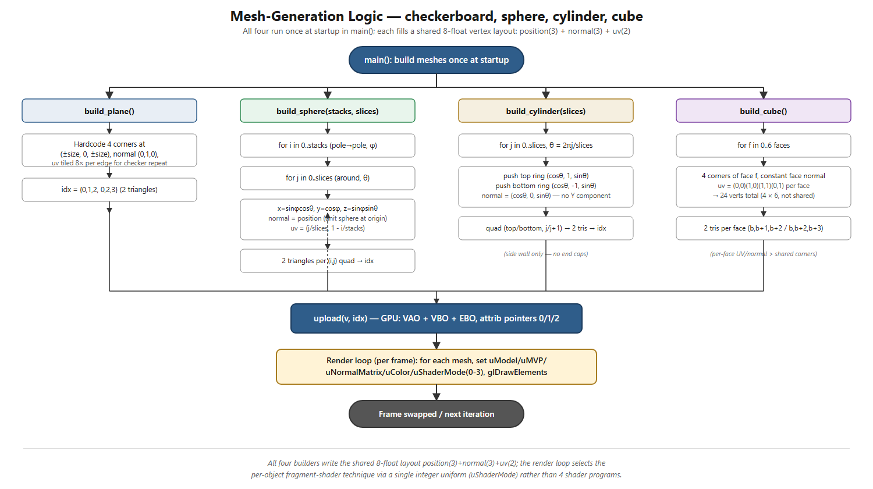
Figure 1. Mesh-generation logic for the checkerboard, sphere, cylinder, and cube.

Code: Primitive Mesh Generation
Complete, commented code from src/main.cpp that builds the checkerboard, sphere, cylinder, and cube meshes:

Checkerboard Plane
static void build_plane(std::vector<float>& v, std::vector<unsigned int>& idx) {
float size = 8.0f;
v = {
-size, 0.0f, -size, 0,1,0, 0.0f, 0.0f,
size, 0.0f, -size, 0,1,0, 8.0f, 0.0f,
size, 0.0f, size, 0,1,0, 8.0f, 8.0f,
-size, 0.0f, size, 0,1,0, 0.0f, 8.0f
};
idx = { 0, 1, 2, 0, 2, 3 };
}

Sphere
static void build_sphere(std::vector<float>& v, std::vector<unsigned int>& idx,
int stacks, int slices) {
v.clear(); idx.clear();
const float PI = 3.14159265f;
for(int i = 0; i <= stacks; ++i){
float phi = PI * float(i) / stacks;
float sphi = std::sin(phi), cphi = std::cos(phi);
for(int j = 0; j <= slices; ++j){
float theta = 2.0f * PI * float(j) / slices;
float stheta = std::sin(theta), ctheta = std::cos(theta);
float x = sphi * ctheta, y = cphi, z = sphi * stheta;
v.push_back(x); v.push_back(y); v.push_back(z);
v.push_back(x); v.push_back(y); v.push_back(z);
v.push_back(float(j)/slices); v.push_back(1.0f - float(i)/stacks);
}
}
int cols = slices + 1;
for(int i = 0; i < stacks; ++i){
for(int j = 0; j < slices; ++j){
unsigned int a = i*cols + j, b = (i+1)*cols + j, c = (i+1)*cols + j+1, d = i*cols + j+1;
idx.push_back(a); idx.push_back(b); idx.push_back(c);
idx.push_back(a); idx.push_back(c); idx.push_back(d);
}
}
}

Cylinder
static void build_cylinder(std::vector<float>& v, std::vector<unsigned int>& idx, int slices) {
v.clear(); idx.clear();
const float PI = 3.14159265f;
for(int j = 0; j <= slices; ++j){
float theta = 2.0f * PI * float(j) / slices;
float c = std::cos(theta), s = std::sin(theta);
// top ring
v.push_back(c); v.push_back(1.0f); v.push_back(s);
v.push_back(c); v.push_back(0); v.push_back(s);
v.push_back(float(j)/slices); v.push_back(1);
// bottom ring
v.push_back(c); v.push_back(-1.0f); v.push_back(s);
v.push_back(c); v.push_back(0); v.push_back(s);
v.push_back(float(j)/slices); v.push_back(0);
}
for(int j = 0; j < slices; ++j){
unsigned int a = j*2, b = j*2+1, c = (j+1)*2+1, d = (j+1)*2;
idx.push_back(a); idx.push_back(b); idx.push_back(c);
idx.push_back(a); idx.push_back(c); idx.push_back(d);
}
}

Cube
static void build_cube(std::vector<float>& v, std::vector<unsigned int>& idx) {
v.clear(); idx.clear();
// 24 verts (4 per face) so each face can have its own normal and UV.
struct F { glm::vec3 n; glm::vec3 c[4]; };
F faces[6] = {
{ glm::vec3( 0, 0, 1), {glm::vec3(-1,-1,1), glm::vec3(1,-1,1), glm::vec3(1,1,1), glm::vec3(-1,1,1)} },
{ glm::vec3( 0, 0,-1), {glm::vec3(1,-1,-1), glm::vec3(-1,-1,-1), glm::vec3(-1,1,-1), glm::vec3(1,1,-1)} },
{ glm::vec3( 1, 0, 0), {glm::vec3(1,-1,1), glm::vec3(1,-1,-1), glm::vec3(1,1,-1), glm::vec3(1,1,1)} },
{ glm::vec3(-1, 0, 0), {glm::vec3(-1,-1,-1), glm::vec3(-1,-1,1), glm::vec3(-1,1,1), glm::vec3(-1,1,-1)} },
{ glm::vec3( 0, 1, 0), {glm::vec3(-1,1,1), glm::vec3(1,1,1), glm::vec3(1,1,-1), glm::vec3(-1,1,-1)} },
{ glm::vec3( 0,-1, 0), {glm::vec3(-1,-1,-1), glm::vec3(1,-1,-1), glm::vec3(1,-1,1), glm::vec3(-1,-1,1)} },
};
float uv[8] = {0,0, 1,0, 1,1, 0,1};
for(int f = 0; f < 6; ++f) {
for(int i = 0; i < 4; ++i) {
v.push_back(faces[f].c[i].x); v.push_back(faces[f].c[i].y); v.push_back(faces[f].c[i].z);
v.push_back(faces[f].n.x); v.push_back(faces[f].n.y); v.push_back(faces[f].n.z);
v.push_back(uv[i*2]); v.push_back(uv[i*2 + 1]);
}
unsigned int b = f * 4;
idx.push_back(b); idx.push_back(b+1); idx.push_back(b+2);
idx.push_back(b); idx.push_back(b+2); idx.push_back(b+3);
}
}

Code: Virtual Camera Control
Complete, commented code that controls the virtual camera — discrete keyboard-event handling (matching the Resource Guide's table exactly) plus the per-frame view-matrix construction:

Camera State
// -----------------------------------------------------------------------------
// Camera state — position plus yaw/pitch/roll (degrees), driven entirely by
// discrete key events (Resource Guide's keyboard scheme), not continuous
// polling or mouse-look. yaw=pitch=roll=0 faces -Z, matching the scene's
// object layout (all objects sit at negative Z ahead of the camera).
// -----------------------------------------------------------------------------
static const glm::vec3 DEFAULT_POS(0.0f, 1.5f, 6.0f);
static const float DEFAULT_YAW = 0.0f, DEFAULT_PITCH = 0.0f, DEFAULT_ROLL = 0.0f;
static glm::vec3 g_pos = DEFAULT_POS;
static float g_yaw = DEFAULT_YAW, g_pitch = DEFAULT_PITCH, g_roll = DEFAULT_ROLL;

Keyboard Event Handling (key_cb)
// -----------------------------------------------------------------------------
// Camera control — implements the Project 9 Resource Guide's keyboard table
// exactly. Arrow keys mean three different things depending on the modifier
// held (plain = X/Y slide, Shift = Z slide, Ctrl = pitch/yaw), so the plain
// arrow keys and their modifiers have to be disambiguated in one callback
// rather than polled independently. GLFW_REPEAT is handled the same as
// GLFW_PRESS so holding a key keeps applying the same discrete step via the
// OS's own key-repeat timing, without needing a separate per-frame poll.
// -----------------------------------------------------------------------------
static void key_cb(GLFWwindow* w, int key, int, int action, int mods) {
if (action != GLFW_PRESS && action != GLFW_REPEAT) return;
bool shift = (mods & GLFW_MOD_SHIFT) != 0;
bool ctrl = (mods & GLFW_MOD_CONTROL) != 0;
if (key == GLFW_KEY_ESCAPE) { glfwSetWindowShouldClose(w, GLFW_TRUE); return; }
if (key == GLFW_KEY_R) { g_pos = DEFAULT_POS; g_yaw = DEFAULT_YAW; g_pitch = DEFAULT_PITCH; g_roll = DEFAULT_ROLL; return; }
if (key == GLFW_KEY_COMMA) { g_roll += 2.0f; return; } // '<' — change camera roll by 2 degrees
if (key == GLFW_KEY_PERIOD) { g_roll -= 2.0f; return; } // '>' — change camera roll by -2 degrees
if (key == GLFW_KEY_RIGHT) {
if (ctrl) g_yaw += 2.0f; // Control Right Arrow: yaw += 2 deg
else if (!shift) g_pos.x += 1.0f; // Right Arrow: slide +X
return;
}
if (key == GLFW_KEY_LEFT) {
if (ctrl) g_yaw -= 2.0f; // Control Left Arrow: yaw -= 2 deg
else if (!shift) g_pos.x -= 1.0f; // Left Arrow: slide -X
return;
}
if (key == GLFW_KEY_UP) {
if (ctrl) g_pitch -= 2.0f; // Control Up Arrow: pitch -= 2 deg
else if (shift) g_pos.z += 1.0f; // Shift Up Arrow: slide +Z ("in")
else g_pos.y += 1.0f; // Up Arrow: slide +Y
return;
}
if (key == GLFW_KEY_DOWN) {
if (ctrl) g_pitch += 2.0f; // Control Down Arrow: pitch += 2 deg
else if (shift) g_pos.z -= 1.0f; // Shift Down Arrow: slide -Z ("out")
else g_pos.y -= 1.0f; // Down Arrow: slide -Y
return;
}
}

Per-Frame View Matrix Construction
while(!glfwWindowShouldClose(win)){
// Camera orientation: build a rotation matrix from yaw (world Y),
// pitch (local X), and roll (local Z) — applied in that order so
// roll tilts the already-yawed-and-pitched view, not the world.
// forward/up are that rotation applied to the default -Z/+Y axes;
// passing the *rotated* up (not world up) into lookAt is what makes
// roll visible, since lookAt's up vector defines the view's "top".
glm::mat4 R = glm::mat4(1.0f);
R = glm::rotate(R, glm::radians(g_yaw), glm::vec3(0, 1, 0));
R = glm::rotate(R, glm::radians(g_pitch), glm::vec3(1, 0, 0));
R = glm::rotate(R, glm::radians(g_roll), glm::vec3(0, 0, 1));
glm::vec3 fwd = glm::normalize(glm::vec3(R * glm::vec4(0, 0, -1, 0)));
glm::vec3 up = glm::normalize(glm::vec3(R * glm::vec4(0, 1, 0, 0)));
glm::mat4 view = glm::lookAt(g_pos, g_pos + fwd, up);
glm::mat4 proj = glm::perspective(glm::radians(60.0f), static_cast<float>(fbw)/fbh, 0.1f, 100.0f);

Code: Fragment Shader (Basic Shading Modes)
Complete, commented fragment shader implementing the checkerboard plus the three per-object basic-shading techniques (shaders/scene.frag):
// scene.frag — basic per-object shading for Project 9. Each object gets a
// distinct, lightweight technique that Project 10 (Advanced Shaders 2) will
// replace with the full version of the same idea:
// mode 0 (ground) procedural checkerboard, Lambert + ambient
// mode 1 (sphere) Lambert + a Fresnel rim highlight — a cheap stand-in
// for reflectivity, ahead of real environment mapping
// mode 2 (cylinder) procedural bump mapping (analytic-derivative ridge
// pattern), ahead of a refined bump/normal map
// mode 3 (cube) a procedural panel/seam pattern giving the surface
// visible structure, ahead of true parallax mapping
#version 410 core
in vec3 vNormal;
in vec3 vWorldPos;
in vec2 vUV;
out vec4 FragColor;
uniform vec3 uLightDir;
uniform vec3 uEyePos;
uniform vec3 uColor;
uniform int uShaderMode; // 0=checkerboard, 1=sphere-fresnel, 2=cylinder-bump, 3=cube-panel
// ---- mode 2: procedural bump map (same technique verified in Lab Q3) ----
const float RIDGE_FREQ = 40.0;
const float RIDGE_AMP = 0.05;
float bumpHeightDv(vec2 uv) {
// Analytic d/dv of sin(v*RIDGE_FREQ)*RIDGE_AMP — using the closed-form
// derivative (not a screen-space dFdx/dFdy of the height itself) keeps
// the ridge strength constant regardless of camera distance.
return cos(uv.y * RIDGE_FREQ) * RIDGE_FREQ * RIDGE_AMP;
}
void main() {
vec3 N = normalize(vNormal);
vec3 L = normalize(uLightDir);
vec3 V = normalize(uEyePos - vWorldPos);
vec3 base = uColor;
if (uShaderMode == 0) {
// 1-meter check size — built from UV grid
bool tile = (mod(floor(vUV.x) + floor(vUV.y), 2.0)) < 0.5;
base = tile ? vec3(0.86, 0.84, 0.78) : vec3(0.18, 0.20, 0.25);
float diff = max(dot(N, L), 0.0);
FragColor = vec4(base * (0.18 + 0.82 * diff), 1.0);
return;
}
if (uShaderMode == 1) {
// Fresnel rim: grazing angles (N nearly perpendicular to V) brighten
// toward white, hinting at a reflective surface without an actual
// environment/cube map — Project 10 replaces this with real
// environment mapping.
float diff = max(dot(N, L), 0.0);
float fres = pow(1.0 - max(dot(N, V), 0.0), 3.0);
vec3 lit = base * (0.18 + 0.82 * diff);
vec3 color = mix(lit, vec3(1.0), fres * 0.55);
FragColor = vec4(color, 1.0);
return;
}
if (uShaderMode == 2) {
// Procedural bump mapping: perturb the shading normal along the
// bitangent by the ridge height field's analytic slope.
vec3 T = normalize(dFdx(vWorldPos));
vec3 B = normalize(cross(N, T));
T = normalize(cross(B, N));
const float STRENGTH = 6.0;
vec3 bumpedN = normalize(N - B * bumpHeightDv(vUV) * STRENGTH);
float diff = max(dot(bumpedN, L), 0.0);
FragColor = vec4(base * (0.18 + 0.82 * diff), 1.0);
return;
}
// uShaderMode == 3: procedural panel/seam pattern — cheap surface detail
// cue ahead of true parallax (height-map UV displacement) mapping.
vec2 g = abs(fract(vUV * 4.0 - 0.5) - 0.5);
float seam = smoothstep(0.0, 0.05, min(g.x, g.y));
vec3 panel = mix(base * 0.55, base, seam);
float diff = max(dot(N, L), 0.0);
FragColor = vec4(panel * (0.18 + 0.82 * diff), 1.0);
}

Vertex Shader (shaders/scene.vert)
#version 410 core
layout(location = 0) in vec3 aPos;
layout(location = 1) in vec3 aNormal;
layout(location = 2) in vec2 aUV;
uniform mat4 uMVP;
uniform mat4 uModel;
uniform mat3 uNormalMatrix;
out vec3 vNormal;
out vec3 vWorldPos;
out vec2 vUV;
void main() {
vec4 wp = uModel * vec4(aPos, 1.0);
vWorldPos = wp.xyz;
vNormal = normalize(uNormalMatrix * aNormal);
vUV = aUV;
gl_Position = uMVP * vec4(aPos, 1.0);
}

Screenshots
The following screenshots show the completed scene executing: the checkerboard ground plane, the sphere with its Fresnel rim, the cylinder with visible procedural bump ridges, the cube with its procedural panel seams, and the fractal-tree background prop, viewed from several camera positions reached using the real keyboard controls.
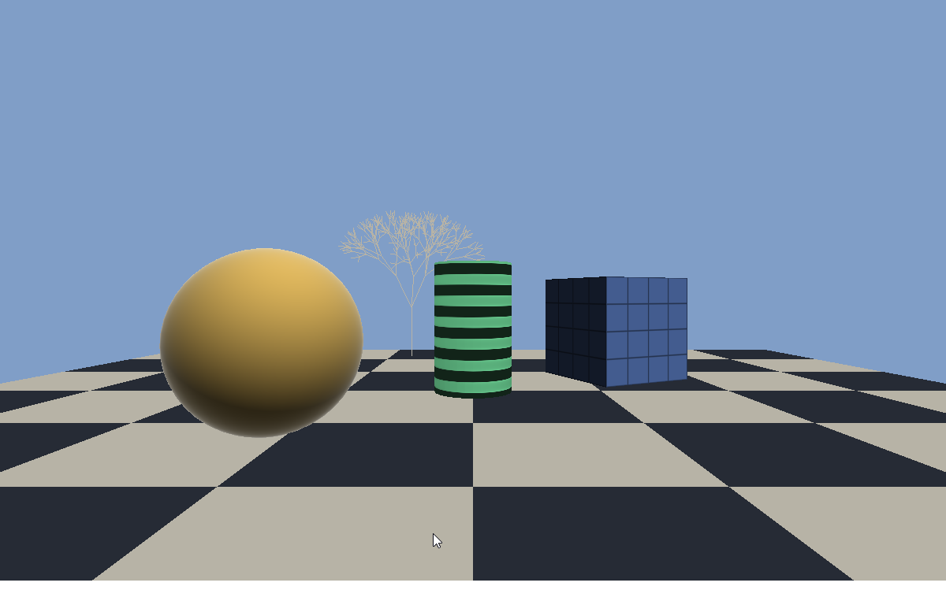
Figure 2. Establishing shot — all three basic shaders visibly distinct from the default camera position.
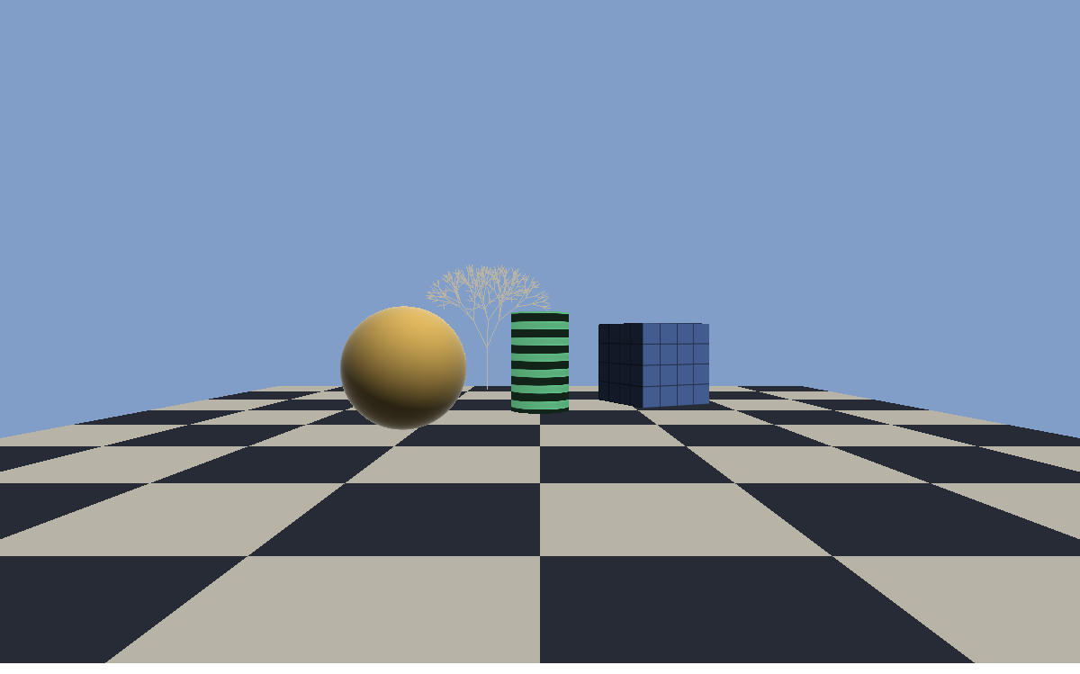
Figure 3. Camera slid closer via Shift+Up Arrow (positive-Z slide).
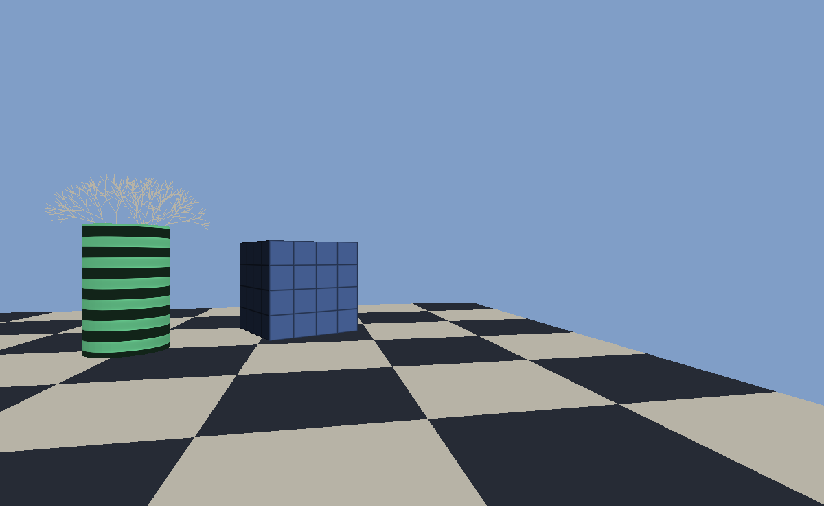
Figure 4. Camera reset, slid right, and yawed left (Ctrl+Left Arrow), framing the cube at an angle.

Navigation Video
A short video (see link below) shows the camera navigating across the checkerboard past all three objects using the real keyboard controls — sliding along X, sliding in along Z, yawing to reveal different cube faces, a visible roll (tilted horizon), a pitch change, and a reset back to the establishing framing.
Video (in repository): https://github.com/ChrisLuciano2/CST310-Project9-AdvancedShaders1/blob/master/docs/Project9_navigation.mp4

Build and Run Instructions
See the accompanying Readme.txt for full requirements and build instructions. Summary:
cmake --preset win-igpu
cmake --build --preset win-igpu --parallel
.\build\win-igpu\Release\topic_09_checkerboard_scene.exe
Controls: arrow keys slide the camera along X/Y; Shift+Up/Down slide along Z; Ctrl+arrows change yaw/pitch by 2°; “,”/“.” change roll by 2°; “r” resets to the default position and orientation; Esc closes the window.

Repository
Complete, commented source code, the README.md, Readme.txt, math derivations, screenshots, and navigation video are hosted at: https://github.com/ChrisLuciano2/CST310-Project9-AdvancedShaders1

References
Angel, E., & Shreiner, D. (2020). Interactive computer graphics: A top-down approach with WebGL (8th ed.). Pearson.
Khronos Group. (2024). OpenGL 4.1 core profile specification. https://www.khronos.org/registry/OpenGL/specs/gl/glspec41.core.pdf
Khronos Group. (2024). OpenGL shading language (GLSL) 4.10 specification. https://www.khronos.org/registry/OpenGL/specs/gl/GLSLangSpec.4.10.pdf
GLFW. (2024). GLFW documentation: Input guide. https://www.glfw.org/docs/latest/input_guide.html
OpenGL Wiki contributors. (2023). Bump mapping. Khronos OpenGL Wiki. https://www.khronos.org/opengl/wiki/Bump_Mapping
OpenGL Wiki contributors. (2023). Fresnel effect. Khronos OpenGL Wiki. https://www.khronos.org/opengl/wiki/Fresnel_effect
de Vries, J. (2024). Learn OpenGL: Advanced lighting — normal mapping. https://learnopengl.com/Advanced-Lighting/Normal-Mapping

