Documentation Packet [ 18 19 12 25 ] Dec 19th 2025
Student Name:
Goals:  - Conduct Performance Reviews and Design Meetings | Events:  - Two-Hour Delay Monday

Changes/Notes:

Assignments:

Design Meeting | Students in a Company Project
Conduct Scrum | Students in a Company Project
Completed Issues Documented | Students in a Company Project
Performance Review | All Students
Self-Study | Students not in a Company Project
Document Work Completed | All Students
DocPac and Reflections | All Students

Design Meeting
Early in the week, your company will be called back to do a design meeting. This is to establish goals and update the instructor on the progress of your project.

Self-Study
As an experiment, we will do one week of “Self-Study”. Determine a goal or activity and write it below. Use the time in class to work towards that goal. We will use the honor system for this one. Be sure to document what you accomplish each day as usual.

Conduct Scrum
- Elect a Scrum Master.
- The Scrum Master will use the flow chart to conduct the Scrum Meeting.
- Each member of the team will follow the directions for “Weekly Scrum” as per previous DocPacs.
- When the Scrum Master does an input/output step in the flow chart, every member writes down the answer to it in the table below the flow chart.
- Once the meeting is complete, each member is to start working on their issue(s).
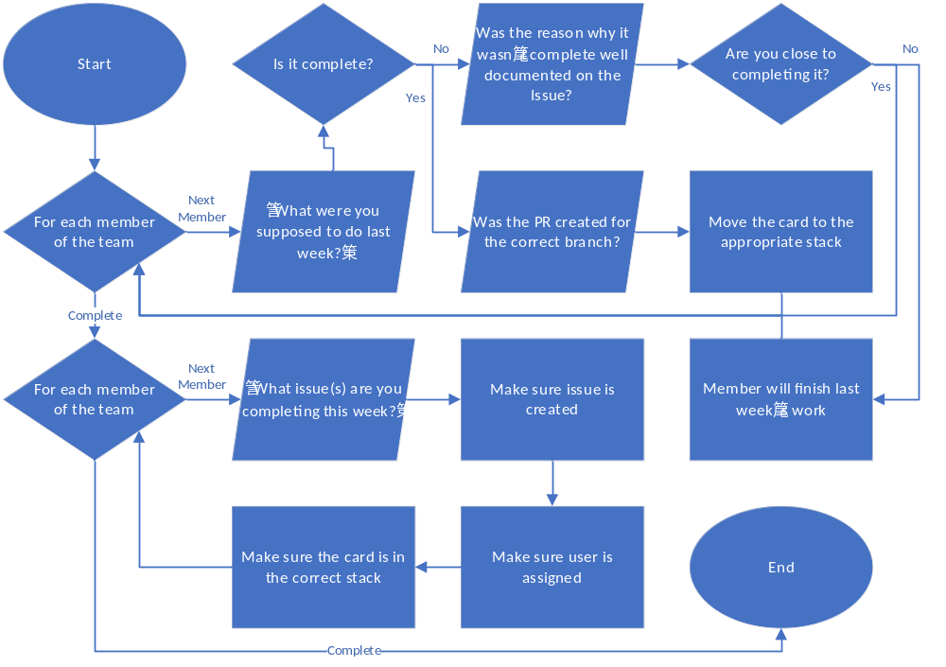
Member name
What issues are you completing this week?
Are the issues created, described, and in the correct project column?

Member name
What issues are you completing this week?
Are the issues created, described, and in the correct project column?

Member name
What issues are you completing this week?
Are the issues created, described, and in the correct project column?

Member name
What issues are you completing this week?
Are the issues created, described, and in the correct project column?

Completed Issue Documentation (Company Work)
Company / Project |  | Company / Project
Issue # |  | Issue #
PR submitting Fix |  | PR submitting Fix
Project Manager  Signature |  | Project Manager  Signature
Notes |  | Notes
Company / Project |  | Company / Project
Issue # |  | Issue #
PR submitting Fix |  | PR submitting Fix
Project Manager  Signature |  | Project Manager  Signature
Notes |  | Notes

Document Work Completed (Everyone)
Day 1
What did you work on?
What did you complete?
What were your delays?
Day 2

Day 3

Day 4

Day 5

Performance Review
Documentation of Work Done in Prior Two Weeks
Performance Notes
Employability Score
  Attitude | Punctuality
  Time Management | Initiative
  Completion | Progress
  Obligations | Devices
Previous Goals:
Improvement Goals:

Reflect on the Day
At the end of each day, mark each category for that day with a ‘1’ or ‘0’. Mark ‘1’ if you believe you were acceptable in that category. Mark ‘0’ if you believe you could improve.
Day |  | M | T | W | Th | F
 | Attitude
Mark ‘0’ if… | ...you were too tired, in a bad mood, or were not optimistic about the class/work.
Explain:
 | Punctuality
Mark ‘0’ if… | …you could have gotten closer to working immediately as the bell rang.
Explain:
 | Time Management
Mark ‘0’ if... | …you could have reduced the time not being productive.
Explain:
 | Initiative
Mark ‘0’ if... | …you did not exhaust all means of solving a problem before giving up.
Explain:
 | Completion
Mark ‘0’ if... | …you did the minimum on a task instead of doing it completely.
Explain:
 | Progress
Mark ‘0’ if... | …you completed less than projected in the amount of time you have to complete it.
Explain:
 | Obligations
Mark ‘0’ if... | …you did not deliver on or progress towards delivering on deals and promises you made.
Explain:
 | Misuse of Devices
Mark ‘0’ if... | …could have used your personal devices less, or not used school equipment inappropriately
Explain:

Reflect on the Week:
You got |  | 1’s out of
Where are your weakest points? What can you do to improve it (actionable plan)?

Reflections
What was one mistake you made in school or otherwise that you can recognize? What can you do in the future to prevent it from happening again?
More to come.

Grading

Conduct Scrum Company:________________________
1 | Had Meeting | Company conducted their meeting, and you were present
2 | Issues | Issues were assigned
3 | Documented | Issues were documented properly on the project’s repo.

Document Work Completed
1 | Clarity | Teacher is able to accurately determine what you worked on
2 | Time Management | The work you did reasonably matches the time given to do it

Completed Issue Documentation
1 | Time Management | Issues were completed in reasonable time
2 | Verified | Project Manager signed that you completed each issue
3 | Documentation | Issue and PR are properly documented on the Github Repo and in DocPac

DocPac and Reflection
1 | DocPac is turned in on time
2 | Answered each question in each prompt fully (no short answers)
3 | Spelling and handwriting
4 | DocPac is neatly folded
5 | DocPac is not stained or damaged
6 | No doodles, scribbles, or unnecessary writing
7 | No repeated answers from other DocPacs
8 | Did not paraphrase assigned work
9 | You are prepared to justify the use of any AI (you know what it does and why)
10 | “Reflect on the Day” are not graded, but will be audited at the end of the quarter.

