**ISYS3257**

**Second HomeWork Lab**

**Due 6:00PM Sunday night: 2/19/2017**

**(Please copy/paste both the Query syntax and results, on a single Word doc to Canvas)**

1. List the projects (id and title) that are run by managers who make more than $40,000.

select p.proj_id, p.proj_title from BC_EMPLOYEE e, BC_PROJECT p

where (p.proj_mgr = e.emp_id and e.emp_salary > 40000)

|  |  |
| --- | --- |
| **PROJ_ID** | **PROJ_TITLE** |
| 3 | New Storage |
| 4 | CRM Training |
| 10 | SAN Install |
| 1 | LAN Upgrade |
| 8 | Win2000 Upgrade |
| 2 | DBMS Upgrade |
| 7 | PurCard Linkage |
| 9 | Updt Web Srvrs |

1. List each person, with their manager’s name and the difference between their salary and their manager’s salary.

(Hint: you need to join the employee table to the department for the manager, then the department to another copy of the employee table for the employee).

select e1.emp_name, e2.emp_name, e2.emp_salary - e1.emp_salary

from BC_EMPLOYEE e1 left join BC_DEPT d on e1.emp_dept = d.dept_num left join BC_EMPLOYEE e2 on d.dept_mgr = e2.emp_id

|  |  |  |
| --- | --- | --- |
| **EMP_NAME** | **MANAGERNAME** | **E2.EMP_SALARY-E1.EMP_SALARY** |
| Jones,Ed | Jones,Ed | 0 |
| Smith,Linda | Jones,Ed | 3000 |
| Ames,Sally | Jones,Ed | 9000 |
| Murphy,Eileen | Smith,Linda | 7000 |
| Waller,David | Smith,Linda | 14500 |
| Tierney,Pat | Jones,Ed | 12500 |
| McDonald,Alex | Jones,Ed | 5000 |
| Torino,Paul | Jones,Ed | 5500 |
| Sawyer,Michelle | Jones,Ed | 3000 |
| Loggins,Brian | Jones,Ed | 10500 |
| Hanley,Kim | Jones,Ed | 10000 |
| Early,Alan | Tierney,Pat | -6000 |
| Torberg,Nancy | Smith,Linda | 20000 |
| Murphy,Mary | Jones,Ed | 21500 |
| Jones,Gary | Jones,Ed | 21000 |
| Geiger,Roy | Smith,Linda | 20500 |
| Sullivan,Jane | Jones,Ed | 17000 |
| Ramos,Peter | Tierney,Pat | 12000 |
| Robertson,Mark | Jones,Ed | 25000 |
| Eden,Janice | Jones,Ed | 19000 |
| Bridges,Judy | Jones,Ed | 14500 |
| Norris,Mike | Jones,Ed | 5500 |
| Riser,Sandy | Tierney,Pat | 13500 |
| Cerrino,Dan | Jones,Ed | 18000 |
| Kelly,Colleen | Jones,Ed | 11500 |

1. How much budget money, and how many budgets, is controlled by each budget manager (using the “bud_amt_orig” value)? Include the person’s name and title.

select e.emp_name, e.emp_title, t1.sumBudget, t1.numBudgets from

(select bud_mgr, sum(bud_amt_orig) sumBudget, count(b.bud_num) numBudgets

from BC_budget b

group by bud_mgr) t1 left join bc_employee e on t1.bud_mgr = e.emp_id

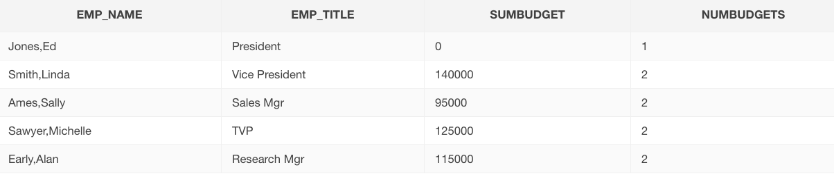

1. Which employees have the word “Mgr” (in any case) anywhere in their job title?

select emp_name from BC_EMPLOYEE where emp_title like '%Mgr%'

|  |
| --- |
| **EMP_NAME** |
| Ames,Sally |
| Murphy,Eileen |
| Torino,Paul |
| Early,Alan |

1. What is the total salary and number of staff managed by each department manager?

select dept_mgr, count(e.emp_id), sum(e.emp_salary)

from BC_dept d left join bc_employee e on d.dept_num = e.emp_dept

group by dept_mgr

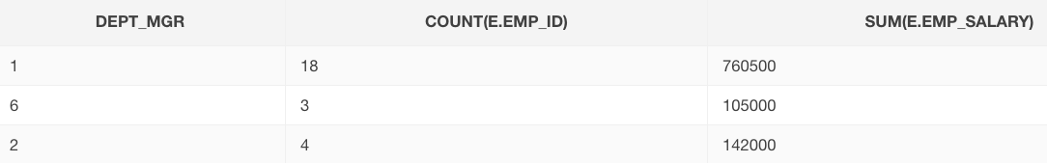

1. For each department, show the number of employees, less the manager, and the highest salary in the department, less the manager’s).

(Hint: Use a subquery to return the manager’s id, where the emp_id <> retuned value)

select d.dept_num, count(e.emp_id), max(e.emp_salary) from BC_dept d left join bc_employee e on d.dept_num = e.emp_Dept

where d.dept_mgr != e.emp_id

group by d.dept_num

|  |  |  |
| --- | --- | --- |
| **DEPT_NUM** | **COUNT(E.EMP_ID)** | **MAX(E.EMP_SALARY)** |
| 1 | 1 | 51000 |
| 2 | 4 | 45000 |
| 3 | 4 | 44000 |
| 4 | 5 | 49000 |
| 5 | 2 | 32500 |
| 6 | 5 | 51000 |
| 7 | 3 | 47500 |

1. List the people’s names and job titles who manage projects started in the last month (i.e. proj_start is greater than sysdate-30).

select distinct e.emp_name, e.emp_title from bc_project p, bc_employee e

where p.proj_start > sysdate-30 and p.proj_mgr = e.emp_id

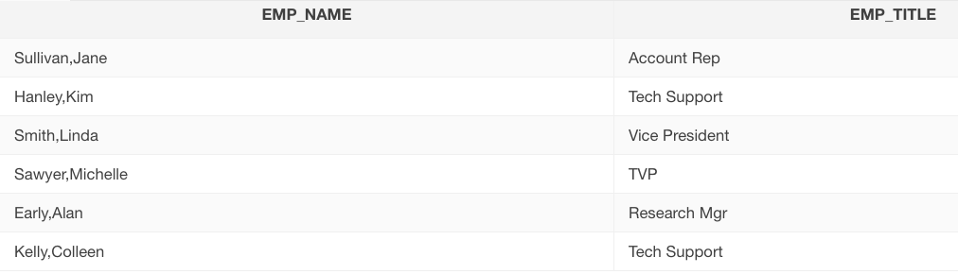

1. Who makes the most money in each department, and how much is that?

(Hint: Use a dependent subquery that returns the maximum salary in the dept. Select the person who has that salary).

select dept_num, e1.emp_name, e1.emp_salary from (select d.dept_num, max(e.emp_salary) topSal from bc_dept d left join bc_employee e on d.dept_num = e.emp_dept group by d.dept_num), bc_employee e1

where topSal = e1.emp_salary

order by dept_num ASC

|  |  |  |
| --- | --- | --- |
| **DEPT_NUM** | **EMP_NAME** | **EMP_SALARY** |
| 1 | Jones,Ed | 54000 |
| 2 | Ames,Sally | 45000 |
| 3 | Hanley,Kim | 44000 |
| 3 | Murphy,Eileen | 44000 |
| 4 | McDonald,Alex | 49000 |
| 5 | Murphy,Mary | 32500 |
| 6 | Sawyer,Michelle | 51000 |
| 6 | Smith,Linda | 51000 |
| 7 | Early,Alan | 47500 |

1. Who acts as both a project manager and a budget manager? List their name, department name and job title. (Hint: use 2 subqueries each returning a list. Then select the emp_ids that are IN both lists).

select distinct emp_name, emp_title from BC_project, Bc_budget, BC_employee

where emp_id = bud_mgr and bud_mgr = proj_mgr

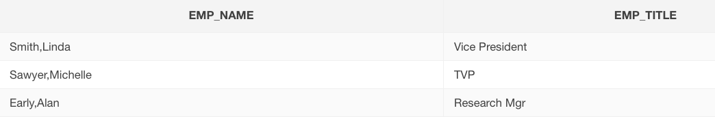

1. List **every** project, along with the project manager’s name, if there is one.

(Hnt: Outer join issue)

select emp_name, proj_id, proj_title, proj_mgr

from bc_project p right outer join bc_employee e on p.proj_mgr = e.emp_id

where proj_mgr is not null

|  |  |  |  |
| --- | --- | --- | --- |
| **EMP_NAME** | **PROJ_ID** | **PROJ_TITLE** | **PROJ_MGR** |
| Smith,Linda | 3 | New Storage | 2 |
| Murphy,Eileen | 4 | CRM Training | 4 |
| Sawyer,Michelle | 10 | SAN Install | 9 |
| Loggins,Brian | 1 | LAN Upgrade | 10 |
| Hanley,Kim | 8 | Win2000 Upgrade | 11 |
| Hanley,Kim | 2 | DBMS Upgrade | 11 |
| Early,Alan | 7 | PurCard Linkage | 12 |
| Sullivan,Jane | 6 | Help Desk Updt | 17 |
| Sullivan,Jane | 5 | Inventory Mgmt | 17 |
| Kelly,Colleen | 9 | Updt Web Srvrs | 25 |