Given the following tables, please generate the SQL syntax to provide the requested reports. Tables are available in the mi257 schema.

Doctor

ID number(4) primary key

name varchar2(20) /* Last,First */

Disease

dis_code char(3) primary key

name varchar2(20)

contagion number(1) /* 0=none, 5=highest */

Expertise

exp_key number(5) primary key /* sequence # */

disease char(3) references disease(dis_code),

ID number(4) references doctor(ID)

Patient

ID number(5) primary key

name varchar2(20) /* Last,First */

doctor number(4) references doctor(ID)

room_code char(3) /* 1st digit is floor */

disease char(3) references disease(code)

med_ins varchar2(10) /* Name of carrier */

bill_amt number(9,2)

admit_dt date

release_dt date /* null until patient is released */

# How many current patients on each floor were admitted on a Friday? Sort the answer by the floor. (Floor is 1st position on room ID.. Current patients have ‘null’ release_dt)

select ID, NAME, DOCTOR, ROOM_CODE, to_char(admit_dt, 'Day mm/dd/yyy') "Date_Admitted", admit_dt, release_dt from mi257.Patient

where room_code LIKE '1%' and to_char(admit_dt, 'Day mm/dd/yyy') LIKE 'Friday%' and (release_dt > sysdate or release_dt is null)

order by room_code



1. Which medical insurer codes are not all capitalized?

select med_ins from mi257.Patient

where upper(MED_INS) <> MED_INS

group by med_ins

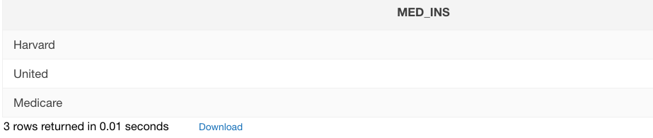

1. For each floor, which CURRENT patient has been there the longest (i.e. has the oldest admit date)?

select * from

(select * from mi257.Patient where substr(room_code, 1,1) = 1 order by sysdate-admit_dt DESC) t1

where ROWNUM = 1

union

select * from

(select * from mi257.Patient where substr(room_code, 1,1) = 2 and (release_dt > sysdate or release_dt is null) order by sysdate-admit_dt DESC)

where ROWNUM = 1

union

select * from

(select * from mi257.Patient where substr(room_code, 1,1) = 3 and (release_dt > sysdate or release_dt is null) order by sysdate-admit_dt DESC) t1

where rownum <= 3

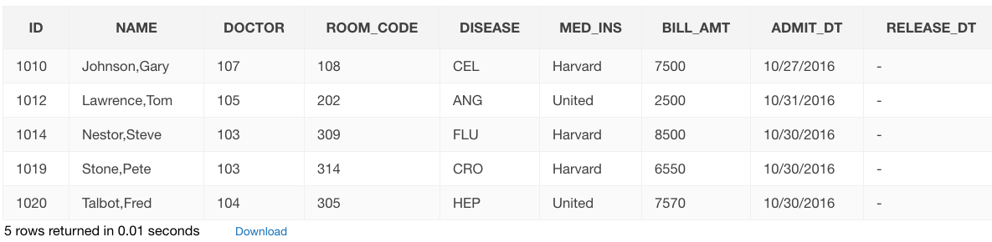

1. Select all doctors (ID, name) who have treated contagion 5 diseases (i.e. the doctor has had patients with that disease).

select Distinct Doc.ID, Doc.name from mi257.doctor Doc, mi257.patient Pat, mi257.disease Dis where Doc.id = Pat.doctor and Pat.Disease = Dis.dis_code and contagion = 5

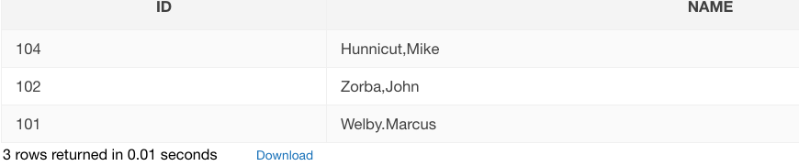

1. List any doctors (Id, name) who have more than 3 current patients.
2. List each disease, assigning it to a “contagion group” which is “low” for contagion levels 0 and 1, “moderate” for contagion levels 2 and 3 and “high” for levels 4 and 5. Sort the results by contagion group, then by disease name within the group. (Union?, Case?)
3. List the doctors (ID and name) with their disease expertise where they never treted a patient with that disease.

select doc.id, doc.name, pat.disease from mi257.patient pat, mi257.doctor doc where pat.doctor = doc.id

and not exists(select * from mi257.expertise exp where exp.disease = pat.disease and doc.id = exp.id)

