**Project 1**

Title

**War! V1**

**Card Game**

Course

**CSC-5**

Section

**40771**

Due Date

**February 6, 2020**

Author

**Christopher Mathis**

**Introduction**

Title: War!

This is the well-known card game War! very popular among children, known for its’ easy to follow and straight forward ruleset. It consists of usually two players whom each have 26 cards (half a deck of cards), the players are to not look at the cards; they are to proceed by both flipping the top card over. Whoever had the higher ranked card, wins that round and gets the losers’ card (suit does not matter in this game, neither does color). However if both players flip the same rank, then the game proceeds to War!, where each player puts down three cards face down and then flips another card from their deck. Whoever had the higher rank, wins the war; if the players flip the same rank again then War! proceeds again in a loop until a winner is declared. In the extremely unlikely event that a war proceeds until both players only have one card left to flip each then they would flip a coin to see who wins the game. The game ends when one player has all fifty-two cards and conversely the other player has zero.

**Summary**

Project Size: About 1200 lines

The Number of Variables: 19

The Number of Concepts: 31

In this version of War! the game is fully functional except for the ability to have continual wars (until both players have only one card left to flip); in this version, you can get two wars but to see who the winner is for the second war, you flip a coin. The other thing excluded is the ability to not have repeat cards, due to using a random number generator; I attempted to use files like the example provided in lab of unique card pull, but unfortunately that doesn’t allow for the correct comparison of the card ranks (some suits would be higher no matter the rank).

I implemented as many concepts as I could, only things I could not figure out how to implement was the math library (the only computation was for percentage) and the for loop (the do-while and while loops were more useful and convenient just based upon the way the game works).

This game has possibilities for later and more advanced concepts, like functions, arrays, as well as sorting/searching.

It took about a week (around 30 - 35 hours) this includes the thought process/brainstorming as well the actual coding, flowcharting, and write-up. I ran into two issues that I have discussed above, which I should be able to figure out for the second project. I am satisfied with this version for the first project, but for the second I need to figure out the issues I experienced. Nonetheless, it was a good experience and good learning tool.

**Screenshots**

**Cross Reference for Project 1**

|  |  |  |  |  |  |
| --- | --- | --- | --- | --- | --- |
| **Chapter** | **Section** | **Topic** | **Where Line #''s** | **Pts** | **Notes** |
| 2 | 2 | cout | Line 45 |  |  |
|  | 3 | libraries | Line 8 | 8 | iostream, iomanip, cmath, cstdlib, fstream, string, ctime |
|  | 4 | variables/literals | Line 27 |  | No variables in global area, failed project! |
|  | 5 | Identifiers | Line 31 |  |  |
|  | 6 | Integers | Line 30 | 3 |  |
|  | 7 | Characters | Line 29 | 3 |  |
|  | 8 | Strings | Line 35 | 3 |  |
|  | 9 | Floats No Doubles | Line 34 | 3 | Using doubles will fail the project, floats OK! |
|  | 10 | Bools | Line 28 | 4 |  |
|  | 11 | Sizeof ***** |  |  |  |
|  | 12 | Variables 7 characters or less | Line 32 |  | All variables <= 7 characters |
|  | 13 | Scope ***** No Global Variables |  |  |  |
|  | 14 | Arithmetic operators | Line 63 |  |  |
|  | 15 | Comments 20%+ | Line 42 | 5 | Model as pseudo code |
|  | 16 | Named Constants | Line 17 |  | All Local, only Conversions/Physics/Math in Global area |
|  | 17 | Programming Style ***** Emulate |  |  | Emulate style in book/in class repositiory |
|  |  |  |  |  |  |
| 3 | 1 | cin | Line 51 |  |  |
|  | 2 | Math Expression | Line 1182 |  |  |
|  | 3 | Mixing data types **** |  |  |  |
|  | 4 | Overflow/Underflow **** |  |  |  |
|  | 5 | Type Casting | Line 1183 | 4 |  |
|  | 6 | Multiple assignment ***** |  |  |  |
|  | 7 | Formatting output | Line 1193 | 4 |  |
|  | 8 | Strings | Line 70 | 3 |  |
|  | 9 | Math Library | N/A | 4 | All libraries included have to be used |
|  | 10 | Hand tracing ****** |  |  |  |
|  |  |  |  |  |  |
| 4 | 1 | Relational Operators | Line 130 |  |  |
|  | 2 | if | Line 55 | 4 | Independent if |
|  | 4 | If-else | Line 265 – Line 274 | 4 |  |
|  | 5 | Nesting | Line 152 – Line 164 | 4 |  |
|  | 6 | If-else-if | Line 130 - 141 | 4 |  |
|  | 7 | Flags ***** |  |  |  |
|  | 8 | Logical operators | Line 52 | 4 |  |
|  | 11 | Validating user input | Line 75 | 4 |  |
|  | 13 | Conditional Operator | Line 1169 | 4 |  |
|  | 14 | Switch | Line 83 | 4 |  |
|  |  |  |  |  |  |
| 5 | 1 | Increment/Decrement | Line 133 | 4 |  |
|  | 2 | While | Line 164 | 4 |  |
|  | 5 | Do-while | Line 61 – Line 1173 | 4 |  |
|  | 6 | For loop | N/A | 4 |  |
|  | 11 | Files input/output both | Line 45 – Line 1192 | 8 |  |
|  | 12 | No breaks in loops ****** |  |  | Failed Project if included |
|  |  |  |  |  |  |
|  |  |  |  |  |  |
| ****** Not required to show | | | Total | 100 |  |

|  |  |  |  |
| --- | --- | --- | --- |
| **Type** | **Variable Name** | **Description** | **Location** |
| unsigned int | pRank | Rank Of Player Card | main() |
|  | cRank | Rank Of Computer Card | main() |
|  | pSuit | Suit Of Player Card | main() |
|  | cSuit | Suit Of Computer Card | main() |
|  | player | Counter Of Player Cards | main() |
|  | comp | Counter Of Computer Cards | main() |
|  | coin | Flipped Coin (1 or 0) | main() |
|  | flip | Input From User To Flip A Coin | main() |
|  | nRounds | Number Of Rounds Played | main() |
|  | pWin | Counter Of Player Wins | main() |
|  | cWin | Counter Of Computer Wins | main() |
| string | msg | Opening Message From File | main() |
|  | cnt | Statement To Continue or Game Is Over (Ternary Operator) | main() |
| float | pPerc | Percentage Of Player Wins | main() |
|  | cPerc | Percentage Of Computer Wins | main() |
| fstream | in | In From File | main() |
|  | out | Out To File | main() |
| char | Choice | Input From User | main() |
| bool | play | Boolean To Start or Exit Game | main() |

**Major Variables**

**Pseudo Code**

*Comments (Name, Date, Etc)*

*System Libraries*

*Percentage Conversion*

*Main() Execution Begins*

*Set Random Number Seed*

*Initialize*

*Display Opening Message Using Files*

*While Loop to Output Whole File*

*Boolean Test To Start or Exit Game*

*If input isn’t Y or y*

*Its false*

*If it is false*

*Exit Game*

*Do-While Loop To Continue Game*

*Prompt To Flip Cards*

*While Loop To Validate Input*

*Flip Cards*

*If Player Rank Is Greater*

*Statements*

*Counters*

*Else if Computer Rank Is Greater*

*Statements*

*Counters*

*Else if Player Rank Equals Computer Rank & Cards Are Greater Than 4*

*Statements*

*Prompt To Flip Cards*

*While Loop To Validate Input*

*Flip Cards*

*If Player Rank Is Greater*

*Statements*

*Counters*

*Else if Computer Rank Is Greater*

*Statements*

*Counters*

*Else*

*Statements*

*Prompt To Flip Coin*

*While Loop To Validate Input*

*Flip Coin*

*If Win Coin Flip*

*Statements*

*Counters*

*Else*

*Statements*

*Counters*

*Else if Player Rank Equals Computer Rank & Player Has 4 Cards*

*Statements*

*Prompt To Flip*

*While loop To Validate Input*

*Flip Cards*

*If Player Rank Is Greater*

*Statements*

*Counters*

*Else if Computer Rank Is Greater*

*Statements*

*Counters*

*Else*

*Statements*

*Prompt To Flip Coin*

*While Loop To Validate Input*

*Flip Coin*

*If Win Coin Flip*

*Statements*

*Counters*

*Else*

*Statements*

*Counters*

*Else if Player Rank Equals Computer Rank & Computer Has 4 Cards*

*Statements*

*Prompt To Flip*

*While loop To Validate Input*

*Flip Cards*

*If Player Rank Is Greater*

*Statements*

*Counters*

*Else if Computer Rank Is Greater*

*Statements*

*Counters*

*Else*

*Statements*

*Prompt To Flip Coin*

*While Loop To Validate Input*

*Flip Coin*

*If Win Coin Flip*

*Statements*

*Counters*

*Else*

*Statements*

*Counters*

*Else if Player Rank Equals Computer Rank & Player Has 3 Cards*

*Statements*

*Prompt To Flip*

*While loop To Validate Input*

*Flip Cards*

*If Player Rank Is Greater*

*Statements*

*Counters*

*Else if Computer Rank Is Greater*

*Statements*

*Counters*

*Else*

*Statements*

*Prompt To Flip Coin*

*While Loop To Validate Input*

*Flip Coin*

*If Win Coin Flip*

*Statements*

*Counters*

*Else*

*Statements*

*Counters*

*Else if Player Rank Equals Computer Rank & Computer Has 3 Cards*

*Statements*

*Prompt To Flip*

*While loop To Validate Input*

*Flip Cards*

*If Player Rank Is Greater*

*Statements*

*Counters*

*Else if Computer Rank Is Greater*

*Statements*

*Counters*

*Else*

*Statements*

*Prompt To Flip Coin*

*While Loop To Validate Input*

*Flip Coin*

*If Win Coin Flip*

*Statements*

*Counters*

*Else*

*Statements*

*Counters*

*Else if Player Rank Equals Computer Rank & Player Has 2 Cards*

*Statements*

*Prompt To Flip*

*While loop To Validate Input*

*Flip Cards*

*If Player Rank Is Greater*

*Statements*

*Counters*

*Else if Computer Rank Is Greater*

*Statements*

*Counters*

*Else*

*Statements*

*Prompt To Flip Coin*

*While Loop To Validate Input*

*Flip Coin*

*If Win Coin Flip*

*Statements*

*Counters*

*Else*

*Statements*

*Counters*

*Else if Player Rank Equals Computer Rank & Computer Has 2 Cards*

*Statements*

*Prompt To Flip*

*While loop To Validate Input*

*Flip Cards*

*If Player Rank Is Greater*

*Statements*

*Counters*

*Else if Computer Rank Is Greater*

*Statements*

*Counters*

*Else*

*Statements*

*Prompt To Flip Coin*

*While Loop To Validate Input*

*Flip Coin*

*If Win Coin Flip*

*Statements*

*Counters*

*Else*

*Statements*

*Counters*

*Else if Player Rank Equals Computer Rank & Player Has 1 Card*

*Statements*

*Prompt To Flip Coin*

*While Loop To Validate Input*

*Flip Coin*

*If Win Coin Flip*

*Statements*

*Counters*

*Else*

*Statements*

*Counters*

*Else if Player Rank Equals Computer Rank & Computer Has 1 Card*

*Statements*

*Prompt To Flip Coin*

*While Loop To Validate Input*

*Flip Coin*

*If Win Coin Flip*

*Statements*

*Counters*

*Else*

*Statements*

*Counters*

*Counter For Rounds*

*Ternary Operator For Continuing Game Or Game Over Statements*

*While Loop To Continue Game (Less Than 52 Cards)*

*If Player Card Equals 52*

*Statement*

*If Computer Card Equals 52*

*Statement*

*Calculate Percentages of Wins*

*Statements Of Stats*

*Output Stats To File*

*Close Files*

*Return (Exit Program)*

**Flowchart**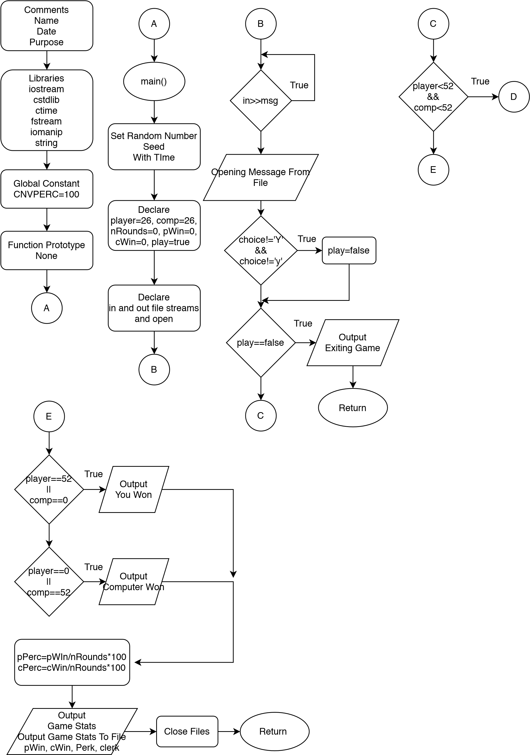

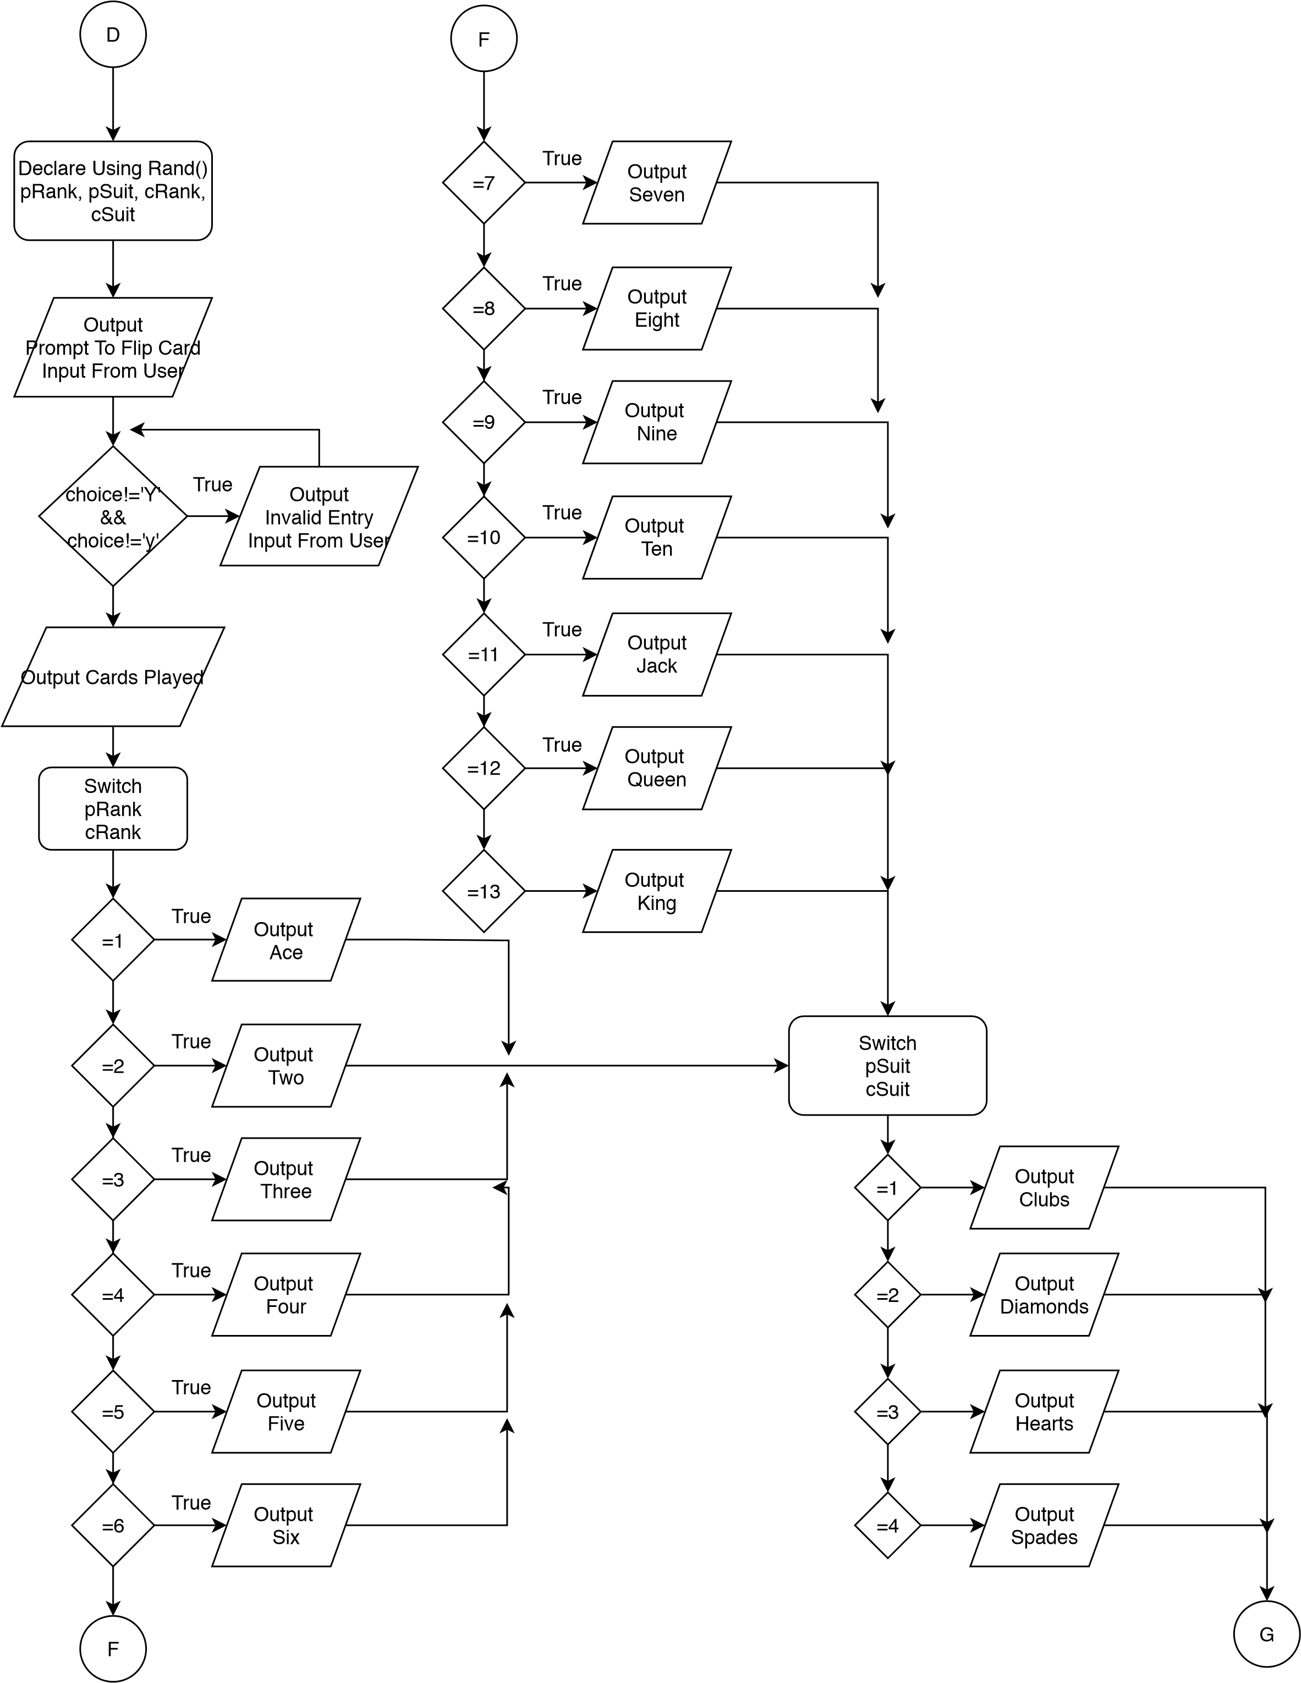

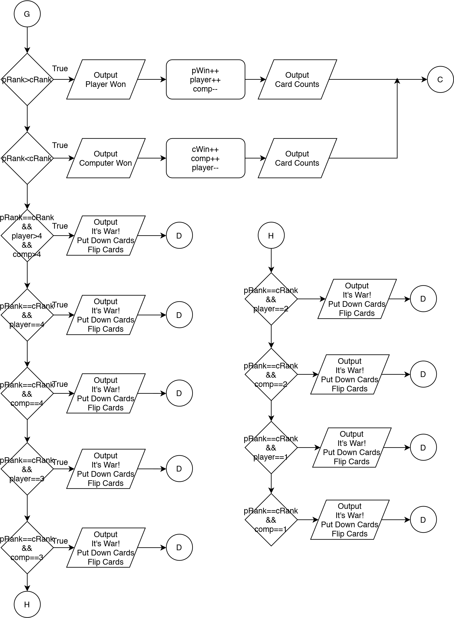

**Program**

/*

* Author: Christopher Mathis

* Created: February 5, 2020

* Purpose: Project 1

*/

//System Libraries

#include <iostream> //Input/Output

#include <iomanip> //Format

#include <ctime> //Time

#include <cstdlib> //Srand/Rand

#include <string> //Strings

#include <fstream> //File I/O

**using** **namespace** std;//Standard Name-Space Where Systm Libraries Exist

//Global Constants

**const** **float** CNVPERC=100;//Conversion From Decimal To Percent

//Execution Begins Here

**int** main(**int** argc, **char**\*\* argv) {

//Set Random Number seed

srand(**static_cast**<**unsigned** **int**>(time(0)));

//Declare Variables

ifstream in; //In From File

ofstream out; //Out To File

string msg; //String To Use For Input From File

**bool** play; //Boolean To Start Or Exit Game

**char** choice; //player Input To Flip Card

**unsigned** **int** pRank, pSuit, cRank, cSuit; //Rank and Suit Of Cards

**unsigned** **int** player, comp; //Counter For Amount of Cards Each Have

**unsigned** **int** coin, flip; //Input Used For Continuing Game

**unsigned** **int** nRounds, pWin, cWin; //Counters For Statistics

**float** pPerc, cPerc; //Percentage Of Rounds Won

string cnt; //Statement Variable Used With Ternary Operator

//Initialize Variables

player=comp=26;//Both Start With Half The Deck (26 Cards)

nRounds=pWin=cWin=0;

play=**true**;

//Display Beginning Message Using File

in.open("beg.dat");

out.open("stat.dat");

**while**(in>>msg){//While Loop To Output Everything From File

cout<<msg<<" ";

}

//Boolean Test To Start Or Exit Game

cout<<endl;

cin>>choice;

**if**(choice!='Y' && choice!='y'){

play=**false**;

}

**if**(play==**false**){

cout<<"Exiting Game.";

**return** 0;

}

//Do-While Loop to Continue the Game

**do**{

//Random Generator To Get Card Value and Suits

pRank=rand()%13+1;

pSuit=rand()%4+1;

cRank=rand()%13+1;

cSuit=rand()%4+1;

//Prompt To Flip Cards

cout<<endl;

cout<<"To Flip The Card, Press Y.\n";

cin>>choice;

cout<<endl;

//While Loop to Validate input

**while**(choice!='Y' && choice!='y'){

cout<<"Invalid Entry, Please Press Y To Flip The Card.\n";

cin>>choice;

cout<<endl;

}

//Flip Cards, Reveal Rank As Well As Suit

cout<<"Player Played ";

**switch**(pRank){

**case** 1:cout<<"Ace ";**break**;

**case** 2:cout<<"Two ";**break**;

**case** 3:cout<<"Three ";**break**;

**case** 4:cout<<"Four ";**break**;

**case** 5:cout<<"Five ";**break**;

**case** 6:cout<<"Six ";**break**;

**case** 7:cout<<"Seven ";**break**;

**case** 8:cout<<"Eight ";**break**;

**case** 9:cout<<"Nine ";**break**;

**case** 10:cout<<"Ten ";**break**;

**case** 11:cout<<"Jack ";**break**;

**case** 12:cout<<"Queen ";**break**;

**case** 13:cout<<"King ";**break**;

}

**switch**(pSuit){

**case** 1:cout<<"Of Clubs.\n";**break**;

**case** 2:cout<<"Of Diamonds.\n";**break**;

**case** 3:cout<<"Of Hearts.\n";**break**;

**case** 4:cout<<"Of Spades.\n";**break**;

}

cout<<"Computer Played ";

**switch**(cRank){

**case** 1:cout<<"Ace ";**break**;

**case** 2:cout<<"Two ";**break**;

**case** 3:cout<<"Three ";**break**;

**case** 4:cout<<"Four ";**break**;

**case** 5:cout<<"Five ";**break**;

**case** 6:cout<<"Six ";**break**;

**case** 7:cout<<"Seven ";**break**;

**case** 8:cout<<"Eight ";**break**;

**case** 9:cout<<"Nine ";**break**;

**case** 10:cout<<"Ten ";**break**;

**case** 11:cout<<"Jack ";**break**;

**case** 12:cout<<"Queen ";**break**;

**case** 13:cout<<"King ";**break**;

}

**switch**(cSuit){

**case** 1:cout<<"Of Clubs.\n";**break**;

**case** 2:cout<<"Of Diamonds.\n";**break**;

**case** 3:cout<<"Of Hearts.\n";**break**;

**case** 4:cout<<"Of Spades.\n";**break**;

}

cout<<endl;

//See Who Gets the Points/Cards

**if**(pRank>cRank){

cout<<"Player Wins This Round!\n"<<endl;

//Counters

pWin++;

player++;

comp--;

cout<<"Player Has "<<player<<" Cards.\n";

cout<<"Computer Has "<<comp<<" Cards.\n";

cout<<endl;

}

**else** **if**(pRank<cRank){

cout<<"Computer Wins This Round!\n"<<endl;

//Counters

cWin++;

player--;

comp++;

cout<<"Player Has "<<player<<" Cards.\n";

cout<<"Computer Has "<<comp<<" Cards.\n";

cout<<endl;

}

**else** **if**(pRank==cRank && player>4 && comp>4){

cout<<"It's War!\n";

cout<<"Both Place 3 Cards Face Down.\n";

cout<<"Each Flip Another Card.\n";

cout<<endl;

//Prompt to Flip

cout<<"To Flip The Card, Press Y.\n";

cin>>choice;

cout<<endl;

//While Loop to Validate Input

**while**(choice!='Y' && choice!='y'){

cout<<"Invalid Entry, Please Press Y.\n";

cin>>choice;

cout<<endl;

}

//Random Generator To Get Card Values and Suits

pRank=rand()%13+1;

pSuit=rand()%4+1;

cRank=rand()%13+1;

cSuit=rand()%4+1;

//Flip Cards, Reveal Rank As Well As Suit

cout<<"Player Played ";

**switch**(pRank){

**case** 1:cout<<"Ace ";**break**;

**case** 2:cout<<"Two ";**break**;

**case** 3:cout<<"Three ";**break**;

**case** 4:cout<<"Four ";**break**;

**case** 5:cout<<"Five ";**break**;

**case** 6:cout<<"Six ";**break**;

**case** 7:cout<<"Seven ";**break**;

**case** 8:cout<<"Eight ";**break**;

**case** 9:cout<<"Nine ";**break**;

**case** 10:cout<<"Ten ";**break**;

**case** 11:cout<<"Jack ";**break**;

**case** 12:cout<<"Queen ";**break**;

**case** 13:cout<<"King ";**break**;

}

**switch**(pSuit){

**case** 1:cout<<"Of Clubs.\n";**break**;

**case** 2:cout<<"Of Diamonds.\n";**break**;

**case** 3:cout<<"Of Hearts.\n";**break**;

**case** 4:cout<<"Of Spades.\n";**break**;

}

cout<<"Computer Played ";

**switch**(cRank){

**case** 1:cout<<"Ace ";**break**;

**case** 2:cout<<"Two ";**break**;

**case** 3:cout<<"Three ";**break**;

**case** 4:cout<<"Four ";**break**;

**case** 5:cout<<"Five ";**break**;

**case** 6:cout<<"Six ";**break**;

**case** 7:cout<<"Seven ";**break**;

**case** 8:cout<<"Eight ";**break**;

**case** 9:cout<<"Nine ";**break**;

**case** 10:cout<<"Ten ";**break**;

**case** 11:cout<<"Jack ";**break**;

**case** 12:cout<<"Queen ";**break**;

**case** 13:cout<<"King ";**break**;

}

**switch**(cSuit){

**case** 1:cout<<"Of Clubs.\n";**break**;

**case** 2:cout<<"Of Diamonds.\n";**break**;

**case** 3:cout<<"Of Hearts.\n";**break**;

**case** 4:cout<<"Of Spades.\n";**break**;

}

cout<<endl;

//See Who Gets The Points/Cards

**if**(pRank>cRank){

cout<<"Player Wins The War!\n"<<endl;

//Counters

pWin++;

player+=5;

comp-=5;

cout<<"Player Has "<<player<<" Cards.\n";

cout<<"Computer Has "<<comp<<" Cards.\n";

cout<<endl;

}

**else** **if**(pRank<cRank){

cout<<"Computer Wins The War!\n"<<endl;

//Counters

cWin++;

player-=5;

comp+=5;

cout<<"Player Has "<<player<<" Cards.\n";

cout<<"Computer Has "<<comp<<" Cards.\n";

cout<<endl;

}

**else**{

cout<<"It's War Again!\n";

cout<<"Flip A Coin, Choose Heads(1) Or Tails(0).\n";

//Choose Heads or Tails

cin>>flip;

//While Loop to Validate Input

**while**(flip!=1 && flip!=0){

cout<<"Invalid Entry, Please Choose Heads(1) Or Tails(0).\n";

cin>>choice;

cout<<endl;

}

//Flip Coin

coin=rand()%2;

cout<<coin<<endl<<endl;

**if**(flip==coin){

cout<<"Player Wins The War!\n"<<endl;

pWin++;

player+=5;

comp-=5;

cout<<"Player Has "<<player<<" Cards.\n";

cout<<"Computer Has "<<comp<<" Cards.\n";

cout<<endl;

}

**else**{

cout<<"Computer Wins The War!\n"<<endl;

cWin++;

player-=5;

comp+=5;

cout<<"Player Has "<<player<<" Cards.\n";

cout<<"Computer Has "<<comp<<" Cards.\n";

cout<<endl;

}

}

}

**else** **if**(pRank==cRank && player==4){

cout<<"It's War!\n";

cout<<"Both Place 3 Cards Face Down.\n";

cout<<"Each Flip Another Card.\n";

cout<<endl;

//Prompt to Flip

cout<<"To Flip The Card, Press Y.\n";

cin>>choice;

cout<<endl;

//While Loop to Validate Input

**while**(choice!='Y' && choice!='y'){

cout<<"Invalid Entry, Please Press Y.\n";

cin>>choice;

cout<<endl;

}

//Random Generator To Get Card Values and Suits

pRank=rand()%13+1;

pSuit=rand()%4+1;

cRank=rand()%13+1;

cSuit=rand()%4+1;

//Flip Cards, Reveal Rank As Well As Suit

cout<<"Player Played ";

**switch**(pRank){

**case** 1:cout<<"Ace ";**break**;

**case** 2:cout<<"Two ";**break**;

**case** 3:cout<<"Three ";**break**;

**case** 4:cout<<"Four ";**break**;

**case** 5:cout<<"Five ";**break**;

**case** 6:cout<<"Six ";**break**;

**case** 7:cout<<"Seven ";**break**;

**case** 8:cout<<"Eight ";**break**;

**case** 9:cout<<"Nine ";**break**;

**case** 10:cout<<"Ten ";**break**;

**case** 11:cout<<"Jack ";**break**;

**case** 12:cout<<"Queen ";**break**;

**case** 13:cout<<"King ";**break**;

}

**switch**(pSuit){

**case** 1:cout<<"Of Clubs.\n";**break**;

**case** 2:cout<<"Of Diamonds.\n";**break**;

**case** 3:cout<<"Of Hearts.\n";**break**;

**case** 4:cout<<"Of Spades.\n";**break**;

}

cout<<"Computer Played ";

**switch**(cRank){

**case** 1:cout<<"Ace ";**break**;

**case** 2:cout<<"Two ";**break**;

**case** 3:cout<<"Three ";**break**;

**case** 4:cout<<"Four ";**break**;

**case** 5:cout<<"Five ";**break**;

**case** 6:cout<<"Six ";**break**;

**case** 7:cout<<"Seven ";**break**;

**case** 8:cout<<"Eight ";**break**;

**case** 9:cout<<"Nine ";**break**;

**case** 10:cout<<"Ten ";**break**;

**case** 11:cout<<"Jack ";**break**;

**case** 12:cout<<"Queen ";**break**;

**case** 13:cout<<"King ";**break**;

}

**switch**(cSuit){

**case** 1:cout<<"Of Clubs.\n";**break**;

**case** 2:cout<<"Of Diamonds.\n";**break**;

**case** 3:cout<<"Of Hearts.\n";**break**;

**case** 4:cout<<"Of Spades.\n";**break**;

}

cout<<endl;

//See Who Gets The Points/Cards

**if**(pRank>cRank){

cout<<"Player Wins The War!\n"<<endl;

//Counters

pWin++;

player+=5;

comp-=5;

cout<<"Player Has "<<player<<" Cards.\n";

cout<<"Computer Has "<<comp<<" Cards.\n";

cout<<endl;

}

**else** **if**(pRank<cRank){

cout<<"Computer Wins The War!\n"<<endl;

//Counters

cWin++;

player-=4;

comp+=4;

cout<<"Player Has "<<player<<" Cards.\n";

cout<<"Computer Has "<<comp<<" Cards.\n";

cout<<endl;

}

**else**{

cout<<"It's War Again!\n";

cout<<"Flip A Coin, Choose Heads(1) Or Tails(0).\n";

//Choose Heads or Tails

cin>>flip;

//While Loop to Validate Input

**while**(flip!=1 && flip!=0){

cout<<"Invalid Entry, Please Choose Heads(1) Or Tails(0).\n";

cin>>choice;

cout<<endl;

}

//Flip Coin

coin=rand()%2;

cout<<coin<<endl<<endl;

**if**(flip==coin){

cout<<"Player Wins The War!\n"<<endl;

pWin++;

player+=5;

comp-=5;

cout<<"Player Has "<<player<<" Cards.\n";

cout<<"Computer Has "<<comp<<" Cards.\n";

cout<<endl;

}

**else**{

cout<<"Computer Wins The War!\n"<<endl;

cWin++;

player-=4;

comp+=4;

cout<<"Player Has "<<player<<" Cards.\n";

cout<<"Computer Has "<<comp<<" Cards.\n";

cout<<endl;

}

}

}

**else** **if**(pRank==cRank && comp==4){

cout<<"It's War!\n";

cout<<"Both Place 3 Cards Face Down.\n";

cout<<"Each Flip Another Card.\n";

cout<<endl;

//Prompt to Flip

cout<<"To Flip The Card, Press Y.\n";

cin>>choice;

cout<<endl;

//While Loop to Validate Input

**while**(choice!='Y' && choice!='y'){

cout<<"Invalid Entry, Please Press Y.\n";

cin>>choice;

cout<<endl;

}

//Random Generator To Get Card Values and Suits

pRank=rand()%13+1;

pSuit=rand()%4+1;

cRank=rand()%13+1;

cSuit=rand()%4+1;

//Flip Cards, Reveal Rank As Well As Suit

cout<<"Player Played ";

**switch**(pRank){

**case** 1:cout<<"Ace ";**break**;

**case** 2:cout<<"Two ";**break**;

**case** 3:cout<<"Three ";**break**;

**case** 4:cout<<"Four ";**break**;

**case** 5:cout<<"Five ";**break**;

**case** 6:cout<<"Six ";**break**;

**case** 7:cout<<"Seven ";**break**;

**case** 8:cout<<"Eight ";**break**;

**case** 9:cout<<"Nine ";**break**;

**case** 10:cout<<"Ten ";**break**;

**case** 11:cout<<"Jack ";**break**;

**case** 12:cout<<"Queen ";**break**;

**case** 13:cout<<"King ";**break**;

}

**switch**(pSuit){

**case** 1:cout<<"Of Clubs.\n";**break**;

**case** 2:cout<<"Of Diamonds.\n";**break**;

**case** 3:cout<<"Of Hearts.\n";**break**;

**case** 4:cout<<"Of Spades.\n";**break**;

}

cout<<"Computer Played ";

**switch**(cRank){

**case** 1:cout<<"Ace ";**break**;

**case** 2:cout<<"Two ";**break**;

**case** 3:cout<<"Three ";**break**;

**case** 4:cout<<"Four ";**break**;

**case** 5:cout<<"Five ";**break**;

**case** 6:cout<<"Six ";**break**;

**case** 7:cout<<"Seven ";**break**;

**case** 8:cout<<"Eight ";**break**;

**case** 9:cout<<"Nine ";**break**;

**case** 10:cout<<"Ten ";**break**;

**case** 11:cout<<"Jack ";**break**;

**case** 12:cout<<"Queen ";**break**;

**case** 13:cout<<"King ";**break**;

}

**switch**(cSuit){

**case** 1:cout<<"Of Clubs.\n";**break**;

**case** 2:cout<<"Of Diamonds.\n";**break**;

**case** 3:cout<<"Of Hearts.\n";**break**;

**case** 4:cout<<"Of Spades.\n";**break**;

}

cout<<endl;

//See Who Gets The Points/Cards

**if**(pRank>cRank){

cout<<"Player Wins The War!\n"<<endl;

//Counters

pWin++;

player+=4;

comp-=4;

cout<<"Player Has "<<player<<" Cards.\n";

cout<<"Computer Has "<<comp<<" Cards.\n";

cout<<endl;

}

**else** **if**(pRank<cRank){

cout<<"Computer Wins The War!\n"<<endl;

//Counters

cWin++;

player-=5;

comp+=5;

cout<<"Player Has "<<player<<" Cards.\n";

cout<<"Computer Has "<<comp<<" Cards.\n";

cout<<endl;

}

**else**{

cout<<"It's War Again!\n";

cout<<"Flip A Coin, Choose Heads(1) Or Tails(0).\n";

//Choose Heads or Tails

cin>>flip;

//While Loop to Validate Input

**while**(flip!=1 && flip!=0){

cout<<"Invalid Entry, Please Choose Heads(1) Or Tails(0).\n";

cin>>choice;

cout<<endl;

}

//Flip Coin

coin=rand()%2;

cout<<coin<<endl<<endl;

**if**(flip==coin){

cout<<"Player Wins The War!\n"<<endl;

pWin++;

player+=4;

comp-=4;

cout<<"Player Has "<<player<<" Cards.\n";

cout<<"Computer Has "<<comp<<" Cards.\n";

cout<<endl;

}

**else**{

cout<<"Computer Wins The War!\n"<<endl;

cWin++;

player-=5;

comp+=5;

cout<<"Player Has "<<player<<" Cards.\n";

cout<<"Computer Has "<<comp<<" Cards.\n";

cout<<endl;

}

}

}

**else** **if**(pRank==cRank && player==3){

cout<<"It's War!\n";

cout<<"Both Place 3 Cards Face Down.\n";

cout<<"Each Flip Another Card.\n";

cout<<endl;

//Prompt to Flip

cout<<"To Flip The Card, Press Y.\n";

cin>>choice;

cout<<endl;

//While Loop to Validate Input

**while**(choice!='Y' && choice!='y'){

cout<<"Invalid Entry, Please Press Y.\n";

cin>>choice;

cout<<endl;

}

//Random Generator To Get Card Values and Suits

pRank=rand()%13+1;

pSuit=rand()%4+1;

cRank=rand()%13+1;

cSuit=rand()%4+1;

//Flip Cards, Reveal Rank As Well As Suit

cout<<"Player Played ";

**switch**(pRank){

**case** 1:cout<<"Ace ";**break**;

**case** 2:cout<<"Two ";**break**;

**case** 3:cout<<"Three ";**break**;

**case** 4:cout<<"Four ";**break**;

**case** 5:cout<<"Five ";**break**;

**case** 6:cout<<"Six ";**break**;

**case** 7:cout<<"Seven ";**break**;

**case** 8:cout<<"Eight ";**break**;

**case** 9:cout<<"Nine ";**break**;

**case** 10:cout<<"Ten ";**break**;

**case** 11:cout<<"Jack ";**break**;

**case** 12:cout<<"Queen ";**break**;

**case** 13:cout<<"King ";**break**;

}

**switch**(pSuit){

**case** 1:cout<<"Of Clubs.\n";**break**;

**case** 2:cout<<"Of Diamonds.\n";**break**;

**case** 3:cout<<"Of Hearts.\n";**break**;

**case** 4:cout<<"Of Spades.\n";**break**;

}

cout<<"Computer Played ";

**switch**(cRank){

**case** 1:cout<<"Ace ";**break**;

**case** 2:cout<<"Two ";**break**;

**case** 3:cout<<"Three ";**break**;

**case** 4:cout<<"Four ";**break**;

**case** 5:cout<<"Five ";**break**;

**case** 6:cout<<"Six ";**break**;

**case** 7:cout<<"Seven ";**break**;

**case** 8:cout<<"Eight ";**break**;

**case** 9:cout<<"Nine ";**break**;

**case** 10:cout<<"Ten ";**break**;

**case** 11:cout<<"Jack ";**break**;

**case** 12:cout<<"Queen ";**break**;

**case** 13:cout<<"King ";**break**;

}

**switch**(cSuit){

**case** 1:cout<<"Of Clubs.\n";**break**;

**case** 2:cout<<"Of Diamonds.\n";**break**;

**case** 3:cout<<"Of Hearts.\n";**break**;

**case** 4:cout<<"Of Spades.\n";**break**;

}

cout<<endl;

//See Who Gets The Points/Cards

**if**(pRank>cRank){

cout<<"Player Wins The War!\n"<<endl;

//Counters

pWin++;

player+=5;

comp-=5;

cout<<"Player Has "<<player<<" Cards.\n";

cout<<"Computer Has "<<comp<<" Cards.\n";

cout<<endl;

}

**else** **if**(pRank<cRank){

cout<<"Computer Wins The War!\n"<<endl;

//Counters

cWin++;

player-=3;

comp+=3;

cout<<"Player Has "<<player<<" Cards.\n";

cout<<"Computer Has "<<comp<<" Cards.\n";

cout<<endl;

}

**else**{

cout<<"It's War Again!\n";

cout<<"Flip A Coin, Choose Heads(1) Or Tails(0).\n";

//Choose Heads or Tails

cin>>flip;

//While Loop to Validate Input

**while**(flip!=1 && flip!=0){

cout<<"Invalid Entry, Please Choose Heads(1) Or Tails(0).\n";

cin>>choice;

cout<<endl;

}

//Flip Coin

coin=rand()%2;

cout<<coin<<endl<<endl;

**if**(flip==coin){

cout<<"Player Wins The War!\n"<<endl;

pWin++;

player+=5;

comp-=5;

cout<<"Player Has "<<player<<" Cards.\n";

cout<<"Computer Has "<<comp<<" Cards.\n";

cout<<endl;

}

**else**{

cout<<"Computer Wins The War!\n"<<endl;

cWin++;

player-=3;

comp+=3;

cout<<"Player Has "<<player<<" Cards.\n";

cout<<"Computer Has "<<comp<<" Cards.\n";

cout<<endl;

}

}

}

**else** **if**(pRank==cRank && comp==3){

cout<<"It's War!\n";

cout<<"Both Place 3 Cards Face Down.\n";

cout<<"Each Flip Another Card.\n";

cout<<endl;

//Prompt to Flip

cout<<"To Flip The Card, Press Y.\n";

cin>>choice;

cout<<endl;

//While Loop to Validate Input

**while**(choice!='Y' && choice!='y'){

cout<<"Invalid Entry, Please Press Y.\n";

cin>>choice;

cout<<endl;

}

//Random Generator To Get Card Values and Suits

pRank=rand()%13+1;

pSuit=rand()%4+1;

cRank=rand()%13+1;

cSuit=rand()%4+1;

//Flip Cards, Reveal Rank As Well As Suit

cout<<"Player Played ";

**switch**(pRank){

**case** 1:cout<<"Ace ";**break**;

**case** 2:cout<<"Two ";**break**;

**case** 3:cout<<"Three ";**break**;

**case** 4:cout<<"Four ";**break**;

**case** 5:cout<<"Five ";**break**;

**case** 6:cout<<"Six ";**break**;

**case** 7:cout<<"Seven ";**break**;

**case** 8:cout<<"Eight ";**break**;

**case** 9:cout<<"Nine ";**break**;

**case** 10:cout<<"Ten ";**break**;

**case** 11:cout<<"Jack ";**break**;

**case** 12:cout<<"Queen ";**break**;

**case** 13:cout<<"King ";**break**;

}

**switch**(pSuit){

**case** 1:cout<<"Of Clubs.\n";**break**;

**case** 2:cout<<"Of Diamonds.\n";**break**;

**case** 3:cout<<"Of Hearts.\n";**break**;

**case** 4:cout<<"Of Spades.\n";**break**;

}

cout<<"Computer Played ";

**switch**(cRank){

**case** 1:cout<<"Ace ";**break**;

**case** 2:cout<<"Two ";**break**;

**case** 3:cout<<"Three ";**break**;

**case** 4:cout<<"Four ";**break**;

**case** 5:cout<<"Five ";**break**;

**case** 6:cout<<"Six ";**break**;

**case** 7:cout<<"Seven ";**break**;

**case** 8:cout<<"Eight ";**break**;

**case** 9:cout<<"Nine ";**break**;

**case** 10:cout<<"Ten ";**break**;

**case** 11:cout<<"Jack ";**break**;

**case** 12:cout<<"Queen ";**break**;

**case** 13:cout<<"King ";**break**;

}

**switch**(cSuit){

**case** 1:cout<<"Of Clubs.\n";**break**;

**case** 2:cout<<"Of Diamonds.\n";**break**;

**case** 3:cout<<"Of Hearts.\n";**break**;

**case** 4:cout<<"Of Spades.\n";**break**;

}

cout<<endl;

//See Who Gets The Points/Cards

**if**(pRank>cRank){

cout<<"Player Wins The War!\n"<<endl;

//Counters

pWin++;

player+=3;

comp-=3;

cout<<"Player Has "<<player<<" Cards.\n";

cout<<"Computer Has "<<comp<<" Cards.\n";

cout<<endl;

}

**else** **if**(pRank<cRank){

cout<<"Computer Wins The War!\n"<<endl;

//Counters

cWin++;

player-=5;

comp+=5;

cout<<"Player Has "<<player<<" Cards.\n";

cout<<"Computer Has "<<comp<<" Cards.\n";

cout<<endl;

}

**else**{

cout<<"It's War Again!\n";

cout<<"Flip A Coin, Choose Heads(1) Or Tails(0).\n";

//Choose Heads or Tails

cin>>flip;

//While Loop to Validate Input

**while**(flip!=1 && flip!=0){

cout<<"Invalid Entry, Please Choose Heads(1) Or Tails(0).\n";

cin>>choice;

cout<<endl;

}

//Flip Coin

coin=rand()%2;

cout<<coin<<endl<<endl;

**if**(flip==coin){

cout<<"Player Wins The War!\n"<<endl;

pWin++;

player+=3;

comp-=3;

cout<<"Player Has "<<player<<" Cards.\n";

cout<<"Computer Has "<<comp<<" Cards.\n";

cout<<endl;

}

**else**{

cout<<"Computer Wins The War!\n"<<endl;

cWin++;

player-=5;

comp+=5;

cout<<"Player Has "<<player<<" Cards.\n";

cout<<"Computer Has "<<comp<<" Cards.\n";

cout<<endl;

}

}

}

**else** **if**(pRank==cRank && player==2){

cout<<"It's War!\n";

cout<<"Both Place 3 Cards Face Down.\n";

cout<<"Each Flip Another Card.\n";

cout<<endl;

//Prompt to Flip

cout<<"To Flip The Card, Press Y.\n";

cin>>choice;

cout<<endl;

//While Loop to Validate Input

**while**(choice!='Y' && choice!='y'){

cout<<"Invalid Entry, Please Press Y.\n";

cin>>choice;

cout<<endl;

}

//Random Generator To Get Card Values and Suits

pRank=rand()%13+1;

pSuit=rand()%4+1;

cRank=rand()%13+1;

cSuit=rand()%4+1;

//Flip Cards, Reveal Rank As Well As Suit

cout<<"Player Played ";

**switch**(pRank){

**case** 1:cout<<"Ace ";**break**;

**case** 2:cout<<"Two ";**break**;

**case** 3:cout<<"Three ";**break**;

**case** 4:cout<<"Four ";**break**;

**case** 5:cout<<"Five ";**break**;

**case** 6:cout<<"Six ";**break**;

**case** 7:cout<<"Seven ";**break**;

**case** 8:cout<<"Eight ";**break**;

**case** 9:cout<<"Nine ";**break**;

**case** 10:cout<<"Ten ";**break**;

**case** 11:cout<<"Jack ";**break**;

**case** 12:cout<<"Queen ";**break**;

**case** 13:cout<<"King ";**break**;

}

**switch**(pSuit){

**case** 1:cout<<"Of Clubs.\n";**break**;

**case** 2:cout<<"Of Diamonds.\n";**break**;

**case** 3:cout<<"Of Hearts.\n";**break**;

**case** 4:cout<<"Of Spades.\n";**break**;

}

cout<<"Computer Played ";

**switch**(cRank){

**case** 1:cout<<"Ace ";**break**;

**case** 2:cout<<"Two ";**break**;

**case** 3:cout<<"Three ";**break**;

**case** 4:cout<<"Four ";**break**;

**case** 5:cout<<"Five ";**break**;

**case** 6:cout<<"Six ";**break**;

**case** 7:cout<<"Seven ";**break**;

**case** 8:cout<<"Eight ";**break**;

**case** 9:cout<<"Nine ";**break**;

**case** 10:cout<<"Ten ";**break**;

**case** 11:cout<<"Jack ";**break**;

**case** 12:cout<<"Queen ";**break**;

**case** 13:cout<<"King ";**break**;

}

**switch**(cSuit){

**case** 1:cout<<"Of Clubs.\n";**break**;

**case** 2:cout<<"Of Diamonds.\n";**break**;

**case** 3:cout<<"Of Hearts.\n";**break**;

**case** 4:cout<<"Of Spades.\n";**break**;

}

cout<<endl;

//See Who Gets The Points/Cards

**if**(pRank>cRank){

cout<<"Player Wins The War!\n"<<endl;

//Counters

pWin++;

player+=5;

comp-=5;

cout<<"Player Has "<<player<<" Cards.\n";

cout<<"Computer Has "<<comp<<" Cards.\n";

cout<<endl;

}

**else** **if**(pRank<cRank){

cout<<"Computer Wins The War!\n"<<endl;

//Counters

cWin++;

player-=2;

comp+=2;

cout<<"Player Has "<<player<<" Cards.\n";

cout<<"Computer Has "<<comp<<" Cards.\n";

cout<<endl;

}

**else**{

cout<<"It's War Again!\n";

cout<<"Flip A Coin, Choose Heads(1) Or Tails(0).\n";

//Choose Heads or Tails

cin>>flip;

//While Loop to Validate Input

**while**(flip!=1 && flip!=0){

cout<<"Invalid Entry, Please Choose Heads(1) Or Tails(0).\n";

cin>>choice;

cout<<endl;

}

//Flip Coin

coin=rand()%2;

cout<<coin<<endl<<endl;

**if**(flip==coin){

cout<<"Player Wins The War!\n"<<endl;

pWin++;

player+=5;

comp-=5;

cout<<"Player Has "<<player<<" Cards.\n";

cout<<"Computer Has "<<comp<<" Cards.\n";

cout<<endl;

}

**else**{

cout<<"Computer Wins The War!\n"<<endl;

cWin++;

player-=2;

comp+=2;

cout<<"Player Has "<<player<<" Cards.\n";

cout<<"Computer Has "<<comp<<" Cards.\n";

cout<<endl;

}

}

}

**else** **if**(pRank==cRank && comp==2){

cout<<"It's War!\n";

cout<<"Both Place 3 Cards Face Down.\n";

cout<<"Each Flip Another Card.\n";

cout<<endl;

//Prompt to Flip

cout<<"To Flip The Card, Press Y.\n";

cin>>choice;

cout<<endl;

//While Loop to Validate Input

**while**(choice!='Y' && choice!='y'){

cout<<"Invalid Entry, Please Press Y.\n";

cin>>choice;

cout<<endl;

}

//Random Generator To Get Card Values and Suits

pRank=rand()%13+1;

pSuit=rand()%4+1;

cRank=rand()%13+1;

cSuit=rand()%4+1;

//Flip Cards, Reveal Rank As Well As Suit

cout<<"Player Played ";

**switch**(pRank){

**case** 1:cout<<"Ace ";**break**;

**case** 2:cout<<"Two ";**break**;

**case** 3:cout<<"Three ";**break**;

**case** 4:cout<<"Four ";**break**;

**case** 5:cout<<"Five ";**break**;

**case** 6:cout<<"Six ";**break**;

**case** 7:cout<<"Seven ";**break**;

**case** 8:cout<<"Eight ";**break**;

**case** 9:cout<<"Nine ";**break**;

**case** 10:cout<<"Ten ";**break**;

**case** 11:cout<<"Jack ";**break**;

**case** 12:cout<<"Queen ";**break**;

**case** 13:cout<<"King ";**break**;

}

**switch**(pSuit){

**case** 1:cout<<"Of Clubs.\n";**break**;

**case** 2:cout<<"Of Diamonds.\n";**break**;

**case** 3:cout<<"Of Hearts.\n";**break**;

**case** 4:cout<<"Of Spades.\n";**break**;

}

cout<<"Computer Played ";

**switch**(cRank){

**case** 1:cout<<"Ace ";**break**;

**case** 2:cout<<"Two ";**break**;

**case** 3:cout<<"Three ";**break**;

**case** 4:cout<<"Four ";**break**;

**case** 5:cout<<"Five ";**break**;

**case** 6:cout<<"Six ";**break**;

**case** 7:cout<<"Seven ";**break**;

**case** 8:cout<<"Eight ";**break**;

**case** 9:cout<<"Nine ";**break**;

**case** 10:cout<<"Ten ";**break**;

**case** 11:cout<<"Jack ";**break**;

**case** 12:cout<<"Queen ";**break**;

**case** 13:cout<<"King ";**break**;

}

**switch**(cSuit){

**case** 1:cout<<"Of Clubs.\n";**break**;

**case** 2:cout<<"Of Diamonds.\n";**break**;

**case** 3:cout<<"Of Hearts.\n";**break**;

**case** 4:cout<<"Of Spades.\n";**break**;

}

cout<<endl;

//See Who Gets The Points/Cards

**if**(pRank>cRank){

cout<<"Player Wins The War!\n"<<endl;

//Counters

pWin++;

player+=2;

comp-=2;

cout<<"Player Has "<<player<<" Cards.\n";

cout<<"Computer Has "<<comp<<" Cards.\n";

cout<<endl;

}

**else** **if**(pRank<cRank){

cout<<"Computer Wins The War!\n"<<endl;

//Counters

cWin++;

player-=5;

comp+=5;

cout<<"Player Has "<<player<<" Cards.\n";

cout<<"Computer Has "<<comp<<" Cards.\n";

cout<<endl;

}

**else**{

cout<<"It's War Again!\n";

cout<<"Flip A Coin, Choose Heads(1) Or Tails(0).\n";

//Choose Heads or Tails

cin>>flip;

//While Loop to Validate Input

**while**(flip!=1 && flip!=0){

cout<<"Invalid Entry, Please Choose Heads(1) Or Tails(0).\n";

cin>>choice;

cout<<endl;

}

//Flip Coin

coin=rand()%2;

cout<<coin<<endl<<endl;

**if**(flip==coin){

cout<<"Player Wins The War!\n"<<endl;

pWin++;

player+=2;

comp-=2;

cout<<"Player Has "<<player<<" Cards.\n";

cout<<"Computer Has "<<comp<<" Cards.\n";

cout<<endl;

}

**else**{

cout<<"Computer Wins The War!\n"<<endl;

cWin++;

player-=5;

comp+=5;

cout<<"Player Has "<<player<<" Cards.\n";

cout<<"Computer Has "<<comp<<" Cards.\n";

cout<<endl;

}

}

}

**else** **if**(pRank==cRank && player==1){

cout<<"It's War!\n";

cout<<"You Cannot Put Any Cards Down, The Computer Will Put 3 Cards Face Down.\n";

cout<<"Flip A Coin, Choose Heads(1) Or Tails(0).\n";

//Choose Heads Or Tails

cin>>flip;

//While Loop To Validate Input

**while**(flip!=1 && flip!=0){

cout<<"Invalid Entry, Please Choose Heads(1) Or Tails(0).\n";

cin>>choice;

cout<<endl;

}

//Flip Coin

coin=rand()%2;

cout<<coin<<endl<<endl;

**if**(flip==coin){

cout<<"Player Wins The War!\n";

pWin++;

player+=5;

comp-=5;

cout<<"Player Has "<<player<<" Cards.\n";

cout<<"Computer Has "<<comp<<" Cards.\n";

cout<<endl;

}

**else**{

cout<<"Computer Wins The War!\n";

cWin++;

player-=1;

comp+=1;

cout<<"Player Has "<<player<<" Cards.\n";

cout<<"Computer Has "<<comp<<" Cards.\n";

cout<<endl;

}

}

**else** **if**(pRank==cRank && comp==1){

cout<<"It's War!\n";

cout<<"You Cannot Put Any Cards Down, The Computer Will Put 3 Cards Face Down.\n";

cout<<"Flip A Coin, Choose Heads(1) Or Tails(0).\n";

//Choose Heads Or Tails

cin>>flip;

//While Loop To Validate Input

**while**(flip!=1 && flip!=0){

cout<<"Invalid Entry, Please Choose Heads(1) Or Tails(0).\n";

cin>>choice;

cout<<endl;

}

//Flip Coin

coin=rand()%2;

cout<<coin<<endl<<endl;

**if**(flip==coin){

cout<<"Player Wins The War!\n";

pWin++;

player+=1;

comp-=1;

cout<<"Player Has "<<player<<" Cards.\n";

cout<<"Computer Has "<<comp<<" Cards.\n";

cout<<endl;

}

**else**{

cout<<"Computer Wins The War!\n";

cWin++;

player-=5;

comp+=5;

cout<<"Player Has "<<player<<" Cards.\n";

cout<<"Computer Has "<<comp<<" Cards.\n";

cout<<endl;

}

}

nRounds++;

cnt=(player<52 && comp<52)?"Continue The Game, Flip A Card.\n":"Game Over.\n";

cout<<cnt;

cout<<endl;

}**while**(player<52 && comp<52);

**if**(player==52 || comp==0){

cout<<endl<<"You Won :)\n"<<endl;

}

**else** **if**(player==0 || comp==52){

cout<<endl<<"Computer Won :(\n"<<endl;

}

pPerc=(**static_cast**<**float**>(pWin)/nRounds)*CNVPERC;

cPerc=(**static_cast**<**float**>(cWin)/nRounds)*CNVPERC;

//Output Stats To Player In Program

cout<<"Player Won "<<pWin<<" Of Rounds, Which Is Good For %"

<<fixed<<setprecision(2)<<showpoint<<pPerc<<" Of The Rounds.\n";

cout<<"Computer Won "<<cWin<<" Of Rounds, Which Is Good For %"

<<fixed<<setprecision(2)<<showpoint<<cPerc<<" Of The Rounds.\n";

//Output Stats To File

out<<"Player Won "<<pWin<<" Of Rounds, Which Is Good For %"

<<fixed<<setprecision(2)<<showpoint<<pPerc<<" Of The Rounds.\n";

out<<"Computer Won "<<cWin<<" Of Rounds, Which Is Good For %"

<<fixed<<setprecision(2)<<showpoint<<cPerc<<" Of The Rounds.\n";

//Exit stage right!

in.close();

out.close();

**return** 0;

}