Learning Taxonomies and Course Objectives

Model 1: Statements of Learning

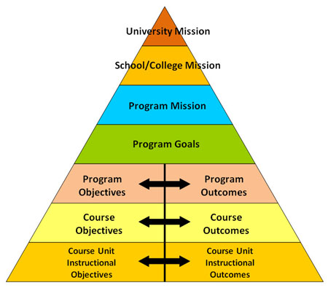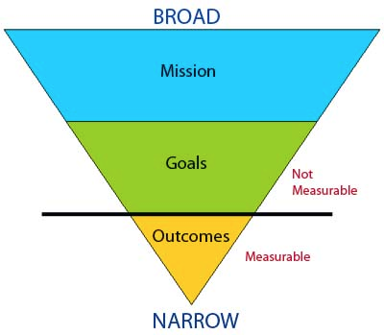

Source: http://assessment.uconn.edu/assessment-primer/

Questions (15 min)

1. What are the five organizational units shown in the left pyramid?

2. What are the four main concepts (vocabulary terms) in the model?

3. What does the pyramid structure suggest about the concepts and organizational units?
Please write your answer in 2-3 complete sentences.

4. What does Model 1 suggest about the relationship between goals and outcomes?

5. What does Model 1 suggest about the relationship between objectives and outcomes?

6. Based on your combined experience as faculty, write a concise definition for each concept from Question 2.

7. Identify the type of each statement of learning below, i.e., which concept is it?

[Biochemistry] Demonstrate (to students) the application of molecular graphics to drug design.
[Literature] Introduce students to modes of satiric writing in the eighteenth century.
[Engineering] Functioning as a member of a team, the student will design and present a concrete structure which complies with engineering standards.
[Liberal Arts] We are a community committed to preparing students to be educated and enlightened citizens who lead productive and meaningful lives.

Model 2: Bloom's Taxonomy

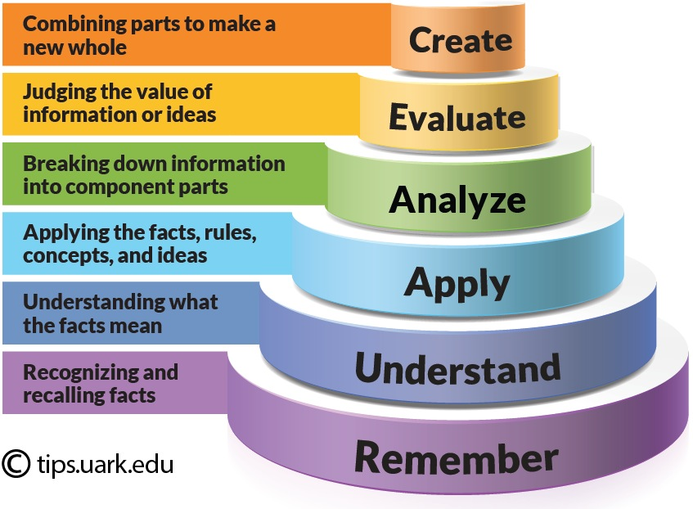

Source: https://tips.uark.edu/using-blooms-taxonomy/

Questions (15 min)

8. What is the meaning of the word taxonomy? (feel free to use a dictionary)

9. What is the difference between analyze and evaluate? Give a specific example.

10. What does the “cake-style” diagram in Model 2 suggest about the six levels?

11. Which levels apply to which types of courses and populations of students?

12. For a given course, is it important to have objectives at all levels? Why or why not?

13. What role does Bloom's Taxonomy play in writing educational objectives?

14. For each learning objective, what is the level of Bloom's Taxonomy?

Read and compare literary works from various historical periods, watching for the evolving ways (historical and cultural, local and global) that gender is constructed in each text.
Define the following terms: hypothesis, experiment, observation, theory.
Develop a daily fundamental practice routine (specific to your needs) that addresses the craft of sound, articulation, flexibility, agility, range, and endurance.
Use appropriate help resources to accomplish programming tasks.
Determine which policy issues are important from the perspective of your own academic major and/or personal interests.
Explain how data are represented, stored, and manipulated by computer hardware.

Model 3: Fink's Taxonomy

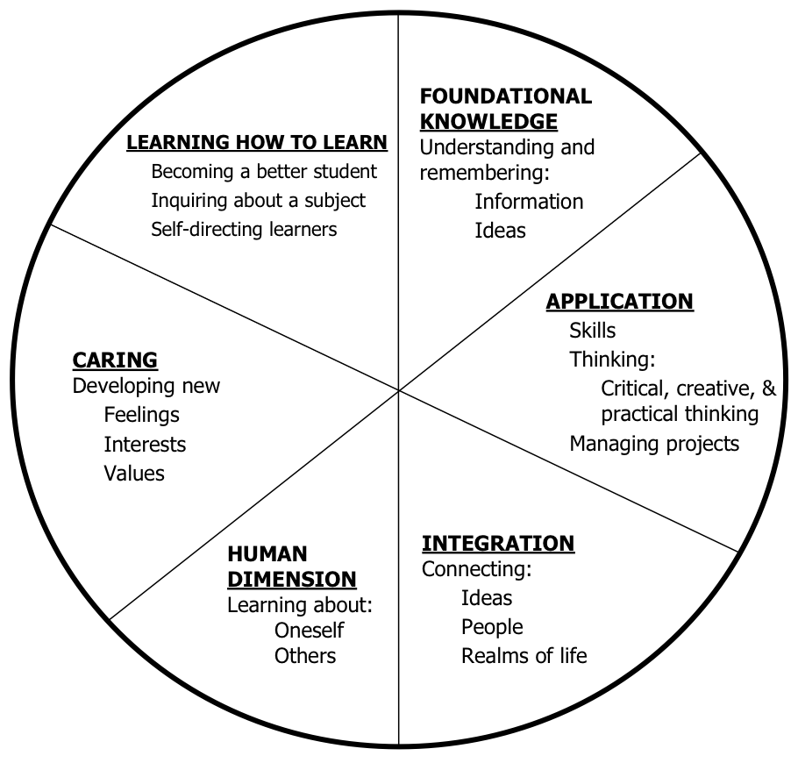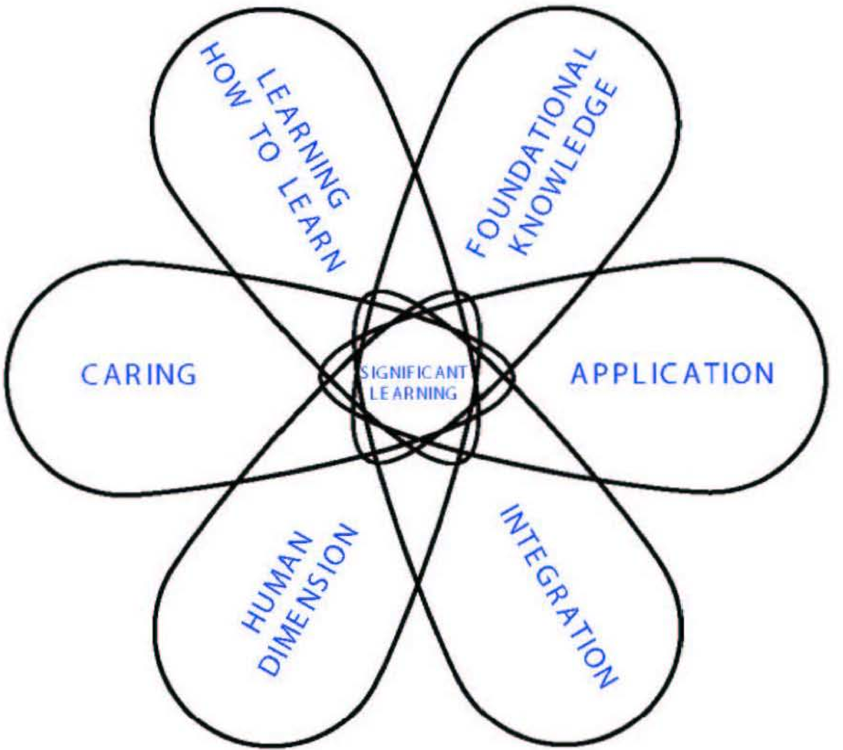

Source: Fink's Self-Directed Guide, Pages 9-10

Questions (15 min)

15. What elements of Fink's Taxonomy are not present in Bloom's? (and vice versa)

16. What does the pie shape (left side of Model 3) suggest about the six categories?

17. What does the petal shape (right side of Model 3) suggest about the six categories?

18. What are the pros and cons of using Fink's Taxonomy as opposed to Bloom's?

19. With respect to the university's mission (and higher education in general), how essential are the three categories on the left half of the pie?

20. For a given course, is it important to have objectives in all six categories? Why or why not?

21. For each learning objective, what is the category of Fink's Taxonomy?

Discuss the impact of climate change within economic, social, and cultural contexts.
Describe how to learn new programming languages, operating systems, and technologies.
Using team feedback, identify where you have strengths and areas that need improvement.
Recognize and identify the following legal terminology: contract, law, statute, and title.
Commit to spending more time outside of class to read articles and be an informed citizen.
Apply computing tools and techniques to solve problems at multiple levels of abstraction.

Model 4: Course Objectives

 | Bad Examples | Good Examples
A | This course will provide students with knowledge about how to write resumes. | Students will create resumes that accurately reflect their education and experience.
B | Students will demonstrate an acceptance of all cultures by strongly agreeing with all items on the Open-Mindedness Inventory. | Students will show a 10-point increase on the Open-Mindedness Inventory from the beginning to the end of the semester.
C | Students will know about JMU’s alternative spring break program. | Students will describe two examples of JMU’s alternative spring break program.
D | Students will understand proper dental hygiene. | Students will explain how poor dental hygiene can lead to poor overall health.
E | Describe and create a marketing plan for your organization. | Create a marketing plan for your organization.
F | Become familiar with the elements of editing. | Identify elements of editing, including composition, setting, and lighting.
G | Complete the assignment. | (deleted)
H | This lab will explain the benefits of various exercise modalities for an elderly person. | The student will determine the most appropriate exercise modality for health maintenance in the patient who is elderly.

Source: https://tips.uark.edu/learning-objectives-before-and-after-examples/

Questions (15 min)

22. For each example in Model 4, identify what is wrong with the bad example (or right with the good example).

23. What types of words should be avoided when writing objectives and outcomes?

24. Are “good” objectives always longer than “bad” objectives? Why or why not?

25. As a team, develop a list of 4-5 “best practices” (or good characteristics) for writing learning objectives. Organize them in a way that can be shared with the rest of the class.

Exercises

Using the handouts and readings on Canvas:

1. Create or revise 2-3 learning objectives for your course. (individually)

2. Share your objectives with a partner, and give feedback to one another.

