Learning Taxonomies and Course Objectives

Model 1: Statements of Learning

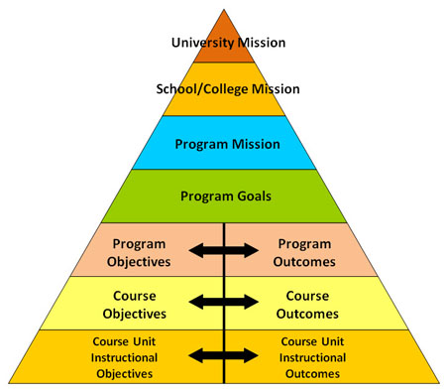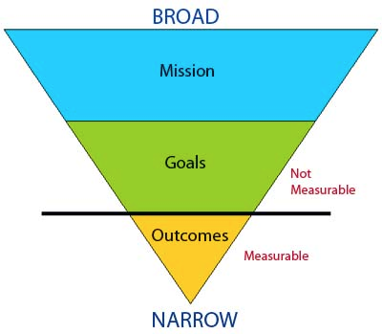

Source: http://assessment.uconn.edu/assessment-primer/

Questions (15 min)

1. What are the five organizational units shown in the left pyramid?

University, College, Program, Course, Unit

2. What are the four main concepts (vocabulary terms) in the model?

Mission, Goals, Objectives, Outcomes

3. What does the pyramid structure suggest about the concepts and organizational units?
Please write your answer in 2-3 complete sentences.

Learning flows from the mission of the institution down to the units of instruction. As you move down the pyramid, you have a larger quantity (courses/units) and higher complexity (objectives/outcomes). At the same time, missions and goals are broad statements, whereas objectives and outcomes are specific.

4. What does Model 1 suggest about the relationship between goals and outcomes?

Goals are broad statements, and they are often unmeasurable. They come from the program's (or department's) mission. Outcomes are measurable statements of student learning, based on the overall goals of the course.

5. What does Model 1 suggest about the relationship between objectives and outcomes?

The arrows suggest they are interchangeable and support each other. Objectives are the input (instructor's intended results) and outcomes are the output (student's achieved results).

6. Based on your combined experience as faculty, write a concise definition for each concept from Question 2.

Mission:
A concise statement that outlines the purpose of an institution and guides its practice.

Goal:
A broad, general statement of what the program (or course) intends to accomplish.

Objective:
A brief, clear statement that describes a desired learning outcome of instruction.

Outcome:
A statement that describes what students achieved by the end of the course/unit.

7. Identify the type of each statement of learning below, i.e., which concept is it?

Objective | [Biochemistry] Demonstrate (to students) the application of molecular graphics to drug design.
Goal | [Literature] Introduce students to modes of satiric writing in the eighteenth century.
Outcome | [Engineering] Functioning as a member of a team, the student will design and present a concrete structure which complies with engineering standards.
Mission | [Liberal Arts] We are a community committed to preparing students to be educated and enlightened citizens who lead productive and meaningful lives.

Model 2: Bloom's Taxonomy

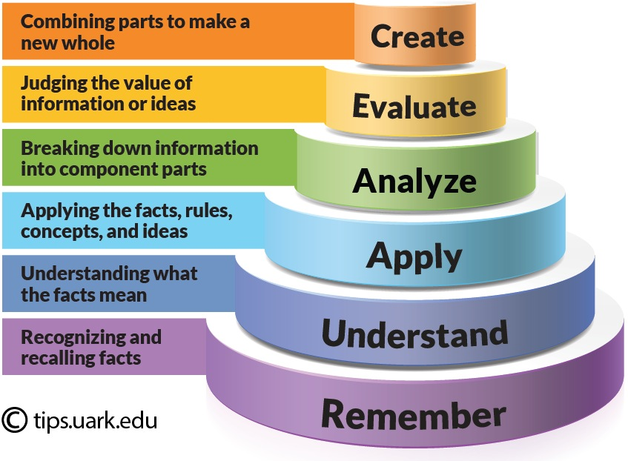

Source: https://tips.uark.edu/using-blooms-taxonomy/

Questions (15 min)

8. What is the meaning of the word taxonomy? (feel free to use a dictionary)

A scheme of classification into categories.

9. What is the difference between analyze and evaluate? Give a specific example.

Evaluate involves making value judgements, not just breaking down information. For example, grading a term paper requires evaluation, whereas underlying positive and negative arguments in a paper is simply analyzing.

10. What does the “cake-style” diagram in Model 2 suggest about the six levels?

They form a hierarchy: each level is built on the foundation of the previous levels.

11. Which levels apply to which types of courses and populations of students?

Typically lower-level courses should focus on remember, understand, and apply. Upper-level courses should focus on analyze, evaluate, and create. But the terms are relative; for example, students of all grade levels can learn to create.

12. For a given course, is it important to have objectives at all levels? Why or why not?

According to Bloom, each of these levels should be covered in a course, and at least one objective should be written for each level. But in practice, certain courses will place more emphasis on some areas than others.

13. What role does Bloom's Taxonomy play in writing educational objectives?

It reminds the instructor about processes of learning and scaffolding; for example, before students can understand something, they must be able to remember it. The taxonomy also provides a common vocabulary for designing assessments and activities at the right level.

14. For each learning objective, what is the level of Bloom's Taxonomy?

Analyze | Read and compare literary works from various historical periods, watching for the evolving ways (historical and cultural, local and global) that gender is constructed in each text.
Remember | Define the following terms: hypothesis, experiment, observation, theory.
Create | Develop a daily fundamental practice routine (specific to your needs) that addresses the craft of sound, articulation, flexibility, agility, range, and endurance.
Apply | Use appropriate help resources to accomplish programming tasks.
Evaluate | Determine which policy issues are important from the perspective of your own academic major and/or personal interests.
Understand | Explain how data are represented, stored, and manipulated by computer hardware.

Model 3: Fink's Taxonomy

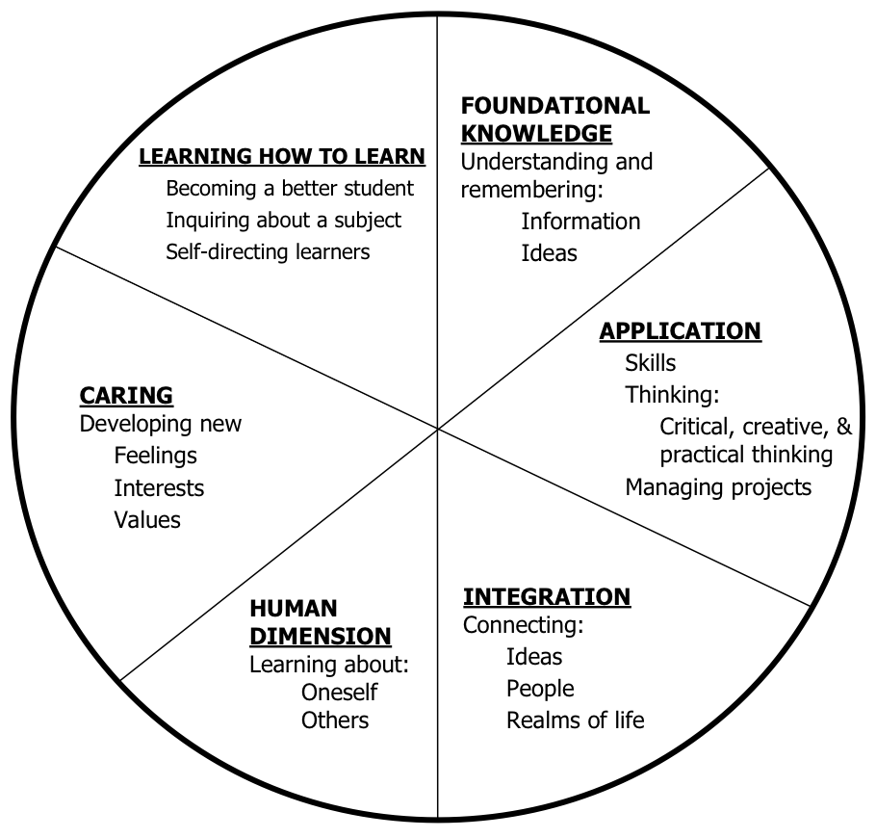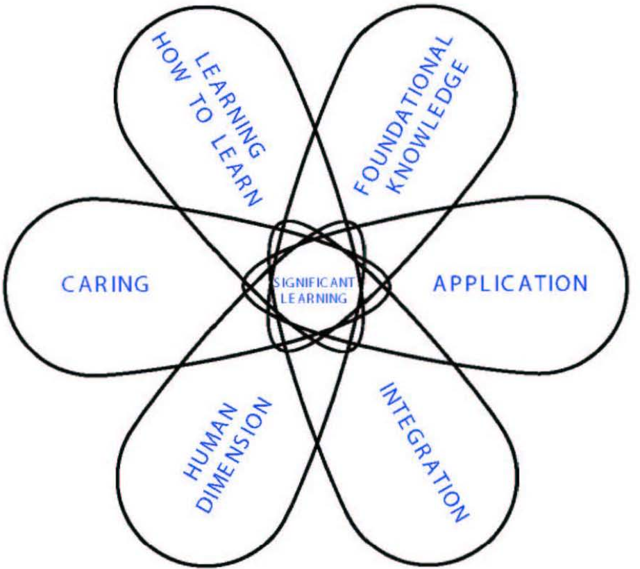

Source: Fink's Self-Directed Guide, Pages 9-10

Questions (15 min)

15. What elements of Fink's Taxonomy are not present in Bloom's? (and vice versa)

Integration, human dimension, caring, learning how to learn.

16. What does the pie shape (left side of Model 3) suggest about the six categories?

They are different and equally important; there is no hierarchy.

17. What does the petal shape (right side of Model 3) suggest about the six categories?

All six categories work together to achieve significant learning.

18. What are the pros and cons of using Fink's Taxonomy as opposed to Bloom's?

Fink's taxonomy prompts the instructor to develop objectives that are not necessarily tied to course content, but at the same time are important to the program's and university's mission.
On the other hand, many instructors dismiss these categories as being too soft or abstract.

19. With respect to the university's mission (and higher education in general), how essential are the three categories on the left half of the pie?

Many instructors dismiss these categories as “soft skills”, but they represent some of the most important learning students gain in higher education. As such, Fink suggests that instructors should have course objectives that explicitly address these skills.

20. For a given course, is it important to have objectives in all six categories? Why or why not?

In general, yes. But as with Bloom's taxonomy, some courses will emphasize certain categories more than others.

21. For each learning objective, what is the category of Fink's Taxonomy?

Integration | Discuss the impact of climate change within economic, social, and cultural contexts.
Learning How To Learn | Describe how to learn new programming languages, operating systems, and technologies.
Human Dimension | Using team feedback, identify where you have strengths and areas that need improvement.
Foundational Knowledge | Recognize and identify the following legal terminology: contract, law, statute, and title.
Caring | Commit to spending more time outside of class to read articles and be an informed citizen.
Application | Apply computing tools and techniques to solve problems at multiple levels of abstraction.

Model 4: Course Objectives

 | Bad Examples | Good Examples
A | This course will provide students with knowledge about how to write resumes. | Students will create resumes that accurately reflect their education and experience.
B | Students will demonstrate an acceptance of all cultures by strongly agreeing with all items on the Open-Mindedness Inventory. | Students will show a 10-point increase on the Open-Mindedness Inventory from the beginning to the end of the semester.
C | Students will know about JMU’s alternative spring break program. | Students will describe two examples of JMU’s alternative spring break program.
D | Students will understand proper dental hygiene. | Students will explain how poor dental hygiene can lead to poor overall health.
E | Describe and create a marketing plan for your organization. | Create a marketing plan for your organization.
F | Become familiar with the elements of editing. | Identify elements of editing, including composition, setting, and lighting.
G | Complete the assignment. | (deleted)
H | This lab will explain the benefits of various exercise modalities for an elderly person. | The student will determine the most appropriate exercise modality for health maintenance in the patient who is elderly.

Source: https://tips.uark.edu/learning-objectives-before-and-after-examples/

Questions (15 min)

22. For each example in Model 4, identify what is wrong with the bad example (or right with the good example).

- not student-centered  - unreasonable expectation  - unspecific, unmeasurable  - understand is meaningless | - multiple levels of Bloom's  - unspecific, unmeasurable  - to-do item, not an objective  - not student-centered

23. What types of words should be avoided when writing objectives and outcomes?

Vague terms like understand, know, and learn. Unspecified amounts like various and miscellaneous. Objectives are easier to measure when they are more precise.

24. Are “good” objectives always longer than “bad” objectives? Why or why not?

Not necessarily; they should be as simple and concise as possible. Avoid including so much detail that they become overwhelming to students.

25. As a team, develop a list of 4-5 “best practices” (or good characteristics) for writing learning objectives. Organize them in a way that can be shared with the rest of the class.

Objectives should be SMART:
Specific
Measurable
Attainable
Relevant
Timely

Exercises

Using the handouts and readings on Canvas:

1. Create or revise 2-3 learning objectives for your course. (individually)

2. Share your objectives with a partner, and give feedback to one another.

