POGIL (in Two Pictures and One Link)

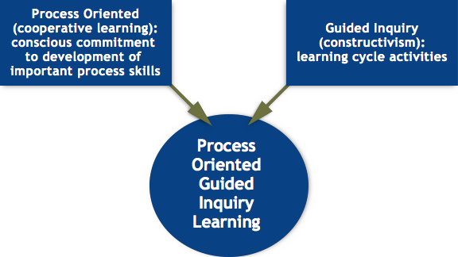

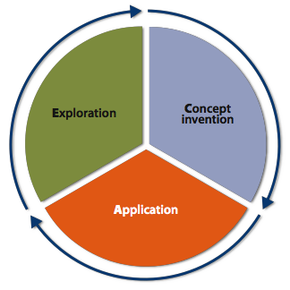

https://pogil.org/resources
POGIL (in Two Pictures and One Link)

https://pogil.org/resources

