What is POGIL?

POGIL is an acronym for Process Oriented Guided Inquiry Learning. In a typical POGIL classroom, students work in small teams with the instructor acting as a facilitator. The student teams use specially designed activities that generally follow a learning cycle paradigm. These activities are designed to have three key characteristics:
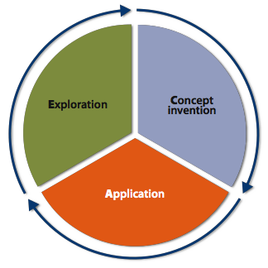
- They help teams to become self-managed and employ the instructor as a facilitator of learning rather than a source of information.
- They guide students through an exploration to invent (construct) their own understanding.
- They use discipline specific content to facilitate the development of important process skills, including higher-level thinking and the ability to learn and to apply knowledge in new contexts.

The POGIL approach has two broad aims: to develop content mastery through student construction of their own understanding, and to develop and improve important learning skills such as information processing, communication, critical thinking, problem solving, teamwork, and metacognition.

Key Elements of the POGIL Pedagogy

A POGIL classroom consists of students working in small, self-managed teams on specially designed guided inquiry materials. These materials supply students with data or information to interpret, followed by guiding questions designed to lead them toward formulation of their own conclusions—essentially a recapitulation of the scientific method.

POGIL focuses on developing process skills in addition to mastering course content. POGIL is an interactive process of refining one’s understanding and developing one's skills for the workplace as a component of the student learning process. The ability to engage in these processes is crucial for students to succeed in active learning environments.

Instruction in a POGIL classroom is student-centered. The instructor serves primarily as a facilitator of student learning. In a POGIL classroom, the instructor observes and addresses individual, team, and classroom-wide needs. This inquiry-based team environment energizes students and provides instructors with instant and constant feedback about what their students understand and misunderstand.

https://pogil.org/

