Damped and Driven HO Simulation

Goal
To use Python Glowscript to explore the simulation, and especially the energy, of a damped and driven harmonic oscillator.

Setup
Open the template here. It’s just a version of the Harmonic Oscillator simulation with a few things added. Copy this to a new program. The initial position is set to be vec(0, 2, 0).

Add Energy Curves
Comment out the lines which plot the position, velocity, and acceleration. Add lines to plot curves for kinetic energy, potential energy, and total energy as a function of time, just like you did in the energy graph activity.
Descript how each of the energy curves behave with respect to one another. (Which comes first, etc?)
> when either potential or kinetic energy fall the other rises. The system starts off with all potential energy and shifts as kinetic energy rises
Explain why the energy curves behave as they do. What causes potential and kinetic energy to change into one another?
> Because of conservation of energy, without friction, the energy in the system is going to stay the same. And because of this there is a trade in potential and kinetic energy that is 1:1.

Add a Damping Force
Add a damping force that follow the formula
$$\vec{F}=-b\vec{v}$$
where $b$ is a constant that you can choose.
Try $b=0.1$. Describe the motion and the behavior of the energy curves. (This is called underdamped motion.)
> the ball still oscillates but the amplitude will go down over time
Why does the total energy not stay constant? Where is the energy going? (This is dissipation.)
> Some of the mechanical energy is changing to thermal energy, giving the ball less motion.
At what points in the motion is the rate of decrease of total energy at a maximum? Why at those points?
> Whenever the ball passes through the equilibrium point the rate of decrease is steepest. That’s when the speed is highest so
Try $b=10$. Describe the motion and the behavior of the energy curves. (This is called overdamped motion.) Contrast it to the underdamped motion.
> the ball drops from the top and slows down basically to a stop at the equilibrium point. Compared to underdamped, overdamped doesn’t allow the ball to oscillate fully.
Guess and check to find approximately what $b$ value is the crossover point between underdamped and overdamped motion. (At this one $b$ value the motion is called critically damped.) How did you define this crossover point?
> At 5.5 the ball is critically damped, because it does not oscilate, just comes to a slow stop.

Add a Driving Force
Now add a driving force with formula
$$\vec{F}=D\sin{{(ω}_{d}t)}\hat{y}$$
where you can control the amplitude $D$ and the driving frequency $ω_{d}$. Also, $\hat{y}=$ vec(0,1,0). Choose $D=20$. Also, set $b=1$ for the damping force and set the initial y position to 0. For this part, turn back on your curve for position. You may also want to turn off your energy curves, as they obscure the position curve.
To help visualize the forces involved, add arrows to represent them by adding these lines to the top:
attach_arrow(ball, "spring_force", color=vec(0.5,0.5,0.5), scale=0.1, shaftwidth=0.1)
attach_arrow(ball, "damping_force", color=vec(0.75,0.5,0), scale=0.1, shaftwidth=0.1)
attach_arrow(ball, "driving_force", color=vec(1,1,0), scale=0.1, shaftwidth=0.1)
and adding the appropriate formulas for each of these forces separately in the main loop. For example:
ball.damping_force = -b*ball.vel
Try $ω_{d}=1$. Describe how the position behaves with time.
> At first the movement is all over the place. After a while the ball shoots either up or down and then works its way back to equilibrium.
The initial behavior before it settles into a regular pattern is called the transient.
Now we’ll focus our attention on the periodic behavior after the transient. What amplitude of motion was produced by $ω_{d}=1$? (Find it by looking at the graph and its gridlines.)
> After the transient period, the amplitude of the ball was around 11 units.
Repeat this by increasing $ω_{d}$ by 1 all the way to 12. Use Excel to make a graph of amplitude vs $ω_{d}$ (drive frequency). Paste it below:
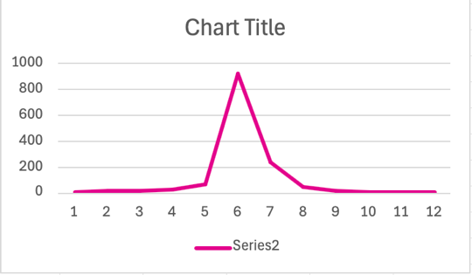

How does amplitude depend on drive frequency? (Describe the shape of the curve.)
> as the drive frequency increases the amplitude keeps increasing until a certain point, where after this point the amplitude starts to drop off
Which drive frequency gave maximum amplitude?
> 6
When maximum amplitude is attained, this is called resonance.
Recall, what is the angular frequency of oscillation $ω$ for the undamped, undriven oscillator? (That is, the angular frequency for the harmonic oscillator without any damping or driving forces.)
> 6.32
How does this compare to the driving frequency for resonance?
> they are the same
Recall an example where have you seen resonance in real life.
> a violin with the strings making noise from the vibration
Perform this same sweep of $ω_{d}$ from 1 to 12 for two more different values of damping, $b=0.1$ and $b=10$, to see how the amplitude curves changes for lower damping and higher damping. Make another graph of amplitude vs $ω_{d}$ that shows all three curves on the same graph, clearly labeled. Paste it below:
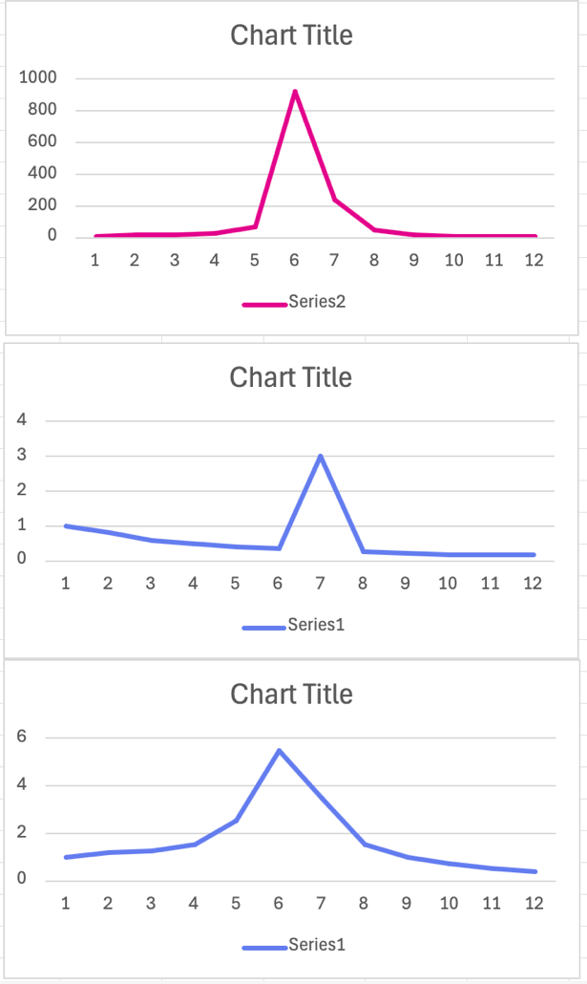
Contrast the shapes and magnitudes of the curves for different amounts of damping.
>with more dampening the amplitude reaches a lower peak
What does this tell you about how damping affects resonance?
> Dampening lowers what frequency something resonates at

Wrap-up
Please reflect on a take-away from this programming activity. Describe something you learned or found memorable and why that connected with you.
> understanding the different impacts of oscillation and how that impacts resonance was very memorable
Finally, upload this file to the Canvas assignment, and add the link to your program below:
https://glowscript.org/#/user/Chrismedkit/folder/MyPrograms/program/Damped&Driven

