Lab Report: Projectile Motion

Part 1 Calibrating the Launcher (Measuring Launch Speed):
- We started brainstorming different ways to calculate the launch speed by setting up our cross of known/unknown variables, with acceleration in the x and y directions already known, we figured that if we measured delta x and y, we would only have to solve for time in order to find the initial velocity in the x direction, which would serve as the launch speed because of our 0 degree launch angle.
- After calculating delta y to be -.8156 meters, delta x to be 1.263 meters, we were able to solve for time. Allowing us to find the initial x velocity
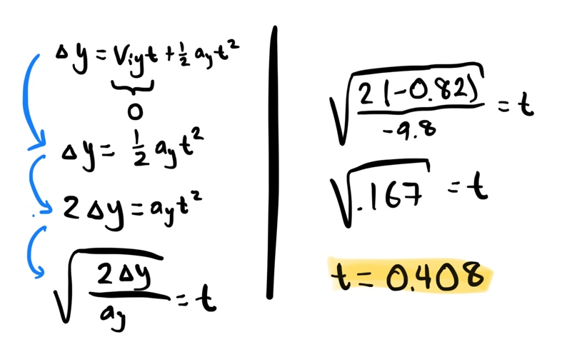
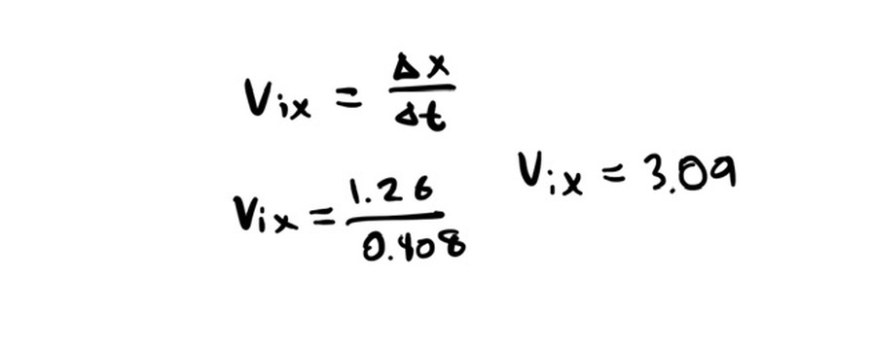
Part 2 Predicting the Landing Position for an Angled Launch:
Using the launch speed, we would be able to find the initial velocity in the x and y directions when launching from a 30-degree angle.
To do this we first started by finding the initial velocity in the x direction using soh-cah-toa. After we used the initial x velocity to solve for the initial y velocity, giving us the variables needed to solve for time.
Once we were able to calculate the time, delta x was be given by the initial x velocity multiplied by the time.
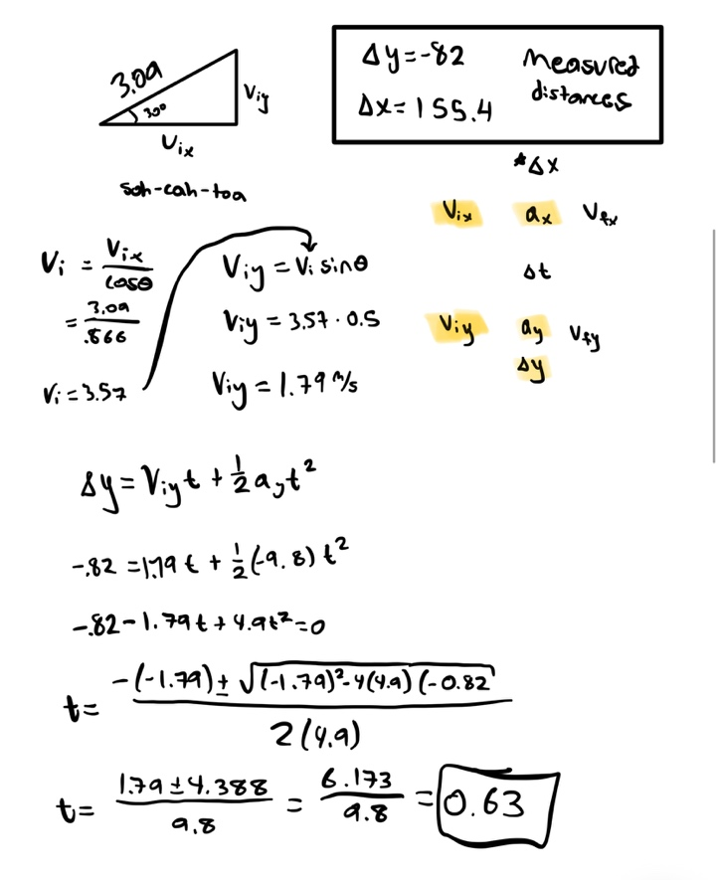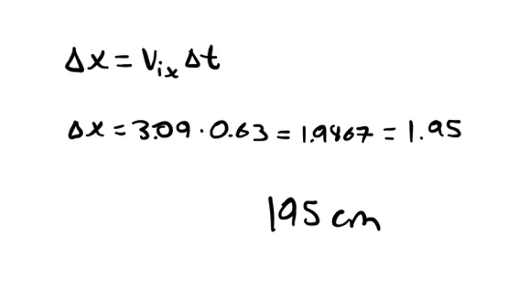

With our original measurement for the x distance being 185.4 cm, our calculation was about 10cm off. (I wrote the value wrong in my notes)
Considering the rounding of decimals we did, we thought that the distance calculated was a good representation of how we could calculate the distances for other angles now that we had a launch speed.

Part 3 Take a shot at a target up front:

We take aim at the target 97.7 cm off the ground, 159.8 cm away from the target. With this information we were able to calculate a launch angle to hit the target.
We calculated a 37-degree angle to hit the target. This angle allowed us to not only hit the paper, but land 4cm away from the bullseye.

Conclusion:

- The most challenging part of the lab was understanding how we wanted to approach calculating the launch speed, and how we would even use the launch speed for part 2
- It helped understand where some numbers come from, when looking back at the homework (visualizing what the problems are asking)
- Being able to work in a group and seeing the different approaches our group
- Not really, maybe something could be improved in part 3.

